Dietary model

A
Insuline tolerance test
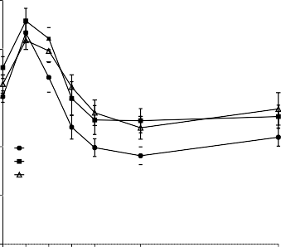
15 D: p=.06 T: p<.001 DxT: p=.04
LF ω6 HF ω6
HF ω3
$
B
AUC ipITT

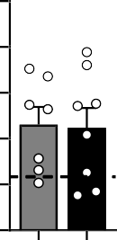
800
12

700
Glycemia (mmol/L)
9

600
AU
6
500

400
3

0
0 5 10 15 20

30 60
Time (min)
300

HF HF
ω6 ω3

C D E
Glucose tolerance test

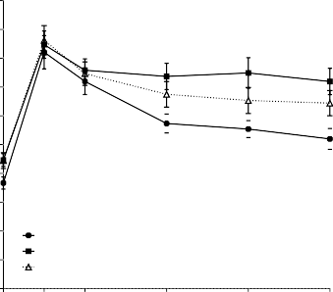
20 D: p=.09 T: p<.001 DxT: p<.001
$
$$
$
LF ω6
HF ω6 HF ω3

18

16

14
Glycemia (mmol/L)

12

10

8

6

4

2

0

Fasting glycemia oGTT

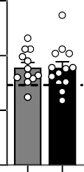
15
Glycemia (mmol/L)

10
$

5

0

2500

2000

1500
AU

1000

500

0

AUC oGTT

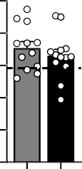

0 15
30 60 90 120
Time (min)
HF HF
ω6 ω3
HF HF
ω6 ω3

F
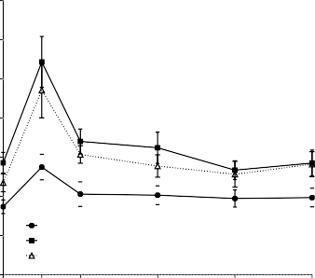
3.5
$$$
$$
$$
$p=.06
$
$$
LF ω6 HF ω6
HF ω3

Glucose-stimulated insulin secretion
D: p=.002 T: p<.001 DxT: p=.26
G
Fasting insulinemia oGTT
H I
AUC GSIS

HOMA-IR

3.0

2.5
Glycemia (mmol/L)

2.0

1.5
3 400 40

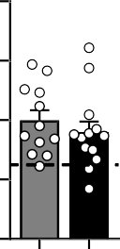
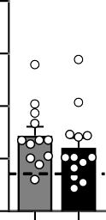
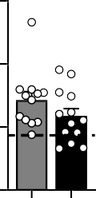
300 30
Glycemia (mmol/L)
HOMA-IR Index
2
200 20
AU

1.0

0.5

0.0
0

15 30 60 90 120
Time (min)

1

0
HF HF
ω6 ω3

100

0

HF HF
ω6 ω3

10

0
HF HF
ω6 ω3

Supplemental Fig S1. The ω-3 PUFA supplementation does not improves glucose homeostasis. (A) Glycemic response and (B) corresponding area under the curve (AUC) to the insulin tolerance test (ipITT) performed at week 10. (C) Glycemic response (D) fasting glycaemia and (E) AUC before and during the glucose tolerance test (oGTT) performed at week 12. (F) Glucose-stimulated insulin secretion
(G) fasting insulin and (H) AUC before and during the oGTT. (I) Homeostasis model assessment of insulin resistance (HOMA-IR). Values are means ± SEM of n=9-13 mice per group. One-way ANOVA followed by Dunnett post hoc test compared to HF-ω6 group. Dotted line represents LF-ω6 group as a reference. *P<.05, **P<.01, ***P<.001.

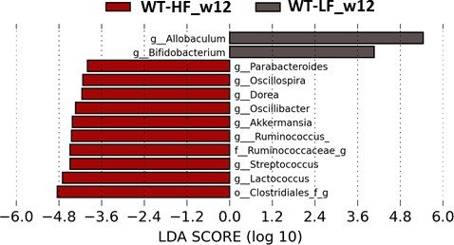
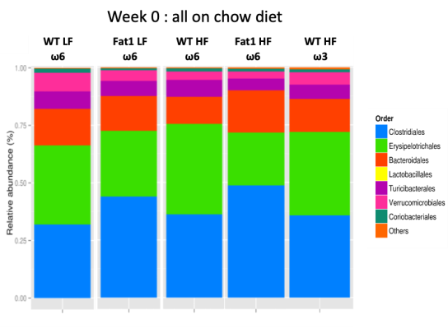
A B

Genetic model C
Fecal Lcn2 D

Caecum

Total cecal SCFA
E

D: p=.58 G: p=.11 DxG: p=.15
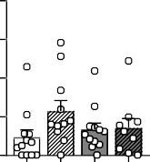
20

15
ng/g feces

10

5
D: p=.005 G: p=.86 DxG: p=.87
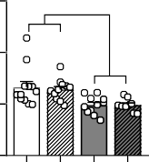
0.6
✱

0.4
Weight (g)

0.2
D: p=.13 G: p=.98 DxG: p=.94
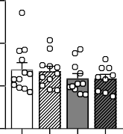
1500
µg/g caecal content

1000

500

0
WT Fat-1 WT Fat-1

0.0

WT Fat-1 WT Fat-1

0
WT Fat-1 WT Fat-1

LF LF HF HF
LF LF HF HF
LF LF HF HF

F
Acetate
G H
Propionate
I
Butyrate
J
Valerate

Isovalerate
K
Isobutyrate

D: p=.63 G: p=.77 DxG: p=.70
D: p=.003 G: p=.14 DxG: p=.35
D: p=.90 G: p=.75 DxG: p=.97
D: p=.02 G: p=.60 DxG: p=.54
D: p<.001 G: p=.76 DxG: p=.74
D: p<.001 G: p=.96 DxG: p=.95

800
µg/g caecal content

600

400

200

0

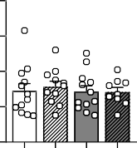
WT Fat-1 WT Fat-1
350
300
µg/g caecal content
250
200
150
100
50
0
✱✱
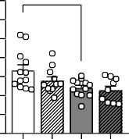
WT Fat-1 WT Fat-1
400

300
µg/g caecal content

200

100

0

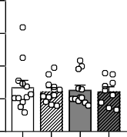
WT Fat-1 WT Fat-1
70
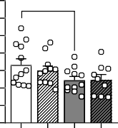
60
✱
µg/g caecal content
50
40
30
20
10
0
WT Fat-1 WT Fat-1
✱✱✱
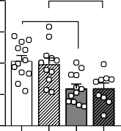
80
✱✱
µg/g caecal content

60

40

20

0
WT Fat-1 WT Fat-1
60

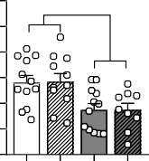
50
✱✱
µg/g caecal content

40

30

20

10

0
WT Fat-1 WT Fat-1

LF LF
HF HF
LF LF
HF HF
LF LF
HF HF
LF LF
HF HF
LF LF
HF HF
LF LF
HF HF

Dietary model
- Fecal Lcn2
- Caecum
N Total cecal SCFA

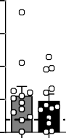
12 2
1
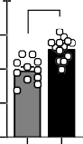
0.4 ✱
9
ng/g feces
Weight (g)
0.3
6
0.2

3 0.1

1500

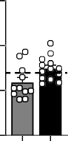
1000
µg/g caecal content

500

0
HF HF
O P ω6 ω3 Q

0.0

HF HF
ω6 ω3 R

0
HF HF
ω6 ω3 S T

600
µg/g caecal content

400

200
Acetate

300
µg/g caecal content

200

100
Propionate
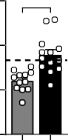
✱✱

250
µg/g caecal content

200

150

100

50
Butyrate
Valerate

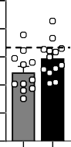
50
µg/g caecal content

40

30

20

10

150

100
µg/g caecal content

50
Isovalerate
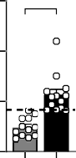
✱✱✱
Isobutyrate
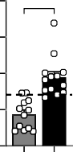
80 ✱✱✱
µg/g caecal content

60

40

20

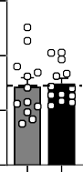
0
HF HF
ω6 ω3

0
HF HF
ω6 ω3

0
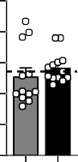
HF HF
ω6 ω3

0
HF HF
ω6 ω3

0
HF HF
ω6 ω3

0
HF HF
ω6 ω3

Supplemental Fig. S2. Impact of endogenous production and ω-3 PUFA supplementation on intestinal health. (A) Stacked bar plot representing the bacterial relative abundance before treatment (all animals on chow diet) at order level, (B) LEfSe analysis identifying significant differentially genera abundance between WT-HF and WT-LF mice after 12 weeks. Panels (C-K) refer to the genetic model and (L-T) to the dietary model. (C, L) Fecal lipocalin-2. (D, M) and (E, N) total caecal short chain fatty acid (SCFA) content. (F, O) acetate (G, P) propionate (H, Q) butyrate (I, R) valerate (J, S) isovalerate and (K, T) isobutyrate caecal concentrations. Values are means ± SEM of n=9-13 mice per group. For the genetic model: two-way ANOVA followed by Tukey post hoc test. P-values of main effects for diet (D) and gene (G) or diet x gene (DxG) interaction are recorded under the title of each graph. For the dietary model: one-way ANOVA followed by Dunnett post hoc test compared to HF-ω6 group. Dotted line represents LF-ω6 group as a reference. *P<.05, **P<.01, ***P<.001. “f” and “g” at the end of taxon denote unclassified family and genus, respectively.

Genetic model

A B C
ALT

AST

Plasma NEFA
D: p=.06 G: p=.37 DxG: p=.73
D: p=.001 G: p=.34 DxG: p=.37
D: p=.45 G: p=.94 DxG: p=.89

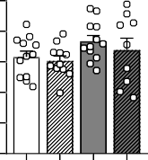
1.0

0.8

0.6
mEq/L

0.4

0.2

0.0
200

150

100
U/L

50

0
p=0.05

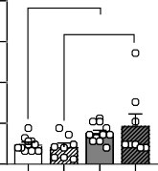
WT Fat-1 WT Fat-1
✱✱
160
140
120
100
U/L
80
60
40
20
0

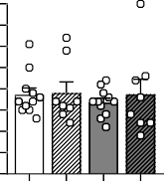
WT Fat-1 WT Fat-1

WT Fat-1 WT Fat-1
LF LF
HF HF
LF LF
HF HF

LF LF HF HF

Dietary model

D Plasma NEFA
E ALT
F AST

1.0
p=.08
p=.06
60

100
p=.07

0.8 80
40
mEq/L
0.6 60
U/L
U/L

0.4 40
20
0.2 20

0.0

HF HF
ω6 ω3

0
HF HF
ω6 ω3

0
HF HF
ω6 ω3

Supplemental Fig. S3. ω3-PUFA supplementation exerts a greater effect improving lipids and reducing hepatic markers of acute injury. Panels (A-C) refer to the genetic model and (D-F) to the dietary model. Plasma (A, D non- esterified fatty acids (B, E) alanine aminotransferase (ALT) (C, F) aspartate aminotransferase (AST). Values are means
± SEM of n=9-13 mice per group. For the genetic model: two-way ANOVA followed by Tukey post hoc test. P-values of main effects for diet (D) and gene (G) or diet x gene (DxG) interaction are recorded under the title of each graph. For the dietary model: one-way ANOVA followed by Dunnett post hoc test compared to HF-ω6 group. Dotted line represents LF-ω6 group as a reference. Thick dotted line on y axis represents the half of the quantification limit (0.08 pg/mg). *P<.05, **P<.01, ***P<.001.

Supplemental Table S1. Hepatic lipid profile of the five treated groups (µM). The two last columns show statistical differences referring to the dietary and the genetic models respectively. Dietary model: One-way ANOVA with Tukey post hoc test (vs HF ω6 group). Significant effects are notified by “diet” (LF WT ω6 vs HF ω6) or “gavage” (HF ω3 group vs HF ω6). Genetic model: 2-way ANOVA followed by a Tukey post hoc test. Significant main effects are notified by “D” (diet) or “G” (gene).

Hepatic Lipid profile (µM)
LF WT LF Fat-1 HF WT HF Fat-1 HF WT  ω6 ω6 ω6 ω6 ω3 |  |  |  |  |  |  |  |  |  |  |  |  |  |  |  | Dietary model Genetic model  One-way ANOVA listing 2-way ANOVA listing
C10:0 | 42.19 | ± | 10.08 | 42.46 | ± | 10.07 | 29.40 | ± | 8.95 | 24.25 | ± | 9.67 | 38.01 | ± | 7.32 | - -  gavage -  diet: p=.09, gavage D, G: p=.07 gavage -  gavage -  diet D, DxG: p=.08  - DxG: p=.08  gavage D, G: p=.07  diet D  diet D  gavage -  gavage D, G  diet, gavage D  diet: p=.06, gavage D, G: p=.05  - -  diet, gavage D, G  gavage -  gavage D, G  diet, gavage D, G:p=.05 diet D  diet D  - -  diet D  diet, gavage D; G:p=.06  - -  gavage G: p=.09  gavage G  gavage G  - D  diet D  diet: p=.07, gavage D, G  - D  diet, gavage D  gavage D: p=.08  gavage D, G, DxG  gavage D: p=.06, G: p=.06  diet, gavage D, G: p=.08  gavage D, G  diet, gavage D  diet, gavage D, G: p=.05  diet, gavage D, G
C14:0 | 37.24 | ± | 3.71 | 30.29 | ± | 4.33 | 39.39 | ± | 5.05 | 30.29 | ± | 6.75 | 16.39 | ± | 1.58
C16:0 | 1269.10 | ± | 101.91 | 1086.40 | ± | 91.54 | 1716.11 | ± | 159.22 | 1381.42 | ± | 195.28 | 1070.63 | ± | 63.97
C18:0 | 332.73 | ± | 15.76 | 313.23 | ± | 13.13 | 306.28 | ± | 5.77 | 321.60 | ± | 29.87 | 358.78 | ± | 15.49
C20:0 | 5.55 | ± | 1.00 | 5.36 | ± | 1.00 | 7.45 | ± | 0.73 | 12.75 | ± | 7.64 | 3.44 | ± | 1.43
C22:0 | 0.34 | ± | 0.25 | 0.08 | ± | 0.08 | 1.90 | ± | 0.46 | 3.03 | ± | 0.61 | 3.57 | ± | 1.58
C24:0 | 9.10 | ± | 1.20 | 5.37 | ± | 1.58 | 8.89 | ± | 1.18 | 9.91 | ± | 1.27 | 6.25 | ± | 1.39
Saturated | 1736.77 | ± | 123.96 | 1483.18 | ± | 106.18 | 2109.41 | ± | 167.31 | 1783.25 | ± | 219.05 | 1497.13 | ± | 76.70
C14:1n5 | 2.18 | ± | 0.36 | 2.06 | ± | 0.41 | 0.69 | ± | 0.29 | 1.08 | ± | 0.28 | 0.65 | ± | 0.22
C16:1n7 | 187.15 | ± | 20.37 | 152.66 | ± | 23.95 | 55.55 | ± | 18.75 | 62.78 | ± | 25.11 | 34.73 | ± | 6.75
C18:1n7 | 121.13 | ± | 38.84 | 103.90 | ± | 28.19 | 183.88 | ± | 27.07 | 131.00 | ± | 25.30 | 56.46 | ± | 5.08
C18:1n9 | 1136.47 | ± | 126.96 | 806.43 | ± | 132.60 | 1842.84 | ± | 218.68 | 1319.89 | ± | 241.22 | 753.66 | ± | 74.76
C18:1n12 | 196.00 | ± | 60.22 | 261.49 | ± | 58.02 | 2239.89 | ± | 150.66 | 1829.67 | ± | 260.43 | 1216.40 | ± | 75.67
C20:1n9 | 15.11 | ± | 2.84 | 9.62 | ± | 1.84 | 24.66 | ± | 4.96 | 16.22 | ± | 2.93 | 10.90 | ± | 0.86
C20:1n12 | 67.35 | ± | 20.29 | 49.85 | ± | 20.19 | 91.23 | ± | 26.29 | 51.77 | ± | 18.19 | 32.56 | ± | 6.82
C20:1n15 | 43.56 | ± | 2.14 | 36.02 | ± | 6.26 | 154.01 | ± | 11.25 | 119.20 | ± | 12.63 | 84.39 | ± | 5.11
C22:1n9 | 0.81 | ± | 0.81 |  | ND |  |  | ND |  |  | ND |  | 2.56 | ± | 0.95
C24:1n9 | 9.51 | ± | 0.59 | 7.34 | ± | 0.89 | 11.41 | ± | 0.85 | 8.84 | ± | 0.99 | 3.52 | ± | 0.83
Monounsaturated | 1779.26 | ± | 206.93 | 1429.37 | ± | 197.82 | 4604.17 | ± | 408.95 | 3540.46 | ± | 549.84 | 2195.82 | ± | 155.43
C16:1Tn7 | 151.83 | ± | 16.69 | 151.38 | ± | 14.37 | 884.95 | ± | 175.09 | 650.65 | ± | 136.48 | 480.91 | ± | 75.46
C18:1n7T | 209.16 | ± | 9.61 | 203.17 | ± | 15.12 | 503.15 | ± | 85.40 | 493.02 | ± | 89.70 | 361.52 | ± | 46.19
C18:1n9T | 175.10 | ± | 54.11 | 159.56 | ± | 52.27 | 220.55 | ± | 79.48 | 112.83 | ± | 78.70 | 254.99 | ± | 53.55
Trans | 536.09 | ± | 58.05 | 514.10 | ± | 47.19 | 1608.65 | ± | 185.05 | 1256.51 | ± | 145.61 | 1097.43 | ± | 96.72
C18:2n6 | 509.65 | ± | 39.11 | 455.15 | ± | 28.73 | 816.06 | ± | 56.67 | 659.92 | ± | 87.63 | 361.48 | ± | 27.76
C18:3n6 | 0.77 | ± | 0.77 | 0.56 | ± | 0.56 | 2.47 | ± | 1.35 | 1.23 | ± | 1.23 | 0.50 | ± | 0.34
C20:2n6 | 20.18 | ± | 1.77 | 18.90 | ± | 2.08 | 21.96 | ± | 2.74 | 15.11 | ± | 2.55 | 10.66 | ± | 5.69
C20:3n6 | 49.99 | ± | 1.94 | 44.01 | ± | 1.84 | 53.26 | ± | 1.83 | 43.38 | ± | 3.79 | 32.04 | ± | 1.24
C20:4n6 | 248.45 | ± | 18.33 | 211.56 | ± | 13.29 | 262.08 | ± | 8.52 | 208.18 | ± | 23.97 | 94.20 | ± | 6.19
C22:2n6 | 0.73 | ± | 0.73 | 0.00 | ± | 0.00 | 2.45 | ± | 1.04 | 2.78 | ± | 1.16 | 0.18 | ± | 0.18
C22:4n6 | 8.02 | ± | 0.40 | 7.77 | ± | 0.24 | 3.79 | ± | 0.40 | 4.32 | ± | 0.38 | 4.77 | ± | 0.21
Total ω6 | 837.78 | ± | 56.84 | 737.96 | ± | 43.22 | 1162.08 | ± | 64.37 | 934.93 | ± | 111.33 | 503.83 | ± | 31.97
C18:3n3 | 2.34 | ± | 0.57 | 1.05 | ± | 0.54 | 6.27 | ± | 2.06 | 6.43 | ± | 4.20 | 4.16 | ± | 1.43
C20:3n3 |  | ND |  |  | ND |  | 4.65 | ± | 0.71 | 5.86 | ± | 0.59 | 7.22 | ± | 0.38
C20:5n3 |  | ND |  |  | ND |  | 3.50 | ± | 1.03 | 13.19 | ± | 11.50 | 82.44 | ± | 7.68
C22:5n3 |  | ND |  |  | ND |  | 2.66 | ± | 1.12 | 11.10 | ± | 4.07 | 39.59 | ± | 4.46
C22:6n3 | 32.67 | ± | 2.48 | 39.46 | ± | 2.79 | 39.29 | ± | 2.76 | 65.39 | ± | 20.21 | 178.94 | ± | 19.43
Total ω3 | 35.01 | ± | 2.94 | 40.51 | ± | 3.16 | 56.36 | ± | 2.96 | 101.96 | ± | 35.68 | 312.35 | ± | 31.45
ω6/ω3 | 24.61 | ± | 1.23 | 18.56 | ± | 0.60 | 20.77 | ± | 0.95 | 13.91 | ± | 2.08 | 1.71 | ± | 0.10
C20:3n9 | 7.94 | ± | 3.42 | 7.67 | ± | 3.14 | 24.71 | ± | 2.70 | 20.34 | ± | 3.47 | 0.68 | ± | 0.68
PUFA | 880.74 | ± | 61.74 | 786.15 | ± | 47.85 | 1243.15 | ± | 66.60 | 1057.24 | ± | 103.67 | 816.86 | ± | 60.46
Total Fatty acids | 4932.86 | ± | 385.87 | 4212.80 | ± | 315.76 | 9565.38 | ± | 697.54 | 7637.46 | ± | 919.33 | 5607.24 | ± | 287.42

Genetic model

A B C

Ether linked PC
D: p=.0001 G: p=.02 DxG: p=.05
✱
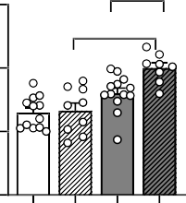
6
✱✱✱
Ether linked PE
D: p=.0003 G: p=.005 DxG: p=.70
✱
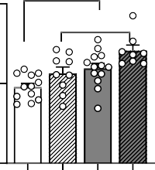
4
✱
PC:PE
D: p=.0003 G: p=.20 DxG: p=.29
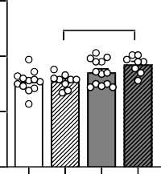
1.5
✱

4 1.0
pmol/g liver
pmol/g liver
Ratio

2

2 0.5

0
WT Fat-1 WT

Fat-1
0
WT Fat-1 WT

Fat-1
0.0

WT Fat-1 WT

Fat-1

LF LF
HF HF
LF LF
HF HF
LF LF
HF HF

D 17-HDHA E

18-HEPE

D: p=.05 G: p=.28 DxG: p=.07

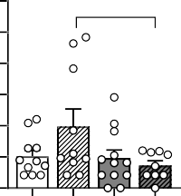
6
p=.07

5

4
pg/mg

3

2

1

0
D: p=.11 G: p=.32 DxG: p=.32
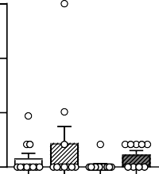
0.6

0.4
pg/mg

0.2

0.0

WT Fat-1 WT Fat-1
WT Fat-1 WT Fat-1

LF LF HF HF
LF LF HF HF

Dietary model
F G Ether linked PE H
Ether linked PC

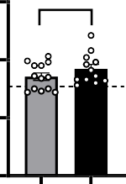
PC:PE

✱✱✱
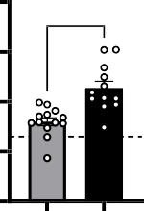
8 5
✱✱✱✱

4
6
pmol/g liver
pmol/g liver
3
4
2

2 1

1.5

1.0
Ratio

0.5
✱✱✱✱

0
HF HF
ω6 ω3

0
HF HF
ω6 ω3

0.0

HF HF
ω6 ω3

I 17-HDHA
✱✱✱
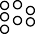
12

9
pg/mg

6

3
J 18-HEPE
✱✱✱
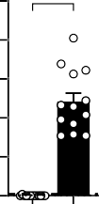
10

8

6
pg/mg

4

2
K
0.25

0.20
PDX
(pg/mg tissue)

0.15

0.10

0.05

PDX
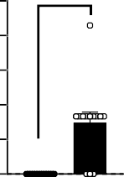
✱✱✱✱

0
HF HF
ω6 ω3

0
HF HF
ω6 ω3

0.00

WTHF HFw3

Supplemental Fig. S4. ω3-PUFA supplementation exert a greater effect improving lipemia and reducing hepatic steatosis compared to fat-1 endogenous production. Panels (A-E) refer to the genetic model and (F-K) to the dietary model. Hepatic (A, G) total ether linked PC (B, H) total ether linked PE (C, H) Total PC to total PE ratio. (D,I) DHA derived 17-HDHA, (E,J) EPA derived 18-HEPE and (K) 17-HDHA derived protectin-DX (PDX). Values are means ± SEM of n=9-13 mice per group. For the genetic model: two-way ANOVA followed by Tukey post hoc test. P-values of main effects for diet (D) and gene (G) or diet x gene (DxG) interaction are recorded under the title of each graph. For the dietary model: one-way ANOVA followed by Dunnett post hoc test compared to HF-ω6 group. Dotted line represents LF-ω6 group as a reference. *P<.05, **P<.01, ***P<.001.

Supplemental Table S2. Hepatic PC profile (pmol/g liver). The two last columns show statistical differences referring to the dietary and the genetic models respectively. Dietary model: One-way ANOVA with Tukey post hoc test (vs HF ω6 group). Significant effects are notified by “diet” (LF WT ω6 vs HF ω6) or “gavage” (HF ω3 group vs HF ω6). Genetic model: 2-way ANOVA followed by a Tukey post hoc test. Significant main effects are notified by “D” (diet) or “G” (gene).

 | LF WT  ω6 | LF Fat 1 ω6 | HF WT  ω6 | HF Fat 1 ω6 | HF WT  ω3 | Dietary Model One-way ANOVA | Genetic Model Two-way ANOVA
PC 30:1 | 0.38 ± 0.31 | 0.45 ± 0.11 | 0.49 ± 0.04 | 1.25 ± 0.06 | 3.00 ± 0.17 | Gavage | D,G,DXG
PC 30:0 | 0.22 ± 0.01 | 0.27 ± 0.02 | 0.16 ± 0.01 | 0.22 ± 0.01 | 0.43 ± 0.03 | Gavage | D,G
PC 32:2 | 0.63± 0.04 | 0.77 ± 0.10 | 0.73 ± 0.04 | 0.99± 0.07 | 1.77 ± 0.11 | Gavage | D,G
PC 32:1 | 2.83 ± 0.20 | 3.46 ± 0.33 | 2.63 ± 0.14 | 3.60 ± 0.20 | 7.77 ± 0.43 | Gavage | G
PC 32:0 | 2.94 ± 0.17 | 3.56 ± 0.33 | 3.33 ± 0.20 | 4.79 ± 0.25 | 8.50 ± 0.15 | Gavage | D,G
PC 34:4 | 0.50 ± 0.03 | 0.55 ± 0.06 | 0.86 ± 0.06 | 1.10 ± 0.06 | 0.97 ± 0.06 | Diet | D,G
PC 34:3 | 4.36 ± 0.26 | 5.54 ± 0.56 | 9.08 ± 0.55 | 12.3 ± 0.67 | 16.2 ± 0.89 | Diet, Gavage | D,G
PC 34:2 | 34.7 ± 1.83 | 45.6 ± 3.88 | 55.8 ± 3.51 | 76.1 ± 3.80 | 114 ± 6.18 | Diet, Gavage | D,G
PC 34:1 | 28.3 ± 1.75 | 29.8 ± 2.27 | 32.7 ± 1.57 | 43.0 ± 2.02 | 83.9 ± 4.83 | Gavage | D.G.DXG
PC 34:0 | 2.72 ± 0.15 | 2.87 ± 0.24 | 3.11 ± 0.16 | 4.04 ± 0.17 | 7.96 ± 0.43 | Gavage | D.G.DXG
PC 35:2 | 0.38 ± 0.02 | 0.43 ± 0.04 | 0.59 ± 0.04 | 0.78 ± 0.06 | 1.07 ± 0.06 | Diet, Gavage | D,G
PC 38:5 | 21.4 ± 1.57 | 20.5 ± 1.80 | 40.2 ± 2.62 | 43.2 ± 2.50 | 43.3 ± 2.77 | Diet | D
PC 38:4 | 28.5 ± 1.90 | 28.5 ± 2.84 | 41.9 ± 2.49 | 48.0 ± 2.19 | 23.4 ± 1.72 | Diet, Gavage | D
PC 38:3 | 7.18 ± 0.49 | 6.72 ± 0.78 | 9.98 ± 0.53 | 11.2 ± 0.42 | 7.76 ± 0.47 | Diet, Gavage | D
PC 40:7 | 2.59 ± 0.18 | 3.36 ± 0.35 | 5.06 ± 0.32 | 7.40 ± 0.33 | 28.3 ± 2.07 | Gavage | D,G,DXG
PC 40:6 | 3.89 ± 0.27 | 4.64 ± 0.55 | 6.41 ± 0.42 | 8.38 ± 0.40 | 31.5 ± 2.26 | Gavage | D,G
PC 40:5 | 2.95 ± 0.23 | 2.68 ± 0.35 | 4.19 ± 0.31 | 4.31 ± 0.26 | 6.16 ± 0.38 | Diet, Gavage | D
PC 40:4 | 0.87 ± 0.06 | 0.81 ± 0.09 | 1.21 ± 0.07 | 1.30 ± 0.07 | 1.02 ± 0.05 | Diet | D
PC 40:3 | 0.23 ± 0.02 | 0.26 ± 0.03 | 0.26 ± 0.01 | 0.37 ± 0.02 | 0.20 ± 0.01 | Gavage | D,G,DXG
PC O34:1 | 0.32 ± 0.02 | 0.36 ± 0.04 | 0.43 ± 0.02 | 0.57 ± 0.02 | 0.58 ± 0.04 | Diet, Gavage | D,G
PC O36:4 | 0.24 ± 0.02 | 0.25 ± 0.02 | 0.27 ± 0.02 | 0.33 ± 0.02 | 0.16 ± 0.01 | Gavage | D
PC O36:3 | 0.17 ± 0.01 | 0.20 ± 0.03 | 0.26 ± 0.02 | 0.32 ± 0.02 | 0.41 ± 0.02 | Diet, Gavage | D,G
PC O36:2 | 0.48 ± 0.02 | 0.48 ± 0.04 | 0.61 ± 0.03 | 0.76 ± 0.03 | 1.08 ± 0.06 | Diet, Gavage | D,G,DXG
PC O36:1 | 0.25 ± 0.02 | 0.23 ± 0.02 | 0.25 ± 0.01 | 0.33 ± 0.01 | 0.54 ± 0.04 | Gavage | D,DXG
PC O38:4 | 0.49 ± 0.03 | 0.51 ± 0.05 | 0.58 ± 0.03 | 0.70 ± 0.02 | 0.47 ± 0.04 | ----- | D
PC O38:3 | 0.21 ± 0.02 | 0.17 ± 0.02 | 0.20 ± 0.01 | 0.23 ± 0.01 | 0.21 ± 0.02 | ----- | DXG

Supplemental Table S3. Hepatic PE profile (%). The two last columns show statistical differences referring to the dietary and the genetic models respectively. Dietary model: One-way ANOVA with Tukey post hoc test (vs HF ω6 group). Significant effects are notified by “diet” (LF WT ω6 vs HF ω6) or “gavage” (HF ω3 group vs HF ω6). Genetic model: 2-way ANOVA followed by a Tukey post hoc test. Significant main effects are notified by “D” (diet) or “G” (gene).

 |  |  |  |  |  | Dietary Model | Genetic
 | LF WT | LF Fat 1 | HF WT | HF Fat 1 | HF WT | One-way | Model
 | ω6 | ω6 | ω6 | ω6 | ω3 | ANOVA | Two-way
 |  |  |  |  |  |  | ANOVA
PE 34:2 | 8.71 ± 0.60 | 10.3 ± 1.03 | 13.1 ± 0.75 | 15.6 ± 0.92 | 16.2 ± 1.28 | Diet, Gavage | D,G
PE 34:1 | 2.20 ± 0.12 | 2.33 ± 0.20 | 2.61 ± 0.13 | 3.11 ± 0.20 | 3.85 ± 0.24 | Gavage | D,G
PE 34:0 | 0.26 ± 0.02 | 0.25 ± 0.03 | 0.30 ± 0.02 | 0.35 ± 0.02 | 0.48 ± 0.03 | Gavage | D
PE 36:5 | 2.09 ± 0.11 | 2.33 ± 0.20 | 2.42 ± 0.15 | 2.65 ± 0.18 | 15.0 ± 0.71 | Gavage | D
PE 36:4 | 21.1 ± 0.81 | 22.0 ± 1.19 | 21.2 ± 1.14 | 23.1 ± 1.38 | 12.0 ± 0.89 | Gavage | ----
PE 36:3 | 9.50 ± 0.54 | 9.84 ± 0.81 | 15.9 ± 0.89 | 17.6 ± 0.86 | 15.1 ± 1.20 | Diet | D
PE 36:2 | 7.00 ± 0.25 | 7.53 ± 0.55 | 11.5 ± 0.61 | 13.5 ± 0.72 | 16.5 ± 1.22 | Diet, Gavage | D, G
PE 36:1 | 1.36 ± 0.06 | 1.35 ± 0.09 | 1.84 ± 0.10 | 2.18 ± 0.11 | 3.23 ± 0.21 | Diet, Gavage | D
PE 38:7 | 0.95 ± 0.04 | 1.45 ± 0.10 | 2.13 ± 0.15 | 3.19 ± 0.18 | 10.0 ± 0.59 | Diet, Gavage | D,G, DXG
PE 38:6 | 17.3 ± 0.81 | 24.1 ± 1.53 | 22.4 ± 1.42 | 31.4 ± 1.85 | 105 ± 5.99 | Gavage | D,G
PE 38:5 | 35.2 ± 1.84 | 33.3 ± 2.36 | 58.1 ± 3.78 | 59.6 ± 3.16 | 62.5 ± 3.89 | Diet | D
PE 38:4 | 52.8 ± 2.39 | 54.6 ± 2.36 | 64.9 ± 3.95 | 71.6 ± 4.07 | 43.8 ± 3.68 | Diet, Gavage | D
PE 38:3 | 8.04 ± 0.37 | 8.12 ± 0.58 | 9.45 ± 0.51 | 10.3 ± 0.60 | 6.89 ± 0.56 | Gavage | D
PE 38:2 | 0.76 ± 0.04 | 0.76 ± 0.06 | 1.01 ± 0.06 | 1.20 ± 0.08 | 1.16 ± 0.07 | Diet | D
PE 38:1 | 0.19 ± 0.01 | 0.22 ± 0.02 | 0.28 ± 0.01 | 0.37 ± 0.02 | 0.73 ± 0.04 | Diet, Gavage | D,G, DXG
PE 40:8 | 0.68 ± 0.03 | 0.88 ± 0.07 | 1.37 ± 0.10 | 1.73 ± 0.11 | 3.59 ± 0.22 | Diet, Gavage | D,G
PE 40:7 | 5.68 ± 0.29 | 7.81 ± 0.61 | 9.06 ± 0.66 | 13.02 ± 1.02 | 41.7 ± 2.67 | Gavage | D,G
PE 40:6 | 8.60 ± 0.45 | 10.33 ± 0.91 | 11.5 ± 0.83 | 14.9 ± 1.09 | 41.7 ± 2.67 | Gavage | D,G
PE 40:5 | 5.50 ± 0.29 | 5.25 ± 0.43 | 6.85 ± 0.51 | 7.06 ± 0.49 | 10.5 ± 0.66 | Gavage | D
PE 40:4 | 1.74 ± 0.09 | 1.77 ± 0.14 | 1.95 ± 0.09 | 2.07 ± 0.12 | 1.23 ± 0.07 | Gavage | D,G
PE 40:3 | 0.25 ± 0.01 | 0.26 ± 0.02 | 0.27 ± 0.01 | 0.30 ± 0.02 | 0.17 ± 0.01 | Gavage | ----
PE O36:5 | 0.16 ± 0.01 | 0.18 ± 0.01 | 0.14 ± 0.01 | 0.16 ± 0.01 | 0.12 ± 0.01 | ----- | D,G
PE 36:0/O38:7 | 0.12 ± 0.01 | 0.11 ± 0.01 | 0.14 ± 0.01 | 0.16 ± 0.01 | 0.27 ± 0.02 | Gavage | D
PE 37:5/O38:5 | 0.23 ± 0.01 | 0.27 ± 0.02 | 0.35 ± 0.02 | 0.44 ± 0.02 | 0.34 ± 0.02 | Diet | D,G
PE 37:4/O38:4 | 0.39 ± 0.02 | 0.43 ± 0.04 | 0.45 ± 0.03 | 0.50 ± 0.03 | 0.31 ± 0.03 | Gavage | D
PE 39:4/O40:4 | 0.39 ± 0.02 | 0.48 ± 0.04 | 0.35 ± 0.02 | 0.40 ± 0.02 | 0.25 ± 0.01 | Gavage | D,G

Genetic model

Total Ceramides
A D: p≤.0001 G: p=.75 DxG: p=.76
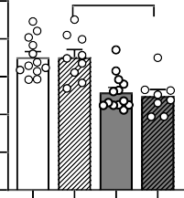
10 ✱

8
% Total Lipids

6

4

2

0
WT Fat-1 WT

Fat-1

LF LF HF HF

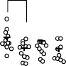
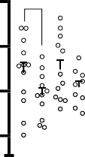
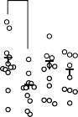
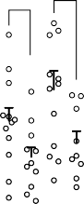
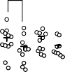
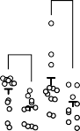
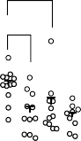
B
p=.06
Fat-1 LF WT HF Fat-1 HF
p=.09
p=.08
✱
✱
✱
✱✱
✱✱
✱
✱
18000

13500
Liver cytokines

WT LF

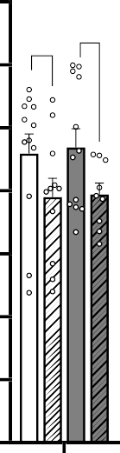
70000
p=.09
p=.08

60000

9000

4500
2500
pg/liver
2000
1500
1000
500
300
200
100
0

50000

40000

30000

20000

10000

0

 | IL-1β | IL-2 | IL-3 | IL-6 | IL-10 | IFN-γ | RANTES | TNF-α
Effect | G | G | G | G | G | D, G | G | G

Supplemental Fig. S5. Impact of endogenous production of ω-3 PUFA on hepatic inflammation. (A) Hepatic ceramides. (B) IL-1β, IL-2, IL-3, IL-6, IL-10, IFN-γ, RANTES and TNF-α hepatic concentrations. Values are means ± SEM of n=9-13 mice per group. Two- way ANOVA followed by Tukey post hoc test. If significant, main effects for diet (D) and gene (G) or diet x gene (DxG) interaction are indicated by the corresponding letter under the x axis for each inflammatory marker. *P<.05, **P<.01, ***P<.001.

Dietary model

A
Total Ceramides
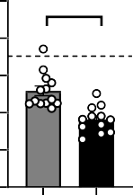
10
✱✱✱✱

8
% Total Lipids

6

4

2

0
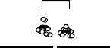
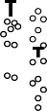
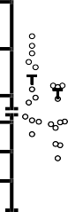
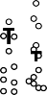
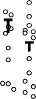
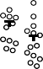
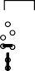
B 20000
15000

10000
8000
6000
4000
pg/liver
2000

1500

1000

500

HFω6 HFω3

✱✱✱

✱

Liver cytokines

HF ω6 HF ω3

✱

70000

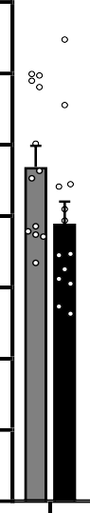
60000

50000

40000

30000

20000

10000

0
IL-1β IL-2 IL-3 IL-6 IL-10 IFN-γ RANTES
0
TNF-α

Supplemental Fig. S6. Impact of ω-3 PUFA supplementation on hepatic inflammation.
(A). Hepatic ceramides. (B) IL-1β, IL-2, IL-3, IL-6, IL-10, IFN-γ,
RANTES and TNF-α hepatic concentrations. Values are means ± SEM of n=9-13 mice per group. One-way ANOVA followed by Dunnett post hoc test compared to HF-ω6 group. Dotted line represents LF-ω6 group as a reference. *P<.05, **P<.01, ***P<.001.

Supplemental Table S4. Hepatic bile acid profile (pM/mg and %). The two last columns show statistical differences referring to the dietary and the genetic models respectively. Dietary model: One-way ANOVA with Tukey post hoc test (vs HF ω6 group). Significant effects are notified by “diet” (LF WT ω6 vs HF ω6) or “gavage” (HF ω3 group vs HF ω6). Genetic model: 2-way ANOVA followed by a Tukey post hoc test. Significant main effects are notified by “D” (diet) or “G” (gene).

Hepatic Bile acids  (pM/mg) | LF WT ω6 LF Fat-1 ω6 HF WT ω6 HF Fat-1 ω6 HF WTω3 |  |  |  |  | Dietary model Genetic model  One-way ANOVA listing 2-way ANOVA listing
CA | 0.99 ± 0.42 | 1.08 ± 0.42 | 0.15 ± 0.03 | 0.22 ± 0.06 | 0.52 ± 0.18 | diet, gavage | D
TCA | 75.14 ± 11.19 | 105.33 ± 16.51 | 103.44 ± 11.82 | 139.11 ± 26.01 | 129.97 ± 13.10 | - | D: p=.07
GCA | 0.07 ± 0.01 | 0.11 ± 0.03 | 0.07 ± 0.02 | 0.10 ± 0.04 | 0.13 ± 0.02 | gavage | -
CDCA | 0.01 ± 0.00 | 0.01 ± 0.00 | 0.01 ± 0.00 | 0.00 ± 0.00 | 0.00 ± 0.00 | - | -
TCDCA | 6.07 ± 1.05 | 7.74 ± 1.25 | 8.81 ± 0.80 | 9.82 ± 1.19 | 8.43 ± 1.00 | diet | D
αMCA | 0.21 ± 0.07 | 0.36 ± 0.09 | 0.16 ± 0.04 | 0.13 ± 0.03 | 0.18 ± 0.04 | - | -
TαMCA | 27.88 ± 4.52 | 35.34 ± 4.17 | 32.43 ± 3.18 | 36.84 ± 6.77 | 36.51 ± 4.64 | - | -
βMCA | 1.00 ± 0.36 | 1.89 ± 0.53 | 1.00 ± 0.17 | 1.20 ± 0.39 | 1.42 ± 0.27 | - | -
TβMCA | 111.70 ± 35.7 | 156.44 ± 20.14 | 160.10 ± 16.98 | 201.02 ± 50.87 | 198.40 ± 24.96 | diet: p=.08 | D: p=.06, G: p=.07
UDCA | 0.03 ± 0.01 | 0.03 ± 0.01 | 0.03 ± 0.01 | 0.01 ± 0.00 | 0.02 ± 0.01 | - | -
TUDCA | 8.75 ± 1.65 | 10.49 ± 1.28 | 11.71 ± 1.39 | 11.93 ± 1.92 | 10.42 ± 1.37 | - | -
Total primary | 231.86 ± 52.25 | 318.83 ± 39.53 | 317.92 ± 29.93 | 400.39 ± 80.70 | 386.00 ± 41.67 | - | D: p=.06, G: p=.07
DCA | 0.00 ± 0.00 | 0.00 ± 0.00 | 0.07 ± 0.05 | 0.01 ± 0.00 | 0.01 ± 0.01 | diet | -
TDCA | 2.09 ± 0.67 | 4.16 ± 1.32 | 4.02 ± 1.13 | 4.45 ± 1.92 | 2.21 ± 0.36 | - | -
TLCA | 0.03 ± 0.01 | 0.05 ± 0.01 | 0.04 ± 0.01 | 0.03 ± 0.01 | 0.03 ± 0.00 | - | -
ωMCA | 0.44 ± 0.07 | 1.06 ± 0.29 | 0.32 ± 0.09 | 0.27 ± 0.06 | 0.56 ± 0.19 | - | D
TωMCA | 70.03 ± 7.04 | 96.19 ± 18.23 | 47.17 ± 10.43 | 56.01 ± 6.70 | 70.73 ± 10.52 | - | D
Total secondary | 72.60 ± 7.39 | 101.48 ± 18.64 | 51.63 ± 10.5 | 60.77 ± 8.35 | 73.54 ± 10.51 | - | D
Total BA | 304.46 ± 54.12 | 420.31 ± 49.59 | 369.55 ± 36.73 | 461.16 ± 81.54 | 459.53 ± 44.13 | - | G: p=.07
Primary / secondary | 3.33 ± 0.69 | 4.57 ± 1.04 | 10.06 ± 2.43 | 7.57 ± 2.13 | 6.60 ± 1.35 | diet | D
Total conjugated | 301.77 ± 53.56 | 415.86 ± 48.89 | 367.80 ± 36.44 | 459.32 ± 81.21 | 456.81 ± 43.97 | - | G: p=.07
Total unconjugated | 2.69 ± 0.85 | 4.44 ± 1.09 | 1.75 ± 0.34 | 1.84 ± 0.51 | 2.72 ± 0.58 | Gavage: p=.09 | -
Conjugated / unconjugated | 171.87 ± 26.42 | 220.62 ± 82.83 | 248.10 ± 26.16 | 351.28 ± 61.69 | 216.64 ± 32.36 | - | D
Hepatic Bile acids (% of BA pool) | LF WT ω6 LF Fat-1 ω6 HF WT ω6 HF Fat-1 ω6 HF WTω3 |  |  |  |  | Dietary model Genetic model One-way ANOVA listing Two-way ANOVA listing
CA | 0.29 ± 0.09 | 0.24 ± 0.1 | 0.04 ± 0.01 | 0.04 ± 0.01 | 0.11 ± 0.03 | Diet, gavage | D
TCA | 25.43 ± 1.30 | 24.27 ± 1.96 | 28.1 ± 1.86 | 29.74 ± 2.01 | 28.37 ± 1.27 | - | D
GCA | 0.02 ± 0.00 | 0.02 ± 0.00 | 0.02 ± 0.00 | 0.02 ± 0.01 | 0.03 ± 0.00 | - | -
CDCA | 0.00 ± 0.00 | 0.00 ± 0.00 | 0.00 ± 0.00 | 0.00 ± 0.00 | 0.00 ± 0.00 | - | -
TCDCA | 2.04 ± 0.10 | 1.88 ± 0.19 | 2.51 ± 0.22 | 2.39 ± 0.24 | 1.88 ± 0.13 | Gavage: p=.05 | D
αMCA | 0.07 ± 0.02 | 0.08 ± 0.02 | 0.04 ± 0.01 | 0.03 ± 0.00 | 0.04 ± 0.01 | - | D
TαMCA | 9.39 ± 0.37 | 8.56 ± 0.50 | 8.83 ± 0.34 | 8.21 ± 0.54 | 7.75 ± 0.39 | - | -
βMCA | 0.28 ± 0.07 | 0.41 ± 0.08 | 0.26 ± 0.03 | 0.23 ± 0.06 | 0.31 ± 0.04 | - | -
TβMCA | 31.76 ± 3.35 | 38.45 ± 3.82 | 43.37 ± 2.91 | 40.76 ± 3.43 | 41.94 ± 2.44 | diet | D
UDCA | 0.01 ± 0.00 | 0.01 ± 0.00 | 0.01 ± 0.00 | 0.00 ± 0.00 | 0.01 ± 0.00 | - | -
TUDCA | 2.93 ± 0.27 | 2.62 ± 0.25 | 3.25 ± 0.33 | 2.69 ± 0.18 | 2.21 ± 0.15 | gavage | -
Total primary | 72.22 ± 3.18 | 76.54 ± 3.54 | 86.44 ± 2.06 | 84.13 ± 2.23 | 82.66 ± 2.20 | diet | D
DCA | 0.00 ± 0.00 | 0.00 ± 0.00 | 0.01 ± 0.01 | 0.00 ± 0.00 | 0.01 ± 0.01 | diet | -
TDCA | 0.86 ± 0.26 | 0.96 ± 0.28 | 1.12 ± 0.32 | 0.94 ± 0.37 | 0.54 ± 0.09 | - | -
TLCA | 0.01 ± 0.00 | 0.01 ± 0.00 | 0.01 ± 0.00 | 0.01 ± 0.00 | 0.01 ± 0.00 | - | -
ωMCA | 0.16 ± 0.02 | 0.24 ± 0.06 | 0.08 ± 0.02 | 0.07 ± 0.01 | 0.22 ± 0.14 | diet | D
TωMCA | 26.75 ± 3.03 | 22.24 ± 3.6 | 12.33 ± 2.04 | 14.86 ± 2.15 | 16.56 ± 2.08 | diet | D
Total secondary | 27.78 ± 3.18 | 23.46 ± 3.54 | 13.56 ± 2.06 | 15.87 ± 2.23 | 17.34 ± 2.20 | diet | D
Total conjugated | 99.19 ± 0.17 | 99.02 ± 0.21 | 99.54 ± 0.05 | 99.62 ± 0.07 | 99.29 ± 0.20 | - | D
Total unconjugated | 0.81 ± 0.17 | 0.98 ± 0.21 | 0.46 ± 0.05 | 0.38 ± 0.07 | 0.71 ± 0.20 | - | D

Genetic model
D
E

A Palmitic acid B
C16:0
2-PG C

PEA

Oleic acid C18:1n9

2-OG
- OEA

D: p=.01 G: p=.07 DxG: p=.60
D: p=.95 G: p=.01 DxG: p=.26
D: p<.001 G: p=.01 DxG: p=.005 D: p=.002 G: p=.03 DxG: p=.60
D: p=.15 G: p=.002 DxG: p=.04
D: p<.001 G: p=.02 DxG: p=.89

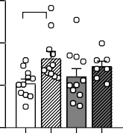
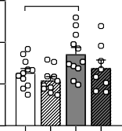
3000 ✱ 3
✱✱

2000 2
µM
pmol/mg liver
0.25

0.20
pmol/mg liver

0.15
✱✱✱
✱✱✱
✱✱
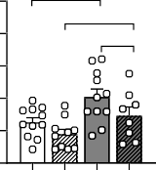
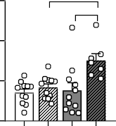
4500 30
p=.07
p=.06
✱
✱✱

3600
pmol/mg liver
20
2700
µM
0.3 ✱✱

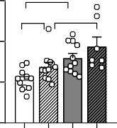
0.2

p=.06 ✱
pmol/mg liver

1000 1

0.10

0.05

1800
10
900

0.1

0
WT Fat-1 WT Fat-1

0
WT Fat-1 WT Fat-1

0.00

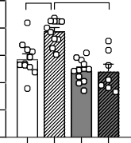
WT Fat-1 WT Fat-1

0
WT Fat-1 WT Fat-1

0
WT Fat-1 WT Fat-1

0.0

WT Fat-1 WT Fat-1

LF LF
HF HF
LF LF
HF HF
LF LF
HF HF
LF LF
HF HF
LF LF
HF HF
LF LF
HF HF

Dietary model

- Palmitic acid H
C16:0
2-PG I

PEA

Oleic acid C18:1n9

2-OG
M OEA

3
K
L
3000 ✱✱

2000 2
µM
pmol/mg liver

1000 1
0.20

0.15
pmol/mg liver

0.10

0.05

4000

3000

2000
µM

1000
✱✱✱ 25
20
pmol/mg liver

15

10

5
0.25

0.20
pmol/mg liver

0.15

0.10

0.05

0
HF HF

0
HF HF

0.00

HF HF

0
HF HF

0
HF HF

0.00

HF HF

ω6 ω3
ω6 ω3
ω6 ω3
ω6 ω3
ω6 ω3
ω6 ω3

Genetic model Dietary model

N Cnr1
D: p=.49 G: p=.72 DxG: p=.05
Normalized Expression (Log2)
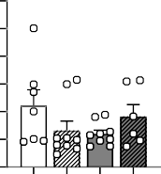
3.0

2.5

2.0

1.5

1.0

0.5

0.0
O
2.0
Normalized Expression (Log2)

1.5

1.0

0.5

0.0

Cnr1

WT Fat-1 WT Fat-1 HF HF

LF LF
HF HF
ω6 ω3

Supplementary Fig S7. Impact of endogenous production and supplementation of ω-3 PUFA on hepatic endocannabinoids. Panels (A-F, N) refer to the genetic model and (G-M, O) to the dietary model. (A, G) Palmitic acid and its (B, H) 2- monoacylglycerol and (C, I) N-acylethanolamine forms. (D, K) Oleic acid and its (E, L) 2-monoacylglycerol and (F, M) N- acylethanolamine forms. (N-O) Relative expression of Cnr1 coding for the cannabinoid receptor type-1 (CB₁) in liver in (N) the genetic model and (O) the dietary model. Values are means ± SEM of n=9-13 mice per group. For the genetic model: two-way ANOVA followed by Tukey post hoc test. P-values of main effects for diet (D) and gene (G) or diet x gene (DxG) interaction are recorded under the title of each graph. For the dietary model: one-way ANOVA followed by Dunnett post hoc test compared to HF-ω6 group. Dotted line represents LF-ω6 group as a reference. *P<.05,
**P<.01, ***P<.001.

Genetic model

2-EPG
A
B
D: p=.07 G: p<.001 DxG: p=.05
EPEA
D: p=.09 G: p<.001 DxG: p=.05

2-DPG
D: p=.65 G: p<001 DxG: p=.004
C

2-DHG
D: p=.07 G: p<.001 DxG: p=.11
D
E

DHEA
D: p=.47 G: p=.002 DxG: p=.90

0.12

0.09
pmol/mg gastroc

0.06

0.03

0.00

WT Fat-1 WT Fat-1
0.0012

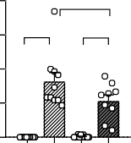
0.0009
✱
✱✱✱
✱✱✱
pmol/mg gastroc

0.0006

0.0003

0.0000

WT Fat-1 WT Fat-1
0.6

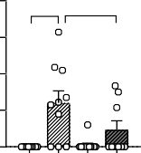
0.5
✱✱✱ ✱
pmol/mg gastroc

0.4

0.3

0.2

0.1

0.0
p=.09

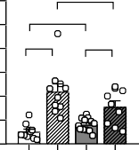
WT Fat-1 WT Fat-1
✱
✱✱✱
✱
2.0

1.5
pmol/mg gastroc

1.0

0.5

0.0

WT Fat-1 WT Fat-1
0.015

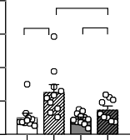
0.010
✱
✱✱✱
✱
pmol/mg gastroc

0.005

0.000

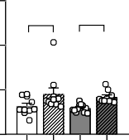

✱ ✱
WT Fat-1 WT Fat-1

LF LF HF HF

2-LG
LF LF HF HF

LEA
LF LF HF HF

2-AG
LF LF HF HF

AEA
LF LF HF HF

F D: p=.44 G: p=.03 DxG: p=.05
G D: p=.32 G: p=.16 DxG: p=.66
H D: p=.52 G: p=.002 DxG: p=.01 I
D: p=.16 G: p=.25 DxG: p=.34

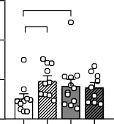
15
✱
✱✱
pmol/mg gastroc

10

5

0
WT Fat-1 WT Fat-1

0.020

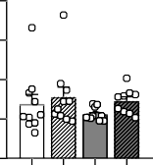
0.015
pmol/mg gastroc

0.010

0.005

0.000
1.5 ✱

1.0
pmol/mg gastroc

0.5

0.0
0.006

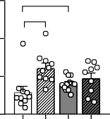
0.004
✱✱✱
pmol/mg gastroc

0.002

0.000

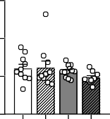
WT Fat-1 WT Fat-1

LF LF HF HF
WT Fat-1 WT Fat-1
WT Fat-1 WT Fat-1
LF LF HF HF

2-PG
LF LF HF HF
LF LF HF HF

J D: p=.18 G: p=.28 DxG: p=.07
PEA
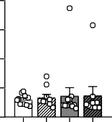
D: p=.65 G: p=.84 DxG: p=.87
K
2-OG
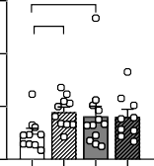
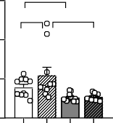
D: p=.42 G: p=.03 DxG: p=.08
✱✱

p=.09 ✱✱✱
L
OEA
D: p<.001 G: p=.16 DxG: p=.30

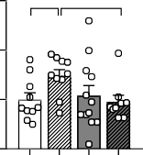
6 ✱ ✱
pmol/mg gastroc

4

0.20 6

0.15
pmol/mg gastroc
pmol/mg gastroc
4

p=.06
M 0.3 ✱✱
0.2
pmol/mg gastroc

2

0
WT Fat-1 WT Fat-1

0.10

0.05

0.00

2

0
WT Fat-1 WT Fat-1

0.1

0.0

WT Fat-1 WT Fat-1

LF LF HF HF
WT Fat-1 WT Fat-1
LF LF HF HF
LF LF HF HF

LF LF HF HF

N 0.8
0.6
pmol/mg gastroc

0.4

0.2

2-EPG

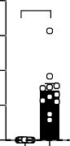
O 0.003
✱✱✱
pmol/mg gastroc

0.002

0.001

EPEA
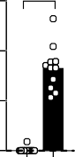
✱✱✱

Dietary model
2-DPG
P
Q
✱✱
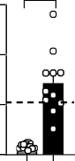
1.5
pmol/mg gastroc

1.0

0.5

2-DHG
✱✱✱
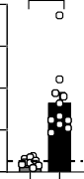
40

30
pmol/mg gastroc

20

10

R 0.015

0.010
pmol/mg gastroc

0.005

DHEA
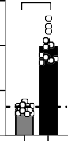
✱✱✱

0.0

HF HF
ω6 ω3
S T

2-LG

0.000

HF HF
ω6 ω3

LEA

0.0

HF HF
ω6 ω3
U

2-AG

0
HF HF
ω6 ω3
V

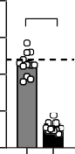
AEA
✱✱✱

0.000

HF HF
ω6 ω3

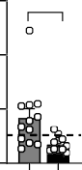
15
✱✱
pmol/mg gastroc

10

5

0
HF HF

0.008

0.006
pmol/mg gastroc

0.004

0.002

0.000
✱✱✱

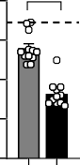
HF HF

0.6

0.4
pmol/mg gastroc

0.2

0.0
✱✱✱

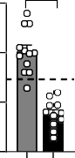
HF HF

0.004

0.003
pmol/mg gastroc

0.002

0.001

0.000

HF HF

ω6 ω3
ω6 ω3
ω6 ω3
ω6 ω3

W 2-PG
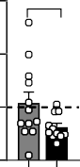
6 p=.07
pmol/mg gastroc

4

2

0
HF HF
X
0.20

0.15
pmol/mg gastroc

0.10

0.05

0.00
PEA

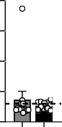
HF HF
Y 2-OG
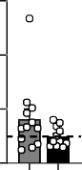
6
pmol/mg gastroc

4

2
1.6327

0
HF HF
Z
0.10

0.08
pmol/mg gastroc

0.06

0.04

0.02

0.00
OEA

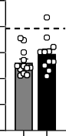
HF HF

ω6 ω3
ω6 ω3
ω6 ω3
ω6 ω3

Supplementary Fig. S8. Impact of endogenous production and supplementation of ω-3 PUFA on endocannabinoid profile in the gastrocnemius muscle. Panels (A-M) refer to the genetic model and (N-Z) to the dietary model. (A, N) 2-MAG and (B, O) NAE forms of EPA. (C, P) 2-MAG form of n-3 DPA. (D, Q) 2-MAG and (E, R) NAE forms of DHA. (F, S) 2-MAG and (G, T) NAE forms of LA. (H, U) 2-MAG and (I, V) NAE forms of AA. (J, W) 2-MAG and (K, X) NAE forms of palmitic acid. (L, Y) 2-MAG and (M, Z) NAE forms of oleic acid. Values are means ± SEM of n=9-13 mice per group. For the genetic model: two- way ANOVA followed by Tukey post hoc test. P-values of main effects for diet (D) and gene (G) or diet x gene (DxG) interaction are recorded under the title of each graph. For the dietary model: one-way ANOVA followed by Dunnett post hoc test compared to HF-ω6 group. Dotted line represents LF-ω6 group as a reference. *P<.05, **P<.01, ***P<.001.

Supplementary Table S5. Quantitative variables were grouped into 11 factors for multiple facator analysis.

Group Definitions
Genetic Wildtype(WT) Diet low fat diet (LF)
Fat1 genotype(F1) High fat diet (HF)
HF diet + omega3 supplementtion (HF-w3)

Factors
Obesity | Body weight gain (BWG) | Endocanom | liver EPA2G(μM)(LIV_EPA2G) | Microbiota | s_Other | Gluco_Home | Fastin blood glucose T0 (FG_GTT)
 | Food Intake (FI) |  | liver t DHA2G(μM)(LIV_DHA2G) |  | g Bifidobacterium_s |  | Fastin blood insulin T0 (FI_GTT)
 | Energy expenditure(EE) |  | liver DPA2G(μM)(LIV_DPA2G) |  | g Adlercreutzia_s |  | Area under the curve for glucose during ITT (AUC_ITT)
 | DEE |  | liver EPEA(μM)(LIV_EPEA) |  | g Barnesiella_s |  | Area under the curve for glucose during GTT (AUC_GTT)
 | Visceral adipose weight(Vat_W) |  | liver DHEA(μM)(LIV_DHEA) |  | g Parabacteroides_s |  | Area under the curve glucose stimulated insulin GTT (AUC_GSIS)
 | Plasma leptin concentration (Leptin) |  | muscle EPEA(μM)(MUS_EPEA) |  | f Rikenellaceae_g_s |  | HOMA-IR
 |  |  | muscle c DHEA(μM)(MUS_DHEA) |  | f S247_g_s
NAFLD | plasma ALT (P_ALT)  plasma AST (P_AST) |  | muscle EPA2G(μM)(MUS_EPA2G)  muscle DHA2G(μM)(MUS_DHA2G) |  | s schaedleri  g Lactococcus_s | Intestinal  Metabolism | caecal acetic acid (μg/g)(Acetic_acid)
 | liver weight (LIV_W) liver TG (LIV_TG)  Total liver fatty acid (μM) (LIV_FA)  SCD1 index (SCD1) SCD16 index (SCD16) |  | muscle DPA2G(μM)(MUS_ DPA2G) liver AEA(μM)(LIV_AEA)  liver 2AG(μM)(LIV_2AG) liver 2LG(μM)(LIV_2LG)  liver LEA(μM)(LIV_LEA) |  | g Streptococcus_s g Turicibacter_s  - Clostridiales_f_g_s  - Clostridiales_f_g_s_2  f Christensenellaceae_g_s |  | caecal Propionic acid (μg/g)(Propionic_acid) caecal butyric acid (μg/g)(Butyric_acid) caecal valeric acid (μg/g)(vlaeric_acid)  caecal isobutyric acid (μg/g)(isobutyric_acid)  caecal isovaleric acid (μg/g)(isovaleric_acid)
 | SCD18 index (SCD18) |  | muscle AEA(μM)(MUS_AEA) |  | f Clostridiaceae_g_s |  | caecum weight (g) (caecum)
 | Liver w6:w3 ratio (LIV_W6W3) Liver w3 (μM) (LIV_W3)  Liver w6 (μM) (LIV_W6) |  | muscle 2AG(μM)(MUS_2AG)  muscler 2LG(μM)(MUS_2LG) muscler LEA(μM)(MUS_LEA) |  | g Clostridium_s g Anaerofustis_s  f Lachnospiraceae_g_s |  | feces LCN2 (ng/g)(FLCN2) feces LPS (μg/g)(Feces_LPS)  feces flagellin (ng/mg)(Feces_Flagellin)
 |  |  | liver 2PG(μM)(LIV_2PG) |  | f Lachnospiraceae_g_s_2 |  | liver CA (pM/mg)(CA)
FA_PUFA | liver EPA(μM)(LIV_EPA) |  | liver PEA(μM)(LIV_PEA) |  | g Anaerostipes_s |  | liver TCA (pM/mg)(TCA)
 | liver DHA(μM)(LIV_DHA) |  | liver OEA(μM)(LIV_OEA) |  | g Blautia_s |  | liver GCA (pM/mg)(GCA)
 | liver DPA(μM)(LIV_DPA) |  | liver 2OG(μM)(LIV_2OG) |  | g Coprococcus_s |  | liver CDCA (pM/mg)(CDCA)
 | Liver AA(μM) (LIV_AA) |  | muscle PEA(μM)(MUS_PEA) |  | g Dorea_s |  | liver TCDCA (pM/mg)(TCDCA)
 | Liver LA(μM) (LIV_LA) |  | muscle 2PG(μM)(MUS_2PG) |  | s gnavus |  | liver aMCA (pM/mg)(aMCA)
 |  |  | muscler 2OG(μM)(MUS_2OG) |  | f Ruminococcaceae_g_s |  | liver TaMCA (pM/mg)(TaMCA)
FA_SAT | liver capric acid (μM)(Caprique) |  | muscler OEA(μM)(MUS_OEA) |  | f Ruminococcaceae_g_s_2 |  | liver bMCA (pM/mg)(bMCA)
 | liver myristic acid (μM)(Myristique) |  |  |  | g Oscillibacter_s |  | liver TbMCA (pM/mg)(TbMCA)
 | liver palmitic acid (μM)(Palmitique) | Plasma | Plasma TG (P_TG) |  | g Oscillospira_s |  | liver UDCA (pM/mg)(UDCA)
 | liver stearic acid (μM)(Stearique) |  | Plasma Nonesterfied fatty acids(P_NEFA) |  | g Ruminococcus_s |  | liver TUDCA (pM/mg)(TUDCA)
 | liver arachidonic acid (μM)(Arachidique) |  | Plasma cholesterol (P_Chol) |  | f [Mogibacteriaceae]_g_s |  | liver total primary bile acids (pM/mg)(Totprim)
 | liver Behenic acid (μM)(Behebique) |  |  |  | f Erysipelotrichaceae_g_s |  | liver DCA (pM/mg)(DCA)
 | liver lignoceric acid (μM)(Lignocerique) | Inflammation | liver LTB4(pg/mg)(LIV_LTB4) |  | g Allobaculum_s |  | liver TDCA (pM/mg)(TDCA)
 | liver myristoleic acid (μM)(myristoleic) |  | liver 17S (pg/mg)(LIV_17S) |  | g Coprobacillus_s |  | liver TLCA (pM/mg)(TLCA)
 | liver pamitoleic acid (μM)(palmitoleic) |  | liver 18RS (pg/mg)(LIV_18RS) |  | s C21_c20 |  | liver wMCA (pM/mg)(wMCA)
 | liver vaccenic acid (μM)(vaccenic) |  | muscle LTB4(pg/mg)(musc_LTB4) |  | g Proteus_s |  | liver TwCA (pM/mg)(TwCA)
 |  |  | muscle17S (pg/mg)(mus_17S) |  | g Anaeroplasma_s |  | liver total secondary bile acids (pM/mg)(Totsec)
FA_Unsat | liver oleic acid (μM)(oleic)  liver petroselinic acid (μM)(petroselinic) |  | muscle 18RS (pg/mg)(mus_18RS)  liver IL-1β(pg/liver)(IL-1β) |  | s muciniphila |  | liver total conjugated bile acids (pM/mg)(TotCon)  liver total primary bile acids (pM/mg)(TotUcon)
 | liver n9 eicosenoic acid (μM)(eicosenoic_9) |  | liver IL2(pg/liver)(IL2)
 | liver n12 eicosenoic acid (μM)(eicosenoic_12) |  | liver IL3(pg/liver)(IL3)
 | liver n15 eicosenoic acid (μM)(eicosenoic_15) |  | liver IL6(pg/liver)(IL6)
 | liver erucic acid (μM)(erucic)  liver nervonic acid (μM)(nervonic) |  | liver IL10 (pg/liver)(IL10)  liver IFNγ (pg/liver)(IIFNγ)
 | liver palmitelaiditic acid (μM)(Palmitelaiditic)  liver Transvaccenicc acid (μM)(Transvaccenic) |  | liver RANTES (pg/liver)(RANTES)  liver TNFα (pg/liver)(TNFα)
liver elaiditic acid (μM)(elaiditic)
liver γlinolenic acid (μM)(linolenic)
liver eicosadienoicacid (μM)(eicosadienoic)
liver DHGLinolenic acid (μM)(DHGLinolenic)
 | liver docosadienoic acid (μM)(docosadienoic)
 | liver adrenic acid (μM)(adrenic)
 | liver n3-eicosatrienoic acid (μM)(eicosatrienoic3)
 | liver n9-eicosatrienoic acid (μM)(eicosatrienoic9)

Supplementary Table S6 Primers used for real-time qPCR.
