Supplementary Information

Effects of orthotopic implantation of rat prostate tumour cells upon components of the N-acylethanolamine and monoacylglycerol signalling systems: an mRNA study

Mireille Alhouayek, Linda Stafberg, Jessica Karlsson, Sofia Halin Bergström and Christopher J. Fowler

Supplementary Table S1. Primer pairs, target sequences and efficiencies.

 |  | Primer pair | Eff. (%) | Target | Exon spanning
Abhd6 | F:  R: | GACGTTCGCATCCCTCACAAC  CTGTGTTGGGACCTTGATCTTGTC | 90 | NM_001007680.1  (114: 771-884) | Yes
Abhd12 | F:  R: | CATCTCGGCAGGAAGCTATAC  AGCCAAGGTCTGAGTGAAAG | 93 | NM_001024314.1  (94: 1173-1266) | Yes
Cnr1 | F:  R: | GCTAGCTTCGGTTCGACATC  GGGAGAACCTGTATGAGGAGAG |  | NM_012784.5  (136: 3367-3502) | No
Cnr2 | F:  R: | GTGCTACCCACCTACCTACA  TAGGAGATCAACGCCGAGAG | 103 | NM_001164143.3 (t.v.1)  (93: 675-767)  NM_001164142.3 (t.v.2)  (93: 573-665)  NM_020543.4 (t.v.3)  (93: 405-497) | No  No  No
Dagla | F:  R: | TTGTGACTGCTGTGGTTCTG  CCACGATGATCCGCCATTT | 99 | NM_001005886.1  (129: 1637-1765) | Yes
Daglb | F:  R: | TTGTGGTTGCCGTGAGAG  GCTTGAGCAATTCCCTTGTG | 91 | NM_001107120.1  (127: 1188-1314) | Yes
Faah | F:  R: | AAGGGCGGCGTTGATGTAAG  AATGATGGCAGGCGGAGTTC | 107 | NM_001369126.1  (81: 3315-3395) | No
Mgll | F:  R: | CGACTTTGAAGGTCCTTGCTG  AGATGAGTGGGTCGGAGTTG |  | NM_138502.2  (132:587-718) | Yes
Naaa | F:  R: | CCACTGAAGAAGGGAACAGAC  TCTGCTACTGAGCCTCACC | 101 | NM_001010967.2  (108: 1414-1521) | No
Napepld | F:  R: | ACTGGTTACTGCCCTGCTTT  AATCCTTACAGCATCCTCTGGG | 94 | NM_199381.1  (138:853-990) | Yes
Psmc4 | F:  R: | CATCTGTCAGGAGAGTGGAATG  GCTTTCTCGAAGTCCTTGGC | 96 | NM_057122.1  (75:1143-1217) | Yes
Ptgs2 | F:  R: | TGAGCGGTTACCACTTCAAA  TGCCAGTGATAGAGTGTGTTG | 91 | NM_017232.3  (109: 1013-1121) | No
Rpl19 | F:  R: | TACTGCCAACGCTCGGAT  AACACATTCCCTTTGACCTTCA | 93 | NM_031103.1  (147: 277-423) | Yes
Rps12 | F:  R: | GAGCACCAGATCAACCTGATAAAG  GCCATAGTCCTTAACTACAACGC | 91 | NM_031709.3  (135: 329-463) | Yes
Il6r | F:  R: | CCACACAGGTCTCTGTTGAAG  GAGGACACTCGTTGCTTCTG |  | NM_017020.3  (77: 999-1075) | Yes
Tnfa | F:  R: | GTGATCGGTCCCAACAAGG  GGTGGTTTGCTACGACGTG |  | NM_012675.3  (136: 307-442) | Yes

Abbreviation: Eff., efficiency, when determined. Primer specificities were checked using Primer-BLAST at https://www.ncbi.nlm.nih.gov/tools/primer-blast/. Product lengths >700 base pairs are not shown in the Table. The numbers in brackets under the NM_ target information refer to the target sequence length and region to which the primer pair binds.

Supplementary Table S2. Comparison of the array data values for host control (HC, N=8), AT1 tumour tissue (N=8) and MLL tumour tissue (N=7).

 |  |  |  |  |  |  |  | ANOVA | Post hoc Dunnett’s T3 tests
 | Feature | HC |  | AT1 tumour |  | MLL tumour |  | P value | HC vs | HC vs | AT1 vs
 | ID | mean | SD | mean | SD | mean | SD | (Welch) | AT1 | MLL | MLL
Anabolic
Napepld | 10853132 | 5.97 | 0.16 | 6.23 | 0.11 | 7.97 | 0.21 | <10⁻⁹ | 0.0080 | 1.0x10⁻⁹ | 3.0x10⁻⁸
Dagla | 10728676 | 5.55 | 0.15 | 7.83 | 0.34 | 7.61 | 0.14 | <10⁻⁹ | 2.6x10⁻⁸ | <10⁻⁹ | 0.32
Daglb | 10760403 | 7.42 | 0.08 | 8.56 | 0.16 | 8.05 | 0.13 | 2x10⁻⁹ | 2.3x10⁻⁸ | 2.1x10⁻⁶ | 4.3x10⁻⁵
Target
Cnr1 | 10868186 | 5.05 | 0.18 | 3.76 | 0.27 | 3.63 | 0.09 | <10⁻⁹ | 2.6x10⁻⁷ | 6.0x10⁻⁹ | 0.47
Cnr2 | 10872935 | 5.86 | 0.10 | 7.44 | 0.19 | 6.58 | 0.21 | 1x10⁻⁹ | 1.0x10⁻⁹ | 9.7x10⁻⁵ | 9.8x10⁻⁶
Catabolic
Faah | 10871182 | 8.34 | 0.10 | 5.82 | 0.53 | 6.05 | 0.22 | <10⁻⁹ | 3.1x10⁻⁶ | 2.1x10⁻⁸ | 0.62
Naaa | 10771690 | 6.75 | 0.21 | 9.35 | 0.37 | 7.82 | 0.32 | 3x10⁻⁹ | 7.0x10⁻⁹ | 6.0x10⁻⁵ | 2.9x10⁻⁶
Mgll | 10857130 | 7.35 | 0.19 | 6.71 | 0.23 | 8.05 | 0.16 | 2.5x10⁻⁸ | 9.9x10⁻⁵ | 1.1x10⁻⁵ | 4.9x10⁻⁸
Abhd6 | 10782695 | 10.36 | 0.04 | 10.12 | 0.10 | 9.27 | 0.12 | 2x10⁻⁹ | 5.2x10⁻⁴ | 2.3x10⁻⁷ | 1.6x10⁻⁸
Abhd12 | 10850668 | 10.30 | 0.09 | 10.15 | 0.08 | 9.35 | 0.10 | <10⁻⁹ | 0.010 | <10⁻⁹ | 2.0x10⁻⁹
Ptgs2 | 10764551 | 5.39 | 0.31 | 6.56 | 0.44 | 6.31 | 0.78 | 2.1x10⁻⁴ | 1.1x10⁻⁴ | 0.053 | 0.84
Other
Tnfa | 10828021 | 5.22 | 0.29 | 7.09 | 0.49 | 5.98 | 0.41 | 3.2x10⁻⁶ | 4.8x10⁻⁶ | 0.0050 | 0.0011

The data are taken from the dataset given as S1 Dataset in Strömvall et al. (ref ⁴⁰ in main article) and are normalised values on a log₂ scale. Note that the dataset returns three sets of values for Abhd12: ID 10850668, recognizing NM_001024314 (shown in the Table); ID10850682, recognizing the putative gene BC078918; and 10884996, recognizing the gene NM_001003928 (Abhd12b). The HC control mean values for the latter two (5.31 and 3.08) were much lower than for the Abhd12 data shown in the table. For the ANOVA P values, which were calculated not assuming equal SD values, the critical value of P assuming a 5% false discovery rate⁷² was 0.05, although it should be taken into account that these data are part of a much larger dataset.⁴⁰

Supplementary Table S3. Comparison of the array data values for host control (HC, N=8), AT1 TINT (N=6) and MLL TINT (N=7).

 |  |  |  |  |  |  |  | ANOVA | Post hoc Dunnett’s T3 tests
 | Feature | HC |  | AT1 TINT |  | MLL TINT |  | P value | HC vs | HC vs | AT1 vs
 | ID | mean | SD | mean | SD | mean | SD | (Welch) | AT1 | MLL | MLL
Anabolic
Napepld | 10853132 | 5.97 | 0.16 | 5.86 | 0.13 | 5.96 | 0.15 | 0.29 | 0.38 | 1.00 | 0.45
Dagla | 10728676 | 5.55 | 0.15 | 5.47 | 0.09 | 5.53 | 0.10 | 0.38 | 0.51 | 0.98 | 0.58
Daglb | 10760403 | 7.42 | 0.08 | 7.40 | 0.09 | 7.46 | 0.07 | 0.35 | 0.98 | 0.59 | 0.44
Target
Cnr1 | 10868186 | 5.05 | 0.18 | 4.58 | 0.18 | 4.76 | 0.19 | 0.0018 | 0.0016 | 0.028 | 0.27
Cnr2 | 10872935 | 5.86 | 0.10 | 5.81 | 0.21 | 5.84 | 0.20 | 0.90 | 0.95 | 1.00 | 0.99
Catabolic
Faah | 10871182 | 8.34 | 0.10 | 8.33 | 0.19 | 8.40 | 0.18 | 0.72 | 1.00 | 0.80 | 0.87
Naaa | 10771690 | 6.75 | 0.21 | 6.87 | 0.41 | 7.05 | 0.49 | 0.36 | 0.88 | 0.41 | 0.86
Mgll | 10857130 | 7.35 | 0.19 | 7.18 | 0.23 | 7.18 | 0.22 | 0.26 | 0.42 | 0.37 | 1.00
Abhd6 | 10782695 | 10.36 | 0.04 | 10.44 | 0.14 | 10.28 | 0.18 | 0.27 | 0.46 | 0.66 | 0.26
Abhd12 | 10850668 | 10.30 | 0.09 | 10.25 | 0.06 | 10.45 | 0.10 | 0.0034 | 0.51 | 0.024 | 0.0034
Ptgs2 | 10764551 | 5.39 | 0.31 | 5.40 | 0.21 | 5.66 | 0.41 | 0.36 | 1.00 | 0.45 | 0.43
Other
Tnfa | 10828021 | 5.22 | 0.29 | 5.11 | 0.28 | 5.23 | 0.38 | 0.75 | 0.86 | 1.00 | 0.88

The data are taken from the dataset given as S1 Dataset in Strömvall et al. (ref ⁴⁰ in main article) and are normalised values on a log₂ scale. See Legend to Supplementary Table S2 regarding the values for Abhd12. Note that the HC values are the same as in Supplementary Table S2. For the ANOVA P values, which were calculated not assuming equal SD values, the critical value of P assuming a 5% false discovery rate was 0.0083, although it should be taken into account that these data are part of a much larger dataset.⁴⁰

Supplementary Fig. S1. Scatterplots of Dagla, Daglb, Cnr1, Faah, Abhd6, Abhd12 and Tnfa gene expression in host control (HC), tumour (tu) tissue and TINT. Comparison of qPCR and Array data.
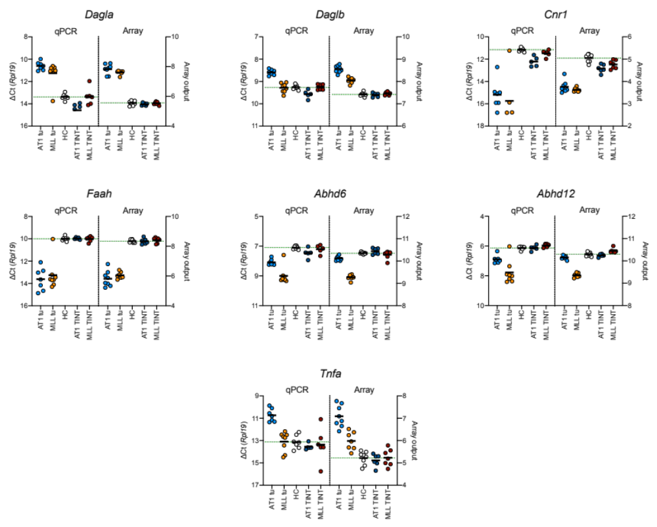

Left axes show the ∆Ct from the qPCR experiments with Rpl19 as reference gene. The right axes show the array data, as normalised values on a log₂ scale, taken from S1 Dataset in Strömvall et al.⁴⁰ The statistical analyses of these data are presented in Tables 1 and 2 (qPCR) of the paper and in Supplementary Tables S2 and S3 (array). Note that the left y-axis but not the right y-axis has been reversed. Thus for both qPCR and Arrays, the direction of change (-1 corresponds to a doubling for the qPCR data, while +1 corresponds to a doubling for the array data) is the same.

Supplementary Fig. S2. Volcano plots of bivariate comparisons between a. host control (“HC”) and tumour tissue; b. HC and TINT. Array data.
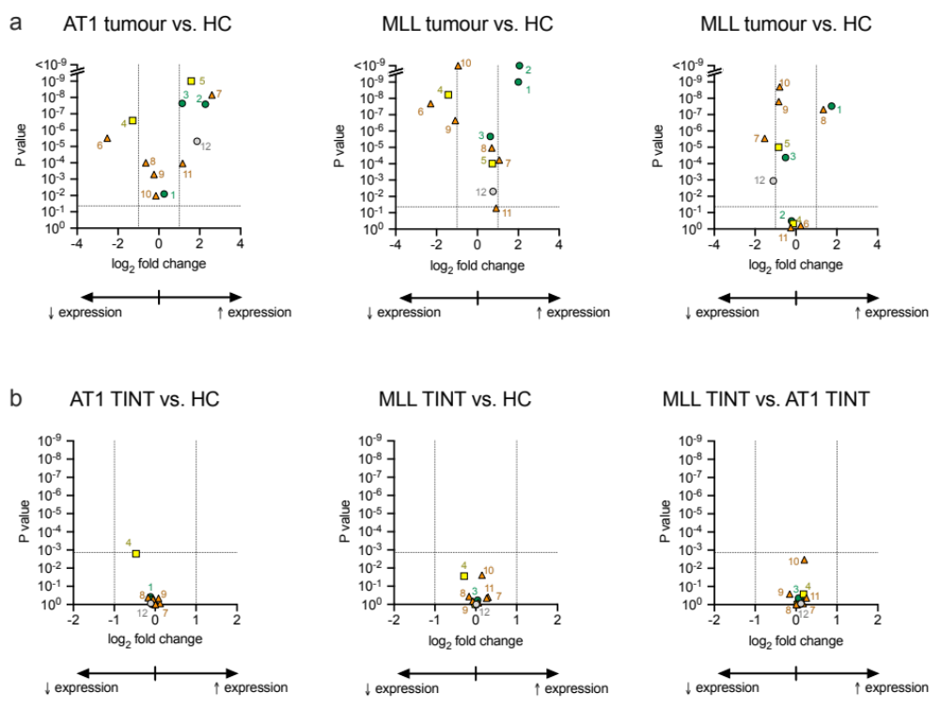

The log₂ fold change is calculated from the mean normalised values summarized in Supplementary Tables 2 and 3. Note the different scales in Panels a and b. The P values are for the post-hoc comparisons given in these Tables. The vertical dotted lines show a fold change of ±1, i.e. a halving/doubling of mRNA expression. The horizontal lines show the critical value of P assuming a 5% false discovery rate (0.043 for Panel a, 0.0014 for Panel b). The genes are numbered as follows: 1, Napepld; 2, Dagla; 3, Daglb; 4, Cnr1; 5, Cnr2; 6, Faah; 7, Naaa; 8, Mgll; 9, Abhd6; 10, Abhd12; 11, Ptgs2 and 12, Tnfa.
Supplementary Fig. S3. Comparison of the mRNA levels seen in cultured AT1 cells and host control (HC) prostate tissue.

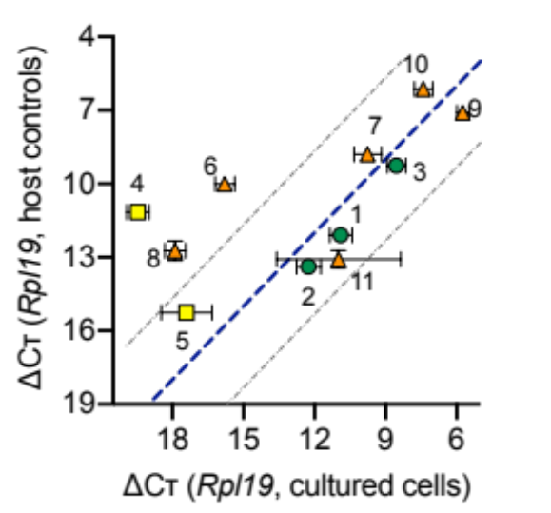

The abscissae show the ∆Ct values for the cultured cells (the same data as shown in Fig. 4A) and the ordinates show the corresponding values (summarized in Table 1) for the HC tissue. Each point represents the mean ± SD. The blue dotted line is the line of identity. The grey lines show where the HC expression is 10-fold higher (upper line) or lower (lower line) than the expression in the AT1 cells. It should be mentioned as a caveat that the experiments were undertaken on different occasions. The genes are numbered as follows: 1, Napepld; 2, Dagla; 3, Daglb; 4, Cnr1; 5, Cnr2; 6, Faah; 7, Naaa; 8, Mgll; 9, Abhd6; 10, Abhd12 and 11, Ptgs2.

