The photoswitchable cannabinoid azo-HU308 enables optical control of Ca²⁺ dynamics in INS-1 β-cells via off-target effects on TRPC channels
Alexander E.G. Viray¹, James A. Frank^{1,2}*

¹ Department of Chemical Physiology and Biochemistry, Oregon Health & Science University, 3181 SW Sam Jackson Park Road, Portland, OR 97239-3098, USA
² Vollum Institute, Oregon Health & Science University, 3181 SW Sam Jackson Park Road, Portland, OR 97239-3098, USA
*Correspondence: frankja@ohsu.edu

SUPPORTING INFORMATION

SUPPORTING FIGURES
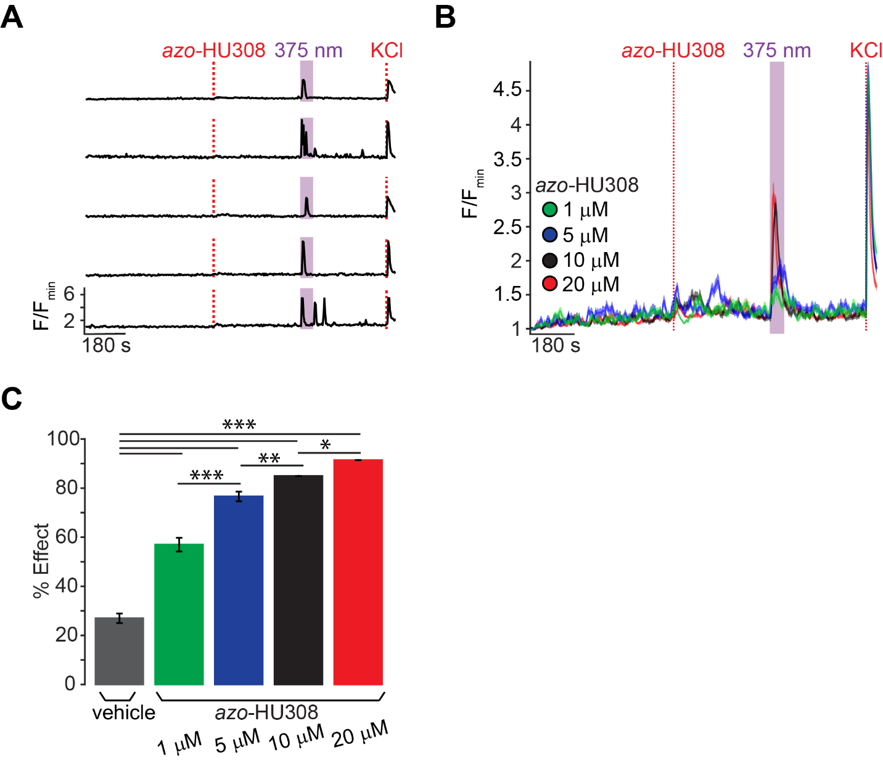
FIGURE S1. azo-HU308 increases Ca²⁺ transient in INS-1 cells with stimulated by UV-A light. INS-1 cells were transfected with RGECO and their Ca²⁺ levels monitored by confocal microscopy. (A) Representative single cell Ca²⁺ traces for INS-1 cells after the addition of azo-HU308 (20 μM), which caused an increase in Ca²⁺ after photoswitching to cis with 375 nm light. KCl (30 mM) was added at the end of each experiment to maximize intracellular Ca²⁺. (B) Averaged Ca²⁺ imaging traces showing dose-response for azo-HU308 at 1μM (N = 157, T = 3), 5 μM (N = 162 cells, T = 3), 10 μM (N = 149, T = 3), and 20 μM (N = 170, T = 4) followed by photoactivation with 375 nm light. (C) Summary bar graph comparing Ca2+ responses to the vehicle (N = 203, T = 4) and dose-response of azo-HU308 as shown in part B. Error bars = mean ± s.e.m. *P < 0.05, **P < 0.01, ***P < 0.001, ns = not significant = P > 0.05. Student’s T-Test.
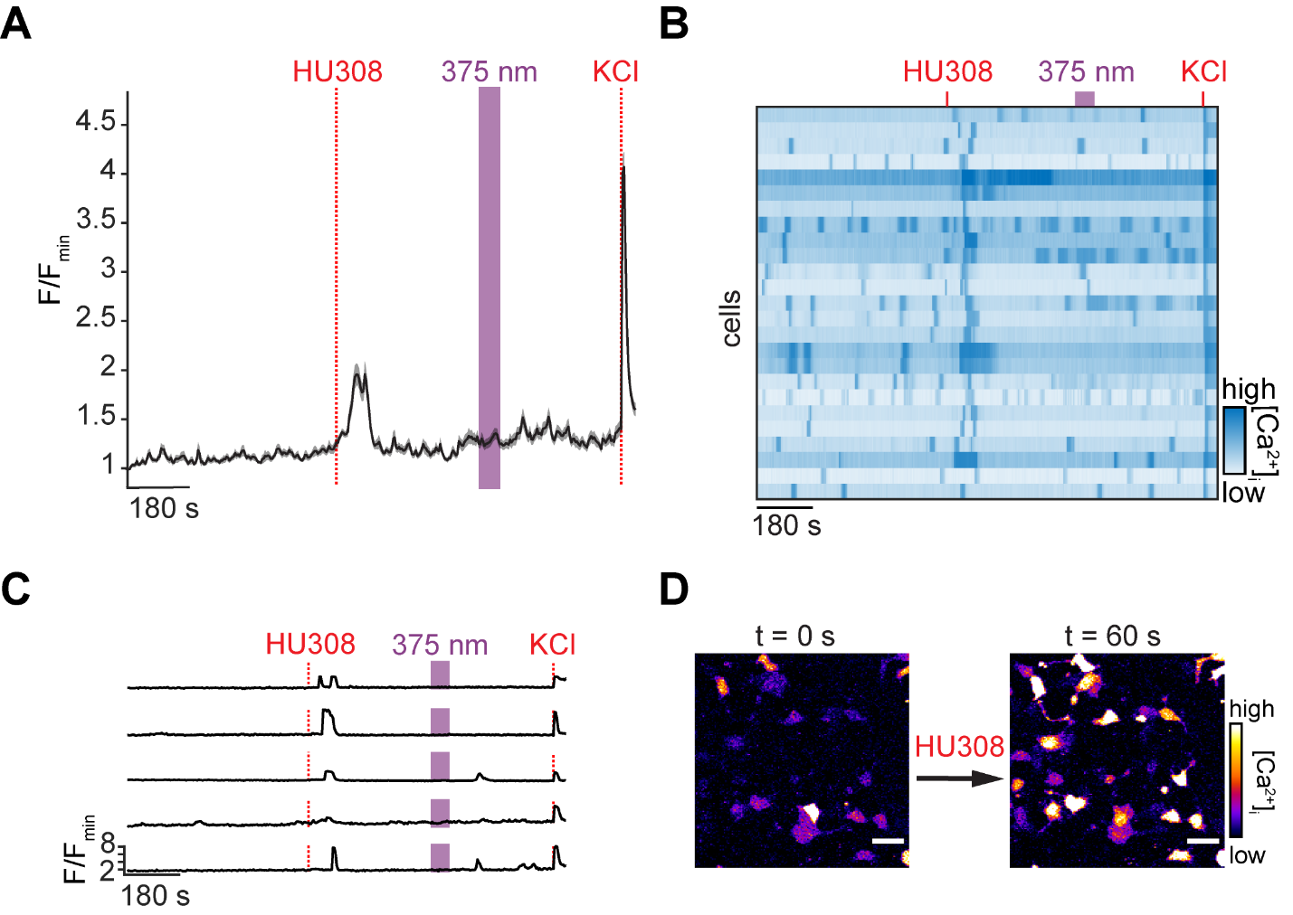
FIGURE S2. Non-photoswitchable HU308 addition causes a short Ca²⁺ transient in INS-1 cells. INS-1 cells were transfected with RGECO and their Ca²⁺ levels monitored by confocal microscopy. (A) Averaged (N = 150, T = 3), (B) heatmap of 25 cells, and (C) representative single cell Ca²⁺ traces for INS-1 cells after the addition of HU308 (20 μM). An increase in Ca²⁺ was observed upon addition, but no response was triggered upon 375 nm irradiation. For A, shaded error bars = mean ± s.e.m.. For B, Ca²⁺ traces from 25 representative cells were normalized to the KCl response. (D) Representative fluorescence micrographs showing increased Ca²⁺ in INS-1 cells after HU308 addition. Scale bar = 30 μm.
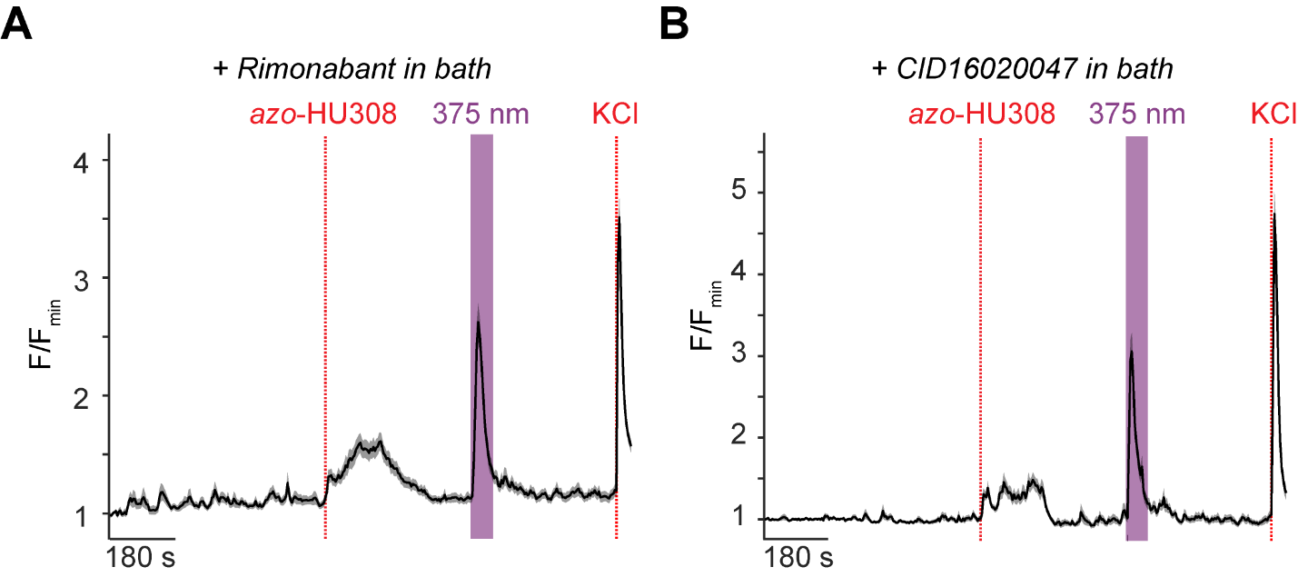
FIGURE S3. azo-HU308’s photoswitching effect on Ca²⁺ is not CB1- or GPR55-mediated. INS-1 cells were transfected with RGECO and their Ca²⁺ levels monitored by confocal microscopy. (A,B) Averaged Ca²⁺ imaging traces showing the effect of azo-HU308 (20 μM) addition and 375 nm photostimulation in the presence of (A) the CB1 antagonist rimonabant (2 μM, N = 103, T = 2) and (B) the GPR55 antagonist CID16020047 (20 μM, N = 104, T = 2). A Ca²⁺ increase was still observed on addition and stimulation. Shaded error bars = mean ± s.e.m.

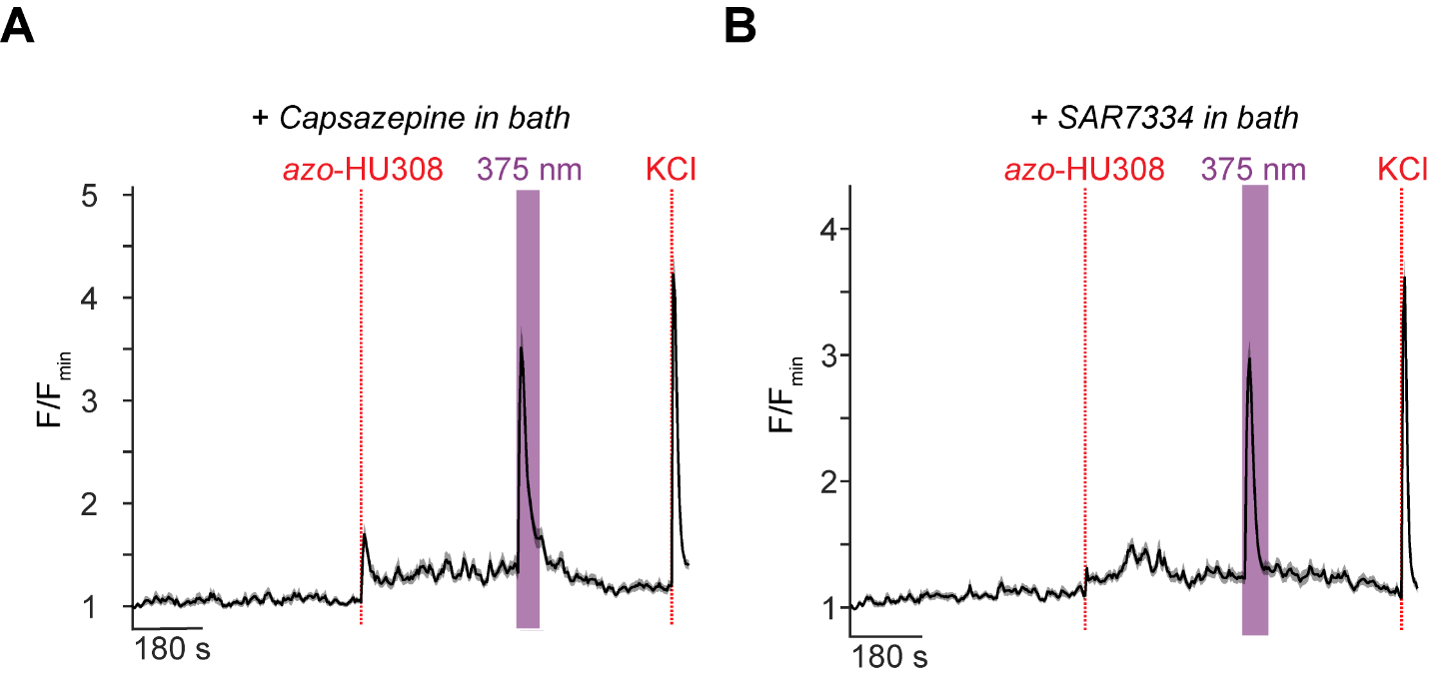 FIGURE S4. azo-HU308’s photoswitching effect is not TRPV1- or TRPC6-mediated. INS-1 cells were transfected with RGECO and their Ca²⁺ levels monitored by confocal microscopy. (A,B) Average Ca²⁺ imaging traces showing that azo-HU308 addition and photostimulation with 375 nm light still had an effect on Ca²⁺ in the presence of (A) the TRPV1 blocker Capsazepine (5 μM, N = 119, T = 2) and (B) the TRPC6 blocker SAR7334 (20 μM, N = 164, T = 3). Shaded error bars = mean ± s.e.m.

SUPPORTING TABLES
TABLE S1: Statistical significance calculations for Figure 1E
conditions | p-value | significance
trans-azo-HU308 / cis-azo-HU308 | 5.32E-68 | ***
HU308 + 375 nm / cis-azo-HU308 | 1.55E-48 | ***
vehicle + 375 nm / cis azo-HU308 | 8.41E-74 | ***
vehicle + 375 nm / HU308 + 375 nm | 0.0238 | *
HU308 dark / HU308 + 375 nm | 2.47E-07 | ***
HU308 dark / cis-azo-HU308 | 1.80E-11 | ***
vehicle dark / cis-azo-HU308 | 0.1169 | n.s.
vehicle dark / HU308 + 375 nm | 5.91E-11 | ***
vehicle dark / vehicle + 375 nm | 0.0139 | *
***P<0.005 (dark blue, *P<0.05 (light blue), ns = P>0.05 (white)
TABLE S2: Statistical significance calculations for Figure S1C
conditions | p-value | significance
-cis 10μM azo-HU308 / -cis 20μM azo-HU308 | 0.0227 | n.s.
-cis vehicle / -cis 10μM azo-HU308 | 3.36E-61 | ***
-cis 1μM azo-HU308 / -cis 5μM azo-HU308 | 2.01E-08 | ***
-cis vehicle / -cis 1μM azo-HU308 | 8.02E-18 | ***
-cis vehicle / -cis 20μM azo-HU308 | 8.41E-74 | ***
cis 5μM azo-HU308 / -cis 10μM azo-HU308 | 0.0032 | ***
-cis vehicle / -cis 5μM azo-HU308 | 1.48E-50 | ***
***P<0.01 (dark blue, *P<0.05 (light blue), ns = P>0.05 (white)
TABLE S3 Statistical significance calculations for Figure 2A
conditions | p-value | significance
-cis azo-HU308 + AM630 | 0.1564 | n.s.
-cis azo-HU308 + CID16020047 | 0.0378 | *
-cis azo-HU308 + YM254890 | 6.62E-25 | ***
-cis azo-HU308 + JWH133 | 0.8940 | n.s.
-cis azo-HU308 + NF449 | 0.0305 | *
-cis azo-HU308 + Pertussis Toxin | 3.71E-04 | ***
-cis azo-HU308 + Rimonabant | 0.3640 | n.s.
-cis azo-HU308 + SR144528 | 4.83E-04 | ***
-cis azo-HU308 + U73122 | 0.4006 | n.s.
-cis azo-HU308 + Xestospongin C | 0.1982 | n.s.
***P<0.01 (dark blue, *P<0.05 (light blue), ns = P>0.05 (white)

TABLE S4: Statistical significance calculations for Figure 3A
conditions | p-value | significance
-cis azo-HU308 + 100μM 2-APB | 1.74E-75 | ***
-cis azo-HU308 + 1μM 2-APB | 0.4480 | n.s.
-cis azo-HU308 + 50μM 2-APB | 3.03E-31 | ***
-cis azo-HU308 + Ca²⁺ free | 1.06E-133 | ***
-cis azo-HU308 + Capsazepine | 0.3447 | n.s.
-cis azo-HU308 + ML204 | 1.80E-26 | ***
-cis azo-HU308 + SAR7334 | 0.1265 | n.s.
-cis azo-HU308 + SKF966365 | 0.0829 | n.s.
***P<0.01 (dark blue, *P<0.05 (light blue), ns = P>0.05 (white)
TABLE S5: Statistical significance calculations for Figure 4A
conditions | p-value | significance
-cis azo-HU308 + Pyr10 | 1.26E-30 | ***
-cis azo-HU308 + siRNAscramble | 0.0248 | *
-cis azo-HU308 + siRNATRPC3 | 1.73E-20 | ***
-cis azo-HU308 + YM58483 | 1.58E-113 | ***
-cis azo-HU308 + Pyr10 /  -cis azo-HU308 + siRNATRPC3 | 1.54E-05 | ***
-cis azo-HU308 + siRNA low GC scramble /  -cis azo-HU308 + siRNATRPC3 | 0.007 | ***
***P<0.01 (dark blue, *P<0.05 (light blue), ns = P>0.05 (white)

