Supplementary Table 1 Characteristics of studies included
Author | Study year¹ | Country | Design | Setting | Participant | Sampling | Mpox gene sequencing | Risk of bias | Confirmed cases (n) | Severe/grave cases rate (%)
Breman et al. [1] | 1970 | Liberia | Cross-sectional | Community | General population | Non-probabilistic | Not reported | Low | 4 | 0.0
Breman et al. [1] | 1971 | Nigeria | Cross-sectional | Community | General population | Non-probabilistic | Not reported | Low | 2 | 50.0
Breman et al. [1] | 1979 | Democratic Republic of Congo | Cross-sectional | Community | General population | Non-probabilistic | Not reported | Low | 38 | 57.9
Arita et al. [2] | 1983 | Multinational | Cross-sectional | Community | General population | Non-probabilistic | Not reported | Low | 131 | 59.5
Jezek et al. [3] | 1985 | Democratic Republic of Congo | Cross-sectional | Community | General population | Non-probabilistic | Not reported | Low | 282 | 39.0
Meyer et al. [4] | 2001 | Democratic Republic of Congo | Cross-sectional | Community | General population | Non-probabilistic | Not reported | Low | 16 | 68.8
Boumandouki et al. [5] | 2003 | Congo | Case series | Hospital | General population | Non-probabilistic | Not reported | Low | 3 | 100.0
Formenty et al. [5] | 2005 | Sudan | Cross-sectional | Community | General population | Non-probabilistic | Clade Ia | Low | 10 | 30.0
Damon et al. [6] | 2005 | Sudan | Case report | Community | General population | Non-probabilistic | Clade Ia | Low | 2 | 50.0
Hoff et al. [7] | 2007 | Democratic Republic of Congo | Cross-sectional | Community | General population | Non-probabilistic | Not reported | Low | 785 | 36.7
Berthet et al. [8] | 2010 | Central African Republic | Case report | Community | General population | Non-probabilistic | Clade Ia | Low | 2 | 0.0
Pittman et al. [9] | 2011 | Democratic Republic of Congo | Cross-sectional | Hospital | General population | Non-probabilistic | Not reported | Moderate | 216 | 63.9
Hughes et al. [10] | 2014 | Democratic Republic of Congo | Cross-sectional | Community | General population | Non-probabilistic | Not reported | Low | 534 | 36.5
Osadebe et al. [11] | 2014 | Democratic Republic of Congo | Cross-sectional | Community | General population | Non-probabilistic | Not reported | Low | 333 | 28.5
Kalthan et al. [12] | 2015 | Central African Republic | Cross-sectional | Community | General population | Non-probabilistic | Not reported | Low | 12 | 83.3
Whitehouse et al. [13] | 2015 | Democratic Republic of Congo | Cross-sectional | Community | General population | Non-probabilistic | Not reported | Low | 1057 | 50.4
Kalthan et al. [14] | 2016 | Central African Republic | Cross-sectional | Community | General population | Non-probabilistic | Not reported | Low | 26 | 61.5
Nakoune et al. [15] | 2016 | Central African Republic | Cross-sectional | Community | General population and HCWs | Non-probabilistic | Not reported | Moderate | 10 | 70.0
Doshi et al. [16] | 2017 | Congo | Case series | Community | General population | Non-probabilistic | Not reported | Moderate | 7 | 85.7
Ogoina et al. [17] | 2017 | Nigeria | Cross-sectional | Hospital | General population | Non-probabilistic | Not reported | Low | 18 | 72.2
Vaughan et al. [18] | 2018 | Nigeria | Case report | Hospital | General population | Non-probabilistic | Clade II | Low | 2 | 0.0
Ogoina et al. [19] | 2018 | Nigeria | Cross-sectional | Hospital | General population | Non-probabilistic | Not reported | Low | 40 | 60.0
Echekwube et al. [20] | 2018 | Nigeria | Case series | Hospital | General population | Non-probabilistic | Not reported | Low | 4 | 25.0
Mande et al. [21] | 2019 | Democratic Republic of Congo | Cross-sectional | Community | General population | Non-probabilistic | Not reported | Low | 21 | 38.1
Hobson et al. [22] | 2021 | Nigeria | Case report | Hospital | General population | Non-probabilistic | Clade II | Low | 3 | 0.0
Amao et al. [23] | 2021 | Nigeria | Cross-sectional | Community | General population | Non-probabilistic | Not reported | Low | 3 | 0.0
Djuicy et al. [24] | 2022 | Cameroon | Cross-sectional | Community and hospital | General population | Non-probabilistic | Clade I and II | Low | 32 | 37.5
Yadouleton et al. [25] | 2022 | Benin | Case series | Community | General population | Non-probabilistic | Clade II | Low | 3 | 0.0
Besombes et al. [26] | 2022 | Central African Republic | Cross-sectional | Community | General population | Non-probabilistic | Clade Ia | Low | 14 | 42.9
Kibungu et al. [27] | 2023 | Democratic Republic of Congo | Case series | Community | General population | Non-probabilistic | Clade Ia | Low | 5 | 0.0
Mmerem et al. [28] | 2023 | Nigeria | Cohort study | Hospital | General population | Non-probabilistic | Not reported | Low | 56 | 66.1
Nizigiyimana et al. [29] | 2024 | Burundi | Cross-sectional | Community | General population | Non-probabilistic | Clade Ib | Low | 154 | 29.2
Brosius et al. [30] | 2024 | Democratic Republic of Congo | Cohort study | Hospital | General population | Non-probabilistic | Clade Ib | Moderate | 431 | 24.8
Mukadi-Bamuleka et al. [31] | 2024 | Democratic Republic of Congo | Cross-sectional | Community | General population | Non-probabilistic | Clade Ib | Low | 9 | 66.7
Kombozi et al. [32] | 2024 | Democratic Republic of Congo | Cross-sectional | Community | General population | Probabilistic | Not reported | Low | 230 | 44.3
Vakaniaki et al. [33] | 2024 | Democratic Republic of Congo | Cross-sectional | Community | General population | Non-probabilistic | Clade Ib | Low | 108 | 9.3
Malembi et al. [34] | 2024 | Democratic Republic of Congo | Cross-sectional | Community | General population | Non-probabilistic | Clade Ib | Low | 814 | 48.9
1: Last year of study implementation;

Study year
Event rate (%)
Severity rate (%)
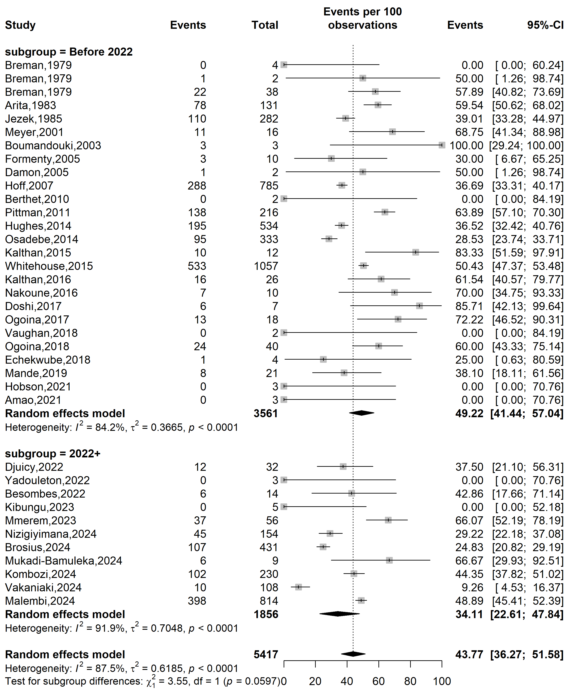
Supplementary Fig. 1 Mpox disease severity rate in Africa by study periods

Country
Event rate (%)
Severity rate (%)
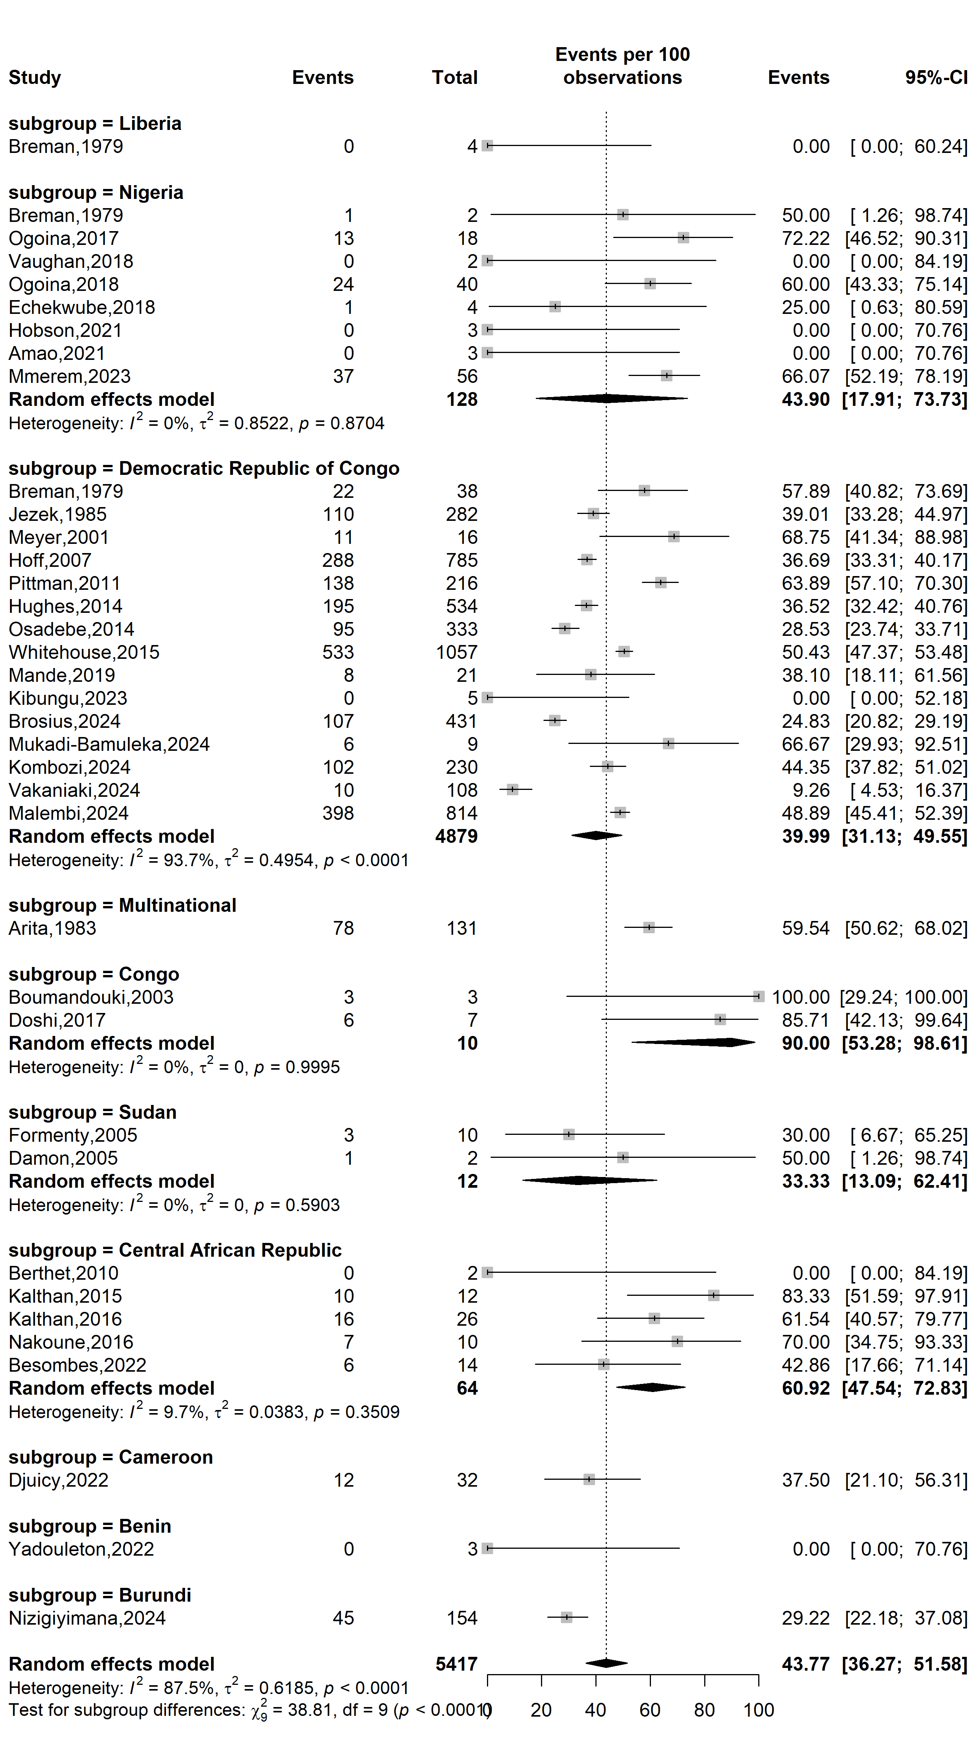
Supplementary Fig. 2 Mpox disease severity rate in Africa by countries

WHO Afro region
Event rate (%)
Severity rate (%)
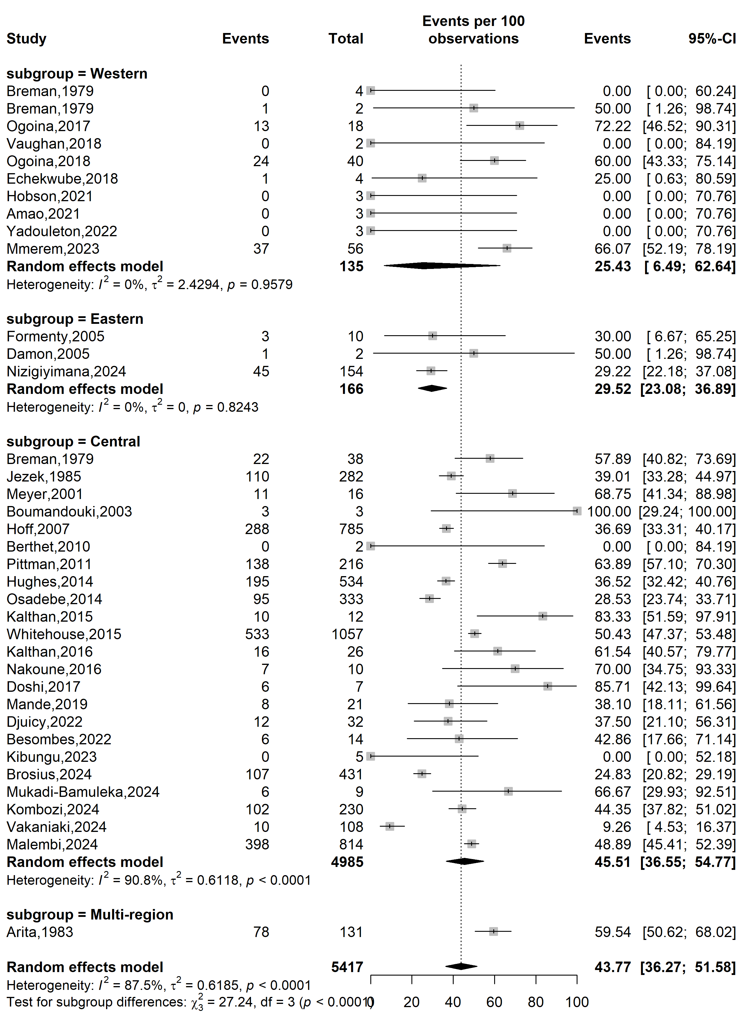
Supplementary Fig. 3 Mpox disease severity rate in Africa by WHO Afro regions
Study design
Event rate (%)
Severity rate (%)
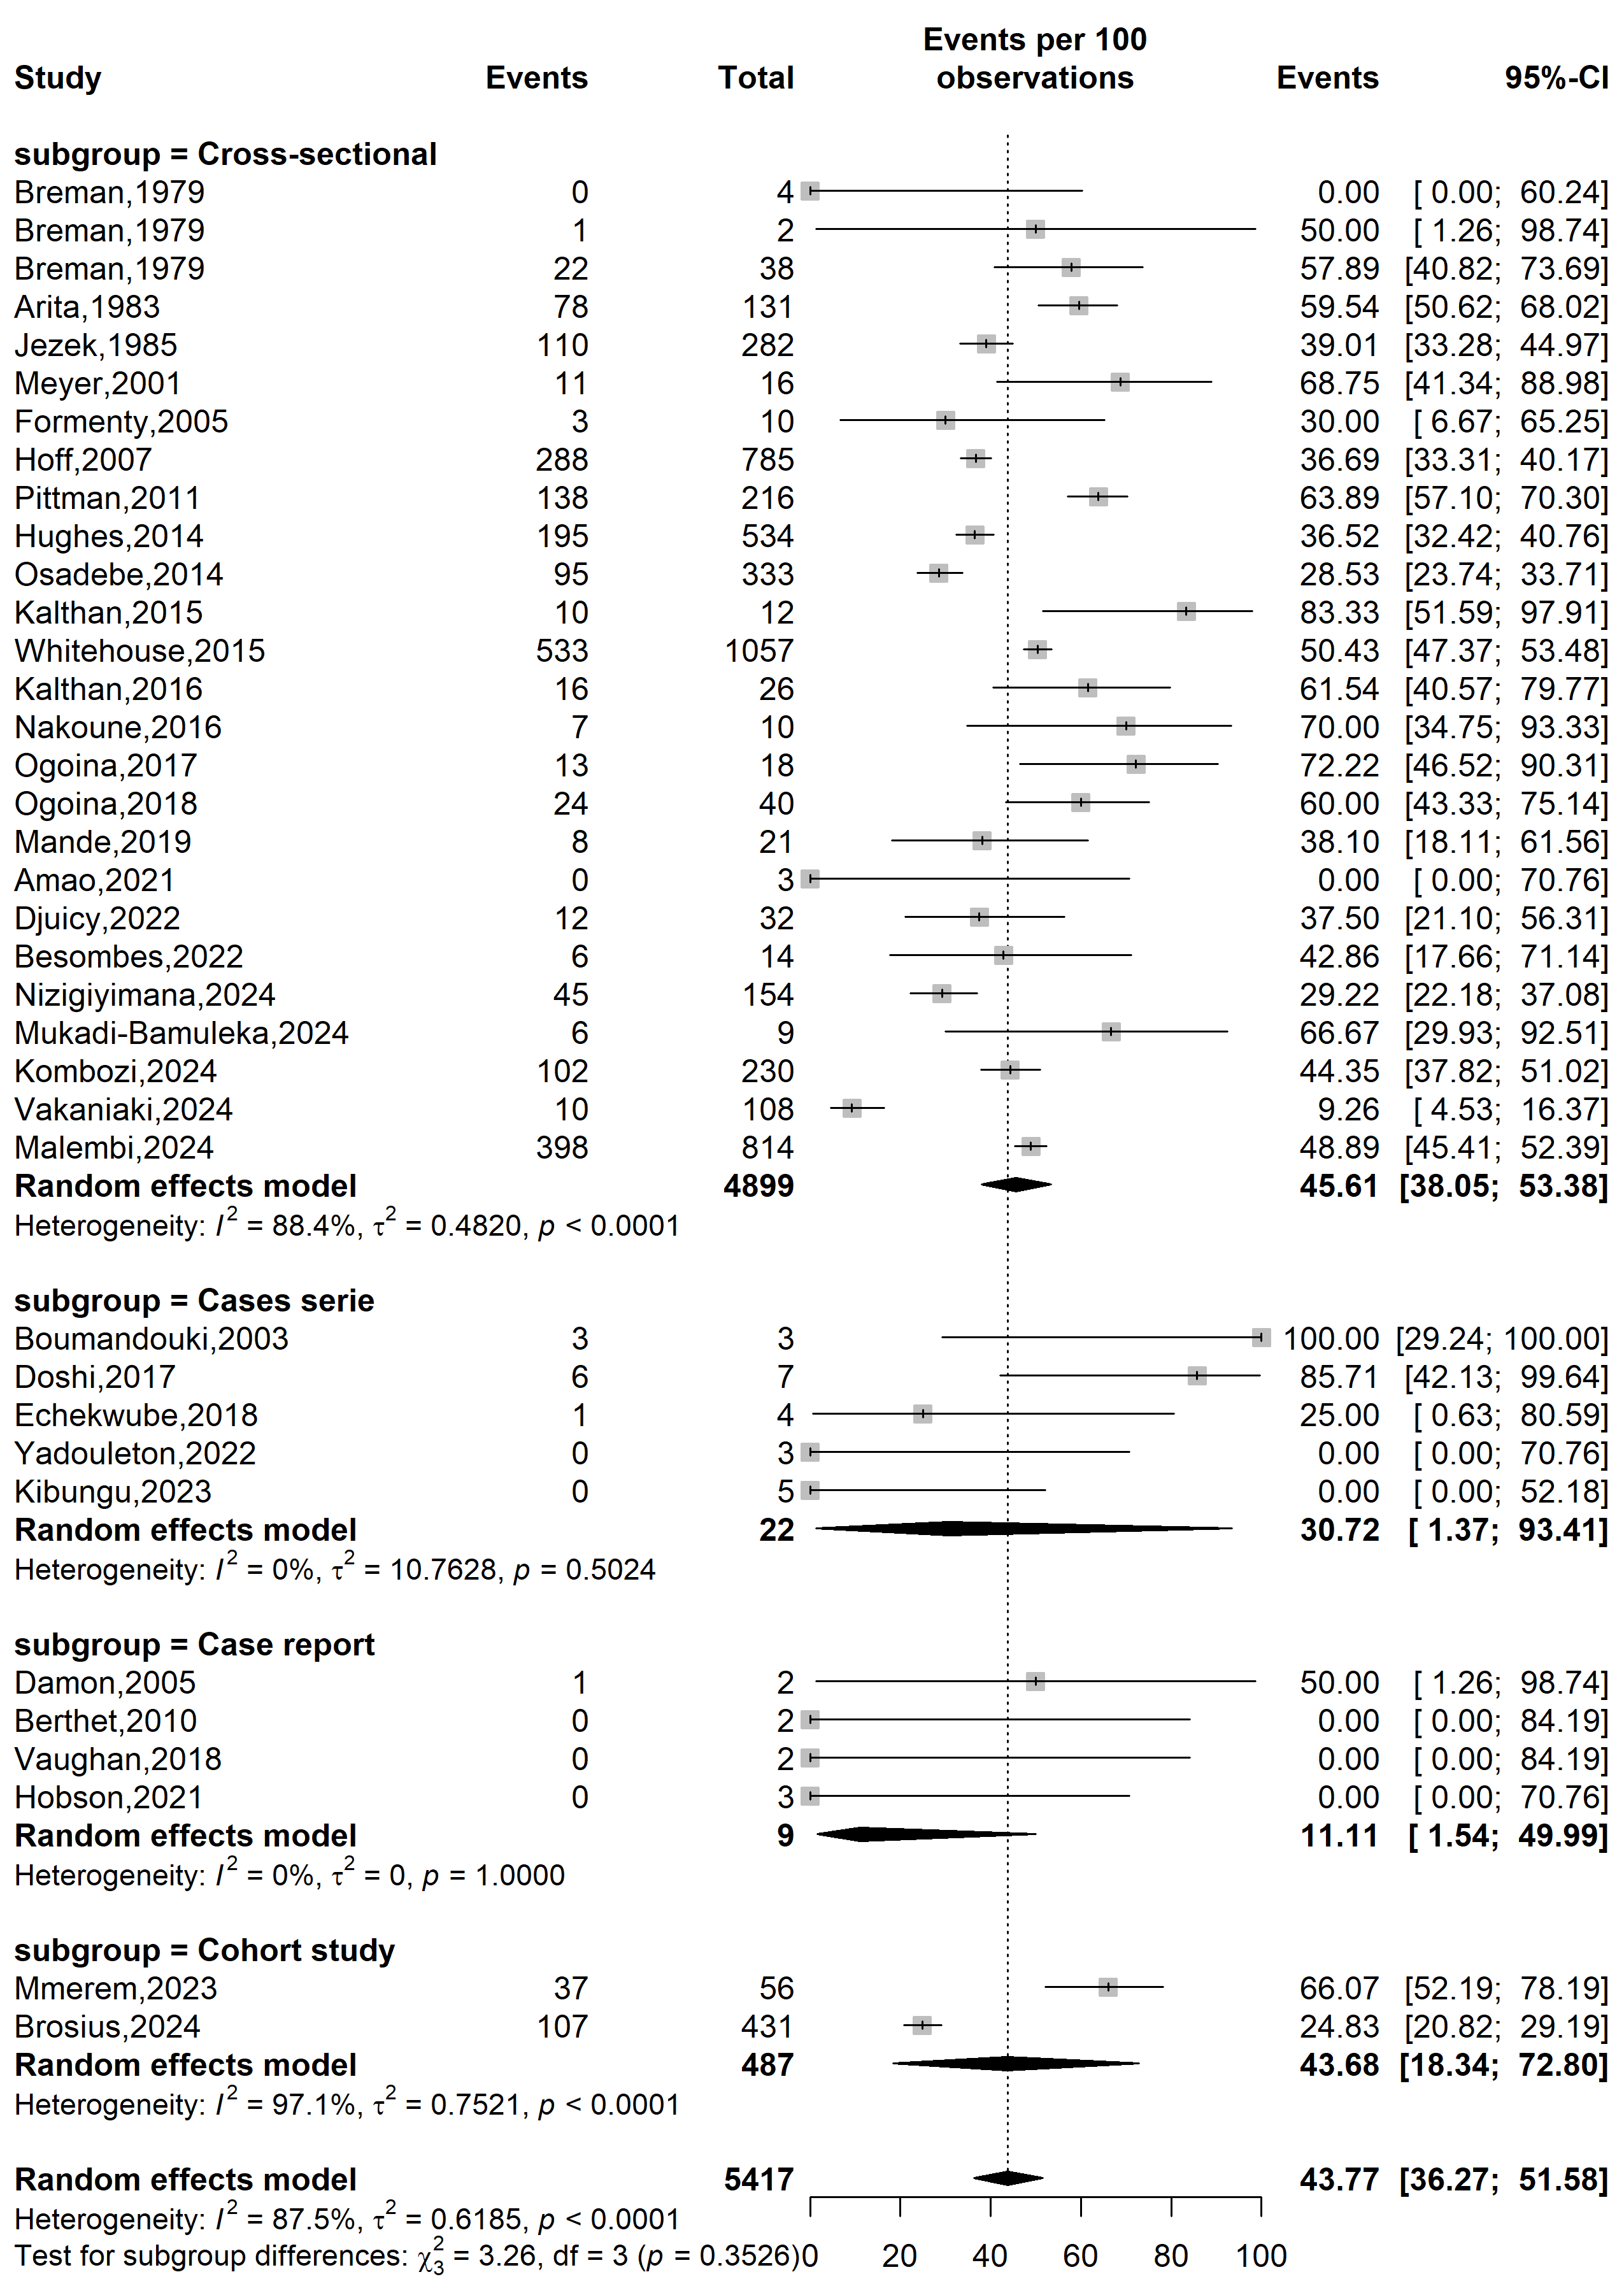
Supplementary Fig. 4 Mpox severity rate in Africa by type of study designs
Study setting
Event rate (%)
Severity rate (%)
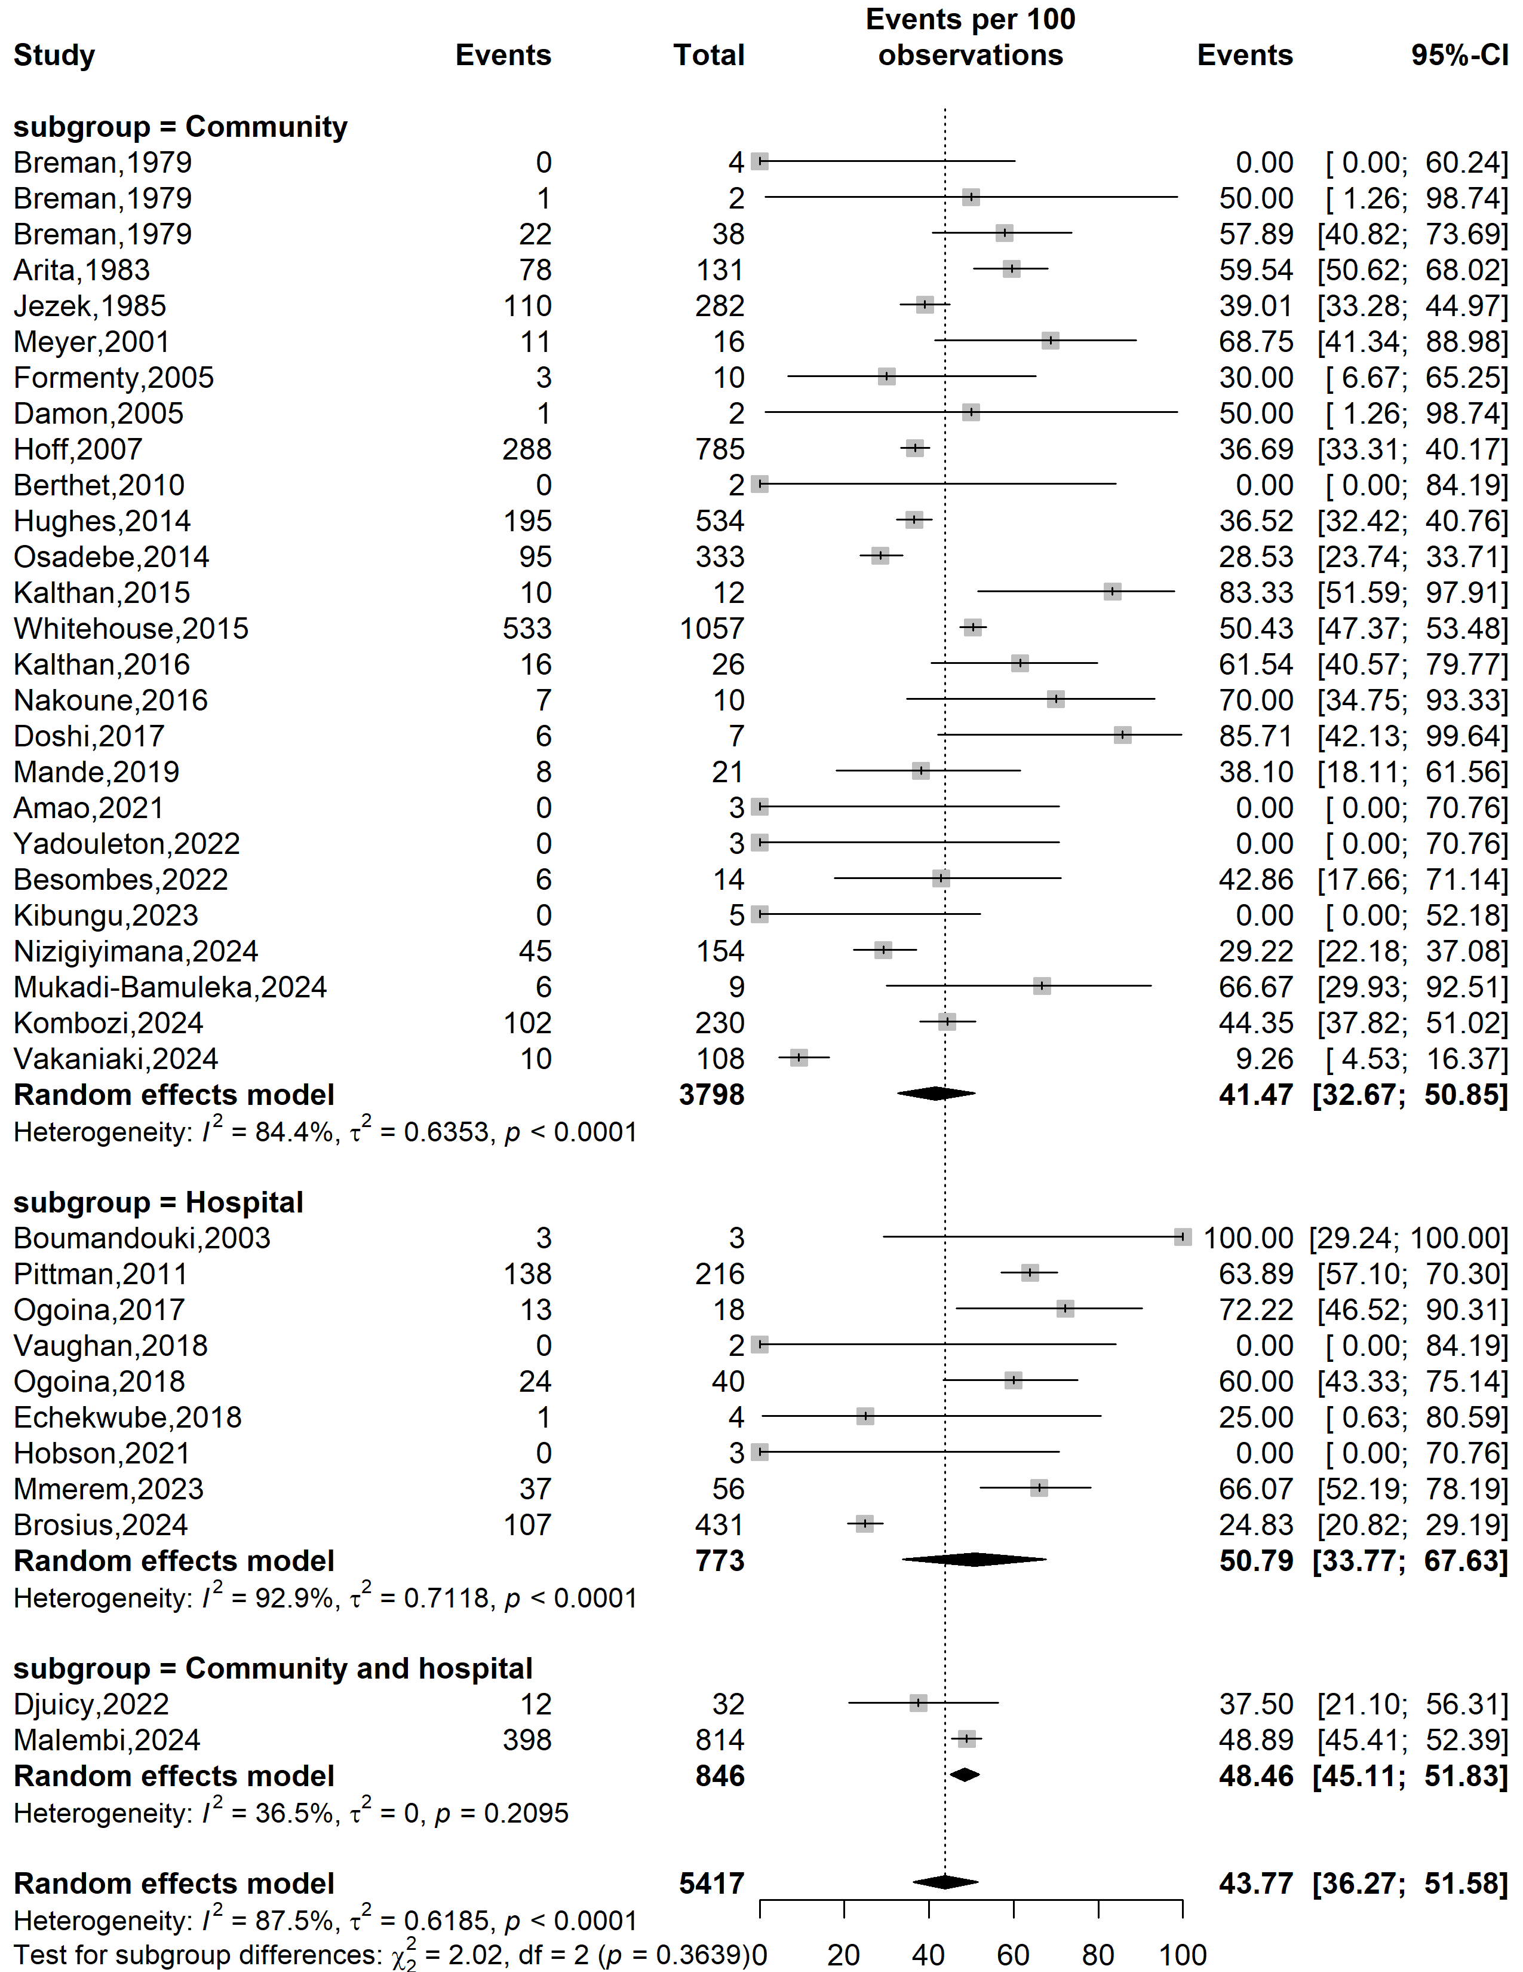
Supplementary Fig. 5 Mpox severity rate in Africa by type of study settings

Mpox clade stratification
Event rate (%)
Severity rate (%)
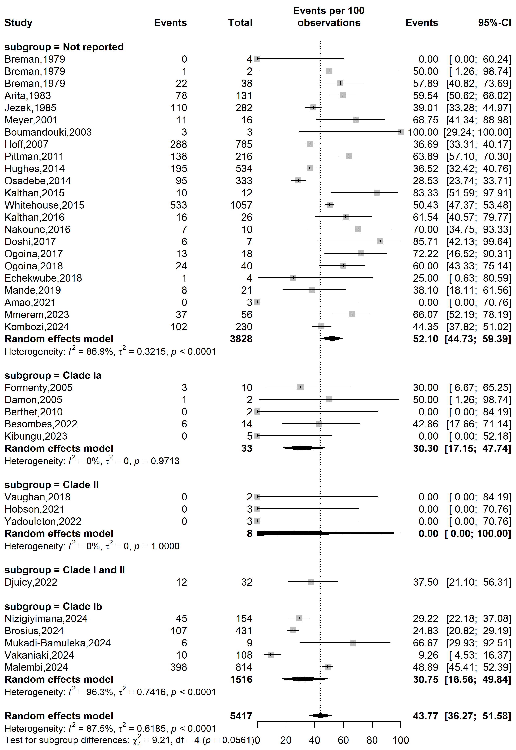
Supplementary Fig. 6 Mpox severity rate in Africa by clade stratifications

Publication bias assessment
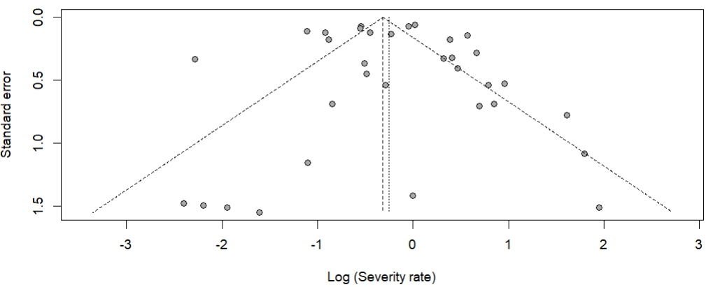
Egger’s test p-value = 0.891
Begg’s test p-value = 0.326

Supplementary Fig. 7 Funnel plot displaying the pseudo 95% confidence limits and tests assessing the publication bias of studies included

Sensitivity analysis
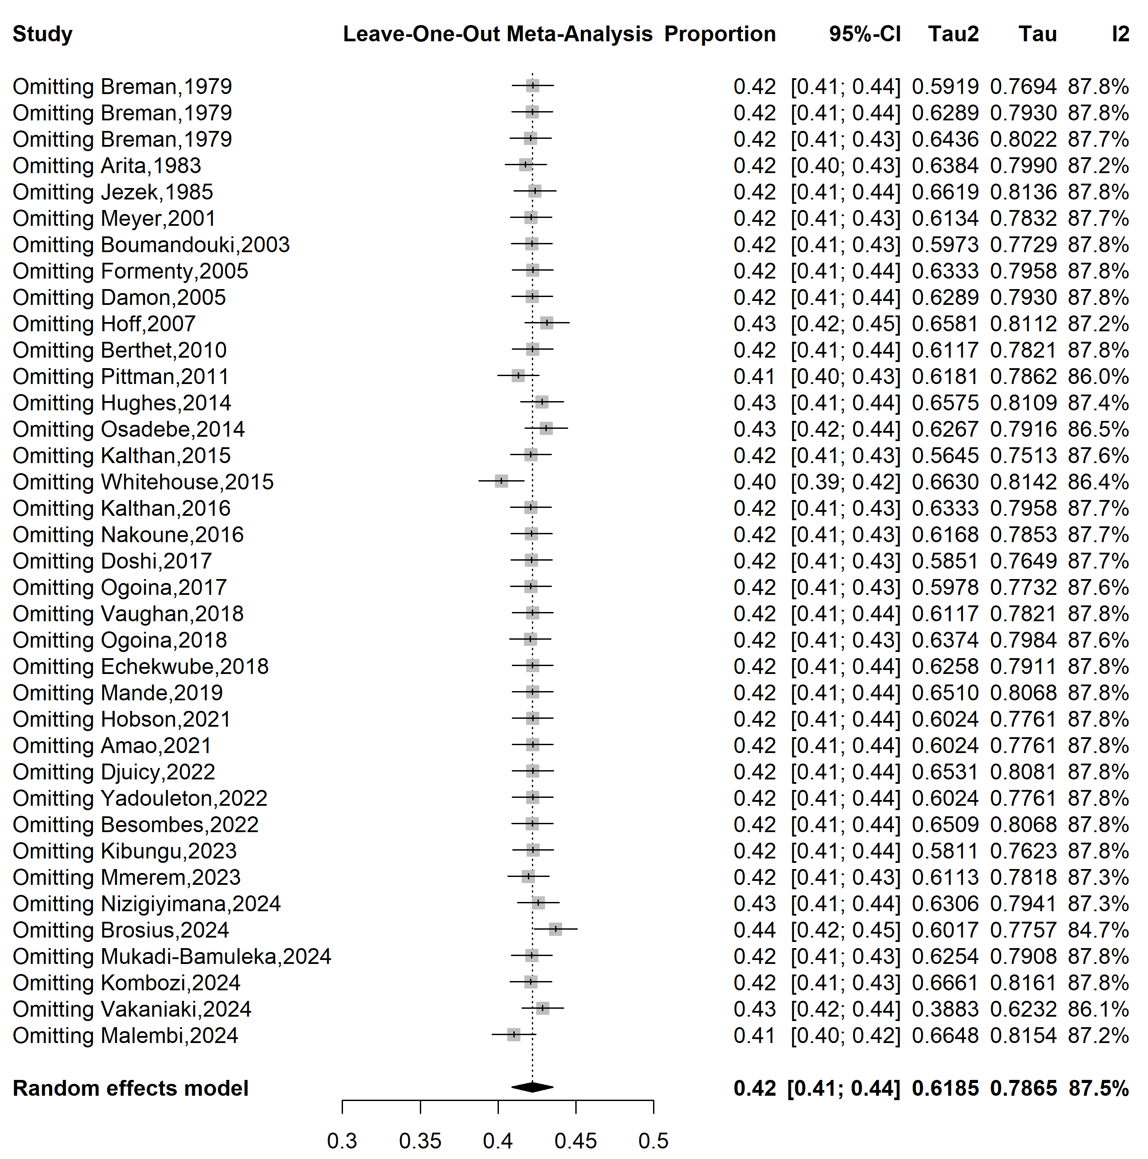
Supplementary Fig. 8 Sensitivity analysis of the mpox disease severity rate in Africa

References
1. Breman JG, Kalisa-Ruti, Steniowski MV, Zanotto E, Gromyko AI, Arita I. Human monkeypox, 1970-79. Bull World Health Organ. 1980;58(2):165–82.
2. Arita I, Jezek Z, Khodakevich L, Ruti K. Human monkeypox: a newly emerged orthopoxvirus zoonosis in the tropical rain forests of Africa. Am J Trop Med Hyg. 1985;34(4):781–9.
3. Jezek Z, Marennikova SS, Mutumbo M, Nakano JH, Paluku KM, Szczeniowski M. Human Monkeypox: A Study of 2,510 Contacts of 214 Patients. J Infect Dis. 1986;154(4):551–5.
4. Meyer H, Perrichot M, Stemmler M, Emmerich P, Schmitz H, Varaine F, et al. Outbreaks of Disease Suspected of Being Due to Human Monkeypox Virus Infection in the Democratic Republic of Congo in 2001. J Clin Microbiol. 2002;40(8):2919–21.
5. Boumandouki P, Bileckot R, Ibara JR, Satounkazi C, Wassa Wassa D, Libama E, et al. [Simian smallpox (or monkey smallpox): study of 8 cases observed at Impfondo Hospital in Republic of Congo]. Bull Soc Pathol Exot 1990. 2007;100(1):17–21.
6. Damon IK, Roth CE, Chowdhary V. Discovery of Monkeypox in Sudan. N Engl J Med. 2006;355(9):962–3.
7. Hoff NA, Morier DS, Kisalu NK, Johnston SC, Doshi RH, Hensley LE, et al. Varicella Coinfection in Patients with Active Monkeypox in the Democratic Republic of the Congo. EcoHealth. 2017;14(3):564–74.
8. Berthet N, Nakouné E, Whist E, Selekon B, Burguière AM, Manuguerra JC, et al. Maculopapular lesions in the Central African Republic. The Lancet. 2011;378(9799):1354.
9. Pittman PR, Martin JW, Kingebeni PM, Tamfum JJM, Mwema G, Wan Q, et al. Clinical characterization and placental pathology of mpox infection in hospitalized patients in the Democratic Republic of the Congo. Bowman N, editor. PLoS Negl Trop Dis. 2023;17(4):e0010384.
10. Hughes CM, Liu L, Davidson WB, Radford KW, Wilkins K, Monroe B, et al. A Tale of Two Viruses: Coinfections of Monkeypox and Varicella Zoster Virus in the Democratic Republic of Congo. Am J Trop Med Hyg. 2021;104(2):604–11.
11. Osadebe L, Hughes CM, Shongo Lushima R, Kabamba J, Nguete B, Malekani J, et al. Enhancing case definitions for surveillance of human monkeypox in the Democratic Republic of Congo. Kasper M, editor. PLoS Negl Trop Dis. 2017;11(9):e0005857.
12. Kalthan E, Dondo-Fongbia JP, Yambele S, Dieu-Creer LR, Zepio R, Pamatika CM. Epidémie de 12 cas de maladie à virus monkeypox dans le district de Bangassou en République Centrafricaine en décembre 2015. Bull Société Pathol Exot. 2016;109(5):358–63.
13. Whitehouse ER, Bonwitt J, Hughes CM, Lushima RS, Likafi T, Nguete B, et al. Clinical and Epidemiological Findings from Enhanced Monkeypox Surveillance in Tshuapa Province, Democratic Republic of the Congo During 2011–2015. J Infect Dis. 2021;223(11):1870–8.
14. Kalthan E, Tenguere J, Ndjapou SG, Koyazengbe TA, Mbomba J, Marada RM, et al. Investigation of an outbreak of monkeypox in an area occupied by armed groups, Central African Republic. Médecine Mal Infect. 2018;48(4):263–8.
15. Nakoune E, Lampaert E, Ndjapou SG, Janssens C, Zuniga I, Van Herp M, et al. A Nosocomial Outbreak of Human Monkeypox in the Central African Republic. Open Forum Infect Dis. 2017;4(4):ofx168.
16. Doshi RH, Guagliardo SAJ, Dzabatou-Babeaux A, Likouayoulou C, Ndakala N, Moses C, et al. Strengthening of Surveillance during Monkeypox Outbreak, Republic of the Congo, 2017. Emerg Infect Dis. 2018;24(6):1158–60.
17. Ogoina D, Iroezindu M, James HI, Oladokun R, Yinka-Ogunleye A, Wakama P, et al. Clinical Course and Outcome of Human Monkeypox in Nigeria. Clin Infect Dis. 2020;71(8):e210–4.
18. Vaughan A, Aarons E, Astbury J, Balasegaram S, Beadsworth M, Beck CR, et al. Two cases of monkeypox imported to the United Kingdom, September 2018. Eurosurveillance. 2018;23(38):1800509.
19. Ogoina D, Yinka-Ogunleye A. Sexual history of human monkeypox patients seen at a tertiary hospital in Bayelsa, Nigeria. Int J STD AIDS. 2022;33(10):928–32.
20. Echekwube PO, Mbaave PT, Abidakun OA, Utoo BT, Swende TZ. Human monkeypox and human immunodeficiency virus co-infection: a case series in Makurdi, Benue State, Nigeria. J Biomed Res Clin Pract. 2020;3(2):375–81.
21. Mande G, Akonda I, Weggheleire AD, Brosius I, Liesenborghs L, Bottieau E, et al. Enhanced surveillance of monkeypox in Bas-Uélé, Democratic Republic of Congo: the limitations of symptom-based case definitions. Int J Infect Dis. 2022;122:647–55.
22. Hobson G, Adamson J, Adler H, Firth R, Gould S, Houlihan C, et al. Family cluster of three cases of monkeypox imported from Nigeria to the United Kingdom, May 2021. Eurosurveillance. 2021;26(32):2100745.
23. Amao LK, Olatunji DI, Igbodo G, Okoli SC, Amaechi I, Goni MI, et al. Trend and enhanced surveillance of Monkeypox during COVID-19 pandemic in Nigeria. J Public Health Afr. 2022;13(1):2184.
24. Djuicy DD, Sadeuh-Mba SA, Bilounga CN, Yonga MG, Tchatchueng-Mbougua JB, Essima GD, et al. Concurrent Clade I and Clade II Monkeypox Virus Circulation, Cameroon, 1979–2022. Emerg Infect Dis. 2024;30(3):433–43.
25. Yadouleton A, Faye M, Tchibozo C, Oke M, Faye O, Lawale T, et al. Introduction of monkeypox virus in Benin, 2022. Mil Med Res. 2022 Nov 9;9(1):63.
26. Besombes C, Mbrenga F, Malaka C, Gonofio E, Schaeffer L, Konamna X, et al. Investigation of a mpox outbreak in Central African Republic, 2021-2022. One Health. 2023;16:100523.
27. Kibungu EM, Vakaniaki EH, Kinganda-Lusamaki E, Kalonji-Mukendi T, Pukuta E, Hoff NA, et al. Clade I–Associated Mpox Cases Associated with Sexual Contact, the Democratic Republic of the Congo. Emerg Infect Dis. 2024;30(1):172–6.
28. Mmerem JI, Umenzekwe CC, Johnson SM, Onukak AE, Chika-Igwenyi NM, Chukwu SK, et al. Mpox and Chickenpox Coinfection: Case Series From Southern Nigeria. J Infect Dis. 2024;229(Supplement_2):S260-4.
29. Nizigiyimana A, Ndikumwenayo F, Houben S, Manirakiza M, Lettow M van, Liesenborghs L, et al. Epidemiological analysis of confirmed mpox cases, Burundi, 3 July to 9 September 2024. Eurosurveillance. 2024;29(42):2400647.
30. Brosius I, Vakaniaki EH, Mukari G, Munganga P, Tshomba JC, Vos ED, et al. Epidemiological and clinical features of mpox during the clade Ib outbreak in South Kivu, Democratic Republic of the Congo: a prospective cohort study. The Lancet. 2025;405(10478):547–59.
31. Mukadi-Bamuleka D, Kinganda-Lusamaki E, Mulopo-Mukanya N, Amuri-Aziza A, O’Toole Á, Modadra-Madakpa B, et al. First imported Cases of MPXV Clade Ib in Goma, Democratic Republic of the Congo: Implications for Global Surveillance and Transmission Dynamics [Internet]. medRxiv; 2024 [cited 2025 Feb 24]. Available from: http://medrxiv.org/lookup/doi/10.1101/2024.09.12.24313188
32. Kombozi YDMerci, Singa Valentin. B, Ley. BL, Antoine. ET, Guild. AK, Lwanga. K, et al. MPOX: EPIDEMIOLOGICAL PROFILE AND FACTORS ASSOCIATED WITH ITS EMERGENCE IN THE ISANGI TERRITORY, DEMOCRATIC REPUBLIC OF CONGO. Int J Appl Sci Eng Rev. 2024;5(5):27–43.
33. Vakaniaki EH, Kacita C, Kinganda-Lusamaki E, O’Toole Á, Wawina-Bokalanga T, Mukadi-Bamuleka D, et al. Sustained human outbreak of a new MPXV clade I lineage in eastern Democratic Republic of the Congo. Nat Med. 2024;30(10):2791–5.
34. Malembi E, Escrig-Sarreta R, Ntumba J, Beiras CG, Shongo R, Bengehya J, et al. Clinical presentation and epidemiological assessment of confirmed human mpox cases in DR Congo: a surveillance-based observational study. The Lancet. 2025;405(10490):1666–75.

