Supplementary Materials

SEM graphing conventions
Table 1: variance-covariance matrix of the variables of the main model.
Table 2: Results of complete case analysis of parallel multiple mediator model in the discovery sample (UCC - above) and in the replication sample (IMAGEN cohort - below)
Figure 1: Path diagram of complete case analysis of parallel multiple mediator model in the discovery sample (Panel A. UCC above) and in the replication sample (Panel B. IMAGEN cohort, below).
Table 3: variance of PLE phenotype explained by the SZ-PRS selected from the LASSO.
Figure 2: Causal mediation effect of CM as function of the sensitivity parameter (ρ).
Figure 3: Explanatory power of a confounder on the causal mediation effect of CM.
Table 4: Results of parallel four-mediator model in the replication sample (IMAGEN cohort).
Figure 4: Path diagram of parallel four-mediator model in the replication sample (IMAGEN cohort).
Table 5: Results of parallel multiple mediation analysis according to the trauma subtype in the discovery sample (UCC).
Figure 5: Path diagram of parallel multiple mediation analysis according to trauma subtype in the discovery sample (UCC).
Table 6: Results of parallel multiple mediation analysis according to the trauma subtype in the replication sample (IMAGEN cohort).
Figure 6: Path diagram of parallel multiple mediation analysis according to the trauma subtype in the replication sample (IMAGEN cohort).

SEM graphing conventions
From Van Lissa, C. J., (2019). tidySEM: Tidy structural equation modeling. R package version 0.2.1. https://github.com/cjvanlissa/tidySEM/

Structural equation modeling (SEM) uses some conventions to graph models visually.

Nodes
Nodes are the “shapes” in a graph. In SEM graphs, we use nodes to indicate variables.
Observed variables
An observed variable is a measured quantity; you have “real data” about this variable. Observed variables are also called measured variables or indicators. Visually, we indicate observed variables as rectangles.
Latent variables
A latent variable is something that exists (according to your theory), but that you did not measure directly. There is no column in the data for this variable. Latent variables are also called “unobserved” variables. Visually, we indicate them as ovals or circles.

Edges
Edges refer to the connections between nodes. In SEM graphs, we use edges to specify relationships between variables.
Regression effects
A regression effect indicates that one variable influences another variable. Regression effects are also called “paths”, “directional effects”, and “factor loadings”. In SEM graphs, we represent regression effects as single-headed arrows, with the accompanying unstandardized regression coefficient.
Covariances
Covariances are also referred to as “correlations” (when a graph depicts standardized coefficients), “undirected associations”, or “unexplained associations”. Visually, we indicate covariances as curved (dashed) lines without arrowheads.
(Residual) variances
Variables often have a variance, and in SEM we can represent this variance as a double-headed arrow that points from a variable to itself. However, this is a simplification. When a variable is endogenous (on the receiving end of one or more causal effects), it gains an additional latent variable predictor known as an “error term”; a latent variable with a loading of 1 and a mean of 0. The variance of this error term represents the “error variance”, also known as “residual variance” or “unexplained variance”. In tidySEM, all error terms are omitted, and all variances (including error variances) are displayed as double-headed arrows.

Table 1: variance-covariance matrix of the variables of the main model
 | CM | PLE | SZ-PRS | Cannabis
CM | 70.1399943 | 46.3551222 | 4.8813426 | 0.5704782
PLE | 46.355122 | 212.538809 | 10.044700 | 1.000641
SZ-PRS | 4.8813426 | 10.0447004 | 26.1217353 | 0.4124109
Cannabis | 0.5704782 | 1.0006415 | 0.4124109 | 0.2217328
Abbreviations: CM: childhood maltreatment; PLE: psychotic-like experiences; SZ-PRS: schizophrenia polygenic risk score at p-value threshold 0.5.

Table 2: Results of complete case analysis of parallel multiple mediator model in the discovery sample (UCC - above) and in the replication sample (IMAGEN cohort - below)
Regressions | Unstandardized estimate (95% CI) | Standardized coefficient | p-value
UCC
Direct effects
Outcome model: PLE (R²=0.159)
SZ-PRS | 0.229 (0.056; 0.401) | 0.080 | 0.009
CM | 0.625 (0.520; 0.730) | 0.359 | <0.001
Cannabis use | 2.48 (0.600; 4.36) | 0.080 | 0.010
Mediator model: CM (R²=0.013)
SZ-PRS | 0.187 (0.082; 0.292) | 0.114 | 0.001
Mediator model: Cannabis use (R²=0.029)
SZ-PRS | 0.016 (0.010; 0.022) | 0.171 | <0.001
Covariances
CM – Cannabis use | 0.493 (0.241; 0.744) | 0.128 | <0.001
Indirect effects (proportion mediated)
CM (30.4%) | 0.117 (0.048; 0.185) | 0.041 | 0.001
Cannabis (10.1%) | 0.039 (0.006; 0.072) | 0.014 | 0.020
Sum | 0.156 (0.079; 0.233) | 0.055 | <0.001
Total effect | 0.385 (0.202; 0.567) | 0.135 | <0.001
IMAGEN cohort
Direct effects
Outcome model: PLE (R²=0.108)
SZ-PRS | 0.360 (-0.305; 1.026) | 0.032 | 0.289
CM | 0.486 (0.393; 0.579) | 0.307 | <0.001
Cannabis use | 1.95 (0.374; 3.520) | 0.073 | 0.015
Mediator model: CM (R²=0.006)
SZ-PRS | 0.573 (0.132; 1.013) | 0.080 | 0.011
Mediator model: Cannabis use (R²=0.010)
SZ-PRS | 0.042 (0.016; 0.068) | 0.098 | 0.002
Covariances
CM – Cannabis use | 0.351 (0.163; 0.540) | 0.116 | <0.001
Indirect effects (proportion mediated)
CM (38.6%) | 0.278 (0.058; 0.499) | 0.024 | 0.013
Cannabis (11.3%) | 0.081 (-0.002; 0.164) | 0.007 | 0.055
Sum | 0.360 (0.120; 0.599) | 0.032 | 0.003
Total effect | 0.720 (0.022; 1.418) | 0.063 | 0.043
Abbreviations: 95% CI: 95% bias-corrected bootstrap confidence interval; UCC: Utrecht cannabis cohort; PLE: psychotic-like experiences; CM: childhood maltreatment; SZ-PRS: schizophrenia polygenic risk score at p-value threshold 0.5.

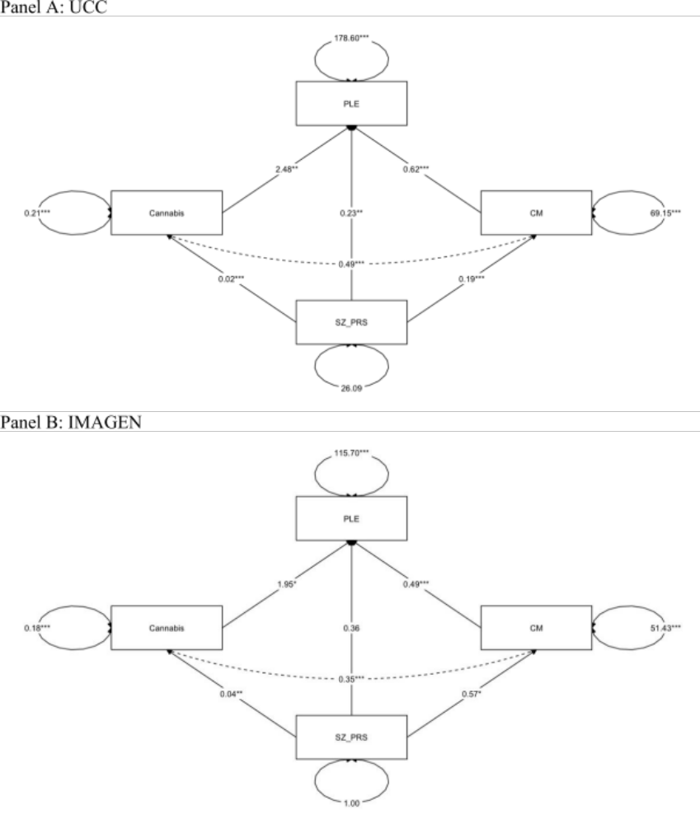
Figure 1: Path diagram of complete case analysis of parallel multiple mediator model in the discovery sample (Panel A. UCC above) and in the replication sample (Panel B. IMAGEN cohort, below).
Legend: the estimates reported are the unstandardized regression coefficients. *p<0.05; **p<0.01; ***p<0.001.
Abbreviations: SZ-PRS: schizophrenia polygenic risk score at p-value threshold 0.5; CM: childhood maltreatment; PLE: psychotic-like experiences.

Table 3: variance of PLE phenotype explained by the SZ-PRS selected from the LASSO
SZ-PRS pt | Unstandardized B estimate (95% CI) | p-value | R²
0.2 | 0.348 (0.190; 0.506) | <0.001 | 0.0139
0.5 | 0.328 (0.181; 0.475) | <0.001 | 0.0143
1 | 0.326 (0.180; 0.471) | <0.001 | 0.0142
Abbreviations: SZ-PRS pt: schizophrenia polygenic risk score p-value threshold; 95% CI: 95% confidence interval.
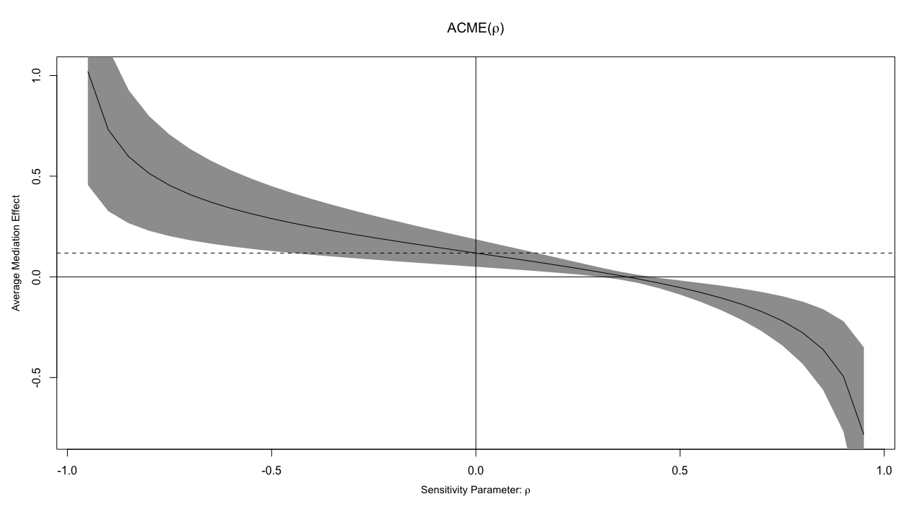

Figure 2: Causal mediation effect of CM as function of the sensitivity parameter (ρ)
ACME: average causal mediation effect of CM.

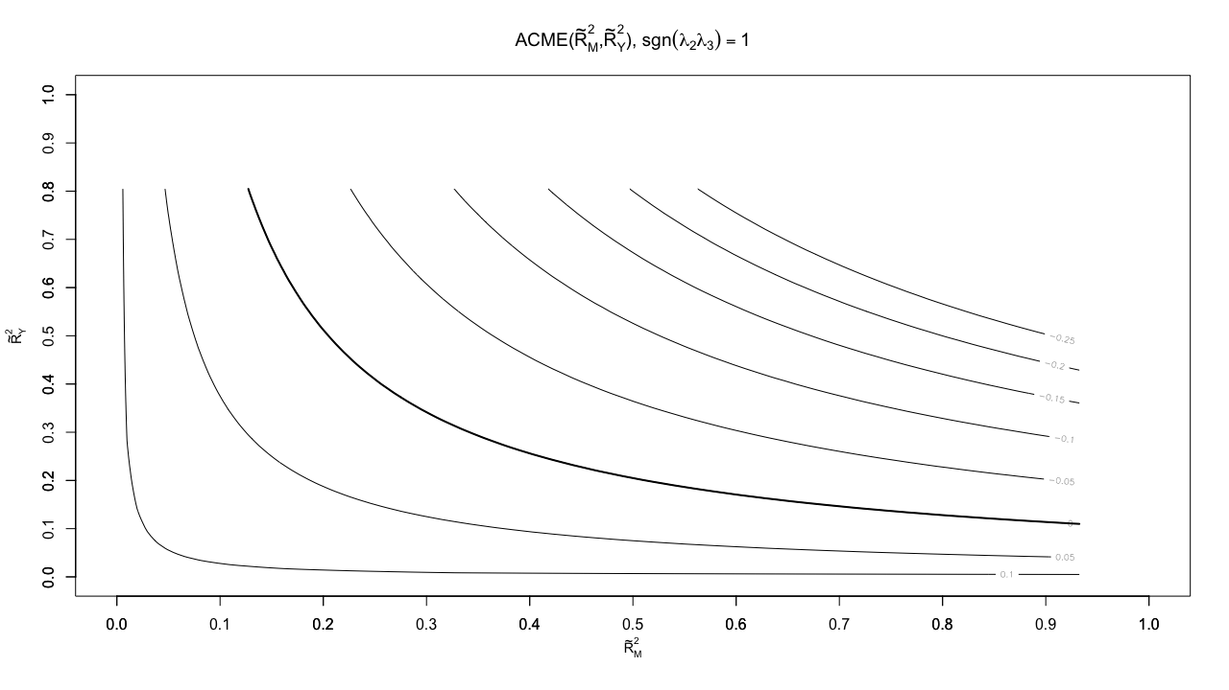
Figure 3: Explanatory power of a confounder on the causal mediation effect of CM
ACME: average causal mediation effect of CM
Table 4: Results of parallel four-mediator model in the replication sample (IMAGEN cohort)
Regressions | Unstandardized B estimate (95% CI) | Standardized estimate | p-value
Direct effects
Outcome model: PLE (R²=0.371)
SZ-PRS | 0.324 (-0.207; 0.855) | 0.028 | 0.231
CM | 0.270 (0.188; 0.352) | 0.172 | <0.001
Cannabis use | 2.36 (0.989; 3.74) | 0.089 | 0.001
Neuroticism | 0.740 (0.673; 0.806) | 0.531 | <0.001
Nicotine | -1.32 (-2.53; -0.11) | -0.056 | 0.032
Mediator model: CM (R²=0.007)
SZ-PRS | 0.618 (0.185; 1.05) | 0.084 | 0.005
Mediator model: Cannabis use (R²=0.009)
SZ-PRS | 0.041 (0.017; 0.065) | 0.094 | 0.001
Mediator model: Neuroticism (R²=0.002)
SZ-PRS | 0.343 (-0.117; 0.803) | 0.042 | 0.144
Mediator model: Nicotine (R²=0.001)
SZ-PRS | 0.008 (-0.019; 0.035) | 0.016 | 0.568
Covariances
CM – Neuroticism | 16.0 (12.2; 19.7) | 0.264 | <0.001
Cannabis – Nicotine | 0.091 (0.078; 0.104) | 0.431 | <0.001
Indirect effects (proportion mediated)
CM (20.1%) | 0.167 (0.039; 0.294) | 0.014 | 0.010
Cannabis (11.6%) | 0.097 (0.017; 0.177) | 0.008 | 0.018
Neuroticism (30.6%) | 0.254 (-0.087; 0.595) | 0.022 | 0.145
Nicotine (-1.3%) | -0.011 (-0.048; 0.027) | -0.001 | 0.581
Sum | 0.507 (0.111; 0.903) | 0.044 | 0.012
Total effect | 0.831 (0.178; 1.48) | 0.072 | 0.013
Abbreviations: 95% CI: 95% bias-corrected bootstrap confidence interval; PLE: psychotic-like experiences; CM: childhood maltreatment; SZ-PRS: schizophrenia polygenic risk score at p-value threshold 0.5.
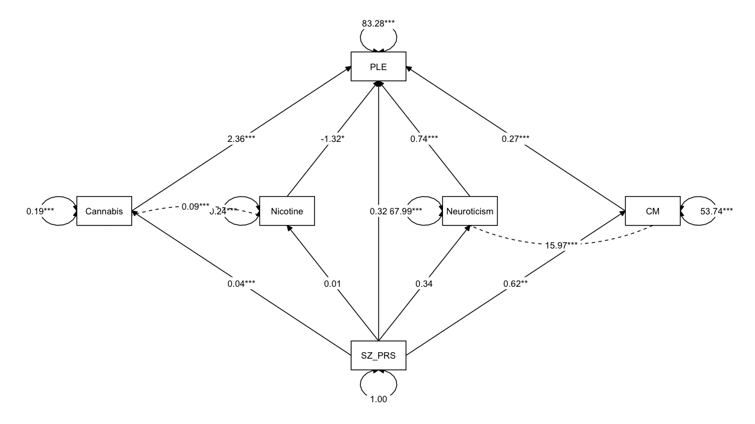
Figure 4: Path diagram of parallel four-mediator model in the replication sample (IMAGEN cohort).
Legend: The estimates reported are the unstandardized regression coefficients. *p<0.05; **p<0.01; ***p<0.001.
Abbreviations: SZ-PRS: schizophrenia polygenic risk score at p-value threshold 0.5; CM: childhood maltreatment; PLE: psychotic-like experiences.

Table 5: Results of parallel multiple mediation analysis according the trauma subtype in the discovery sample (UCC)
Regressions | Unstandardized B estimate (95% CI) | Standardized estimate | p-value
Direct effects
Outcome model: PLE (R²=0.168)
SZ-PRS | 0.242 (0.102; 0.382) | 0.091 | 0.001
Sexual Abuse | 0.287 (-0.137; 0.711) | 0.044 | 0.184
Physical Abuse | -0.854 (-1.45; -0.257) | -0.099 | 0.005
Emotional Abuse | 1.49 (1.19; 1.79) | 0.354 | <0.001
Physical Neglect | 0.278 (-0.178; 0.735) | 0.036 | 0.232
Emotional Neglect | 0.481 (0.221; 0.742) | 0.126 | <0.001
Mediator model: Sexual abuse (R²=0.002)
SZ-PRS | -0.018 (-0.044; 0.008) | -0.044 | 0.176
Mediator model: Physical abuse (R²=0.007)
SZ-PRS | 0.025 (0.006; 0.045) | 0.082 | 0.010
Mediator model: Emotional abuse (R²=0.004)
SZ-PRS | 0.038 (-0.001; 0.078) | 0.061 | 0.006
Mediator model: Physical Neglect (R²=0.003)
SZ-PRS | 0.019 (-0.003; 0.041) | 0.055 | 0.090
Mediator model: Emotional neglect (R²=0.012)
SZ-PRS | 0.077 (0.029; 0.126) | 0.111 | 0.002
Indirect effects (proportion mediated)
Sexual abuse (1.6%) | -0.005 (-0.016; 0.006) | -0.002 | 0.346
Physical abuse (7.0%) | -0.022 (-0.044; 0.001) | -0.008 | 0.060
Emotional abuse (18.1%) | 0.057 (-0.002; 0.117) | 0.021 | 0.060
Physical neglect (1.6%) | 0.005 (-0.005; 0.016) | 0.002 | 0.326
Emotional neglect (11.7%) | 0.037 (0.007; 0.068) | 0.014 | 0.017
Sum | 0.073 (0.003; 0.134) | 0.027 | 0.041
Total effect | 0.315 (0.169; 0.461) | 0.188 | <0.001
Abbreviations: 95% CI: 95% bias-corrected bootstrap confidence interval; PLE: psychotic-like experiences; SZ-PRS: schizophrenia polygenic risk score at p-value threshold 0.5.

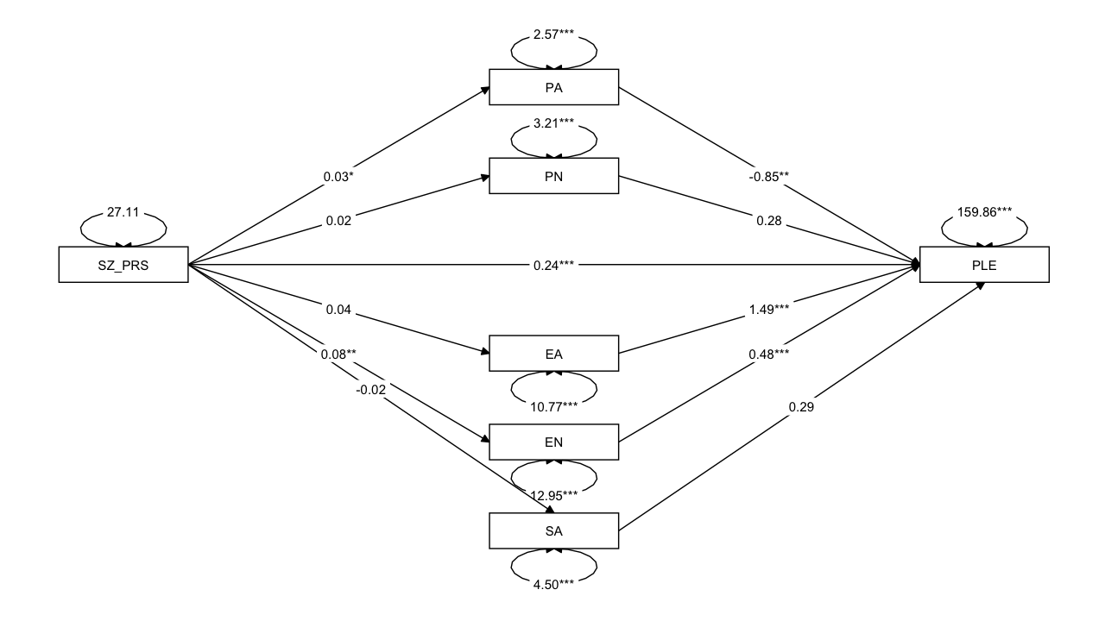Figure 5: Path diagram of parallel multiple mediation analysis according to trauma subtype in the discovery sample (UCC).
Legend: The estimates reported are the unstandardized regression coefficients. *p<0.05; **p<0.01; ***p<0.001.
Abbreviations: SZ-PRS: schizophrenia polygenic risk score at p-value threshold 0.5; PLE: psychotic-like experiences; PS: physical abuse; PN: physical neglect; EA: emotional abuse; EN: emotional neglect; SA: sexual abuse.

Table 6: Results of parallel multiple mediation analysis according the trauma subtype in the replication sample (IMAGEN cohort)
Regressions | Unstandardized B estimate (95% CI) | Standardized estimate | p-value
Direct effects
Outcome model: PLE (R²=0.123)
SZ-PRS | 0.499 (-0.128; 1.13) | 0.043 | 0.119
Sexual abuse | 0.046 (-0.396; 0.488) | 0.006 | 0.840
Physical abuse | -0.684 (-1.45; 0.085) | -0.068 | 0.081
Emotional abuse | 1.30 (0.947; 1.66) | 0.307 | <0.001
Physical neglect | -0.183 (-0.669; 0.302) | -0.026 | 0.459
Emotional neglect | 0.496 (0.200; 0.792) | 0.133 | 0.001
Mediator model: Sexual abuse (R²<0.001)
SZ-PRS | 0.024 (-0.071; 0.119) | 0.015 | 0.619
Mediator model: Physical abuse (R²<0.001)
SZ-PRS | 0.013 (-0.054; 0.081) | 0.012 | 0.699
Mediator model: Emotional abuse (R²=0.005)
SZ-PRS | 0.184 (0.024; 0.343) | 0.068 | 0.024
Mediator model: Physical neglect (R²=0.002)
SZ-PRS | 0.074 (-0.023; 0.171) | 0.045 | 0.136
Mediator model: Emotional neglect (R²=0.010)
SZ-PRS | 0.305 (0.123; 0.487) | 0.099 | 0.001
Indirect effects (proportion mediated)
Sexual abuse (0.1%) | 0.001 (-0.010; 0.013) | <0.001 | 0.852
Physical abuse (-1.0%) | -0.009 (-0.057; 0.038) | -0.001 | 0.705
Emotional abuse (27.5%) | 0.239 (0.020; 0.458) | 0.021 | 0.032
Physical neglect (-1.6%) | -0.014 (-0.053; 0.026) | -0.001 | 0.505
Emotional neglect (17.4%) | 0.151 (0.023; 0.280) | 0.013 | 0.021
Sum | 0.369 (0.126; 0.612) | 0.032 | 0.003
Total effect | 0.868 (0.211; 1.53) | 0.076 | 0.010
Abbreviations: 95% CI: 95% bias-corrected bootstrap confidence interval; PLE: psychotic-like experiences; SZ-PRS: schizophrenia polygenic risk score at p-value threshold 0.5.

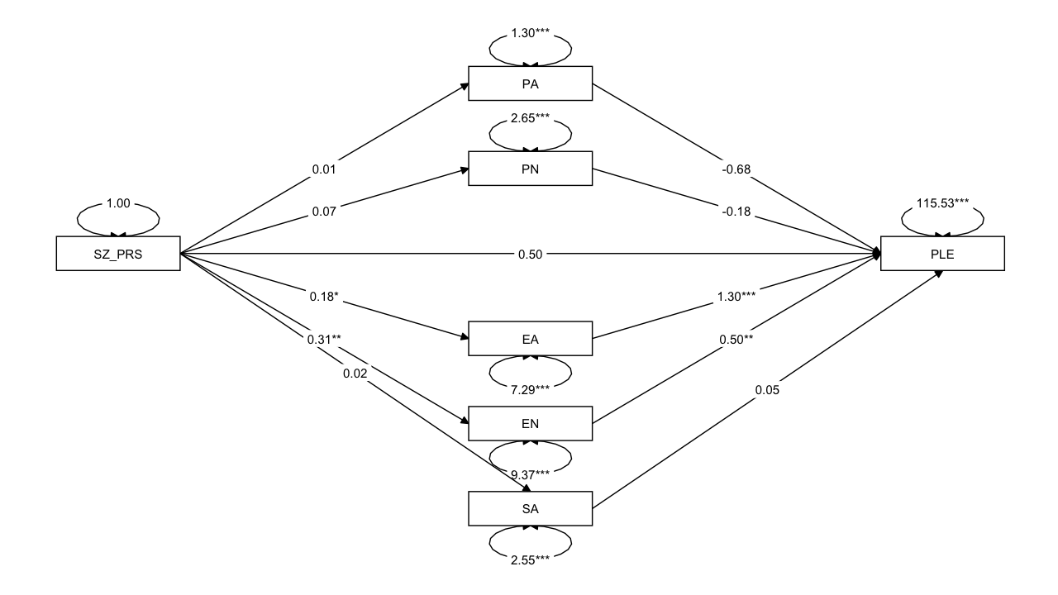
Figure 6: Path diagram of parallel multiple mediation analysis according the trauma subtype in the replication sample (IMAGEN cohort)
Legend: The estimates reported are the unstandardized regression coefficients. *p<0.05; **p<0.01; ***p<0.001.
Abbreviations: SZ-PRS: schizophrenia polygenic risk score at p-value threshold 0.5; PLE: psychotic-like experiences; PS: physical abuse; PN: physical neglect; EA: emotional abuse; EN: emotional neglect; SA: sexual abuse.

