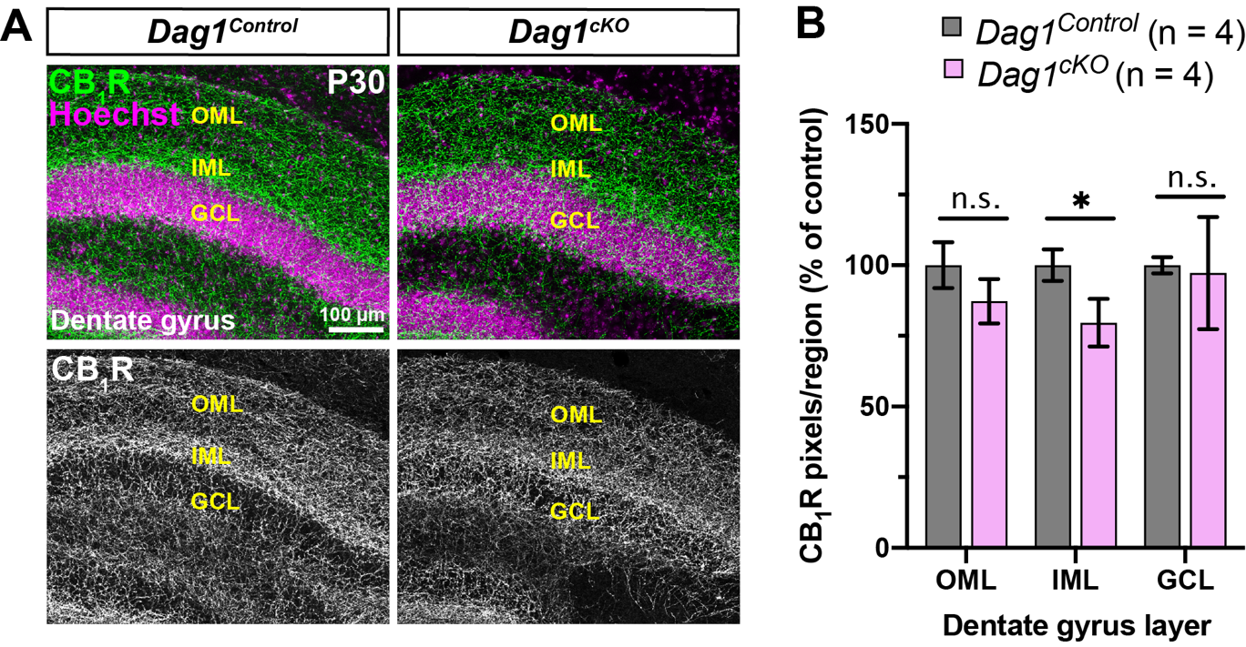
Figure S2. CCK+ interneuron innervation of the dentate gyrus is minimally altered in Dag1^{cKO} mice. (A) Immunostaining of CB₁R in the dentate gyrus from P30 Dag1^{Control} (left panels) and Dag1^{cKO} mice (right panels). Single channel images of CB₁R (gray) are shown below. (B) Quantification of CB₁R pixels for each dentate gyrus layer (*P < 0.05, unpaired two-tailed Student’s t-test; n = 4 mice/genotype). Data are presented as mean values ± s.e.m. Data are normalized to Dag1^{Control} signal in each dentate gyrus layer. OML, outer molecular layer; IML, inner molecular layer; GCL, granule cell layer.

