Supplementary Material
Identifying Key Predictive Features for Opioid Use Disorder Using Machine Learning

Suraiya Akhter*, John H. Miller
* Correspondence: sakhter1@emporia.edu

Supplementary Data

Training dataset
The training dataset can be accessible at https://github.com/suraiya14/OUDP.

Testing dataset
The testing dataset can be accessible at https://github.com/suraiya14/OUDP.

Supplementary Tables

Feature Set before applying feature reduction algorithm
Table S1. List of features used for feature reduction analysis
CATAG6 | IRSEX | NEWRACE2 | IREDUHIGHST2 | INCOME | IRMARIT | IRWRKSTAT | COUTYP4
PYUD5ALC | PYUD5MRJ | PYUD5COC | PYUD5HER | EDUD5PNRMIS | TOBYR | ALCYR | MRJYR
COCYR | HERYR | AMDEYR | SMIPY | SUICTHNK | IRSUITRYYR | SUTRTPY | MHTRTPY
ASTHMAEVR | DIABETEVR | HRTCONDYR | BOOKED | IRHHSIZ2 | NOBOOKY2 | MEDICARE | PRVHLTIN

2.2 ADT reduced features
Table S2. List of features obtained from ADT
EDUD5PNRMIS | PYUD5ALC | CATAG6 | SUTRTPY | MRJYR
SMIPY | IREDUHIGHST2 | PYUD5HER | DIABETEVR | IRWRKSTAT

2.3 CVFE reduced features
In the following tables S3-S7, c, e and p indicate count of disjoint sub-parts, count of iterations and ratios of recurring iterations for the extraction of common features, respectively.
Table S3. List of features obtained from CVFE (c = 2, e = 5, p = 0.2)
EDUD5PNRMIS | SUTRTPY | PYUD5HER | SMIPY | MEDICARE | ASTHMAEVR | PYUD5ALC | CATAG6
DIABETEVR | AMDEYR | MHTRTPY | SUICTHNK | MRJYR | PYUD5COC | IRWRKSTAT | PRVHLTIN
IREDUHIGHST2 | TOBYR | NEWRACE2 | PYUD5MRJ | ALCYR | INCOME | IRMARIT | NOBOOKY2
COUTYP4 | IRHHSIZ2 | HRTCONDYR | IRSEX | BOOKED | IRSUITRYYR
Table S4. List of features obtained from CVFE (c = 3, e = 5, p = 0.6)
EDUD5PNRMIS | SUTRTPY | PYUD5HER | SMIPY | AMDEYR | MEDICARE | CATAG6 | PYUD5ALC
ASTHMAEVR | IRWRKSTAT | DIABETEVR | MHTRTPY | INCOME | PYUD5MRJ | PRVHLTIN | HRTCONDYR
MRJYR | IREDUHIGHST2 | TOBYR | PYUD5COC | IRHHSIZ2 | NOBOOKY2 | NEWRACE2 | ALCYR
BOOKED | COUTYP4 | IRMARIT | IRSEX | SUICTHNK
Table S5. List of features obtained from CVFE (c = 4, e = 10, p = 0.6)
EDUD5PNRMIS | SUTRTPY | MEDICARE | ASTHMAEVR | PYUD5HER | SMIPY | PYUD5ALC | CATAG6
DIABETEVR | AMDEYR | MHTRTPY | MRJYR | SUICTHNK | IRWRKSTAT | PYUD5COC | PRVHLTIN
IREDUHIGHST2 | TOBYR | NEWRACE2 | PYUD5MRJ | ALCYR | INCOME | IRMARIT | NOBOOKY2
COUTYP4 | IRHHSIZ2 | HRTCONDYR | IRSEX | BOOKED
Table S6. List of features obtained from CVFE (c = 8, e = 5, p = 0.6)
EDUD5PNRMIS | CATAG6 | PYUD5ALC | SUTRTPY | ASTHMAEVR | IRWRKSTAT | MHTRTPY | INCOME
PYUD5MRJ | PRVHLTIN | MEDICARE | IREDUHIGHST2 | MRJYR | IRHHSIZ2 | TOBYR | NEWRACE2
ALCYR | PYUD5COC | COUTYP4 | IRMARIT | IRSEX
Table S7. List of features obtained from CVFE (c = 10, e = 10, p = 0.2)
EDUD5PNRMIS | CATAG6 | PYUD5ALC | ASTHMAEVR | IRWRKSTAT | INCOME | MHTRTPY | PYUD5MRJ
SUTRTPY | PRVHLTIN | IREDUHIGHST2 | TOBYR | IRHHSIZ2 | MEDICARE | NEWRACE2 | MRJYR
ALCYR | COUTYP4 | IRMARIT | AMDEYR | IRSEX

HFE reduced features
The lists of features obtained from the HFE method are presented in Tables S8–S10. In each table, the first 8, 16, and 24 features correspond to β values of 25, 50, and 75, respectively.
Table S8. List of features obtained from HFE with β = 25

EDUD5PNRMIS | PYUD5COC | SUTRTPY | TOBYR
PYUD5ALC | PYUD5HER | BOOKED | NOBOOKY2

Table S9. List of features obtained from HFE with β = 50.

EDUD5PNRMIS | PYUD5COC | SUTRTPY | TOBYR | PYUD5ALC | PYUD5HER | BOOKED | NOBOOKY2
PRVHLTIN | MHTRTPY | IRWRKSTAT | MRJYR | PYUD5MRJ | SMIPY | AMDEYR | DIABETEVR

Table S10. List of features obtained from HFE with β = 75.

EDUD5PNRMIS | PYUD5COC | SUTRTPY | TOBYR | PYUD5ALC | PYUD5HER | BOOKED | NOBOOKY2
PRVHLTIN | MHTRTPY | IRWRKSTAT | MRJYR | PYUD5MRJ | SMIPY | AMDEYR | DIABETEVR
ASTHMAEVR | INCOME | IREDUHIGHST2 | CATAG6 | SUICTHNK | IRMARIT | HERYR | COCYR

3. Supplementary Figures
3.1 ADT summary plot
Figure S1 – A alternative decision tree representation using the reduced ADT feature set.
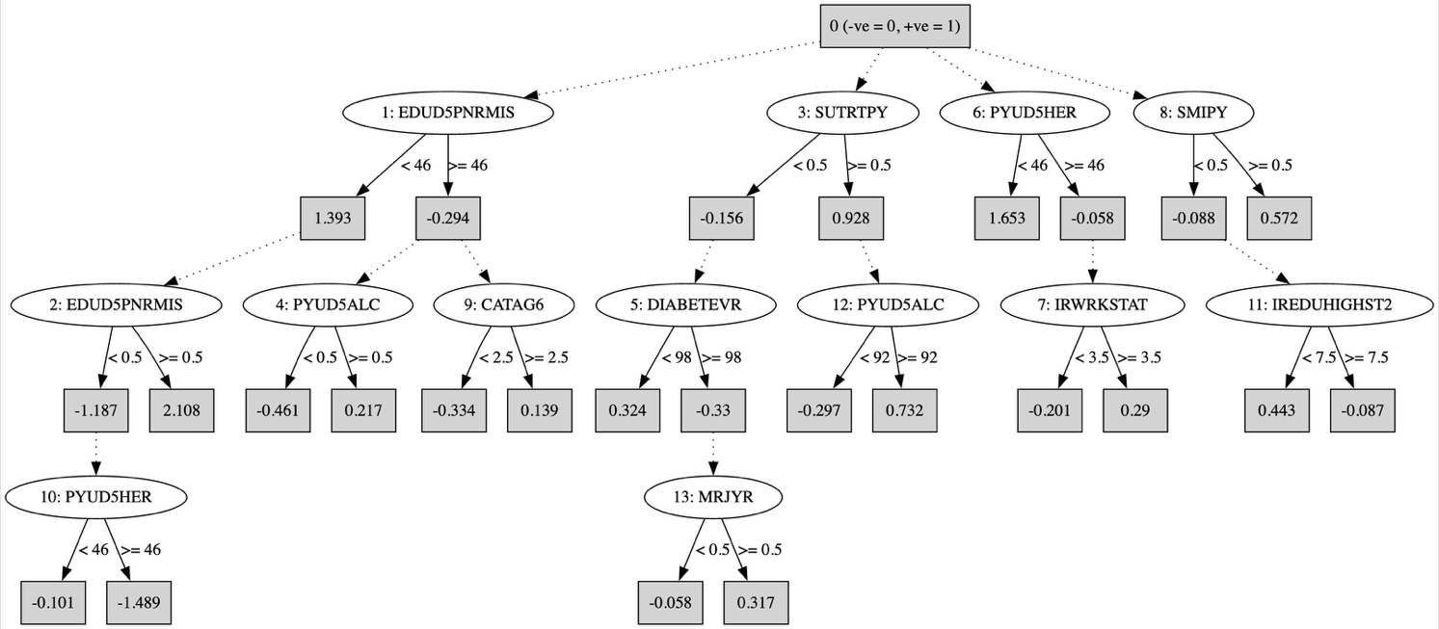

3.2 Hypergraph
Figure S2 – Hypergraph representation of the training dataset
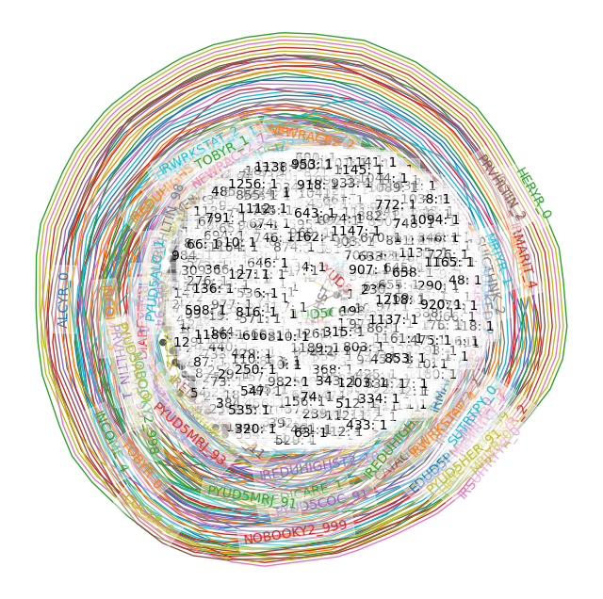

3.3 Confusion matrices
Figure S3 – Confusion matrices of the machine learning model built with the reduced feature sets
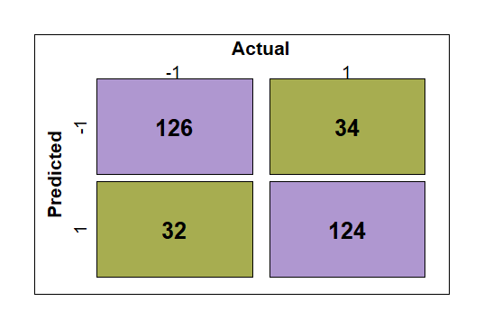  - CVFE (c = 2, e = 5, p = 0.2) | 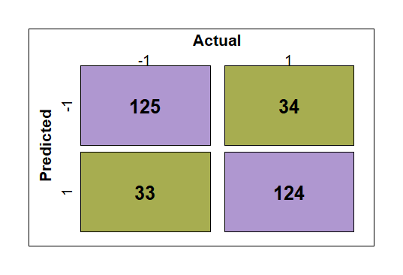  - CVFE (c = 3, e = 5, p = 0.6) | 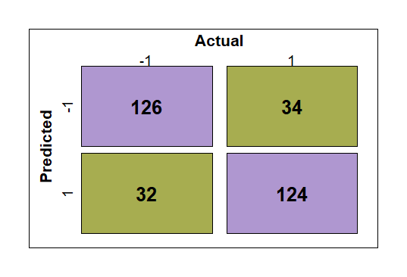  - CVFE (c = 4, e = 10, p = 0.6)
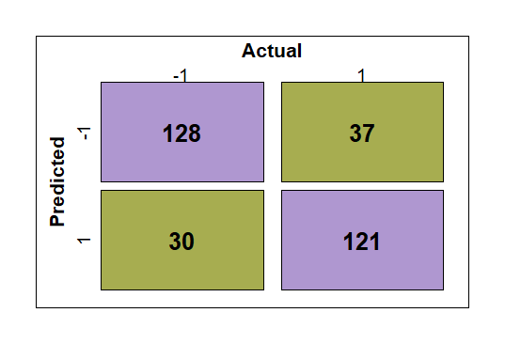  - CVFE (c = 8, e = 5, p = 0.6) | 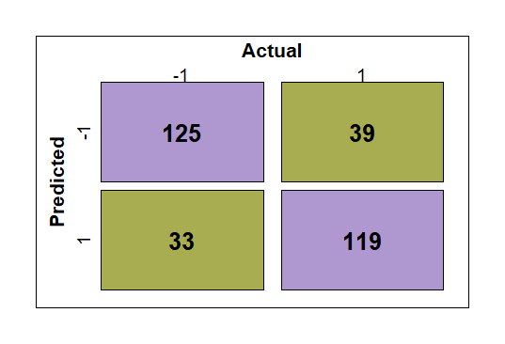  - CVFE (c = 10, e = 10, p=0.2) | 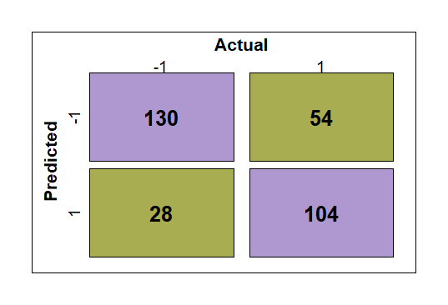  - HFE (β =25)
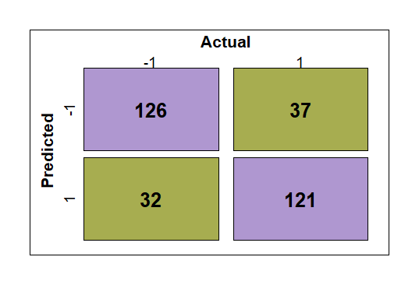  - HFE (β = 50) | 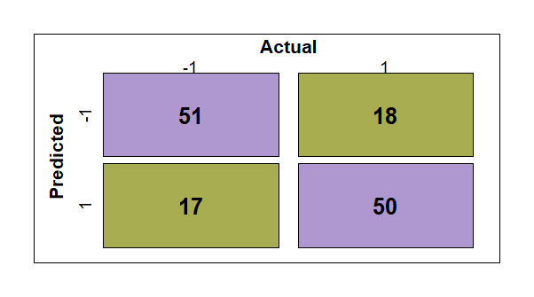  - HFE (β = 75) | 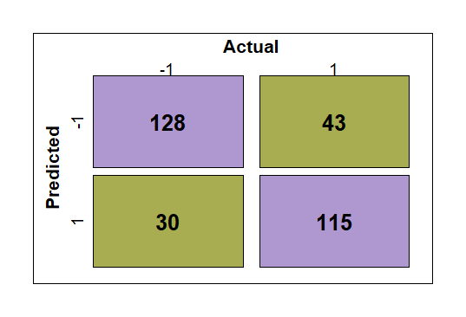  - ADT

