Appendix File for: Cannabidiol as an Alternative Analgesic for Acute Dental Pain.

V. Chrepa¹, S. Villasenor², A. Mauney², G. Kotsakis¹, L. Macpherson²

¹UTHealth San Antonio, School of Dentistry, San Antonio, Texas
²University of Texas at San Antonio, San Antonio, Texas
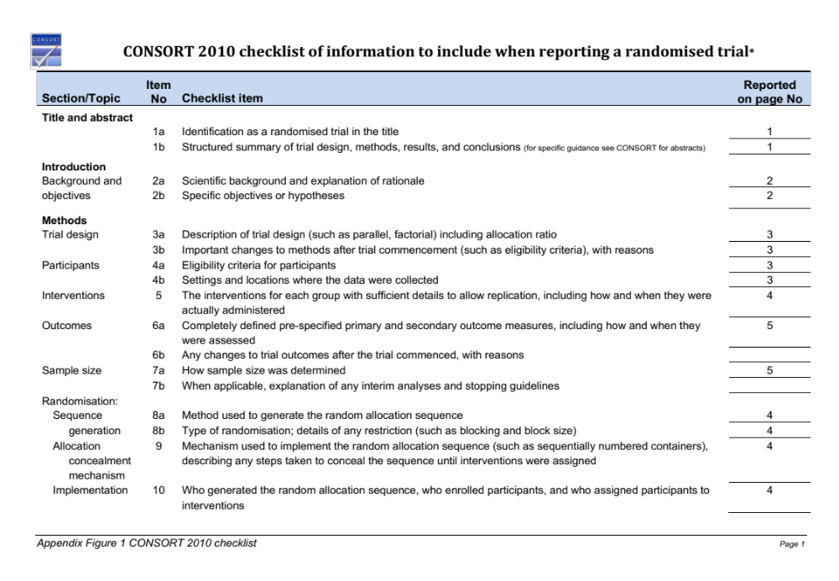
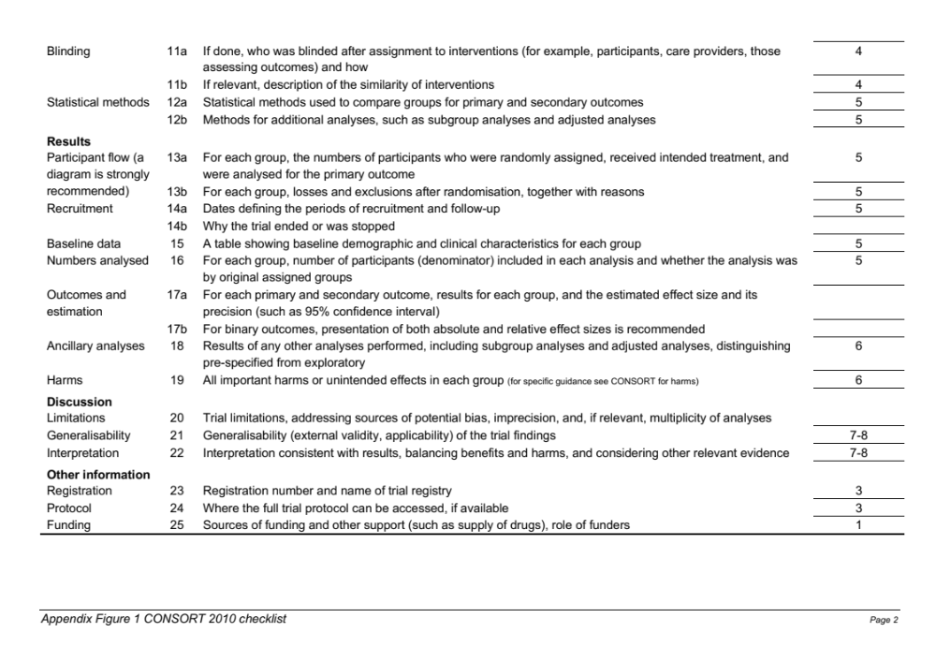

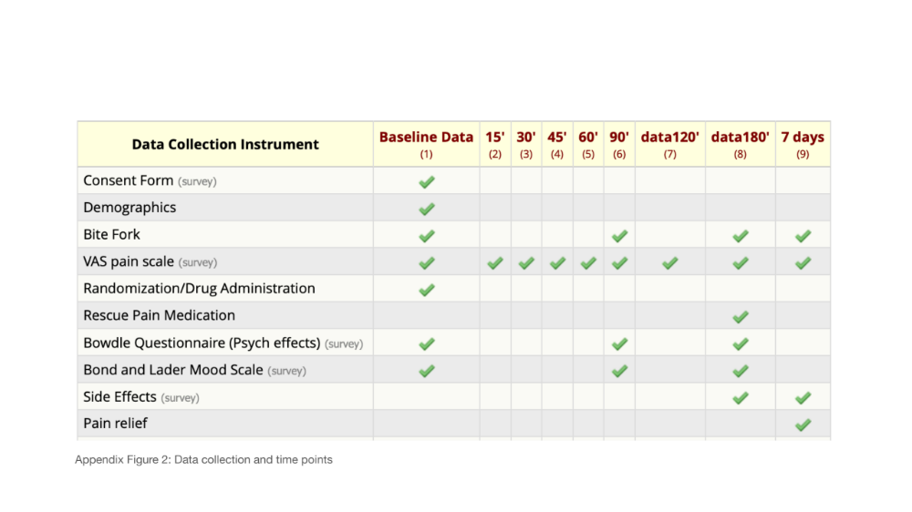

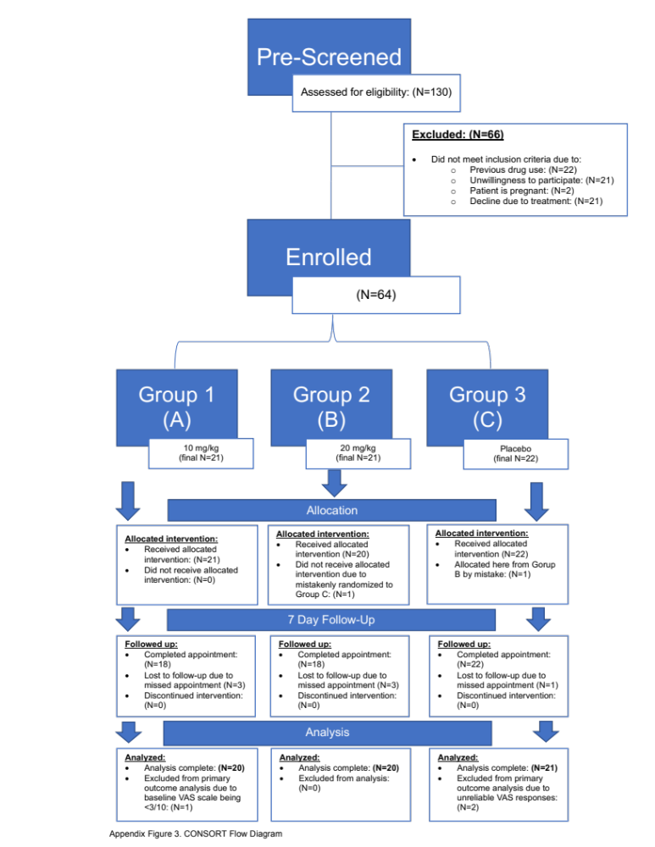
 | Group |  |  | P-value
Pain relief after the 3-hour period (hours) | CBD 10mg/kg (n=11) | CBD 20mg/kg (n=15) | Placebo (n=16) | P>0.05
Pain relief after the 3-hour period (hours) | N (%) | N (%) | N (%)
No pain relief | 1 (9%) | 1 (6%) | 4 (25%)
1-6 hours | 5 (45.4%) | 7 (46.6%) | 6 (37.5%)
> 6 hours | 5 (45.4%) | 7 (46.6%) | 5 (31.2%)
Time-to-next analgesic after the 3-hour period | N (%) | N (%) | N (%) | P>0.05
Immediately | 1 (9%) | 1 (6%) | 2 (12.5%)
1- 6 hours | 1 (9%) | 4 (26.6%) | 1 (6%)
6-24 hours | 3 (27.2%) | 2 (13.3%) | 5 (31.2%)
>24h or no medication | 6 (54.5%) | 8 (53.3%) | 8 (50%)

Appendix Table 1. Pain relief duration and time-to-next analgesic after the 3-hour observation period.
 |  | Time point |  |  |  |  |  | P-value
 |  | BL |  | 90' |  | 180'
 | Group | Mean | Std Dev | Mean | Std Dev | Mean | Std Dev
*Bowdle Internal Perception (mm) | Placebo | 9.09 | 18.83 | 3.32 | 7.54 | 2.77 | 6.41
 | CBD 10mg/kg | 15.86 | 37.23 | 14.14 | 31.76 | 13.52 | 29.93 | 0.30
 | CBD 20mg/kg | 16.05 | 23.68 | 12.00 | 28.84 | 7.40 | 16.90 | 0.55
*Bowdle External Perception (mm) | Placebo | 21.00 | 37.77 | 13.05 | 30.57 | 4.32 | 8.45
 | CBD 10mg/kg | 11.71 | 38.55 | 16.62 | 40.06 | 21.29 | 37.15 | 0.93
 | CBD 20mg/kg | 45.35 | 84.78 | 19.90 | 33.15 | 22.75 | 39.05 | 0.23
*Bowdle Drug High (mm) | Placebo | 13.04 | 25.45 | 33.87 | 39.85 | 22.96 | 36.78
 | CBD 10mg/kg | 12.38 | 23.63 | 19.90 | 27.62 | 23.24 | 31.74 | 0.98
 | CBD 20mg/kg | 35.05 | 48.61 | 35.70 | 42.32 | 30.55 | 37.34 | 0.19
Bond and Lader Calmness (mm) | Placebo | 88.27 | 33.78 | 94.14 | 16.21 | 102.73 | 13.91
 | CBD 10mg/kg | 96.52 | 27.61 | 96.10 | 32.90 | 105.05 | 29.41 | 0.52
 | CBD 20mg/kg | 99.05 | 36.69 | 112.53 | 33.91 | 95.68 | 31.63 | 0.28
Bond and Lader Alertness (mm) | Placebo | 407.36 | 38.10 | 432.64 | 51.92 | 431.59 | 42.75
 | CBD 10mg/kg | 392.67 | 65.31 | 407.14 | 35.42 | 412.24 | 50.89 | 0.09
 | CBD 20mg/kg | 394.58 | 51.97 | 409.37 | 46.63 | 399.37 | 44.91 | 0.06
Bond and Lader Mood (mm) | Placebo | 288.18 | 22.27 | 281.09 | 38.56 | 276.09 | 36.98
 | CBD 10mg/kg | 280.38 | 46.82 | 275.24 | 37.24 | 278.38 | 28.09 | 0.93
 | CBD 20mg/kg | 281.95 | 54.30 | 273.32 | 53.69 | 282.16 | 50.58 | 0.96

Appendix Table 2. Psychoactive (Bowdle Questionnaire) and Mood Change effects (Bond and Lader Questionnaire) between the groups at Baseline (BL), 90’ and 180’ time point (pooled data). *Bowdle questions have the scale format of (not at all (0)------ Extremely (100)), and most responses were “0”, hence the high variability in the sample population.

