SUPPLEMENTARY INFORMATION
SUPPLEMENTARY FIGURE S1. Chemical structures of SR141716A and AM251. SR141716A (A) and AM251 (B) are biarylpyrazole compounds. The p-chloro group at C-5 of the pyrazole ring in SR141716A is replaced by a p-iodo group in AM251.

SUPPLEMENTARY FIGURE S2. Agarose gel image. Amplicons of the correct sizes for genotyping of Gpr55^{+/+} (207 bp) and Gpr55^{−/−} mice (299 bp).

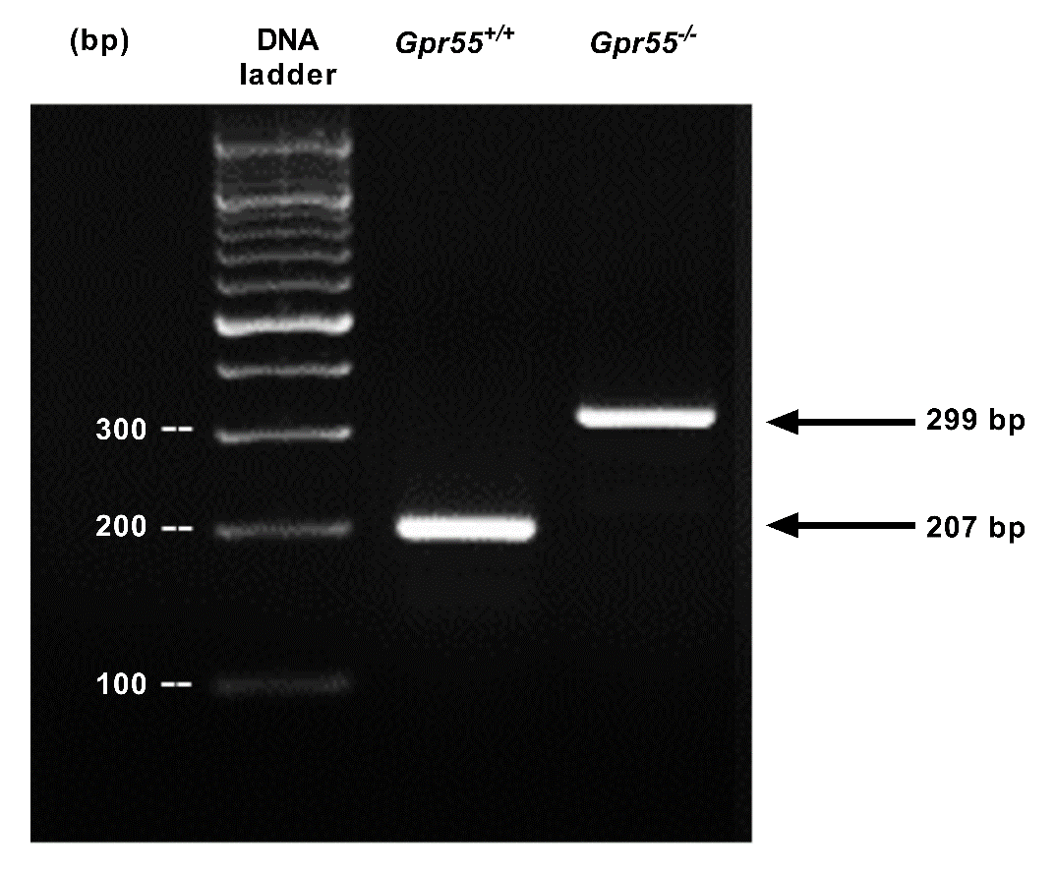

SUPPLEMENTARY Table S1. Characteristics of the organ donors and the human islet preparations used in this study.
Donor | Gender | Age  (years) | BMI  (kg/m²) | Islet purity (%) | Islet viability  (%)
Number 1 | Female | 23 | 20 | 90 | 85
Number 2 | Female | 43 | 30 | 65 | 75
Number 3 | Female | 47 | 36 | 70 | 75
Number 4 | Male | 34 | 26 | 75 | 75
Number 5 | Male | 60 | 32 | 90 | 80
Number 6 | Female | 52 | 23 | 75 | 80
Number 7 | Female | 44 | 29 | 80 | 85
Number 8 | Male | 40 | 24 | 45 | 90
Number 9 | Male | 55 | 31 | 35 | 85
Number 10 | Female | 37 | 30 | 90 | 85
Number 11 | Female | 40 | 27 | 50 | 80
Number 12 | Male | 58 | 29 | 70 | 70
Number 13 | Female | 38 | 37 | 80 | 90
Number 14 | Female | 53 | 23 | 85 | 60
Number 15 | Male | 41 | 20 | 70 | 85
Number 16 | Female | 55 | 24 | 80 | 85
Number 17 | Male | 50 | 24 | 80 | 85

SUPPLEMENTARY Table S2. Primers used for quantitative RT-PCR. Mouse and human primers from Qiagen were used to quantify mRNAs encoding CB₁, GPR119, GPR18, GPR92, OPRD1, TRPV1, GPR3, GPR6 and GPR12, and β-actin in islets isolated from Gpr55^{+/+} and Gpr55^{−/−} mice and in human islets.
Gene symbol | Primer assay  (Mus musculus and Homo sapiens)
Cnr1 | QT02522457
Gpr119 | QT01758953
Gpr18 | QT00129227
Lpar5 | QT00312571
Oprd1 | QT00103250
Trpv1 | QT00167048
Gpr3 | QT00249732
Gpr6 | QT00296044
Gpr12 | QT01062656
Actb | QT00095242
CNR1 | QT00203287
GPR119 | QT00231609
GPR18 | QT01001504
LPAR5 | QT02449860
OPRD1 | QT00000210
TRPV1 | QT00046109
GPR3 | QT00203014
GPR6 | QT00202272
GPR12 | QT00205772
ACTB | QT00095431

SUPPLEMENTARY Table S3. List of primary and secondary antibodies used for immunofluorescence staining.
Antibody | Dilution | Vendor | Catalogue number
Anti-Ki67  (rabbit) | 1:200 | Abcam | ab15580
Anti-insulin  (guinea pig) | 1:200 | Dako | A0564
AlexaFluor 488  (goat anti-rabbit) | 1:150 | Jackson ImmunoResearch Laboratories | 111-545-003
AlexaFluor 594  (donkey anti-guinea pig) | 1:150 | Jackson ImmunoResearch Laboratories | 711-586-152

