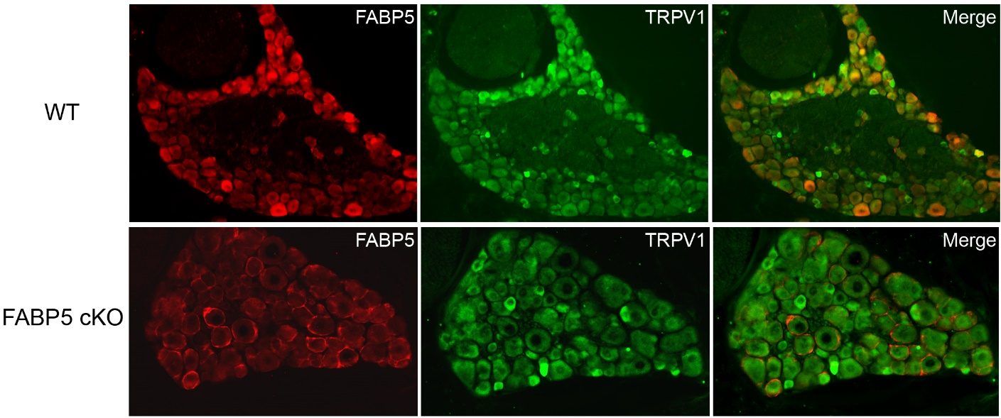

Supplementary Figure 1. FABP5 and TRPV1 immunolocalization in DRGs of WT and FABP5 cKO mice.
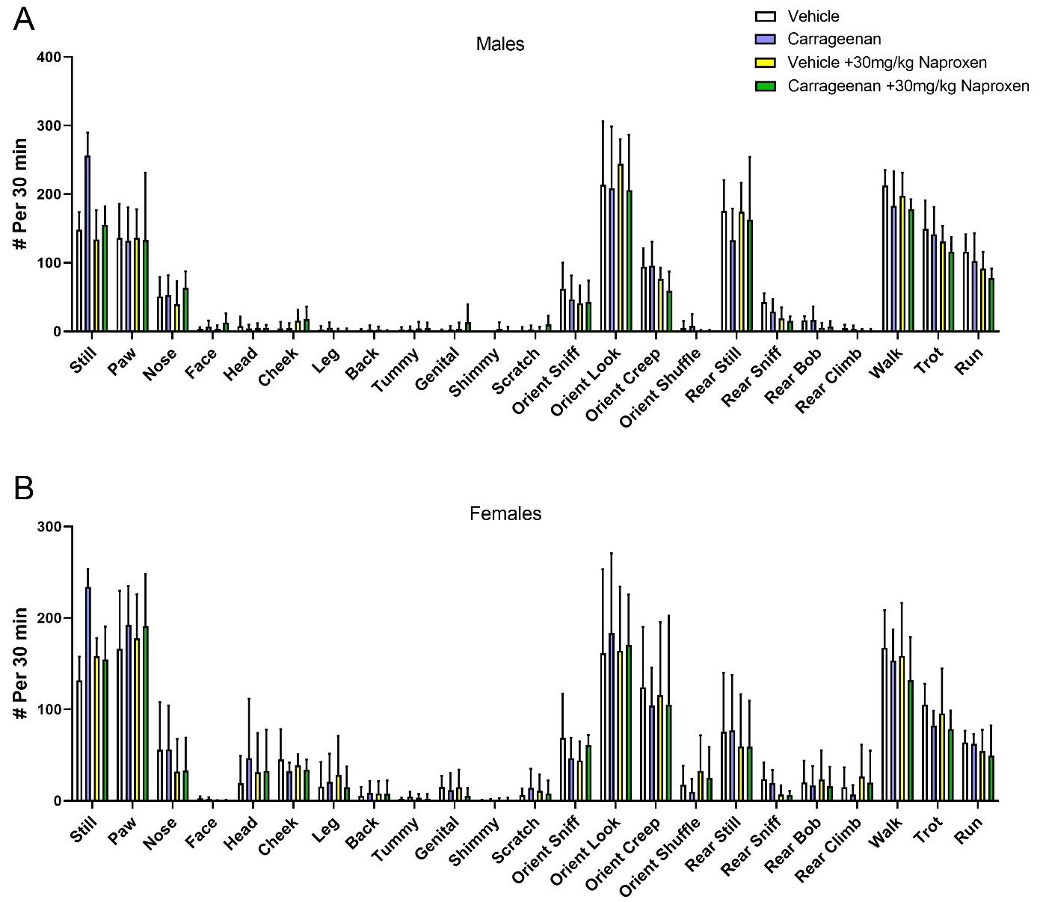

Supplementary Figure 2. Behavioral responses of WT male and female mice before and after carrageenan administration. Male (a) and female (b) mice were injected with vehicle or naproxen (30 mg/kg, i.p.) and behavioral responses were scored via the behavioral spectrometer. On the subsequent day, vehicle and naproxen administration was followed by injection of carrageenan (n = 6).

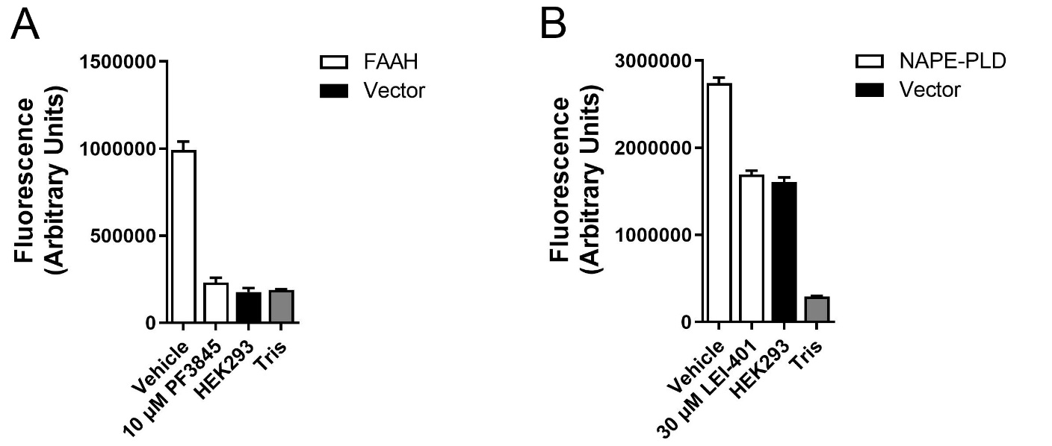

Supplementary Figure 3. Validation of FAAH and NAPE-PLD activity assays. (a) Hydrolysis of AMC-AEA (100 µM) by HEK293 cells transfected with mouse FAAH (white bars) or vector control (black bar). Negative control reactions only contained AMC-AEA in Tris buffer (gray bar). Note that AMC-AEA hydrolysis is only observed in FAAH transfected cells and is inhibited by PF3845 (10 µM), confirming that AMC-AEA is a selective FAAH substrate (n = 3). (b) PED-A1 (10 µM) hydrolysis by mouse NAPE-PLD transfected HEK293 cells (white bars) incubated with vehicle (1% DMSO) or LEI-401 (30 µM) as well as vector transfected controls (black bar). Note that hydrolysis of the phospholipase A1 substrate PED-A1 is observed in vector transfected cells. Importantly, increased PED-A1 hydrolysis is observed in NAPE-PLD expressing cells and is inhibited by the selective NAPE-PLD inhibitor LEI-401. Consequently, the enzymatic activity sensitive to LEI-401 corresponds to NAPE-PLD (n = 3).

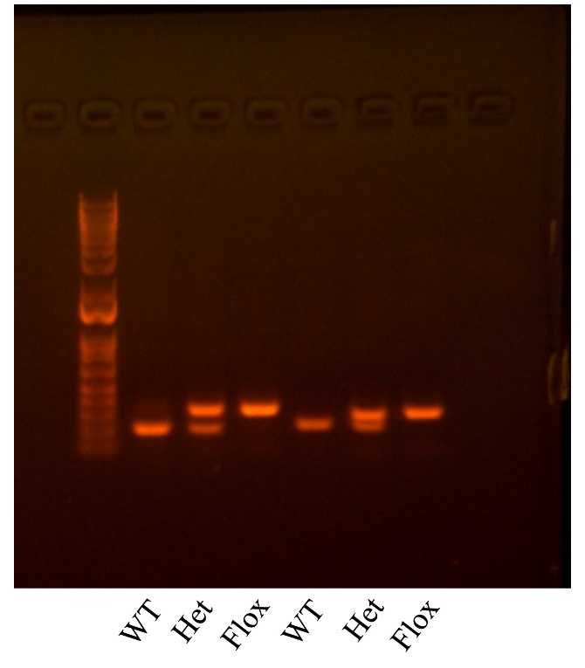

Supplementary Figure 4. Full image of gel presented in Fig. 1b.

