Supplementary Data

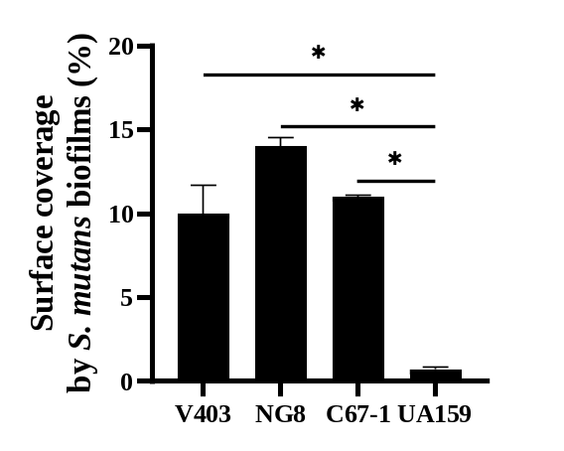

Figure S1. Biofilm formation of single S. mutans strains in 0.2% sucrose. Biofilms were grown under laminar flow without SAG coating and quantified at 10 h as percentage of surface coverage.

A
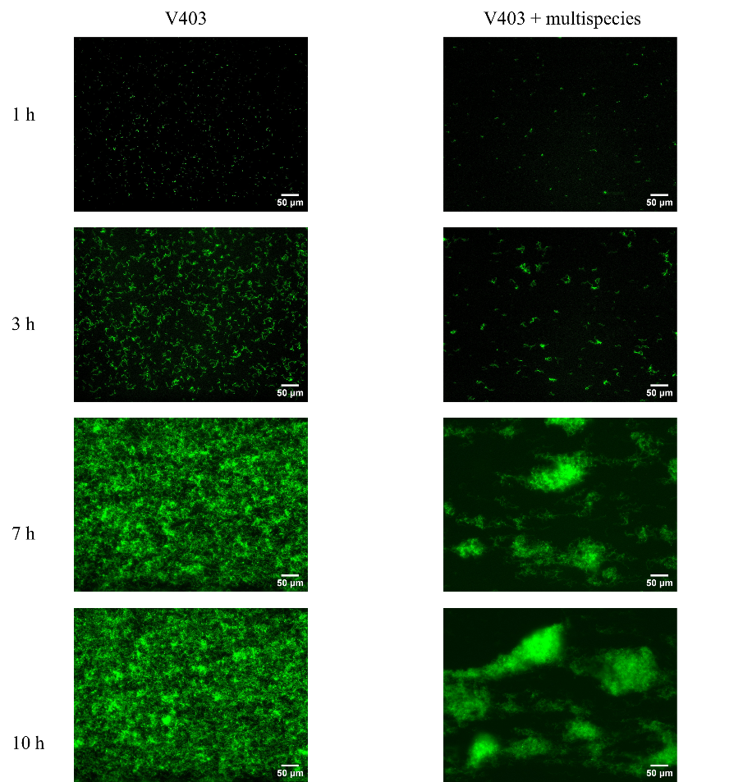
B
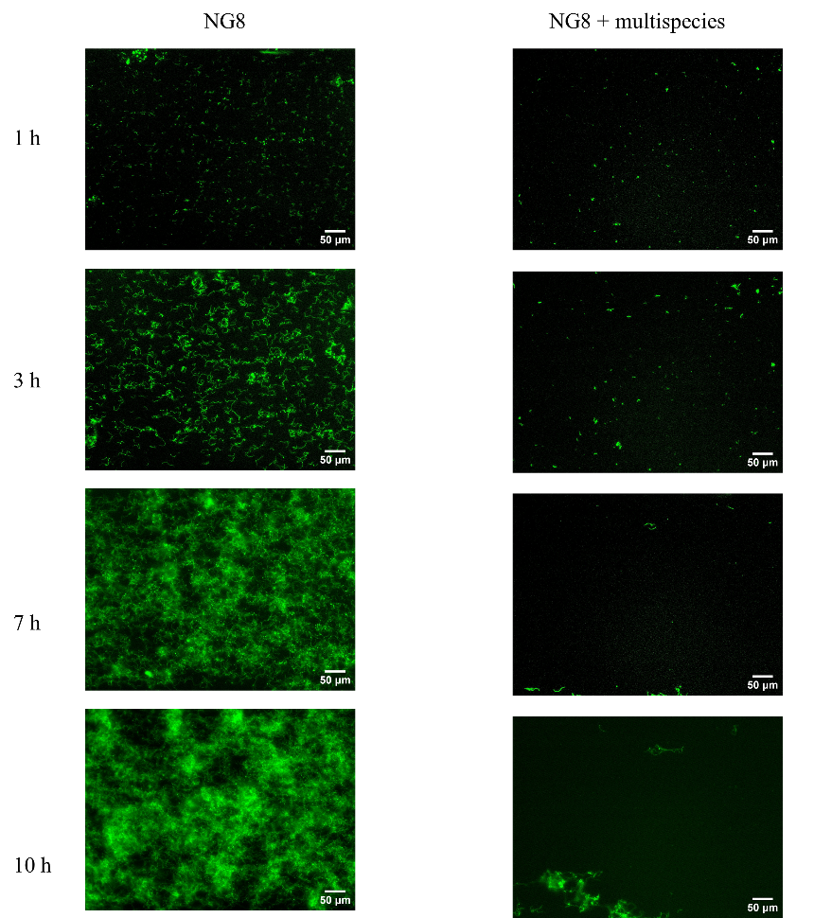
C
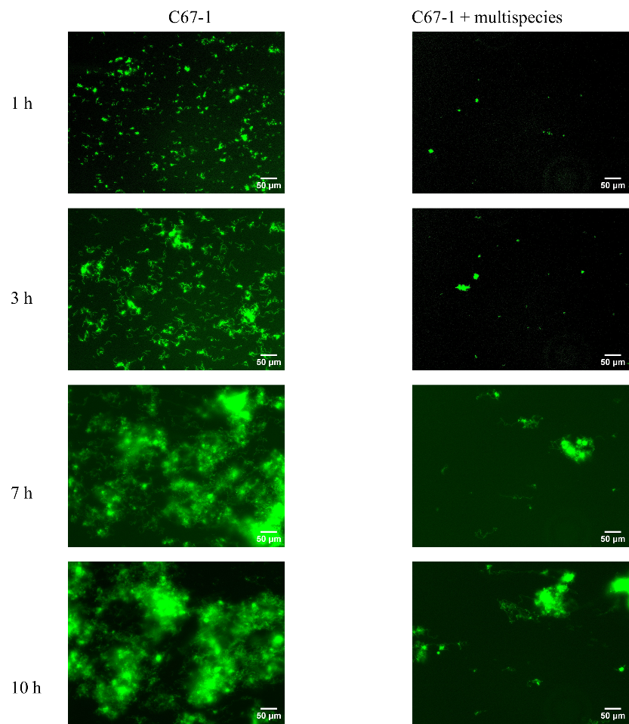
D
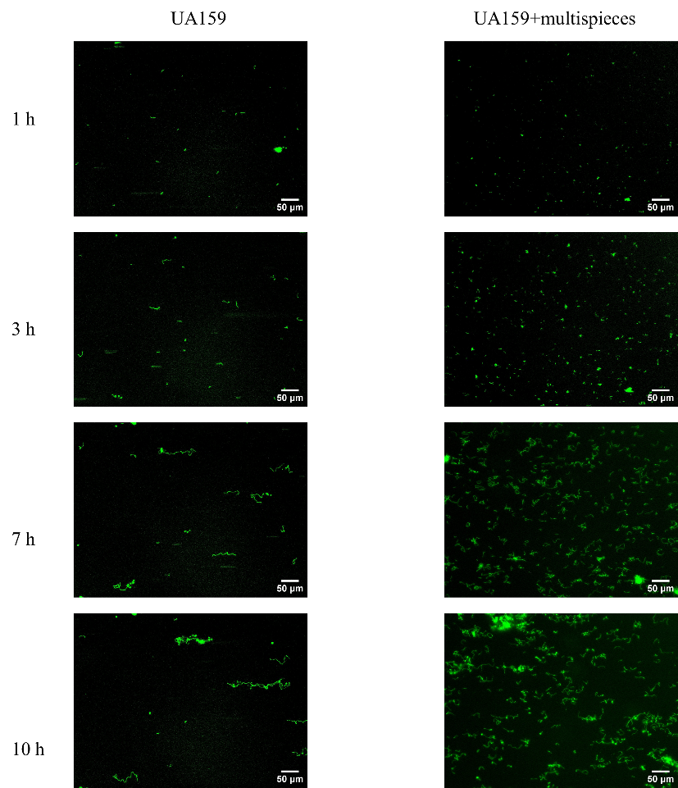
Figure S2. Representative images of S. mutans biofilm formation on SAG-coated surfaces under laminar flow.
Images were acquired using a 10x objective and a FITC filter (Filter set 44, Zeiss). Excitation was at 488 nm (bandwidth 30 nm) and emission at 520 nm (bandwidth 40 nm), with a 150 ms exposure time for all groups. Biofilms were imaged at 1, 3, 7, and 10 h, without (left panel) or with multispecies community (right panel). A. V403; B. NG8; C. C67-1; D. UA159. Scale bar: 50 µm.

Supplementary video Inhibition of multispecies community on S. mutans NG8 biofilm development under laminar flow.
Videos were recorded using a 10x Zeiss objective at 30 min intervals over 10 h. GFP-labelled NG8 was visualized using a FITC filter (Filter set 44, Zeiss). Multispecies communities were not stained and were observed under bright-field imaging A. Single S. mutans NG8; B. S. mutans NG8 in the presence of a multispecies community. Scale bar: 50 µm.

