Risk Factors, Protective Factors, Peripheral Biomarkers, and Neurocognitive Markers Associated with Mood Disorders: An Umbrella Review of 103 Meta-analyses and Systematic Reviews

Summary
e Appendix 1.PRIOR checklist 3
e Appendix 2.Full search strategy 8
e Appendix 3.Definitions of risk/protective factor, biomarker and neurocognitive markers 13
e Appendix 4. List of included articles 15
e Appendix 5.Rating the reporting quality of the review according to AMSTAR-2 25
e Appendix 6.AMSTAR-2 quality rating 27
e Appendix 7.Criteria for evaluation of the strength of associations according to umbrella review criteria 47
e Appendix 8. Potential environmental risk factors of depression, with details of statistical test results. 49
e Appendix 9. Potential environmental protective factors of depression, with details of statistical test results. 58
e Appendix 10. Potential environmental peripheral biomarkers of depression, with details of statistical test results. 61
e Appendix 11. Potential environmental neurocognitive markers of depression, with details of statistical test results. 63
e Appendix 12. Potential environmental risk factors of bipolar disorder, with details of statistical test results. 65
e Appendix 13. Potential environmental peripheral biomarkers of bipolar disorder, with details of statistical test results. 66
e Appendix 14. Potential environmental neurocognitive markers of bipolar disorder, with details of statistical test results. 68
e Figure S1 Funnel plot of meta-analysis of the association between history of mental illness and depression 69
e Figure S2. Funnel plot of meta-analysis of the association between perinatal domestic violence and depression 70
e Figure S3. Funnel plot of meta-analysis of the association between job strain and depression 71
e Figure S4. Funnel plot of meta-analysis of the association between poor marital relationship and depression 72
e Figure S5. Funnel plot of meta-analysis of the association between premature infants and depression 73
e Figure S6. Funnel plot of meta-analysis of the association between poor relationship between mother-in-law and daughter-in-law and depression 74
e Figure S7. Funnel plot of meta-analysis of the association between sexual abuse and depression 75
e Figure S8. Funnel plot of meta-analysis of the association between lack of social support and depression 76
e Figure S9. Funnel plot of meta-analysis of the association between insomnia and depression 77
e Figure S10. Funnel plot of meta-analysis of the association between premenstrual syndrome and depression 78
e Figure S11. Funnel plot of meta-analysis of the association between financial difficulty and depression 79
e Figure S12. Funnel plot of meta-analysis of the association between intimate partner violence and depression 80
e Figure S13. Funnel plot of meta-analysis of the association between chronic diseases in the elderly and depression 81
e Figure S14. Funnel plot of meta-analysis of the association between infection with COVID and depression 82
e Figure S15. Funnel plot of meta-analysis of the association between elderly people have low levels of education and depression 83
e Figure S16. Funnel plot of meta-analysis of the association between neuroticism and depression 84
e Figure S17. Funnel plot of meta-analysis of the association between second-hand smoke and depression 85
e Figure S18. Funnel plot of meta-analysis of the association between have complications of diabetes and depression 86
e Figure S19. Funnel plot of meta-analysis of the association between elderly frailty and depression 87
e Figure S20. Funnel plot of meta-analysis of the association between financial instability and depression 88
e Figure S21. Funnel plot of meta-analysis of the association between periodontal disease and depression 89
e Figure S22. Funnel plot of meta-analysis of the association between unemployment during pregnancy and depression 90
e Figure S23. Funnel plot of meta-analysis of the association between mother's depression and depression 91
e Figure S24. Funnel plot of meta-analysis of the association between low level of education and depression 92
e Figure S25. Funnel plot of meta-analysis of the association between insufficient support from relatives and depression 93
e Figure S26. Funnel plot of meta-analysis of the association between antenatal depression and depression 94
e Figure S27. Funnel plot of meta-analysis of the association between marital conflict and depression 95
e Figure S28. Funnel plot of meta-analysis of the association between father unemployed and depression 96
e Figure S29. Funnel plot of meta-analysis of the association between unfavorable marital status and depression 97
e Figure S30. Funnel plot of meta-analysis of the association between poor economic foundation and depression 98
e Figure S31. Funnel plot of meta-analysis of the association between low level of education and depression 99
e Figure S32. Funnel plot of meta-analysis of the association between history of complications of pregnancy and depression 100
e Figure S33. Funnel plot of meta-analysis of the association between have a history of miscarriage and depression 101
e Figure S34. Funnel plot of meta-analysis of the association between unplanned pregnancy and depression 102
e Figure S35. Funnel plot of meta-analysis of the association between poor living condition and depression 103
e Figure S36. Funnel plot of meta-analysis of the association between suffering from chronic physical diseases before pregnancy and depression 104
e Figure S37. Funnel plot of meta-analysis of the association between my mother-in-law is a caregiver and depression 105
e Figure S38. Funnel plot of meta-analysis of the association between not graduating from high school and depression 106
e Figure S39. Funnel plot of meta-analysis of the association between dementia patients and depression 107
e Figure S40. Funnel plot of meta-analysis of the association between postpartum stress events and depression 108
e Figure S41. Funnel plot of meta-analysis of the association between premature ejaculation and depression 109
e Figure S42. Funnel plot of meta-analysis of the association between premature ejaculation and depression 110
e Figure S43. Funnel plot of meta-analysis of the association between insulin use in patients with diabetes and depression 111
e Figure S44. Funnel plot of meta-analysis of the association between edentulous disease and depression 112
e Figure S45. Funnel plot of meta-analysis of the association between parenting stress and depression 113
e Figure S46. Funnel plot of meta-analysis of the association between homozygous mutation of rs41423247 gene polymorphism of glucocorticoid receptor and depression 114
e Figure S47. Funnel plot of meta-analysis of the association between perinatal smoking and depression 115
e Figure S48. Funnel plot of meta-analysis of the association between family environment and depression 116
e Figure S49. Funnel plot of meta-analysis of the association between parent depression and depression 117
e Figure S50. Common biomarkers and risk factors for bipolar disorder and major depressive disorder 118

Section and Topic | Item # | Checklist item | Location where item is reported
TITLE
Title | 1 | Identify the report as an overview of reviews. | 1-2
ABSTRACT
Abstract | 2 | Provide a comprehensive and accurate summary of the purpose, methods, and results of the overview of reviews. | 3-4
INTRODUCTION
Rationale | 3 | Identify the report as an overview of reviews. | 5-6
Objectives | 4 | Provide an explicit statement of the objective(s) or question(s) addressed by the overview of reviews. | 5-6
METHODS
Eligibility criteria | 5a | Specify the inclusion and exclusion criteria for the overview of reviews. If supplemental primary studies were included, this should be stated, with a rationale. | 6-7
Eligibility criteria | 5b | Specify the definition of “systematic review” as used in the inclusion criteria for the overview of reviews. | 6-7
Information sources | 6 | Specify all databases, registers, websites, organisations, reference lists, and other sources searched or consulted to identify systematic reviews and supplemental primary studies (if included). Specify the date when each source was last searched or consulted. | 6
Search strategy | 7 | Present the full search strategies for all databases, registers and websites, such that they could be reproduced. Describe any search filters and limits applied. | Appendix p 9
Selection process | 8 | a. Describe the methods used to decide whether a systematic review or supplemental primary study (if included) met the inclusion criteria of the overview of reviews.  b. Describe how overlap in the populations, interventions, comparators, and/or outcomes of systematic reviews was identified and managed during study selection. | 6-8
Data collection process | 9a | Describe the methods used to collect data from reports. | 6-8
Data collection process | 9b | If applicable, describe the methods used to identify and manage primary study overlap at the level of the comparison and outcome during data collection. For each outcome, specify the method used to illustrate and/or quantify the degree of primary study overlap across systematic reviews. | 6-8
Data collection process | 9c | If applicable, specify the methods used to manage discrepant data across systematic reviews during data collection. | 6-8
Data items | 10 | List and define all variables and outcomes for which data were sought. Describe any assumptions made and/or measures taken to identify and clarify missing or unclear information. | 6-8
Risk of bias assessment | 11a | Describe the methods used to assess risk of bias or methodological quality of the included systematic reviews. | 7
Risk of bias assessment | 11b | Describe the methods used to collect data on (from the systematic reviews) and/or assess the risk of bias of the primary studies included in the systematic reviews. Provide a justification for instances where flawed, incomplete, or missing assessments are identified but not reassessed. | 8
Risk of bias assessment | 11c | Describe the methods used to assess the risk of bias of supplemental primary studies (if included). | 8
Synthesis methods | 12a | Describe the methods used to summarise or synthesise results and provide a rationale for the choice(s). | 8
Synthesis methods | 12b | Describe any methods used to explore possible causes of heterogeneity among results. | 7-8
Synthesis methods | 12c | Describe any sensitivity analyses conducted to assess the robustness of the synthesised results. | 7-8
Reporting bias assessment | 13 | Describe the methods used to collect data on (from the systematic reviews) and/or assess the risk of bias due to missing results in a summary or synthesis (arising from reporting biases at the levels of the systematic reviews, primary studies, and supplemental primary studies, if included). | 8
Certainty assessment | 14 | Describe the methods used to collect data on (from the systematic reviews) and/or assess certainty (or confidence) in the body of evidence for an outcome. | 8
RESULTS
Systematic review and supplemental  primary study selection | 15a | Describe the results of the search and selection process, including the number of records screened, assessed for eligibility, and included in the overview of reviews, ideally with a flow diagram. | 8-9, Appendix p 25-43
Systematic review and supplemental  primary study selection | 15b | Provide a list of studies that might appear to meet the inclusion criteria, but were excluded, with the main reason for exclusion. | 7
Characteristics of systematic reviews and supplemental primary studies | 16 | Cite each included systematic review and supplemental primary study (if included) and present its characteristics. | 8-12
Primary study overlap | 17 | Describe the extent of primary study overlap across the included systematic reviews. | 8-12
Risk of bias in systematic reviews,  primary studies, and supplemental  primary studies | 18a | Present assessments of risk of bias or methodological quality for each included systematic review. | 8-12
 | 18b | Present assessments (collected from systematic reviews or assessed anew) of the risk of bias of the primary studies included in the systematic reviews. | 8-12
 | 18c | Present assessments of the risk of bias of supplemental primary studies (if included). | 8-12
Summary or synthesis of results | 19a | For all outcomes, summarise the evidence from the systematic reviews and supplemental primary studies (if included). If meta-analyses were done, present for each the summary estimate and its precision and measures of statistical heterogeneity. If comparing groups, describe the direction of the effect. | 8-12
Summary or synthesis of results | 19b | If meta-analyses were done, present results of all investigations of possible causes of heterogeneity. | 8-12
Summary or synthesis of results | 19c | If meta-analyses were done, present results of all sensitivity analyses conducted to assess the  robustness of synthesised results | 8-12
Reporting biases | 20 | Present assessments (collected from systematic reviews and/or assessed anew) of the risk of bias due to missing primary studies, analyses, or results in a summary or synthesis (arising from reporting biases at the levels of the systematic reviews, primary studies, and supplemental primary studies, if included) for each summary or synthesis assessed. | 8-12
Certainty of evidence | 21 | Present assessments (collected or assessed anew) of certainty (or confidence) in the body of evidence for each outcome. | 8-12
DISCUSSION
Discussion | 22a | Summarise the main findings, including any discrepancies in findings across the included systematic reviews and supplemental primary studies (if included). | 12
Discussion | 22b | Provide a general interpretation of the results in the context of other evidence. | 12
Discussion | 22c | Discuss any limitations of the evidence from systematic reviews, their primary studies, and supplemental primary studies (if included) included in the overview of reviews. Discuss any limitations of the overview of reviews methods used. | 12-19
Discussion | 22d | Discuss implications for practice, policy, and future research (both systematic reviews and primary research). Consider the relevance of the findings to the end users of the overview of reviews, eg, healthcare providers, policymakers, patients, among others. | 12-19
OTHER INFORMATION
Registration and protocol | 23a | Provide registration information for the overview of reviews, including register name and registration number, or state that the overview of reviews was not registered. | 3
Registration and protocol | 23b | Provide registration information for the overview of reviews, including register name and registration number, or state that the overview of reviews was not registered. | 3
Registration and protocol | 23c | Describe and explain any amendments to information provided at registration or in the protocol. Indicate the stage of the overview of reviews at which amendments were made. | 3
Support | 24 | Describe sources of fnancial or non-fnancial support for the overview of reviews, and the role of the funders or sponsors in the overview of reviews. | 23
Competing interests | 25 | Describe sources of fnancial or non-fnancial support for the overview of reviews, and the role of the funders or sponsors in the overview of reviews. | 22
Author information | 26a  26b | Provide contact information for the corresponding author.  Describe the contributions of individual authors and identify the guarantor of the overview of reviews. | 22
Availability of data, code and other materials | 27 | Report which of the following are publicly available and where they can be found: template data collection forms; data extracted from included studies; data used for all analyses; analytic code; any other materials used in the review. | 22
From: Moher D, Liberati A, Tetzlaff J, Altman DG, The PRISMA Group (2009). Preferred Reporting Items for Systematic Reviews and Meta-Analyses: The PRISMA Statement. PLoS Med 6(7):e1000097. doi:10.1371/journal.pmed1000097

Full search strategy

PubMed
(((("Mood Disorders"[Mesh]) OR (((((((Disorder, Mood[Title/Abstract]) OR (Disorders, Mood[Title/Abstract])) OR (Mood Disorder[Title/Abstract])) OR (Affective Disorders[Title/Abstract])) OR (Affective Disorder[Title/Abstract])) OR (Disorder, Affective[Title/Abstract])) OR (Disorders, Affective[Title/Abstract]))) OR (((("Depressive Disorder, Major"[Mesh]) OR (((Depressive Disorders, Major[Title/Abstract]) OR (Major Depressive Disorders[Title/Abstract])) OR (Major Depressive Disorder[Title/Abstract]))) OR (("Depressive Disorder"[Mesh]) OR ((((major depression[Title/Abstract]) OR (Depressive Disorders[Title/Abstract])) OR (Disorder, Depressive[Title/Abstract])) OR (Disorders, Depressive[Title/Abstract])))) OR ("Depression"[Mesh]))) OR (("Bipolar Disorder"[Mesh]) OR ((((((((((Bipolar Disorders[Title/Abstract]) OR (Disorder, Bipolar[Title/Abstract])) OR (Bipolar Mood Disorder[Title/Abstract])) OR (Bipolar Mood Disorders[Title/Abstract])) OR (Disorder, Bipolar Mood[Title/Abstract])) OR (Mood Disorder, Bipolar[Title/Abstract])) OR (Affective Psychosis, Bipolar[Title/Abstract])) OR (Bipolar Affective Psychosis[Title/Abstract])) OR (Psychoses, Bipolar Affective[Title/Abstract])) OR (Psychosis, Bipolar Affective[Title/Abstract])))) AND ((((("Risk Factors"[Mesh]) OR ((((((((Factor, Risk[Title/Abstract]) OR (Risk Factor[Title/Abstract])) OR (Social Risk Factors[Title/Abstract])) OR (Factor, Social Risk[Title/Abstract])) OR (Factors, Social Risk[Title/Abstract])) OR (Risk Factor, Social[Title/Abstract])) OR (Risk Factors, Social[Title/Abstract])) OR (Social Risk Factor[Title/Abstract]))) OR (("Protective Factors"[Mesh]) OR (((Factor, Protective[Title/Abstract]) OR (Factors, Protective[Title/Abstract])) OR (Protective Factor[Title/Abstract])))) OR (("Biomarkers"[Mesh]) OR ((((((((((peripheral biomarkers[Title/Abstract]) OR (Marker, Biological[Title/Abstract])) OR (Biological Marker[Title/Abstract])) OR (Biologic Marker[Title/Abstract])) OR (Marker, Biologic[Title/Abstract])) OR (Biological Markers[Title/Abstract])) OR (Biologic Markers[Title/Abstract])) OR (Markers, Biologic[Title/Abstract])) OR (Biomarker[Title/Abstract])) OR (Markers, Biological[Title/Abstract])))) OR (neurocognitive markers[Title/Abstract]))
Embase
No. Query Results
#66. #63 AND ('human'/de OR 'meta analysis'/de OR
'systematic review'/de) AND 'meta analysis
topic'/de AND 'systematic review topic'/de
#65. #63 AND ('human'/de OR 'meta analysis'/de OR
'systematic review'/de) AND 'meta analysis
topic'/de
#64. #63 AND ('human'/de OR 'meta analysis'/de OR
'systematic review'/de)
#63. #61 AND #62
#62. #42 OR #47 OR #59 OR #60
#61. #9 OR #21 OR #32
#60. 'neurocognitive markers':ab,ti
#59. #48 OR #49 OR #50 OR #51 OR #52 OR #53 OR #54 OR
#55 OR #56 OR #57 OR #58
#58. 'markers, biological':ab,ti
#57. 'biomarker':ab,ti
#56. 'markers, biologic':ab,ti
#55. 'biologic markers':ab,ti
#54. 'biological markers':ab,ti
#53. 'biomarkers':ab,ti
#52. 'marker, biologic':ab,ti
#51. 'biological marker':ab,ti
#50. 'marker, biological':ab,ti
#49. 'peripheral biomarkers':ab,ti
#48. 'biologic marker':ab,ti
#47. #43 OR #44 OR #45 OR #46
#46. 'protective factors':ab,ti
#45. 'factors, protective':ab,ti
#44. 'factor, protective':ab,ti
#43. 'protective factor':ab,ti
#42. #33 OR #34 OR #35 OR #36 OR #37 OR #38 OR #39 OR
#40 OR #41
#41. 'social risk factor':ab,ti
#40. 'risk factors, social':ab,ti
#39. 'risk factor, social':ab,ti
#38. 'factors, social risk':ab,ti
#37. 'factor, social risk':ab,ti
#36. 'social risk factors':ab,ti
#35. 'risk factors':ab,ti
#34. 'factor, risk':ab,ti
#33. 'risk factor'/exp
#32. #22 OR #23 OR #24 OR #25 OR #26 OR #27 OR #28 OR
#29 OR #30 OR #31
#31. 'psychoses, bipolar affective':ab,ti
#30. 'bipolar affective psychosis':ab,ti
#29. 'affective psychosis, bipolar':ab,ti
#28. 'mood disorder, bipolar':ab,ti
#27. 'disorder, bipolar mood':ab,ti
#26. 'bipolar mood disorders':ab,ti
#25. 'bipolar mood disorder':ab,ti
#24. 'disorder, bipolar':ab,ti
#23. 'bipolar disorders':ab,ti
#22. 'bipolar disorder'/exp
#21. #10 OR #11 OR #12 OR #13 OR #14 OR #15 OR #16 OR
#17 OR #18 OR #19 OR #20
#20. 'depression':ab,ti
#19. 'disorders, depressive':ab,ti
#18. 'disorder, depressive':ab,ti
#17. 'depressive disorders':ab,ti
#16. 'depressive disorder':ab,ti
#15. 'major depressive disorder':ab,ti
#14. 'major depressive disorders':ab,ti
#13. 'depressive disorders, major':ab,ti
#12. 'depressive disorder, major':ab,ti
#11. 'major depressive disorder':ab,ti
#10. 'major depression'/exp
#9. #1 OR #2 OR #3 OR #4 OR #5 OR #6 OR #7 OR #8
#8. 'disorders, affective':ab,ti
#7. 'disorder, affective':ab,ti
#6. 'affective disorder':ab,ti
#5. 'affective disorders':ab,ti
#4. 'mood disorders':ab,ti
#3. 'disorders, mood':ab,ti
#2. 'disorder, mood':ab,ti
#1. 'mood disorder'/exp
Web of Science
1: TS=(mood disorder OR Disorder, Mood OR Disorders, Mood OR Mood Disorders OR Affective Disorders OR Affective Disorder OR Disorder, Affective OR Disorders, Affective)
152422

2: TS=(major depression OR major depressive disorder OR Depressive Disorder, Major OR Depressive Disorders OR Major Major Depressive Disorders OR Major Depressive Disorder OR Depressive Disorder Depressive Disorders OR Disorder, Depressive OR Disorders, Depressive OR depression)
799085

3: TS=(bipolar disorder OR Bipolar Disorders OR Disorder, Bipolar OR Bipolar Mood Disorder OR Bipolar Mood Disorders OR Disorder, Bipolar Mood OR Mood Disorder, Bipolar OR Affective Psychosis, Bipolar OR Bipolar Affective Psychosis OR Psychoses, Bipolar Affective OR Psychosis, Bipolar Affective)
93833

4: #2 OR #1 OR #3
902045

5: TS=(Risk Factor OR Factor, Risk OR Risk Factors OR Social Risk Factors OR Factor, Social Risk OR Factors, Social Risk OR Risk Factor, Social OR Risk Factors, Social OR Social Risk 2430250

6: TS=(protective factor OR Factor, Protective OR Factors, Protective OR Protective Factors )
234855

7: TS=(Biologic Marker OR peripheral biomarkers OR Marker, Biological OR Biological Marker OR Marker, Biologic OR Biomarkers OR Biological Markers OR Biologic Markers
OR Markers, Biologic OR Biomarker OR Markers, Biological)
1030947

8: TS=(neurocognitive markers ORneurocognitive marker)
0

9: #5 OR #6 OR #7 OR #8
3455576

10: #4 AND #9
152917

11: #4 AND #9 and Review Paper (Article Type)
22553

12: #4 AND #9 and Review Paper (Article Type) and Abstract (Article Type)
1150

13: #4 AND #9 and Review Paper (Article Type) and Abstract (Article Type) and Randomized Controlled Trials As Topic (MeSH)
1128

14: #4 AND #9 and Review Paper (Article Type) and Abstract (Article Type) and Randomized Controlled Trials As Topic (MeSH) and Humans (MeSH)
1114

Cochrane
#1 MeSH descriptor: [Mood Disorders] explode all trees 18175
#2 (Disorder, Mood):ti,ab,kw OR (Disorders, Mood):ti,ab,kw OR (Mood Disorder):ti,ab,kw OR (Affective Disorders):ti,ab,kw OR (Affective Disorder):ti,ab,kw (Word variations have been searched) 30812
#3 (Disorder, Affective):ti,ab,kw OR (Disorders, Affective):ti,ab,kw (Word variations have been searched) 22540
#4 #1 or #2 or #3 43709
#5 MeSH descriptor: [Depressive Disorder, Major] explode all trees 6360
#6 (major depressive disorder):ti,ab,kw OR (Depressive Disorders, Major):ti,ab,kw OR (Major Depressive Disorders):ti,ab,kw OR (Major Depressive Disorder):ti,ab,kw OR (Depressive Disorder):ti,ab,kw (Word variations have been searched) 45025
#7 (Depressive Disorders):ti,ab,kw OR (Disorder, Depressive):ti,ab,kw OR (Disorders, Depressive):ti,ab,kw OR (depression):ti,ab,kw OR (major depression):ti,ab,kw (Word variations have been searched) 103413
#8 #5 or #6 or #7 103413
#9 MeSH descriptor: [Bipolar Disorder] explode all trees 3252
#10 (Bipolar Disorders):ti,ab,kw OR (Disorder, Bipolar):ti,ab,kw OR (Bipolar Mood Disorder):ti,ab,kw OR (Bipolar Mood Disorders):ti,ab,kw OR (Disorder, Bipolar Mood):ti,ab,kw (Word variations have been searched) 7337
#11 (Mood Disorder, Bipolar):ti,ab,kw OR (Affective Psychosis, Bipolar):ti,ab,kw OR (Bipolar Affective Psychosis):ti,ab,kw OR (Psychoses, Bipolar Affective):ti,ab,kw OR (Psychosis, Bipolar Affective):ti,ab,kw (Word variations have been searched) 2310
#12 #9 or #10 or #11 7337
#13 #4 or #8 or #12 124298
#14 MeSH descriptor: [Risk Factors] explode all trees 32903
#15 (Factor, Risk):ti,ab,kw OR (Risk Factor):ti,ab,kw OR (Social Risk Factors):ti,ab,kw OR (Factor, Social Risk):ti,ab,kw OR (Factors, Social Risk):ti,ab,kw (Word variations have been searched) 113521
#16 (Risk Factor, Social):ti,ab,kw OR (Risk Factors, Social):ti,ab,kw OR (Social Risk Factor):ti,ab,kw (Word variations have been searched) 6530
#17 #14 or #15 or #16 113521
#18 MeSH descriptor: [Protective Factors] explode all trees 222
#19 (Factor, Protective):ti,ab,kw OR (Factors, Protective):ti,ab,kw OR (Protective Factor):ti,ab,kw (Word variations have been searched) 11918
#20 #18 or #19 11918
#21 MeSH descriptor: [Biomarkers] explode all trees 26547
#22 (peripheral biomarkers):ti,ab,kw OR (Marker, Biological):ti,ab,kw OR (Biological Marker):ti,ab,kw OR (Biologic Marker):ti,ab,kw OR (Marker, Biologic):ti,ab,kw (Word variations have been searched) 10543
#23 (Biological Markers):ti,ab,kw OR (Biologic Markers):ti,ab,kw OR (Markers, Biologic):ti,ab,kw OR (Biomarker):ti,ab,kw OR (Markers, Biological):ti,ab,kw (Word variations have been searched) 53149
#24 #21 or #22 or #23 58606
#25 (neurocognitive markers):ti,ab,kw OR (neurocognitive marker):ti,ab,kw (Word variations have been searched) 280
#26 #17 or #20 #24 or #25 114236
#27 #13 and #26 in Cochrane Reviews 262

Definitions of risk/protective factor, biomarker and neurocognitive markers
Risk/Protective factor
Risk factors were defined as any attribute, characteristic, or exposure of an individual that increases the likelihood of developing a disease or injury.

https://www.mdpi.com/1999-4923/15/6/1630

* Additionally, in our review, protective factors were defined as any attribute, characteristic, or exposure of an individual that decreases the likelihood of developing a disease or injury.
Biomarker/Neurocognitive markers
Biomarkers were defined as any substance, structure, or process that can be measured in the body or its products that can influence or predict the incidence of outcome or disease.

https://link.springer.com/referenceworkentry/10.1007/978-1-4020-5614-7_3038

* Additionally, in our review, neurocognitive markers were defined as any neuron and glial specific expression of transcription factors, enzymes, cytoskeletal proteins, and receptors.

List of included articles
Item | Titles of the included literature
1 | Risk factors for postpartum depressive symptoms among fathers: A systematic review and meta-analysis
2 | Domestic Violence and Perinatal Mental Disorders: A Systematic Review and Meta-Analysis
3 | Job strain as a risk factor for clinical depression: systematic review and meta-analysis with additional individual participant data
4 | A meta-analysis of risk factors for depression in adults and children after natural disasters
5 | Psychosocial risk factors for postpartum depression in Chinese women: a meta-analysis
6 | Antenatal depression and its association with adverse birth outcomes in low and middle-income countries: A systematic review and  meta-analysis
7 | Preterm birth as a risk factor for postpartum depression: A systematic review and meta-analysis
8 | The association of parental fatal and non-fatal-suicidal behaviour with offspring suicidal behaviour and depression: a systematic review and meta-analysis
9 | Sexual Abuse and Lifetime Diagnosis of Psychiatric Disorders: Systematic Review and Meta-analysis
10 | The association between five forms of child maltreatment and depressive and anxiety disorders: A systematic review and meta-analysis
11 | Insomnia and the risk of depression: a meta-analysis of prospective cohort studies
12 | History of premenstrual syndrome and development of postpartum depression: A systematic review and meta-analysis
13 | Association between epilepsy and risk of depression: A meta-analysis
14 | Maternal violence experiences and risk of postpartum depression: A meta-analysis of cohort studies
15 | Intimate Partner Violence and Incident Depressive Symptoms and Suicide Attempts: A Systematic Review of Longitudinal Studies
16 | Health status and risk for depression among the elderly: a meta-analysis of published literature
17 | Association between depressive symptoms in the postpartum period and COVID-19: A meta-analysis
18 | Association of urinary incontinence and depression or anxiety: a meta-analysis
19 | Eczema is a shared risk factor for anxiety and depression: A meta-analysis and systematic review
20 | Marital Status and Risk for Late Life Depression: a Meta-analysis of the Published Literature
21 | Vascular Risk Factors and Depression in Later Life: A Systematic Review and Meta-Analysis
22 | Night Shift Work and Risk of Depression: Meta-analysis of Observational Studies
23 | Association between arthritis and depression risk: a prospective study and meta-analysis
24 | Personality traits as a risk factor for postpartum depression: A systematic review and meta-analysis
25 | Relationship between Secondhand Smoke Exposure and Depressive Symptoms: A Systematic Review and Dose–Response Meta-Analysis
26 | Antenatal depression and its association with adverse birth outcomes in low and middleincome countries: A systematic review and  meta-analysis
27 | History of premenstrual syndrome and development of postpartum depression: A systematic review and meta-analysis
28 | EDUCATION AND RISK FOR LATE LIFE DEPRESSION: A META-ANALYSIS OF PUBLISHED LITERATURE
29 | Risk and protective factors of co-morbid depression in patients with type 2 diabetes mellitus: a meta-analysis
30 | Relationship between depression and frailty in older adults: A systematic review and meta-analysis
31 | Is depression associated with oral health outcomes in adults and elders? A systematic review and meta-analysis
32 | Risk factors for postpartum depressive symptoms among fathers: A systematic review and meta-analysis
33 | Risk factors for depression and anxiety in pregnant women during the COVID-19 pandemic: Evidence from meta-analysis
34 | The association between gestational diabetes and postpartum depression: A systematic review and meta-analysis
35 | Effort–reward imbalance at work and risk of depressive disorders. A systematic review and meta-analysis of prospective cohort studies
36 | Risk factors of perinatal depression in women: a systematic review and meta-analysis
37 | Epidemiology of antenatal depression in Africa: a systematic review and meta-analysis
39 | Prevalence and risk of mental disorders in the perinatal period among migrant women: a systematic review and meta-analysis
38 | Prevalence of Symptoms of Anxiety and Depression in Inflammatory Bowel Disease: Systematic Review and Meta-analysis
39 | Red and Processed Meat Consumption and Risk of Depression: A Systematic Review and Meta-Analysis
40 | Psychosocial risk factors for postpartum depression in Chinese women: a meta-analysis
41 | Psychological outcomes after hysterectomy for benign conditions: a systematic review and meta-analysis
42 | Early parental loss in childhood and depression in adults: A systematic review and meta-analysis of case-controlled studies
43 | Vitamin D Deficiency and Antenatal and Postpartum Depression: A Systematic Review
44 | A meta-analysis of risk factors for depression in adults and children after natural disasters
45 | Risk and protective factors of co-morbid depression in patients with type 2 diabetes mellitus: a meta analysis
46 | Is sarcopenia associated with depression? a systematic review and meta-analysis of observational studies
47 | Association between NR3C1 rs41423247 polymorphism and depression A PRISMA-compliant meta-analysis
48 | Relationship between premature ejaculation and depression A PRISMA-compliant systematic review and meta-analysis
49 | Association between neuraxial labor analgesia and postpartum depression: A meta-analysis
50 | Association Between Disturbed Sleep and Depression in Children and Youths a Systematic Review and Meta-analysis of Cohort Studies
51 | The association between insulin therapy and depression in patients with type 2 diabetes mellitus: a meta-analysis
52 | Imaging Markers of Post-Stroke Depression and Apathy: a Systematic Review and Meta-Analysis
53 | Is depression associated with oral health outcomes in adults and elders? A systematic review and meta-analysis
54 | Type 2 diabetes mellitus as a risk factor for the onset of depression: a systematic review and meta-analysis
55 | Is Family History of Depression a Risk Factor for Poststroke Depression? Meta-Analysis
56 | Association of metabolically healthy obesity with depressive symptoms: pooled analysis of eight studies
57 | Dietary patterns and depression risk: A meta-analysis
58 | Copper in depressive disorder: A systematic review and meta-analysis of observational studies
59 | Dose–response association of screen time-based sedentary behaviour in children and adolescents and depression: a meta-analysis of observational studies
60 | Air Pollution (Particulate Matter) Exposure and Associations with Depression, Anxiety, Bipolar, Psychosis and Suicide Risk: A Systematic Review and Meta-Analysis
61 | Cognitive function and risk for depression in old age: a meta-analysis of published literature
62 | Research Review: Developmental origins of depression – a systematic review and meta-analysis
63 | Risk factors for depressive symptoms among older Chinese adults: A meta-analysis
64 | Psychological and contextual risk factors for first-onset depression among adolescents and young people around the globe: A systematic review and meta-analysis
65 | Hypertension and risk of depression in the elderly: a meta-analysis of prospective cohort studies
66 | Is there any association between Toxoplasma gondii infection and depression? A systematic review and meta-analysis
67 | Depression and anxiety in long-term cancer survivors compared with spouses and healthy controls: a systematic review and meta-analysis
68 | Association of a priori dietary patterns with depressive symptoms: a harmonized meta-analysis of observational studies
69 | Green Tea Consumption and Risk of Depression Symptoms: As Systematic Review and Meta-Analysis of Observational Studies
70 | Fruit and vegetable consumption and the risk of depression: A meta-analysis
71 | Dietary fiber intake, depression, and anxiety: a systematic review and meta-analysis of epidemiologic studies
72 | Coffee, tea, caffeine and risk of depression: A systematic review and dose–response meta-analysis of observational studies
73 | Fish consumption and risk of depression: a meta-analysis
74 | Fermented dairy foods consumption and depressive symptoms: A meta-analysis of cohort studies
75 | Association of peripheral manifestation of brain-derived neurotrophic factor with depression: A meta-analysis
76 | A systematic review and meta-analysis of lipid metabolomic signatures of Major Depressive Disorder
77 | The association between tryptophan levels and postpartum mood disorders: a systematic review and meta-analysis
78 | Serum 25-Hydroxyvitamin D Levels and Depression in Older Adults: A Dose−Response Meta-Analysis of Prospective Cohort Studies
79 | Is depression associated with increased oxidative stress? A systematic review and meta-analysis
80 | Plasma levels of Nesfatin-1 as a New Biomarker in Depression in Asians: Evidence from Meta-analysis
81 | Serum S100B in manic bipolar disorder patients: Systematic review and meta-analysis
82 | Decreased glial cell line-derived neurotrophic factor levels in patients with depression: A meta-analytic study
83 | Peripheral vascular endothelial growth factor as a novel depression biomarker: A meta-analysis
84 | Cerebrospinal fluid monoamine metabolite concentrations in depressive disorder: A meta-analysis of historic evidence
85 | Cannabis use and mania symptoms: A systematic review and meta-analysis
86 | The bidirectional longitudinal association between depressive symptoms and HbA1c: A systematic review and meta-analysis
87 | An updated meta-analysis of oxidative stress markers in bipolar disorder
88 | Patients with rheumatoid arthritis have a higher risk of bipolar disorder: A systematic review and meta-analysis
89 | Cannabis use and mania symptoms: A systematic review and meta-analysis
90 | The potential association between obesity and bipolar disorder: a meta-analysis
91 | Prenatal and perinatal risk factors for bipolar disorder: A systematic review and meta-analysis
92 | Morning cortisol levels in schizophrenia and bipolar disorder: A meta-analysis
93 | Brain-derived neurotrophic factor as a state-marker of mood episodes in bipolar disorders: A systematic review and meta-regression analysis
94 | Serum folate levels in bipolar disorder: a systematic review and meta-analysis
95 | Malondialdehyde as a candidate biomarker for bipolar disorder: A meta-analysis
96 | Cerebrospinal fluid markers of inflammation and infections in schizophrenia and affective disorders: a systematic review and  meta-analysis
97 | Homocysteine as a peripheral biomarker in bipolar disorder: A meta-analysis
98 | Serum S100B in manic bipolar disorder patients: Systematic review and meta-analysis
99 | Glial and neuronal markers in bipolar disorder: A meta-analysis testing S100B and NSE peripheral blood levels
100 | ANK3 gene polymorphisms and bipolar disorder: a meta-analysis
101 | Glial and neuronal markers in bipolar disorder: A meta-analysis testing S100B and NSE peripheral blood levels
102 | Meta-analysis demonstrates lack of association of the GSK3B 250C/T polymorphism with risk of bipolar disorder
103 | Meta-analysis reveals no association of the Val66Met polymorphism of brain-derived neurotrophic factor with either schizophrenia or bipolar disorder

Rating the reporting quality of the included reviews with AMSTAR-2*
AMSTAR-2 (A Measurement Tool to Assess Systematic Reviews) assesses reviews on the following categories:
- formulation of the research question;
- a priori design provided;
- explanation for the chosen study design of the included studies;
- comprehensive literature search;
- study selection;
- data extraction;
- presence of a list of excluded studies, along with reason for exclusion;
- comprehensive description of the main features of the included studies;
- risk of bias assessment;
- information about the sources of funding for the studies included in the review;
- methods for statistical combination of results;
- assessment of the potential impact of risk of bias of individual studies on the meta-analysis result;
- discussion / interpretation of the potential impact of risk of bias of individual studies on the meta-analysis result;
- discussion of the heterogeneity observed in the study results;
- likelihood of publication bias;
- declaration of study authors’ conflict of interest.
Of these 16 domains, seven can particularly affect the validity of the review and its conclusion and are considered “critical domains” (domains 2 – 4 – 7 – 9 – 11 – 13 – 15). Each item allows for the following response options: yes, partial yes, or no. AMSTAR-2 is not intended to be scored. AMSTAR-2 proposes the following scheme for interpreting weaknesses detected in critical and non-critical items:
High
No or one non-critical weakness: the systematic review provides an accurate and comprehensive summary of the results of the available studies that address the question of interest.
Moderate
More than one non-critical weakness*: the systematic review has more than one weakness but no critical flaws. It may provide an accurate summary of the results of the available studies that were included in the review.
Low
One critical flaw with or without non-critical weaknesses: the review has a critical flaw and may not provide an accurate and comprehensive summary of the available studies that address the question of interest.
Critically low
More than one critical flaw with or without non-critical weaknesses: the review has more than one critical flaw and should not be relied on to provide an accurate and comprehensive summary of the available studies.
*Multiple non-critical weaknesses may diminish confidence in the review and it may be appropriate to move the overall appraisal down from moderate to low confidence.
* From: Shea BJ, Reeves BC, Wells G, Thuku M, Hamel C, Moran J, Moher D, Tugwell P, Welch V, Kristjansson E, Henry DA. AMSTAR 2: a critical appraisal tool for systematic reviews that include randomised or non randomised studies of healthcare interventions, or both. BMJ 2017, 358, j4008.

AMSTAR-2 quality rating

 |  | 1 | 2 | 3 | 4 | 5 | 6 | 7 | 8 | 9 | 10 | 11 | 12 | 13 | 14 | 15 | 16 | AMSTAR 2 quality/  AMSTAR 2 quality when protocol assessment was ruled out
Gestational diabetes | Milad Azami | yes | yes | no | yes | yes | yes | yes | yes | yes | no | yes | yes | yes | yes | yes | no | Moderate/Moderate
Insulin use in patients with diabetes | Xiaosu Bai | yes | no | no | no | yes | yes | no | yes | yes | no | yes | yes | yes | yes | yes | no | Critically low/Low
Glycated haemoglobin | Magdalena Beran | yes | no | yes | no | yes | yes | yes | yes | yes | no | yes | yes | yes | yes | yes | no | Critically low/Low
Low concentration of vitamin D | Fariba Aghajafari | yes | no | no | no | yes | yes | no | no | yes | no | yes | no | yes | no | no | no | Critically low/Critically low
Edentulous disease | Mariana Gonzalez Cademartori | yes | yes | yes | no | yes | yes | yes | yes | yes | no | yes | yes | yes | yes | yes | no | Low/Low
Vascular endothelial growth factor（VEGF） | André F. Carvalho | yes | yes | no | no | yes | yes | no | yes | yes | yes | yes | yes | yes | yes | yes | yes | Critically low/Critically low
Immigrants | Fraser M Anderson | yes | yes | no | yes | yes | yes | no | yes | yes | yes | yes | yes | yes | yes | no | yes | Critically low/Critically low
Child abuse history | Jessica Agnew-Blais | yes | yes | no | yes | yes | yes | no | yes | yes | yes | yes | yes | yes | yes | yes | yes | Low/Low
Early maladaptation | Amy Bishop | yes | yes | no | yes | yes | yes | no | yes | yes | no | yes | yes | yes | yes | yes | no | Low/Low
8-OHdGF2-Isopropane | Catherine N. Black | yes | no | no | yes | yes | yes | no | yes | yes | yes | yes | yes | yes | yes | yes | yes | Critically low/low
8 Biomarkers | Nicole C. Brown | yes | no | no | yes | yes | yes | no | yes | yes | no | yes | yes | yes | yes | yes | no | Critically low/Low
Arab Israel | M. Azizi | yes | no | no | yes | yes | yes | yes | yes | yes | yes | yes | yes | yes | no | no | yes | Critically low/Low
Malondialdehyde | Enrico Capuzzi | no | no | no | no | yes | yes | no | yes | no | yes | yes | yes | yes | yes | yes | yes | Critically low/Critically low
Risk Factors/Protective Factors - Adolescent Depression | Kathryn Elizabeth Cairns | yes | no | yes | yes | yes | yes | yes | yes | yes | yes | yes | yes | yes | yes | yes | yes | Low/High
Parenting stress | Najmus Sehr Ansari | yes | no | no | yes | yes | yes | no | yes | yes | yes | yes | yes | yes | yes | no | yes | Critically low/Low
Air pollution | Isobel Braithwaite | yes | no | yes | yes | yes | yes | yes | yes | yes | yes | yes | yes | yes | yes | yes | yes | Low/High
People surviving disasters | J. P. Bonde | yes | yes | yes | yes | yes | yes | yes | yes | yes | yes | yes | yes | yes | yes | yes | yes | High/High
Recent intimate noner violence | Loraine J Bacchus | yes | no | yes | yes | yes | yes | no | yes | yes | no | yes | yes | yes | yes | no | no | Critically low/Critically low
Premenstrual syndrome | Sifan Cao | yes | no | yes | yes | yes | yes | yes | yes | yes | yes | yes | yes | yes | yes | yes | yes | Low/High
Brain-derived neurotrophic factor polymorphism of genes(BDNF rs6265) | Mei-Hua Bao | yes | no | no | no | yes | yes | no | yes | no | no | yes | yes | yes | yes | yes | no | Critically low/Critically low
Intimate noner violence and postnoum depression | Lea Bo Sønderlund Ankerstjerne | yes | yes | no | yes | yes | yes | yes | yes | yes | no | yes | yes | yes | yes | no | no | Moderate/Moderate
Biomarkers of MDD | Veni Bharti | yes | no | yes | yes | yes | yes | no | yes | no | yes | yes | yes | yes | yes | yes | yes | Critically low/Critically low
IBD-Depression | Alessandra Biaggi | yes | no | no | yes | yes | yes | no | yes | no | yes | yes | yes | yes | yes | no | no | Critically low/Critically low
Pre-eclampsia (PE)-PDD | Luisa Caropreso | yes | no | no | no | yes | yes | no | yes | yes | yes | yes | yes | yes | yes | no | yes | Critically low/Critically low
S100B and NSE peripheral blood levels-BD | Francesco Bartoli | yes | yes | yes | no | yes | yes | yes | yes | yes | yes | yes | yes | yes | yes | yes | yes | Low/Low
5-HTTLPR S-Allele genotype | Pengfei Cheng | yes | yes | no | no | yes | yes | no | yes | yes | no | yes | yes | yes | yes | yes | yes | Critically low/Critically low
Intimate noner Violence in Women - Depression | Karen M. Devries | yes | no | no | yes | yes | yes | no | yes | no | yes | yes | yes | yes | yes | no | yes | Critically low/Critically low
5-HTTLPR-Depression | Ze Gao | yes | no | no | no | yes | yes | no | yes | no | yes | yes | yes | yes | yes | yes | yes | Critically low/Critically low
5-HTTLPR-Polymorphism-Depression | H. Clarke | yes | no | no | no | yes | yes | no | yes | no | no | yes | yes | yes | yes | yes | yes | Critically low/Critically low
Lesion-Depression PSD | Elles Douven | yes | no | no | no | yes | yes | yes | yes | yes | no | yes | yes | yes | yes | yes | yes | Low/Moderate
Risk factors for prenatal depression | Abel Fekadu Dadi | yes | no | no | no | yes | yes | no | yes | yes | yes | yes | yes | yes | yes | yes | yes | Critically low/low
Risk factors for antenatal depression | Abel Fekadu Dadi | yes | no | no | no | yes | yes | no | yes | yes | yes | yes | yes | yes | yes | yes | yes | Critically low/low
Marijuana-BD | Melanie Gibbs | yes | no | no | no | yes | yes | yes | yes | yes | yes | yes | yes | yes | yes | no | yes | Critically low/low
Epilepsy-Depression | Chu Chu | yes | no | no | no | yes | yes | no | yes | yes | yes | yes | yes | yes | yes | yes | yes | Critically low/low
Secondhand smoke exposure - depression | Changlin Han | yes | no | no | no | yes | yes | no | yes | no | yes | yes | yes | yes | yes | yes | yes | Critically low/low
Age of parents - BD | Giovanna Fico | yes | yes | yes | no | yes | yes | no | yes | yes | yes | yes | yes | yes | yes | yes | yes | Low/High
Death of parents - depression | G. Geulayov | yes | no | no | yes | yes | yes | no | yes | no | no | yes | no | no | yes | no | no | Critically low/Low
Myocytopenia-Depression | KE-VIN CHANG | yes | no | no | yes | yes | yes | no | yes | yes | yes | yes | yes | yes | yes | yes | yes | Critically low/Low
Coffee Tea Caffeine-Depression | Giuseppe Grosso | yes | no | no | no | yes | yes | no | yes | yes | no | yes | yes | yes | yes | yes | yes | Critically low/Low
Chronic diseases of the elderly - depression | HUANG CHANG-QUAN | yes | no | no | no | yes | yes | no | yes | no | yes | yes | yes | yes | yes | no | yes | Critically low/Critically low
Rheumatoid arthritis (RA)-BD | Nipith Charoenngam | yes | no | no | no | yes | yes | no | yes | no | yes | yes | yes | yes | yes | yes | yes | Critically low/Critically low
Urinary Incontinence (UI) - Depression | Shulin Cheng | yes | yes | no | no | yes | yes | no | yes | yes | yes | yes | yes | yes | yes | yes | yes | Low/High
Child abuse - depression | M.J. Gardner | yes | no | no | no | yes | yes | no | yes | yes | yes | yes | yes | yes | yes | yes | yes | Low/High
Cortisol levels - depression | Leah Girshkin | yes | no | no | no | yes | yes | no | yes | no | yes | yes | yes | yes | yes | yes | yes | Critically low/Low
Educational attainment - depression | HUANG CHANG-QUAN | yes | no | no | no | yes | yes | no | yes | no | yes | yes | yes | yes | yes | yes | no | Critically low/Critically low
Homocysteine (Hcy)-PSD post-stroke depression | Yupei Chen | yes | no | no | no | yes | yes | no | yes | yes | yes | yes | yes | yes | yes | yes | yes | Critically low/Low
Sexual abuse | Laura P. Chen, BS | yes | yes | no | no | yes | yes | no | yes | yes | no | yes | yes | yes | yes | yes | no | Low/Moderate
Serum-BD | Maria Inês da Rosa | yes | yes | no | no | yes | yes | no | yes | no | no | yes | yes | yes | yes | yes | no | Critically low/Low
Premature-PPD | Juliana Arantes Figueiredo de Paula Eduardo | yes | no | yes | no | yes | yes | no | yes | no | yes | yes | yes | yes | yes | no | yes | Critically low/Critically low
Hysterectomy-Depression | Maram Darwish | yes | no | yes | no | yes | yes | no | yes | yes | yes | yes | yes | yes | yes | yes | yes | Critically low/Low
BDNF-BD | Brisa S. Fernandes | yes | no | no | no | yes | yes | yes | yes | yes | no | yes | yes | yes | yes | yes | no | Low/Moderate
BDNF-BD | Brisa Simões Fernandes | yes | no | no | no | yes | yes | no | yes | yes | yes | yes | yes | yes | yes | yes | yes | Critically low/Low
GNβ3 C825T-Depression | Liang Fang | yes | no | no | no | yes | yes | no | yes | yes | yes | yes | yes | yes | yes | yes | yes | Critically low/Low
GSK3B 250C/T-BD | Guodi Chen | yes | no | no | no | yes | yes | no | yes | no | no | yes | yes | yes | yes | yes | no | Critically low/Critically low
5-HTTLPR（SS）-PSD | Kwok Kei Mak, | yes | no | no | no | yes | yes | no | yes | no | no | yes | yes | yes | yes | yes | yes | Critically low/Critically low
Essential amino acid tryptophan-PPD | Zhao Feng Liu | yes | yes | yes | no | yes | yes | no | yes | yes | yes | yes | yes | yes | yes | no | yes | Low/Low
People with dementia - depression | Chang-Quan Huang | yes | no | no | no | yes | yes | no | yes | no | no | yes | yes | yes | yes | yes | no | Critically low/Low
Metabolic health/unhealthy obesity-depression | M Jokela | yes | no | yes | no | yes | yes | no | yes | no | no | yes | yes | yes | yes | yes | no | Critically low/Critically low
Sleep disorders in children and adolescents - depression | Cecilia Marino, MD, PhD | yes | no | no | no | yes | yes | no | yes | yes | yes | yes | yes | yes | yes | yes | yes | Critically low/Low
Fermented dairy product intake - depression | Yupeng Luo | yes | no | no | no | yes | yes | no | yes | no | no | yes | yes | yes | yes | yes | no | Critically low/Low
Obesity-Depression | Floriana S. Luppino, MD | yes | no | no | no | yes | yes | no | yes | yes | no | yes | yes | yes | yes | yes | no | Low/Moderate
Hypertension-Depression | J Long | yes | no | no | no | yes | yes | no | yes | no | no | yes | yes | yes | yes | yes | no | Critically low/Low
Work stress - depression | I. E. H. Madsen | yes | no | no | no | yes | yes | no | yes | no | yes | yes | yes | yes | yes | yes | yes | Critically low/Critically low
Sedentary behaviour based on screen time - depression | Mingli Liu | yes | no | no | no | yes | yes | no | yes | yes | yes | yes | yes | yes | yes | yes | yes | High/High
Healthy Eating Patterns - Depression | Ye Li | yes | no | no | no | yes | yes | no | yes | no | yes | yes | yes | yes | yes | yes | yes | Critically low/Low
Glial cell-derived neurotrophic factor (GDNF)-depression | Pao-Yen Lin | yes | no | no | no | yes | yes | no | yes | no | yes | yes | yes | yes | yes | yes | yes | Critically low/Critically low
Insomnia-Depression | Liqing Li | yes | no | no | no | yes | yes | no | yes | yes | yes | yes | yes | yes | yes | yes | yes | Critically low/Critically low
Eczema-Depression | Qing Long | yes | no | no | no | yes | yes | no | yes | no | yes | yes | yes | yes | yes | yes | yes | Critically low/Critically low
Fruit and vegetable consumption - depression | Xiaoqin Liu M.D. | yes | no | no | no | yes | yes | no | yes | yes | yes | no | yes | yes | yes | yes | yes | Critically low/Critically low
Perinatal domestic violence - depression | Louise M. Howard | yes | yes | yes | no | yes | yes | no | yes | yes | no | yes | yes | yes | yes | yes | yes | Low/High
Psychological factors of common depression in pregnant women during new crown pneumonia - Depression | Yupeng Luo | yes | no | no | no | yes | yes | yes | yes | yes | no | yes | yes | yes | yes | yes | no | Low/High
Plasma endolipin-1 levels - depression | Min Liu | yes | no | no | no | yes | yes | no | yes | no | no | yes | yes | yes | yes | yes | yes | Critically low/Low
Serum 25-hydroxyvitamin D [25(OH)D] concentration-depression | Haibin Li, Ph.D. | yes | yes | no | no | yes | yes | no | yes | yes | no | yes | yes | yes | yes | yes | no | Moderate/Moderate
Folate levels - BD | Yung-Chi Hsieh | yes | no | no | no | yes | yes | yes | yes | no | yes | yes | yes | yes | yes | yes | yes | Critically low/Low
Night shift work - depression | Aeyoung Lee | yes | no | no | no | yes | yes | no | yes | no | yes | yes | yes | yes | yes | yes | yes | Critically low/Critically low
Infection with new crown pneumonia - depression | Chenxinzi Lin | yes | no | no | no | yes | yes | yes | yes | no | yes | yes | yes | yes | yes | yes | yes | Critically low/Low
Fish consumption - depression | Fang Li | yes | no | no | no | yes | yes | no | yes | no | yes | yes | yes | yes | yes | yes | yes | Critically low/Critically low
BDNF-BD | Tetsufumi Kanazawa | yes | no | yes | no | yes | yes | no | yes | no | no | yes | yes | yes | yes | no | no | Critically low/Critically low
MTHFR C677T polymorphism-depression | Wei Jiang | yes | no | no | no | yes | yes | no | yes | yes | no | yes | yes | yes | yes | yes | no | Low/Moderate
rs41423247 gene polymorphism 7 pure mutation-depression | Qiuju Peng, MD | yes | no | no | no | yes | yes | no | yes | yes | yes | yes | yes | yes | yes | yes | yes | Critically low/Low
Type 2 diabetes - depression | A. Nouwen & K | yes | no | yes | no | yes | yes | yes | yes | no | no | yes | yes | yes | yes | yes | no | Critically low/Low
Child abuse - depression | Valentina Nanni, M.D. | yes | no | no | no | yes | yes | no | yes | no | no | yes | yes | yes | yes | yes | no | Critically low/Critically low
Various psychological and social factors - postnatal depression | Weijing Qi | yes | no | no | no | yes | yes | no | yes | no | no | yes | yes | yes | yes | yes | no | Critically low/Critically low
Exposure to effort-reward imbalance-depression at work | Rugulies R | yes | yes | no | yes | yes | yes | no | yes | no | no | yes | yes | yes | yes | yes | no | Low/High
Toxoplasma gondii infection - depression | Tooran Nayeri Chegeni | yes | yes | no | no | yes | yes | no | yes | no | yes | yes | yes | yes | yes | yes | yes | Critically low/Critically low
Red and processed meat intake - depression | Daniele Nucci | yes | no | yes | no | yes | yes | yes | yes | yes | yes | yes | yes | yes | yes | yes | yes | Low/High
Risk Factors for Depression in Older Adults - Depression | Qin-wei Qiu | yes | no | no | no | yes | yes | no | yes | no | no | yes | yes | yes | yes | no | no | Critically low/Critically low
Cerebrospinal fluid (CSF)-BD | Sonja Orlovska-Waast | yes | yes | no | no | yes | yes | no | yes | no | no | yes | yes | yes | yes | yes | no | Critically low/Critically low
Dietary fibre intake - depression | Faezeh Saghafian | yes | yes | no | no | yes | yes | yes | yes | yes | no | yes | yes | yes | yes | yes | no | Moderate/Moderate
Neuroticism - Postnoum Depression | Meritxell Puyan´e | yes | yes | no | no | yes | yes | no | yes | no | yes | yes | yes | yes | yes | yes | yes | Low/Low
Fruits and Vegetables - Depression | Faezeh Saghafian | yes | no | no | no | yes | yes | no | yes | no | no | yes | yes | yes | yes | yes | no | Critically low/Critically low
Homocysteine (Hcy)-BD | E. Salagre Q1 a | yes | no | no | no | yes | yes | no | yes | yes | no | yes | yes | yes | yes | yes | yes | Low/Moderate
Gender, Family Environment,  Other Mental Health Issues and Parental Depression - Depression | Gloria A. Pedersen | yes | yes | yes | no | yes | yes | no | yes | no | yes | yes | yes | yes | yes | no | yes | Critically low/Critically low
Serum homocysteine-depression | Fatemeh Moradi | yes | no | no | no | yes | yes | no | yes | no | no | yes | yes | yes | yes | yes | yes | Critically low/Low
Blood Copper Levels - Depression | Ni Mengmei | yes | no | no | no | yes | yes | no | yes | yes | yes | yes | yes | yes | yes | yes | yes | Critically low/Low
Number of stressful life events-Depression | Neil Risch, PhD | yes | no | no | no | yes | yes | no | yes | no | no | yes | yes | yes | yes | no | yes | Critically low/Critically low
Eating Patterns-Depression | Mary Nicolaou | yes | no | no | no | yes | yes | no | yes | yes | no | yes | yes | yes | yes | yes | yes | Critically low/Critically low
Physical activity during pregnancy - PDD | Aurélie Nakamura | yes | yes | no | no | yes | yes | no | yes | yes | yes | yes | yes | yes | yes | yes | no | Low/Low
Spouses of Long-Term Cancer Survivors vs. Spouses of Healthy Group-Depression | Alex J Mitchell | yes | no | no | no | yes | yes | no | yes | yes | yes | yes | yes | yes | yes | yes | no | Critically low/Low
BDNF-Depression | K Munkholm | yes | no | no | no | yes | yes | no | yes | no | no | yes | yes | yes | yes | yes | no | Critically low/Critically low
CSF HVA-Depression | Shintaro Ogawa | yes | no | no | no | yes | yes | no | yes | no | no | yes | yes | yes | yes | yes | yes | Critically low/Critically low
rs10994336-BD | Yang Roby | yes | no | no | no | yes | yes | no | yes | no | yes | yes | yes | yes | yes | yes | yes | Critically low/Low
Depression complicating type 2 diabetes | Aidibai Simayi | yes | no | no | no | yes | yes | no | yes | no | yes | yes | yes | yes | yes | yes | yes | Critically low/Low
Violence - postnatal depression | Qian Wu | yes | no | no | no | yes | yes | no | yes | yes | no | yes | yes | yes | yes | yes | no | Critically low/Critically low
Risk Factors for Antenatal Depression - Depression | Abriham Zegeye | yes | no | yes | no | yes | yes | no | yes | yes | no | yes | yes | yes | yes | yes | yes | Critically low/Critically low
Risk factors for PWE depression in patients with epilepsy - Depression | Yanhong Yang | yes | no | no | no | yes | yes | yes | yes | yes | no | yes | yes | yes | yes | yes | no | Low/Low
Obesity-BD | Zhuoxian Zhao | yes | no | no | no | yes | yes | no | yes | no | no | yes | yes | yes | yes | yes | yes | Critically low/Critically low
Parental absence - divorce - death - depression | Clarisse Marie Claudine SIMBI | yes | no | no | no | yes | yes | no | yes | yes | yes | yes | yes | yes | yes | yes | yes | Critically low/Low
Arthritis-Depression | Qingping Xue | yes | no | no | no | yes | yes | no | yes | no | yes | yes | yes | yes | yes | yes | yes | Critically low/Critically low
Marital status (unmarried) - depression | X-Y YAN | yes | no | no | no | yes | yes | no | yes | no | no | yes | yes | yes | yes | yes | yes | Critically low/Critically low
Healthy Eating Patterns - Depression | Pei-Yu Wu | yes | yes | no | no | yes | yes | no | yes | yes | yes | yes | yes | yes | yes | yes | yes | Low/Low
Experiencing any violence - PPD | Senmao Zhang | yes | no | no | no | yes | yes | no | yes | no | yes | yes | yes | yes | yes | yes | yes | Critically low/Critically low
Positive family history of mental disorders - depression | Veselin T. Tenev, M.D | yes | no | no | no | yes | yes | no | yes | no | no | yes | yes | yes | yes | no | yes | Critically low/Critically low
Elderly frailty-depression | Pinar Soysal | yes | no | no | no | yes | yes | no | yes | yes | yes | yes | yes | yes | yes | yes | yes | Critically low/Low
Brain-derived neurotrophic factor (BDNF)-Depression | Sagun Tiwari | yes | no | no | no | yes | yes | no | yes | no | no | yes | yes | yes | yes | yes | yes | Critically low/Low
Analgesia in labour with the use of an axial neck - depression | Jian Wang | yes | yes | no | no | yes | yes | no | yes | no | no | yes | yes | yes | yes | yes | yes | Critically low/Critically low
Diabetics-Depression | Aihua Tong | yes | no | yes | no | yes | yes | no | yes | no | no | yes | yes | yes | yes | yes | no | Critically low/Critically low
Perinatal and antenatal risk factors - BD | Augusto Ossamu Shintani | yes | yes | yes | no | yes | yes | no | yes | yes | yes | yes | yes | yes | yes | yes | yes | High/High
Perinatal Depression Risk Factors - Depression | Kai Yang | yes | no | no | no | yes | yes | no | yes | no | yes | yes | yes | yes | yes | yes | yes | Critically low/Critically low
Cardiovascular Risk Factors-Depression | Vyara Valkanova | yes | no | no | no | yes | yes | no | yes | no | yes | yes | yes | yes | yes | yes | yes | Critically low/Critically low
Many factors of depression | Yingying Su | yes | yes | yes | no | yes | yes | no | yes | yes | yes | yes | yes | yes | yes | yes | yes | Low/Low
Premature ejaculation (PE)-depression | Yue Xia, MD, PhD | yes | yes | no | no | yes | yes | no | yes | yes | yes | yes | yes | yes | yes | yes | yes | Low/Low
Post-natural disaster depression | Bihan Tang | yes | no | no | no | yes | yes | no | yes | no | yes | yes | yes | yes | yes | yes | yes | Critically low/Critically low
Association of Hypothyroidism  and Clinical Depression | Henry Bode | yes | yes | yes | yes | yes | yes | yes | yes | yes | yes | yes | yes | yes | yes | yes | yes | High/High
Association of metabolic syndrome  and its components with the risk of  depressive symptoms: A systematic  review and meta-analysis of cohort studies | Hong-Bae Kim | yes | no | no | no | yes | yes | no | yes | no | yes | yes | yes | yes | yes | yes | yes | Critically low/Critically low
Note: The iterms represented by numbers in the above table are given below.
1. Did the research questions and inclusion criteria for the review include the components of PICO?
2. Did the report of the review contain an explicit statement that the review methods were established prior to the conduct of the review and did the report justify any significant deviations from the protocol?
3. Did the review authors explain their selection of the study designs for inclusion in the review?
4. Did the review authors use a comprehensive literature search strategy?
5. Did the review authors perform study selection in duplicate?
6. Did the review authors perform data extraction in duplicate?
7. Did the review authors provide a list of excluded studies and justify the exclusions?
8. Did the review authors describe the included studies in adequate detail?
9. Did the review authors use a satisfactory technique for assessing the risk of bias (RoB) in individual studies that were included in the review?
10. Did the review authors report on the sources of funding for the studies included in the review?
11. If meta-analysis was performed, did the review authors use appropriate methods for statistical combination of results?
12. If meta-analysis was performed, did the review authors use appropriate methods for statistical combination of results?
13. Did the review authors account for RoB in primary studies when interpreting/discussing the results of the review?
14. Did the review authors provide a satisfactory explanation for, and discussion of, any heterogeneity observed in the results of the review?
15. If they performed quantitative synthesis did the review authors carry out an adequate investigation of publication bias (small study bias) and discuss its likely impact on the results of the review?
16. Did the review authors report any potential sources of conflict of interest, including any funding they received for conducting the review?

Criteria for evaluation of the strength of associations according to umbrella review criteria*

Strength of association | Criteria
Convincing (Class I) | More than 1000 participants  effects calculations | ✔
Convincing (Class I) | Significant summary associations (p<10⁻⁶) per random | ✔
Convincing (Class I) | No evidence of small-study effects | ✔
Convincing (Class I) | No evidence of excess of significance bias | ✔
Convincing (Class I) | Prediction intervals not including the null value | ✔
Convincing (Class I) | Largest study nominally significant (p<0.05) | ✔
Convincing (Class I) | Not large heterogeneity  (I²<50%) | ✔
Highly Suggestive (Class II) | More than 1000 participants | ✔
 | Significant summary associations (p<10⁻⁶) per random effects calculation | ✔
 | Largest study nominally significant (p<0.05) | ✔
Suggestive (Class III) | More than 1000 participants | ✔
 | Significant summary associations (p<10⁻³) per random effects calculations | ✔
Weak (Class IV) | Significant summary associations (p<0.05) per random effects calculations | ✔
Non-significant association | Non-significant summary associations (p>0.05) | ✔
* From: Machado MO, Veronese N, Sanches M, Stubbs B, Koyanagi A, Thompson T, Tzoulaki I, Solmi M, Vancampfort D, Schuch FB, Maes M, Fava GA, Ioannidis JP, Carvalho AF. The association of depression and all cause and cause-specific mortality: an umbrella review of systematic reviews and meta-analyses. BMC medicine 2018, 16 (1), 112.

Potential environmental risk factors of depression, with details of statistical test results

 | Study | O | E | Excess significance bias | Random effects p-value | SE | Lower limit of prediction interval | Upper limit of prediction interval
Convincing (class I)
History of mental illness | Ansari et al(2021) | 4 | 8 | None | 0.00E+00 | 0.147533461 | 6.480834417 | 7.054309835
Perinatal domestic violence | Howard et al (2013) | 1.5 | 3 | None | 0.00E+00 | 0.070486162 | 2.961847123 | 3.238152877
Job strain | Madsen et al(2017) | 3.5 | 5 | None | 1.682473272 | 9.48E-11 | 1.584279442 | 1.955720558
Female | Tang et al(2014) | No data available | No data available | Unobtainable because necessary data was not reported | 2.72E-12 | 6.45E-02 | 1.44354174 | 1.69645826
Highly suggestive (class Ⅱ)
Poor marital relationship | Qi et al(2021) | 9 | 8 | excess significance bias | 0.00E+00 | 0.095897361 | 3.372041172 | 3.747958828
History of common male diseases | Dadi et al (2020) | 6.5 | 5 | excess significance bias | 2.22E-16 | 0.143151525 | 2.98942301 | 3.55057699
Premature infants | Eduardo et al(2019) | 6 | 4 | excess significance bias | 1.25E-09 | 0.189415292 | 2.788746027 | 3.531253973
Parents passed away | Geulayov et al(2012) | No data available | No data available | Unobtainable because necessary data was not reported | 0.00E+00 | 3.51E-02 | 2.941243141 | 3.078756859
History of Violence | Dadi et al (2020) | 5.5 | 4 | excess significance bias | 2.62E-12 | 0.156541666 | 2.683178335 | 3.296821665
Poor relationship Between mother-in-law  and daughter-in-law | Qi et al(2021) | 5 | 4 | excess significance bias | 1.90E-11 | 0.158084748 | 2.580153893 | 3.199846107
Sexual abuse | Chen et al(2010) | 8 | 12 | None | 0.00E+00 | 0.110981781 | 2.442475709 | 2.877524291
Lack of social support | Qi et al(2021) | 5 | 4 | excess significance bias | 0.00E+00 | 5.22E-02 | 2.467659406 | 2.672340594
Child abuse | Gardner et al (2019) | 10.5 | 8 | excess significance bias | 0.00E+00 | 7.52E-02 | 2.332544559 | 2.627455441
Insomnia | Li et al(2016) | 17 | 26 | None | 0.00E+00 | 9.35E-02 | 2.086793631 | 2.453206369
Premenstrual syndrome | Cao et al(2019) | 9.5 | 15 | None | 2.44E-15 | 9.96E-02 | 2.004865899 | 2.395134101
Epilepsy | Chu et al(2022) | 11.5 | 14 | None | 0.00E+00 | 9.57E-02 | 1.862397939 | 2.237602061
Violence | Zhang et al (2019) | 16 | 21 | None | 2.22E-16 | 8.71E-02 | 1.869371348 | 2.210628652
Financial difficulty | Dadi et al (2020) | 5 | 10 | None | 2.32E-03 | 0.205511368 | 1.467197719 | 2.272802281
Intimate partner violence | Devries et al(2013) | 3 | 4 | None | 1.23E-08 | 0.119057148 | 1.736647991 | 2.203352009
Chronic diseases in the elderly | Huang et al(2009) | 6 | 9 | None | 1.48E-08 | 0.107649658 | 1.629006671 | 2.050993329
Infection with COVID | Lin et al(2013) | 6.5 | 8 | None | 0.00E+00 | 3.76E-02 | 1.75631093 | 1.90368907
Urinary incontinence | Cheng et al(2020) | 6 | 9 | None | 0.00E+00 | 2.73E-02 | 1.676573852 | 1.783426148
Eczema | Long et al (2022) | 9 | 9 | None | 4.56E-09 | 8.44E-02 | 1.474604466 | 1.805395534
Elderly people have low levels of education | Huang et al(2009) | 11 | 12 | None | 3.49E-11 | 6.91E-02 | 1.444656165 | 1.715343835
Unmarried | YAN et al(2011) | 12 | 15 | None | 3.44E-12 | 6.30E-02 | 1.426553541 | 1.673446459
Cardiovascular risk factors | Valkanova(2013) | No data available | No data available | Unobtainable because necessary data was not reported | 9.97E-07 | 8.15E-02 | 1.330237845 | 1.649762155
Night shift work | Lee et al(2017) | 5.5 | 8 | None | 8.77E-07 | 7.27E-02 | 1.287434316 | 1.572565684
Arthritis | Xue et al(2020) | 13 | 7 | excess significance bias | 0.00E+00 | 2.96E-02 | 1.362011677 | 1.477988323
Neuroticism | Puyan´e et al (2022) | 6.5 | 10 | None | 1.03E-07 | 5.92E-02 | 1.614037988 | 1.485962012
Adverse obstetric history | Dadi et al (2020) | 6 | 8 | None | 6.59E-11 | 0.106917632 | 1.800441442 | 2.219558558
Second-hand smoke | Han et al(2019) | 12 | 4 | excess significance bias | 0.00E+00 | 2.78E-02 | 1.265510813 | 1.374489187
Suggestive (class Ⅲ)
Have Complications of diabetes | Simayi et al(2019) | 5 | 7 | None | 3.24E-05 | 0.257009855 | 2.406260684 | 3.413739316
Elderly frailty | Soysal et al(2017) | 2.5 | 3 | None | 1.75E-04 | 0.258701132 | 2.132945782 | 3.147054218
Financial instability | Ansari et al(2021) | 2.5 | 5 | None | 3.47E-04 | 0.225429016 | 1.798159129 | 2.681840871
Periodontal disease | Cademartori et al(2018) | No data available | No data available | Unobtainable because necessary data was not reported | 2.63E-04 | 0.046 | 1.33549825 | 1.6491
Unemployment during pregnancy | Luo et al(2022) | 2 | 4.5 | None | 3.12E-04 | 0.143898088 | 1.397959748 | 1.962040252
Mother's depression | Ansari et al(2021) | 3.5 | 5 | None | 2.08E-04 | 0.136635522 | 1.392194377 | 1.927805623
Gestational diabetes | Azami et al(2019) | 8 | 9 | None | 6.01E-04 | 0.135146951 | 1.325111975 | 1.854888025
Exposure to effort reward imbalance at work | Rugulies et al(2017) | 3 | 5 | None | 4.59E-05 | 9.78E-02 | 1.298234526 | 1.681765474
Low level of education | Yang et al(2022) | 12 | 7 | excess significance bias | 1.15E-04 | 8.72E-02 | 1.22903906 | 1.57096094
Insufficient support from relatives | Dadi et al(2020) | 9 | 4.5 | excess significance bias | 1.51E-04 | 8.12E-02 | 1.200932382 | 1.519067618
Inflammatory bowel disease | Barberio et al(2021) | No data available | No data available | Unobtainable because necessary data was not reported | 4.01E-05 | 4.44E-02 | 1.112987024 | 1.287012976
Red meat and processed meat intake | Nucci et al(2020) | 8 | 8.5 | None | 6.42E-05 | 1.93E-02 | 1.042258979 | 1.117741021
Weak (class Ⅳ)
Poor self perceived health status | Qiu et al(2020) | No data available | No data available | Unobtainable because necessary data was not reported | 4.28E-02 | 1.025800539 | 5.979430944 | 10.00056906
Antenatal Depression | Qi et al(2021) | 5 | 4.5 | excess significance bias | 0.00E+00 | 0.125580404 | 7.453862408 | 7.946137592
Marital conflict | Zegeye et al(2018) | 4 | 2 | excess significance bias | 7.99E-05 | 0.500432284 | 6.219152724 | 8.180847276
Father unemployed | Ansari et al(2021) | 1.5 | 3 | None | 2.53E-03 | 0.625468473 | 5.384081793 | 7.835918207
Unfavorable marital status | Dadi et al(2020) | 3 | 5 | None | 1.27E-03 | 0.443018471 | 3.305432567 | 5.038316203
Poor economic foundation | Qi et al(2021) | 8 | 6 | excess significance bias | 0.00E+00 | 9.11E-02 | 3.491482619 | 3.848517381
Low level of education | Ansari et al(2021) | 1 | 1 | None | 4.00E-02 | 0.618119336 | 2.348486101 | 4.771513899
History of Complications of pregnancy | Zegeye et al(2018) | 1.5 | 3 | None | 7.42E-05 | 0.293558529 | 2.624625282 | 3.775374718
Parental separation | SIMBI et al(2020) | 3 | 3.5 | None | 5.14E-06 | 0.250972782 | 2.648093347 | 3.631906653
Have a history of miscarriage | Zegeye et al(2018) | 3 | 1.3 | excess significance bias | 1.57E-09 | 0.181980356 | 2.643318502 | 3.356681498
Male Gender Preference | Dadi et al(2020) | 2 | 3 | None | 4.18E-03 | 0.380094866 | 2.225014062 | 3.714985938
Low concentration of vitamin D | Aghajafari et al(2018) | No data available | No data available | Unobtainable because necessary data was not reported | 2.55E-03 | 0.331625996 | 2.715002103 | 3.369986952
Unplanned pregnancy | Qi et al(2021) | 4 | 3 | excess significance bias | 0.00E+00 | 0.103943474 | 2.346270791 | 2.753729209
Poor living condition | Qi et al(2021) | 4 | 2 | excess significance bias | 3.00E-13 | 0.122284315 | 2.200322743 | 2.679677257
Negative life events | Qiu et al(2020) | No data available | No data available | Unobtainable because necessary data was not reported | 3.07E-11 | 0.133651857 | 2.16804236 | 2.69195764
Previous trauma- | Tang et al(2014) | No data available | No data available | Unobtainable because necessary data was not reported | 2.22E-03 | 0.266576219 | 1.737510612 | 2.782489388
Parental loss | SIMBI et al(2020) | 4 | 4.5 | None | 1.49E-07 | 0.148341941 | 1.889249795 | 2.470750205
Suffering from chronic physical diseases before pregnancy | Luo et al(2022) | 2 | 2.5 | None | 1.89E-02 | 0.316015736 | 1.480609158 | 2.719390842
My mother-in-law is a caregiver | Qi et al(2021) | 3 | 2 | excess significance bias | 2.94E-08 | 0.120434333 | 1.713948706 | 2.186051294
Not graduating from high school | Simayi et al(2019) | 3 | 4 | None | 9.99E-04 | 0.196641424 | 1.524582808 | 2.295417192
Dementia patients | Huang et al(2011) | 2 | 8.5 | None | 1.06E-02 | 0.234226018 | 1.360917006 | 2.279082994
Postpartum stress events | Ansari et al(2021) | 1 | 2 | None | 1.98E-05 | 0.136433568 | 1.769961237 | 1.790038763
Parental death | SIMBI et al(2020) | 1 | 2.5 | None | 1.17E-02 | 0.217301838 | 1.370088398 | 2.185911602
Premature ejaculation | Xia et al(2016) | 4 | 4 | None | 3.84E-12 | 7.04E-02 | 1.492074322 | 1.767925678
Using axle neck for labor analgesia for parturients in low incidence rate areas | Wang et al(2022) | 2 | 3.5 | None | 3.26E-03 | 0.151158806 | 1.26372874 | 1.85627126
Sleep disorder in children and adolescents | Marino et al(2021) | 4 | 5 | None | 5.02E-03 | 0.144516674 | 1.21674732 | 1.78325268
Insulin use in patients with diabetes | Bai et al(2018) | 6 | 6 | None | 2.35E-03 | 0.11294701 | 1.18862386 | 1.63137614
Undereducated | Luo et al(2022) | 2 | 3 | None | 6.84E-03 | 0.127047402 | 1.160987092 | 1.659012908
Hypothyroidism | Bode et al(2021) | 10 | 12.5 | None | 5.98E-03 | 9.54E-02 | 1.112939274 | 1.487060726
Edentulous disease | Cademartori et al(2018) | 2 | 2 | None | 1.03E-02 | 9.62E-02 | 1.259808583 | 1.468594635
Type 2 diabetes | Nouwen et al(2010) | 5 | 5.5 | None | 1.08E-03 | 6.58E-02 | 1.111063947 | 1.368936053
Unhealthy obesity | Jokela et al(2013) | No data available | No data available | Unobtainable because necessary data was not reported | 1.03E-02 | 8.07E-02 | 1.071773087 | 1.388226913
Unhealthy eating patterns | Li et al(2017) | 6 | 9.5 | None | 7.81E-03 | 6.22E-02 | 1.058058034 | 1.301941966
Sedentary behavior during screen time | Liu et al（2015） | 8 | 10 | None | 8.01E-03 | 4.27E-02 | 1.036228578 | 1.203771422
Air pollution | Braithwaite et al(2019) | 1 | 2.5 | None | 1.34E-02 | 3.85E-02 | 1.02449106 | 1.17550894
Reduced general sense of support | Luo et al(2022) | No data available | No data available | Unobtainable because necessary data was not reported | 6.95E-05 | 1.46E-02 | 1.031289367 | 1.088710633
Parenting stress | Ansari et al(2021) | 1 | 1 | None | 2.99E-03 | 1.96E-02 | 1.021533012 | 1.098466988
Homozygous mutation of rs41423247 gene polymorphism of Glucocorticoid receptor | Peng et al(2018) | 2 | 4.5 | None | 5.60E-03 | 9.43E-02 | 0.585074263 | 0.954925737
Perinatal smoking | Yang et al(2022) | 3 | 2 | excess significance bias | 7.12E-03 | 0.171672663 | 0.293521581 | 0.966478419
Not significant (NS)
Family environment | Pedersen et al(2022) | 1 | 1.5 | None | 0.154722333 | 0.585299518 | 1.152812945 | 3.447187055
Parent depression | Pedersen et al(2022) | 4 | 4 | None | 0.165929741 | 0.339254461 | 0.935061256 | 2.264938744
Hypertension | Long et al(2014) | 2.5 | 3 | None | 0.230746244 | 0.123844462 | 0.917264855 | 1.402735145
Toxoplasma infection | Chegeni et al(2019) | No data available | No data available | Unobtainable because necessary data was not reported | 0.151639244 | 9.75E-02 | 0.958941252 | 1.341058748
Spouses of long-term cancer survivors and healthy group spouses | Mitchell et al(2013) | 7 | 8 | None | 0.158875052 | 7.41E-02 | 0.964815322 | 1.255184678

Potential environmental protective factors of depression, with details of statistical test results

Convincing (class I) | Study | O | E | Excess significance bias | Random effects p-value | SE | Lower limit of prediction interval | Upper limit of prediction interval
Mediterranean diet score (MDS) | Nicolaou et al(2019) | 3 | 3 | None | 7.33E-15 | 1.79E-02 | 0.834908035 | 0.905091965
Green tea consumption | Yaegashi et al(2022) | 3 | 5 | None | 2.92E-10 | 6.59E-02 | 0.530785894 | 0.789214106
Highly suggestive (class Ⅱ)
Fruit consumption | Liu et al(2016) | 4 | 5 | None | 8.01E-07 | 3.06E-02 | 0.800100758 | 0.919899242
Gender-male | Simayi et al(2019) | No data available | No data available | Unobtainable because necessary data was not reported | 8.80E-11 | 8.94E-02 | 0.384792691 | 0.735207309
Suggestive (class Ⅲ)
Dietary fiber intake | Saghafian et al(2021) | 8 | 9 | None | 5.56E-06 | 2.31955150377042E-02 | 0.854536791 | 0.945463209
Weak (class Ⅳ)
Alternative Healthy Diet Index | Nicolaou et al(2019) | 2 | 3 | None | 1.01E-02 | 2.82E-02 | 0.874736306 | 0.985263694
Good social support | Qiu et al(2020) | No data available | No data available | Unobtainable because necessary data was not reported | 2.09E-02 | 4.08E-02 | 0.829955821 | 0.990044179
Vegetable consumption | Liu et al (2016) | 3 | 4 | None | 1.07E-03 | 3.06E-02 | 0.830100758 | 0.949899242
Fermented milk products intake | Luo et al(2023) | 7 | 4 | excess significance bias | 1.53E-02 | 4.81E-02 | 0.795811054 | 0.984188946
Fish consumption | Li et al(2015) | 12 | 13 | None | 1.46E-03 | 5.86E-02 | 0.715222376 | 0.944777624
Higher levels of vitamin D | Aghajafari et al(2018) | No data available | No data available | Unobtainable because necessary data was not reported | 4.66E-03 | 7.45E-02 | 0.664043405 | 0.955956595
Coffee | Grosso et al(2016) | 3.5 | 5 | None | 1.75E-03 | 8.77E-02 | 0.588146585 | 0.931853415
Vegetable intake | Saghafian et al(2018) | No data available | No data available | Unobtainable because necessary data was not reported | 4.14E-03 | 9.57E-02 | 0.572397939 | 0.947602061
Current social situation | Simayi et al(2019) | No data available | No data available | Unobtainable because necessary data was not reported | 4.61E-03 | 0.157520997 | 0.331258845 | 0.948741155
Effect of axle neck analgesia on parturients in areas with high incidence rate of PPD | Wang et al(2022) | 4.5 | 5 | None | 3.03E-02 | 0.228224713 | 0.162679562 | 0.291148058
Marital status (married) | Simayi et al(2019) | No data available | No data available | Unobtainable because necessary data was not reported | 5.06E-03 | 0.226499769 | 0.226499769 | 0.973939546
Take regular exercise | Simayi et al(2019) | No data available | No data available | Unobtainable because necessary data was not reported | 3.80E-02 | 0.324490027 | -0.126000453 | 1.146000453
Not significant (NS)
Dietary methods to stop hypertension | Nicolaou et al(2019) | 2 | 3 | None | 0.117088534 | 3.95E-02 | 0.862611914 | 1.017388086

Potential environmental peripheral biomarkers of depression, with details of statistical test results

Suggestive(class Ⅲ) | Study | O | E | Excess significance bias | Random effects p-value | SE | Lower limit of prediction interval | Upper limit of prediction interval
BDNF | Tiwari et al(2022) | 8 | 16 | None | 7.90E-04 | 0.265263664 | -1.409916781 | -0.370083219
Weak(class Ⅳ)
Plasma lipids | Liu et al(2020) | No data available | No data available | Unobtainable because necessary data was not reported | 1.87E-04 | 0.423284472 | 0.750362435 | 2.409637565
Serum | Li et al(2019) | 3 | 3 | None | 6.34E-03 | 4.68E-02 | 0.788211753 | 0.971788247
Triglyceride | Bharti et al(2021) | 5 | 5 | None | 1.60E-05 | 0.127530678 | 0.300039871 | 0.799960129
VEGF | Carvalho et al(2015) | 4 | 10 | None | 6.38E-04 | 0.100483676 | 0.146051996 | 0.539948004
8-Hydroxy-2′-deoxyguanosine | Black et al(2014) | 5 | 5 | None | 0.014872705 | 0.127451544 | 0.060194974 | 0.559805026
CSF HVA | Ogawa et al(2018) | 5 | 11.5 | None | 5.46E-05 | 9.18E-02 | -0.549899816 | -0.190100184
Very low density lipoprotein | Bharti et al(2021) | 1 | 2 | None | 5.12E-04 | 0.132558978 | -0.719815597 | -0.200184403
GDNF | Lin et al(2015) | 4 | 6 | None | 6.90E-05 | 0.18358338 | -0.729823425 | -0.010176575
TRP | Liu et al(2022) | 2 | 2.5 | None | 6.11E-06 | 1.193100275 | -7.72847654 | -3.05152346
Not significant (NS)
Docosahexaenoic acid | Bharti et al(2021) | 2 | 3 | None | 0.903994621 | 23.99144533 | -44.13323285 | 49.91323285
Lipid peroxidation | Brown et al(2014) | 4 | 6 | None | 1.17E-07 | 0.305978262 | 1.020282607 | 3.619753911
Glycosylated hemoglobin | Beran et al(2022) | 2 | 2.5 | None | 5.09E-10 | 4.95E-02 | 1.093005952 | 1.286994048
Apolipoprotein A | Bharti et al(2021) | 1 | 2 | None | 0.532916316 | 0.979093674 | -1.309023602 | 2.529023602
Eicosapentaenoic acid | Bharti et al(2021) | 1.5 | 2 | None | 0.888521513 | 0.785349446 | -1.429284914 | 1.649284914
High density lipoprotein | Bharti et al(2021) | 4 | 5.5 | None | 0.246064907 | 0.224361373 | -0.699748292 | 0.179748292
Total cholesterol | Bharti et al(2021) | 1 | 2 | None | 5.50E-02 | 0.239773276 | -0.929955621 | 0.009955621
Apolipoprotein B | Bharti et al(2021) | 1 | 1 | None | 0.117488752 | 0.30072773 | -1.059426351 | 0.119426351
Omega-3 fatty acid | Bharti et al(2021) | 1 | 1 | None | 0.802972695 | 8.068829926 | -17.82490665 | 13.80490665

Potential environmental neurocognitive markers of depression, with details of statistical test results

Suggestive (class Ⅲ) | Study | O | E | Excess significance bias | Random effects p-value | SE | Lower limit of prediction interval | Upper limit of prediction interval
MTHFR C677T polymorphism  （TT vs. CC;  TT vs. CC + CT:  TT + CT vs. CC;  T vs C) | Jiang et al(2015) | 6.5 | 8 | None | 5.56E-05 | 0.103878927 | 1.316397304 | 1.723602696
Weak (class Ⅳ)
5-HTTLPR S-Allele in the additive model | Cheng et al(2014) | 1.5 | 2 | None | 4.77E-02 | 0.490227675 | 1.67915312 | 3.60084688
Frontal lobe lesion | Douven et al(2017) | No data available | No data available | Unobtainable because necessary data was not reported | 1.13E-05 | 9.84E-02 | 1.347230942 | 1.732769058
5-HTTLpR S-Allele in the recessive model | Cheng et al(2014) | 1 | 2 | None | 1.25E-02 | 0.143223756 | 1.14928096 | 1.71071904
5-HTTLPR | Clarke et al(2010) | No data available | No data available | Unobtainable because necessary data was not reported | 1.46E-03 | 0.02418526 | 1.03259689 | 1.12740311
Not significant (NS)
5-HTTLpR S-Allele in the dominant model | Cheng et al(2014) | 2 | 2.5 | None | 8.07E-02 | 0.391067621 | 1.2135028 | 2.7464972
BDNF gene polymorphism-GvsA | Bao et al(2018) | 3 | 2.5 | None | 8.47E-01 | 0.252595084 | 0.5549138 | 1.5450862
BDNF gene polymorphism-GG vs GA | Bao et al(2018) | 3 | 2.5 | None | 8.90E-01 | 0.220196012 | 0.53841584 | 1.40158416
BDNF gene polymorphism-GG vs GA+AA | Bao et al(2018) | 3 | 2.5 | None | 3.08E-01 | 0.194578859 | 0.43862543 | 1.20137456
BDNF gene polymorphism-GG vs AA | Bao et al(2018) | 3 | 2.5 | None | 8.88E-02 | 0.27154418 | 0.09777376 | 1.16222624

Potential environmental risk factors of bipolar disorder, with details of statistical test results

Suggestive (class Ⅲ) | Study | O | E | Excess significance bias | Random effects p-value | SE | Lower limit of prediction interval | Upper limit of prediction interval
Marijuana | Gibbs et al(2015) | 1 | 2 | None | 2.04E-05 | 0.255502291 | 2.46921551 | 3.47078449
Rheumatoid arthritis | Charoenngam et al(2019) | 3 | 4 | None | 9.88E-04 | 0.219410342 | 1.629955729 | 2.490044271
Obesity | Zhao et al(2016) | 3 | 4.5 | None | 1.53E-06 | 0.118759669 | 1.537231048 | 2.002768952
Weak (class Ⅳ)
Perinatal asphyxia | Shintani et al(2023) | No data available | No data available | Unobtainable because necessary data was not reported | 3.86E-02 | 0.182979795 | 1.101359601 | 1.818640399
Obstetric complications | Shintani et al(2023) | No data available | No data available | Unobtainable because necessary data was not reported | 1.56E-04 | 9.09E-02 | 1.231921462 | 1.588078538
Birth weight less than 2500 grams | Shintani et al(2023) | No data available | No data available | Unobtainable because necessary data was not reported | 1.98E-02 | 0.105940398 | 1.07235682 | 1.48764318

Potential environmental peripheral biomarkers of bipolar disorder, with details of statistical test results

Weak (class Ⅳ) | Study | O | E | Excess significance bias | Random effects p-value | SE | Lower limit of prediction interval | Upper limit of prediction interval
DNR/RNR damage | Brown et al(2014) | 2 | 2 | None | 3.10E-04 | 0.870701169 | 1.423425708 | 4.836574292
Homocysteine | Salagre et al(2017) | 4 | 4.5 | None | 0.00E+00 | 9.18E-02 | 0.800164878 | 1.159835122
Nitric oxide | Brown et al(2014) | 2 | 3 | None | 3.77E-02 | 4.48E-01 | 0.051129188 | 1.808870812
BDNF | Fernandes et al(2011) | 5 | 6.5 | None | 4.24E-08 | 0.147900576 | 0.520114872 | 1.099885128
Serum S100B | Maria et al(2016) | 1 | 1 | None | 1.09E-04 | 0.208240757 | 0.391848116 | 1.568022307
Elevated cerebrospinal fluid protein | Sonja et al(2018) | 1 | 1 | None | 2.78E-06 | 9.18E-02 | 0.25006359 | 0.60993641
F2-isoprostanes | Maria et al(2016) | 1 | 1 | None | 1.16E-03 | 0.14786817 | 0.190178386 | 0.769821614
Increased cerebrospinal fluid serum albumin ratio | Sonja et al(2018) | 2 | 2 | None | 2.78E-06 | 9.18E-02 | 0.25006359 | 0.60993641
Morning cortisol levels | Girshkin et al(2014) | 6 | 9 | None | 7.43E-03 | 7.85E-02 | 0.056088803 | 0.363911197
Folic acid level | Hsieh et al(2019) | 2 | 3 | None | 2.15E-02 | 0.918037306 | -2.010353119 | 1.588353119
Not significant (NS)
Nitrotyrosine | Brown et al(2014) | 1 | 2 | None | 8.27E-02 | 0.676919693 | -0.156762599 | 2.496762599
Protein carbony | Brown et al(2014) | 2 | 2.5 | None | 0.232265948 | 0.519888512 | -0.398981484 | 1.638981484
Superoxide dismutase | Brown et al(2014) | 5 | 6 | None | 0.802138262 | 0.479329311 | -0.81948545 | 1.05948545
Glutathione peroxidase | Brown et al(2014) | 4 | 4 | None | 0.81510121 | 0.214107877 | -0.469651439 | 0.369651439
Catalase | Brown et al(2014) | 2 | 2.5 | None | 9.84E-02 | 0.957945781 | -3.45757373 | 0.29757373

Potential environmental neurocognitive markers of bipolar disorder, with details of statistical test results

Weak (class Ⅳ) | Study | O | E | Excess significance bias | Random effects p-value | SE | Lower limit of prediction interval | Upper limit of prediction interval
ANK3 Single-nucleotide polymorphism | Roby et al(2017) | No data available | No data available | Unobtainable because necessary data was not reported | 2.49E-03 | 5.47E-02 | 1.072752499 | 1.287247501
S100 Calcium-binding protein B | Bartoli et al(2020) | No data available | No data available | Unobtainable because necessary data was not reported | 0.00E+00 | 9.11E-02 | 3.491482619 | 3.848517381
Not significant (NS)
GSK3B-50C/T | Chen et al(2014) | No data available | No data available | Unobtainable because necessary data was not reported | 6.65E-02 | 4.53E-03 | 1.059124152 | 1.076875848
Val66Met variant of BDNF | Kanazawa et al(2007) | No data available | No data available | Unobtainable because necessary data was not reported | 0.189024999 | 3.91E-02 | 0.873458516 | 1.026541484
Neuron-specific enolase | Bartoli et al(2020) | No data available | No data available | Unobtainable because necessary data was not reported | 0.00E+00 | 0.095897361 | 3.372041172 | 3.747958828

Figure S1. Funnel plot of meta-analysis of the association between history of mental illness and depression

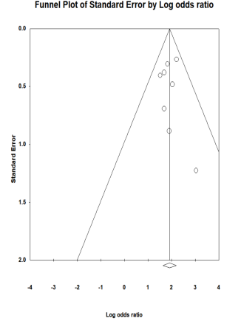

Figure S2. Funnel plot of meta-analysis of the association between perinatal domestic violence and depression

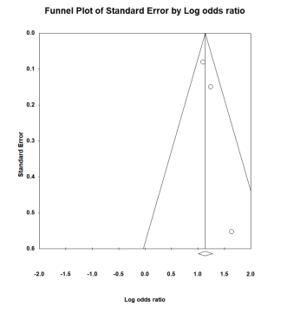

Figure S3. Funnel plot of meta-analysis of the association between job strain and depression
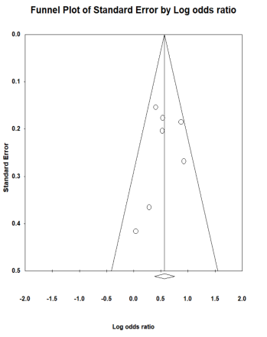

Figure S4. Funnel plot of meta-analysis of the association between poor marital relationship and depression
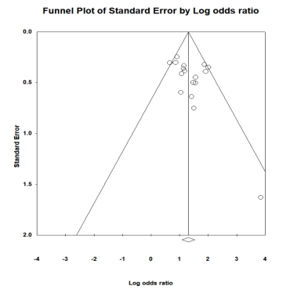

Figure S5. Funnel plot of meta-analysis of the association between premature infants and depression
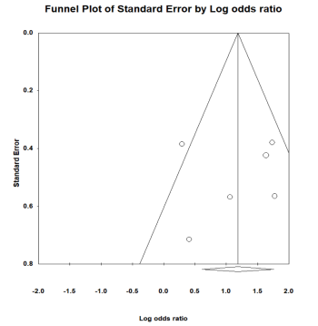

Figure S6. Funnel plot of meta-analysis of the association between poor relationship between mother-in-law and daughter-in-law and depression
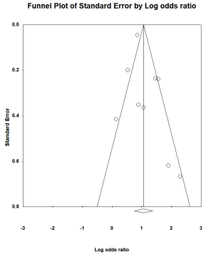

Figure S7. Funnel plot of meta-analysis of the association between sexual abuse and depression
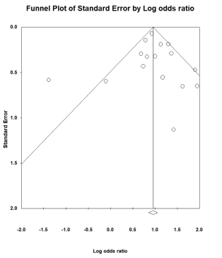

Figure S8. Funnel plot of meta-analysis of the association between lack of social support and depression
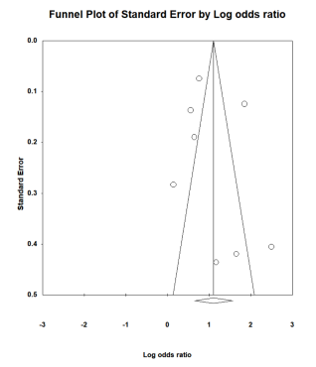

Figure S9. Funnel plot of meta-analysis of the association between insomnia and depression
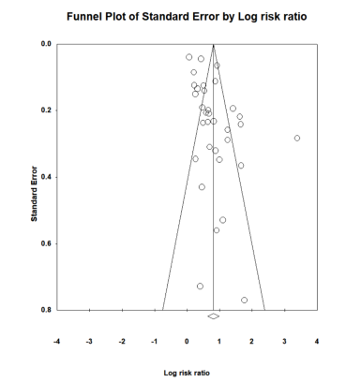

Figure S10. Funnel plot of meta-analysis of the association between premenstrual syndrome and depression
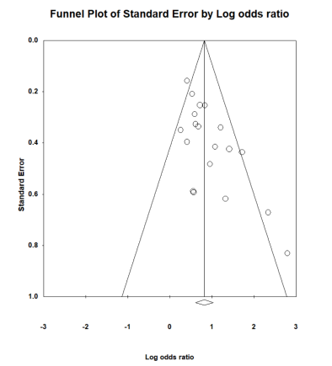

Figure S11. Funnel plot of meta-analysis of the association between financial difficulty and depression
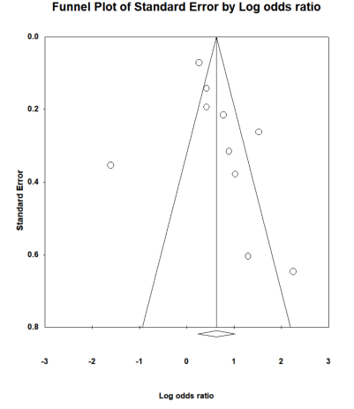

Figure S12. Funnel plot of meta-analysis of the association between intimate partner violence and depression
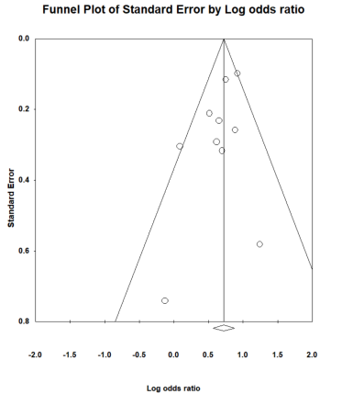

Figure S13. Funnel plot of meta-analysis of the association between chronic diseases in the elderly and depression
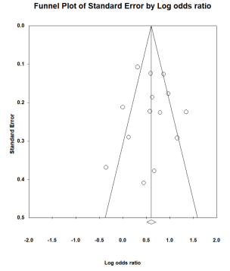

Figure S14. Funnel plot of meta-analysis of the association between infection with COVID and depression
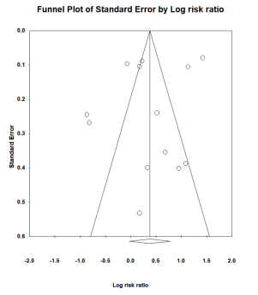

Figure S15. Funnel plot of meta-analysis of the association between elderly people have low levels of education and depression
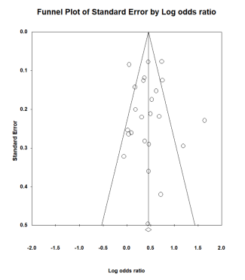

Figure S16. Funnel plot of meta-analysis of the association between neuroticism and depression
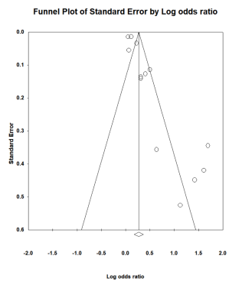

Figure S17. Funnel plot of meta-analysis of the association between second-hand smoke and depression
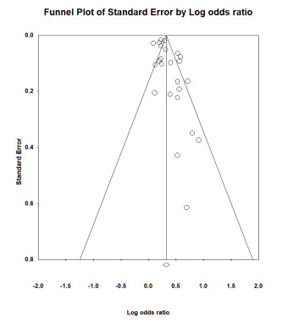

Figure S18. Funnel plot of meta-analysis of the association between have complications of diabetes and depression
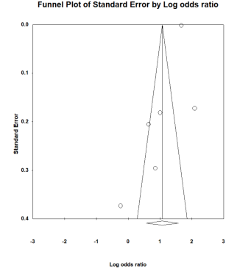

Figure S19. Funnel plot of meta-analysis of the association between elderly frailty and depression
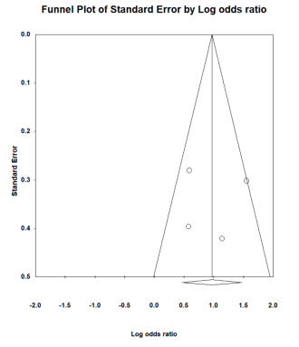

Figure S20. Funnel plot of meta-analysis of the association between financial instability and depression
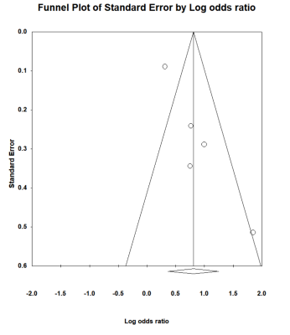

Figure S21. Funnel plot of meta-analysis of the association between periodontal disease and depression
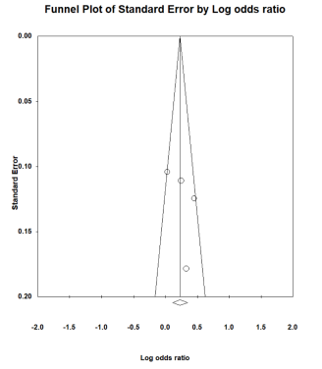

Figure S22. Funnel plot of meta-analysis of the association between unemployment during pregnancy and depression
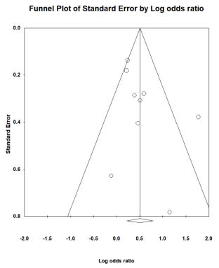

Figure S23. Funnel plot of meta-analysis of the association between mother's depression and depression
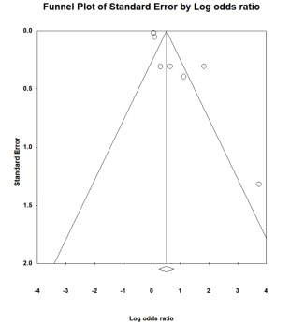

Figure S24. Funnel plot of meta-analysis of the association between low level of education and depression
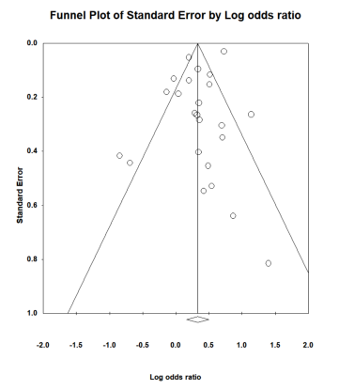

Figure S25. Funnel plot of meta-analysis of the association between insufficient support from relatives and depression
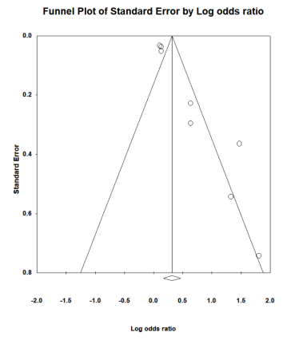

Figure S26. Funnel plot of meta-analysis of the association between antenatal depression and depression
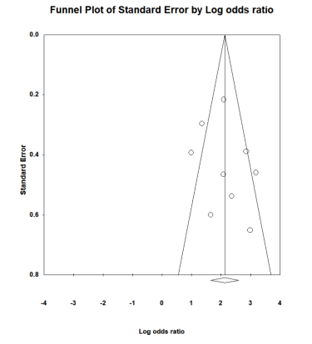

Figure S27. Funnel plot of meta-analysis of the association between marital conflict and depression
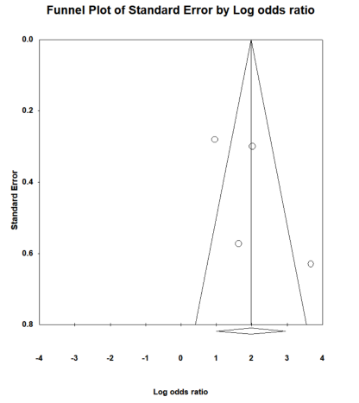

Figure S28. Funnel plot of meta-analysis of the association between father unemployed and depression
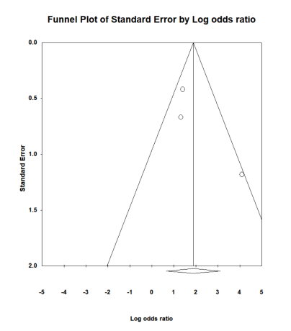

Figure S29. Funnel plot of meta-analysis of the association between unfavorable marital status and depression
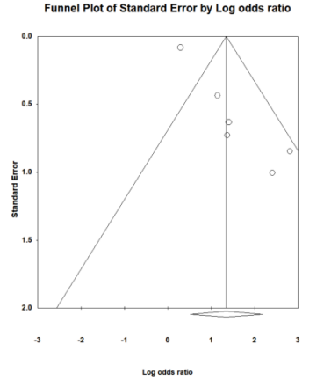

Figure S30. Funnel plot of meta-analysis of the association between poor economic foundation and depression
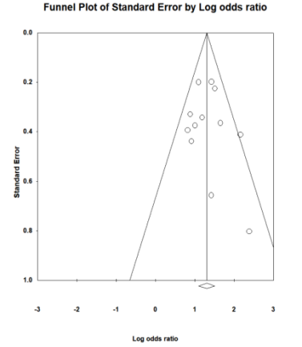

Figure S31. Funnel plot of meta-analysis of the association between low level of education and depression
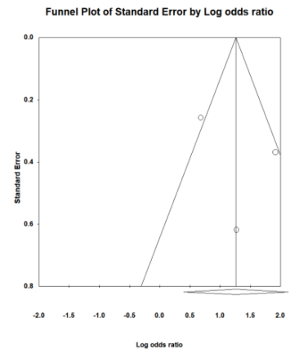

Figure S32. Funnel plot of meta-analysis of the association between history of complications of pregnancy and depression
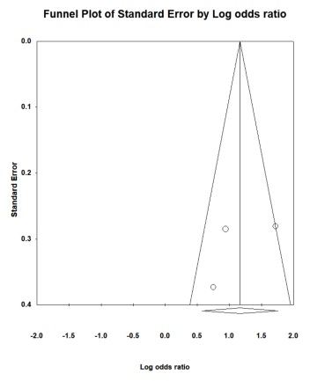

Figure S33. Funnel plot of meta-analysis of the association between have a history of miscarriage and depression
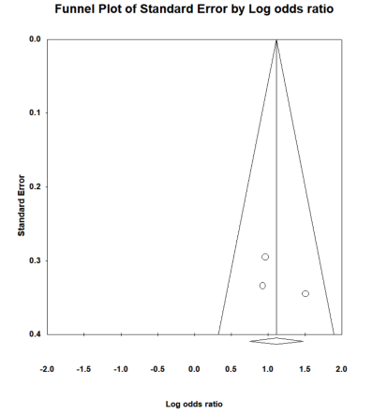

Figure S34. Funnel plot of meta-analysis of the association between unplanned pregnancy and depression
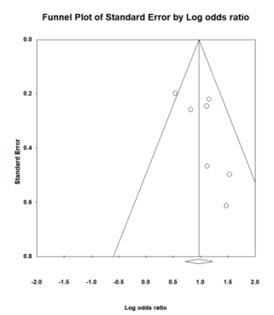

Figure S35. Funnel plot of meta-analysis of the association between poor living condition and depression
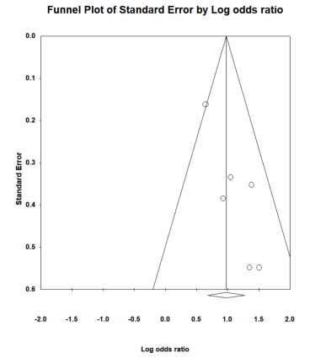

Figure S36. Funnel plot of meta-analysis of the association between suffering from chronic physical diseases before pregnancy and depression
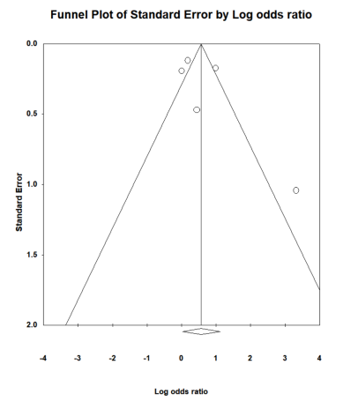

Figure S37. Funnel plot of meta-analysis of the association between my mother-in-law is a caregiver and depression
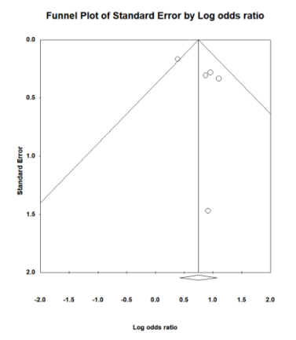

Figure S38. Funnel plot of meta-analysis of the association between not graduating from high school and depression
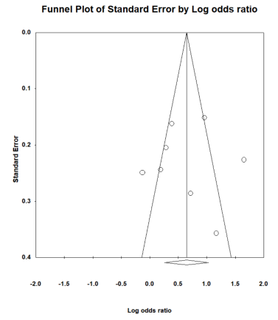

Figure S39. Funnel plot of meta-analysis of the association between dementia patients and depression
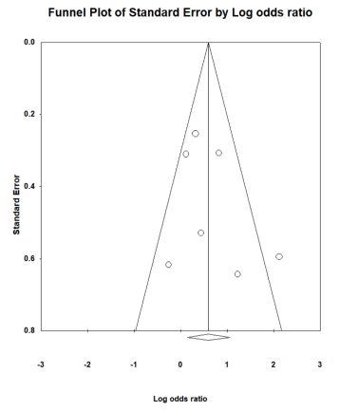

Figure S40. Funnel plot of meta-analysis of the association between postpartum stress events and depression
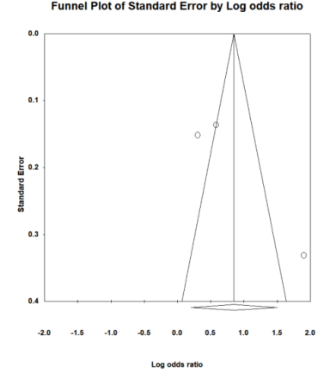

Figure S41. Funnel plot of meta-analysis of the association between premature ejaculation and depression
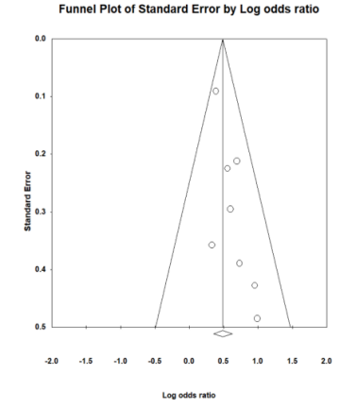

Figure S42. Funnel plot of meta-analysis of the association between premature ejaculation and depression
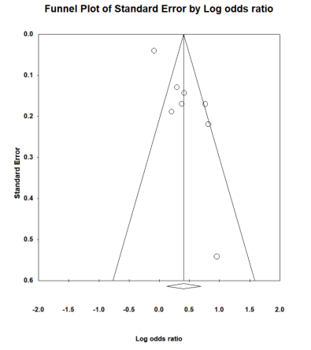

Figure S43. Funnel plot of meta-analysis of the association between insulin use in patients with diabetes and depression
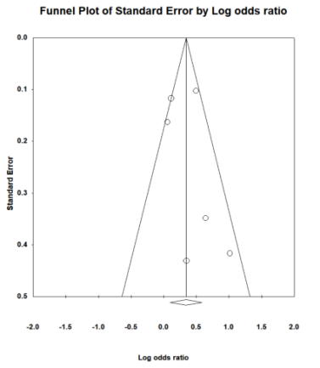

Figure S44. Funnel plot of meta-analysis of the association between edentulous disease and depression
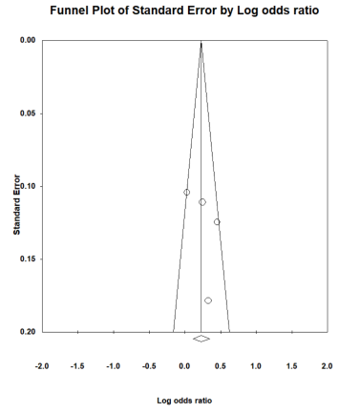

Figure S45. Funnel plot of meta-analysis of the association between parenting stress and depression
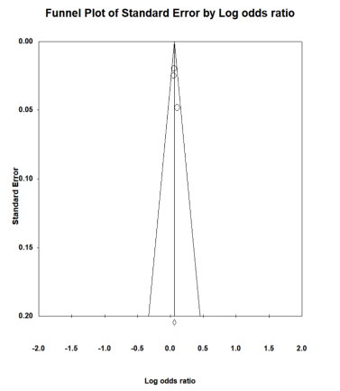

Figure S46. Funnel plot of meta-analysis of the association between homozygous mutation of rs41423247 gene polymorphism of glucocorticoid receptor and depression
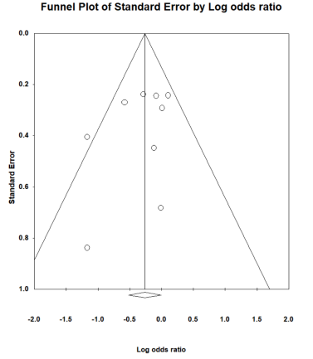

Figure S47. Funnel plot of meta-analysis of the association between perinatal smoking and depression
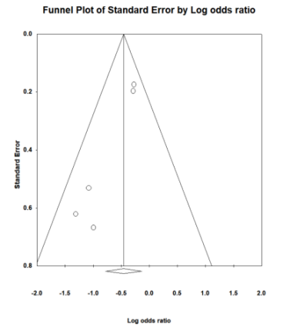

Figure S48. Funnel plot of meta-analysis of the association between family environment and depression
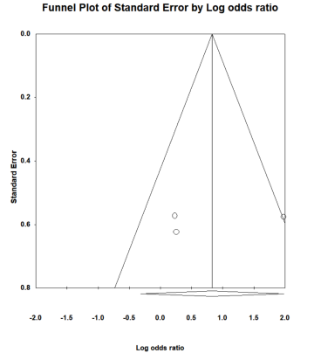

Figure S49. Funnel plot of meta-analysis of the association between parent depression and depression
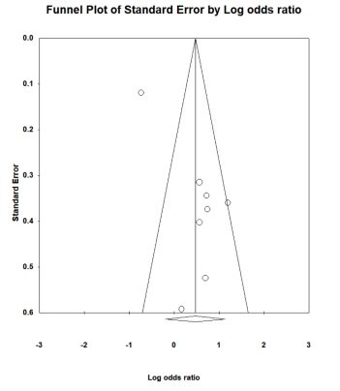

Figure S50. Common biomarkers and risk factors for bipolar disorder and major depressive disorder

