Supplementary Material

Supplementary Figures and Tables
Supplementary Table 1. Means and confidence intervals of demographic outcome variables (3-class model)ª.
Variable | Class 1  M (95% CI) | Class 2  M (95% CI) | Class 3  M (95% CI) | Significant Contrasts
Age | 26.53 (25.97, 27.1) | 25.7 (25.23, 26.16) | 25.22 (24.26, 26.19) | C1>C2*, C3*
Percentage of males | 56% (47%, 64%) | 61% (54%, 68%) | 66% (51%, 80%)
Percentage in a relationship | 51% (43%, 59%) | 38% (32%, 44%) | 47% (35%, 60%) | C1>C2*
Percentage who have completed secondary/high school | 79% (72%, 87%) | 74% (68%, 81%) | 75% (61%, 88%)
Percentage who are currently employed | 74% (66%, 82%) | 80% (74%, 86%) | 82% (70%, 93%)
Percentage who have Caucasian ethnicity | 74% (66%, 82%) | 79% (73%, 85%) | 75% (62%, 89%)
Percentage who live alone | 28% (21%, 36%) | 26% (21%, 31%) | 23% (12%, 35%)
Note. *p < .05, **p < .01, ***p < .001
ªAnalyses were adjusted for age, gender, education, employment, Caucasian ethnicity, and total scores of the AUDIT, DAST and FTND.

Supplementary Table 2. Means and confidence intervals of cannabis use variables (3-class model)ª.
Variable | Class 1  M (95% CI) | Class 2  M (95% CI) | Class 3  M (95% CI) | Significant Contrasts
Age of first use | 17.12 (16.63, 17.61) | 16.28 (15.88, 16.69) | 16.44 (15.6, 17.28) | C1>C2*
Age of regular use | 20.47 (19.92, 21.03) | 19.35 (18.89, 19.8) | 19.23 (18.28, 20.18) | C1>C2**,C3*
Self-reported “high” during use (10 = very blazed) | 5.3 (4.98, 5.62) | 6.38 (6.11, 6.64) | 6.25 (5.7, 6.81) | C1<C2***,C3**
Percentage who sometimes/always drive high | 16% (9%, 23%) | 32% (26%, 39%) | 30% (17%, 44%) | C1<C2**
Percentage who sometimes/often go to work high | 12% (6%, 18%) | 26% (20%, 33%) | 40% (25%, 55%) | C1<C2**,C3**
Percentage with half or more peers using cannabis | 38% (29%, 47%) | 72% (65%, 78%) | 74% (60%, 88%) | C1<C2***,C3***
Percentage who use cannabis all day | 7% (2%, 12%) | 22% (16%, 28%) | 26% (12%, 40%) | C1<C2***,C3*
Percentage usually using cannabis and alcohol | 19% (12%, 26%) | 16% (10%, 21%) | 30% (17%, 43%) | C2<C3*
Number of days using cannabis per week
1-2 times | 50% (41%, 58%) | 26% (19%, 33%) | 32% (18%, 46%) | C1>C2***,C3*
3-5 times | 27% (18%, 35%) | 30% (23%, 36%) | 35% (20%, 49%)
6-7 times | 24% (16%, 31%) | 44% (37%, 52%) | 33% (19%, 48%) | C1<C2***
Preferred type of marijuana
Mostly dried heads | 51% (42%, 60%) | 42% (35%, 50%) | 55% (39%, 71%)
Mostly dried leaves | 22% (15%, 29%) | 19% (13%, 26%) | 20% (7%, 33%)
Sinsemilla | 17% (10%, 24%) | 34% (27%, 41%) | 21% (7%, 34%) | C1<C2**
I don't know | 10% (5%, 16%) | 4% (1%, 7%) | 5% (0%, 11%)
Preferred route of administration
Joint | 25% (17%, 32%) | 14% (9%, 20%) | 29% (14%, 44%) | C1>C2*
Pipe | 28% (19%, 36%) | 29% (22%, 36%) | 24% (11%, 38%)
Water Pipe / Bong | 11% (5%, 17%) | 13% (8%, 18%) | 11% (2%, 19%)
Blunt | 10% (5%, 15%) | 12% (7%, 17%) | 13% (2%, 23%)
Vaporizer | 3% (0%, 7%) | 9% (5%, 13%) | 7% (0%, 14%)
Other | 23% (15%, 31%) | 23% (17%, 29%) | 17% (5%, 28%)
Preferred company during use
Alone | 76% (68%, 83%) | 77% (71%, 84%) | 77% (64%, 89%)
Friends/partner | 72% (64%, 80%) | 92% (87%, 96%) | 80% (68%, 93%) | C1<C2***
Family | 7% (2%, 11%) | 20% (14%, 26%) | 9% (0%, 18%) | C1<C2**
Others | 4% (0%, 7%) | 9% (5%, 13%) | 3% (0%, 8%) | C1<C2**
Preferred location during use
In public | 31% (23%, 40%) | 44% (37%, 51%) | 42% (27%, 57%) | C1<C2*
At home | 44% (81%, 93%) | 95% (92%, 98%) | 93% (86%, 100%) | C1<C2*
At friend’s house | 61% (52%, 70%) | 83% (77%, 89%) | 74% (60%, 88%) | C1<C2***
Note. *p < .05, **p < .01, ***p < .001
ªAnalyses were adjusted for age, gender, education, employment, Caucasian ethnicity, and total scores of the AUDIT, DAST and FTND.

Supplementary Table 3. Means and confidence intervals of mental health and substance use outcome variables (3-class model)ª.
Variable | Class 1  M (95% CI) | Class 2  M (95% CI) | Class 3  M (95% CI) | Significant Contrasts
Mental health outcomes:
Total Apathy Evaluation Scale score | 42.9 (41.68, 44.12) | 42.35 (41.35, 43.36) | 41.92 (39.84, 44.01)
CAPE Positive Psychotic Experiences subscale | 24.54 (23.38, 25.71) | 26.95 (25.99, 27.91) | 29.57 (27.57, 31.57) | C1<C2**, C3***; C2<C3**
CAPE Negative Psychotic Experiences subscale | 20.64 (19.37, 21.92) | 22.89 (21.84, 23.94) | 24.76 (22.57, 26.95) | C1<C2**, C3**
DASS-21 Depression subscale | 2.47 (1.77, 3.18) | 3.67 (3.09, 4.26) | 4.84 (3.63, 6.05) | C1<C2*, C3**
DASS-21 Anxiety subscale | 1.92 (1.39, 2.46) | 2.76 (2.32, 3.2) | 4.37 (3.46, 5.29) | C1<C2*, C3***; C2<C3**
DASS-21 Stress subscale | 2.73 (2.12, 3.34) | 4.18 (3.67, 4.69) | 5.12 (4.07, 6.18) | C1<C2**, C3***
Percentage who have ever sought mental health treatment | 14% (7%, 20%) | 19% (14%, 25%) | 10% (1%, 19%)
Problematic cannabis use:
Total CUPIT score | 24.59 (22.78, 26.41) | 31.96 (30.46, 33.45) | 33.6 (30.5, 36.71) | C1<C2***, C3***
CUPIT Impaired Control subscale | 22.41 (20.86, 23.97) | 28.66 (27.38, 29.94) | 29.11 (26.45, 31.78) | C1<C2***, C3***
CUPIT Problems subscale | 2.18 (1.65, 2.71) | 3.29 (2.86, 3.73) | 4.49 (3.58, 5.4) | C1<C2**, C3***; C2<C3*
CUPIT Cut-off score ≥ 12 | NA^{b} | NA^{b} | NA^{b}
CUPIT Cut-off score ≥ 20 | 70% (61%, 78%) | 95% (92%, 98%) | 92% (83%, 100%) | C1<C2***, C3***
Substance use outcomes:
Total AUDIT score | 10.81 (9.68, 11.94) | 12.61 (11.67, 13.55) | 13.26 (11.31, 15.21) | C1<C2*, C3*
Total DAST score | 1.05 (0.81, 1.29) | 1.39 (1.19, 1.59) | 1.35 (0.94, 1.77) | C1<C2*
Total FTND score | 0.82 (0.45, 1.2) | 1.29 (0.98, 1.6) | 0.66 (0.03, 1.3)
Note. *p < .05, **p < .01, ***p < .001
ªAnalyses were adjusted for age, gender, education, employment, Caucasian ethnicity, and total scores of the AUDIT, DAST and FTND.
^{b}NA indicates model could not be estimated due to zero cell count.

Supplementary Figures

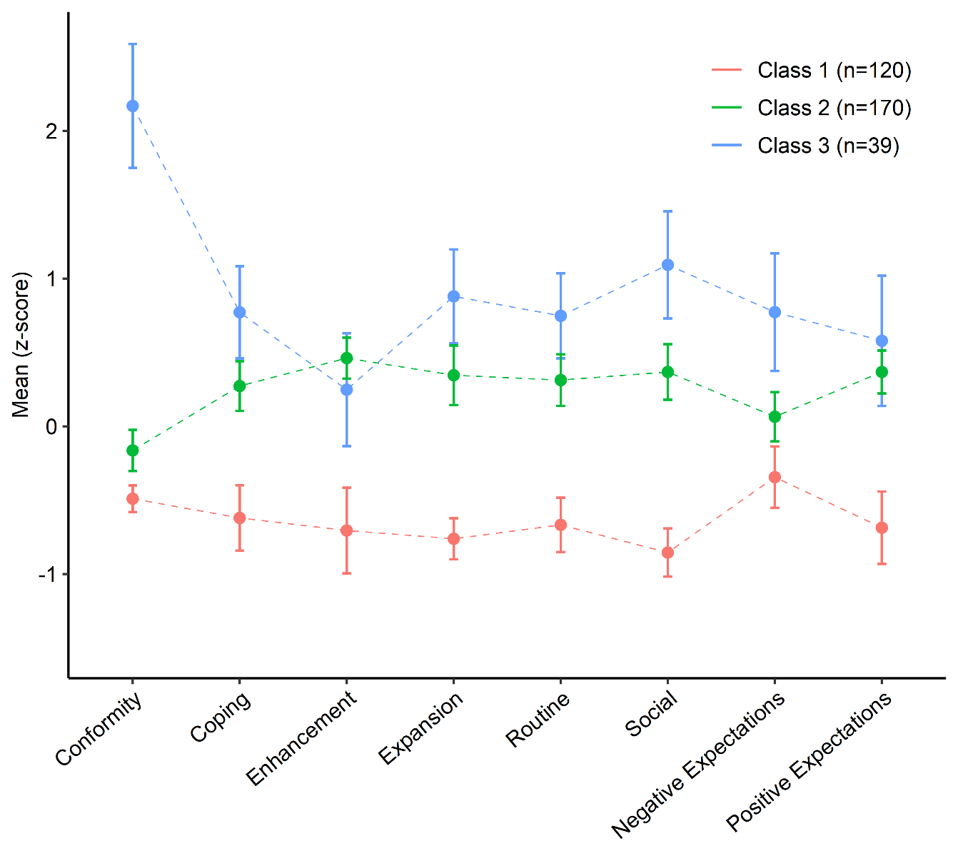
Supplementary Figure 1. Latent profile of participants based on marijuana use motives and cannabis use expectancies. Error bars represent 95% confidence intervals.

