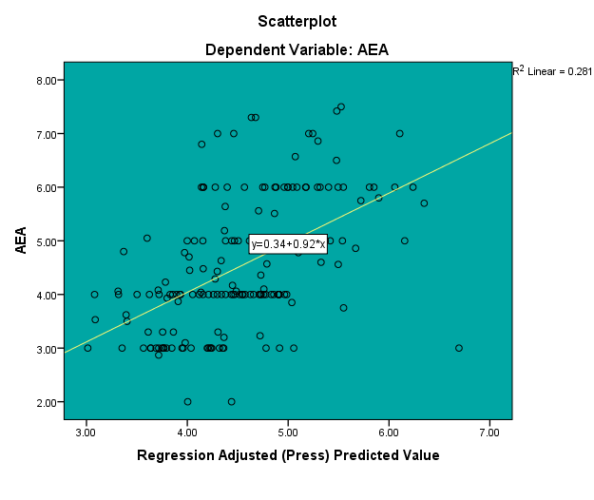
Fig. 1 Linear regression analysis graph of measured and whole model predicted AEA value (Healthy Dietary Pattern)

Linear regression analysis graph of measured and whole model predicted AEA value
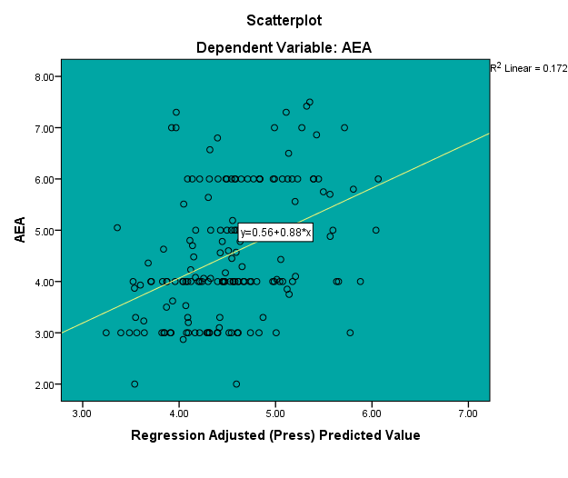
Fig. 2 Linear regression analysis graph of measured and whole model predicted AEA value (Western Dietary Pattern)

Fig. 3 The association between Traditional Pattern Score and AEA
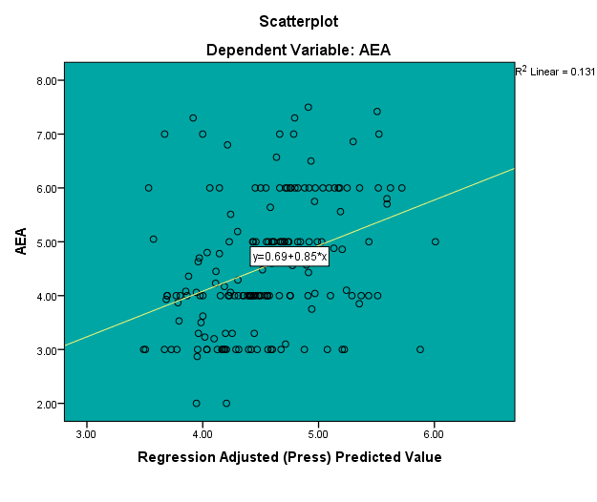
Fig. 3 Linear regression analysis graph of measured and whole model predicted AEA value (Traditional Dietary Pattern)

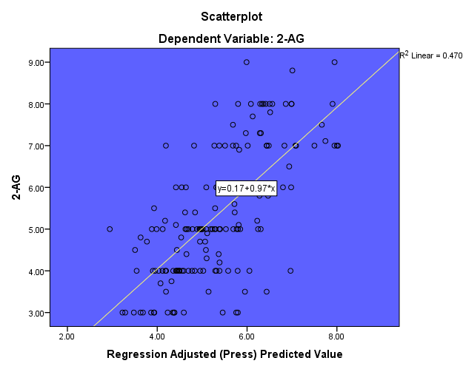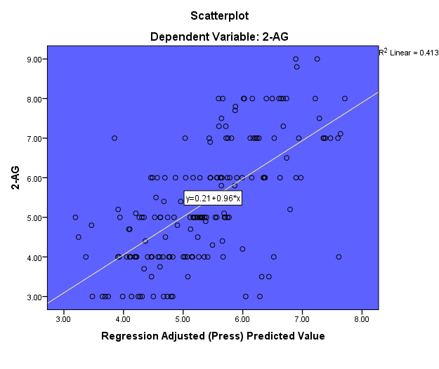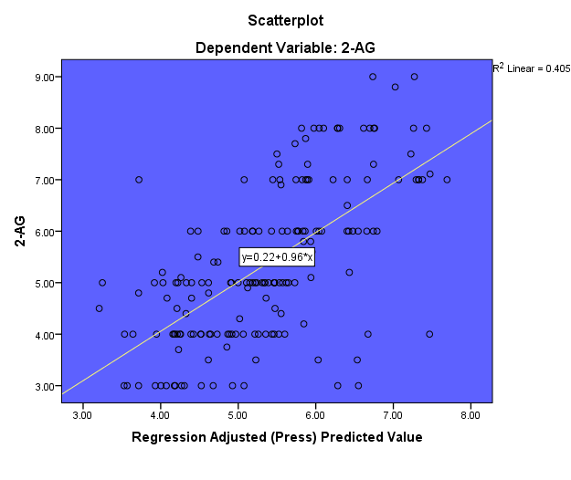
Fig. 4 Linear regression analysis graph of measured and whole model predicted 2-AG value (Healthy Dietary Pattern)

Fig. 4 The association between Healthy Pattern Score and AEA
Fig. 5 Linear regression analysis graph of measured and whole model predicted 2-AG value (Western Dietary Pattern)

Fig. 6 Linear regression analysis graph of measured and whole model predicted 2-AG value (Traditional Dietary Pattern)

