Supplementary Figures 4A-B: LocusZoom plots for genome-wide significant signals from the multi-ancestry GWAS of cannabis use cessation in PLWH in the United States.
A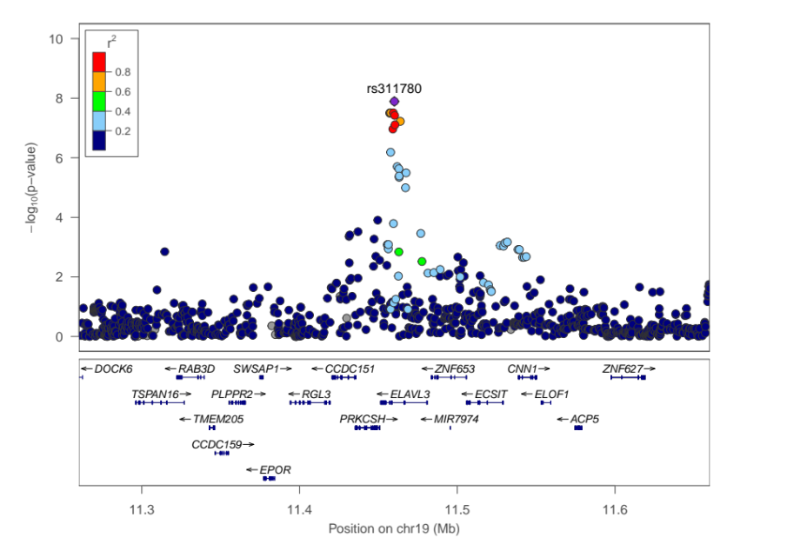B