Human metabolism of the semi-synthetic cannabinoids hexahydrocannabinol, hexahydrocannabiphorol and their acetates using hepatocytes and urine samples

Karin Lindbom^{1,=}, Caitlyn Norman^{1,=}, Steven Baginski², Lucas Krebs³, Darta Stalberga¹, Tobias Rautio⁴, Xiongyu Wu⁴, Robert Kronstrand^{1,5}, and Henrik Green^{1,5,*}

¹ Division of Clinical Chemistry and Pharmacology, Department of Biomedical and Clinical Sciences, Linköping University, Linköping, Sweden
² Leverhulme Research Centre for Forensic Science, School of Science and Engineering, University of Dundee, Dundee, UK
³ Institute for Chemistry and Bioanalytics, School of Life Sciences, University of Applied Sciences Northwestern Switzerland, Muttenz, Switzerland
⁴ Department of Physics, Chemistry and Biology, Linköping University, Linköping, Sweden.
⁵ Department of Forensic Genetics and Forensic Toxicology, National Board of Forensic Medicine, Linköping, Sweden
* Corresponding author: henrik.green@liu.se
⁼ These authors contributed equally to this work.

Supplementary Information 8:
5’OH-HHC Synthesis and Characterisation

S8.1. Synthesis of 5’OH-HHC
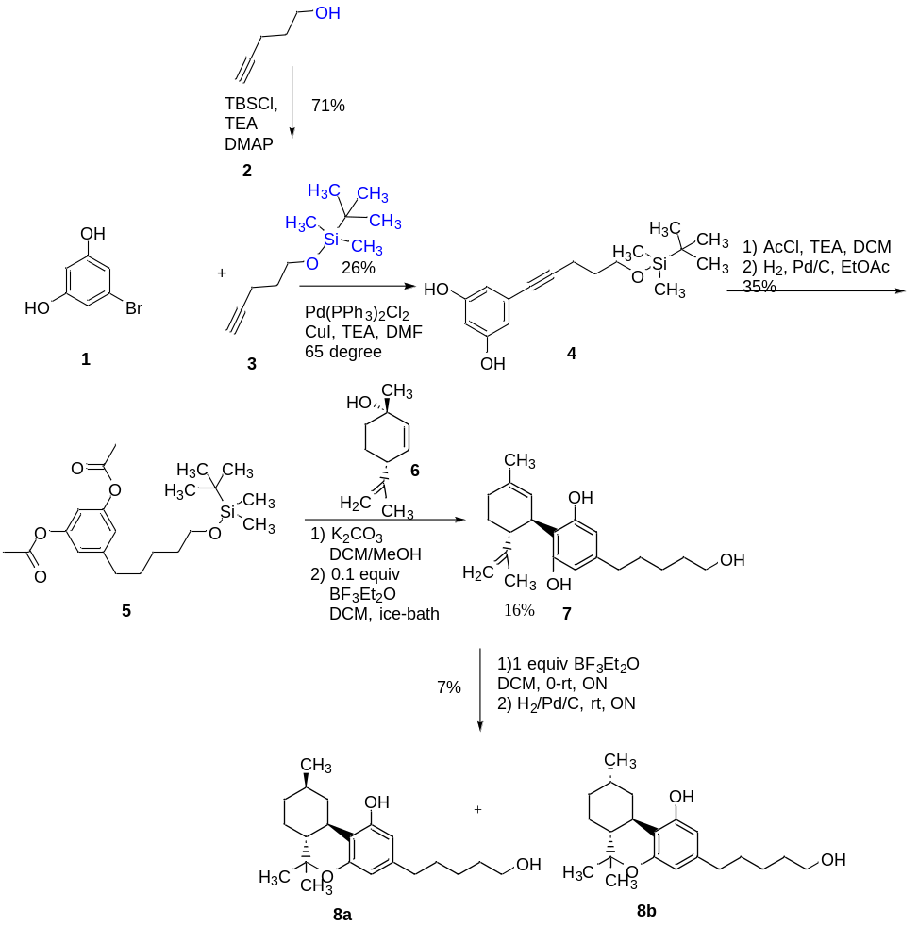
Scheme 1. Synthesis of 5’OH-HHC.
Compound 5 was synthesized in three steps. Firstly, a coupling reaction of 1,3-dihydroxy-5-bromobenzene 1 with compound 3 using Pd(PPh₃)₂Cl₂ and CuI as catalysts and triethylamine (TEA) as base in N,N’-dimethylformamide (DMF) at 65 °C, was applied to give 4 in 26% yield. Secondly, a protection reaction with acetyl group using TEA as base in dichloromethane (DCM) was carried out, followed by a hydrogenation with hydrogen gas under the catalyst of Pd/C in ethyl acetate (EtOAc) giving compound 5 in 35% yield for two steps.
Compound 5 was deprotected using K₂CO₃ in DCM/MeOH at room temperature. After work-up, the crude product was dissolved in anhydrous DCM, and (1S, 4R)-1-methyl-4-(prop-1-en-2-yl)-cyclohex-2-en (6) (1.0 equivalent) was added following by BF₃Et₂O (0.1 equivalent) in an ice-bath. The reaction mixture was stirred for 15 minutes. The reaction mixture was purified using preparative liquid chromatography to give compound 7 (16% yield).
Compound 7 was dissolved in anhydrous DCM. BF₃Et₂O (1.0 equivalent) was added to the above solution at about 0 °C. The reaction mixture was allowed to be warmed up to room temperature and stirred overnight. After work-up, the crude product was dissolved in ethyl acetate, and 5mol% Pd/C was added, the resulting mixture was stirred under H₂ gas overnight. After filtration and concentration, the resulting crude product was purified using preparative liquid chromatography to give the product 8a and 8b as a mixture in 7% yield. The ratio of 8a:8b is about 5:6.
S8.2. Characterisation of the synthesised product (5’OH-HHC) by ¹H-NMR.
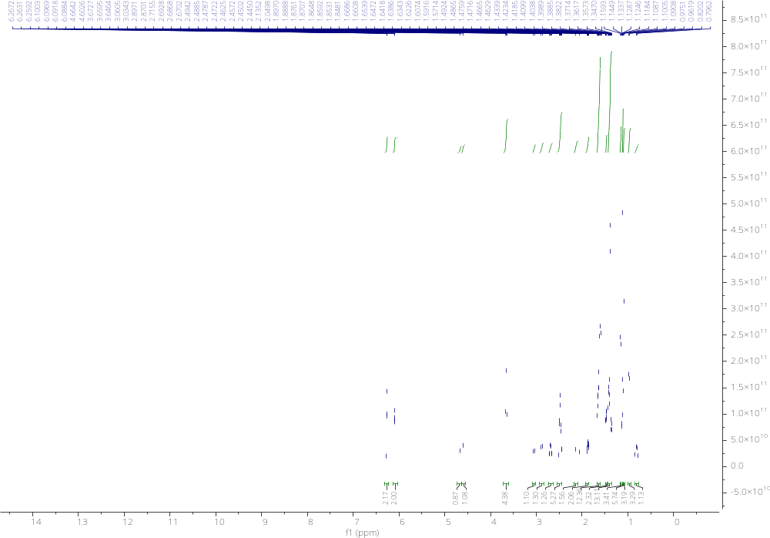
Figure S8.1. ¹H-NMR of synthesised products 8a and 8b.
The ¹H-NMR was assigned according to COSY and the references of HHC (9S) and HHC (9R), which was published by Cayman Chemical. ¹H-NMR (500 MHz, CDCl₃) of 8a (9R): δ 6.24 (d, J = 2.0 Hz, 1H, ), 6.07 (d, J = 1.7 Hz, 1 H), 4.66 (br s, 1H, OH), 3.66 (t, J = 6.5 Hz, 2H), 3.05 (br d, J = 13 Hz, 1H), 2.52-2.44 (m, 3H), 1.91-1.84 (m, 2H), 1.67-1.53 (m, 5H), 1.49-1.27 (m, 3H, Me group is not included.), 1.39 (s, 3H), 1.10-1.06 (m, 1H, Me group is not included.), 1.09 (s, 3H, Me), 0.97 (d, J = 6.6 Hz, 3H, Me), 0.81 (q, J = 11.8 Hz, 1H).
¹H-NMR (500 MHz, CDCl₃) of 8b (9S): δ 6.23 (d, J = 1.9 Hz, 1H), 6.06 (d, J = 1.7 Hz, 1H), 4.60 (br s, 1H, OH), 3.66 (t, J = 6.5 Hz, 2H), 2.88 (br d, J = 13 Hz, 1H), 2.69 (dt, J = 11.5, 3.0 Hz, 1H), 2.52-2.44 (m, 2H), 2.17-2.09 (m, 1H), 1.67-1.53 (m, 6H), 1.49-1.27 (m, 5H), 1.11-1.04 (m, 1H), 1.38 (s, 3H), 1.15 (d, J = 7.0 Hz, 3H), 1.11 (s, 3H, Me).

S8.3. Characterisation of the synthesised product (5’OH-HHC) by LC-QToF-MS
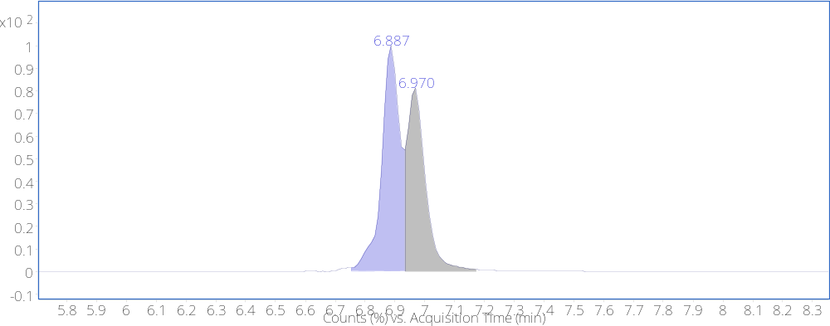
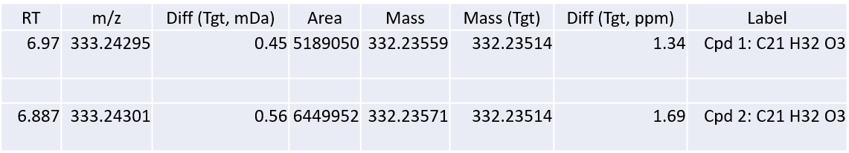
Figure S8.2. Chromatogram of synthesised (9R)- and (9S)-5’OH-HHC from LC-QToF-MS analysis with an ACN gradient.
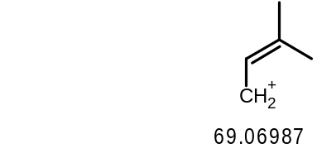
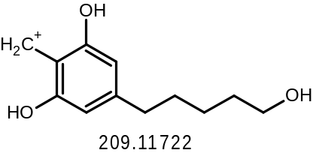
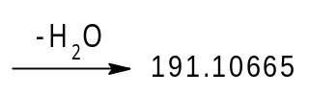
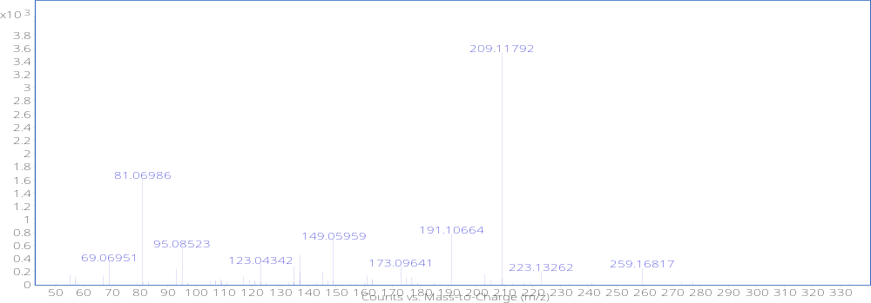
Figure S8.3. Mass spectrum from ACN gradient of peak at a retention time of 6.887 min and structures of major mass fragment.
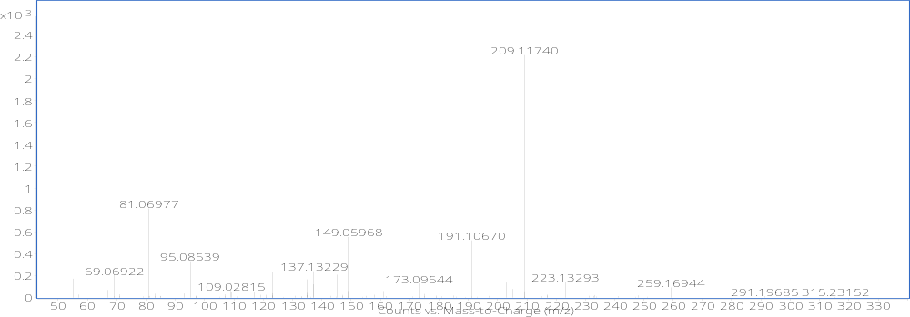
Figure S8.4. Mass spectrum from ACN gradient of peak at a retention time of 6.970 min and structures of major mass fragment.
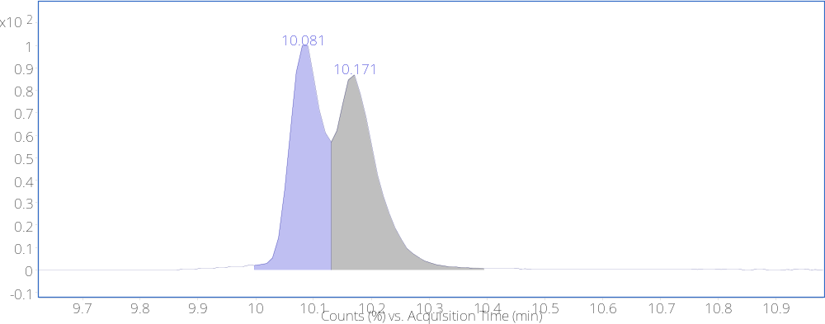
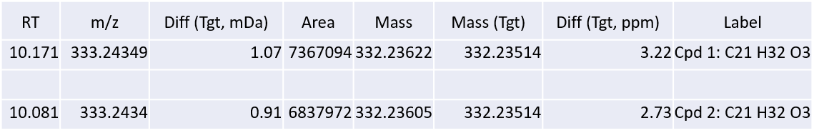

Figure S8.5. Chromatogram of synthesised (9R)- and (9S)-5’OH-HHC from LC-QToF-MS analysis with a MeOH gradient.
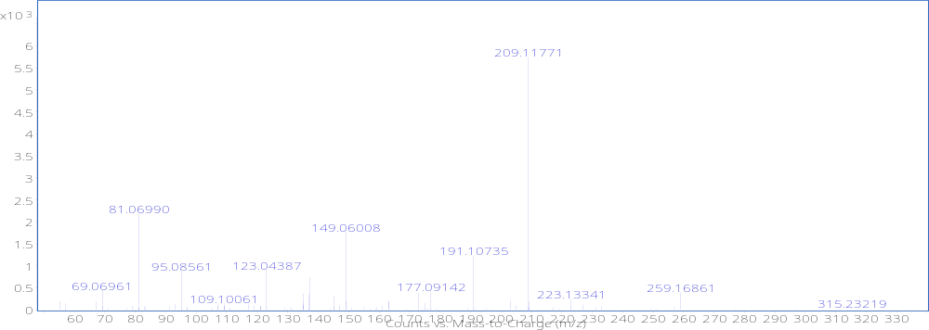
Figure S8.6. Mass spectrum from MeOH gradient of peak at a retention time of 10.081 min and structures of major mass fragment.
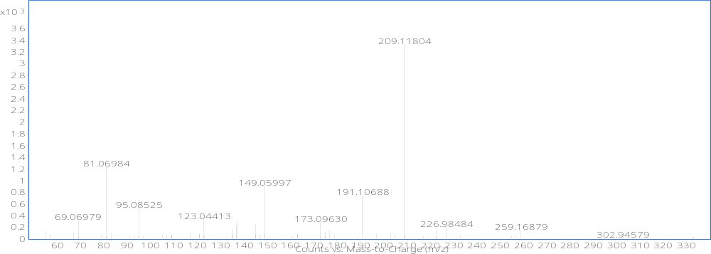
Figure S8.7. Mass spectrum from MeOH gradient of peak at a retention time of 10.171 min and structures of major mass fragment.

Stothard, A., Layle, N., Martin, M., et al. Characterization of Hexahydrocannabinol Diastereomers by NMR, HPLC, GC-MS, and TLC. Available from: https://www.caymanchem.com/literature/characterization-of-hhc-diastereomers (accessed on 25-04-2024).

