Determination of size-segregated water-soluble organic compounds in diesel-biodiesel blends exhaust emissions
Margarita Evtyugina¹, Cátia Gonçalves¹, Sérgio Correia², Célia Alves¹, Luiz Carlos Daemme³, Renato de Arruda Penteado Neto³
¹Department of Environment, Centre for Environmental and Marine Studies (CESAM), University of Aveiro, 3810-193 Aveiro, Portugal
²Rio de Janeiro State University, Faculty of Technology, Resende, RJ 27537-000, Brazil
³ LACTEC – Technology Institute for Development, Curitiba, PR, Brazil, 80210-170
SUPLEMENTARY MATERIAL
Table S1 Pearson’s correlation coefficients between biodiesel content (BD) and EFs of dicarboxylic acids
 | BD | Oxalic acid | Succinic acid | Malic acid | Glutaric acid | Adipic acid | Pimelic acid | Suberic acid | Azelaic acid | Sebacic acid | Thapsic acid
BD | 1.00
Oxalic acid | -0.79 | 1.00
Succinic acid | -0.47 | -0.16 | 1.00
Malic acid | -0.09 | -0.34 | 0.48 | 1.00
Glutaric acid | 0.28 | -0.77 | 0.70 | 0.30 | 1.00
Adipic acid | -0.96 | 0.75 | 0.42 | 0.30 | -0.36 | 1.00
Pimelic acid | 0.04 | -0.26 | 0.12 | 0.92 | -0.01 | 0.22 | 1.00
Suberic acid | -0.37 | 0.17 | 0.18 | 0.83 | -0.26 | 0.61 | 0.90 | 1.00
Azelaic acid | -0.61 | 0.21 | 0.53 | 0.84 | -0.04 | 0.77 | 0.75 | 0.92 | 1.00
Sebacic acid | 0.73 | -0.26 | -0.87 | -0.07 | -0.41 | -0.59 | 0.27 | 0.04 | -0.36 | 1.00
Thapsic acid | 0.17 | -0.35 | 0.05 | 0.90 | 0.01 | 0.09 | 0.99 | 0.84 | 0.66 | 0.37 | 1.00

Table S2 Pearson’s correlation coefficients between biodiesel content (BD) and EFs of hydroxy acids
 | BD | Glycolic acid | Glyceric acid | 3-Hydroxy-propanoic acid | 3-Hydroxy-butanoic acid | 3,4-Di-  hydroxy-  butanoic acid | 2-Hydroxy-sebacic acid
BD | 1.00
Glycolic acid | -0.95 | 1.00
Glyceric acid | 0.17 | -0.36 | 1.00
3-hydroxypropanoic acid | -0.85 | 0.64 | 0.25 | 1.00
3-Hydroxybutanoic acid | 0.33 | -0.45 | 0.96 | 0.02 | 1.00
3,4-Dihydroxybutanoic acid | -0.22 | -0.10 | 0.48 | 0.68 | 0.24 | 1.00
2-Hydroxysebacic acid | -0.05 | -0.26 | 0.31 | 0.49 | 0.09 | 0.96 | 1.00

Table S3 Pearson’s correlation coefficients between biodiesel content (BD) and EFs of aromatic acids
 | BD | Benzoic acid | 4-Hydroxy-benzoic acid | Cinnamic acid | 3-Hydroxy-benzoic acid | Phthalic acid | Vanillic acid | Terephthalic acid | Syringic acid
BD | 1.00
Benzoic acid | 0.67 | 1.00
4-Hydroxybenzoic acid | -0.80 | -0.28 | 1.00
Cinnamic acid | -0.16 | -0.38 | 0.44 | 1.00
3-Hydroxybenzoic acid | -0.47 | -0.16 | 0.86 | 0.78 | 1.00
Phthalic acid | -0.62 | -0.64 | 0.74 | 0.87 | 0.84 | 1.00
Vanillic acid | -0.78 | -0.24 | 0.53 | -0.47 | 0.03 | 0.02 | 1.00
Terephthalic acid | -0.85 | -0.24 | 0.69 | -0.30 | 0.23 | 0.18 | 0.98 | 1.00
Syringic acid | -0.03 | 0.25 | 0.59 | 0.72 | 0.89 | 0.58 | -0.30 | -0.10 | 1.00

Table S4 Pearson’s correlation coefficients between biodiesel content (BD) and EFs of alkanoic acids
 | BD | C8 | C9 | C10 | C11 | C12 | C13 | C14 | C15 | C16 | C17 | C18 | C19 | C20 | C22
BD | 1.00
C8 | 0.83 | 1.00
C9 | 0.68 | 0.97 | 1.00
C10 | 0.79 | 1.00 | 0.98 | 1.00
C11 | 0.85 | 0.99 | 0.96 | 0.99 | 1.00
C12 | 0.72 | 0.97 | 1.00 | 0.98 | 0.97 | 1.00
C13 | 0.85 | 0.57 | 0.45 | 0.54 | 0.65 | 0.53 | 1.00
C14 | 0.91 | 0.78 | 0.62 | 0.74 | 0.76 | 0.61 | 0.56 | 1.00
C15 | 0.69 | 0.21 | -0.02 | 0.15 | 0.23 | 0.01 | 0.56 | 0.74 | 1.00
C16 | -0.78 | -0.50 | -0.40 | -0.47 | -0.58 | -0.48 | -0.99 | -0.45 | -0.49 | 1.00
C17 | 0.42 | -0.16 | -0.36 | -0.22 | -0.10 | -0.29 | 0.63 | 0.28 | 0.81 | -0.63 | 1.00
C18 | -0.44 | -0.87 | -0.96 | -0.90 | -0.85 | -0.94 | -0.22 | -0.40 | 0.30 | 0.18 | 0.60 | 1.00
C19 | -0.21 | 0.37 | 0.57 | 0.43 | 0.34 | 0.53 | -0.31 | -0.22 | -0.82 | 0.30 | -0.93 | -0.78 | 1.00
C20 | -0.28 | -0.67 | -0.71 | -0.68 | -0.59 | -0.64 | 0.21 | -0.52 | 0.11 | -0.30 | 0.66 | 0.76 | -0.59 | 1.00
C22 | -0.01 | -0.47 | -0.66 | -0.53 | -0.48 | -0.66 | -0.07 | 0.19 | 0.72 | 0.11 | 0.67 | 0.80 | -0.90 | 0.34 | 1.00

Table S5. Emission factors of WSO (ng/km)
 | B0 |  |  | B10 |  |  | B20 |  |  |  |  |  | B30
 | N | UF | F | N | UF | F | N |  | UF |  | F |  | N |  | UF |  | F
Straight-chain, saturated carboxylic acids (alkanoic acids)
Octanoic (caprylic) acid | 22.9 | 5.34 | 67.0 | 30.4 | 3.80 | 59.4 | 25.4 |  | 169 |  | 106 |  | 126 |  | 68.5 |  | 59.4
Nonanoic (pelargonic) acid | 43.8 | 3.34 | 131 | 56.4 | 1.70 | 125 | 87.3 |  | 370 |  | 220 |  | 200 |  | 127 |  | 109
Decanoic (caproic) acid | 16.7 | 2.15 | 38.3 | 25.8 | 0.927 | 52.9 | 25.6 |  | 67.0 |  | 50.9 |  | 52.4 |  | 33.8 |  | 31.6
Undecanoic acid | 2.50 | 0.466 | 5.01 | 2.39 | 0.836 | 4.42 | 4.72 |  | 8.17 |  | 7.05 |  | 7.74 |  | 4.57 |  | 5.06
Dodecanoic (lauric) acid | 9.04 | 1.70 | 23.4 | 14.8 | 1.47 | 26.6 | 56.5 |  | 28.7 |  | 28.5 |  | 36.9 |  | 19.2 |  | 22.1
Tridecanoic acid | 0.71 | 0.332 | 1.51 | 2.88 | 0.435 | 4.23 | 2.15 |  | 2.44 |  | 3.21 |  | 3.52 |  | 1.89 |  | 3.85
Tetradecanoic (myristic) acid | 10.1 | 11.6 | 11.7 | 11.8 | 3.60 | 23.1 | 10.6 |  | 9.30 |  | 21.6 |  | 13.8 |  | 13.8 |  | 25.3
Pentadecanoic acid | 1.95 | 1.95 | 2.69 | 3.87 | 1.54 | 2.31 | 1.62 |  | 2.08 |  | 1.22 |  | 5.13 |  | 6.14 |  | 11.7
Hexadecanoic (palmitic) acid | 267 | 220 | 153 | 194 | 73.5 | 144 | 18.1 |  | 222 |  | 185 |  | 89.6 |  | 152 |  | 142
Heptadecanoic acid | 0.533 | 0.434 | 0.608 | 3.20 | 0.290 | 1.33 | 0.332 |  | 0.388 |  | 0.278 |  | 1.57 |  | 1.67 |  | 3.01
Octadecanoic (stearic) acid | 16.5 | 19.6 | 13.3 | 15.9 | 3.21 | 11.5 | 6.14 |  | 5.16 |  | 9.16 |  | 12.7 |  | 11.8 |  | 19.1
Nonadecanoic acid | 0.551 | 0.920 | 0.330 | Nd | Nd | Nd | 0.642 |  | 1.48 |  | 1.03 |  | 0.187 |  | Nd |  | 0.143
Eicosanoic (arachidic) acid | 0.327 | 0.230 | 0.385 | 0.708 | 0.065 | 0.50 | 0.178 |  | 0.157 |  | 0.130 |  | 0.530 |  | 0.459 |  | Nd
Docosanoic (behenic) acid | 0.162 | 0.046 | 0.422 | 0.550 | Nd | Nd | Nd |  | Nd |  | Nd |  | Nd |  | 0.301 |  | 0.508
Amino acids
Glycine | Nd | Nd | Nd | 17.8 | Nd | 27.7 | Nd |  | Nd |  | Nd |  | 9.55 |  | Nd |  | 10.1
L-Serine | Nd | Nd | Nd | Nd | Nd | Nd | Nd |  | Nd |  | Nd |  | Nd |  | Nd |  | Nd
5-oxo-L-proline | Nd | 21.1 | 13.5 | 6.41 | Nd | 319 | Nd |  | 15.6 |  | Nd |  | 8.021 |  | 3.09 |  | Nd
Other acids
Cis-Pinonic acid | 9.91 | 5.46 | 23.0 | 22.7 | 5.36 | 12.7 |  | 6.38 |  | 17.62 |  | 15.11 |  | 6.61 |  | 4.09 |  | 3.87
Pinic acid | 2.67 | 2.02 | 8.67 | 3.74 | 1.60 | 4.44 |  | 3.74 |  | 5.38 |  | 4.83 |  | 3.52 |  | 2.81 |  | 3.95
Citric acid | 0.187 | 0.165 | 2.30 | 0.55 | 0.115 | 0.569 |  | 0.392 |  | 0.327 |  | 0.842 |  | 3.11 |  | 0.748 |  | 5.58
Cis,cis-9-12-octanedecanoic, 9-cis-hexadecenoic (linoleic) (C18:2)acid | 0.440 | 0.373 | Nd | 0.385 | 0.064 | Nd |  | Nd |  | Nd |  | Nd |  | Nd |  | 0.173 |  | Nd
cis-9-Octadecenoic (oleic) acid | 1.01 | 1.15 | 0.565 | 1.70 | 0.168 | 1.52 |  | 0.270 |  | 0.461 |  | 0.638 |  | 0.334 |  | 0.484 |  | 0.778
Dehydroabietic acid | 7.72 | 3.89 | 3.65 | 4.30 | 3.14 | 5.07 |  | 3.331 |  | 60.8 |  | 11.7 |  | 2.43 |  | 1.77 |  | 6.08
Isopimaric acid | 9.92 | 9.00 | 9.30 | 9.46 | 10.7 | Nd |  | 8.95 |  | 9.23 |  | 9.56 |  | 8.92 |  | 9.67 |  | 8.27
Glycerol | 299 | 668 | 798 | 585 | 568 | 806 |  | 469 |  | 490 |  | 489 |  | 533 |  | 690 |  | 645
Polyethylene glycols
Diethylene glycol | 16.5 | 27.4 | 70.8 | 98.8 | 74.0 | 77.1 |  | 120 |  | 126 |  | 108 |  | 48.9 |  | 50.2 |  | 44.4
Triethylene glycol | 26.3 | 16.3 | 96.2 | 85.1 | 42.7 | 42.1 |  | 46.7 |  | 37.1 |  | 28.0 |  | 37.0 |  | 19.9 |  | 35.3
Tetraethylene glycol | 1.25 | 0.405 | 1.76 | 1.64 | 1.32 | 0.649 |  | 1.35 |  | 0.968 |  | 0.876 |  | 1.94 |  | 1.29 |  | 1.44
1-monostearin | 1.43 | 1.36 | 2.40 | 7.36 | Nd | Nd |  | Nd |  | Nd |  | Nd |  | Nd |  | Nd |  | Nd
Other compounds
Urea | Nd | 288 | Nd | Nd | Nd | 52 |  | Nd |  | 998 |  | Nd |  | Nd |  | Nd |  | Nd
Vanillin | 3.62 | 2.39 | 5.84 | 5.77 | 3.41 | 8.69 |  | 8.55 |  | 8.62 |  | 5.04 |  | 10.5 |  | 8.10 |  | 8.13
Hexadecanol | 2.91 | 2.87 | 3.40 | 2.34 | 4.56 | 3.55 |  | 2.58 |  | 2.66 |  | 2.50 |  | 3.33 |  | 3.48 |  | 3.79
Octadecanol | 1.07 | 2.11 | 1.25 | 2.05 | 1.24 | 4.13 |  | 0.522 |  | 0.695 |  | 0.424 |  | 1.44 |  | 2.11 |  | 2.08

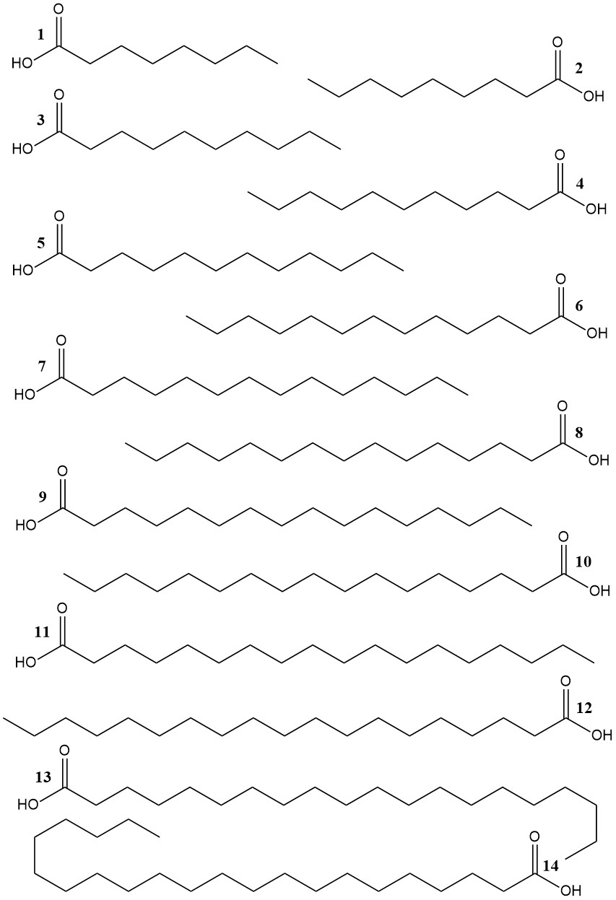
Figure S1A Molecular structure of alkanoic acids (1 – octanoic (caprylic) acid, 2 – nonanoic (pelargonic) acid, 3 – decanoic (caproic) acid, 4 – undecanoic acid, 5 – dodecanoic (lauric) acid, 6 – tridecanoic acid, 7 – tetradecanoic (myristic) acid, 8 – pentadecanoic acid, 9 – hexadecanoic (palmitic) acid, 10 – heptadecanoic acid, 11 – octadecanoic (stearic) acid, 12 – nonadecanoic acid, 13 – eicosanoic (arachidic) acid, 14 – docosanoic (behenic) acid
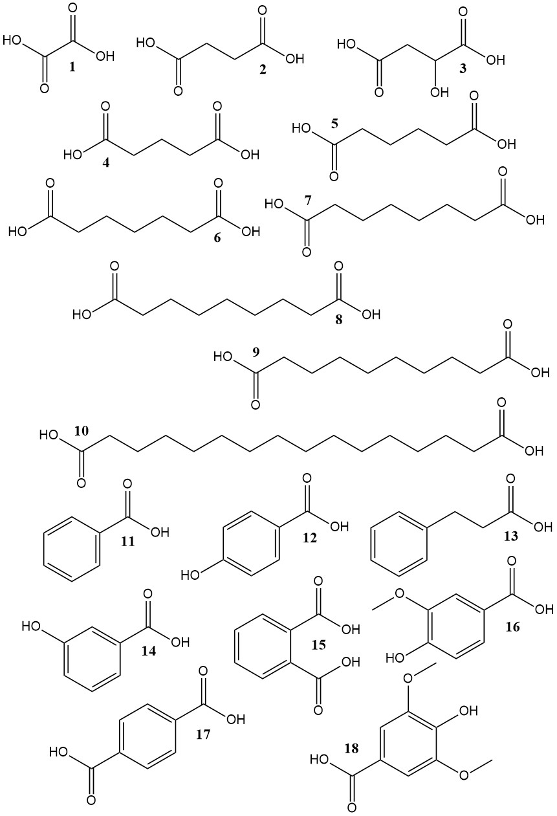
Figure S1B Molecular structure of dicarboxylic and aromatic acids (1 – ethanedioic (oxalic anhydrous) acid, 2 – butanedioic (succinic) acid, 3 – hydroxybutanedioic (malic) acid, 4 – 1,5-pentanedioic (glutaric) acid, 5 – hexanedioic (adipic) acid, 6 – heptanedioic (pimelic) acid, 7 – octanedioic (suberic) acid, 8 – nonanedioic (azelaic) acid, 9 – decanedioic (sebacic) acid, 10 – hexanedecanedioic (thapsic) acid, 11 – benzoic acid, 12 – 4-hydroxybenzoic acid, 13 – trans-cinnamic acid, 14 – 3-hydroxybenzoic acid, 15 – phthalic acid, 16 – vanillic acid, 17 – terephthalic acid, 18 – syringic acid
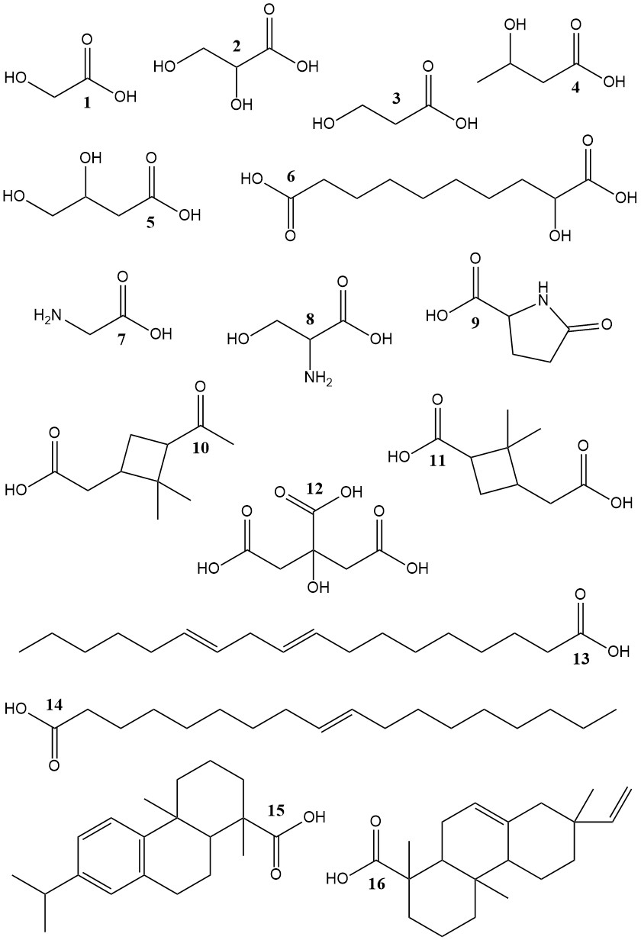
Figure S1C Molecular structure of hydroxy, amino- and other acids (1 – glycolic acid, 2 – glyceric acid, 3 – 3-hydroxypropanoic (hydracrylic) acid, 4 – 3-hydroxybutanoic (hydroxybutyric) acid, 5 – 3,4- dihydroxybutanoic acid, 6 – 2-hydroxysebacic acid, 7 – glycine, 8 – L-serine, 9 – 5-oxo-L-proline, 10 – cis-pinonic acid, 11 – pinic acid, 12 – citric acid, 13 – cis,cis-9-12-octanedecanoic, 9–cis-hexadecenoic (linoleic) (C18:2)acid, 14 – cis-9-octadecenoic (oleic) acid, 15 – dehydroabietic acid, 16 – isopimaric acid
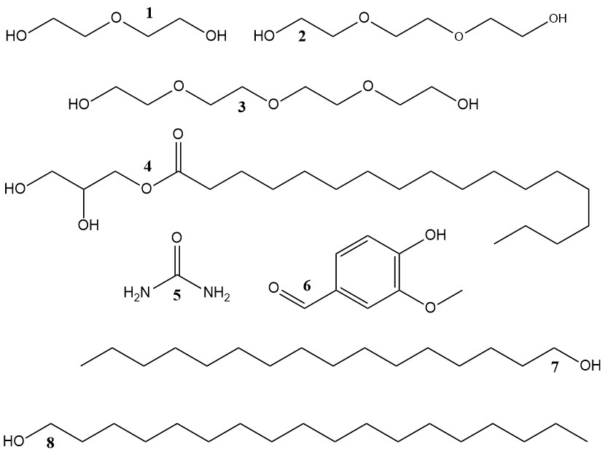
Figure S1D Molecular structure of glycol and other compounds (1 - diethylene glycol, 2 - triethylene glycol, 3 – tetraethylene glycol, 4 – 1-monostearin, 5 – urea, 6 – vanillin, 7 – hexadecanol, 8 – octadecanol

Fig S2 Emissions factors (sum of all particle size fractions) of dicarboxylic acids for different types of fuels. Note: the UF fraction of B15 is missing because its extract was lost.
Fig S3 Emissions factors (sum of all size fractions) of hydroxy acids for different types of fuels. Note: the UF fraction of B15 is missing because its extract was lost.

Fig S4 Emissions factors (sum of all size fractions) of aromatic acids for different types of fuels. Note: the UF fraction of B15 is missing because its extract was lost.

Fig S5 Emissions factors (sum of all size fractions) of alkanoic acids for different types of fuels. Note: the UF fraction of B15 is missing because its extract was lost.

