Supplementary Information:
Comparing natural language processing representations of disease sequences for prediction in the electronic healthcare record

Thomas Beaney^{1,2}, (0000-0001-9709-7264), Sneha Jha², Asem Alaa², Alexander Smith³, Jonathan Clarke², Thomas Woodcock¹, Azeem Majeed¹, Paul Aylin¹, Mauricio Barahona²

- Department of Primary Care and Public Health, Imperial College London, London, W6 8RP, United Kingdom
- Centre for Mathematics of Precision Healthcare, Department of Mathematics, Imperial College London, London, SW7 2AZ, United Kingdom
- Department of Epidemiology and Biostatistics, Imperial College London, London, W2 1PG, United Kingdom

Corresponding Author:
Dr Thomas Beaney
Department of Primary Care and Public Health, Imperial College London, London, W6 8RP, United Kingdom
Email: thomas.beaney@imperial.ac.uk

Ethnicity data cleaning
NHS healthcare data in England uses the same ethnic categories as the 2001 census, which categorise ethnicity into a 5-level and a 16-level grouping.¹ We used the 5-level grouping using the ethnicity codes developed by Davidson et al (2021).² We removed four codes from these list representing examination findings, as suggesting clinician observed findings rather than reported by the patient. We followed the algorithm from Mathur et al (2020) to identify ethnicity:³
- Remove duplicate ethnicity codes recorded on the same date
- Assign each code to the 5 and 16 level ethnicity categories
- If only one ethnicity code, use single code to define ethnicity
- If more than one code, use most frequently occurring ethnicity code
- If more than one code with the same count, use the latest ethnicity code instead.

Reconciliation of death recording
Deaths are recorded in both CPRD and in the Office for National Statistics (ONS) mortality statistics, of which the latter are generally regarded as the gold standard for recording deaths, given the legal requirement for its reporting in England and Wales.⁴ However, the ONS figures represent only deaths recorded in England and Wales; the 7,524 deaths present only in CPRD may therefore reflect deaths that occurred outside of England and Wales, which would not be recorded in ONS but still represent genuine data. Delmestri and Prieto-Alhambra (2020) developed guidelines for reconciling the two sources of deaths.⁵ Although their study used CPRD GOLD, the process of death registration in GP practices contributing to CPRD Aurum is likely to be similar, making these recommendations applicable. We adapted their recommendations to reconcile the two sources of death, as follows:
- Use CPRD date of death if this is the only source present.
- Use ONS date of death if this is the only source present and the match rank equals 1 or 2.
- If data are recorded in both sources, use ONS only if match rank equals 1 or 2, or CPRD if match rank 3 or more.
Here, the match rank refers to CPRD’s linkage criterion, with 1 and 2 corresponding to a match including the full date of birth to increase the robustness of the linkage.

Table S1: Sequence lengths for each patient
Sequence length | Number (%)
Mean | 27.1
Median | 13
>32 | 1459380 | (23.22%)
>64 | 599344 | (9.53%)
>128 | 171646 | (2.73%)
>256 | 44415 | (0.71%)
Total | 6286233

Table S2: count of number of incident (newly diagnosed) diseases during one year of follow-up, for diseases with at least 5,000 occurrences

Disease | Count
Raised Total Cholesterol | 24321
Raised LDL-C | 20267
Raised Triglycerides | 18769
Enthesopathy and synovial disorder | 16549
Low HDL-C | 16523
Obesity | 13000
Hypertension | 12709
Osteoarthritis (excl spine) | 12139
Anxiety disorders | 11989
Depression | 10587
Dermatitis | 10030
Gastro-oesophageal reflux disease | 9178
Hearing loss | 8857
Diabetes Mellitus other or not specified* | 8324
Cataract | 7767
Type 2 Diabetes Mellitus* | 7177
Chronic Kidney Disease | 6063
Allergic and chronic rhinitis | 5587
Atrial Fibrillation | 5483
Gastritis and duodenitis | 5461
Diverticular Disease | 5396
Alcohol Misuse | 5032
* Note diabetes diseases are grouped in analysis

LDA
We assumed asymmetric Dirichlet priors for both disease-topic and patient-topic distributions. Previous studies have suggested using asymmetric document-topic distributions produce more coherent topics, but found little difference in the choice of word-topic prior.^{6,7} In our case, our a priori expectation is that the disease-topic prior should be asymmetric, as we would not expect many diseases to occur in multiple topics (indeed, this would be an undesirable property). We used the gensim implementation of LDA which implements the online variational Bayes algorithm developed by Hoffman et al (2010), and estimates the values of the asymmetric priors.^{8,9}

We estimated the number of passes and iterations required through the whole dataset using a sub-sample of the data. Given the computational load of calculating the evaluation metrics, we selected sub-samples of 0.1% and 1% of the data, and calculated convergence and perplexity metrics across a range of iterations and passes with a fixed number of 20 topics. Results from the 1% sub-sample are shown in Figure S1 and indicated that 30 iterations and 25 passes were sufficient for convergence; similar results were seen for the 0.1% sub-sample of data, and when using 50 topics. Models therefore used 30 iterations and 25 passes.

To select the optimal number of topics, we divided our data into an 90:10 train-test split and selected the number of topics resulting in the lowest value of the perplexity score on a test set.¹⁰ For disease sequences (Figure S2), we ran models over a range of topics from five to 100 and for Medcode sequences (Figure S3), from five to 300.^{10,11} For diseases, we selected 70 topics as optimal, and for Medcodes, selected 100 topics as optimal. Using the optimal number of topics, we then repeated the LDA algorithm using the full dataset to generate topic distributions for the full patient cohort.
Figure S1: Trial of passes and iterations on 1% sample of data with LDA
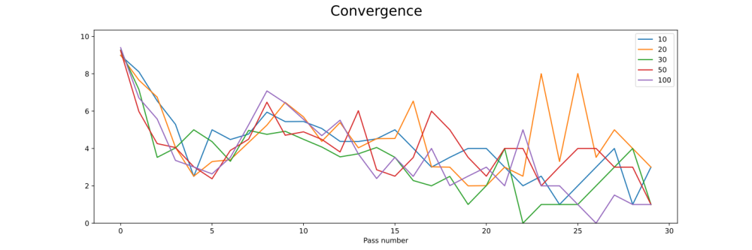
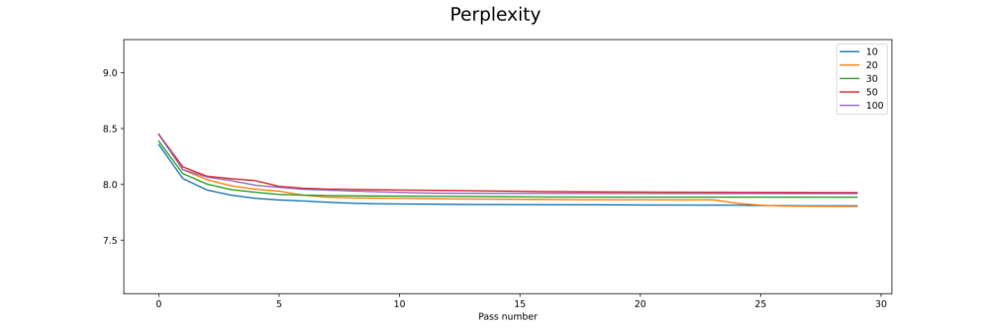
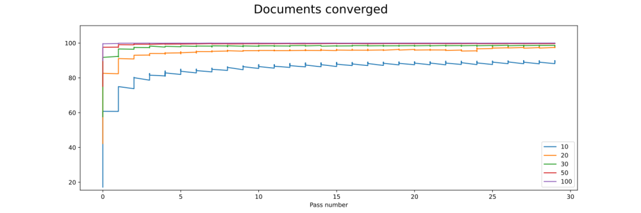
Note: y-axis displays metric values. Line colours represent number of iterations

Figure S2: Topic perplexity on the test set for diseases
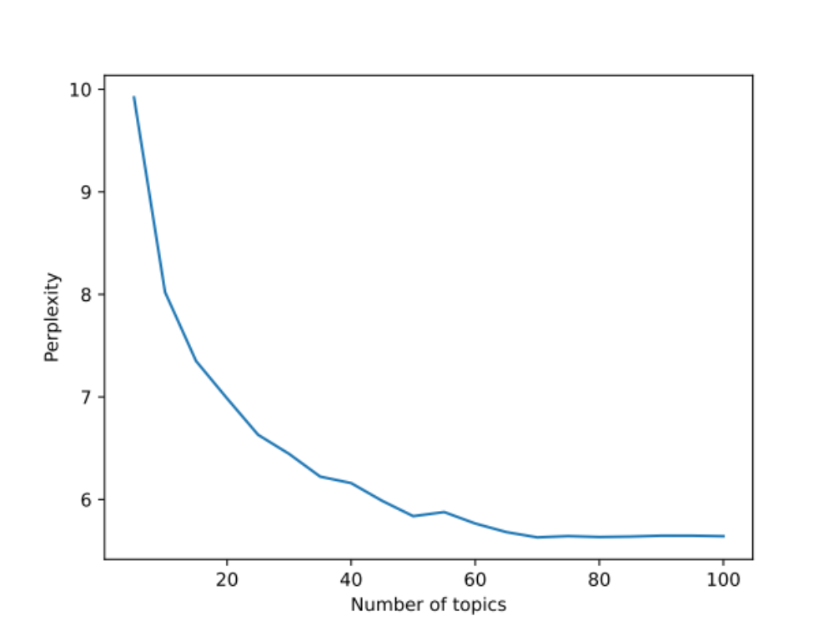

Figure S3: Topic perplexity on the test set for Medcodes
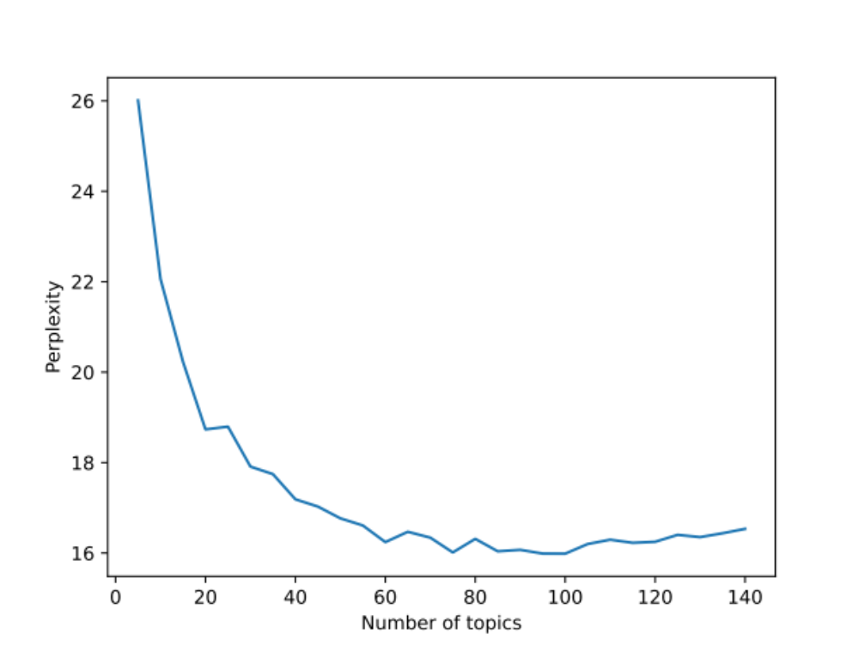
Doc2vec
Given our previous work using word2vec found that changing the default parameters of window size (=5), negative sampling (=5) and down-sampling (=0.001) made little difference to the learned disease representations, we retained these default settings for doc2vec.¹² However, initial evaluations of the embeddings suggested poor results, related to the learning rate and epochs. To evaluate different hyperparameter settings of the doc2vec models, we created a metric based on patients with the same disease sequences, expecting that a well-performing model should result in patients with the same disease sequence being assigned a similar vector. We first define the set of all 1,498,469 patients with a duplicate disease sequence, S (with 171,378 unique disease sequences). The algorithm proceeds as follows:

- Draw a random bootstrap sample of 10,000 patients from set S.
- For each patient $P_{i}$ in set S, determine $D_{i}$, the sub-set of patients from set S with the same disease sequence.
- For each patient, $P_{i}$, calculate the set ${Sim}_{i,N}$, of the N most similar patients based on cosine similarity from set S.
- Calculate the metric $M_{i}$ as the percentage of set $D_{i}$ that are in the set ${Sim}_{i,N}$
- Calculate the metric $M$of the mean of values of $M_{i}$ across all patients $P_{i}$

We compare values of N most-similar patients for 1% and 0.1% of the total dataset. The resulting metric can then be interpreted as the probability that the algorithm identifies patients which have the same disease sequence as being in the top 1% or 0.1% of most similar patients. Using this metric as a guide, experiments were run varying the learning rate, epochs and vector size, aiming to optimise the metric for values of 1% and 0.1%. For disease sequences, we trialled vector sizes of 30 and 100, learning rates of 0.025 (the default), 0.01, 0.0075, 0.005, 0.00025 and 0.001, and epochs of 10, 20, 50 and 100, shown in Table S3.

We followed the same approach for testing doc2vec models trained on Medcode sequences, shown in Table S4. Given models were well-performing using default settings, we trialled only over vector sizes of 30 and 100, learning rates of 0.025 and 0.0075 and epochs of 10, 20, 50 and 100.

Table S3: Comparisons of doc2vec algorithms, vector size, learning rate and epochs for disease sequences

Model | Vector size | Learning rate | Epochs | % exact duplicates in top 1% | % of exact duplicates in top 0.1%
DBOW | 30 | 0.025 | 10 | 22.3% | 8.6%
DBOW | 30 | 0.025 | 20 | 27.8% | 12.1%
DBOW | 30 | 0.025 | 50 | 33.7% | 15.9%
DBOW | 30 | 0.025 | 100 | 35.8% | 17.8%
DBOW | 30 | 0.01 | 10 | 49.9% | 22.4%
DBOW | 30 | 0.01 | 20 | 64.7% | 35.8%
DBOW | 30 | 0.01 | 50 | 75.4% | 47.5%
DBOW | 30 | 0.01 | 100 | 78.7% | 53.5%
DBOW | 30 | 0.0075 | 10 | 61.7% | 31.3%
DBOW | 30 | 0.0075 | 20 | 81.8% | 50.3%
DBOW | 30 | 0.0075 | 50 | 93.5% | 69.8%
DBOW | 30 | 0.0075 | 100 | 96.1% | 76.1%
DBOW | 30 | 0.005 | 10 | 63.4% | 34.0%
DBOW | 30 | 0.005 | 20 | 84.3% | 56.4%
DBOW | 30 | 0.005 | 50 | 96.0% | 77.1%
DBOW | 30 | 0.005 | 100 | 98.4% | 83.6%
DBOW | 30 | 0.0025 | 10 | 47.4% | 20.6%
DBOW | 30 | 0.0025 | 20 | 77.5% | 49.0%
DBOW | 30 | 0.0025 | 50 | 95.1% | 75.0%
DBOW | 30 | 0.0025 | 100 | 98.2% | 82.9%
DBOW | 30 | 0.001 | 10 | 7.2% | 1.8%
DBOW | 30 | 0.001 | 20 | 41.1% | 16.9%
DBOW | 30 | 0.001 | 50 | 88.1% | 63.1%
DBOW | 30 | 0.001 | 100 | 96.6% | 78.4%
DBOW | 100 | 0.025 | 10 | 34.9% | 13.4%
DBOW | 100 | 0.025 | 20 | 40.7% | 17.8%
DBOW | 100 | 0.025 | 50 | 44.2% | 21.6%
DBOW | 100 | 0.025 | 100 | 46.4% | 22.9%
DBOW | 100 | 0.01 | 10 | 64.1% | 31.4%
DBOW | 100 | 0.01 | 20 | 78.5% | 44.6%
DBOW | 100 | 0.01 | 50 | 86.2% | 58.0%
DBOW | 100 | 0.01 | 100 | 88.9% | 63.2%
DBOW | 100 | 0.0075 | 10 | 75.2% | 40.9%
DBOW | 100 | 0.0075 | 20 | 89.1% | 58.5%
DBOW | 100 | 0.0075 | 50 | 95.3% | 74.0%
DBOW | 100 | 0.0075 | 100 | 96.3% | 77.7%
DBOW | 100 | 0.005 | 10 | 76.8% | 46.2%
DBOW | 100 | 0.005 | 20 | 91.7% | 65.8%
DBOW | 100 | 0.005 | 50 | 98.2% | 82.0%
DBOW | 100 | 0.005 | 100 | 99.3% | 86.2%
DBOW | 100 | 0.0025 | 10 | 72.4% | 41.3%
DBOW | 100 | 0.0025 | 20 | 90.6% | 65.3%
DBOW | 100 | 0.0025 | 50 | 98.2% | 82.1%
DBOW | 100 | 0.0025 | 100 | 99.4% | 87.2%
DBOW | 100 | 0.001 | 10 | 25.2% | 7.2%
DBOW | 100 | 0.001 | 20 | 76.9% | 45.2%
DBOW | 100 | 0.001 | 50 | 97.3% | 78.8%
DBOW | 100 | 0.001 | 100 | 99.2% | 85.8%
DM | 30 | 0.025 | 10 | 4.0% | 1.2%
DM | 30 | 0.025 | 20 | 11.6% | 5.1%
DM | 30 | 0.025 | 50 | 26.7% | 12.8%
DM | 30 | 0.025 | 100 | 45.8% | 22.0%
DM | 30 | 0.01 | 10 | 1.8% | 0.2%
DM | 30 | 0.01 | 20 | 3.1% | 0.4%
DM | 30 | 0.01 | 50 | 20.6% | 9.9%
DM | 30 | 0.01 | 100 | 53.0% | 28.1%
DM | 30 | 0.0075 | 10 | 1.5% | 0.1%
DM | 30 | 0.0075 | 20 | 2.6% | 0.5%
DM | 30 | 0.0075 | 50 | 15.6% | 6.5%
DM | 30 | 0.0075 | 100 | 50.4% | 27.4%
DM | 30 | 0.005 | 10 | 1.4% | 0.1%
DM | 30 | 0.005 | 20 | 1.9% | 0.4%
DM | 30 | 0.005 | 50 | 3.5% | 0.5%
DM | 30 | 0.005 | 100 | 8.2% | 2.7%
DM | 30 | 0.0025 | 10 | 1.3% | 0.1%
DM | 30 | 0.0025 | 20 | 1.4% | 0.1%
DM | 30 | 0.0025 | 50 | 1.8% | 0.3%
DM | 30 | 0.0025 | 100 | 2.9% | 0.5%
DM | 30 | 0.001 | 10 | 1.0% | 0.1%
DM | 30 | 0.001 | 20 | 1.0% | 0.2%
DM | 30 | 0.001 | 50 | 1.3% | 0.2%
DM | 30 | 0.001 | 100 | 1.6% | 0.3%
DM | 100 | 0.025 | 10 | 10.1% | 4.5%
DM | 100 | 0.025 | 20 | 17.8% | 8.7%
DM | 100 | 0.025 | 50 | 28.1% | 14.2%
DM | 100 | 0.025 | 100 | 33.8% | 17.9%
DM | 100 | 0.01 | 10 | 6.4% | 2.6%
DM | 100 | 0.01 | 20 | 16.6% | 8.4%
DM | 100 | 0.01 | 50 | 38.0% | 18.8%
DM | 100 | 0.01 | 100 | 54.2% | 30.0%
DM | 100 | 0.0075 | 10 | 4.8% | 1.6%
DM | 100 | 0.0075 | 20 | 12.4% | 6.1%
DM | 100 | 0.0075 | 50 | 31.7% | 15.6%
DM | 100 | 0.0075 | 100 | 44.9% | 25.1%
DM | 100 | 0.005 | 10 | 2.9% | 0.7%
DM | 100 | 0.005 | 20 | 7.4% | 3.2%
DM | 100 | 0.005 | 50 | 28.3% | 14.0%
DM | 100 | 0.005 | 100 | 32.6% | 16.6%
DM | 100 | 0.0025 | 10 | 1.9% | 0.2%
DM | 100 | 0.0025 | 20 | 3.9% | 1.2%
DM | 100 | 0.0025 | 50 | 13.4% | 6.8%
DM | 100 | 0.0025 | 100 | 34.1% | 17.7%
DM | 100 | 0.001 | 10 | 1.0% | 0.1%
DM | 100 | 0.001 | 20 | 1.3% | 0.2%
DM | 100 | 0.001 | 50 | 6.2% | 2.2%
DM | 100 | 0.001 | 100 | 14.6% | 7.0%
* Rows highlighted in bold are those selected with highest values of both metrics

Table S4: Comparisons of doc2vec algorithms, vector size, learning rate and epochs for Medcode sequences

Model | Vector size | Learning rate | Epochs | % exact duplicates in top 1% | % of exact duplicates in top 0.1%
DBOW | 30 | 0.025 | 10 | 60.4% | 36.8%
DBOW | 30 | 0.025 | 20 | 70.0% | 45.1%
DBOW | 30 | 0.025 | 50 | 77.5% | 54.6%
DBOW | 30 | 0.025 | 100 | 80.3% | 58.5%
DBOW | 30 | 0.0075 | 10 | 83.3% | 66.1%
DBOW | 30 | 0.0075 | 20 | 92.6% | 79.4%
DBOW | 30 | 0.0075 | 50 | 96.9% | 86.4%
DBOW | 30 | 0.0075 | 100 | 98.9% | 89.8%
DBOW | 100 | 0.025 | 10 | 80.9% | 58.9%
DBOW | 100 | 0.025 | 20 | 83.6% | 62.5%
DBOW | 100 | 0.025 | 50 | 85.6% | 67.0%
DBOW | 100 | 0.025 | 100 | 86.6% | 66.4%
DBOW | 100 | 0.0075 | 10 | 90.8% | 76.7%
DBOW | 100 | 0.0075 | 20 | 96.1% | 84.6%
DBOW | 100 | 0.0075 | 50 | 99.4% | 90.0%
DBOW | 100 | 0.0075 | 100 | 100.0% | 92.1%
DM | 30 | 0.025 | 10 | 18.2% | 7.6%
DM | 30 | 0.025 | 20 | 63.6% | 42.4%
DM | 30 | 0.025 | 50 | 92.8% | 79.4%
DM | 30 | 0.025 | 100 | 97.8% | 87.2%
DM | 30 | 0.0075 | 10 | 1.7% | 0.4%
DM | 30 | 0.0075 | 20 | 3.5% | 1.4%
DM | 30 | 0.0075 | 50 | 50.0% | 31.8%
DM | 30 | 0.0075 | 100 | 90.0% | 78.0%
DM | 100 | 0.025 | 10 | 48.5% | 34.3%
DM | 100 | 0.025 | 20 | 78.3% | 61.7%
DM | 100 | 0.025 | 50 | 93.9% | 75.9%
DM | 100 | 0.025 | 100 | 98.0% | 82.3%
DM | 100 | 0.0075 | 10 | 15.8% | 7.6%
DM | 100 | 0.0075 | 20 | 47.3% | 33.3%
DM | 100 | 0.0075 | 50 | 87.6% | 76.3%
DM | 100 | 0.0075 | 100 | 96.0% | 85.6%
* Rows highlighted in bold are those selected with highest values of both metrics

BERT models
Figure S4 shows our model input set up for EHR-BERT. Multiple diseases/Medcodes (D1, D2, D3, etc.) can be recorded at each visit. Each visit is represented by the visit number (ordered from 1 to N), and calendar year of the visit. Additional demographic information includes age at each visit, and time-invariant attributes of gender, ethnicity, and deprivation decile. Gender was included as three categories of ‘female’, ‘male’ or ‘indeterminate/unknown’. Ethnicity was included as White, South Asian Black, Other, Mixed, or unknown. Deprivation used deciles from 1 (most deprived) to 10 (least deprived) or ‘unknown’. Note that in EHR-BERT, as with BEHRT, there is no absolute positional embedding, as there is no natural ordering of the codes within-visit, and so the absolute position is non-informative.

Figure S4: EHR-BERT embedding model for an example of a sequence of four visits in one patient
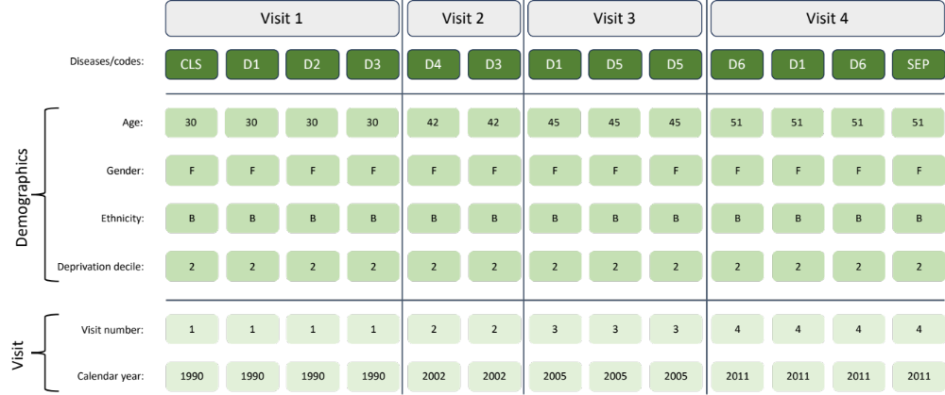

Table S5: Comparison of prediction of mortality over different epochs for transformer models (best performance on AUC and APS for each model highlighted in bold)
Model | Epochs | Covariates | AUC | APS
MedBERT diseases | 10 | Included | 0.848 | 0.182
MedBERT diseases | 50 | Included | 0.848 | 0.183
MedBERT diseases | 100 | Included | 0.849 | 0.184
MedBERT Medcodes | 10 | Included | 0.845 | 0.179
MedBERT Medcodes* | 50 | Included | 0.847 | 0.182
MedBERT Medcodes* | 100 | Included | 0.847 | 0.182
BEHRT diseases | 10 | Included | 0.858 | 0.205
BEHRT diseases | 50 | Included | 0.860 | 0.209
BEHRT diseases | 100 | Included | 0.861 | 0.210
BEHRT Medcodes | 10 | Included | 0.856 | 0.202
BEHRT Medcodes* | 50 | Included | 0.860 | 0.208
BEHRT Medcodes* | 100 | Included | 0.860 | 0.208
EHR-BERT diseases | 10 | Included | 0.864 | 0.211
EHR-BERT diseases | 50 | Included | 0.866 | 0.215
EHR-BERT diseases | 100 | Included | 0.866 | 0.216
EHR-BERT Medcodes | 10 | Included | 0.860 | 0.206
EHR-BERT Medcodes | 50 | Included | 0.863 | 0.210
EHR-BERT Medcodes | 100 | Included | 0.863 | 0.211
* Indicates where best model not consistent between AUC and APS (one model results in the highest AUC, another in the highest APS)

Table S6: Comparison of prediction of any hypertension code over different epochs for transformer models (best performance on AUC and APS for each model highlighted in bold)
Model | Epochs | Covariates | AUC | APS
MedBERT diseases | 10 | Included | 0.915 | 0.559
MedBERT diseases | 50 | Included | 0.915 | 0.558
MedBERT diseases | 100 | Included | 0.915 | 0.562
MedBERT Medcodes | 10 | Included | 0.912 | 0.554
MedBERT Medcodes* | 50 | Included | 0.912 | 0.555
MedBERT Medcodes* | 100 | Included | 0.912 | 0.556
BEHRT diseases | 10 | Included | 0.920 | 0.592
BEHRT diseases | 50 | Included | 0.920 | 0.600
BEHRT diseases | 100 | Included | 0.920 | 0.606
BEHRT Medcodes | 10 | Included | 0.917 | 0.581
BEHRT Medcodes | 50 | Included | 0.918 | 0.593
BEHRT Medcodes | 100 | Included | 0.918 | 0.598
EHR-BERT diseases | 10 | Included | 0.921 | 0.605
EHR-BERT diseases | 50 | Included | 0.920 | 0.613
EHR-BERT diseases | 100 | Included | 0.920 | 0.616
EHR-BERT Medcodes | 10 | Included | 0.915 | 0.580
EHR-BERT Medcodes | 50 | Included | 0.917 | 0.596
EHR-BERT Medcodes | 100 | Included | 0.918 | 0.602
* Indicates where best model not consistent between AUC and APS (one model results in the highest AUC, another in the highest APS)

Supplementary results
Figure S5: Model ROC-AUC (panel A) and APS (panel B) for different embedding models for prediction of mortality, emergency department attendances and emergency admissions within 12 months; without covariates)
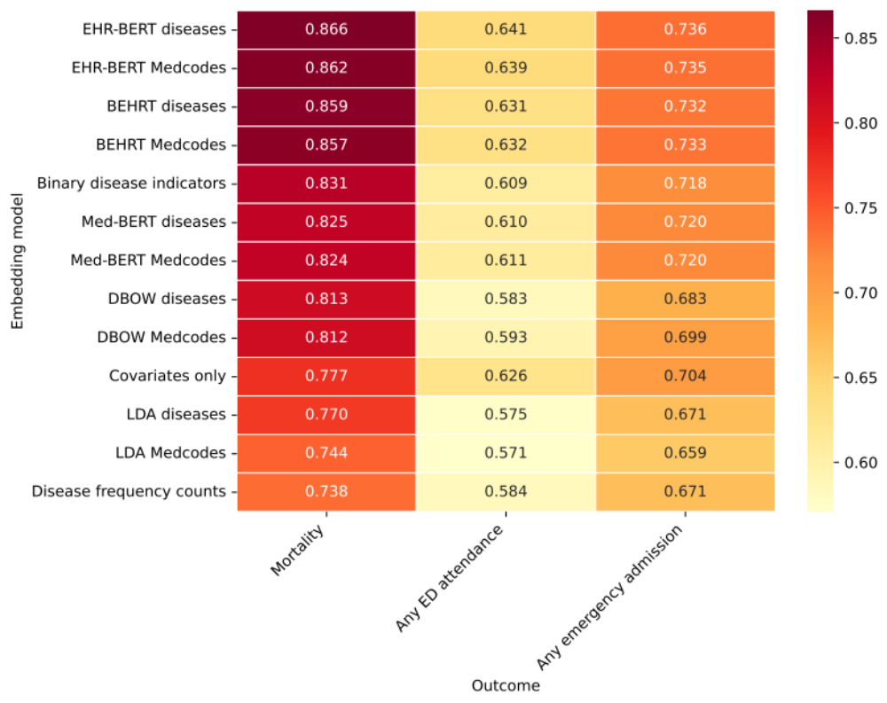
A

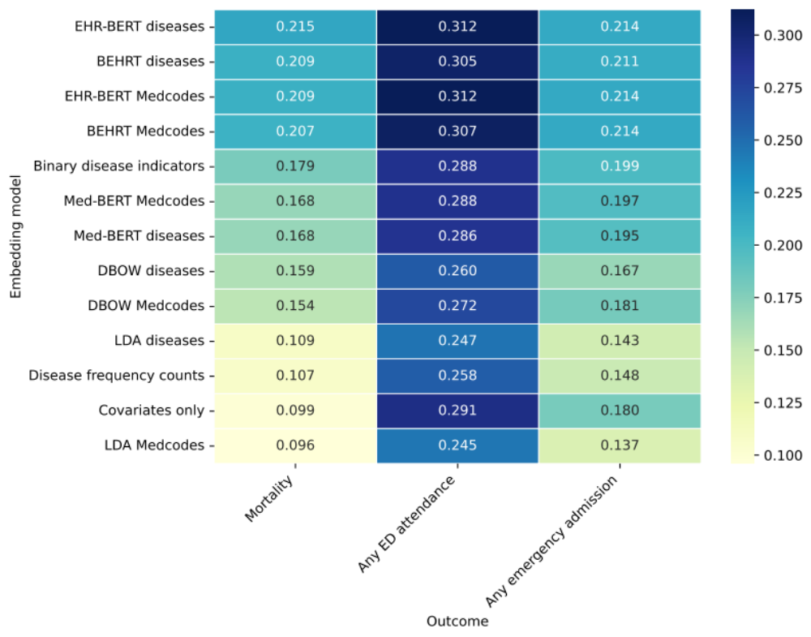
B

Figure S6: Model ROC-AUC (panel A) and APS (panel B) for different embedding models for prediction of any versus new diseases developed within 12 months; without covariates
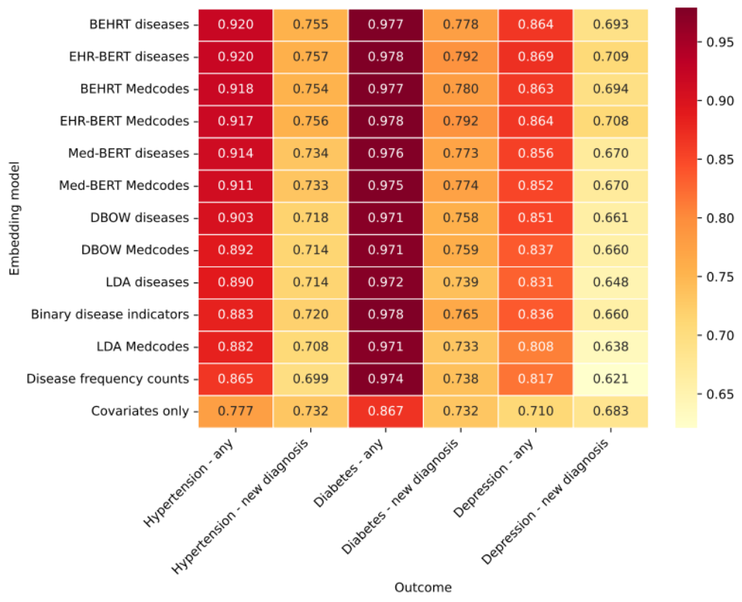
A

B

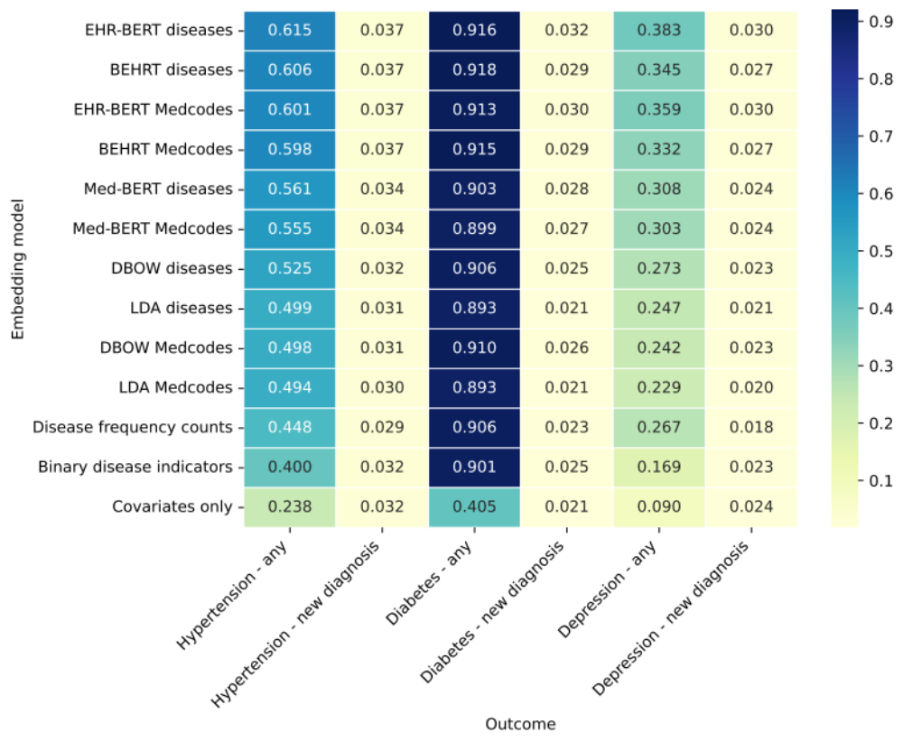

References

1. NHS Digital. Data Model and Dictionary: Ethnic Category. https://www.datadictionary.nhs.uk/data_elements/ethnic_category.html.
2. Davidson, J. et al. Codelists for: ‘Ethnic differences in the incidence of clinically diagnosed influenza: an England population-based cohort study 2008-2018’. https://datacompass.lshtm.ac.uk/id/eprint/2102/ (2021) doi:10.17037/DATA.00002102.
3. Mathur, R., Palla, L., Farmer, R. E., Chaturvedi, N. & Smeeth, L. Ethnic differences in the severity and clinical management of type 2 diabetes at time of diagnosis: A cohort study in the UK Clinical Practice Research Datalink. Diabetes Research and Clinical Practice 160, (2020).
4. Gallagher, A. M., Dedman, D., Padmanabhan, S., Leufkens, H. G. M. & de Vries, F. The accuracy of date of death recording in the Clinical Practice Research Datalink GOLD database in England compared with the Office for National Statistics death registrations. Pharmacoepidemiology and Drug Safety 28, 563–569 (2019).
5. Delmestri, A. & Prieto-Alhambra, D. CPRD GOLD and linked ONS mortality records: Reconciling guidelines. Int J Med Inform 136, 104038 (2020).
6. Wallach, H., Mimno, D. & McCallum, A. Rethinking LDA: Why Priors Matter. in Advances in Neural Information Processing Systems vol. 22 (Curran Associates, Inc., 2009).
7. Syed, S. & Spruit, M. Selecting Priors for Latent Dirichlet Allocation. in 2018 IEEE 12th International Conference on Semantic Computing (ICSC) 194–202 (IEEE, 2018). doi:10.1109/ICSC.2018.00035.
8. Hoffman, M., Bach, F. & Blei, D. Online Learning for Latent Dirichlet Allocation. in Advances in Neural Information Processing Systems (eds. Lafferty, J., Williams, C., Shawe-Taylor, J., Zemel, R. & Culotta, A.) vol. 23 (Curran Associates, Inc., 2010).
9. Řehůřek, R. & Sojka, P. Software Framework for Topic Modelling with Large Corpora. in Proceedings of the LREC 2010 Workshop on New Challenges for NLP Frameworks 45–50 (ELRA, 2010).
10. Röder, M., Both, A. & Hinneburg, A. Exploring the Space of Topic Coherence Measures. in Proceedings of the Eighth ACM International Conference on Web Search and Data Mining 399–408 (Association for Computing Machinery, 2015). doi:10.1145/2684822.2685324.
11. Stevens, K., Kegelmeyer, P., Andrzejewski, D. & Buttler, D. Exploring Topic Coherence over Many Models and Many Topics. in Proceedings of the 2012 Joint Conference on Empirical Methods in Natural Language Processing and Computational Natural Language Learning 952–961 (Association for Computational Linguistics, 2012).
12. Beaney, T. et al. Identifying multi-resolution clusters of diseases in ten million patients with multimorbidity in primary care in England. 2023.06.30.23292080 Preprint at https://doi.org/10.1101/2023.06.30.23292080 (2023).

