Supplementary file
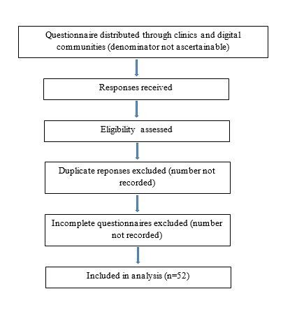

Supplementary Figure S1: Participant flow diagram

Supplementary Table S1. Questionnaire items used in the present analysis
Section | Questionnaire item | Response options
Demographics | What is your gender? | Male; Female; Other/Prefer not to say
Demographics | What is your age range? | Under 18; 18–25; 26–35; 36–45; 46–55; ≥56
Demographics | What is your country of residence? | Free text
Demographics | Education level | No formal education; Primary; Secondary; Tertiary
Clinical characteristics | What is your SCD genotype? | HbSS; HbSC; HbSβ-thalassemia; Other
Clinical characteristics | When was the last time you had a blood transfusion? | Never; <3 months; 3–6 months; 6–12 months; >12 months
Clinical characteristics | How many vaso-occlusive crises have you experienced in the past year? | None; 1–2; 3–5; >5
Clinical characteristics | Have you ever had a stroke or neurological complication? | Yes; No
Healthcare access | Do you have health insurance or access to healthcare services? | Yes; No
CDG domain | When was the last time you saw a hematologist? | <3 months; 3–6 months; 6–12 months; >12 months; Never
CDG domain | Are you currently receiving regular clinic follow-up for SCD? | Yes; No
CDG domain | Have you been assessed for heart disease? | Yes; No
CDG domain | Do you know your Vitamin B12 levels? | Yes; No; Not sure
Abbreviations: CDG, Care Delivery Gap; SCD, sickle cell disease.

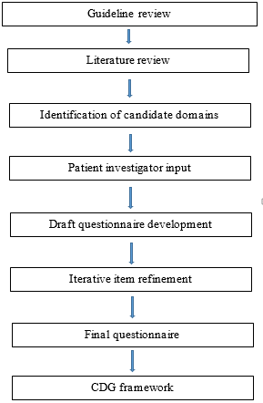

Supplementary Figure S2: Questionnaire and framework development process

Supplementary Table S2. CDG Framework Domain Mapping
Table S2. Mapping of Care Delivery Gap domains to survey items, scoring rules, and guideline-referenced care processes
CDG Domain | Survey Question | CDG Rule (1 point assigned if unmet) | Guideline-Referenced Care Process | Primary Guideline Source
Specialist involvement | When was the last time you saw a hematologist? | No hematology review within the preceding 12 months | Ongoing specialist involvement and access to clinicians experienced in SCD management | NHLBI Expert panel report 2014
Continuity of follow-up | Are you currently receiving any form of regular clinic follow-up for SCD? | No regular SCD follow-up within the preceding 12 months | Longitudinal clinical monitoring and routine comprehensive care | NHLBI Expert panel report 2014
Biochemical surveillance* | Do you know your vitamin B12 levels? | No reported B12 testing and/or participant uncertain of B12 status within the preceding 12 months | Exploratory micronutrient-surveillance domain included to assess longitudinal monitoring of potentially relevant nutritional parameters in SCD | Exploratory domain; not guideline derived
Organ-specific preventive screening | Have you been assessed for any heart disease? | No reported cardiopulmonary screening within guideline-referenced intervals | Preventive evaluation for cardiopulmonary complications and organ damage surveillance | ASH 2020 cerebrovascular and cardiopulmonary guidance
* Exploratory domain. Unlike the other three domains, vitamin B12 surveillance was included as a hypothesis-generating micronutrient-monitoring indicator and was not intended to represent a current guideline-mandated quality measure. Its inclusion was based on biological plausibility, chronic hemolytic stress, sustained erythropoietic demand, and the potential overlap between manifestations of vitamin B12 insufficiency and SCD-related clinical features.

Supplementary Table S3. Care Delivery Gap scoring algorithm
Domain | Criterion for domain met (Score = 0) | Criterion for domain unmet (Score = 1)
Specialist involvement | Hematology review within previous 12 months | No hematology review within previous 12 months
Continuity of follow-up | Regular SCD follow-up within previous 12 months | No regular SCD follow-up within previous 12 months
Organ-specific preventive screening | Reported cardiovascular/cardiopulmonary screening within guideline-referenced interval | No reported screening within guideline-referenced interval
Biochemical surveillance* | Vitamin B12 status known or tested within previous 12 months | No vitamin B12 testing and/or unknown vitamin B12 status
Exploratory micronutrient-surveillance domain included for hypothesis generation and framework development; not intended as a current guideline-mandated quality indicator.
Composite score interpretation
Total score | Category
0–1 | Low
2 | Moderate
3–4 | High
Calculation: Total CDG score = sum of unmet domains (possible range 0–4). Equal weighting was adopted for proof-of-concept framework development and does not imply equivalent clinical importance across domains.

Supplementary Table S4: Age-specific eligibility criteria for CDG domain

Domain | Adult eligibility | Paediatric eligibility
Specialist review | All | All
Follow-up | All | All
Preventive screening | Age-specific if applicable | Age-specific if applicable
B12 surveillance | All | All

