Supplemental materials

Methods – Additional information

Enrolment Questionnaire
Health status of participants was self-assessed by using 5-point scale: excellent, very good, good, fair, poor.

Case Definition
Participants who experienced any of the listed symptoms (fever, cough, general weakness, fatigue, headache, muscle ache, sore throat, runny nose, shortness of breath, lack of appetite, nausea, vomiting, diarrhoea, altered mental status, loss of taste, or loss of smell) were tested by PCR for SARS-CoV-2.

Definition of Prior Infection
We defined previous infection as a PCR-confirmed infection prior to start of study follow-up, that was documented in either the Etabib database or the MoH/Mandatory Health insurance database.

Statistical analyses
In addition to hospital location (urban or sub-urban) and previous SARS-CoV-2 infection that were included in the multivariable model as fixed effects, other potential confounders (e.g., calendar month, age, sex, occupation, hands-on care, household size, chronic condition, smoking, health status) were selected using augmented backward elimination with a change-in-estimate criterion of 5% and a significance threshold of 0.2 (1), however none were retained in the final model.

Assessment of Time Since Vaccination
We assessed the effect of time since vaccination on rVE against symptomatic infection over the following time intervals: 7–89, 90–150 and ≥150 days following booster dose. These periods were selected based on empirical information (power to estimate VE) and on bibliography (presence of neutralising antibodies 7 days after receiving booster dose(2), meta-analysis showing that 5 months after booster dose, VE dropped below 20% (3) ). We included symptomatic participants if they had symptoms in the window 14 days before and 4 days after the positive SARS-CoV-2 test.

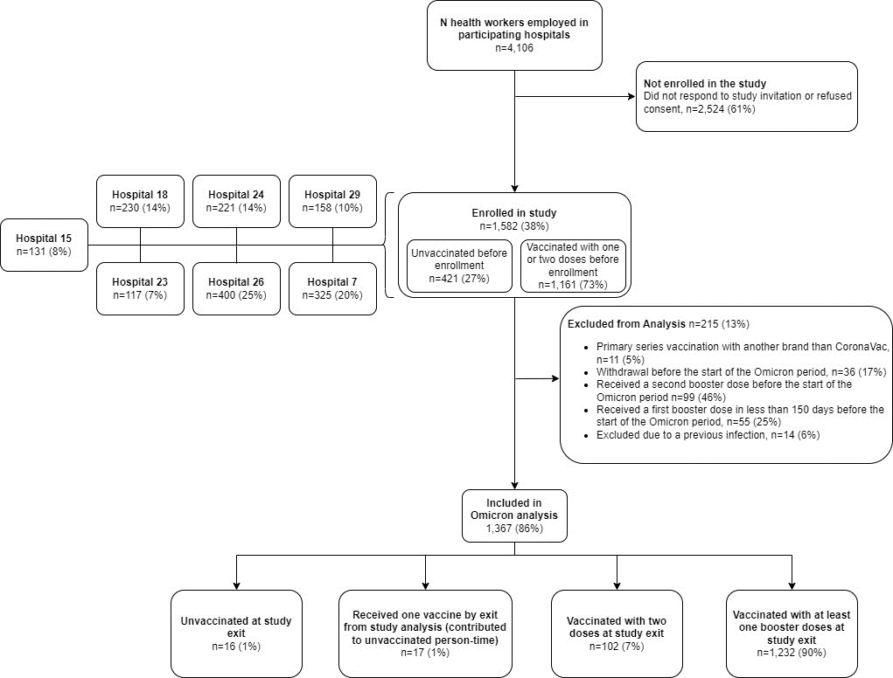

Figure S1. Flowchart illustrating the enrolment of healthcare workers in COVID-19 vaccine effectiveness study, Azerbaijan, 2022

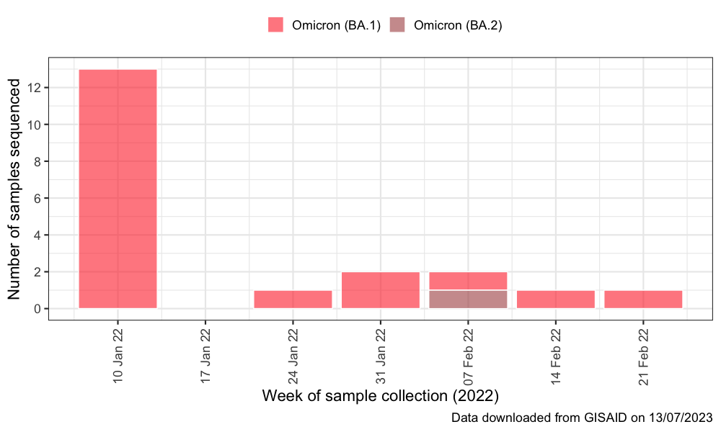
Figure S2. Whole genome sequencing results from SARS-CoV-2 positive samples from the study and from general surveillance data, GISAID, Azerbaijan, December 2021 – August 2022
Study samples (N=8), surveillance samples (N=12)

Table S1. Table 1. Demographic and occupational characteristics of health care worker participants by vaccination status on the last day of the follow-up period (n=115), Azerbaijan, 2022
 | All Participants, N=1367 | Unvaccinated, N=16 | Partially vaccinated (one dose), N=17 | Vaccinated with primary vaccine series (two doses), N=102 | Vaccinated with booster dose (third dose), N=1232
Age, N=1367
Median (IQR) | 48 (39-57) | 46 (33.8-62) | 46 (35-59) | 47.5 (39-58) | 48 (39-57)
Age group, years, N=1367
20-29, n (%) | 73 (5) | 3 (19) | 0 (0) | 10 (10) | 60 (5)
30-39, n (%) | 290 (21) | 4 (25) | 7 (41) | 20 (20) | 259 (21)
40-49, n (%) | 371 (27) | 1 (6) | 2 (12) | 24 (24) | 344 (28)
50-59, n (%) | 416 (30) | 3 (19) | 6 (35) | 24 (24) | 383 (31)
60+, n (%) | 217 (16) | 5 (31) | 2 (12) | 24 (24) | 186 (15)
Sex, N=1367
M, n (%) | 91 (7) | 1 (6) | 1 (6) | 8 (8) | 81 (7)
F, n (%) | 1276 (93) | 15 (94) | 16 (94) | 94 (92) | 1151 (93)
Hospital, N=1367
Hospital 15, n (%) | 122 (9) | 0 (0) | 0 (0) | 2 (2) | 120 (10)
Hospital 18, n (%) | 204 (15) | 1 (6) | 1 (6) | 8 (8) | 194 (16)
Hospital 23, n (%) | 95 (7) | 3 (19) | 2 (12) | 15 (15) | 75 (6)
Hospital 24, n (%) | 191 (14) | 3 (19) | 4 (24) | 27 (26) | 157 (13)
Hospital 26, n (%) | 359 (26) | 1 (6) | 8 (47) | 28 (27) | 322 (26)
Hospital 29, n (%) | 127 (9) | 5 (31) | 1 (6) | 14 (14) | 107 (9)
Hospital 7, n (%) | 269 (20) | 3 (19) | 1 (6) | 8 (8) | 257 (21)
Hospital Location, N=1367
Urban, n (%) | 517 (38) | 4 (25) | 5 (29) | 37 (36) | 471 (38)
Sub-urban, n (%) | 850 (62) | 12 (75) | 12 (71) | 65 (64) | 761 (62)
Occupation/Role in hospital, N=1367
Nurse or Midwife, n (%) | 506 (37) | 4 (25) | 6 (35) | 36 (35) | 460 (37)
Medical Doctor, n (%) | 349 (26) | 5 (31) | 6 (35) | 23 (23) | 315 (26)
Other, n (%) | 512 (37) | 7 (44) | 5 (29) | 43 (42) | 457 (37)
BMI, N=1367
Underweight or normal, n (%) | 382 (28) | 7 (44) | 3 (18) | 24 (24) | 348 (28)
Overweight, n (%) | 509 (37) | 6 (38) | 5 (29) | 37 (36) | 461 (37)
Obese, n (%) | 476 (35) | 3 (19) | 9 (53) | 41 (40) | 423 (34)
Smoking, N=1367
Currently smokes, n (%) | 38 (3) | 1 (6) | 0 (0) | 1 (<1) | 36 (3)
Never smokes, n (%) | 1315 (96) | 15 (94) | 15 (88) | 101 (>99) | 1184 (96)
Smoked previously, n (%) | 14 (1) | 0 (0) | 2 (12) | 0 (0) | 12 (<1)
Any chronic condition, N=1367
No, n (%) | 820 (60) | 10 (62) | 9 (53) | 53 (52) | 748 (61)
Yes, n (%) | 547 (40) | 6 (38) | 8 (47) | 49 (48) | 484 (39)
Number of chronic conditions, N=1367
0, n (%) | 820 (60) | 10 (62) | 9 (53) | 53 (52) | 748 (61)
1, n (%) | 383 (28) | 4 (25) | 4 (24) | 27 (26) | 348 (28)
≥2, n (%) | 164 (12) | 2 (12) | 4 (24) | 22 (22) | 136 (11)
Number of household members, N=1280
1-3, n (%) | 500 (39) | 9 (60) | 9 (53) | 32 (34) | 450 (39)
4-5, n (%) | 654 (51) | 3 (20) | 7 (41) | 51 (54) | 593 (51)
≥6, n (%) | 126 (10) | 3 (20) | 1 (6) | 11 (12) | 111 (10)
Hands on care, N=1367
No, n (%) | 798 (58) | 10 (62) | 11 (65) | 62 (61) | 715 (58)
Yes, n (%) | 569 (42) | 6 (38) | 6 (35) | 40 (39) | 517 (42)
Delay between 2nd dose and end of follow-up (days), N=1334
Median (IQR) | 328 (219-346) | _ | _ | 185 (165-241) | 333 (282.2-346)
Delay between 3rd dose and end of follow-up (days), N=1232
Median (IQR) | 94 (55.2-117.5) | _ | _ | _ | 94 (55.2-117.5)
COVID-19 vaccination status and vaccine brand at study period start, N=1367
Unvaccinated, n (%) | 16 (1) | 16 (100)
CoronaVac - 1 dose, n (%) | 17 (1) |  | 17 (100)
CoronaVac - 2 doses, n (%) | 102 (7) |  |  | 102 (100)
CoronaVac - 3 doses, n (%) | 1186 (87) |  |  |  | 1186 (96)
2 doses CoronaVac + 1 dose BNT162b2, n (%) | 46 (3) |  |  |  | 46 (4)

Table S2. Table with GISAID sample IDs and information about the authors
(website: https://epicov.org/epi3/epi_set/230713gx?main=true)

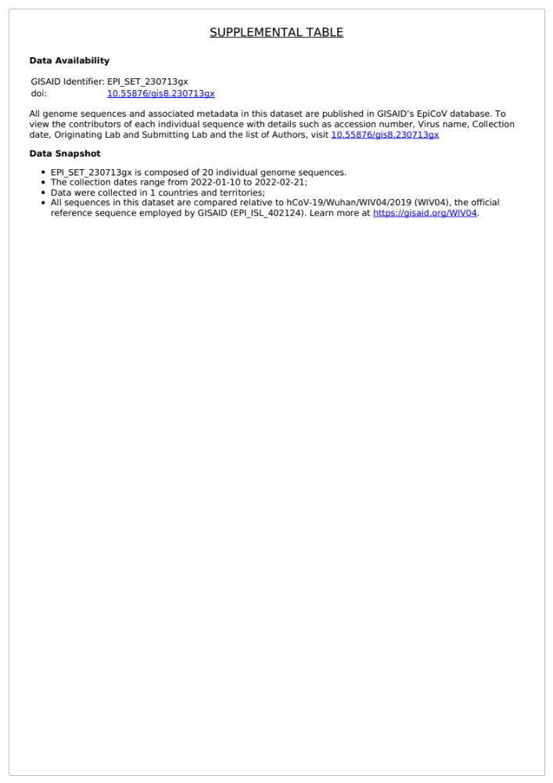

References
1. Dunkler D, Plischke M, Leffondré K, Heinze G. Augmented Backward Elimination: A Pragmatic and Purposeful Way to Develop Statistical Models. PLoS One [Internet]. 2014;9(11):1–19. Available from: https://doi.org/10.1371/journal.pone.0113677
2. Li M, Yang J, Wang L, Wu Q, Wu Z, Zheng W, et al. A booster dose is immunogenic and will be needed for older adults who have completed two doses vaccination with CoronaVac: a randomised, double-blind, placebo-controlled, phase 1/2 clinical trial. medRxiv [Internet]. 2021; Available from: https://www.medrxiv.org/content/early/2021/08/08/2021.08.03.21261544
3. Shao W, Chen X, Zheng C, Liu H, Wang G, Zhang B, et al. Effectiveness of COVID-19 vaccines against SARS-CoV-2 variants of concern in real-world: a literature review and meta-analysis. Emerg Microbes Infect [Internet]. 2022;11(1):2383–92. Available from: https://doi.org/10.1080/22221751.2022.2122582

