Appendix

Table A: Missing data for covariates

Measure | Percent missing (%)
Index of Multiple Deprivation | 1.68
Ethnicity | 10.21
Government Office Region | 0.05

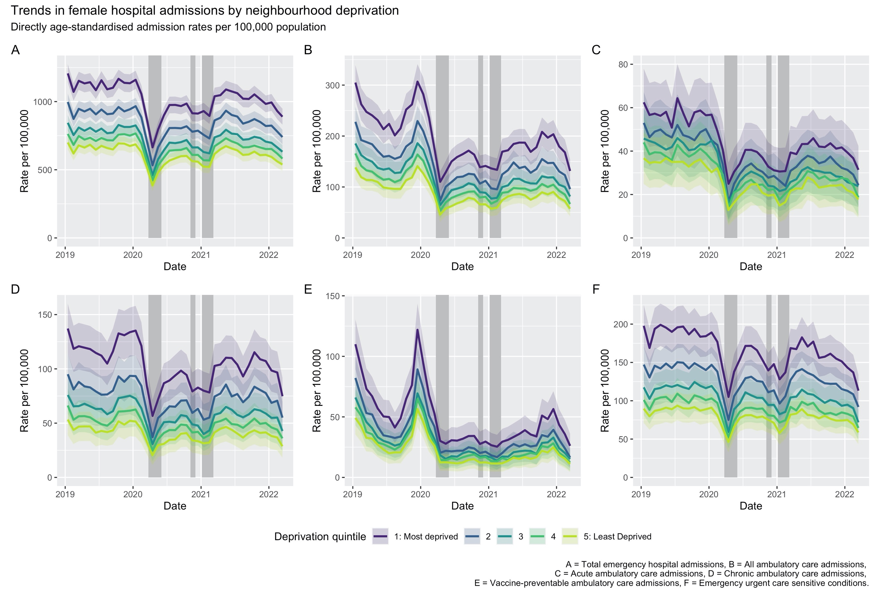
Figure A: Directly age-standardised admission rates for females by socioeconomic deprivation quintile.

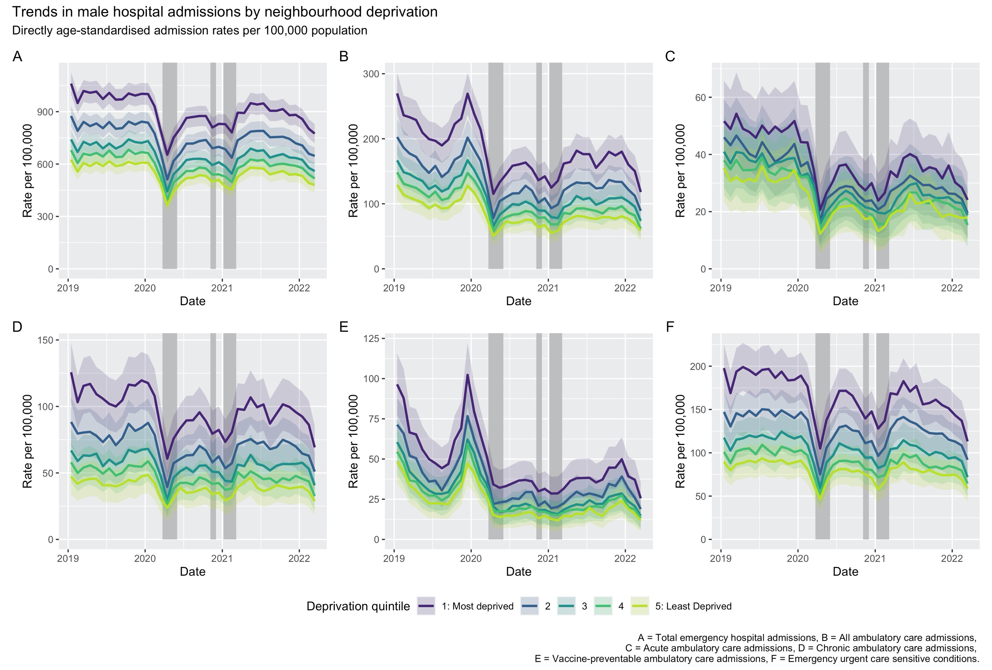
Figure B: Directly age-standardised admission rates for males by socioeconomic deprivation quintile.

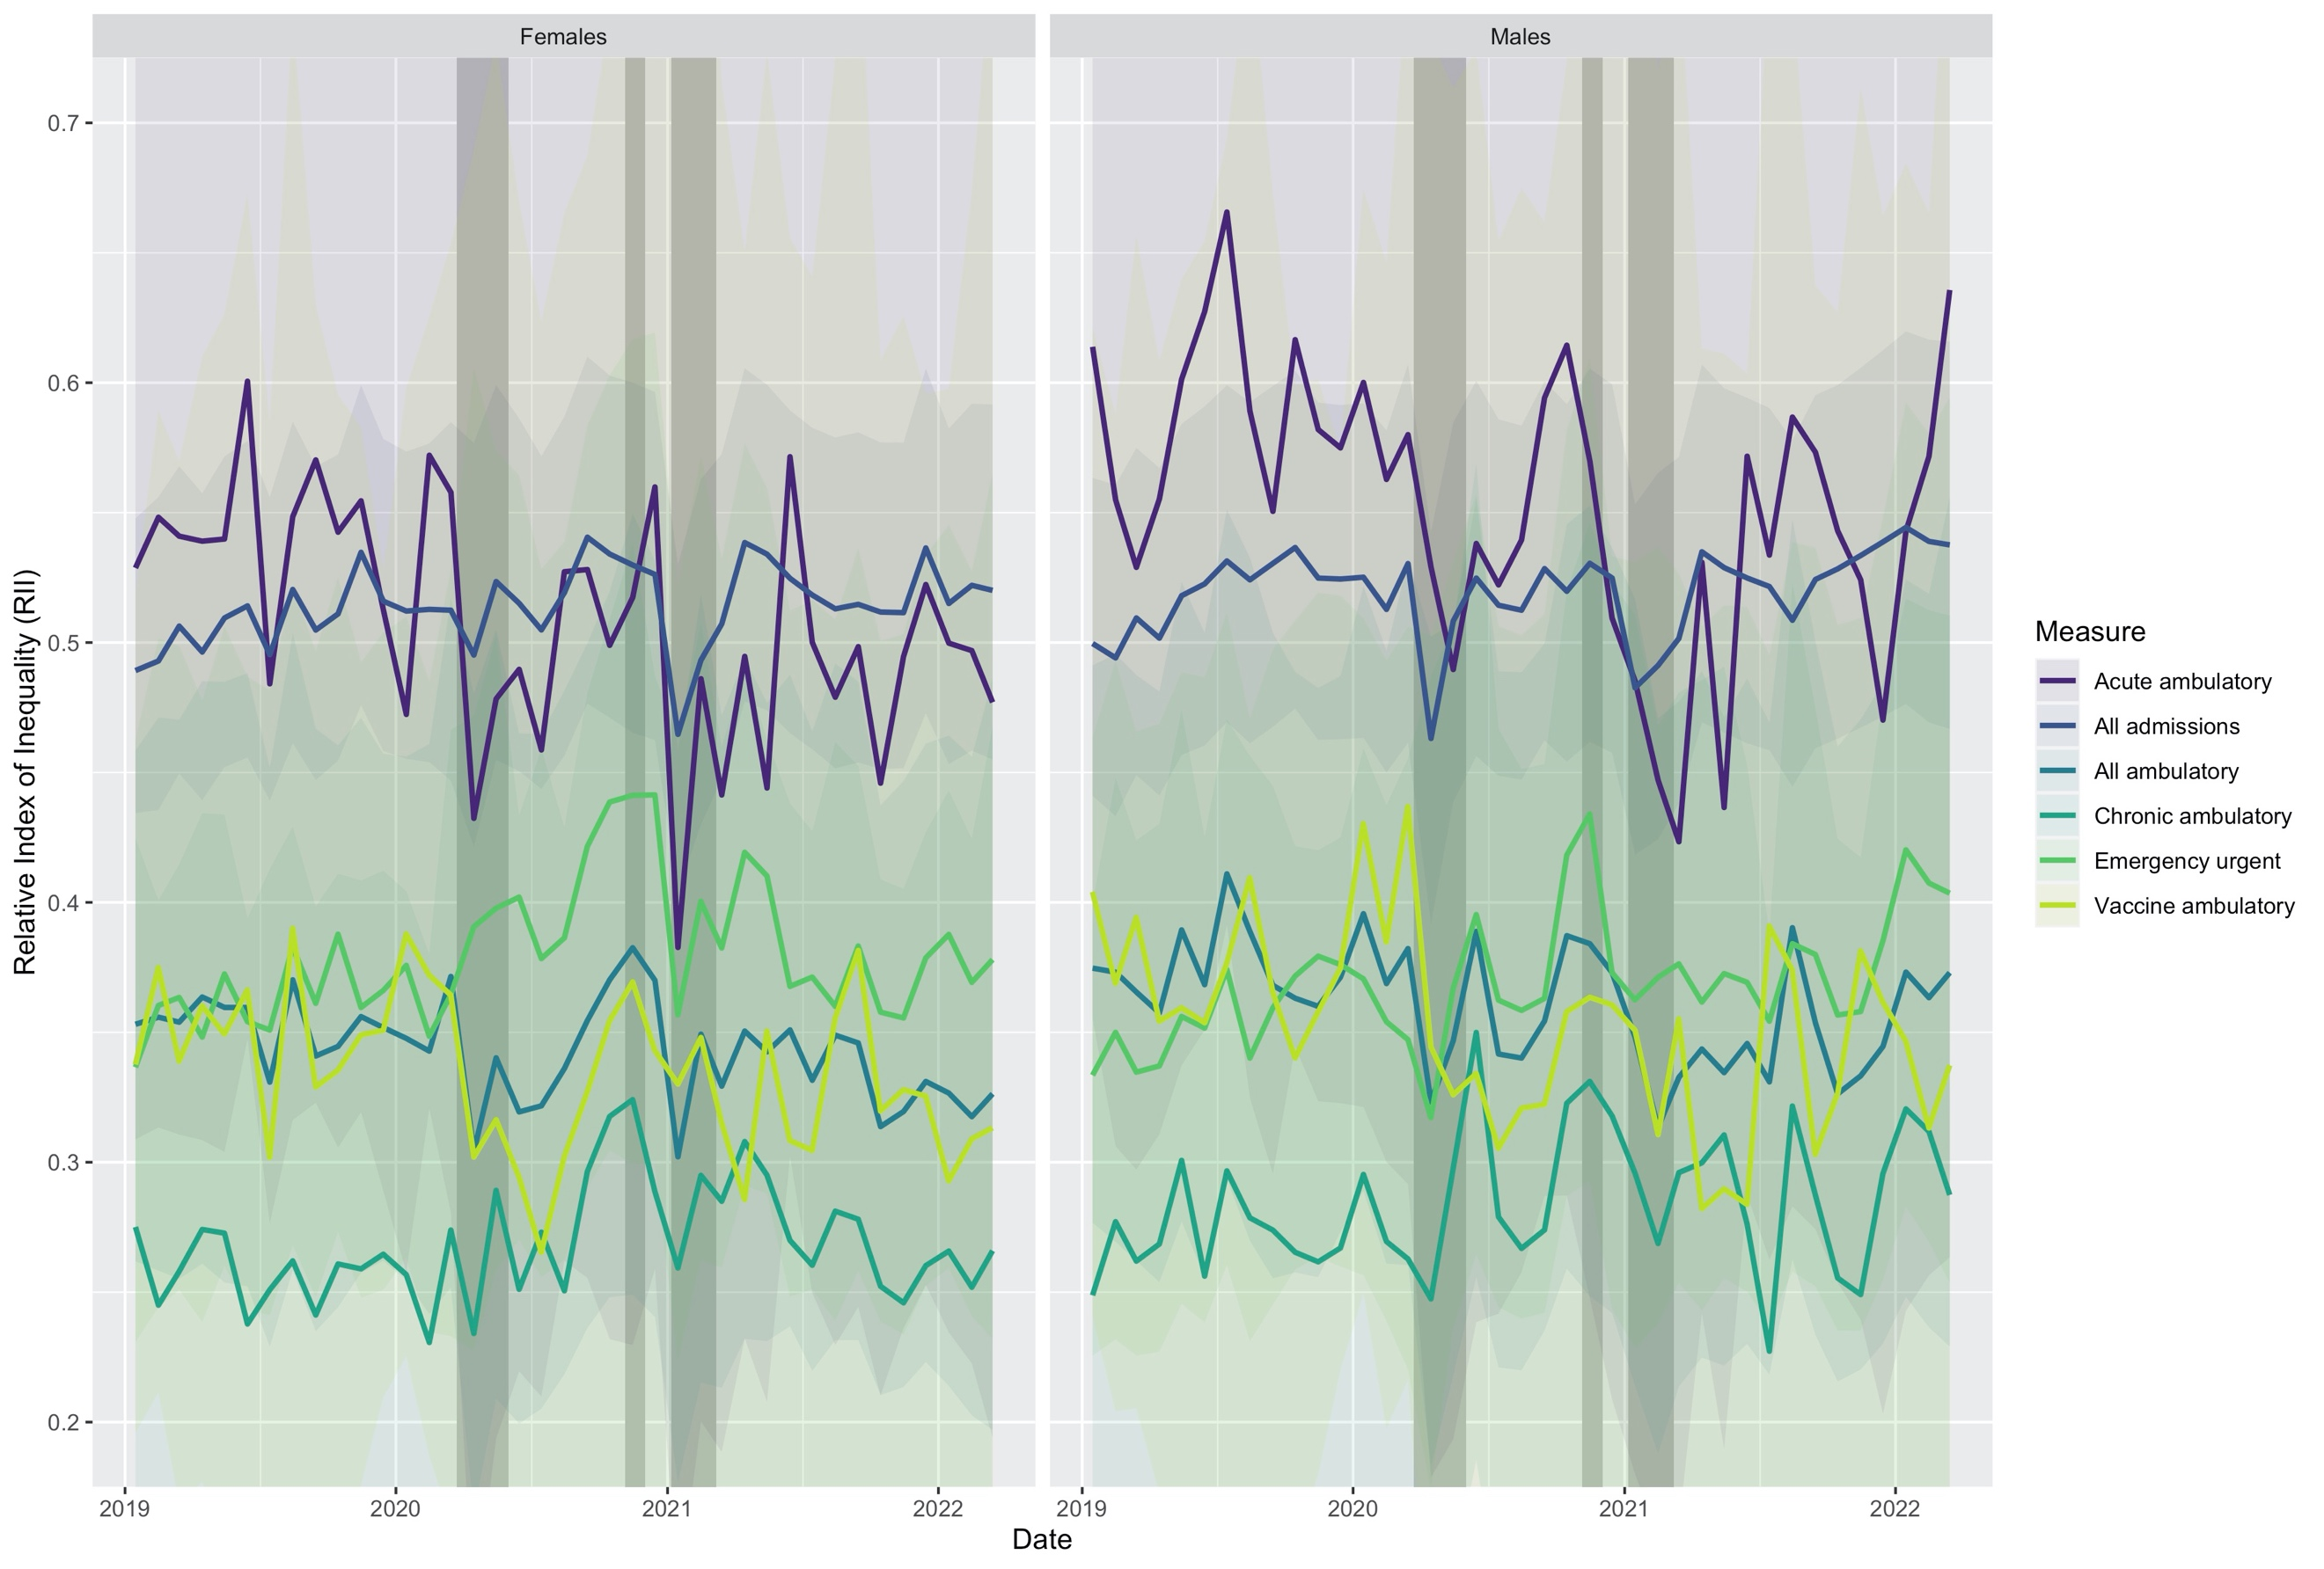
Figure C: Estimated Relative Index of Inequality (RII) for socioeconomic deprivation by sex.

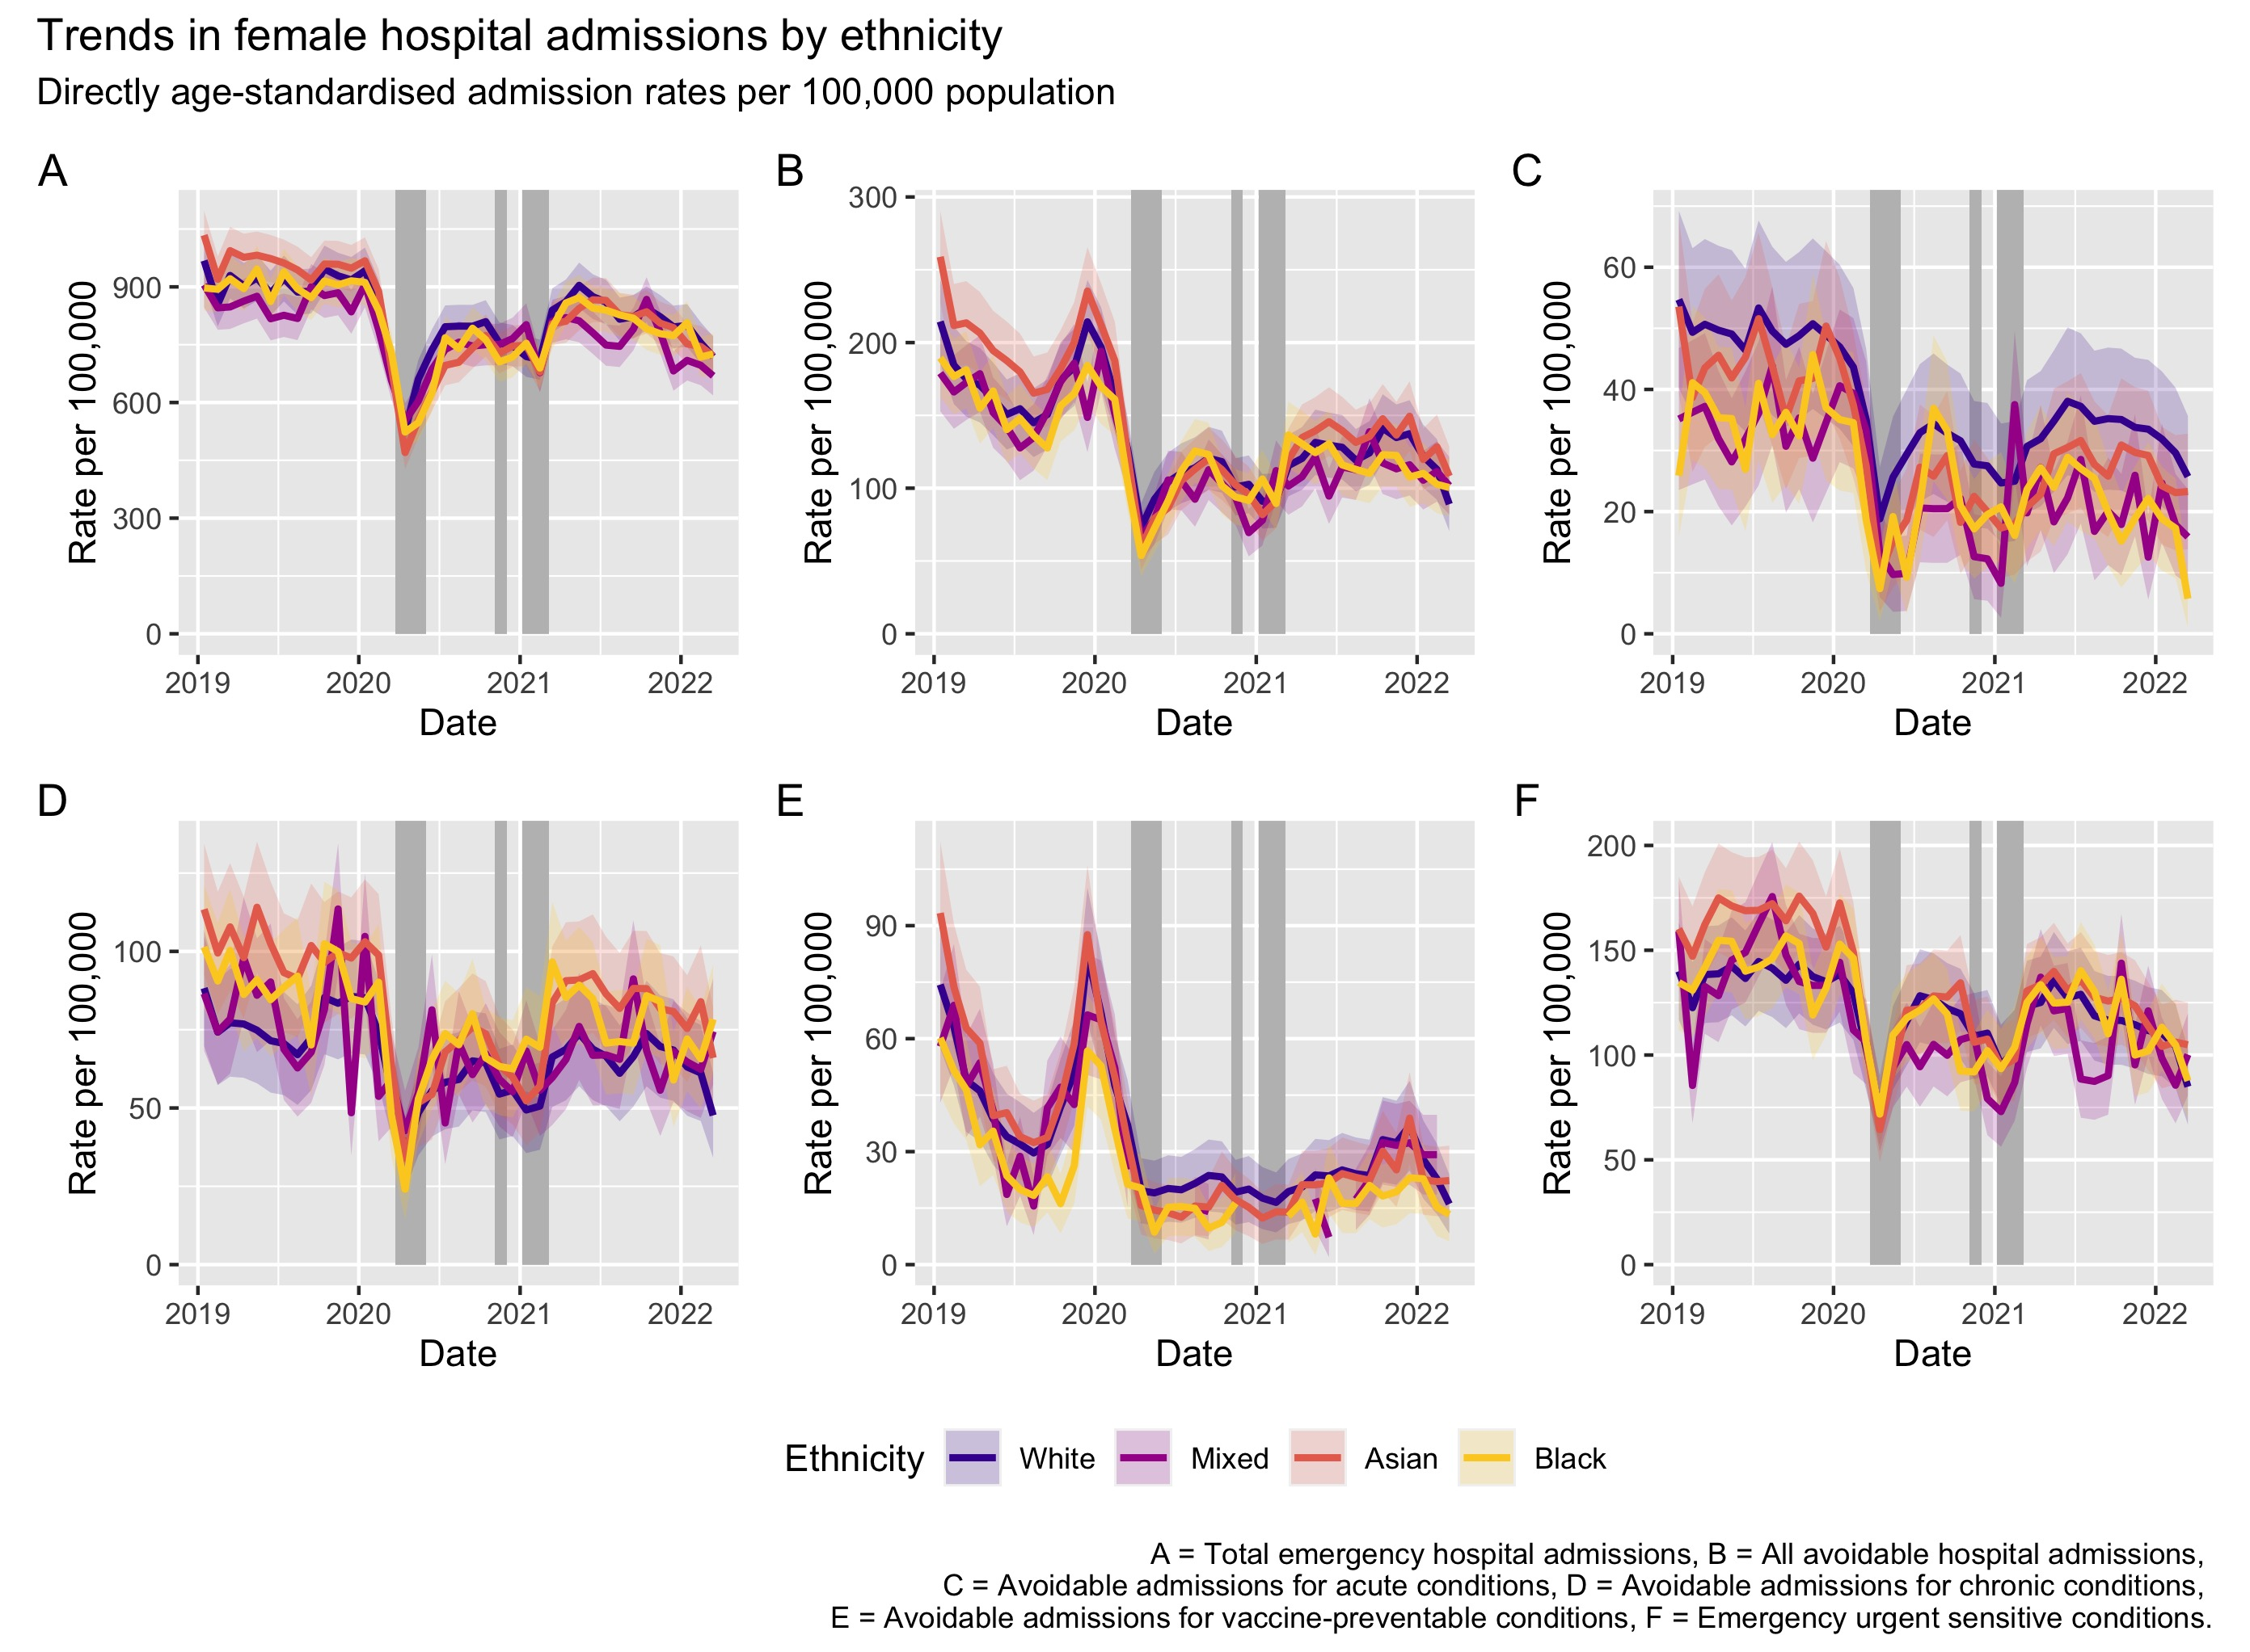
Figure D: Directly age-standardised admission rates for females by ethnicity.
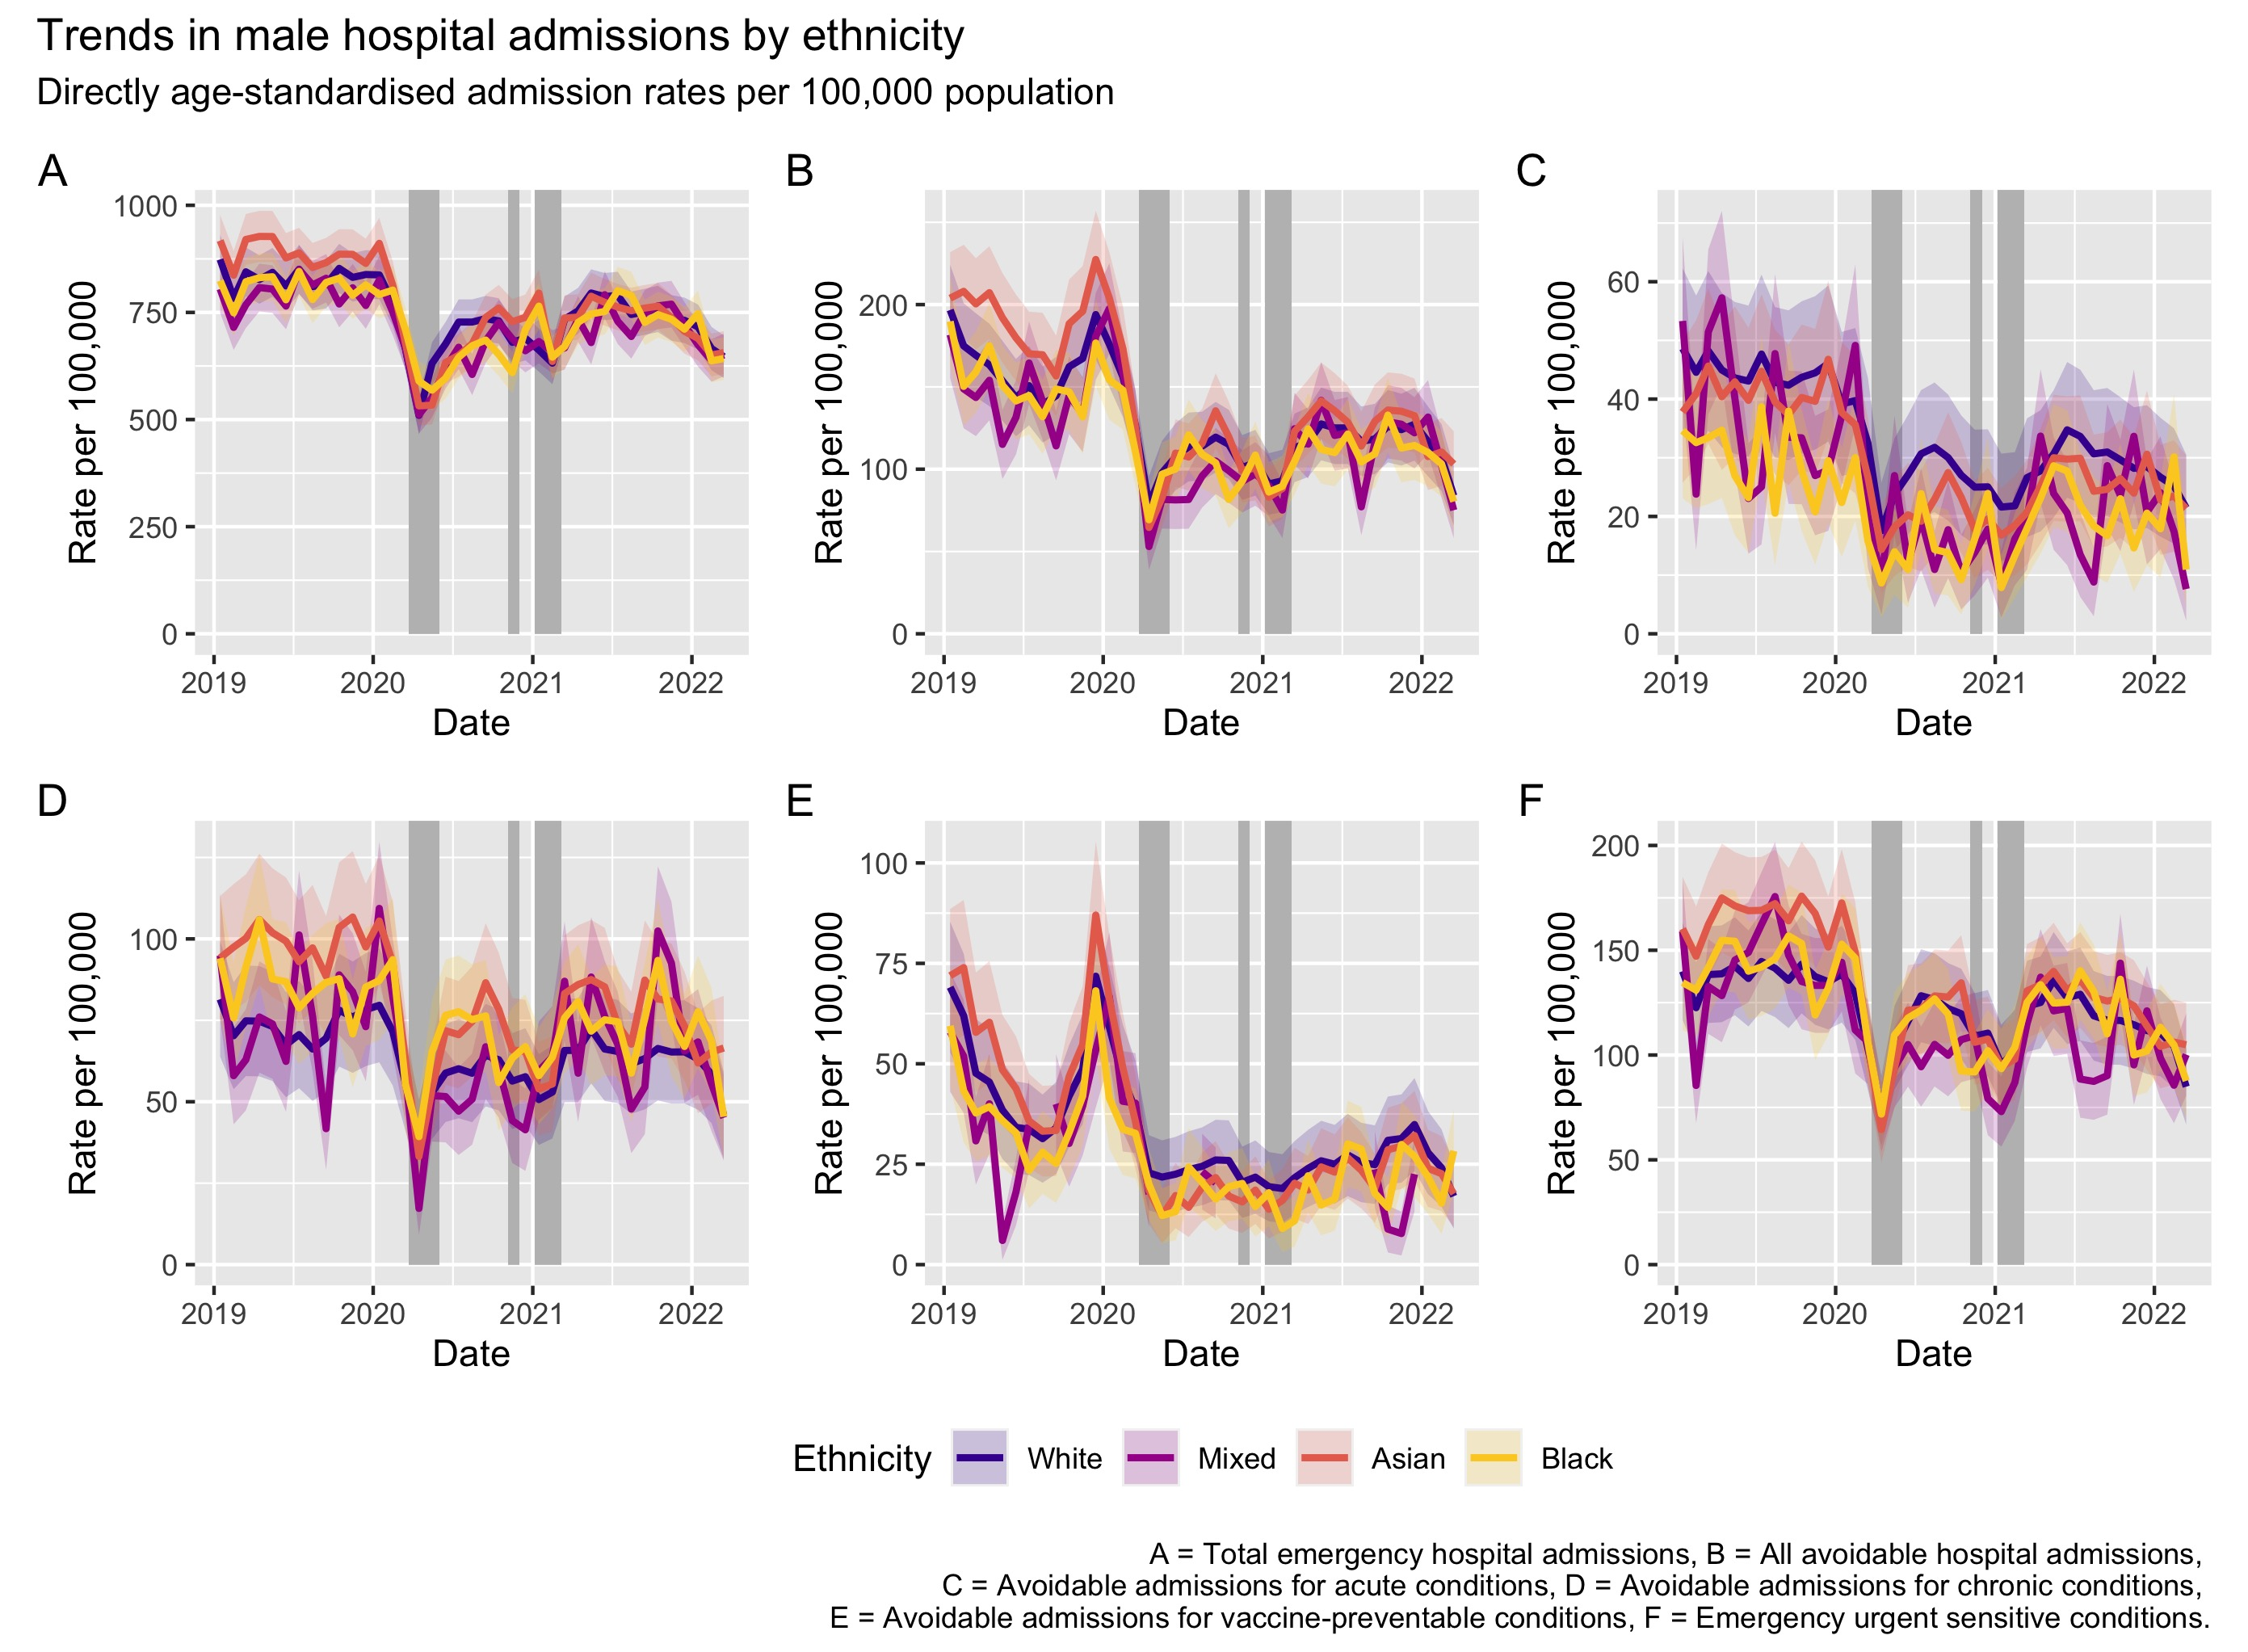
Figure E: Directly age-standardised admission rates for males by ethnicity.

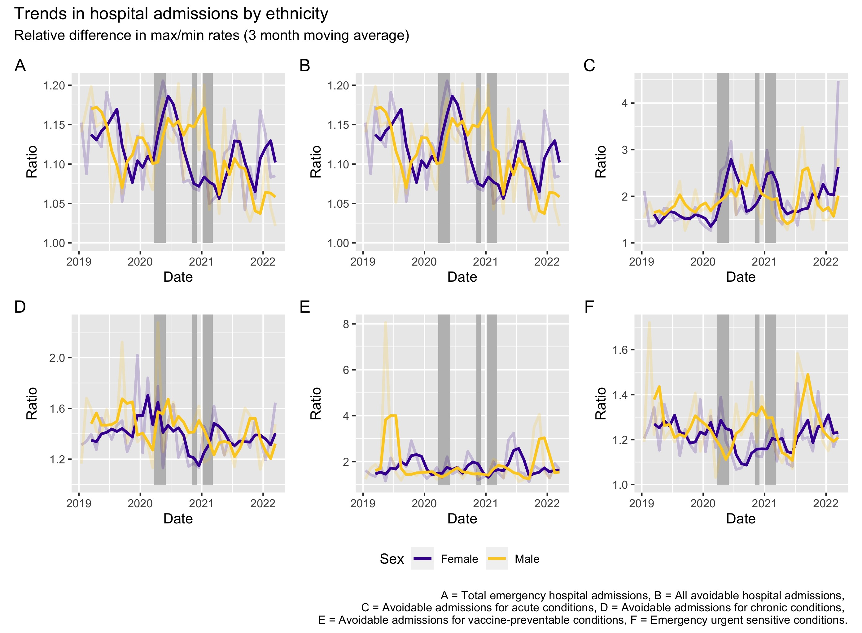
Figure F: The ratio of directly standardised rates for admission (per 100,000) between the maximum and minimum values across ethnic groups and by cause.

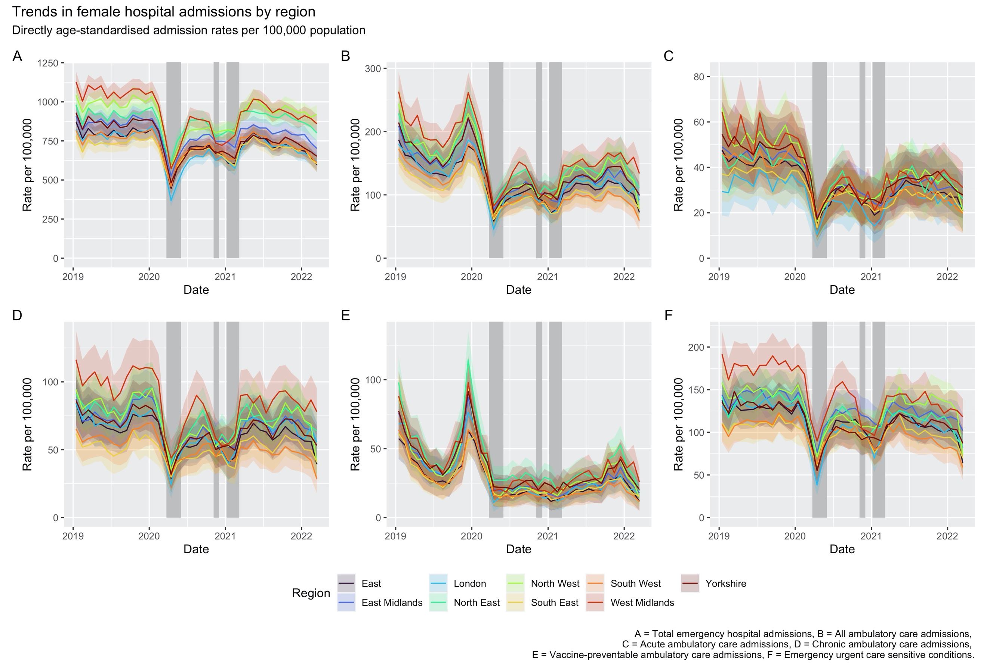
Figure G: Directly age-standardised admission rates for females by region.

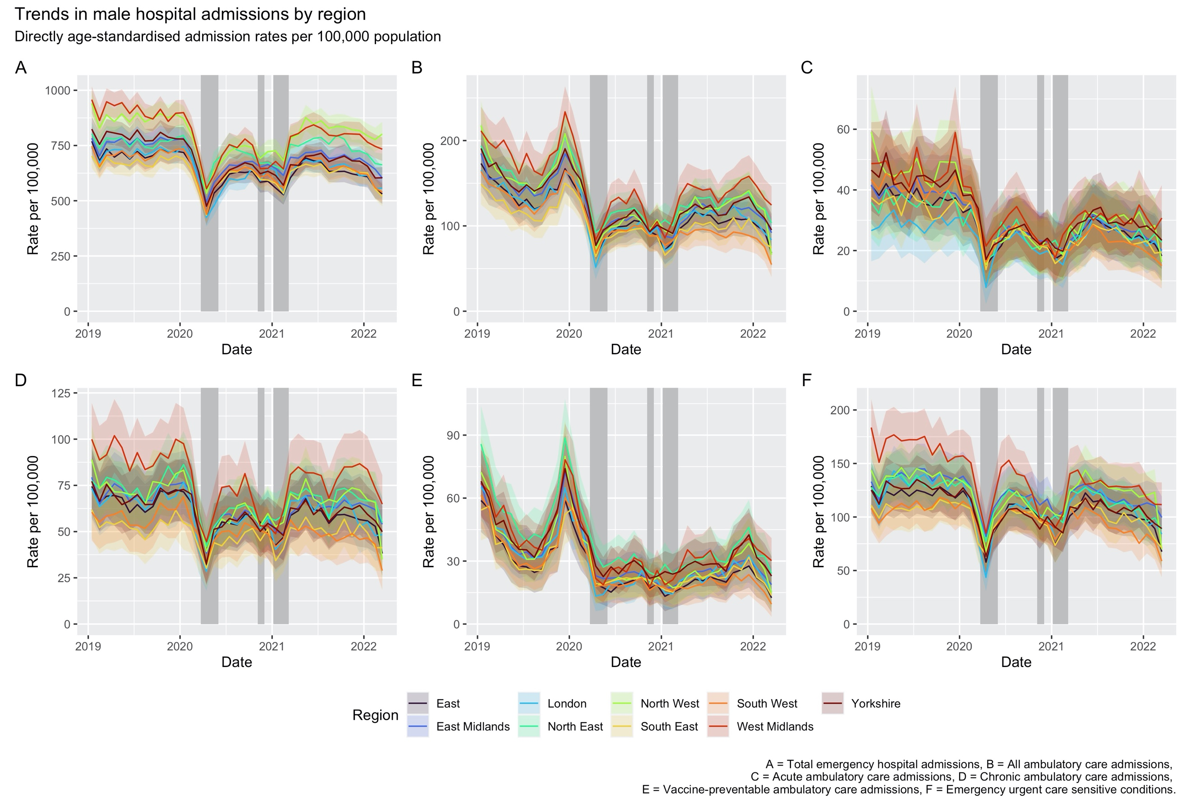
Figure H: Directly age-standardised admission rates for males by region.

