Rapid detection and quantification of Novel Psychoactive Substances (NPS) using Raman spectroscopy and surface-enhanced Raman scattering
Howbeer Muhamadali ^{1,2}, Alexandra Watt ², Yun Xu ^{1,2}, Malama Chisanga ², Abdu Subaihi^{2,3}, Carys Jones ², David I. Ellis ², Oliver B. Sutcliffe ⁴, and Royston Goodacre ^{1,2}
¹ Department of Biochemistry, Institute of Integrative Biology, University of Liverpool, Biosciences Building, Crown Street, Liverpool L69 7ZB, UK
² School of Chemistry, Manchester Institute of Biotechnology, University of Manchester, Manchester, M1 7DN, UK
³ Department of Chemistry, University College in Al-Qunfudah, Umm Al-Qura niversity,1109 Makkah Al-Mukarramah, Saudi Arabia

⁴ MANchester DRug Analysis and Knowledge Exchange (MANDRAKE), School of Science and the Environment, Faculty of Science and Engineering, Manchester Metropolitan University, John Dalton Building, Chester Street, Manchester, M1 5GD, UK

Keywords: Spectroscopy, Raman, SERS, Drug detection, psychoactive compounds

Table S1. All samples and their corresponding sample numbers, showing alternative names and structures for each of the psychoactive compounds analysed in this study.

Samples | Compound name | Synonyms | Structure
1 | Methcathinone hydrochloride | MC.HCl | 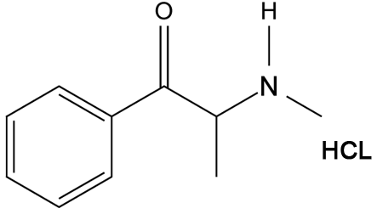
2 | 2-Methylmethcathinone hydrochloride | 2-MMC.HCl | 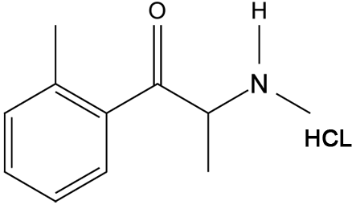
3 | 3-Methylmethcathinone hydrochloride | 3-MMC.HCl | 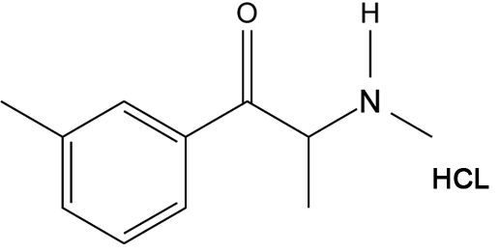
4 | 4-Methyl-  methcathinone hydrochloride | 4-MMC.HCl | 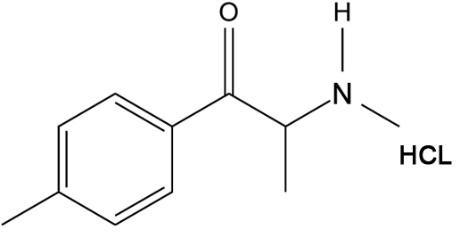
5 | 4-(Trifluoromethyl)methcathinone hydrochloride | 4-TFMMC.HCl | 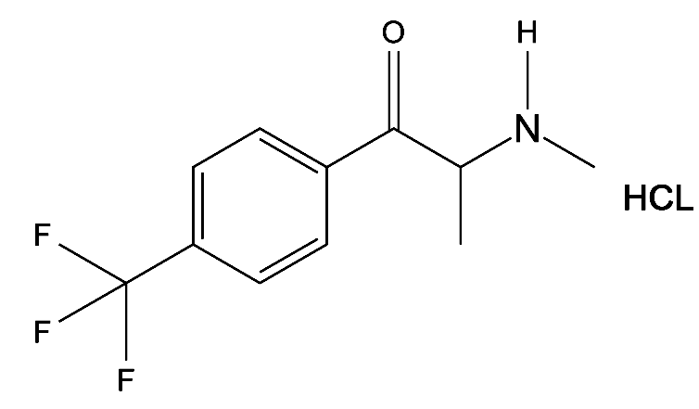
6 | 4-Methoxymethcathinone hydrobromide | Methedrone.HBr | 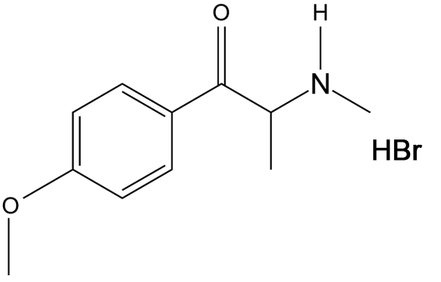
7 | 4-Methylcathinone hydrochloride | nor-mephedrone.HCl | 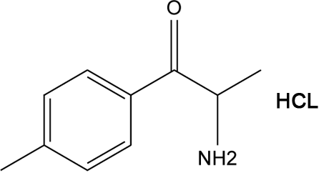
8 | 4-Methylephedrine hydrochloride | - | 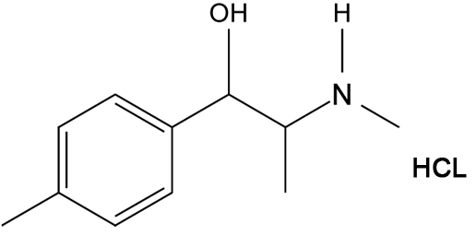
9 | 4-Methylcathine hydrochloride | - | 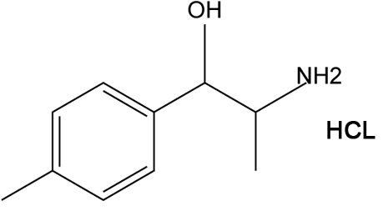
10 | 2-Aminoindane hydrochloride | 2AI | 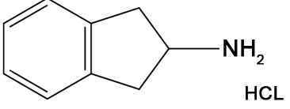
11 | N-Methyl-2-aminoindane hydrochloride | NM-2AI | 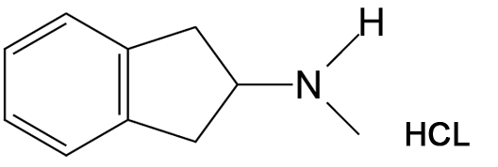
12 | 5,6-Methylenedioxy- 2-aminoindane hydrochloride | MDAI.HCl | 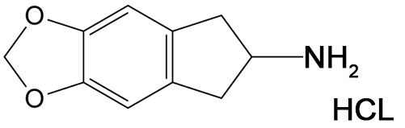
13 | 5-Iodo-2-aminoindane hydrochloride | 5-IAI.HCl | 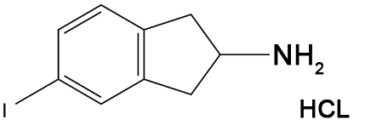
14 | Diphenidine hydrochloride | DPH.HCl | 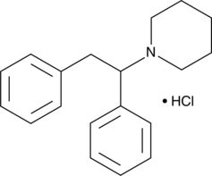
15 | 2-Methoxphenidine hydrochloride | 2-MXP.HCl | 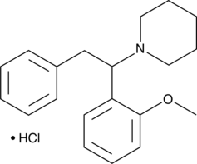
16 | 3-Methoxphenidine hydrochloride | 3-MXP.HCl | 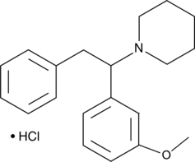
17 | 4-Methoxphenidine hydrochloride | 4-MXP.HCl | 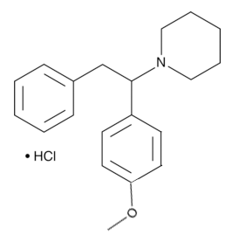
18 | Ephenidine hydrochloride | EPE | 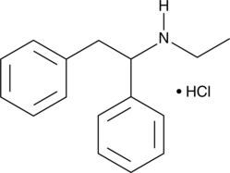
19 | Isoquinolin-8-yl 1-(cyclohexylmethyl)-1H-indole-3-carboxylate | BB-22 | 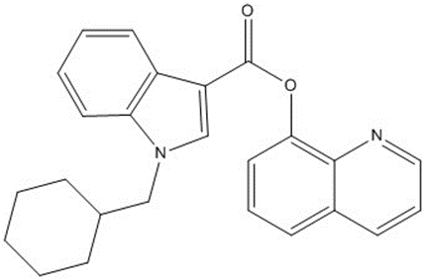
20 | methyl (S)-2-(1-(cyclohexylmethyl)-1H-indole-3-carboxamido)-3,3-dimethylbutanoate | MMB-CHMINACA | 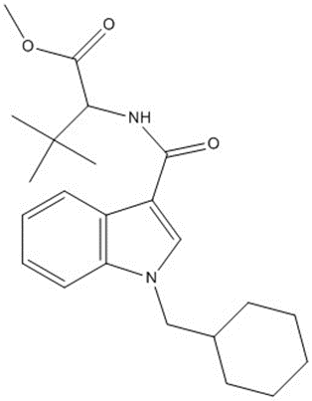
21 | N-adamantyl-1-fluoropentylindole-3-Carboxamide | STS-135 | 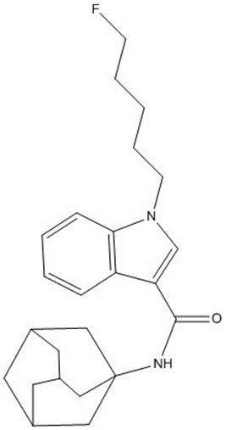
22 | N-(Adamantan-1-yl)-1-(5-fluoropentyl)-1H-indazole-3-carboxamide | 5F-AKB48 | 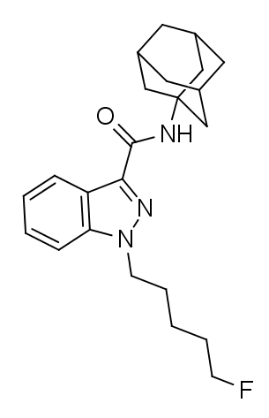
23 | N-[(1S)-1-(aminocarbonyl)-2-methylpropyl]-1-[(4-fluorophenyl)methyl]-1H-indazole-3-carboxamide | AB-FUBINACA | 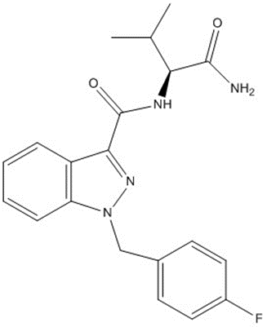

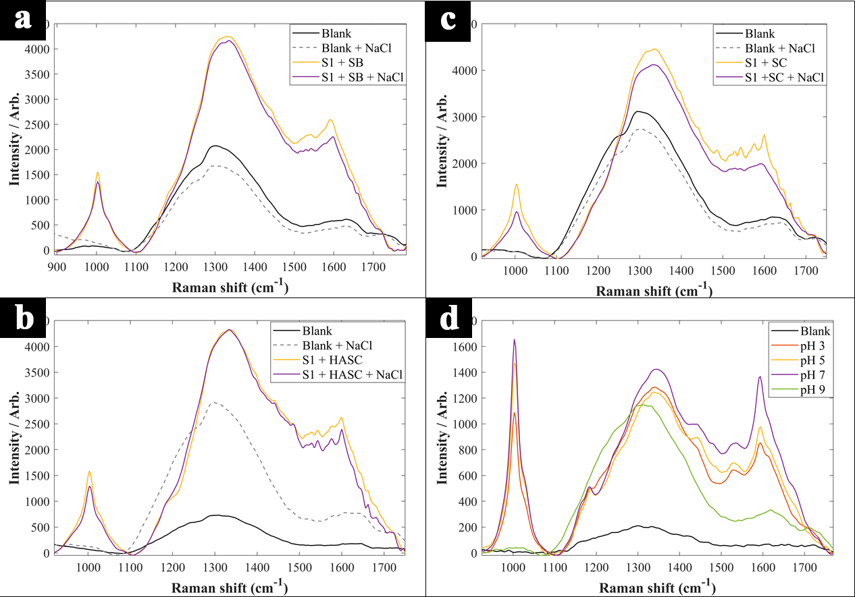
Figure S1. Comparison of SERS spectra of sample 1 (S1: methcathinone) generated using different nanoparticles and pH levels. methcathinone with silver borohydride (SB) (+NaCl) (a), methcathinone with silver citrate (SC) (+NaCl) (b), methcathinone with silver hydroxylamine (HASC) (+NaCl) (c), methcathinone with silver hydroxylamine (d). Blank samples are the nanoparticles only.

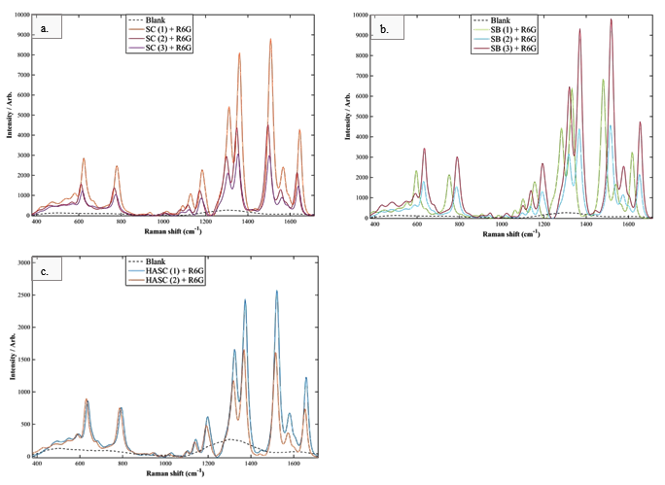
Figure S2. Comparison of SERS spectra of R6G acquired using the synthesized colloids; (a) silver citrate reduced colloid, (b) silver borohydride reduced colloid, (c) silver hydroxylamine reduced colloid.

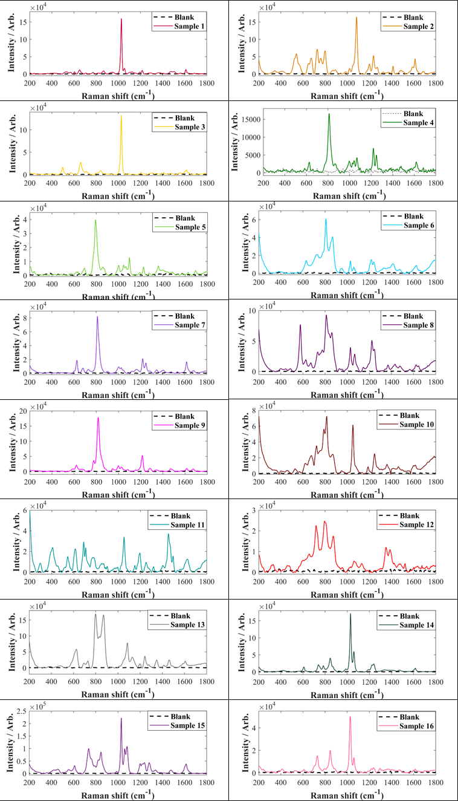
Figure S3. Comparison of the SERS spectra of all the samples in liquid form.

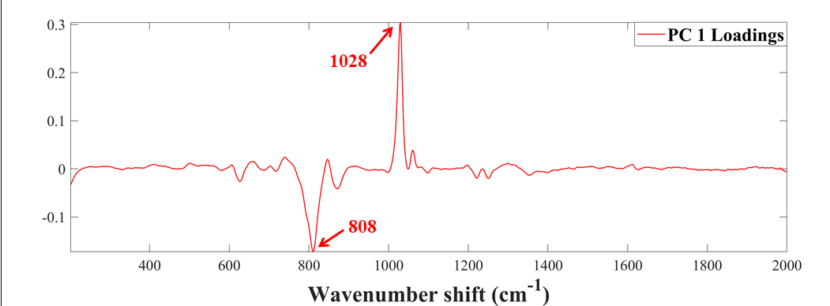
Figure S4. PCA loadings plot of all SERS spectral data (this corresponds to the PCA scores plots in the main paper: Fig 4), highlighting the most significant vibrational bands contributing to the clustering patterns in PC1.

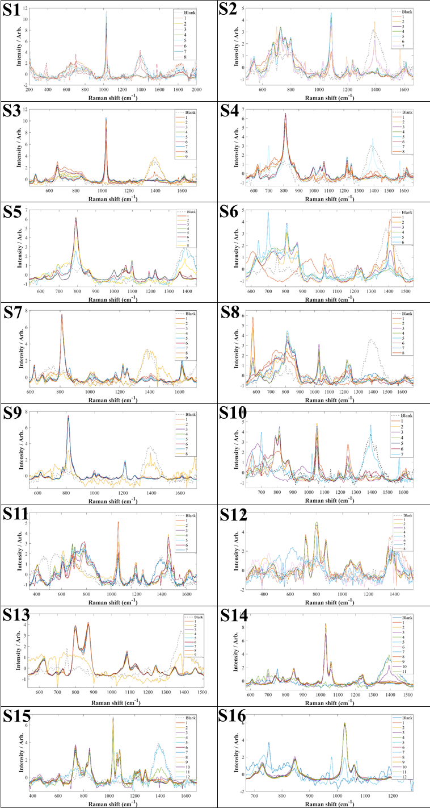
Figure S5. Comparison of the SERS spectra generated for all the samples at different concentration ranges, in liquid form. The corresponding concentration ranges for these figures are provided in Table 1.
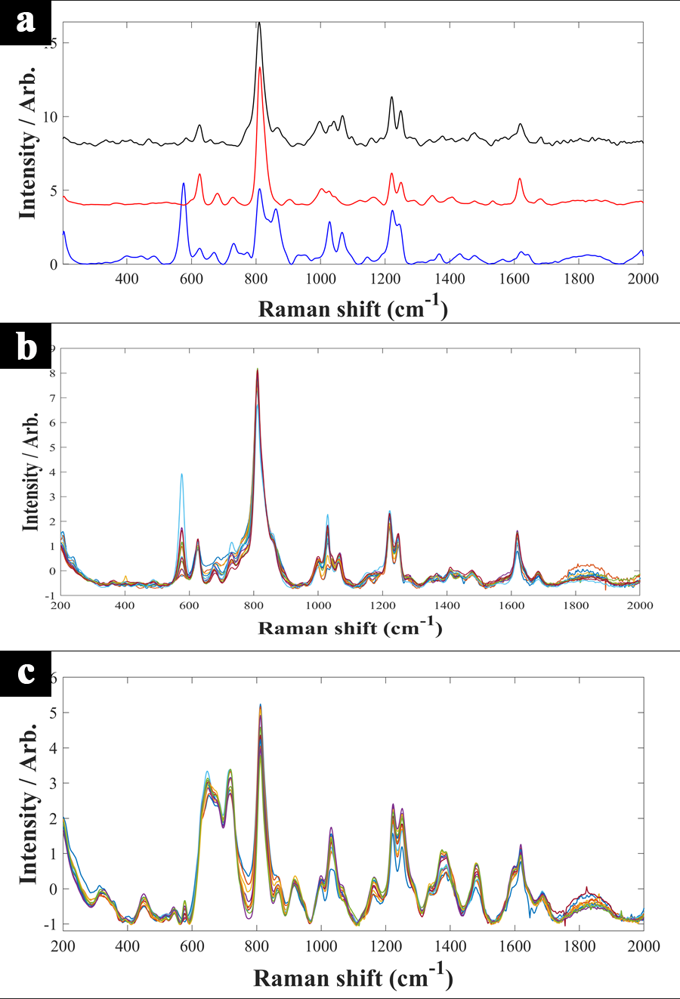
Figure S6. Comparison of SERS spectra of 4-MMC (black) and two of its metabolites, nor-mephedrone (red) and 4-methylephedrine (blue) in water (a). Multiplexed SERS spectra of all the samples in water (b), and urine (c).

Table S2. Summary of concentration ranges used for the multiplexed detection of 4-MMC and its metabolites in both water and urine.
Time | 4-MMC | nor-mephedrone | 4-methylephedrine
1 | 50 | 0 | 0
2 | 40 | 6.7 | 3.3
3 | 32 | 12 | 6
4 | 25.6 | 16.3 | 8.1
5 | 20.5 | 19.7 | 9.8
6 | 16.4 | 22.4 | 11.2
7 | 13.1 | 24.6 | 12.3
8 | 10.5 | 26.3 | 13.2
9 | 8.4 | 27.7 | 13.9
10 | 6.7 | 28.9 | 14.4
11 | 5.4 | 29.8 | 14.9
12 | 4.3 | 30.5 | 15.2
13 | 3.4 | 31 | 15.5
14 | 2.7 | 31.5 | 15.8

