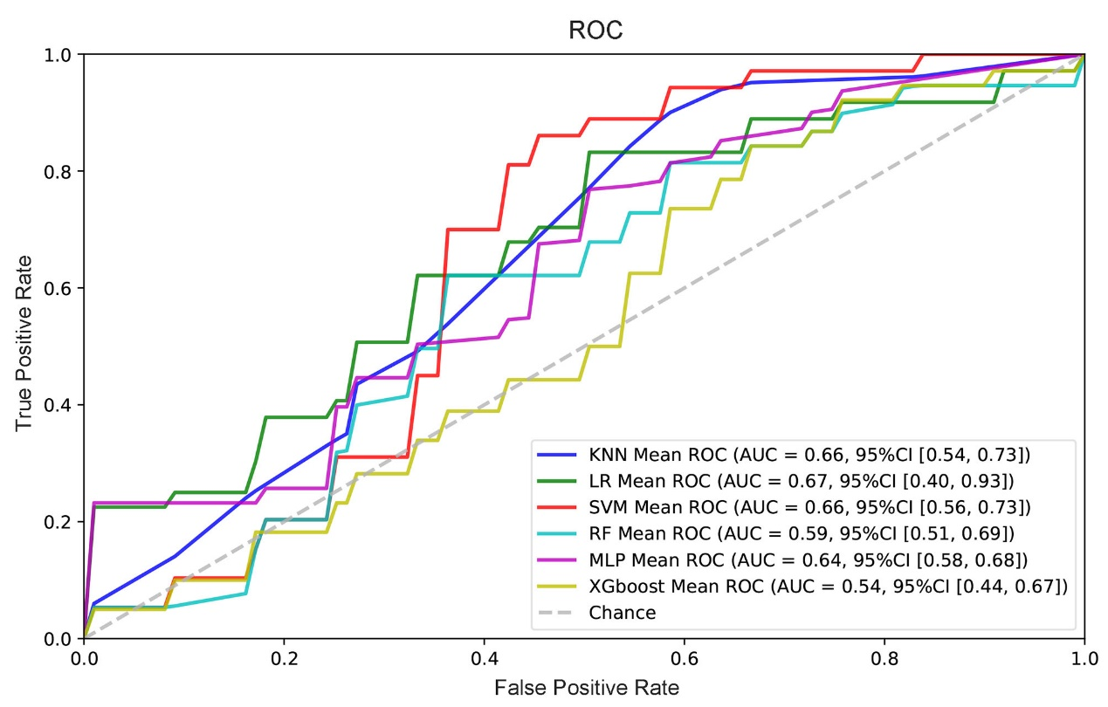Fig. S1 Construction 6 models to predict inevitable miscarriage. The figure shows the average ROC curves of the 6 models. The mean AUC values with standard deviations of the different prediction models are shown in the box.

