Supplementary Figures

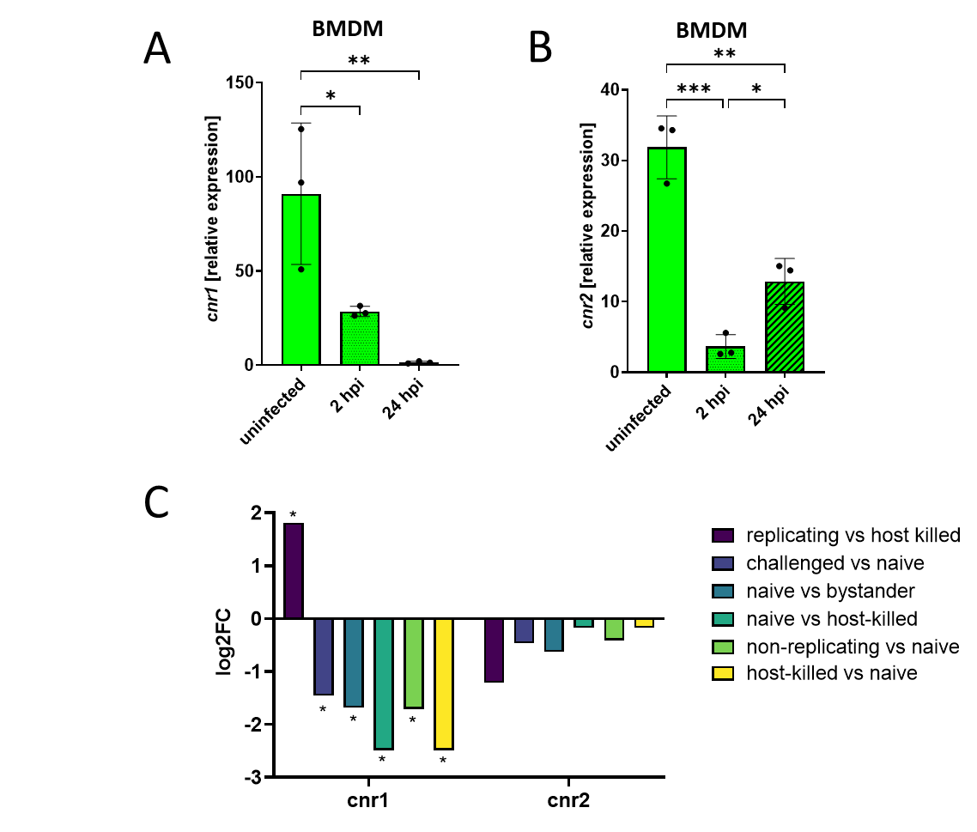
Figure S1. (A, B) Cnr1 and Cnr2 expression in Salmonella-infected macrophages over time. The gene expression levels of Cnr1 and Cnr2 were analyzed by qPCR in BMDMs following Salmonella infection with an MOI of 10. Samples were collected at 0-, 2-, and 24-hours post-infection (hpi). Expression was normalized to beta-actin housekeeping gene. Data represent the mean ± SEM from three biological replicates. Statistical significance is indicated as follows: *p < 0.05, **p < 0.01, ***p < 0.001. (C). Differential expression analysis of CNR1 and CNR2 was performed using RNA-seq data from Schade et al. ³⁷, which profiled transcriptomes of human THP-1 macrophages infected with Salmonella Typhi 18-h post-infection. Cannabinoid receptor expression across five macrophage populations: naïve, bystander, host-killed, non-replicating, and replicating is shown. Statistical significance was determined by adjusted p-values; asterisks indicate significant differential expression (*p < 0.05).

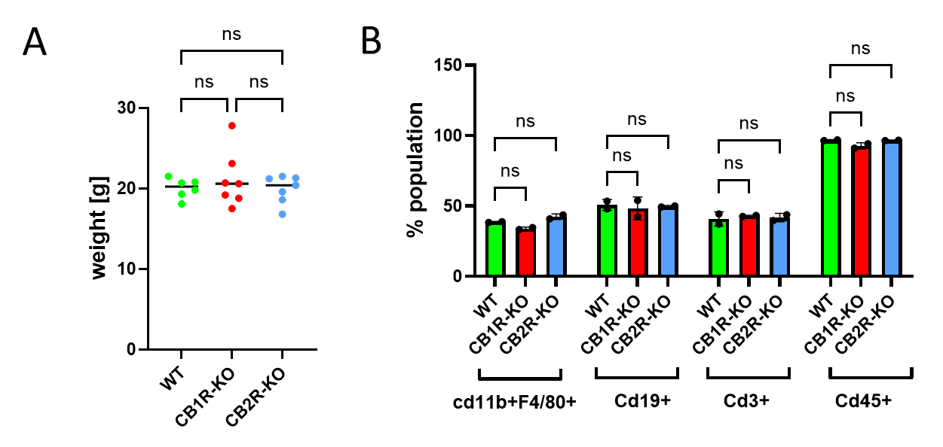

Figure S2. Baseline characteristics of WT, CB1R-KO, and CB2R-KO mice prior to Salmonella Typhimurium infection. (A) Body weights of wild-type (WT), CB1 receptor knockout (CB1R-KO), and CB2 receptor knockout (CB2R-KO) C57BL/6 mice prior to infection (n = 6 or 7 per group). (B) Flow cytometry quantification of live immune cell subsets in the spleen before infection, including CD11b⁺F4/80⁺ (macrophages), CD45⁺ (leukocytes), CD19⁺ (B cells), and CD3⁺ (T cells) (n = 2 per group).
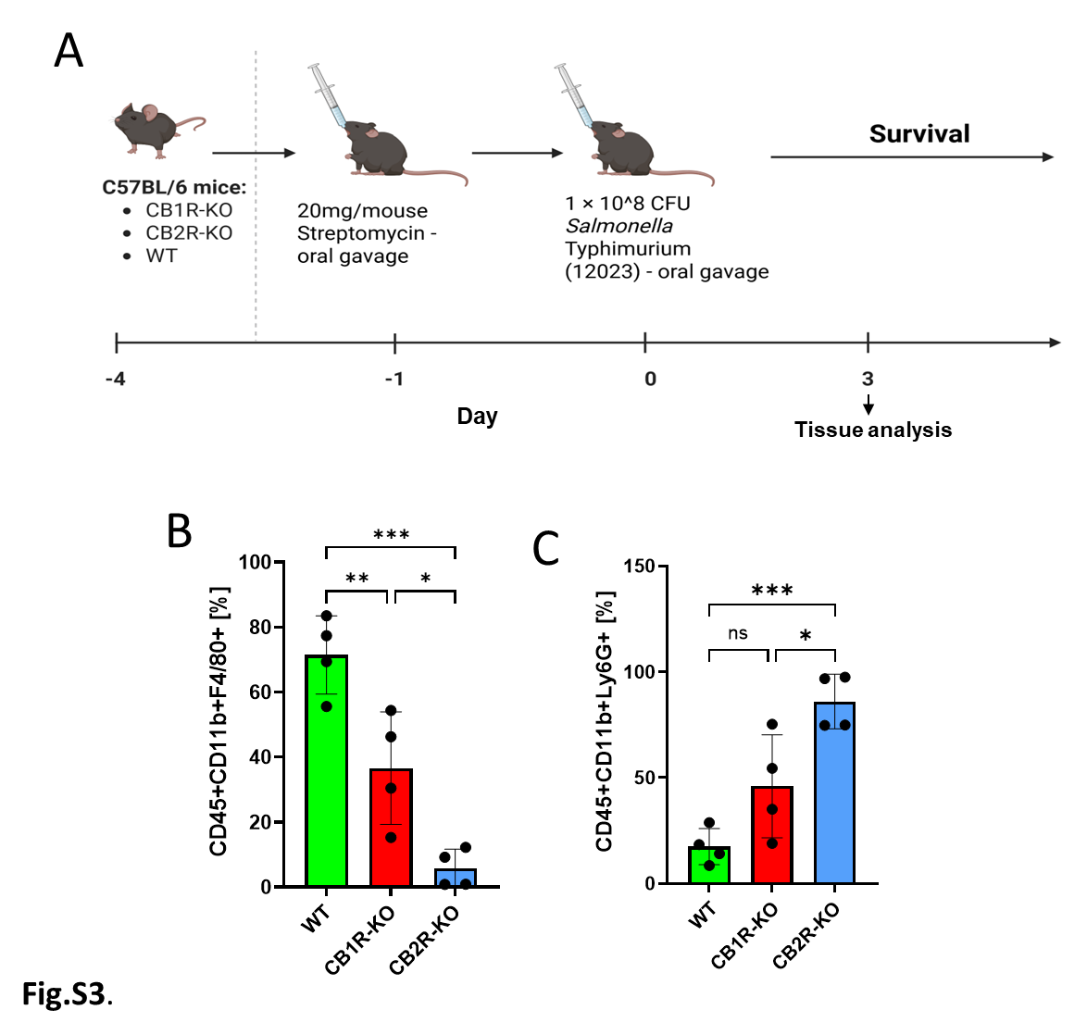
Figure S3. CB1R and CB2R modulate splenic innate immune responses and cytokine expression following Salmonella Typhimurium infection. (A) Experimental timeline for infection and analysis. C57BL/6 mice—wild-type (WT), CB1 receptor knockout (CB1R-KO), and CB2 receptor knockout (CB2R-KO)—were pre-treated with 20 mg/mouse streptomycin by oral gavage (day -1), followed by oral gavage with 1 × 10⁸ CFU Salmonella Typhimurium (strain 12023) on day 0. Survival was recorded daily. (B-C) Flow cytometry quantification of innate immune cell subsets in spleens 3 days post-infection: (B) Macrophages (Live CD45⁺CD11b⁺F4/80⁺) and (C) neutrophils (Live CD45+CD11b+Ly6G+). Data are presented as mean ± SEM, with individual data points representing single animals. A single cohort of littermate-controlled animals was used. Statistical comparisons were performed using one-way ANOVA followed by Tukey’s post hoc test. Significance levels: *p < 0.05, **p < 0.01, ***p < 0.001.

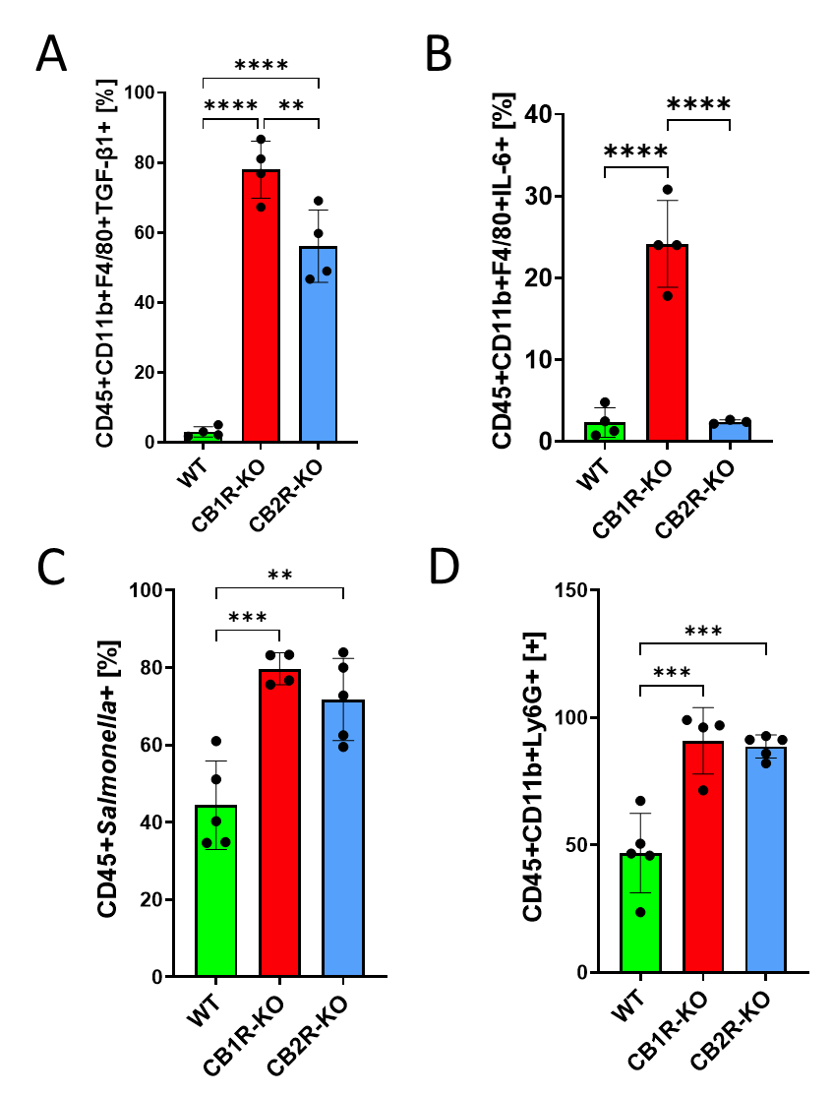
Figure S4. CB1R and CB2R influence splenic cytokine expression and systemic inflammation in a colitis-associated model of Salmonella infection. Wild-type (WT), CB1 receptor knockout (CB1R-KO), and CB2 receptor knockout (CB2R-KO) C57BL/6 mice were pretreated with streptomycin (20 mg/mouse, oral gavage) on day −1 and infected orally with Salmonella enterica serovar Typhimurium (1 × 10⁸ CFU, strain 12023) on day 0. (A–B) Intracellular cytokine staining of splenic macrophages (CD45⁺CD11b⁺F4/80⁺) at 3 days post-infection (dpi), showing expression levels of (A) TGF-β and (B) IL-6 across genotypes. (C) Flow cytometry analysis of peripheral blood leukocytes at 2 dpi, quantifying the percentage of Salmonella-positive live cells. (D) Frequency of circulating neutrophils (CD45⁺CD11b⁺Ly6G⁺) in peripheral blood at 2 dpi. Data are presented as mean ± SEM, with individual data points representing single animals. A single cohort of littermate-controlled animals was used. Statistical comparisons were performed using one-way ANOVA followed by Tukey’s post hoc test. Significance levels: *p < 0.05, **p < 0.01, ***p < 0.001, ****p < 0.0001.
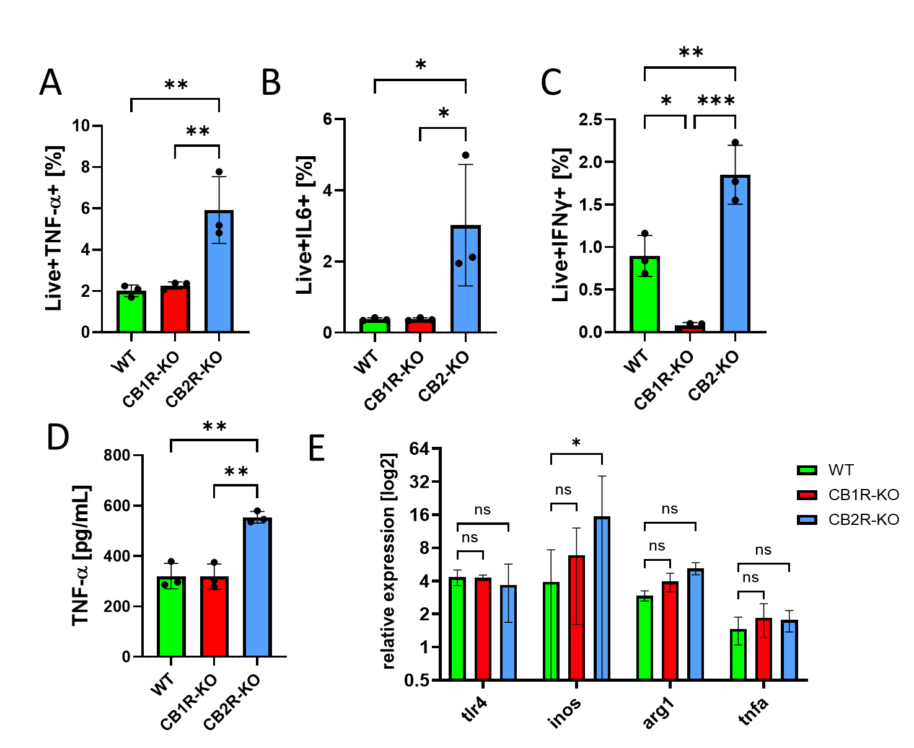
Figure S5. Differential cytokine production by CB1R- and CB2R-deficient bone marrow–derived macrophages following Salmonella infection. Bone marrow–derived macrophages (BMDMs) were isolated from wild-type (WT), CB1 receptor knockout (CB1R-KO), and CB2 receptor knockout (CB2R-KO) mice and infected in vitro with Salmonella enterica serovar Typhimurium (strain 12023) for 2 hours. (A–C) Flow cytometry analysis of intracellular TNF-α (A), IL-6 (B), and IFN-γ (C) expression in infected BMDMs across the three genotypes. (D) ELISA quantification of TNF-α levels in culture supernatants from infected BMDMs. (E). Quantitative PCR analysis of Tlr4, Inos, Arg1, and Tnfa mRNA expression in uninfected BMDMs from the indicated genotypes, assessing baseline transcriptional differences in innate immune mediators. Data represent mean ± SEM, with individual points indicating biological replicates from independent mice. Statistical comparisons were performed using one-way ANOVA followed by Tukey’s post hoc test. Significance: *p < 0.05, **p < 0.01, ***p < 0.001.
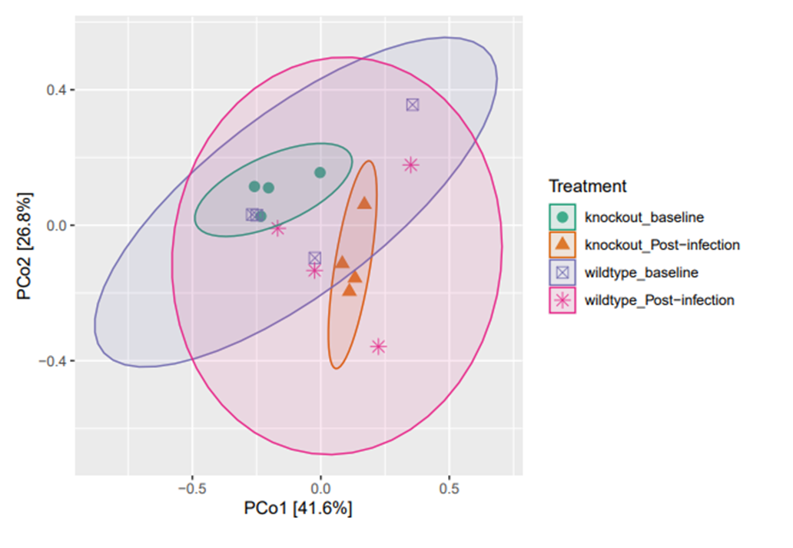
Figure S6. Principal Coordinates Analysis (PCoA) of microbial community composition. PCoA was performed using Bray–Curtis dissimilarity to assess beta diversity across four experimental groups: wild-type (WT), CB1 receptor knockout (CB1R-KO), and CB2 receptor knockout (CB2R-KO) mice and infected or not with Salmonella Typhimurium. Each point represents the microbial profile of one sample. Ellipses indicate 95% confidence intervals for each group. Axes represent the first two principal coordinates, explaining 41.6% and 26.8% of the total variance, respectively. PERMANOVA analysis showed significant differences in community composition between CB1R-KO baseline and CB1R-KO infected samples (R² = 0.53, p = 0.032), but no significant differences between other groups (p > 0.05).

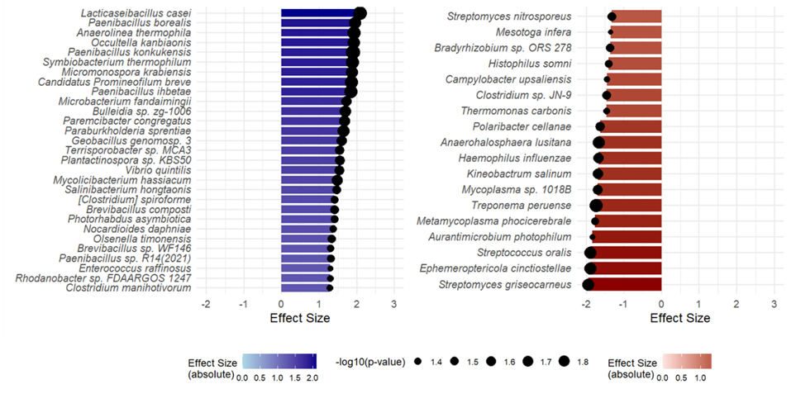
Figure S7. Baseline gut microbiota composition differs between CB2R-KO and WT mice. Differential abundance analysis of microbial taxa in CB2R knockout (CB2R-KO) and wild-type (WT) mice at baseline (pre-infection). Blue bars indicate taxa significantly enriched in CB2R-KO mice, while red bars indicate enrichment in WT mice. The length of each bar corresponds to the effect size, and the circle size represents -log10(p-value), reflecting the statistical significance of the difference. Microbial taxa shown met a significance threshold.

Supplementary tables

Table S1. Differential gut microbiota in uninfected CB2R-KO mice compared to wild-type (WT) controls. Differentially abundant microbial species between CB2R knockout (CB2R-KO) and WT mice under uninfected conditions, based on statistical analysis of relative abundance (showing only species with p-values < 0.05). Positive effect sizes indicate higher abundance in WT mice, while negative values indicate lower abundance in WT mice (i.e., enrichment in CB2R-KO mice). P-values were calculated using appropriate statistical methods for compositional microbiome data.

Effect | p-value | Species
2.09461301 | 0.016419942 | Lacticaseibacillus casei
1.9500251 | 0.023590036 | Paenibacillus borealis
1.9279183 | 0.019063603 | Anaerolinea thermophila
1.91716869 | 0.020523527 | Occultella kanbiaonis
1.88795722 | 0.014631822 | Paenibacillus konkukensis
1.88280659 | 0.019200332 | Symbiobacterium thermophilum
1.86365563 | 0.023671723 | Micromonospora krabiensis
1.84733133 | 0.01939435 | Candidatus Promineofilum breve
1.84499514 | 0.018978666 | Paenibacillus ihbetae
1.72230061 | 0.032593127 | Microbacterium fandaimingii
1.70368267 | 0.026260831 | Bulleidia sp. zg-1006
1.66588914 | 0.028250136 | Paremcibacter congregatus
1.64872739 | 0.023929813 | Paraburkholderia sprentiae
1.59599263 | 0.033633309 | Geobacillus genomosp. 3
1.54589672 | 0.037769798 | Terrisporobacter sp. MCA3
1.53952654 | 0.035104282 | Plantactinospora sp. KBS50
1.52528588 | 0.03567719 | Vibrio quintilis
1.47687768 | 0.030364217 | Mycolicibacterium hassiacum
1.45716909 | 0.040074024 | Salinibacterium hongtaonis
1.41077893 | 0.044905514 | [Clostridium] spiroforme
1.40738619 | 0.040194609 | Brevibacillus composti
1.40593884 | 0.043339715 | Photorhabdus asymbiotica
1.37653862 | 0.046304981 | Nocardioides daphniae
1.34053808 | 0.042288714 | Olsenella timonensis
1.3024732 | 0.046600946 | Brevibacillus sp. WF146
1.30215058 | 0.044381311 | Paenibacillus sp. R14(2021)
1.29882132 | 0.048931478 | Enterococcus raffinosus
1.29705911 | 0.047515001 | Rhodanobacter sp. FDAARGOS 1247
1.27970949 | 0.047243162 | Clostridium manihotivorum
-1.3248141 | 0.038874446 | Streptomyces nitrosporeus
-1.3570921 | 0.049189491 | Mesotoga infera
-1.3631185 | 0.042929954 | Bradyrhizobium sp. ORS 278
-1.409225 | 0.045011988 | Histophilus somni
-1.4459969 | 0.048496804 | Campylobacter upsaliensis
-1.4642281 | 0.040955847 | Clostridium sp. JN-9
-1.4653563 | 0.047587962 | Thermomonas carbonis
-1.6275485 | 0.037155851 | Polaribacter cellanae
-1.6750265 | 0.023986638 | Anaerohalosphaera lusitana
-1.6751416 | 0.031530908 | Haemophilus influenzae
-1.6853897 | 0.031918984 | Kineobactrum salinum
-1.6954616 | 0.035341574 | Mycoplasma sp. 1018B
-1.7417026 | 0.020090427 | Treponema peruense
-1.7678427 | 0.044641191 | Metamycoplasma phocicerebrale
-1.8453395 | 0.048982214 | Aurantimicrobium photophilum
-1.8913793 | 0.025504946 | Streptococcus oralis
-1.8980907 | 0.024776446 | Ephemeroptericola cinctiostellae
-1.950164 | 0.023753328 | Streptomyces griseocarneus

Table S2. Differential gut microbiota in infected CB2R-KO mice compared to wild-type (WT) controls. Differentially abundant microbial species between CB2R knockout (CB2R-KO) and WT mice under infected conditions, based on statistical analysis of relative abundance (showing only species with p-values < 0.05). Positive effect sizes indicate higher abundance in WT mice, while negative values indicate lower abundance in WT mice (i.e., enrichment in CB2R-KO mice). P-values were calculated using appropriate statistical methods for compositional microbiome data.

effect | p-value | species
3.859164 | 0.003752 | Limosilactobacillus reuteri
2.482954 | 0.012019 | Lactobacillus acidophilus
2.433801 | 0.043101 | Faecalitalea cylindroides
2.427716 | 0.009612 | Thermophilibacter immobilis
2.342164 | 0.006799 | Collinsella stercoris
2.222094 | 0.017555 | Lactobacillus intestinalis
2.186714 | 0.01683 | Bifidobacterium animalis
1.98508 | 0.036836 | Leptogranulimonas caecicola
1.966884 | 0.011173 | Levilactobacillus brevis
1.96591 | 0.017345 | Olsenella sp. oral taxon 807
1.914523 | 0.019453 | Streptomyces incarnatus
1.870418 | 0.0258 | Sulfuriflexus mobilis
1.813473 | 0.031319 | Mammaliicoccus stepanovicii
1.809254 | 0.021712 | Streptomyces peucetius
1.793468 | 0.019977 | Streptomyces phaeolivaceus
1.771369 | 0.027766 | Desulfuromonas versatilis
1.759965 | 0.024658 | Collinsella aerofaciens
1.750412 | 0.026085 | Nocardia cyriacigeorgica
1.750301 | 0.023543 | Comamonas thiooxydans
1.747648 | 0.03646 | Paenibacillus sp. R14(2021)
1.701353 | 0.019995 | Suicoccus acidiformans
1.67555 | 0.032139 | Limosilactobacillus fermentum
1.671052 | 0.047338 | Vibrio palustris
1.670792 | 0.024908 | Paraburkholderia sprentiae
1.660302 | 0.028287 | Achromobacter pestifer
1.64522 | 0.028993 | Arthrobacter sp. NicSoilB4
1.635731 | 0.025347 | Halobacillus halophilus
1.6218 | 0.029817 | Streptococcus sp. Marseille-Q6470
1.621177 | 0.035643 | Actinoplanes sp. N902-109
1.599131 | 0.037966 | Haladaptatus salinisoli
1.597443 | 0.023203 | Lactobacillus gasseri
1.579575 | 0.019945 | Virgibacillus phasianinus
1.579332 | 0.025205 | Parolsenella massiliensis
1.563837 | 0.029819 | Mycobacterium senriense
1.559932 | 0.035843 | Lactobacillus helveticus
1.556545 | 0.035437 | Proteus sp. ZN5
1.536247 | 0.040078 | Lactobacillus prophage Lj771
1.522036 | 0.044351 | Streptococcus parauberis
1.5155 | 0.037113 | Rhodococcus fascians
1.511237 | 0.027138 | Amedibacterium intestinale
1.507483 | 0.036098 | Melaminivora jejuensis
1.487471 | 0.046571 | Pseudomonas sp. Seg1
1.48642 | 0.043436 | Xanthomonas translucens
1.482214 | 0.042267 | Lactobacillus iners
1.478858 | 0.041698 | Symbiobacterium thermophilum
1.475707 | 0.02744 | Lactobacillus paragasseri
1.434723 | 0.049845 | Gordonia amarae
1.415214 | 0.041926 | Parolsenella catena
1.411494 | 0.049944 | Vagococcus fluvialis
1.410431 | 0.03465 | Enterococcus wangshanyuanii
1.409487 | 0.043769 | Cardiobacterium hominis
1.403889 | 0.047767 | Bacillus rugosus
1.3987 | 0.040472 | Erythrobacter neustonensis
1.385053 | 0.044034 | Streptococcus canis
1.373219 | 0.037262 | Methylotenera mobilis
1.365567 | 0.045745 | Fictibacillus arsenicus
1.356855 | 0.042264 | Bacillus sp. OxB-1
1.346039 | 0.03991 | Lactobacillus crispatus
1.345834 | 0.049842 | Glutamicibacter sp. JL.03c
1.329695 | 0.044913 | Chania multitudinisentens
1.316348 | 0.045106 | Mycetohabitans rhizoxinica
1.308129 | 0.047967 | Tumebacillus avium
1.297817 | 0.045247 | Amylolactobacillus amylophilus
1.284907 | 0.044601 | Fusobacterium ulcerans
1.271263 | 0.042396 | Xenorhabdus doucetiae
1.230383 | 0.041816 | Paenibacillus protaetiae
-1.30874 | 0.040528 | Sphingobacterium spiritivorum
-1.34059 | 0.044479 | Adhaeribacter swui
-1.3477 | 0.045952 | Thiomicrorhabdus aquaedulcis
-1.35098 | 0.049048 | Leisingera sp. BMJM1
-1.36347 | 0.043606 | Flavobacterium sp. K5-23
-1.3753 | 0.048457 | Burkholderia sp. PAMC 26561
-1.37621 | 0.043822 | Methanospirillum hungatei
-1.38065 | 0.049631 | Salinibacter ruber
-1.41991 | 0.039885 | Mucilaginibacter ginsenosidivorax
-1.43456 | 0.044726 | Flavobacterium inviolabile
-1.43561 | 0.048758 | Arachidicoccus sp. B3-10
-1.43801 | 0.045297 | Hymenobacter sp. 5420S-77
-1.4484 | 0.045731 | Elizabethkingia meningoseptica
-1.45291 | 0.0394 | Chryseobacterium sp. 3008163
-1.45434 | 0.045606 | Flavobacterium crassostreae
-1.45719 | 0.049326 | Tatumella ptyseos
-1.46334 | 0.035326 | Ottowia testudinis
-1.46371 | 0.042696 | Deep-sea thermophilic phage D6E
-1.46496 | 0.035678 | Lacunisphaera limnophila
-1.4674 | 0.041228 | Kaistella flava (ex Peng et al. 2021)
-1.4913 | 0.034719 | Nocardioides rotundus
-1.52652 | 0.038584 | Nonlabens sp. Ci31
-1.54228 | 0.042487 | Paraburkholderia fungorum
-1.55604 | 0.039254 | Chryseobacterium sp. PCH239
-1.56392 | 0.034406 | Mucilaginibacter rubeus
-1.57396 | 0.026701 | Corynebacterium flavescens
-1.58245 | 0.034161 | Mucilaginibacter ginkgonis
-1.59836 | 0.026153 | Methylocaldum marinum
-1.59932 | 0.03033 | Flavobacterium kingsejongi
-1.61474 | 0.040414 | Colwellia sp. Arc7-635
-1.62897 | 0.035 | Micavibrio aeruginosavorus
-1.64183 | 0.027637 | Flavobacterium sangjuense
-1.64638 | 0.029855 | Nocardioides sp. TF02-7
-1.64849 | 0.040786 | Alistipes finegoldii
-1.65471 | 0.029089 | Pedobacter sp. SW-16
-1.67248 | 0.036393 | Qipengyuania aquimaris
-1.69297 | 0.033417 | Muricauda sp. SCSIO 64092
-1.70141 | 0.029863 | Capnocytophaga sp. oral taxon 864
-1.70914 | 0.047653 | Fulvivirga sp. W9P-11
-1.71551 | 0.03361 | Methylococcus sp. EFPC2
-1.7211 | 0.03064 | Arenibacter algicola
-1.75791 | 0.021201 | Chryseobacterium sp. 6424
-1.82521 | 0.019388 | Chryseobacterium lactis
-1.92894 | 0.025678 | Alistipes onderdonkii
-1.95761 | 0.034083 | Kaistella antarctica
-1.99955 | 0.011186 | Odoribacter splanchnicus
-2.04097 | 0.020681 | Chryseobacterium oryzae
-2.05013 | 0.019308 | Alistipes dispar
-2.14015 | 0.012442 | Opitutus sp. GAS368
-2.36793 | 0.016644 | Alistipes megaguti

References:
1. Schade R, Butler DSC, McKenna JA, Di Luccia B, Shokoohi V, Hamblin M, Pham THM, Monack DM. Transcriptional profiling links unique human macrophage phenotypes to the growth of intracellular Salmonella enterica serovar Typhi. Sci Rep. 2024;14(1):12811. Epub 20240604. doi: 10.1038/s41598-024-63588-6. PubMed PMID: 38834738; PMCID: PMC11150401.

