Supplementary Material
Biomimetic bone scaffold functionalized with traditional Chinese medicine ingredients and collagen-binding IGF-1 for bone regeneration
Xiaobo Gao^{1,2}, Xiaomin Zhao², Ying Zhang², Bocheng Lei ^{3,}*
¹ Department of Stomatology, Chifeng municipal hospital, Chifeng, Inner Mongolia, 024000, P.R. China.
² Affiliated Chifeng Clinical Medical College of Inner Mongolia Medical University, Chifeng, Inner Mongolia, 024000, P.R. China.
³ Stomatology College of Chifeng University, Chifeng, Inner Mongolia, 024000, P.R. China.
* Correspondence: Bocheng Lei, email: 1178609705@qq.com

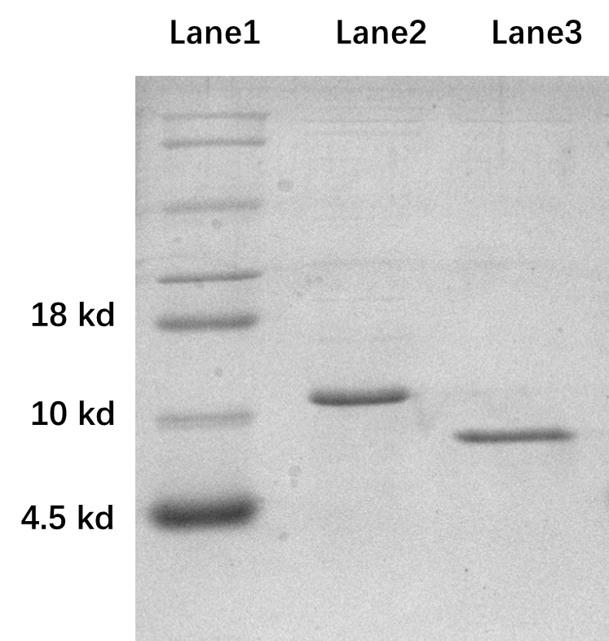
Figure S1 the SDS-PAGE result of recombinant IGF-1. Line 1: marker; lane 2: CBD-IGF-1; lane 3: commercial IGF-1.

Figure S2. Standard calibration curve established using methanolic solutions containing known Nef concentrations through UV spectrophotometric analysis at a detection wavelength of 270 nm.

Figure S3. Standard calibration curve of the IGF-1 ELISA kit.

Figure S4. Cross-sectional X-ray images of the scaffolds obtained by MicroCT. (A)PLGA; (B)PLGA/10nBM; (C) PLGA/20nBM;(D) PLGA/30nBM.

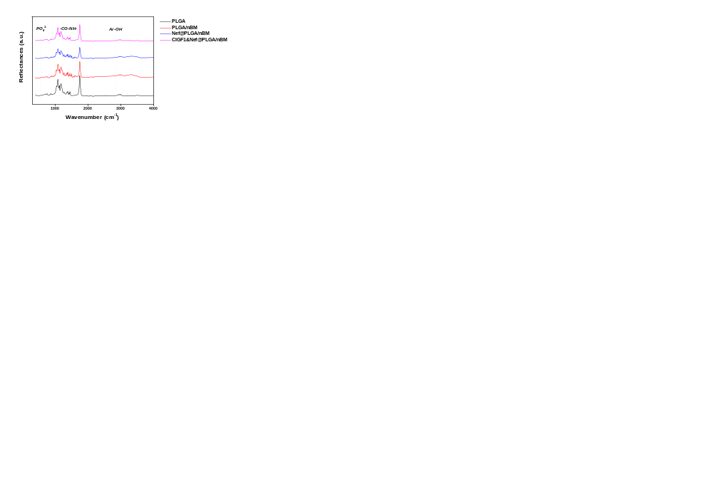
Figure S5. Analysis of the FT-IR spectra of scaffolds in each group.

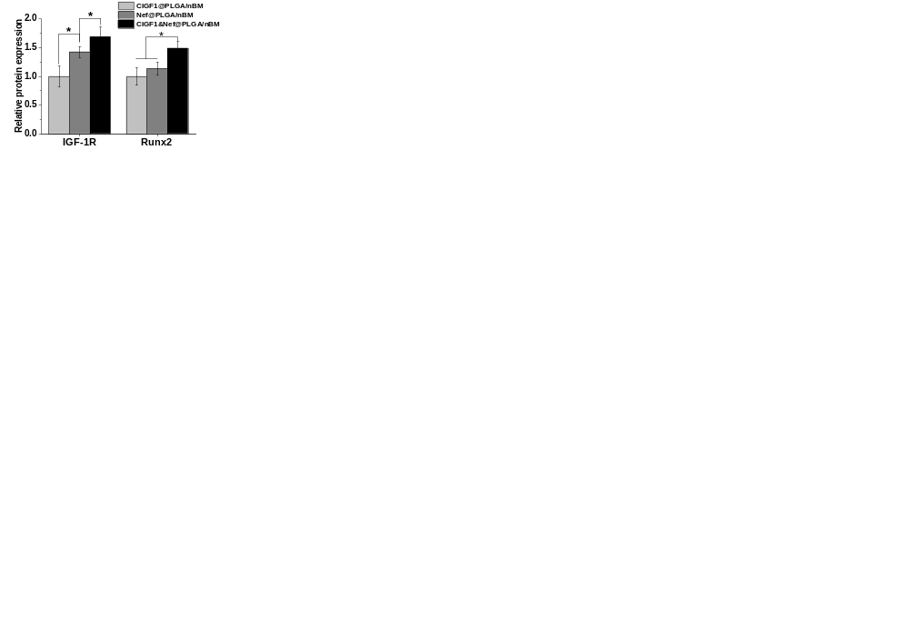
Figure S6. The quantitative analysis of the immunofluorescence staining results.

Table S1. Primers used in RT-PCR
Gene | Forward primer sequence (5’-3’) | Reverse primer sequence (3’-5’)
COL1 | CCCAGCGGTGGTTATGACTT | TCGATCCAGTACTCTCCGCT
Runx2 | GCCAGTAATCTTCGTGCCAG | TAGTGAGCTTCTTCCTGGGGA
OPN | CCAGCCAAGGACCAACTACA | AGTGTTTGCTGTAATGCGCC
IGF-1R | TTTCCACTCCGCATTTCTGC | CGTCCAAAAACAAGAGCGCA
GAPDH | CTTGTGCAGTGCCAGCCTC | GATGGTGATGGGTTTCCCGT

Table S2. Information of primary antibodies in immunofluorescence staining
Name | Brand | Product code | Host species | Dilution ratio
Runx2 | Invitrogen | MA5-32373 | Rabbit | 1: 100
IGF-1R | Invitrogen | PA5-79444 | Rabbit | 1: 100

Table S3. EE and LC of Nef in scaffolds (100 mg)
 | EE (%) | LC (%)
Nef | 73.07 ± 3.19 | 0.0057 ± 0.0015

Table S4. Adhesion amount of IGF-1 and CDB-IGF-1 on scaffolds (100 mg)
 | Adhesion amount (ng)
IGF-1 | 51.95 ± 2.83 ng
CBD-IGF-1 | 84.23 ± 4.12 ng

