Supplementary Information

Isolation and characterization of synthesis intermediates
and byproducts in hexahydrocannabiphorol

Willi Schirmer^{1, 2}, Ilche Gjuroski², Martina Vermathen², Julien Furrer², Stefan Schürch², Wolfgang Weinmann¹
¹Institute of Forensic Medicine, Forensic Toxicology and Chemistry, University of Bern, Murtenstrasse 26, 3008 Bern, Switzerland
²Department of Chemistry, Biochemistry and Pharmaceutical Sciences, University of Bern, Freiestrasse 3, 3012 Bern, Switzerland

Corresponding author:
Willi Schirmer, Institute of Forensic Medicine, Forensic Toxicology and Chemistry,
University of Bern, Murtenstrasse 26, 3008 Bern, Switzerland
e-mail address: willi.schirmer@irm.unibe.ch

NMR (¹H-NMR, ¹H-¹H-COSY, ¹H-¹³C-HSQC, ¹H-¹³C-HMBC, ¹H-¹H-NOESY)
- Compound 1 S1-S12
- Compound 2 S13-S23
- Compound 3 S24-S28
- Compound 4 S29-S37
- Compound 5 S38-S44
- Compound 6 S45-S58

GC-MS
- n-Alkanes (Kovàts-index) S59
- GC-MS Spectra reference compounds S60-S64
  - (9R)-HHCP, (9S)-HHCP, Δ⁹-THCP, CBP, CBDP
- GC-MS spectra isolated compounds S65-S72
  - GC-EI-MS Compounds 1 – 6
  - XIC 344 impure fraction with (9S)-HHCP
  - GC-EI-MS Impure fraction with (9S)-HHCP
- GC-MS chromatograms and spectra of MTPA esters
  - (9R)-HHCP S73-S76
  - (9S)-HHCP S77-S80
  - Compounds 1 – 6 S81-S98
  - (9S)-HHCP in impure fraction S99-S102
- Chromatograms HHCP sample
  - TIC 100 mg/L HHCP sample S103
  - XIC 395 amu S104
- Chromatograms of high molecular mass fraction
  - XIC 480 underivatized sample S105
  - XIC 480 derivatized sample (MSTFA) S106
  - XIC 482 underivatized sample S107
  - XIC 482 derivatized sample (MSTFA) S108
  - XIC 554 underivatized sample S109
  - XIC 554 derivatized sample (MSTFA) S110
- GC-MS spectra of high molecular mass compounds
  - 480 amu (3 compounds) underivatized S111-S113
  - 482 amu (2 compound) underivatized S114-S115
  - 552 amu (1 compound) derivatized (MSTFA) S116
  - 554 amu (3 compounds) derivatized (MSTFA) S117-S119
  - 624 amu (2 compounds) derivatized (MSTFA) S120-S121
  - 626 amu (1 compound) derivatized (MSTFA) S122

  - 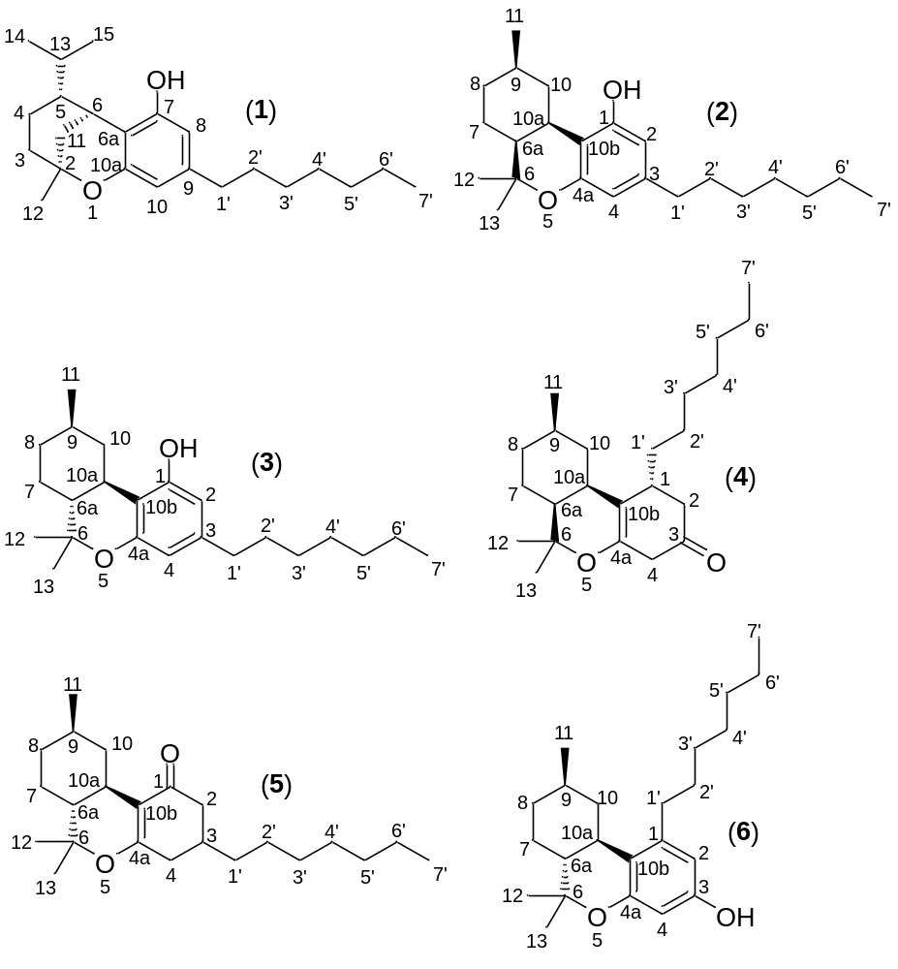
Compound 1: rel-(2S,5R,6S)-9-heptyl-5-isopropyl-2-methyl-3,4,5,6-tetrahydro-2H-2,6-methanobenzo[b]oxocin-7-ol (iso-HHCP)

Compound 2: rel-(6aS,9R,10aR)-3-heptyl-6,6,9-trimethyl-6a,7,8,9,10,10a-hexahydro-6H-benzo[c]chromen-1-ol (cis-HHCP)

Compound 3: rel-(6aR, 9R, 10aR)-6,6,9-trimethyl-3-heptyl-6a,7,8,9,10,10a-hexahydrobenzo[c]chromen-1-ol
((9R)-HHCP)

Compound 4: rel-(1R,6aS,9R,10aR)-1-heptyl-6,6,9-trimethyl-2,3,4,6,6a,7,8,9,10,10a-decahydro-1H-benzo[c]chromen-3-one (precursor to cis-abn-HHCP)

Compound 5: rel-(6aR,9R,10aR)-3-heptyl-6,6,9-trimethyl-2,3,4,6,6a,7,8,9,10,10a-decahydro-1H-benzo[c]chromen-1-one (precursor to (9R)-HHCP)

Compound 6: rel-(6aS,9R,10aS)-1-heptyl-6,6,9-trimethyl-6a,7,8,9,10,10a-hexahydro-6H-benzo[c]chromen-3-ol (precursor to ortho-HHCP)

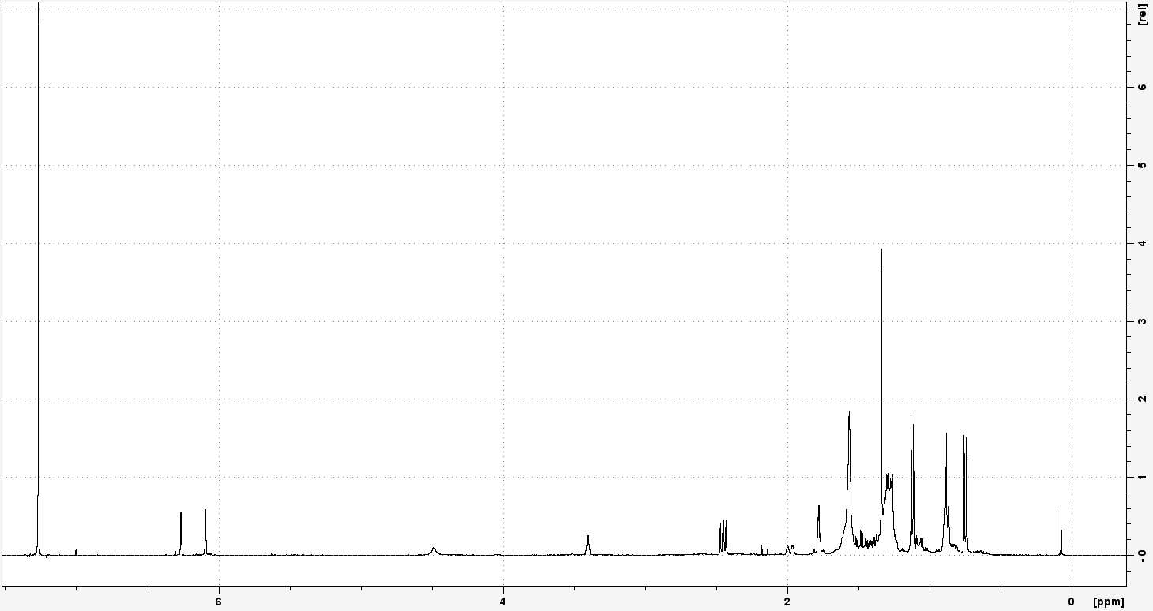
S1: ¹H-NMR of Compound 1. Recorded at 400.33 MHz in CDCl₃.

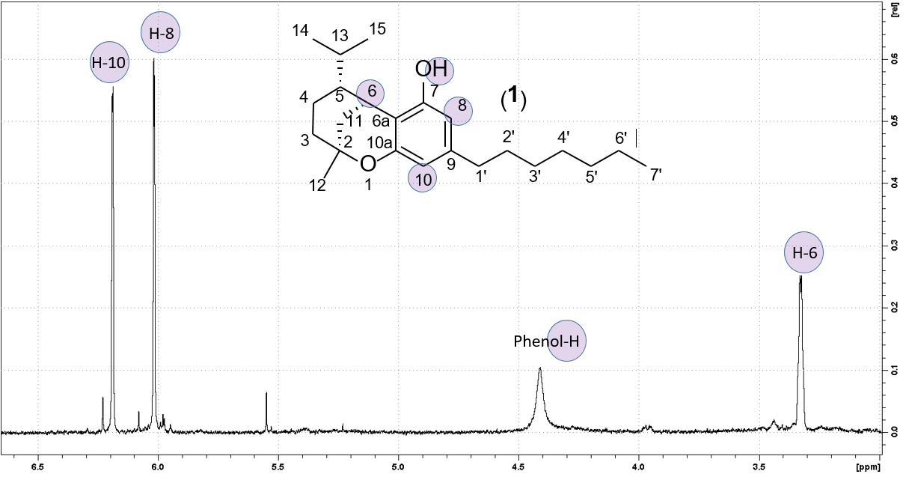
S2: ¹H-NMR of Compound 1, detailed view. Recorded at 400.33 MHz in CDCl₃.
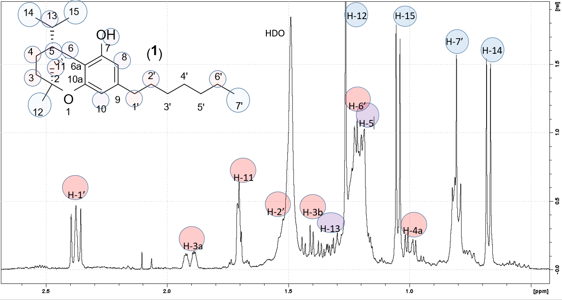
S3: ¹H-NMR of Compound 1, detailed view. Recorded at 400.33 MHz in CDCl₃.

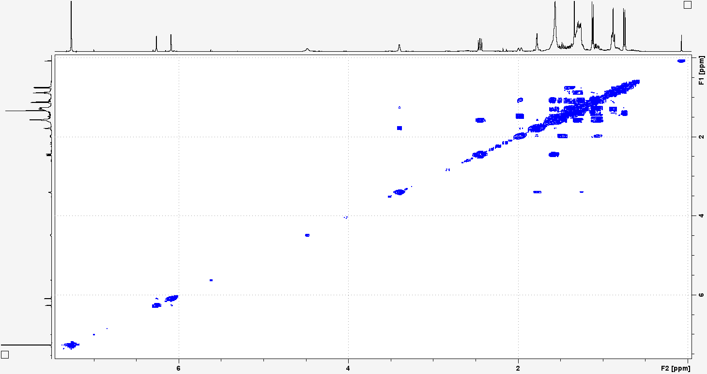
S4: ¹H-¹H-COSY of Compound 1. Recorded at 400.33 MHz in CDCl₃.
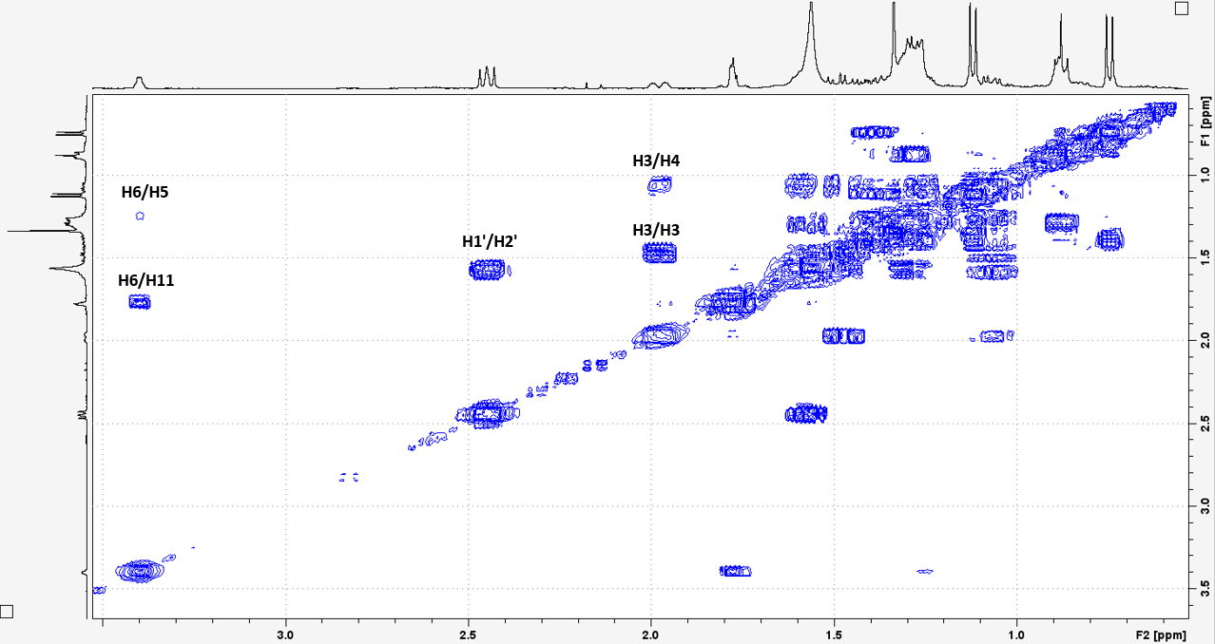
S5: ¹H-¹H-COSY of Compound 1, detailed view. Recorded at 400.33 MHz in CDCl₃.
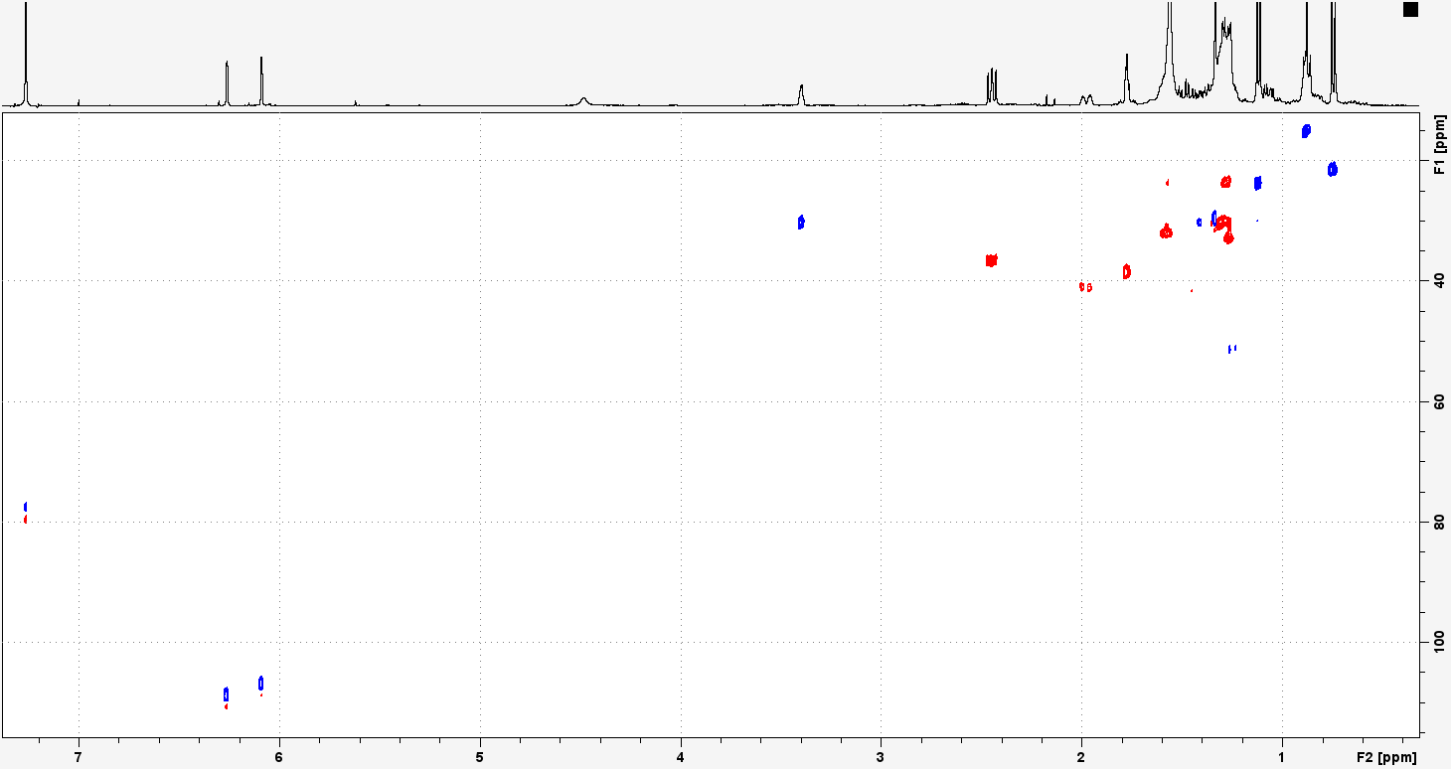
S6: ¹H-¹³C-HSQC of Compound 1. Recorded at 400.33 MHz in CDCl₃.

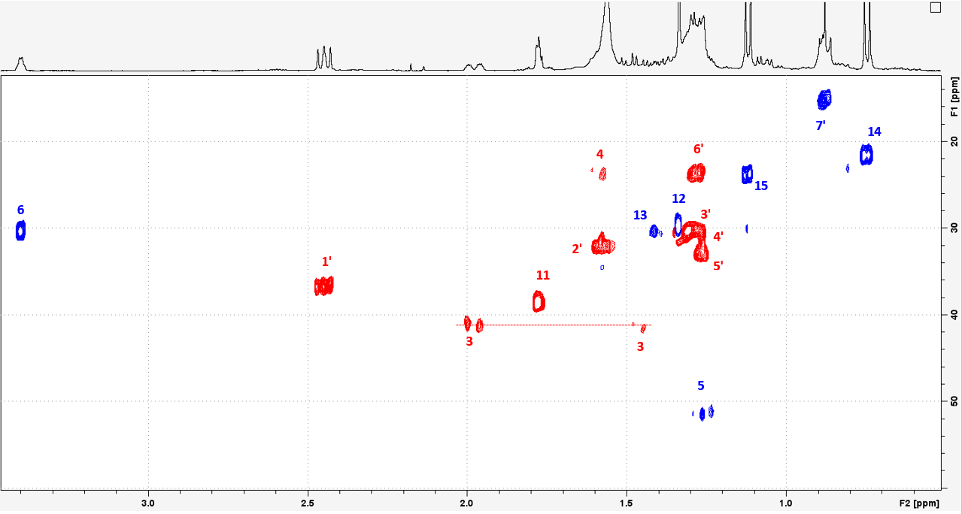
S7: ¹H-¹³C-HSQC of Compound 1, detailed view. Recorded at 400.33 MHz in CDCl₃.
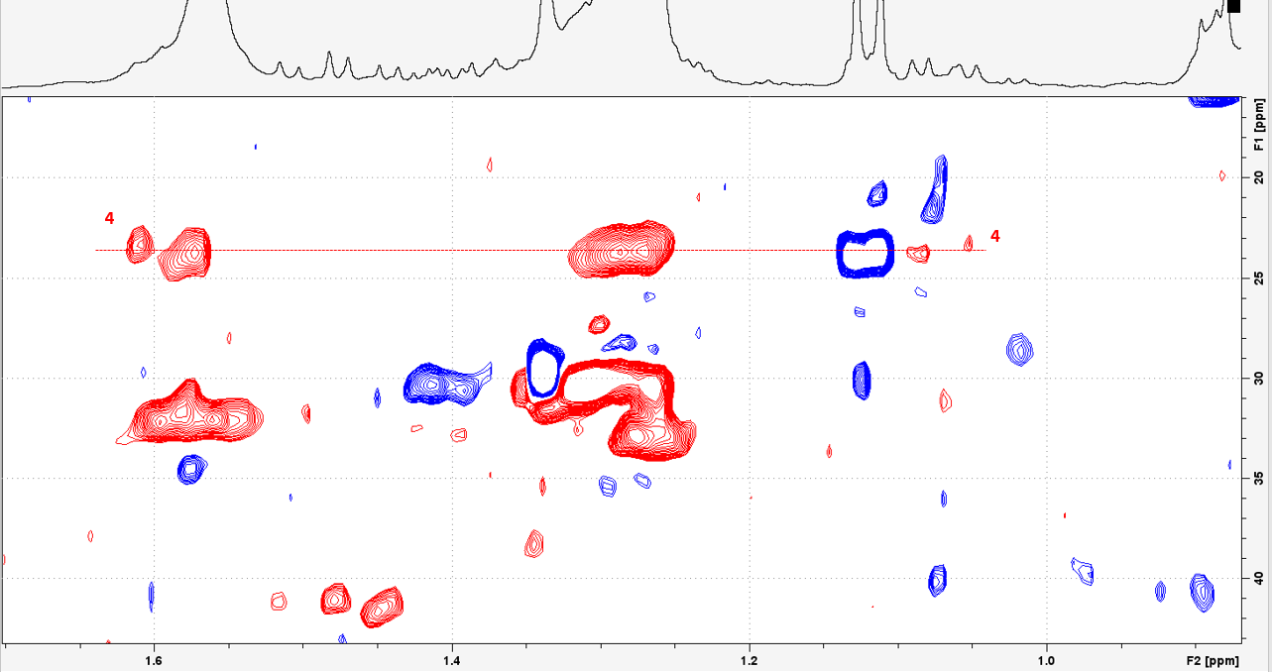
S8: ¹H-¹³C-HSQC of Compound 1, detailed view. Recorded at 400.33 MHz in CDCl₃.

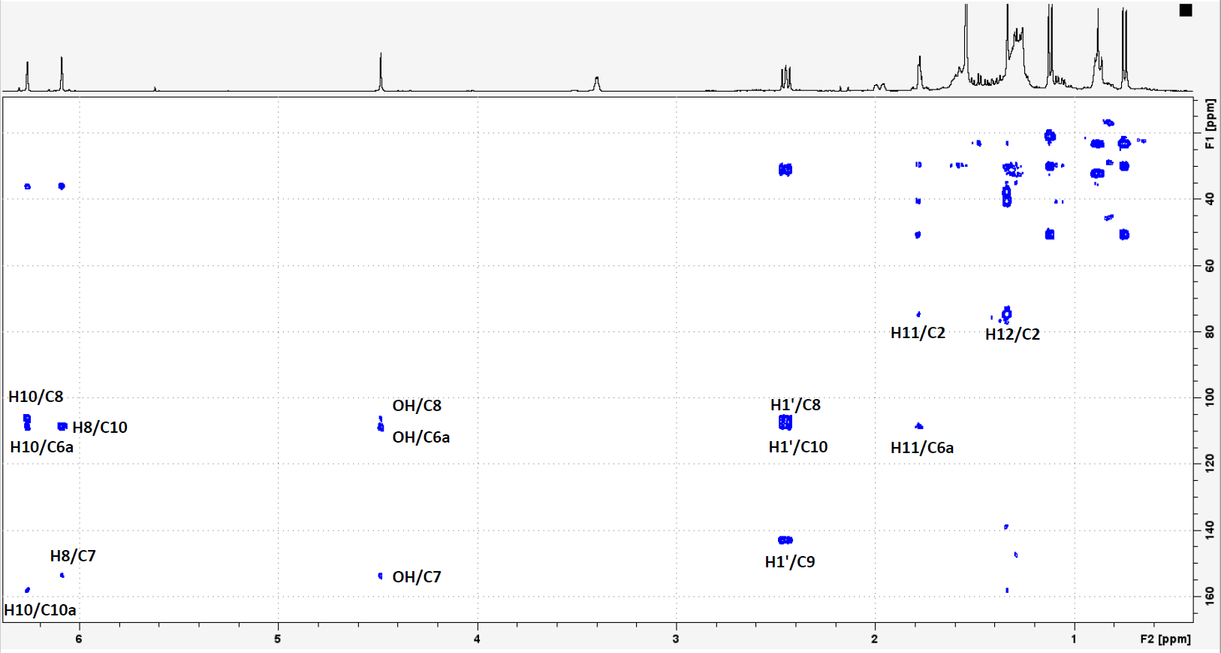
S9: ¹H-¹³C-HMBC of Compound 1. Recorded at 400.33 MHz in CDCl₃.

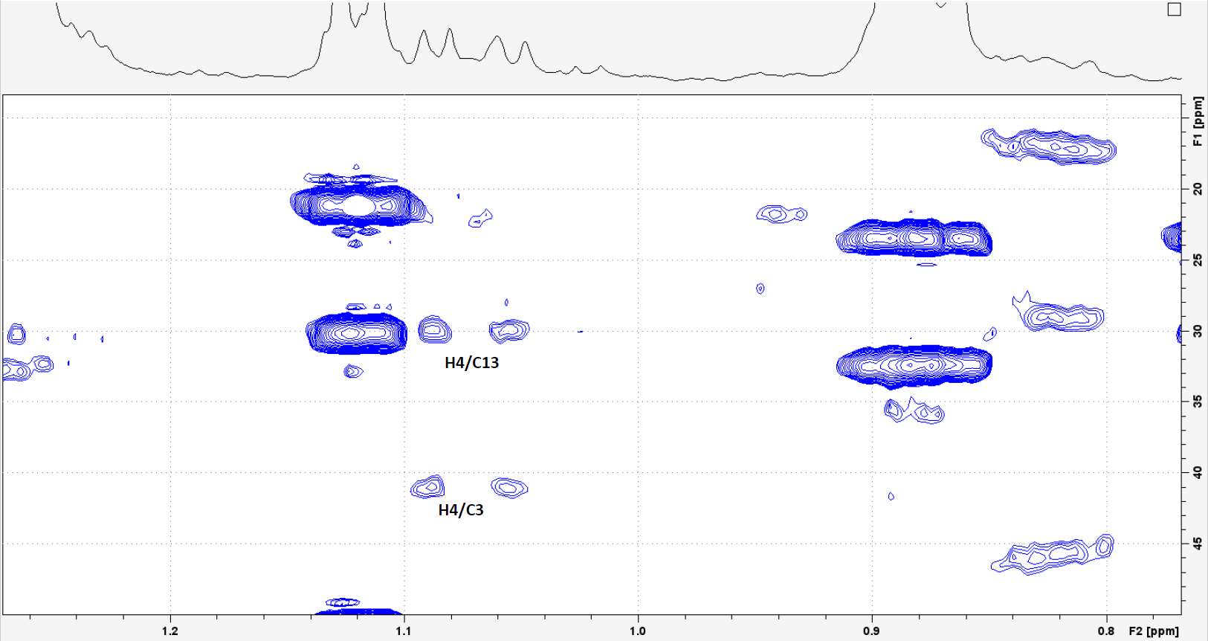
S10: ¹H-¹³C-HMBC of Compound 1, detailed view. Recorded at 400.33 MHz in CDCl₃.

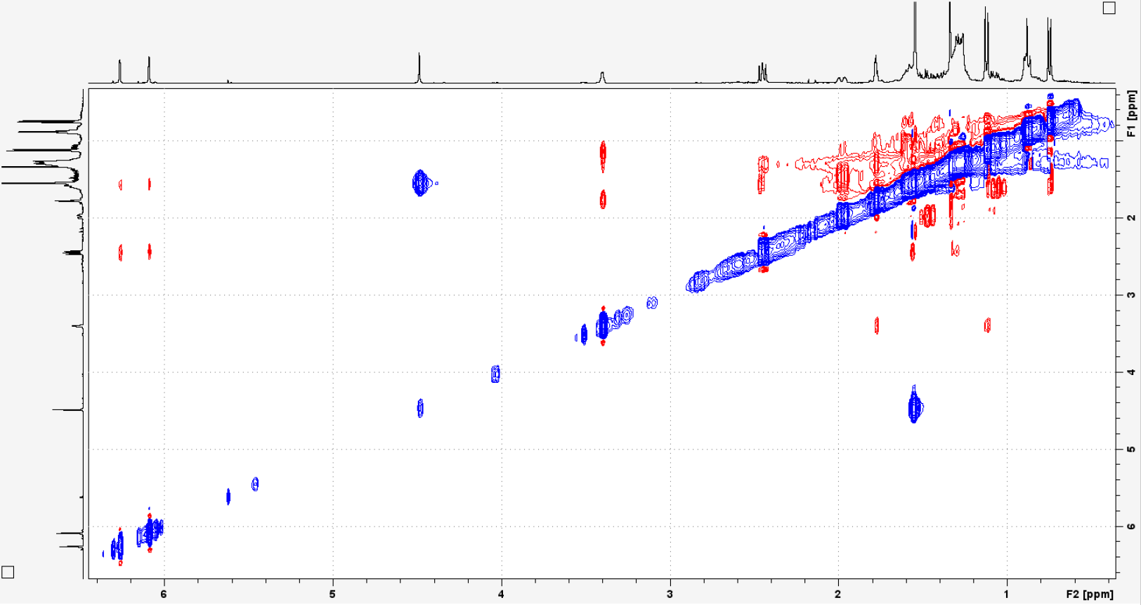
S11: NOESY of Compound 1. Recorded at 400.33 MHz in CDCl₃.

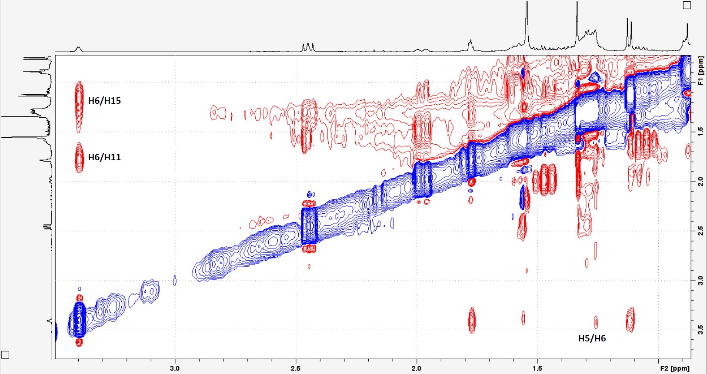
S12: NOESY of Compound 1, detailed view. Recorded at 400.33 MHz in CDCl₃. 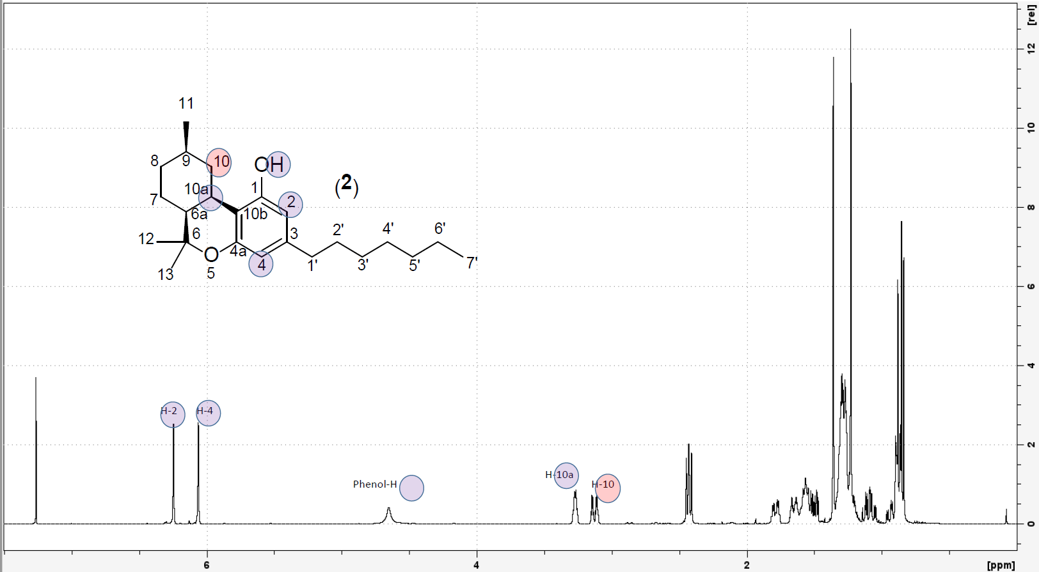
S13: ¹H-NMR of Compound 2. Recorded at 400.33 MHz in CDCl₃.

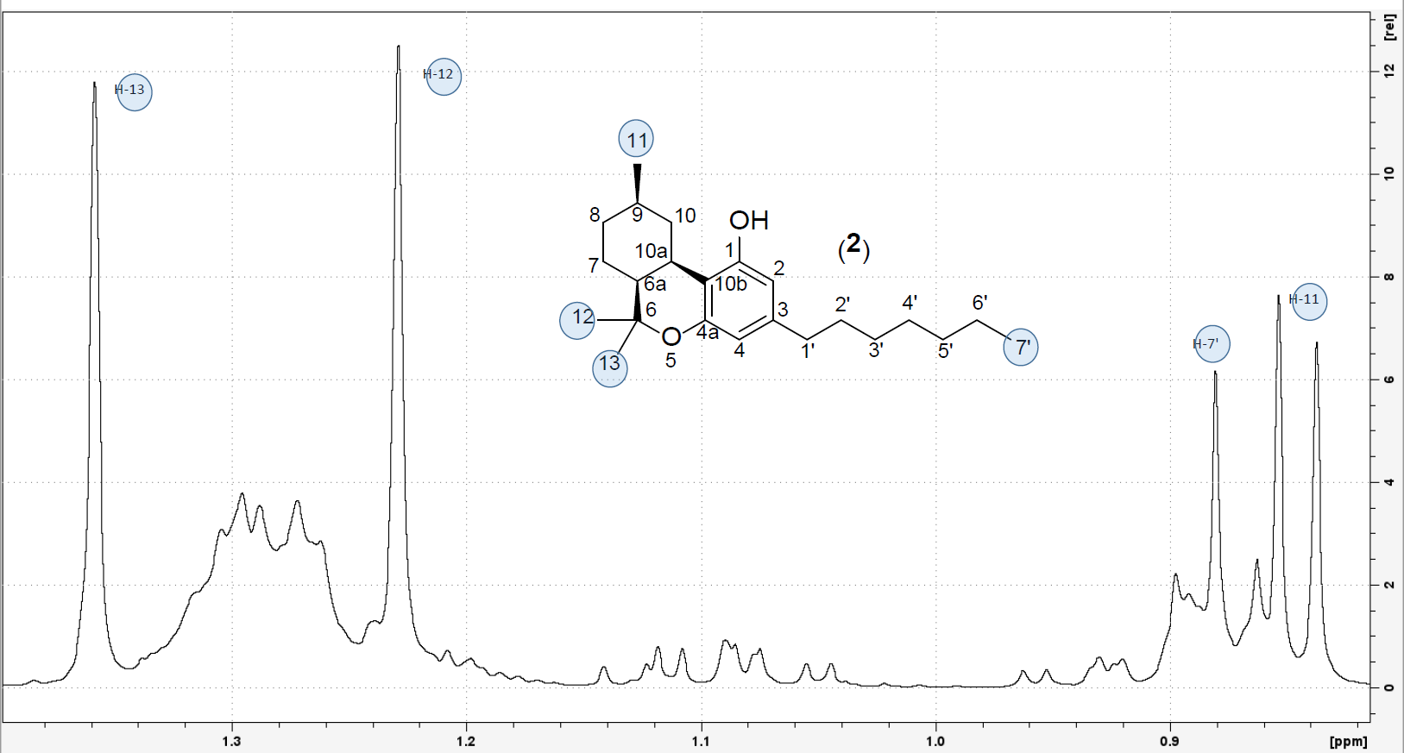
S14: ¹H-NMR of Compound 2, detailed view. Recorded at 400.33 MHz in CDCl₃.

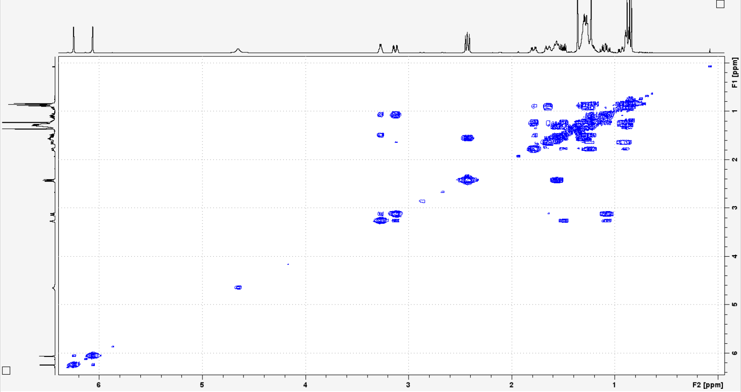
S15: ¹H-¹H-COSY of Compound 2. Recorded at 400.33 MHz in CDCl₃.

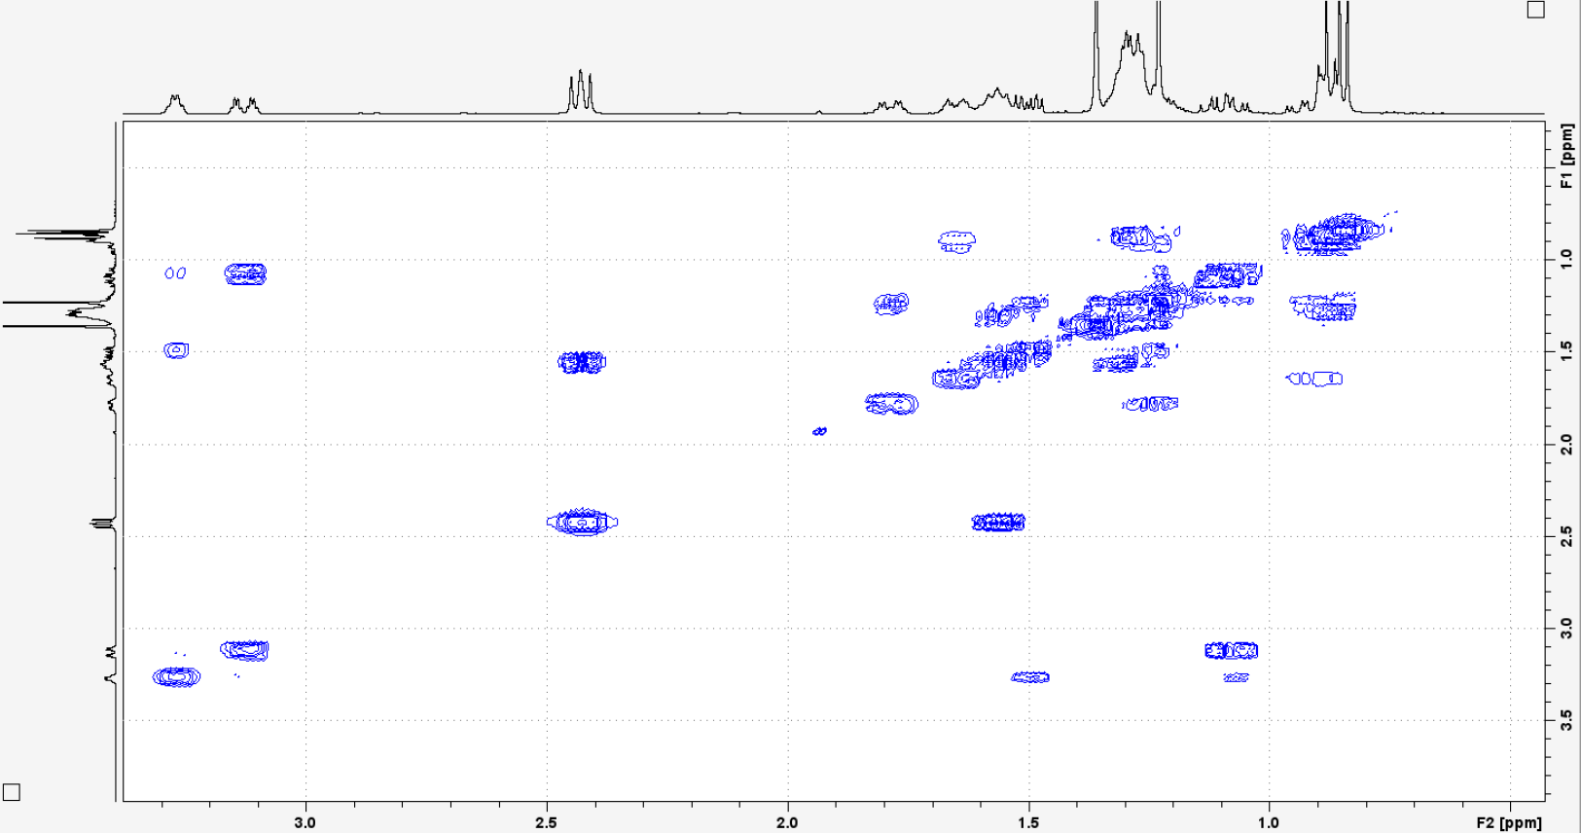
S16: ¹H-¹H-COSY of Compound 2, detailed view. Recorded at 400.33 MHz in CDCl₃.
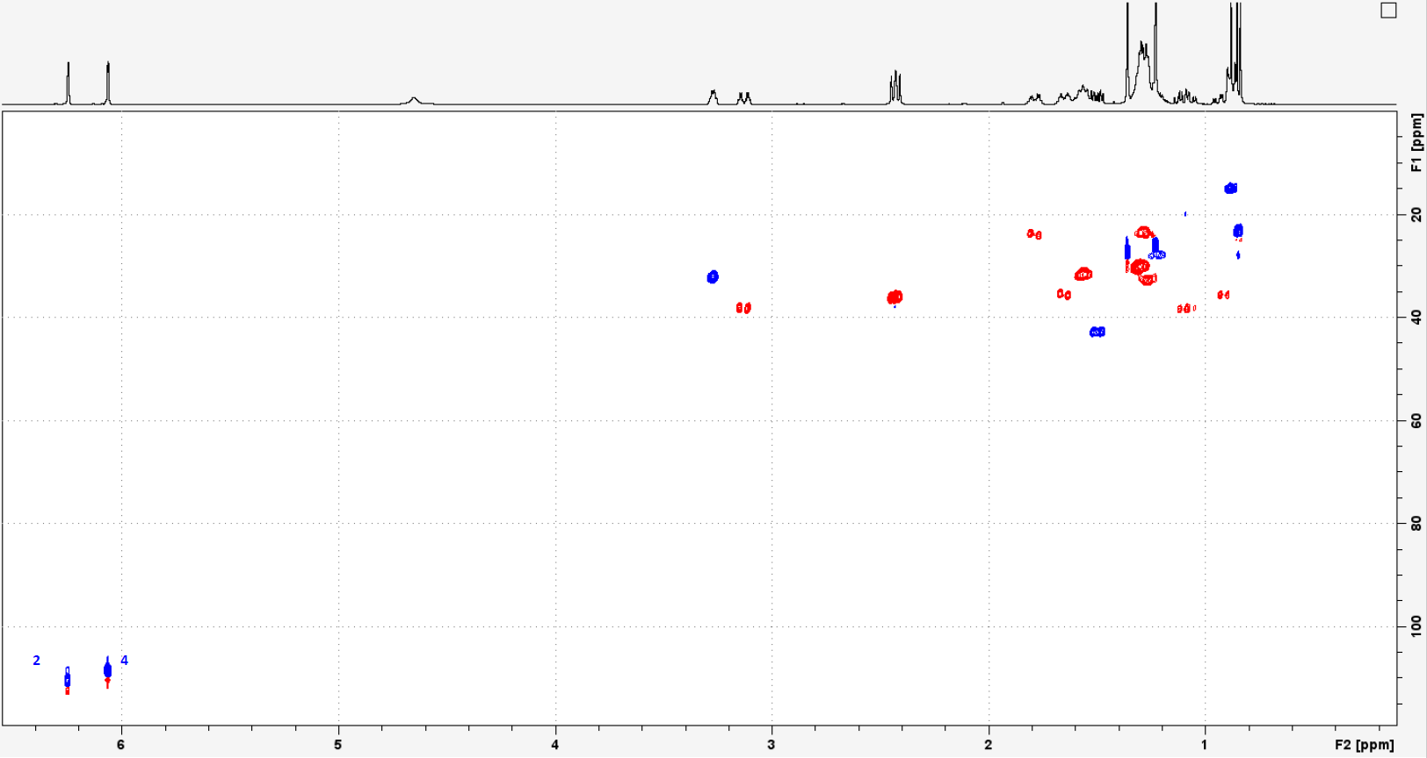
S17: ¹H-¹³C-HSQC of Compound 2 Recorded at 400.33 MHz in CDCl₃.

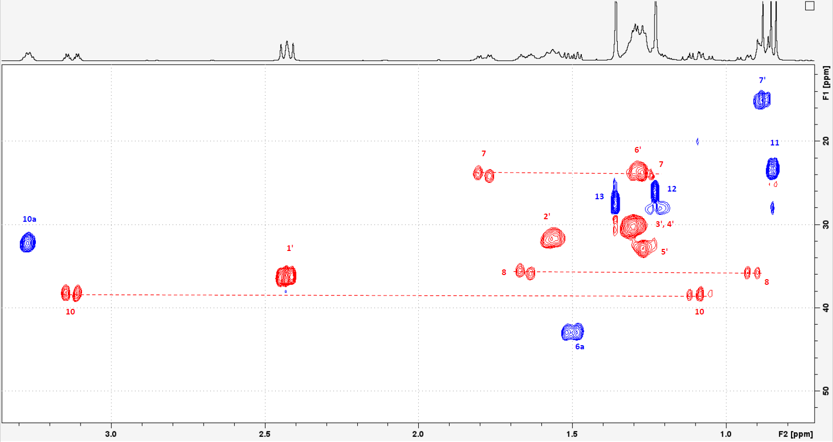
S18: ¹H-¹³C-HSQC of Compound 2, detailed view. Recorded at 400.33 MHz in CDCl₃.

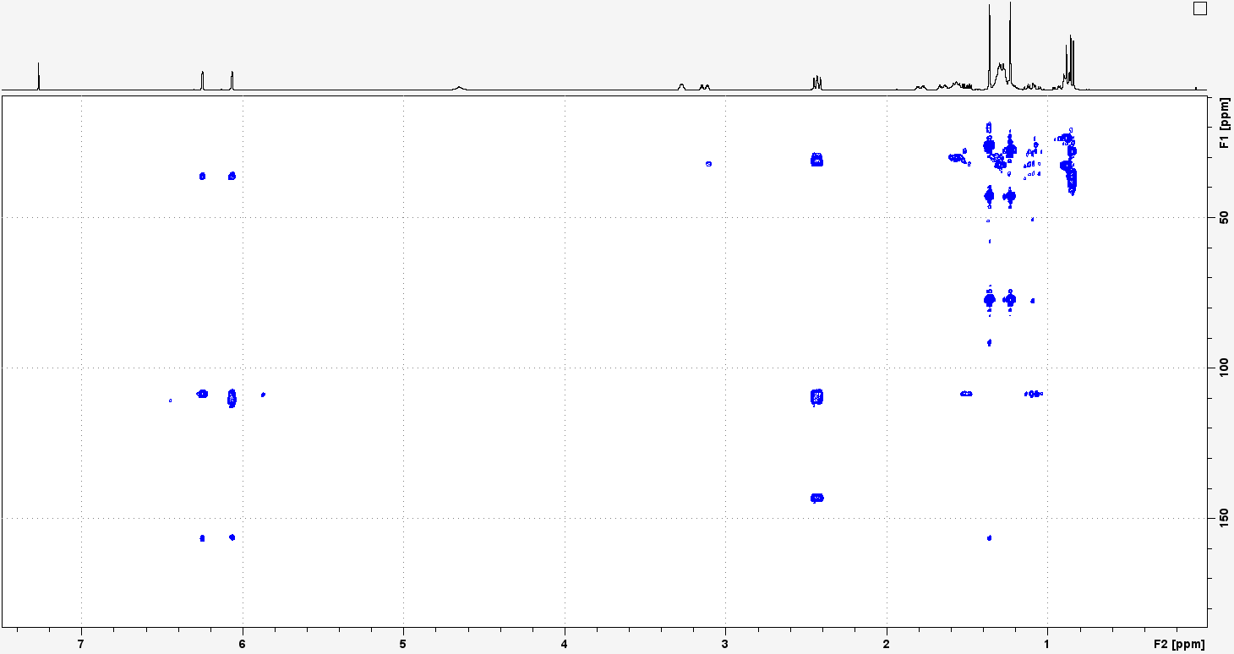
S19: ¹H-¹³C-HMBC of Compound 2. Recorded at 400.33 MHz in CDCl₃.

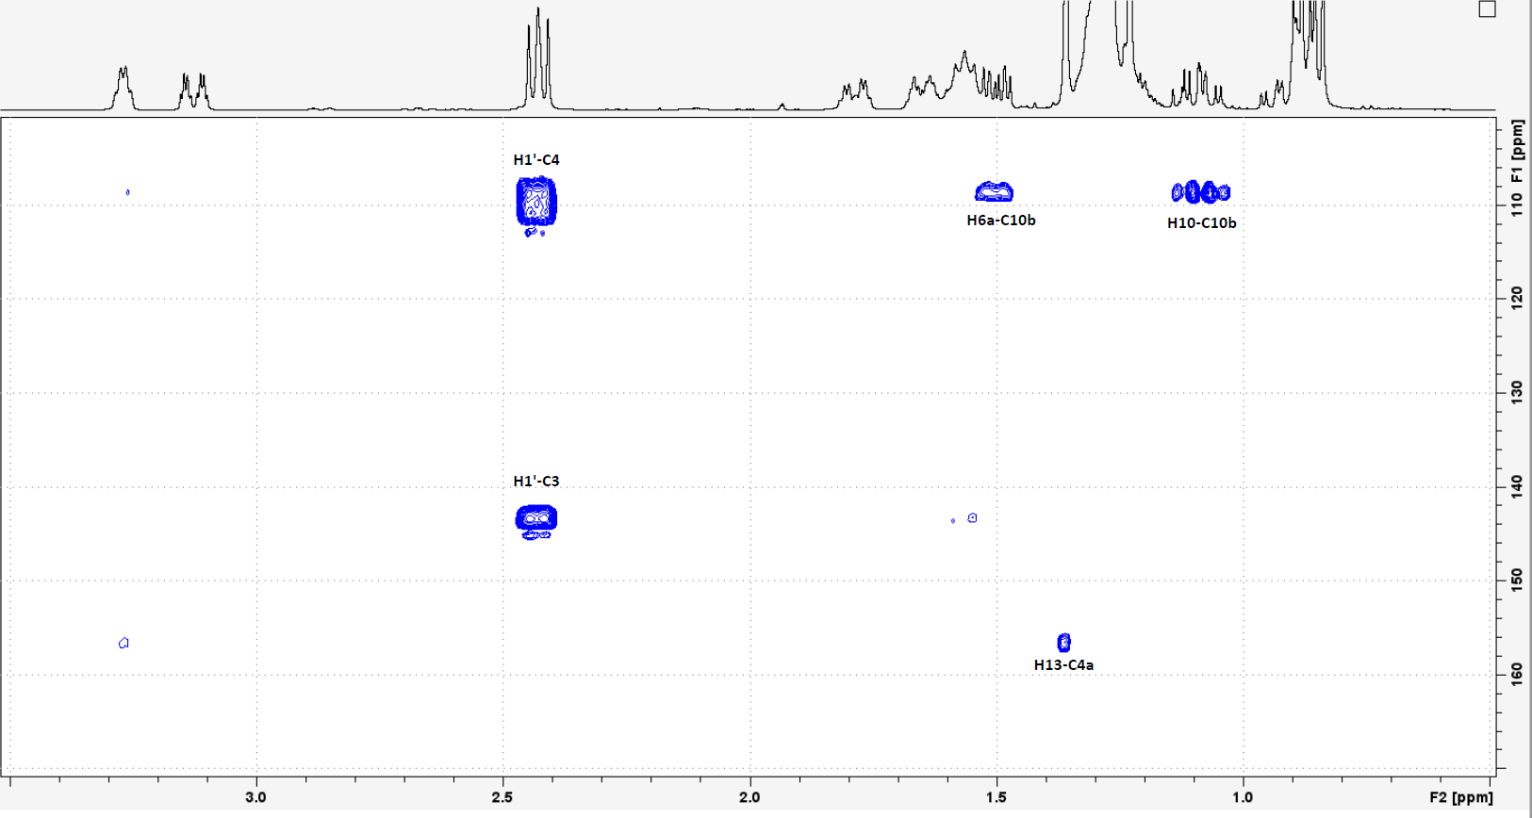
S20: ¹H-¹³C-HMBC of Compound 2, detailed view. Recorded at 400.33 MHz in CDCl₃.

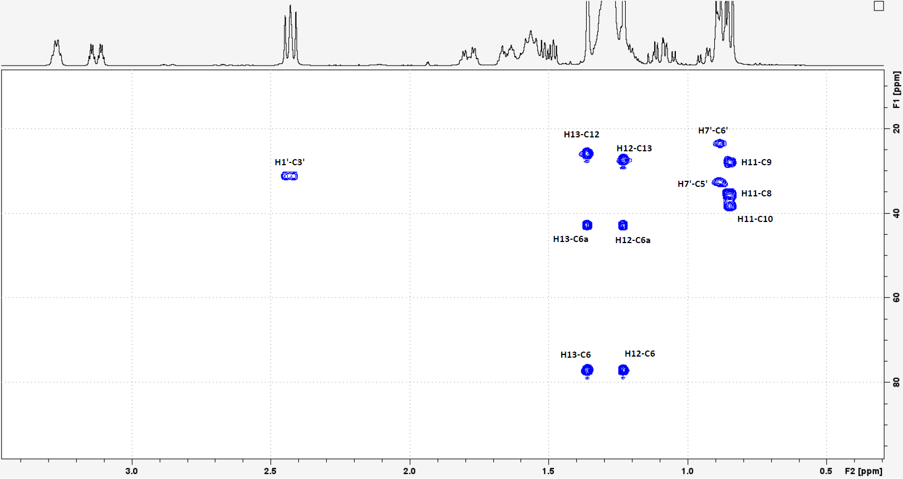
S21: ¹H-¹³C-HMBC of Compound 2, detailed view. Recorded at 400.33 MHz in CDCl₃.

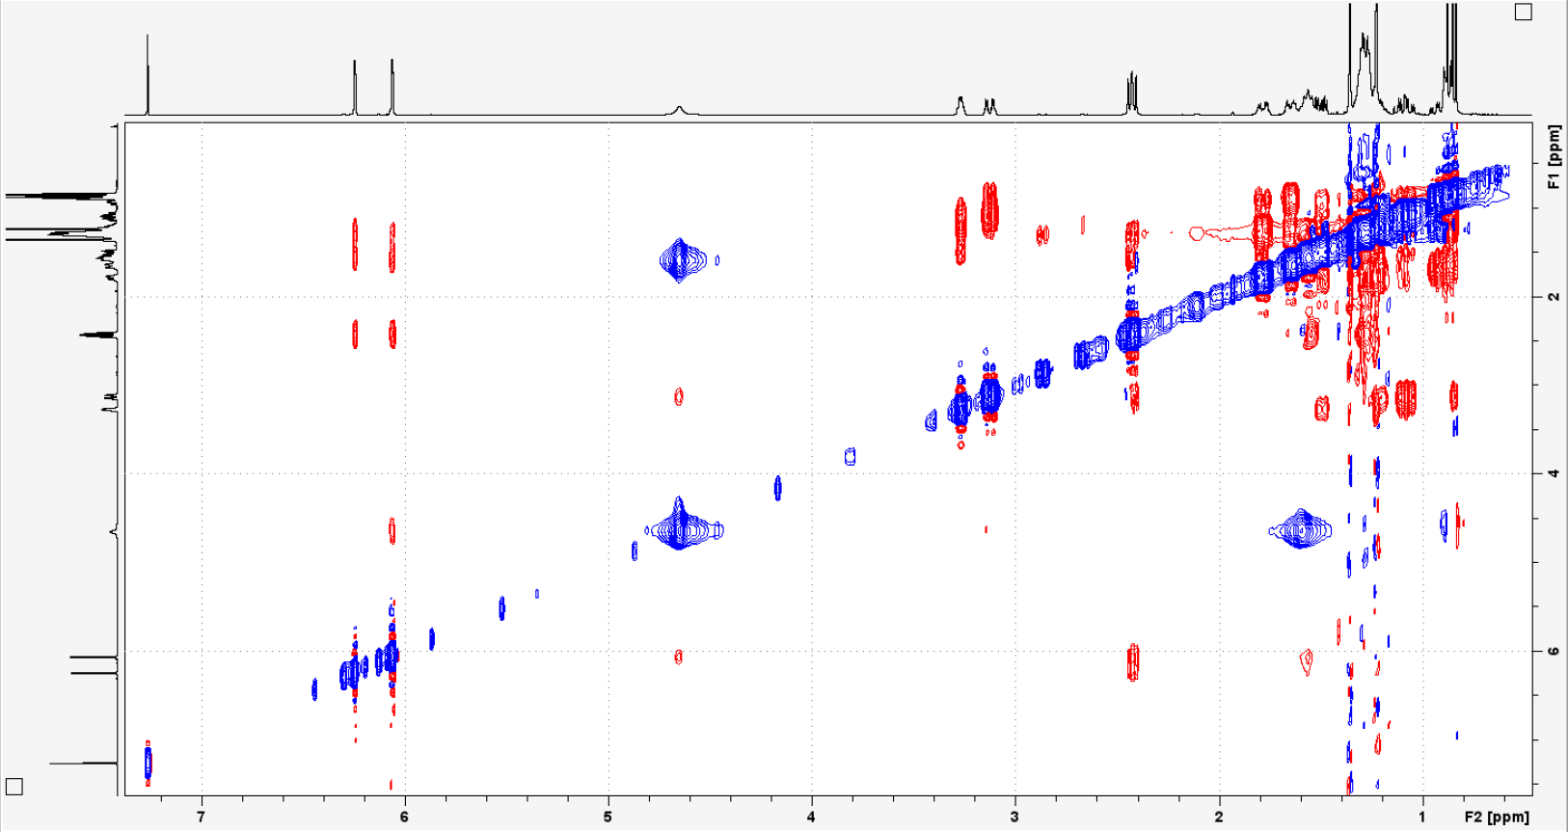
S22: NOESY of Compound 2. Recorded at 400.33 MHz in CDCl₃.

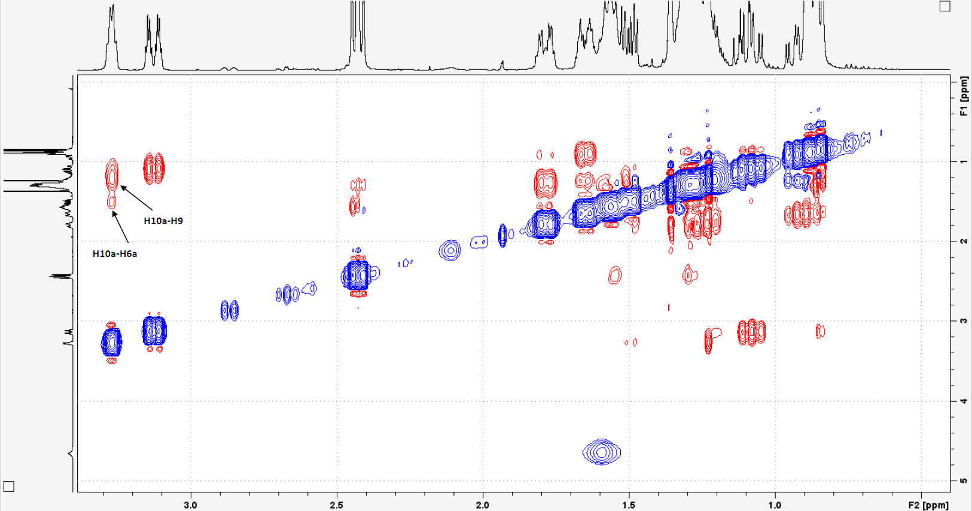
S23: NOESY of Compound 2, detailed view. Recorded at 400.33 MHz in CDCl₃.

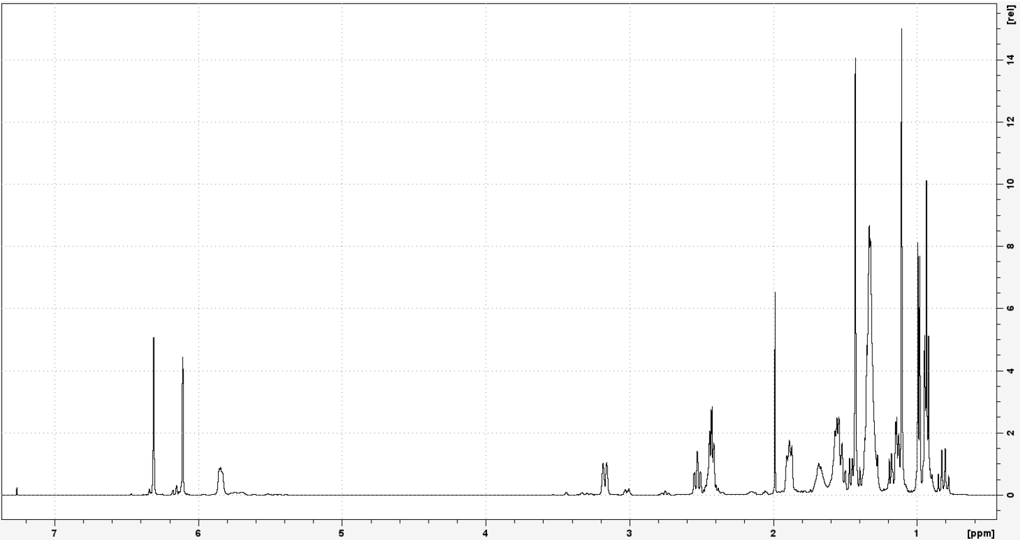
S24: ¹H-NMR of Compound 3. Recorded at 500.13 MHz in CDCl₃.

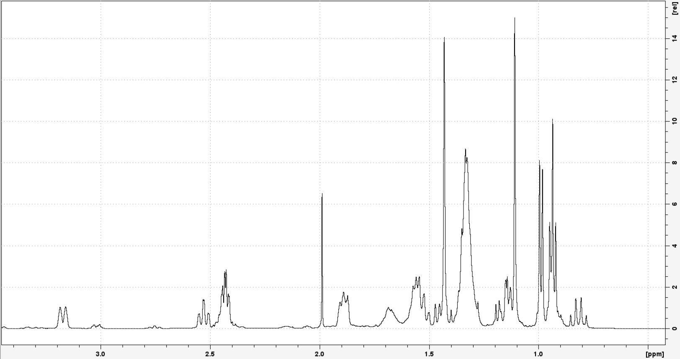
S25: ¹H-NMR of Compound 3, detailed view. Recorded at 500.13 MHz in CDCl₃.

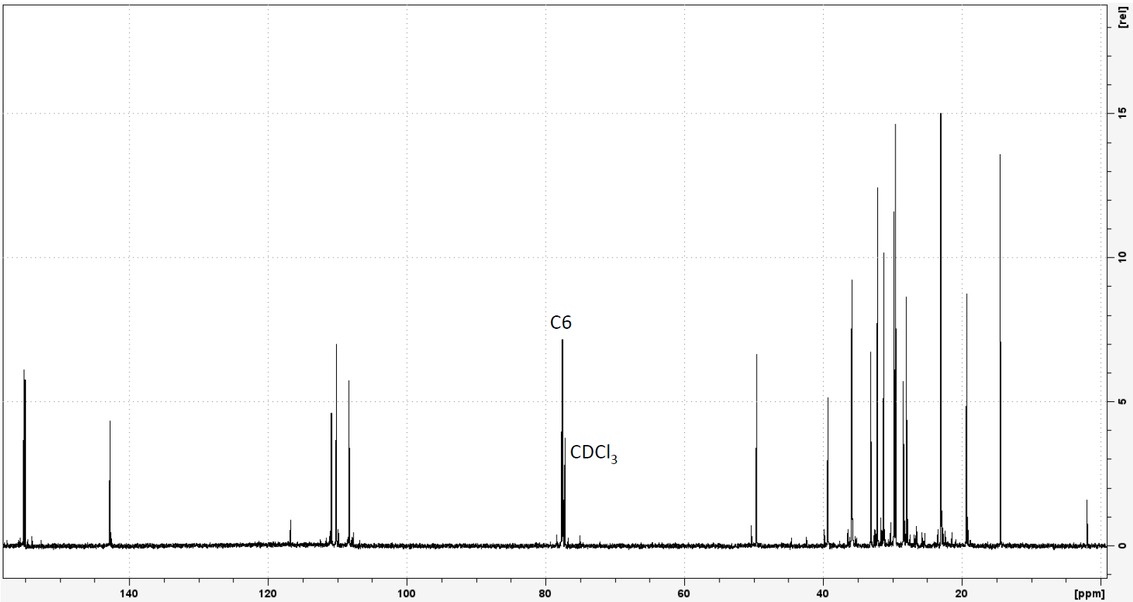
S26: ¹³C-NMR of Compound 3. Recorded at 125.76 MHz in CDCl₃.

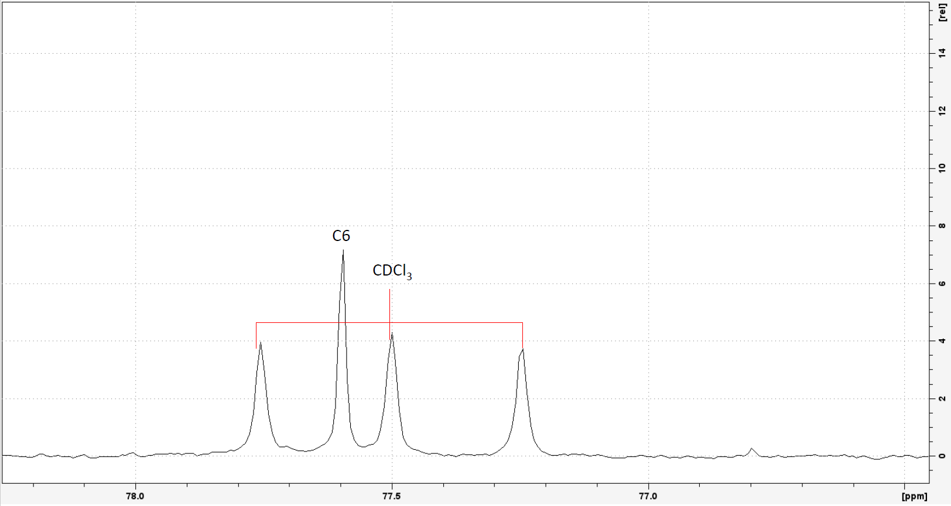
S27: ¹³C-NMR of Compound 3, detailed view. Recorded at 125.76 MHz in CDCl₃.

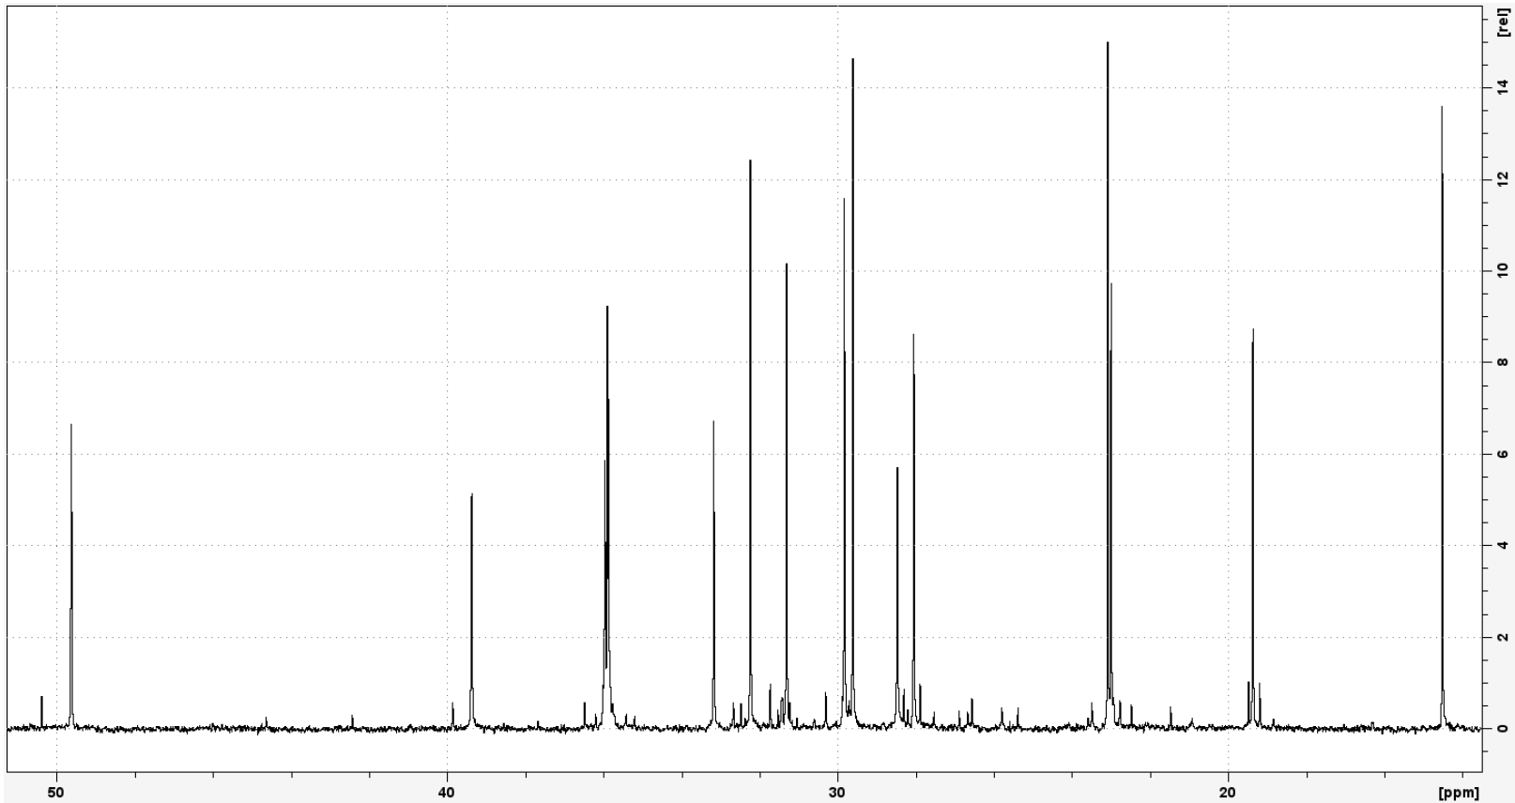
S28: ¹³C-NMR of Compound 3, detailed view. Recorded at 125.76 MHz in CDCl₃.

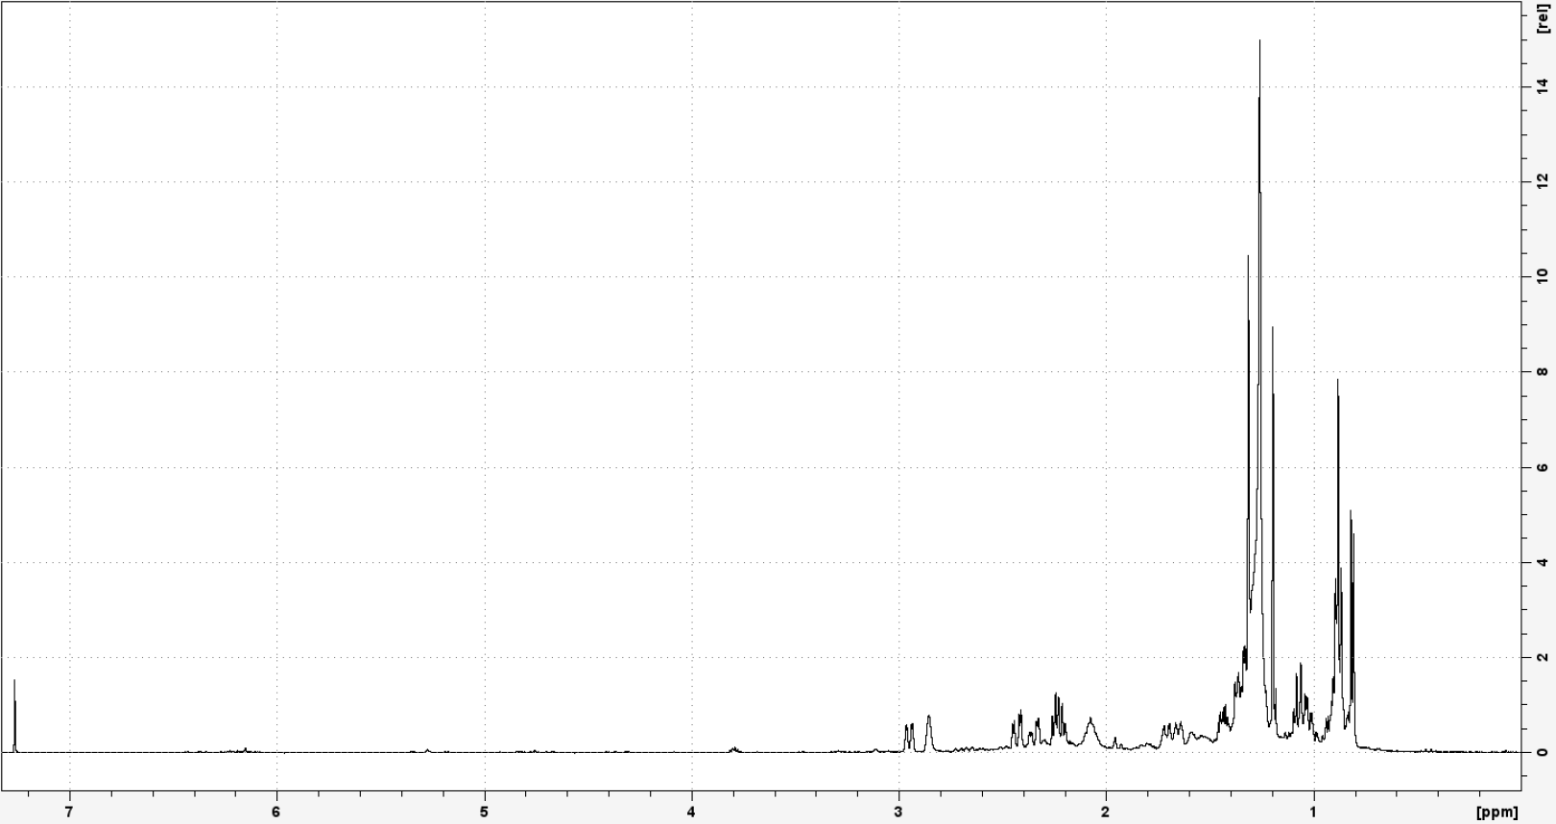
S29: ¹H-NMR of Compound 4. Recorded at 500.13 MHz in CDCl₃.

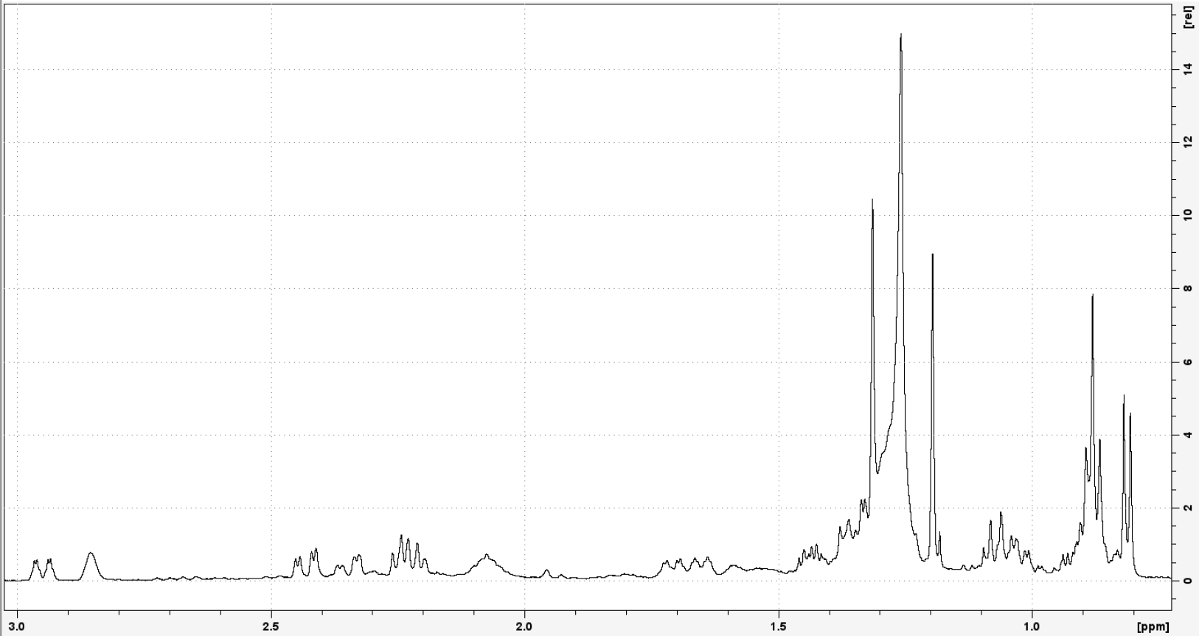
S30: ¹H-NMR of Compound 4, detailed view. Recorded at 500.13 MHz in CDCl₃.

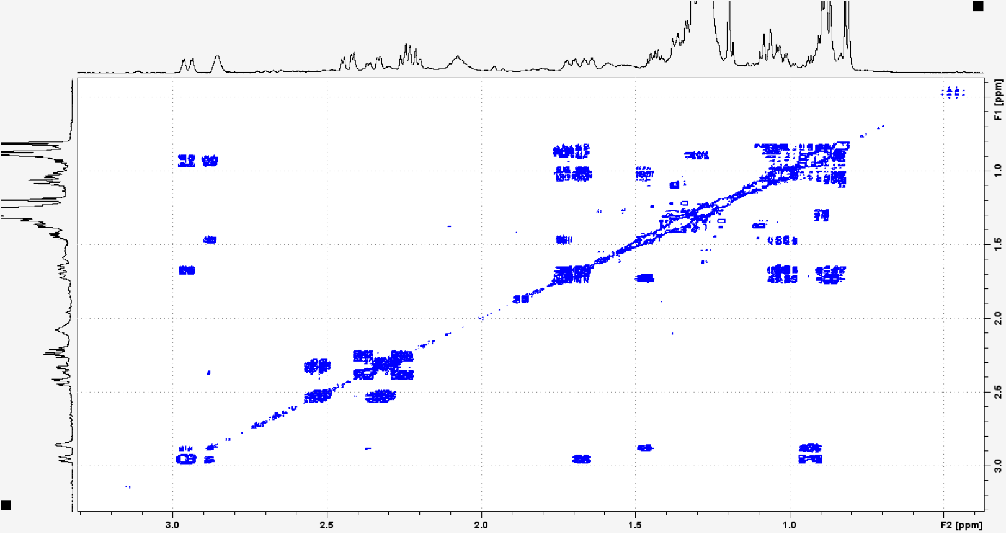
S31: ¹H-¹H-COSY of Compound 4. Recorded at 500.13 MHz in CDCl₃.

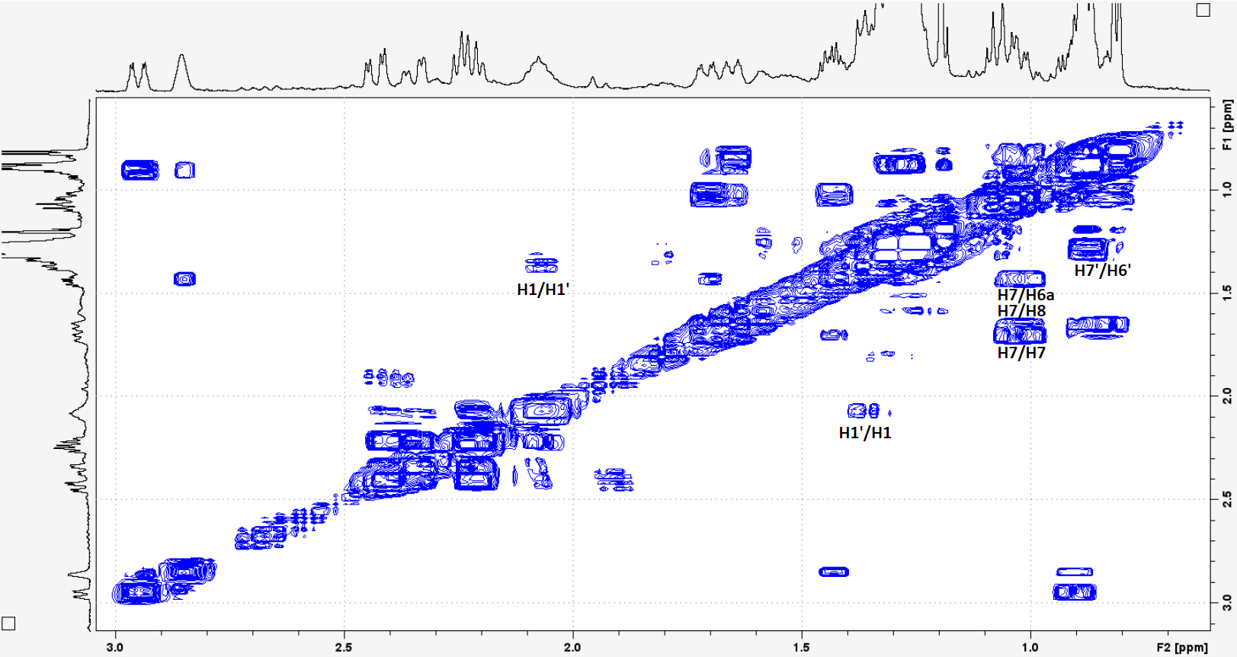
S32: ¹H-¹H-COSY of Compound 4, detailed view. Recorded at 500.13 MHz in CDCl₃.

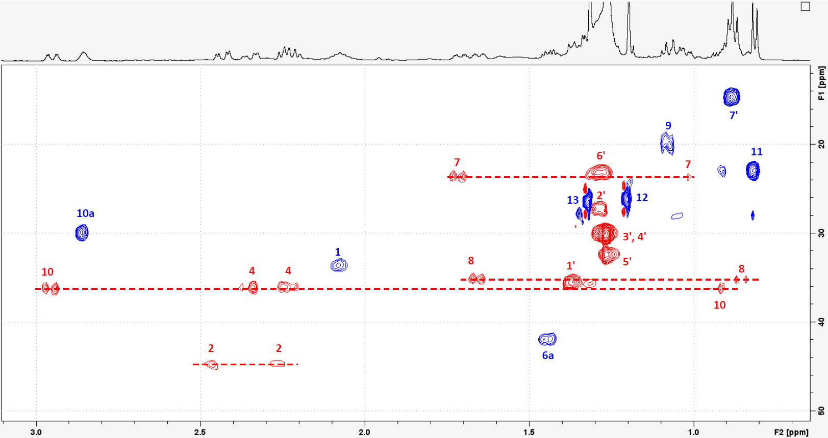
S33: ¹H-¹³C-HSQC of Compound 4, detailed view. Recorded at 500.13 MHz in CDCl₃.
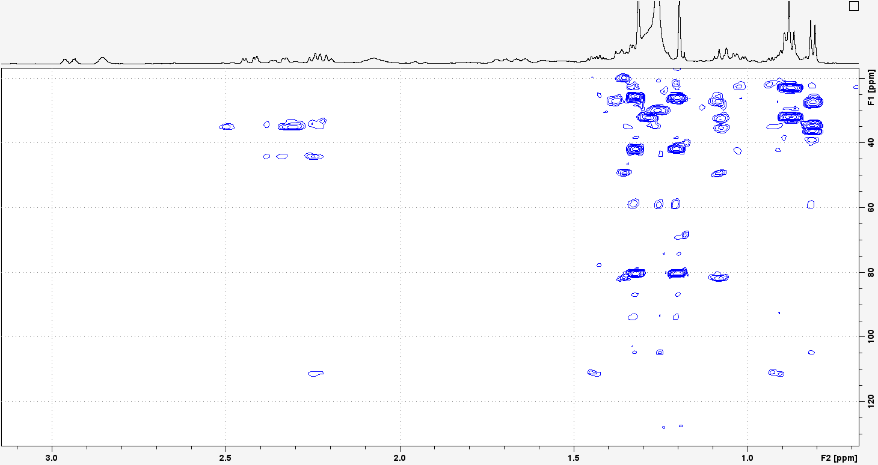S34: ¹H-¹³C-HMBC of Compound 4. Recorded at 500.13 MHz in CDCl₃.
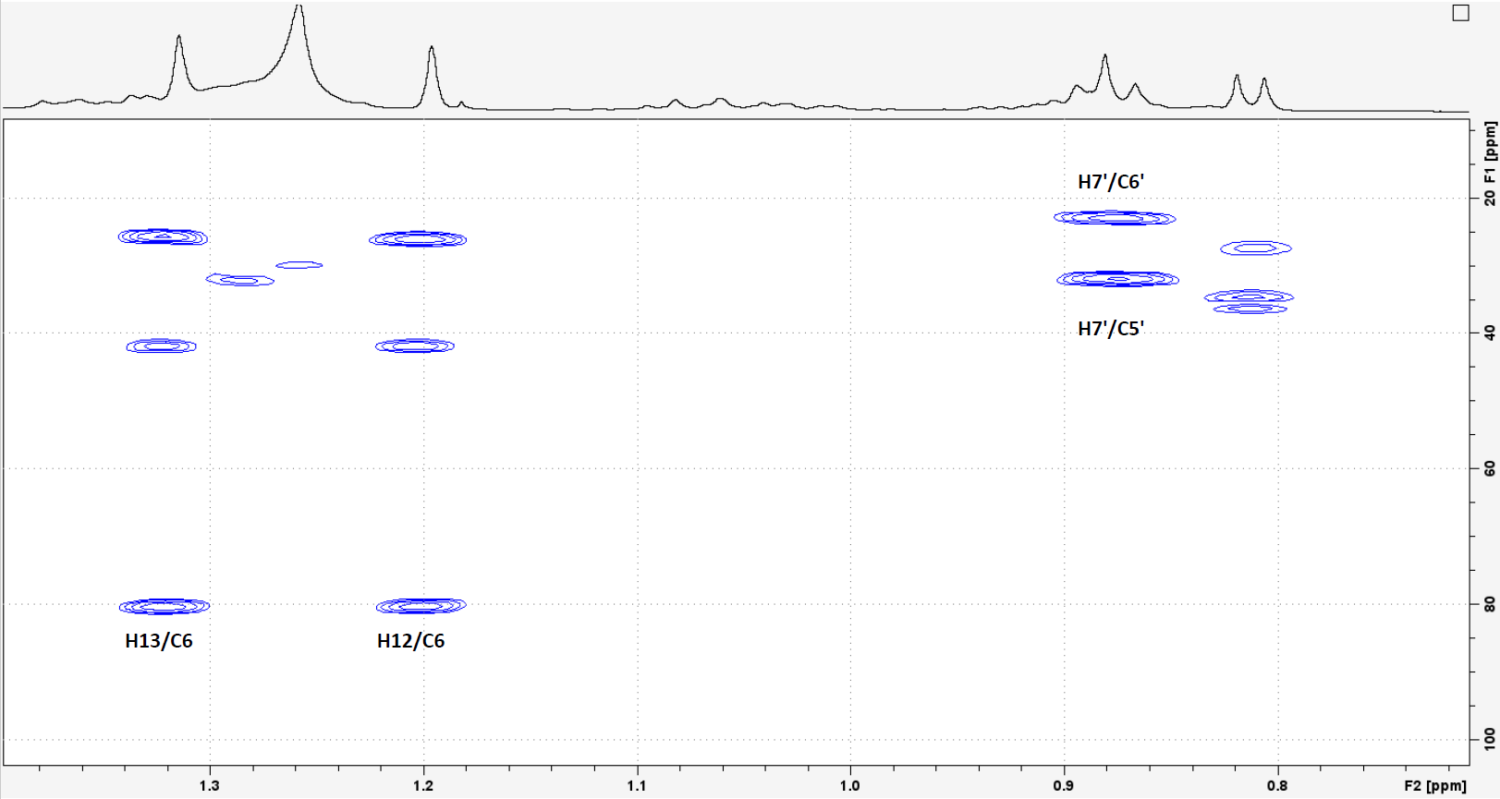
S35: ¹H-¹³C-HMBC of Compound 4, detailed view. Recorded at 500.13 MHz in CDCl₃.
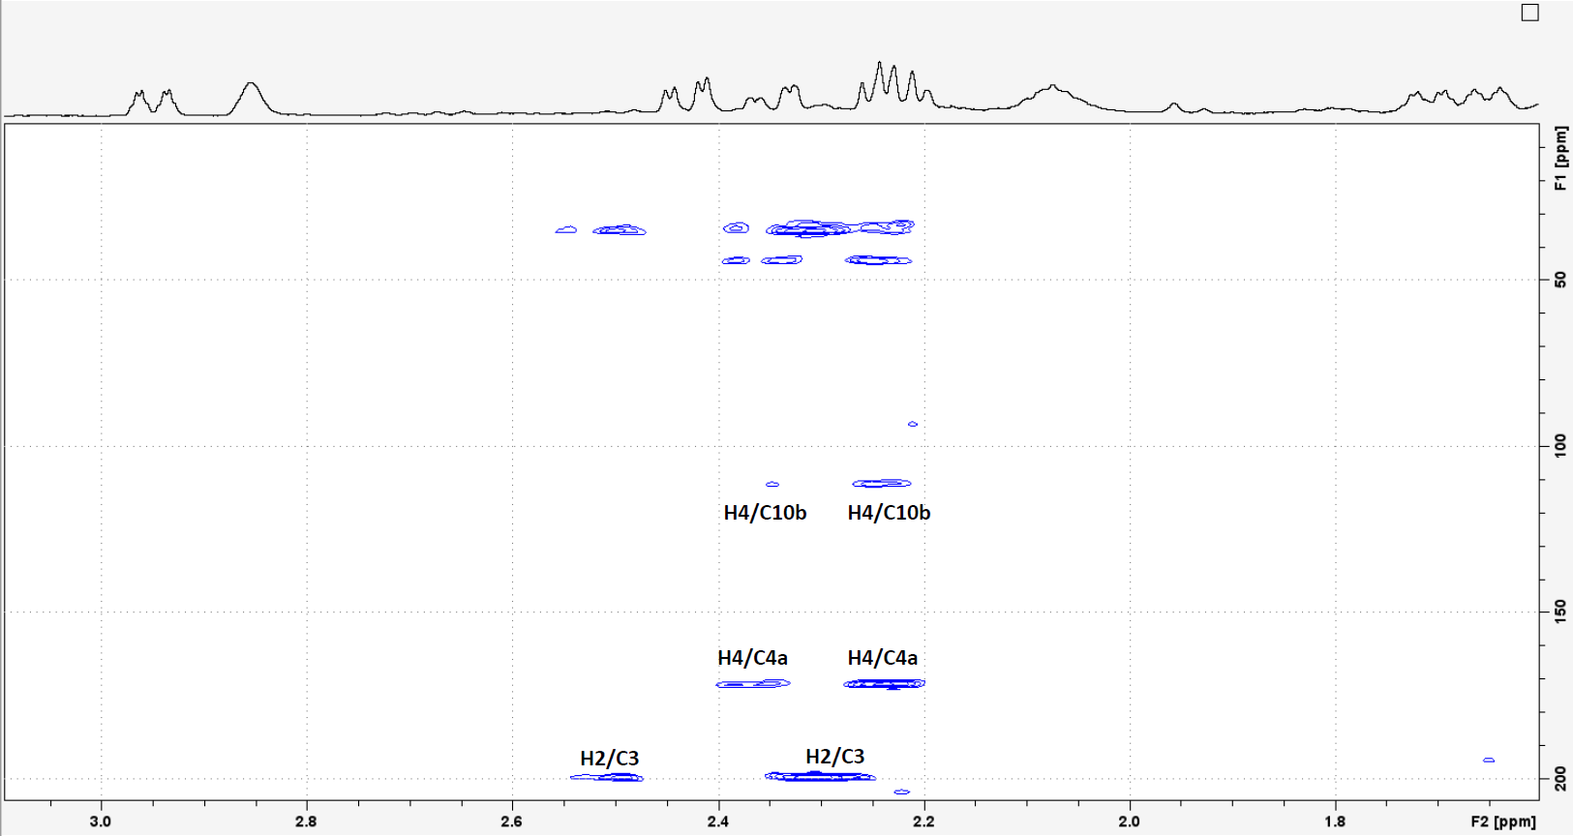
S36: ¹H-¹³C-HMBC of Compound 4, detailed view. Recorded at 500.13 MHz in CDCl₃.
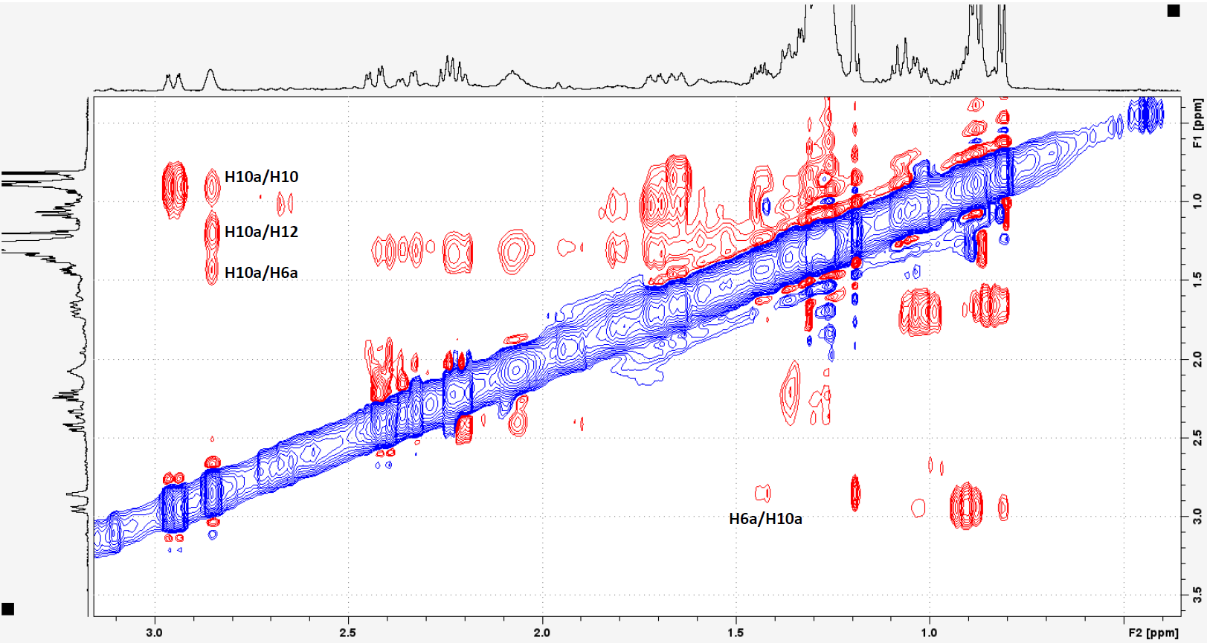
S37: NOESY of Compound 4. Recorded at 500.13 MHz in CDCl₃.
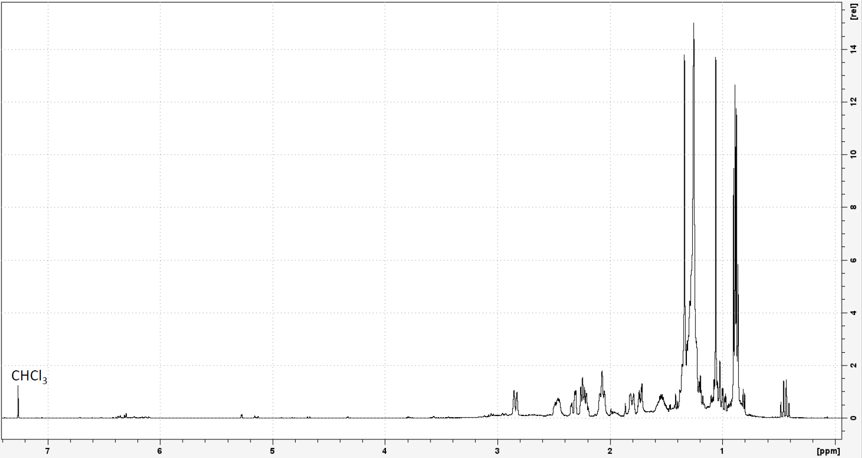
S38: ¹H-NMR of Compound 5. Recorded at 500.13 MHz in CDCl₃.

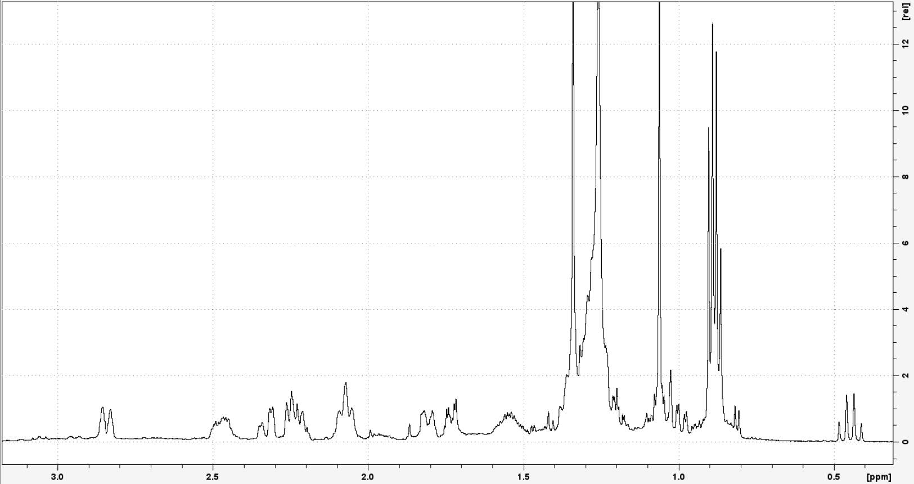
S39: ¹H-NMR of Compound 5, detailed view. Recorded at 500.13 MHz in CDCl₃.
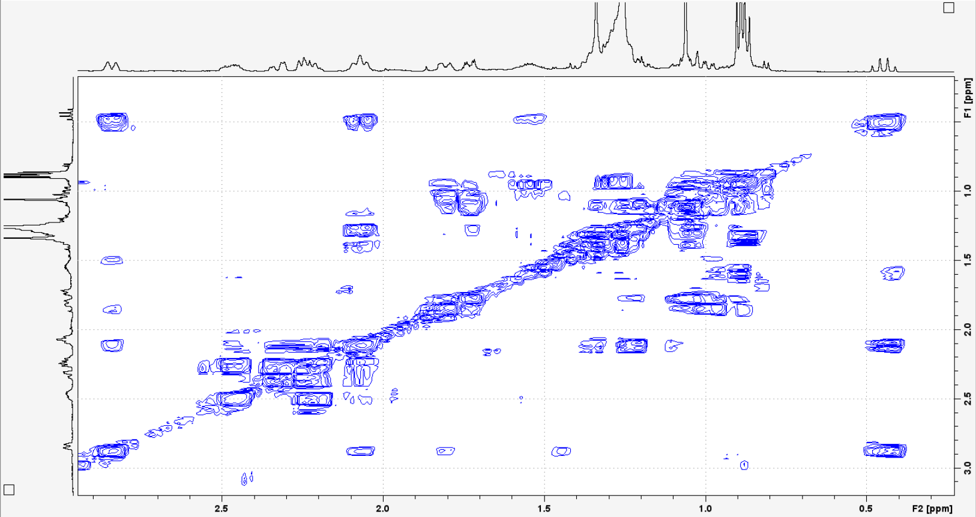
S40: ¹H-¹H-COSY of Compound 5. Recorded at 500.13 MHz in CDCl₃.
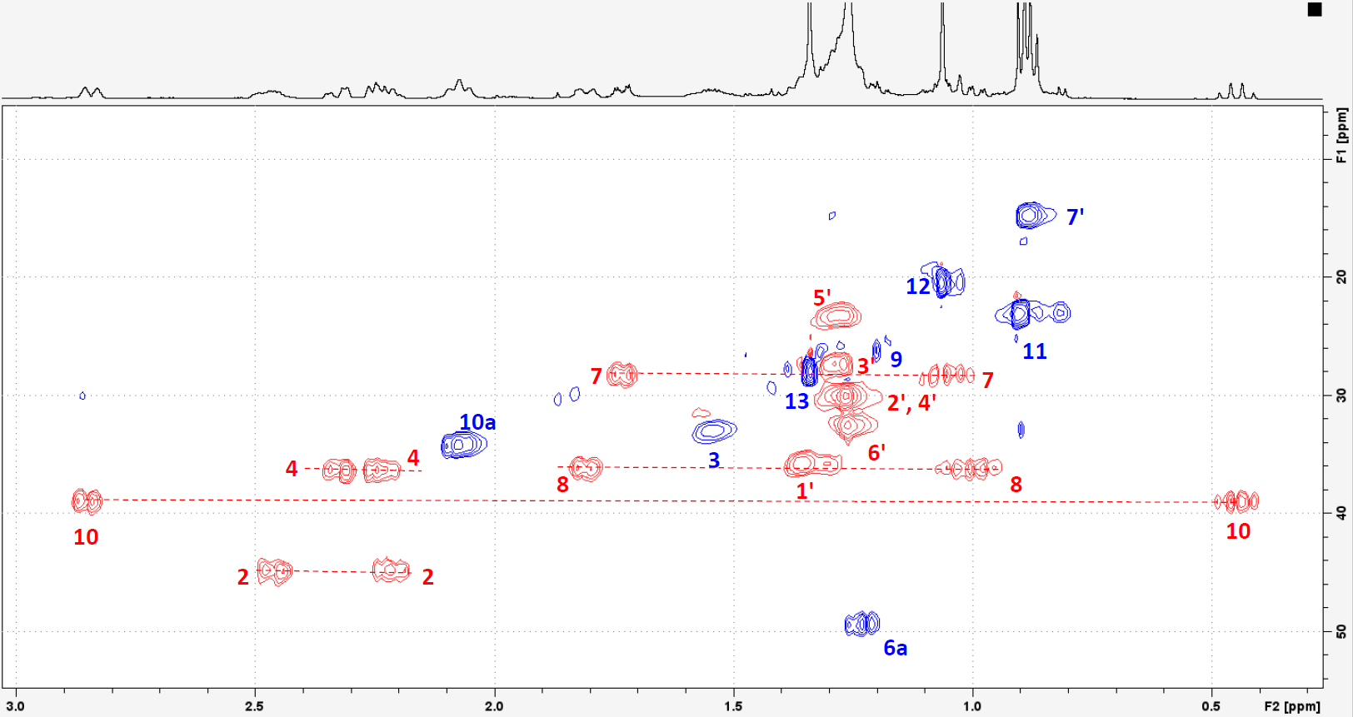
S41: ¹H-¹³C-HSQC of Compound 5, detailed view. Recorded at 500.13 MHz in CDCl₃.
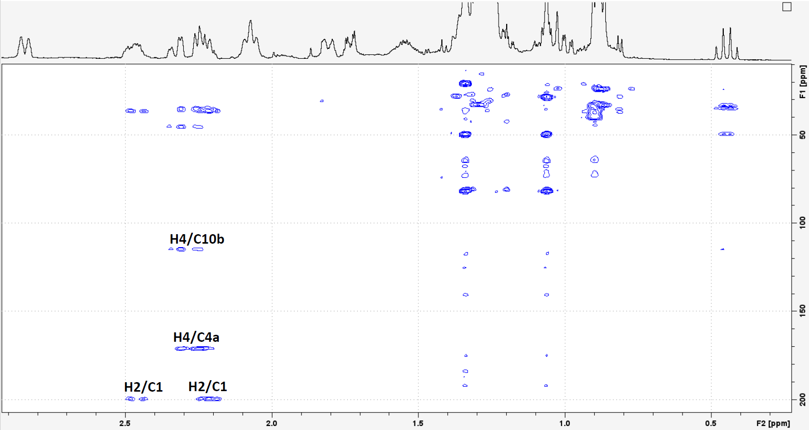
S42: ¹H-¹³C-HMBC of Compound 5, detailed view. Recorded at 500.13 MHz in CDCl₃.
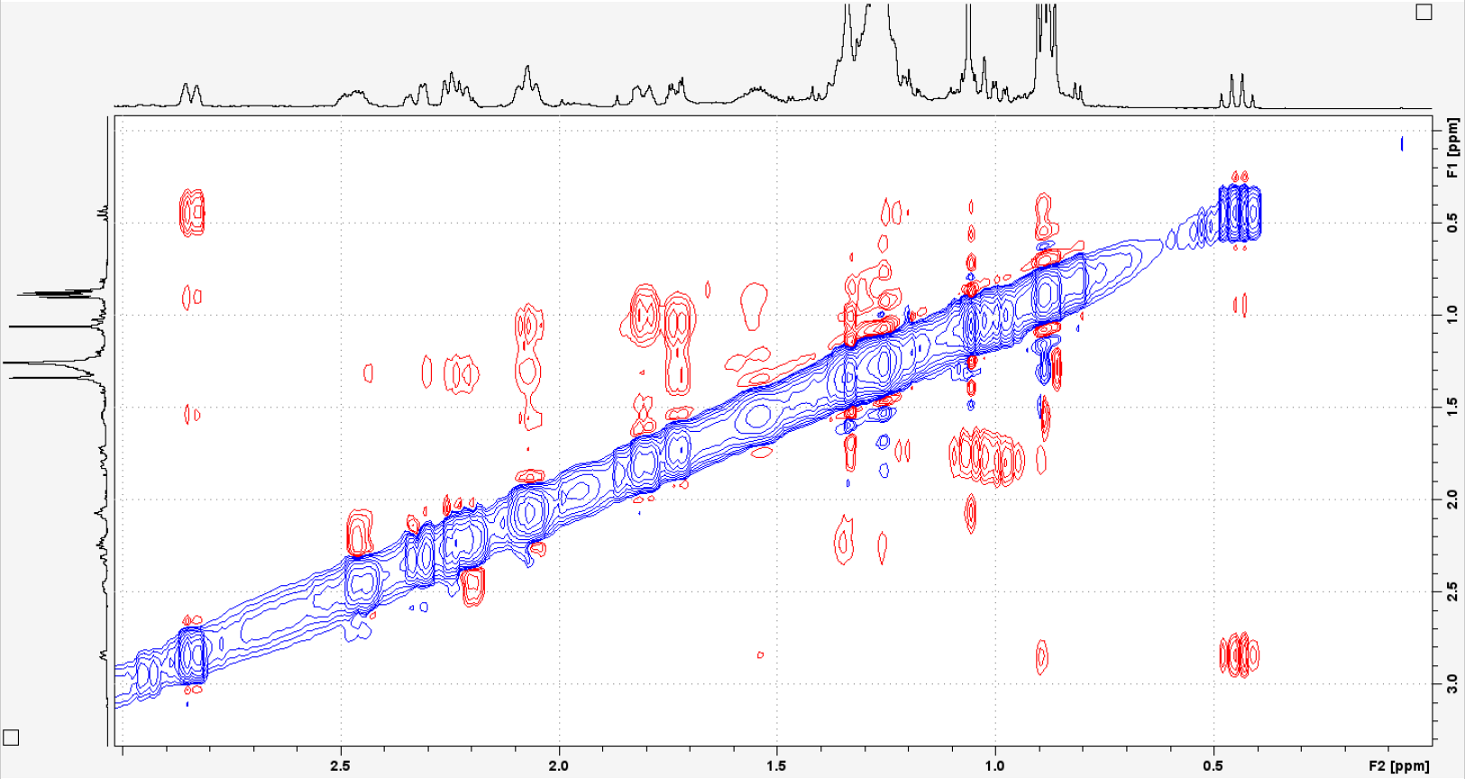
S43: NOESY of Compound 5. Recorded at 500.13 MHz in CDCl₃.
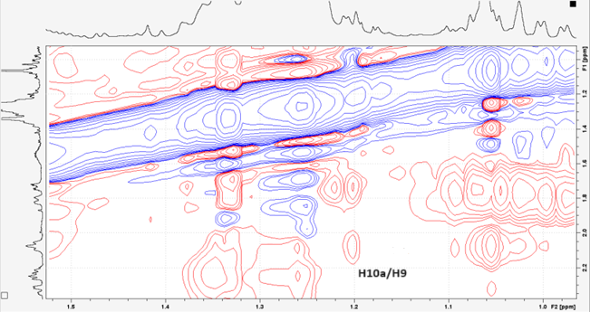
S44: NOESY of Compound 5, detailed view. Recorded at 500.13 MHz in CDCl₃.
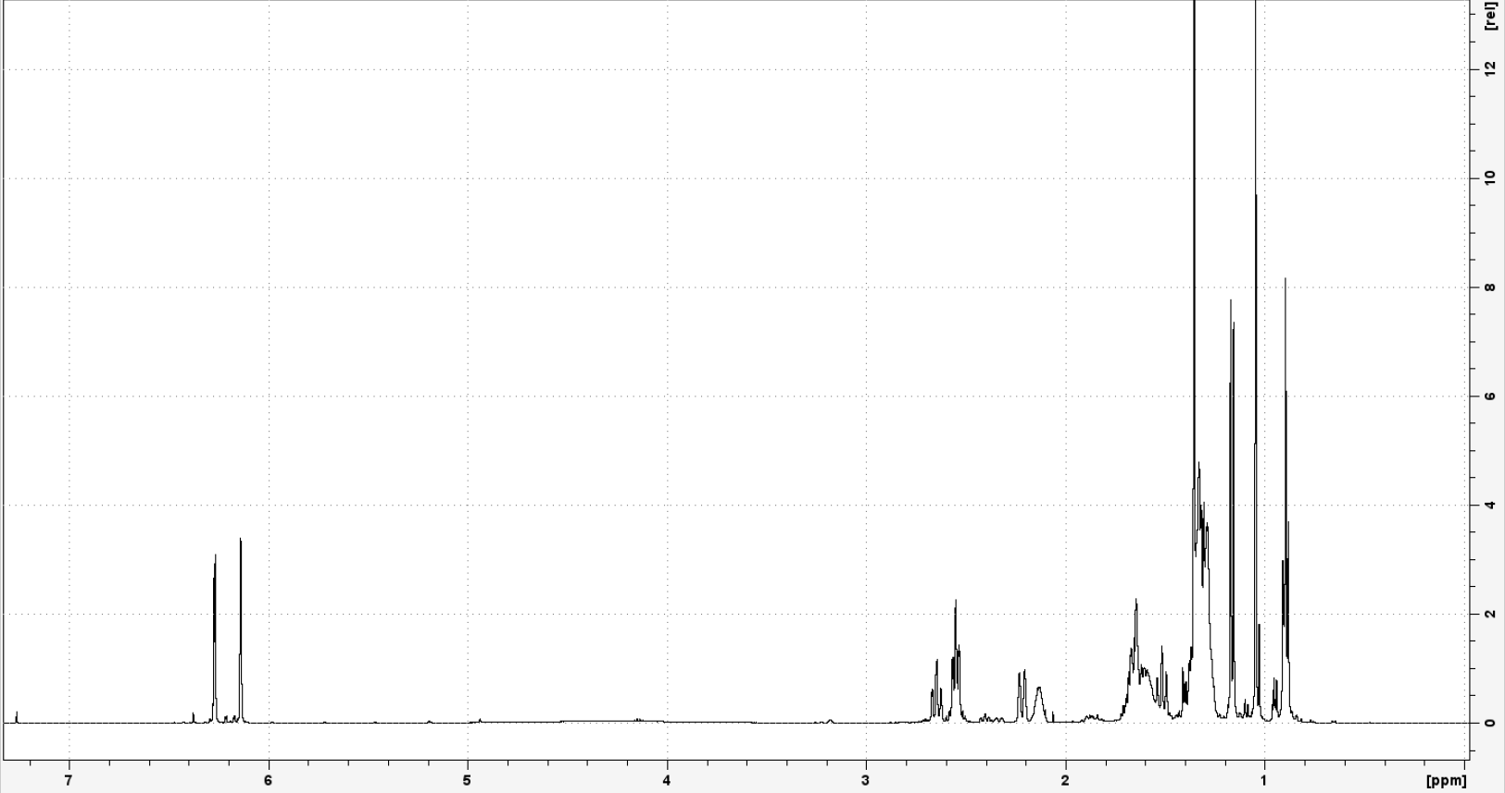
S45: ¹H-NMR of Compound 6. Recorded at 500.13 MHz in CDCl₃.
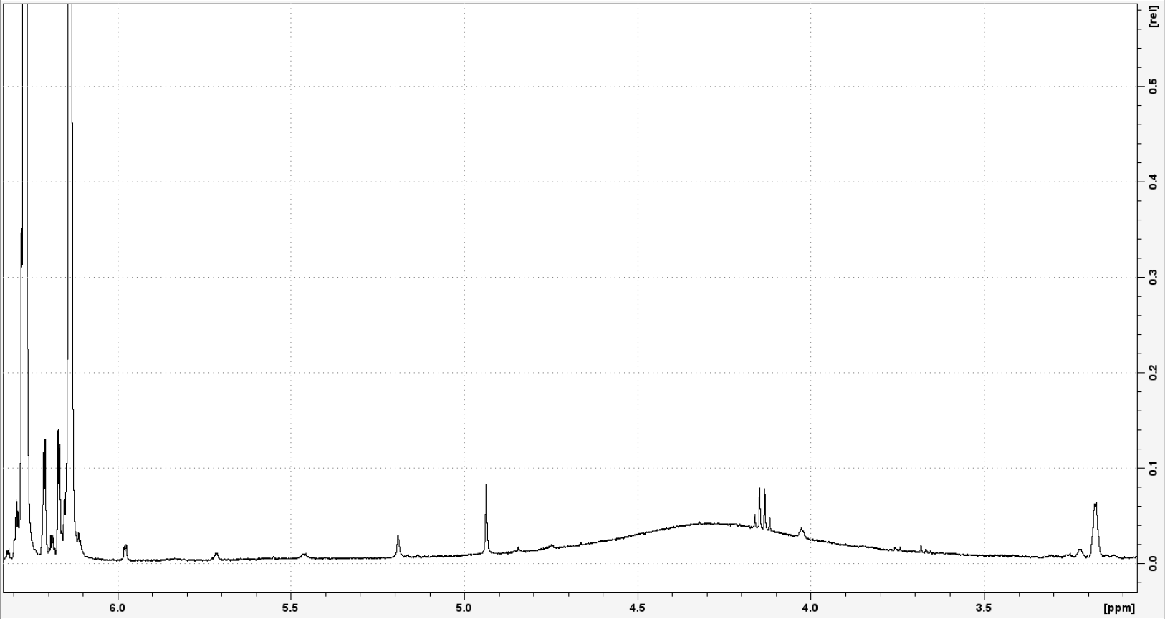
S46: ¹H-NMR of Compound 6, detailed view. Recorded at 500.13 MHz in CDCl₃.

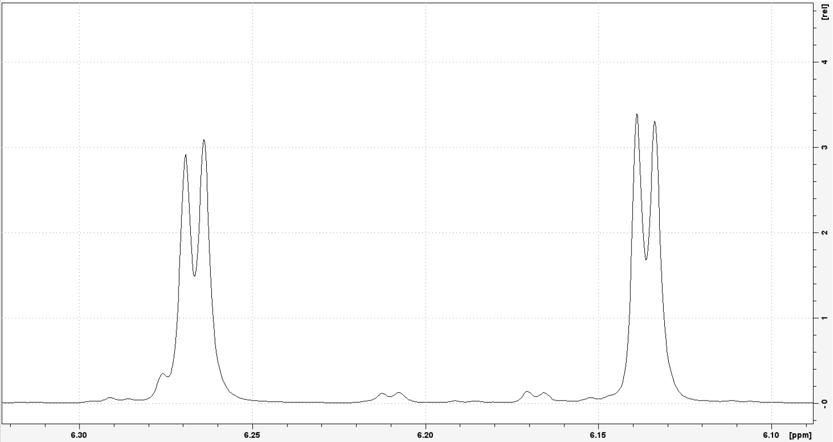
S47: ¹H-NMR of Compound 6, detailed view. Recorded at 500.13 MHz in CDCl₃.
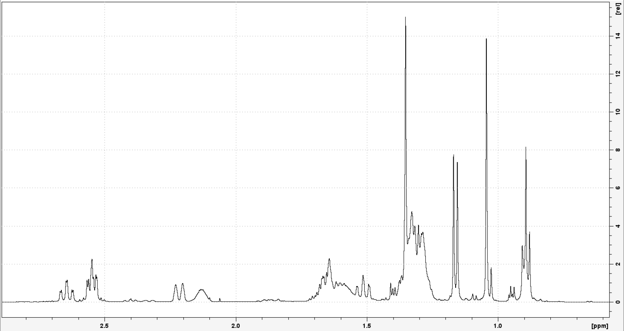
S48: ¹H-NMR of Compound 6, detailed view. Recorded at 500.13 MHz in CDCl₃.
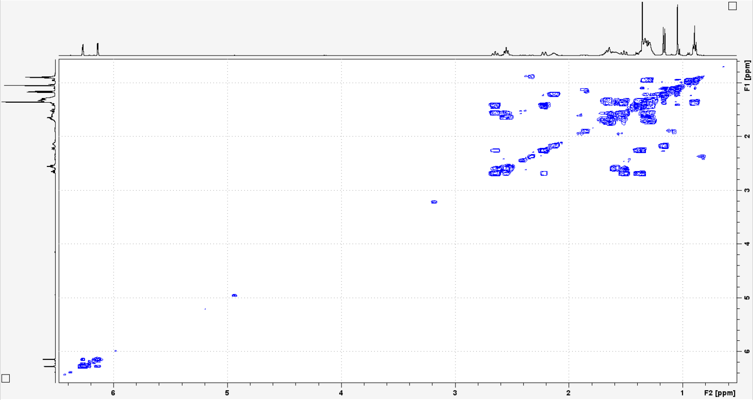
S49: ¹H-¹H-COSY of Compound 6. Recorded at 500.13 MHz in CDCl₃
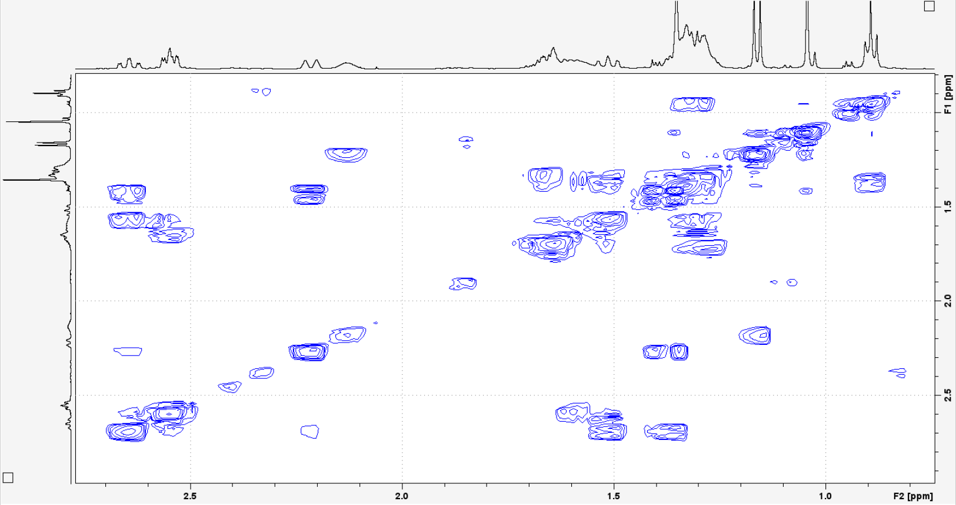
S50: ¹H-¹H-COSY of Compound 6, detailed view. Recorded at 500.13 MHz in CDCl₃
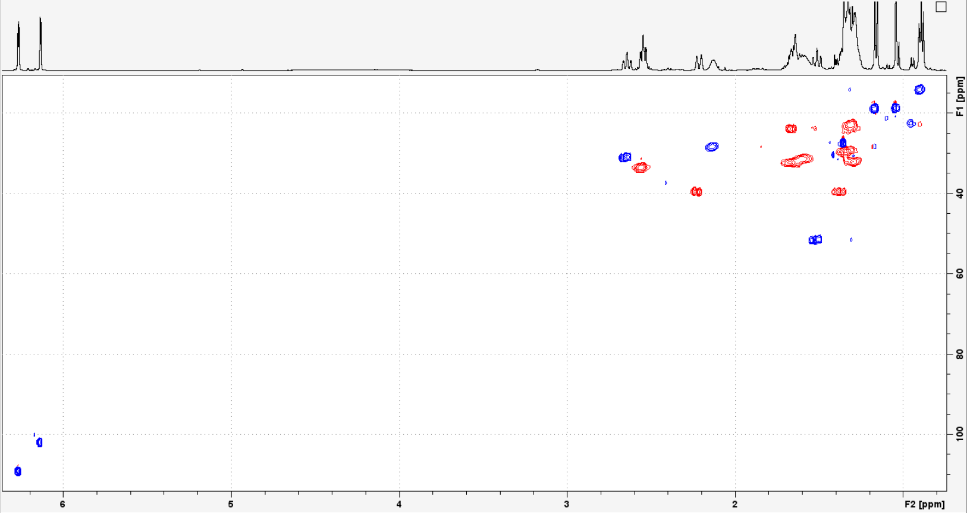
S51: ¹H-¹³C-HSQC of Compound 6. Recorded at 500.13 MHz in CDCl₃.
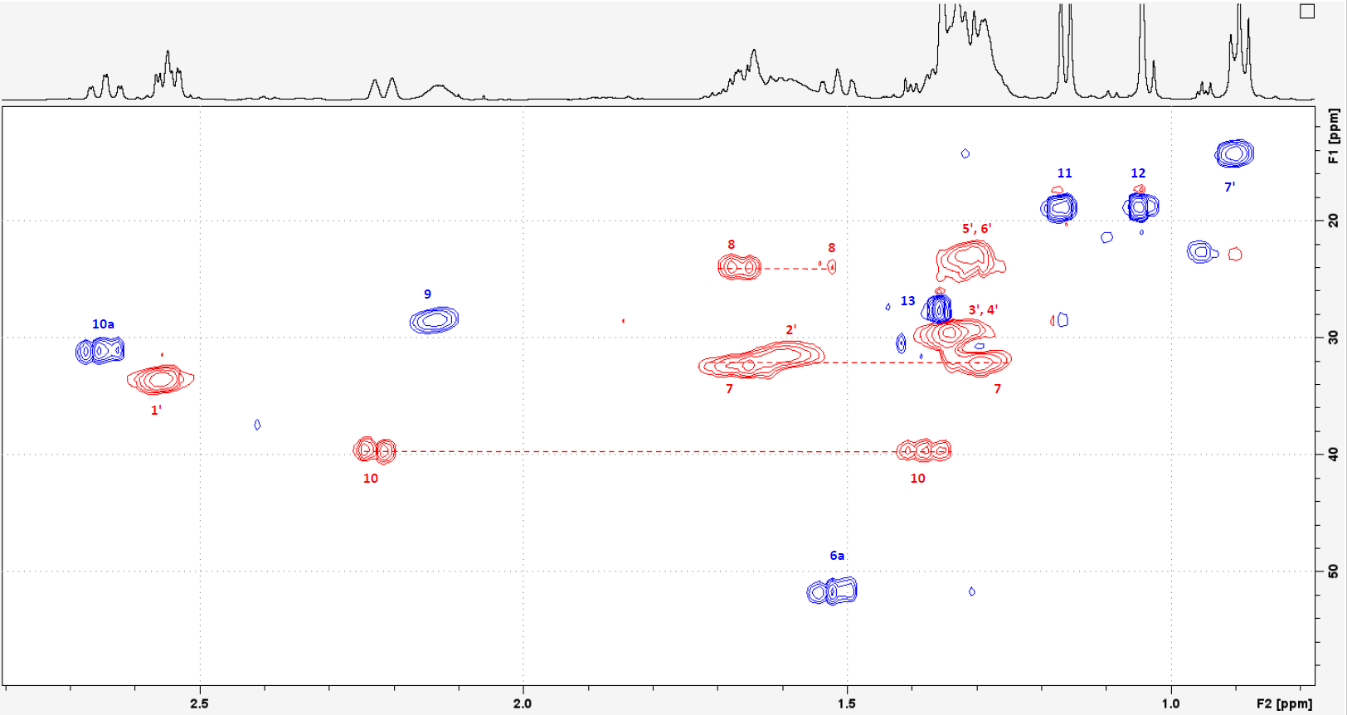
S52: ¹H-¹³C-HSQC of Compound 6, detailed view. Recorded at 500.13 MHz in CDCl₃.
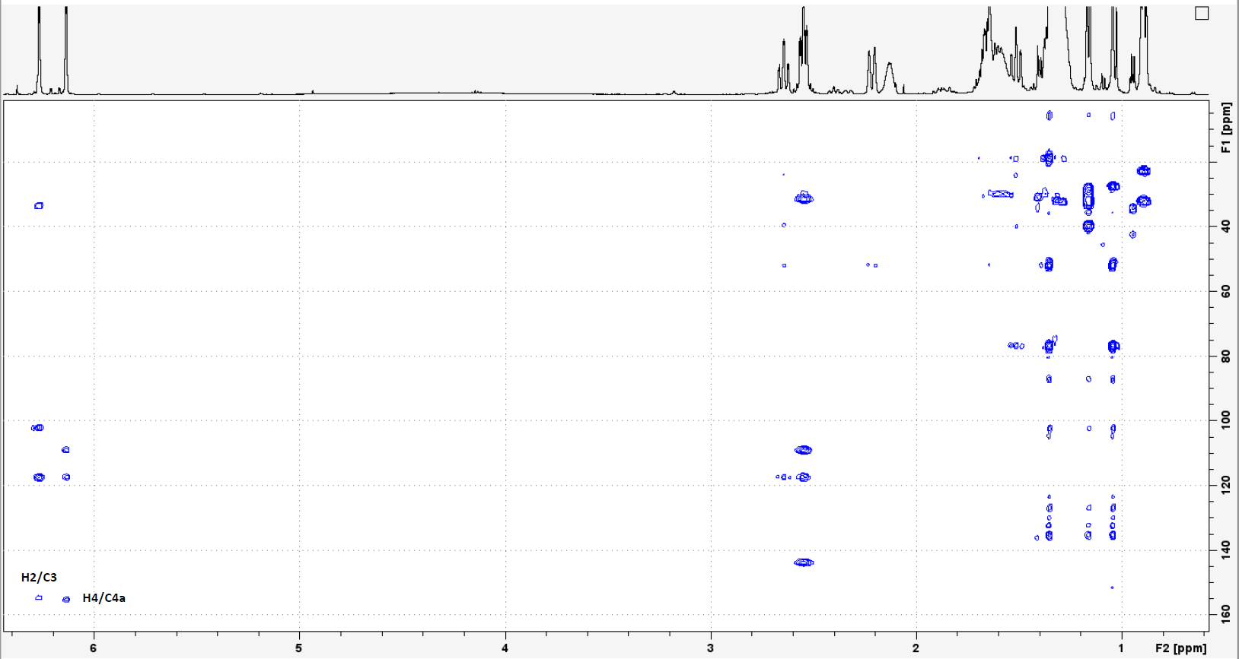
S53: ¹H-¹³C-HMBC of Compound 6. Recorded at 500.13 MHz in CDCl₃.
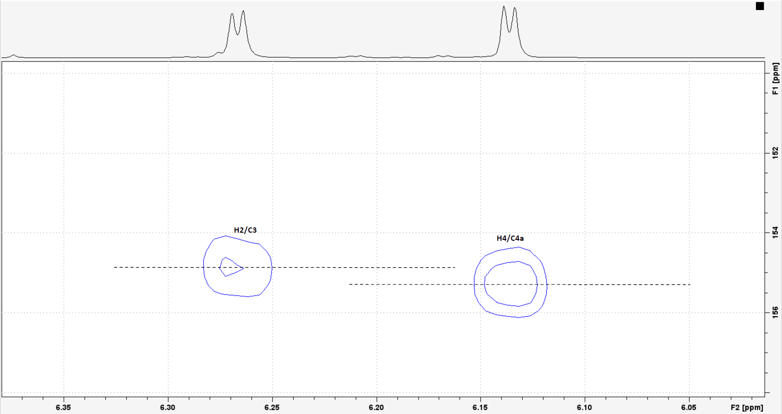
S54: ¹H-¹³C-HMBC of Compound 6, detailed view. Recorded at 500.13 MHz in CDCl₃.
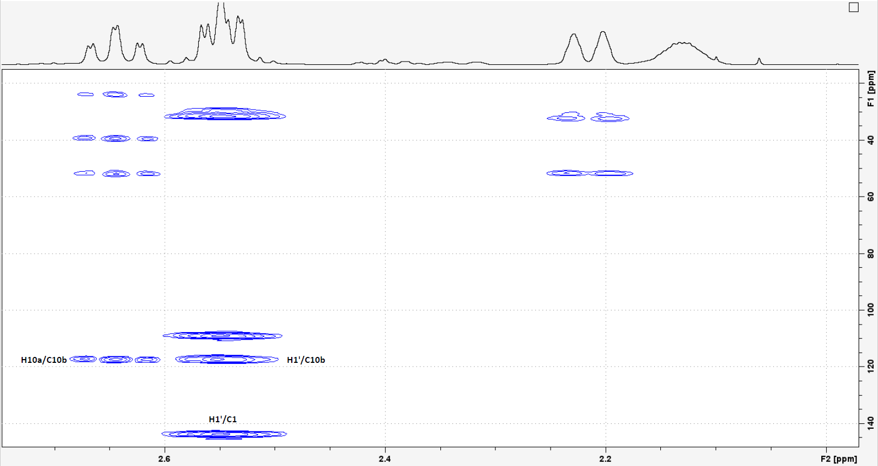
S55: ¹H-¹³C-HMBC of Compound 6, detailed view. Recorded at 500.13 MHz in CDCl₃.
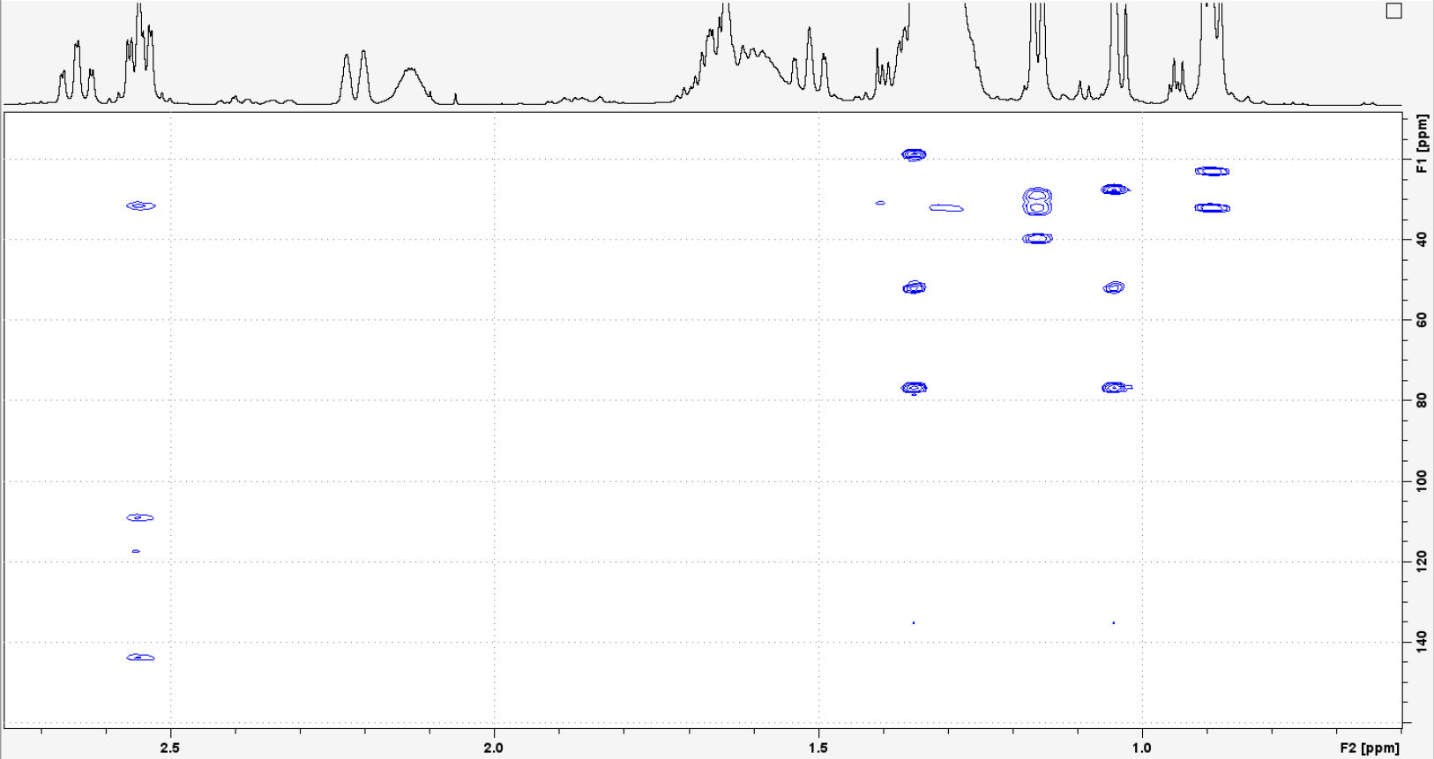
S56: ¹H-¹³C-HMBC of Compound 6, detailed view. Recorded at 500.13 MHz in CDCl₃.
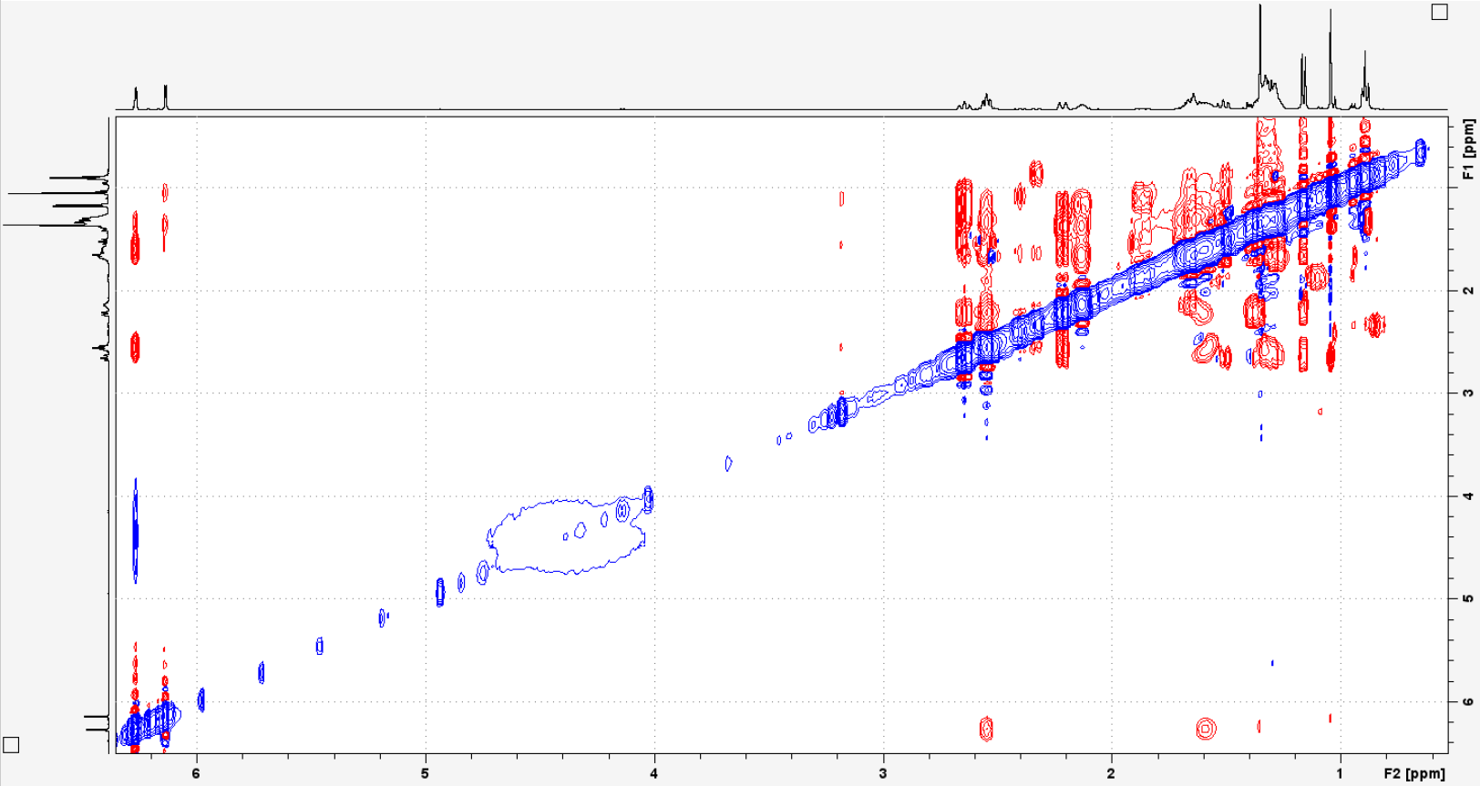
S57: NOESY of Compound 6. Recorded at 500.13 MHz in CDCl₃.
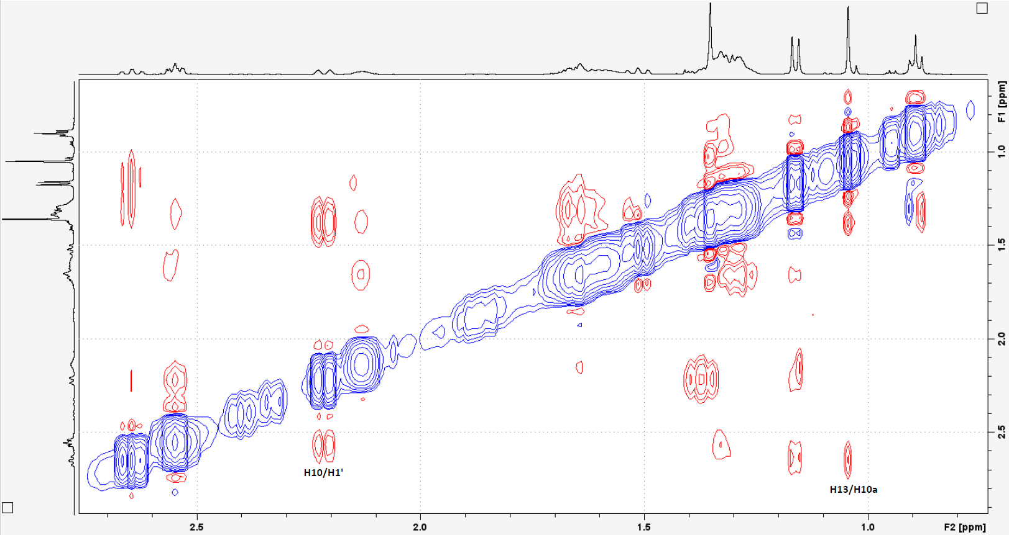
S58: NOESY of Compound 6, detailed view. Recorded at 500.13 MHz in CDCl₃.

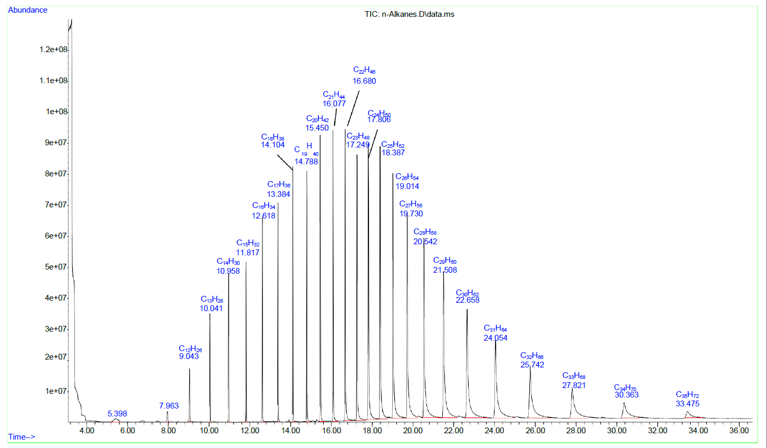
S59: Chromatogram of an alkane standard (C7-C40) for the determination of the Kováts indices.
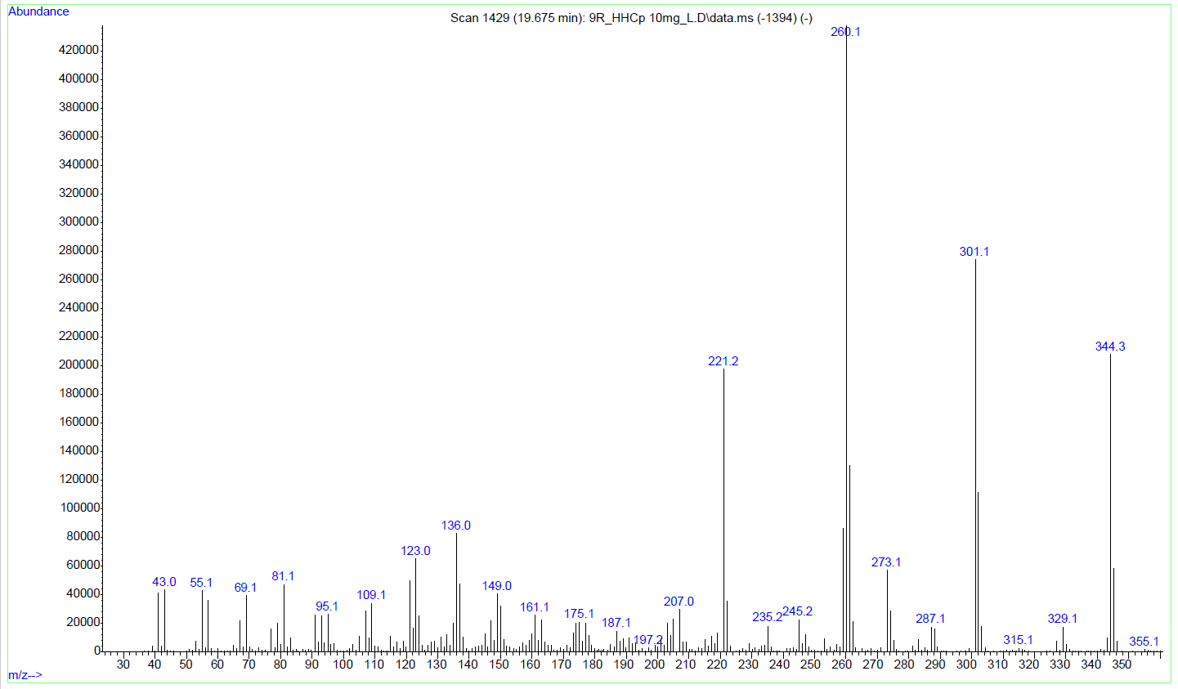
S60: GC-EI-MS of (9R)-HHCP.
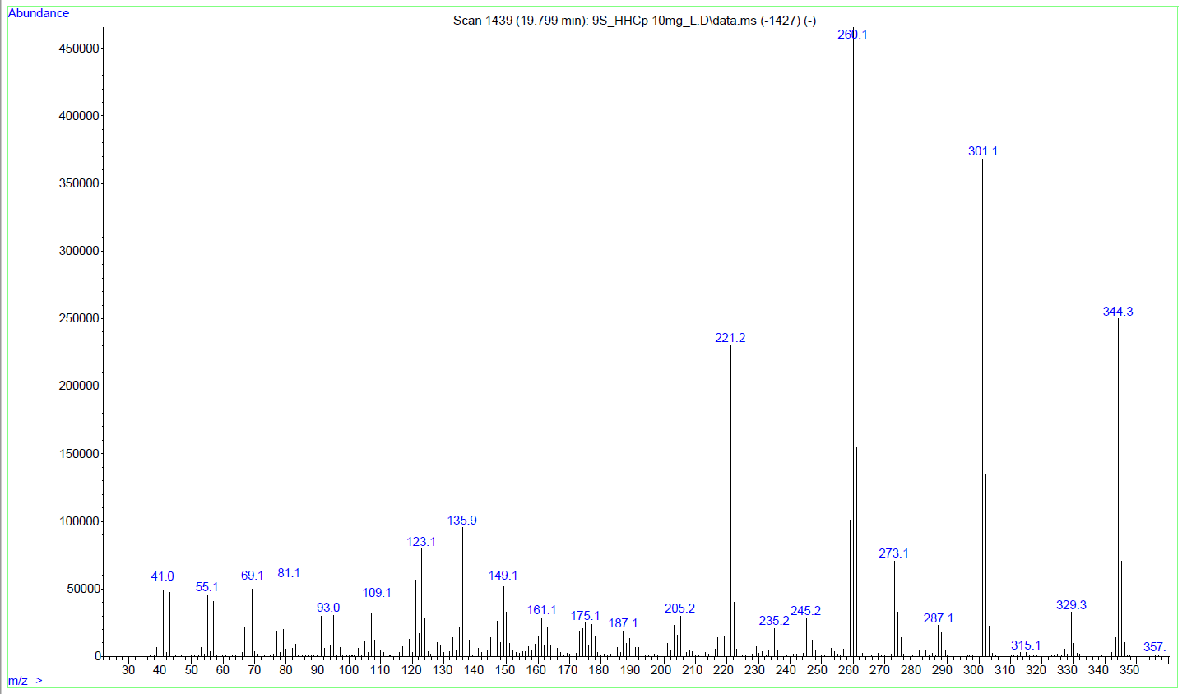
S61: GC-EI-MS of (9S)-HHCP.

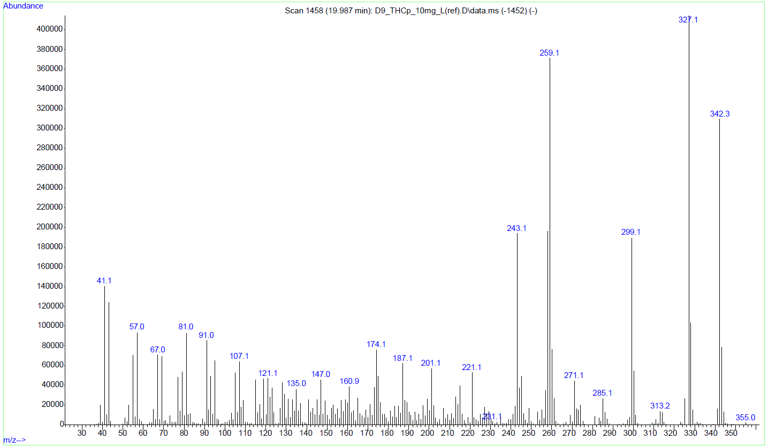
S62: GC-EI-MS of Δ⁹-THCP.
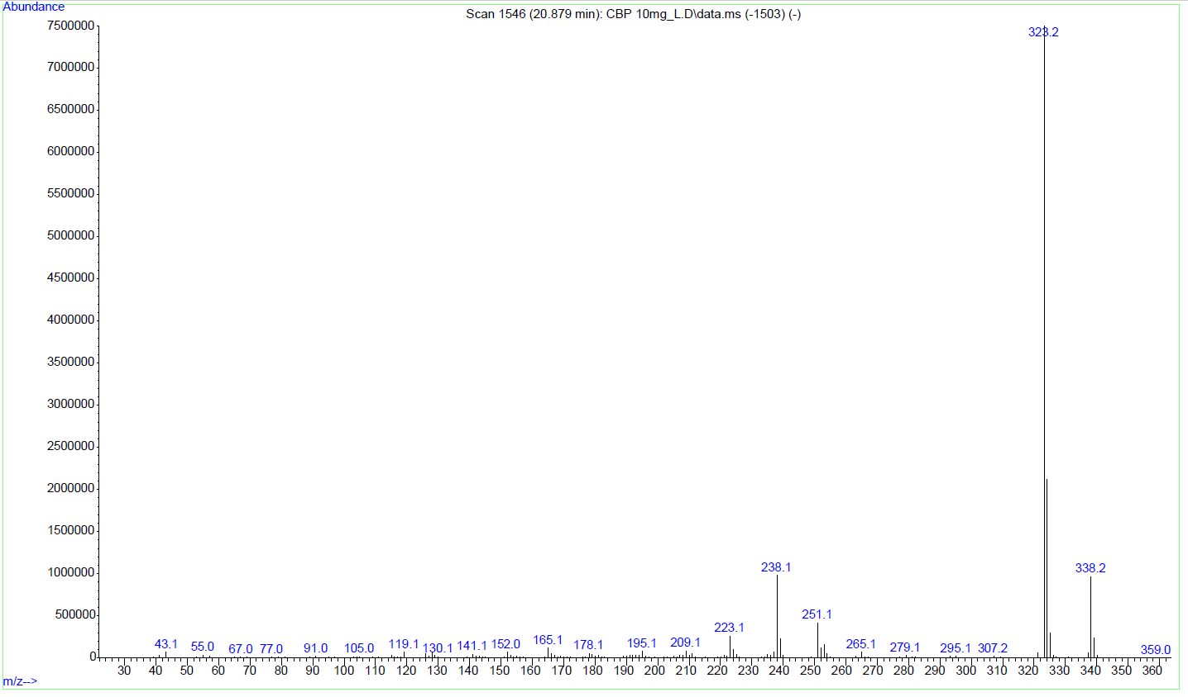
S63: GC-EI-MS of cannabiphorol (CBP).
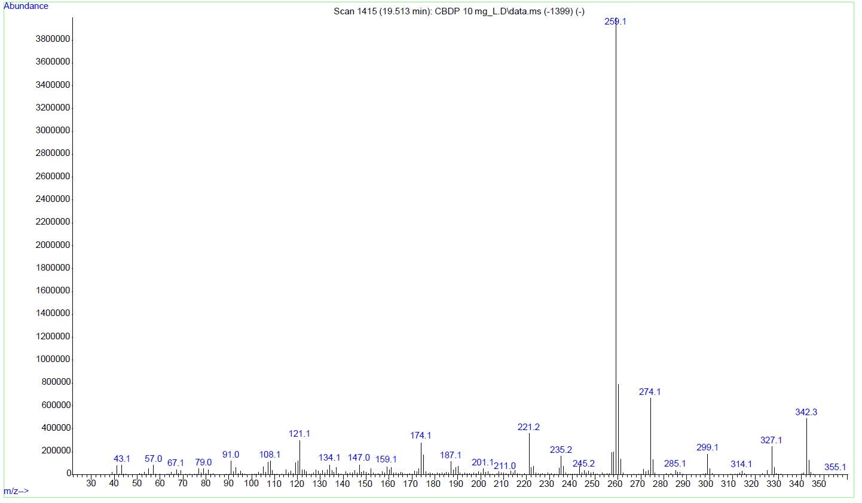
S64: GC-EI-MS of cannabidiphorol (CBDP).

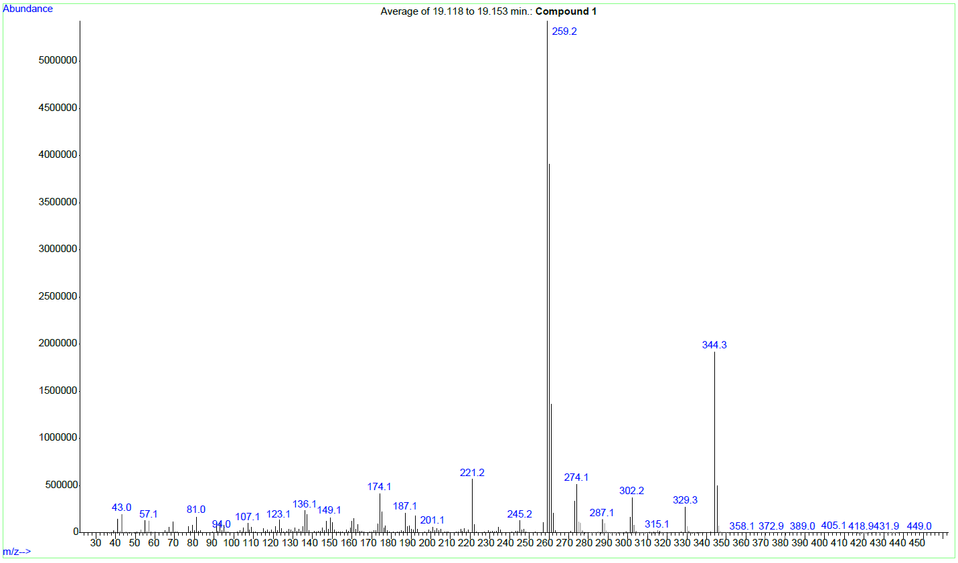
S65: GC-EI-MS of Compound 1.
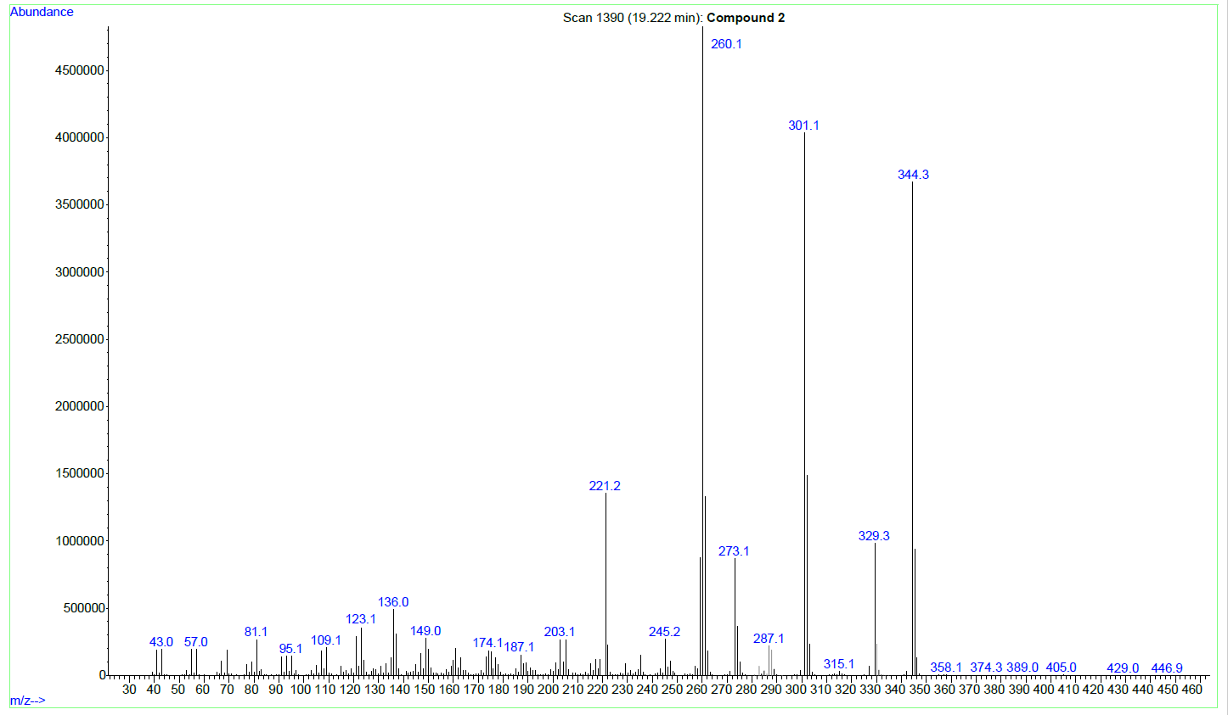
S66: GC-EI-MS of Compound 2.
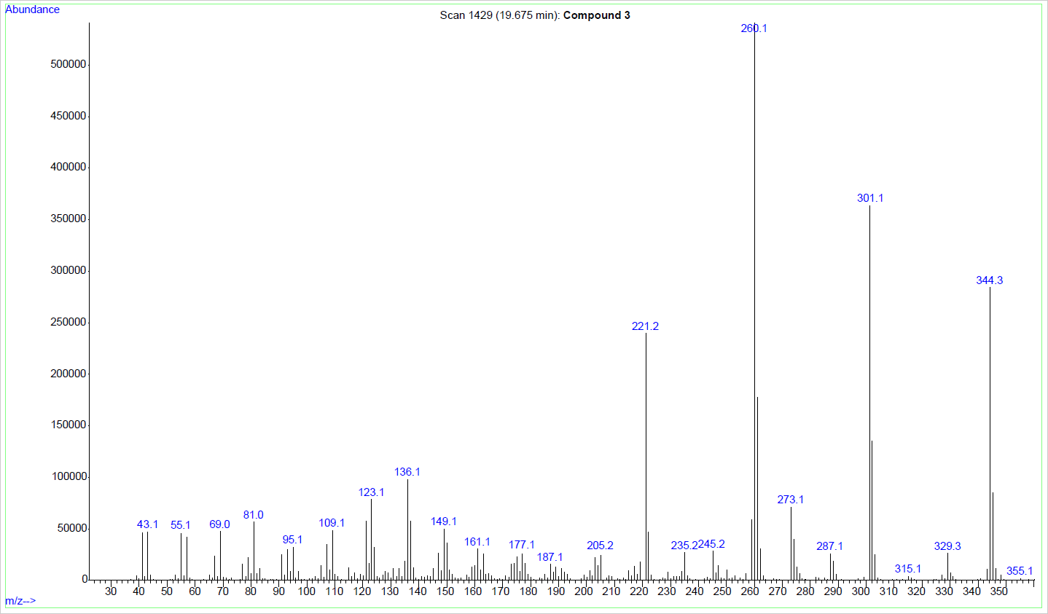
S67: GC-EI-MS of Compound 3.
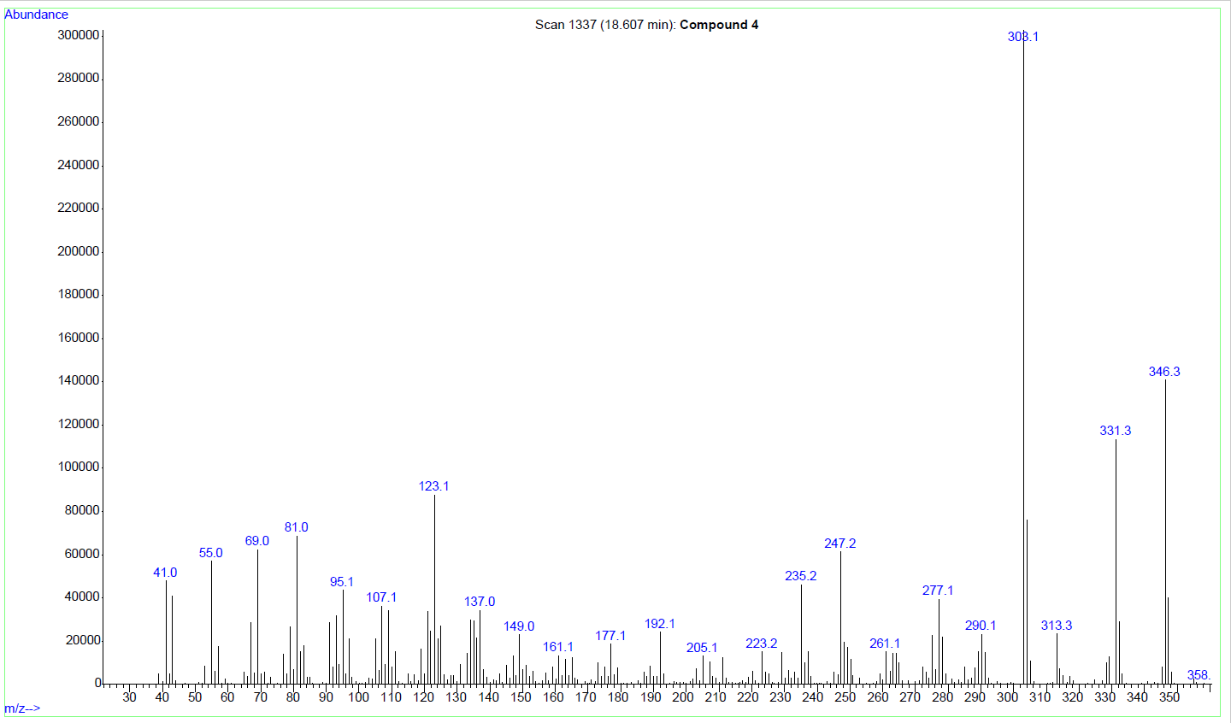
S68: GC-EI-MS of Compound 4.
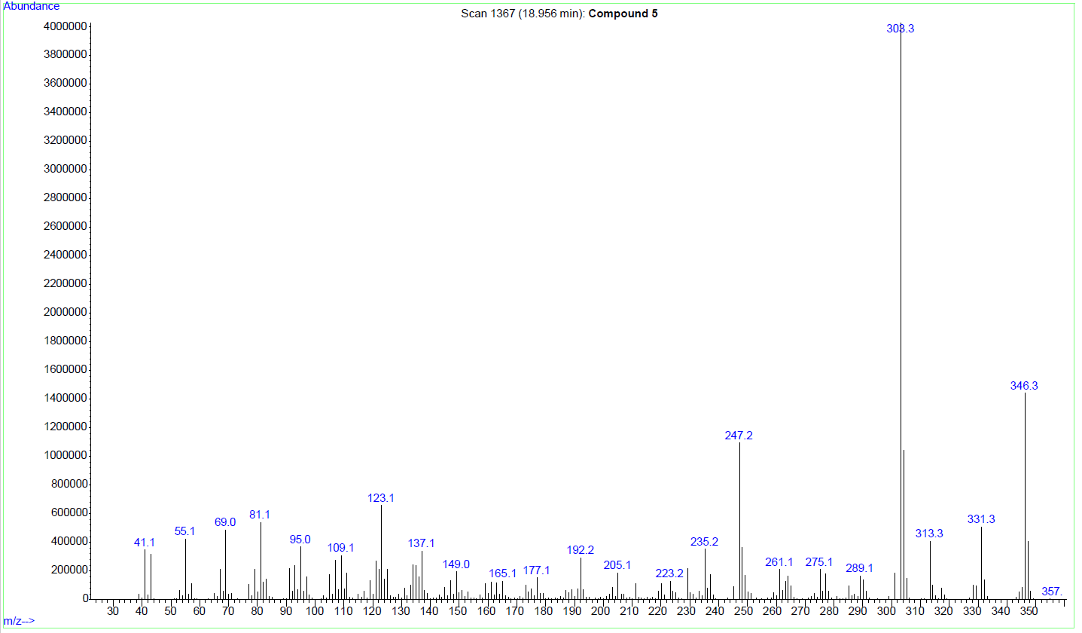
S69: GC-EI-MS of Compound 5.
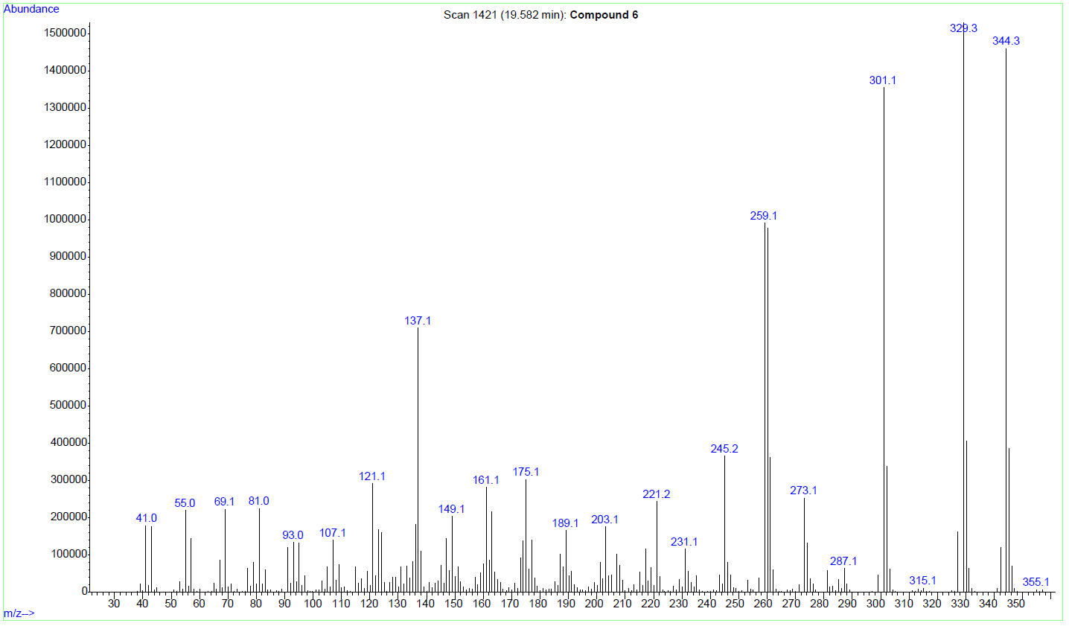
S70: GC-EI-MS of Compound 6.

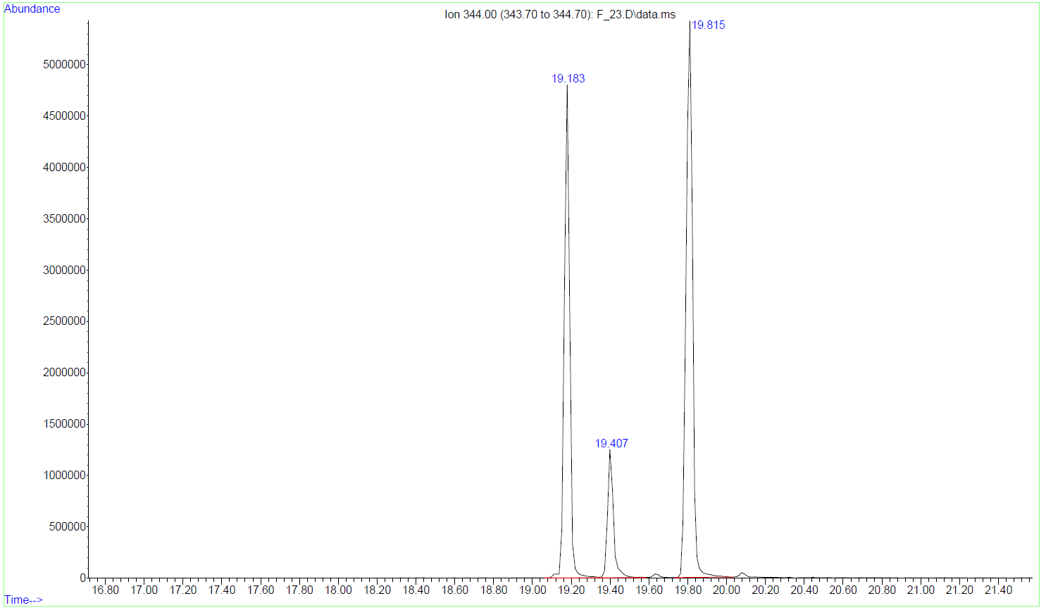
S71: Extracted ion chromatogram (m/z 344) of a fraction containing (9S)-HHCP
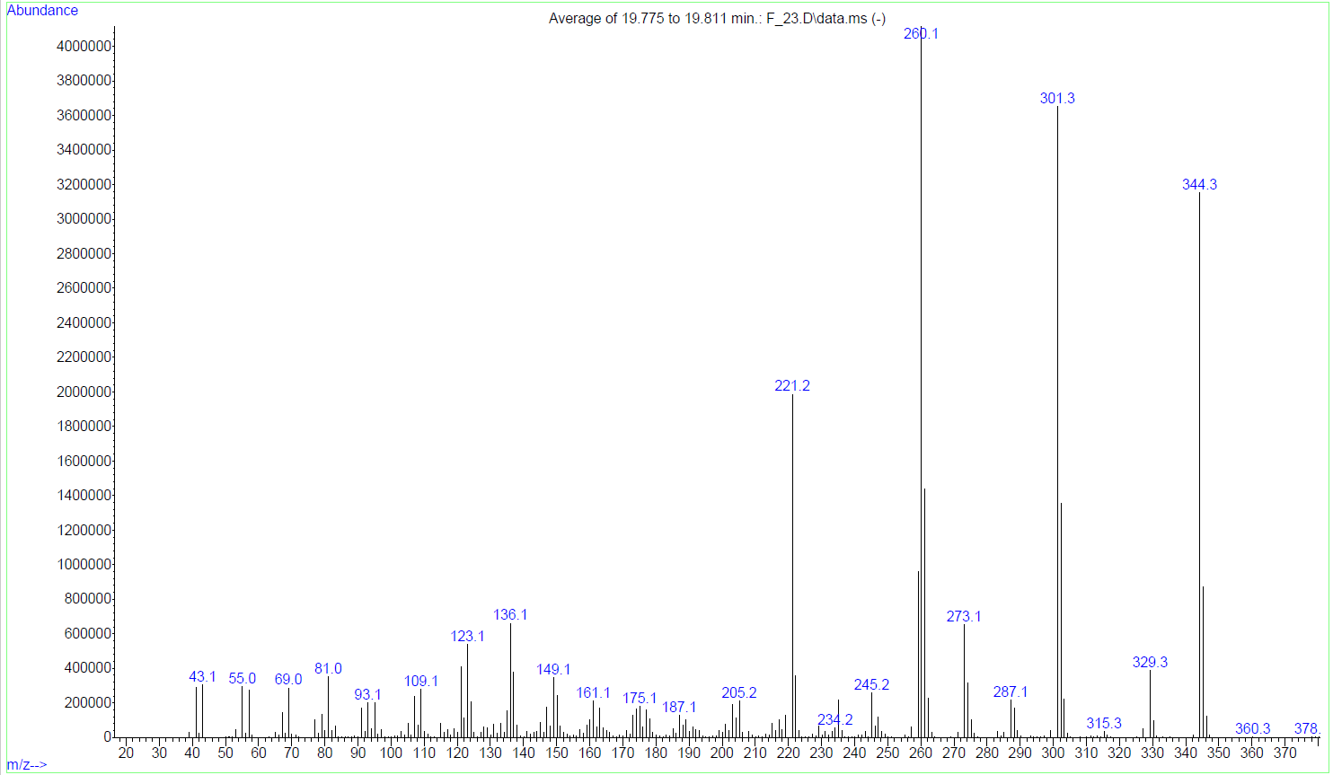
S72: GC-EI-MS of the compound eluting 19.82 min ((9S)-HHCP)
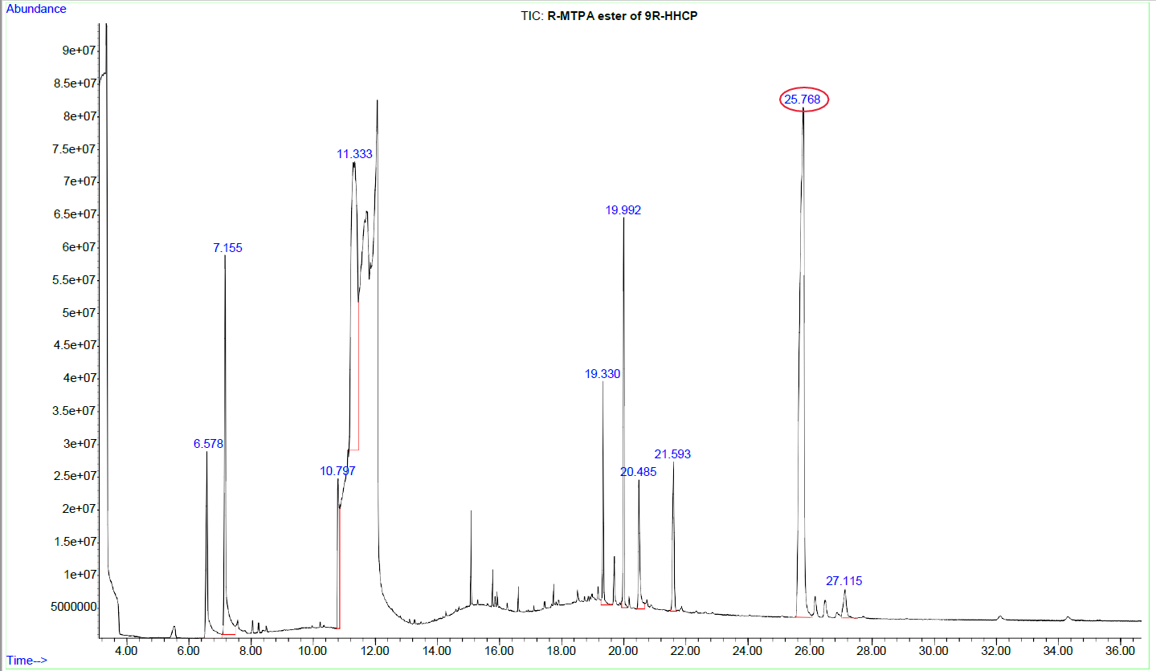
S73: TIC of the (R)-MTPA ester of (9R)-HHCP at 25.77 min.
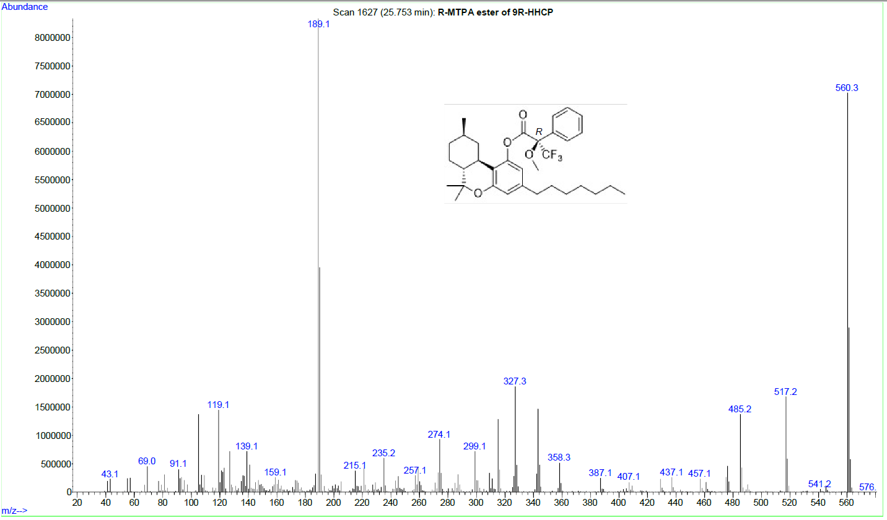
S74: GC-EI-MS of the (R)-MTPA ester of (9R)-HHCP.
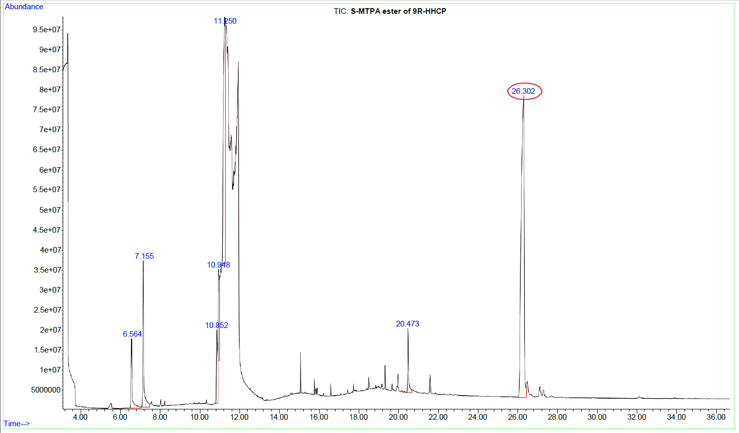
S75: TIC of the (S)-MTPA ester of (9R)-HHCP at 26.30 min.
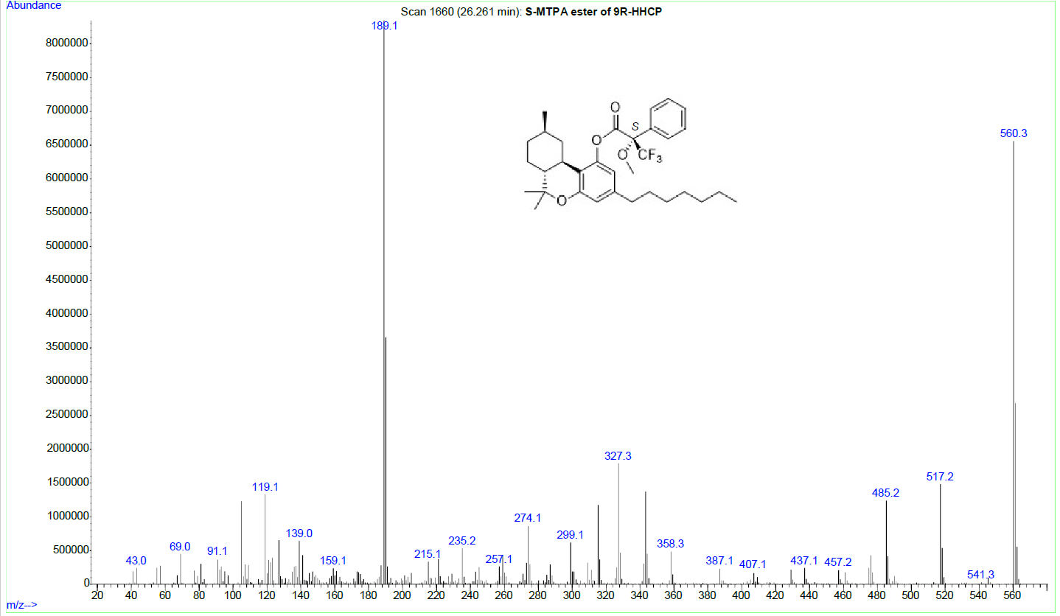
S76: GC-EI-MS of the (S)-MTPA ester of (9R)-HHCP.
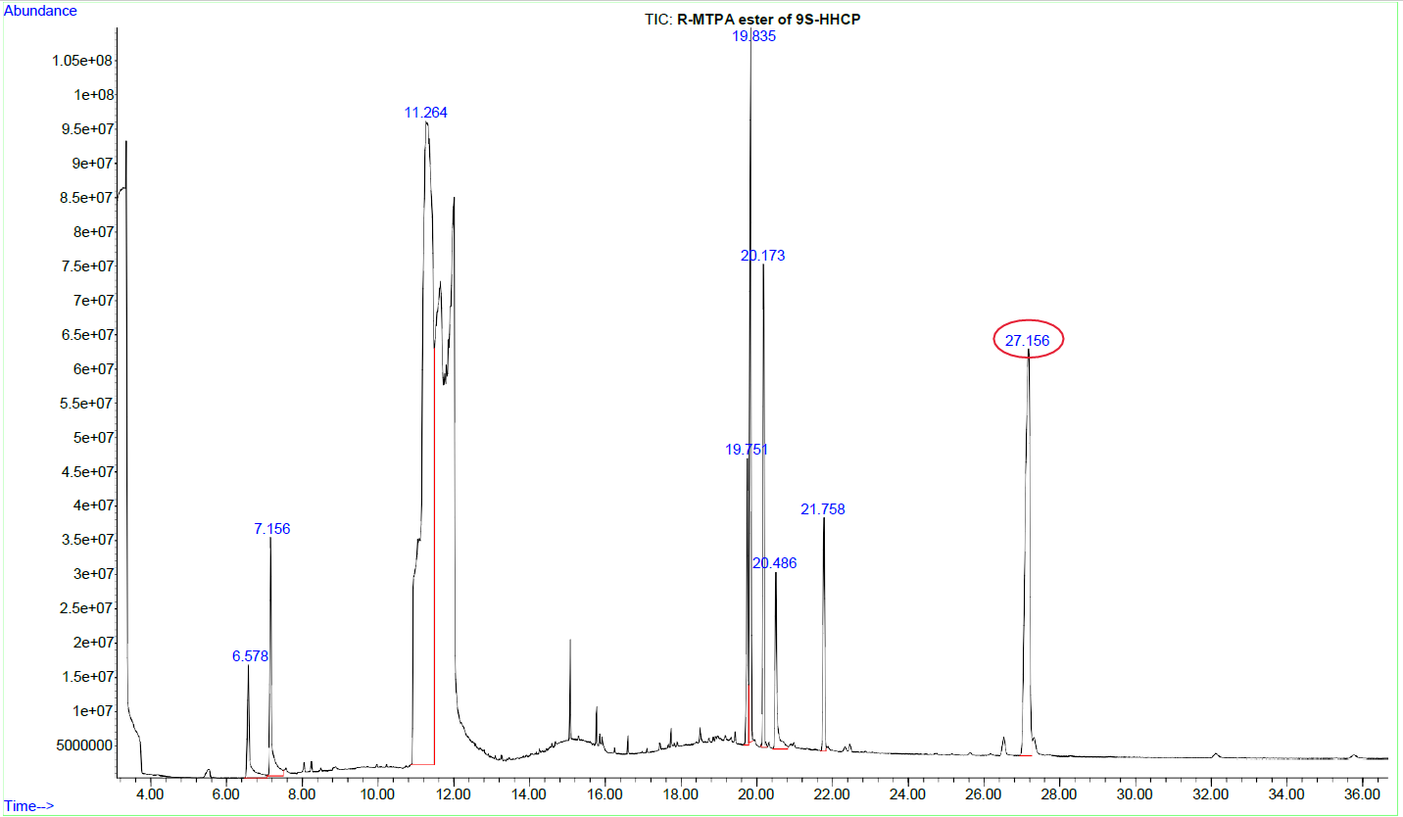
S77: TIC of the (R)-MTPA ester of (9S)-HHCP at 27.16 min.
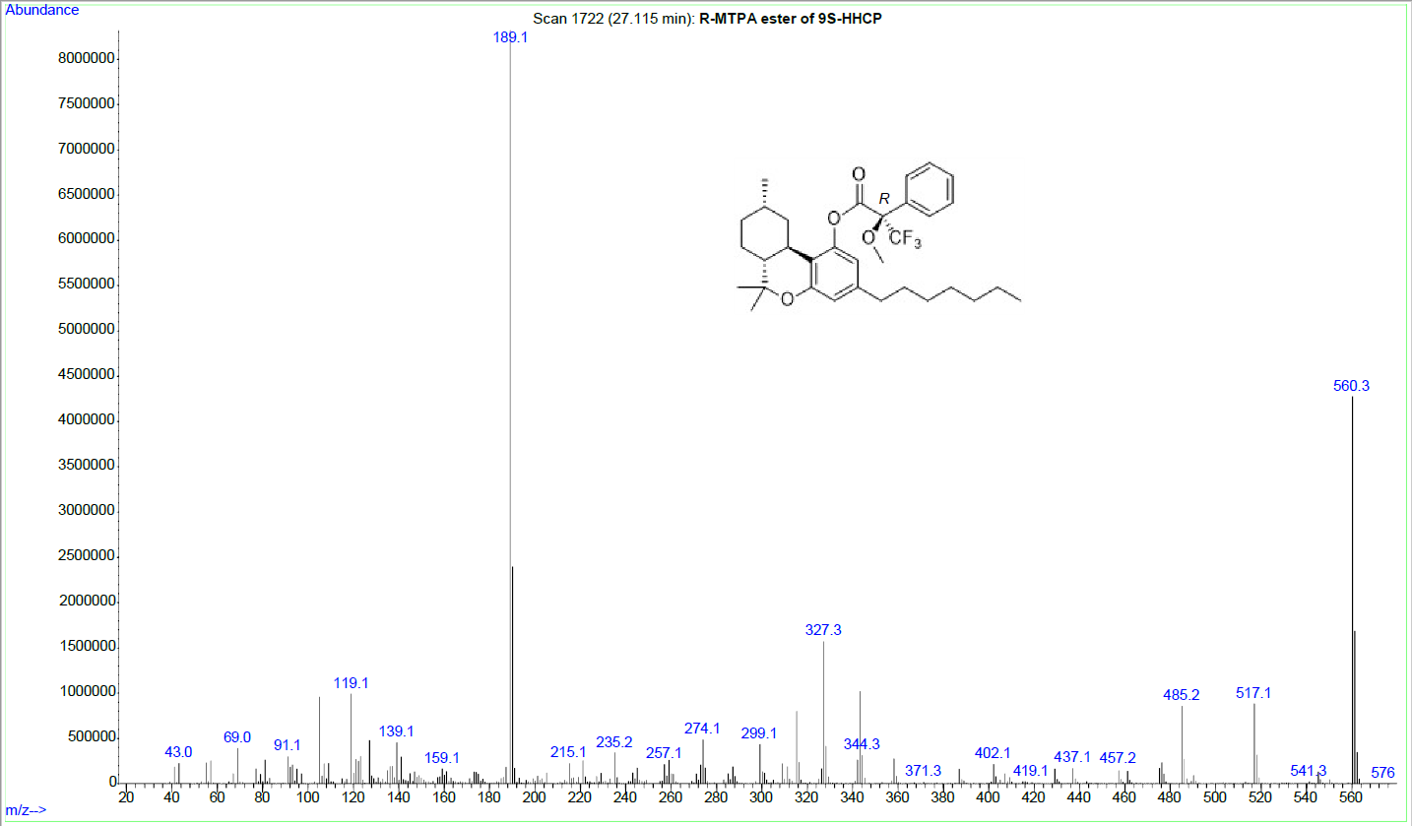
S78: GC-EI-MS of (R)-MTPA ester of (9S)-HHCP.
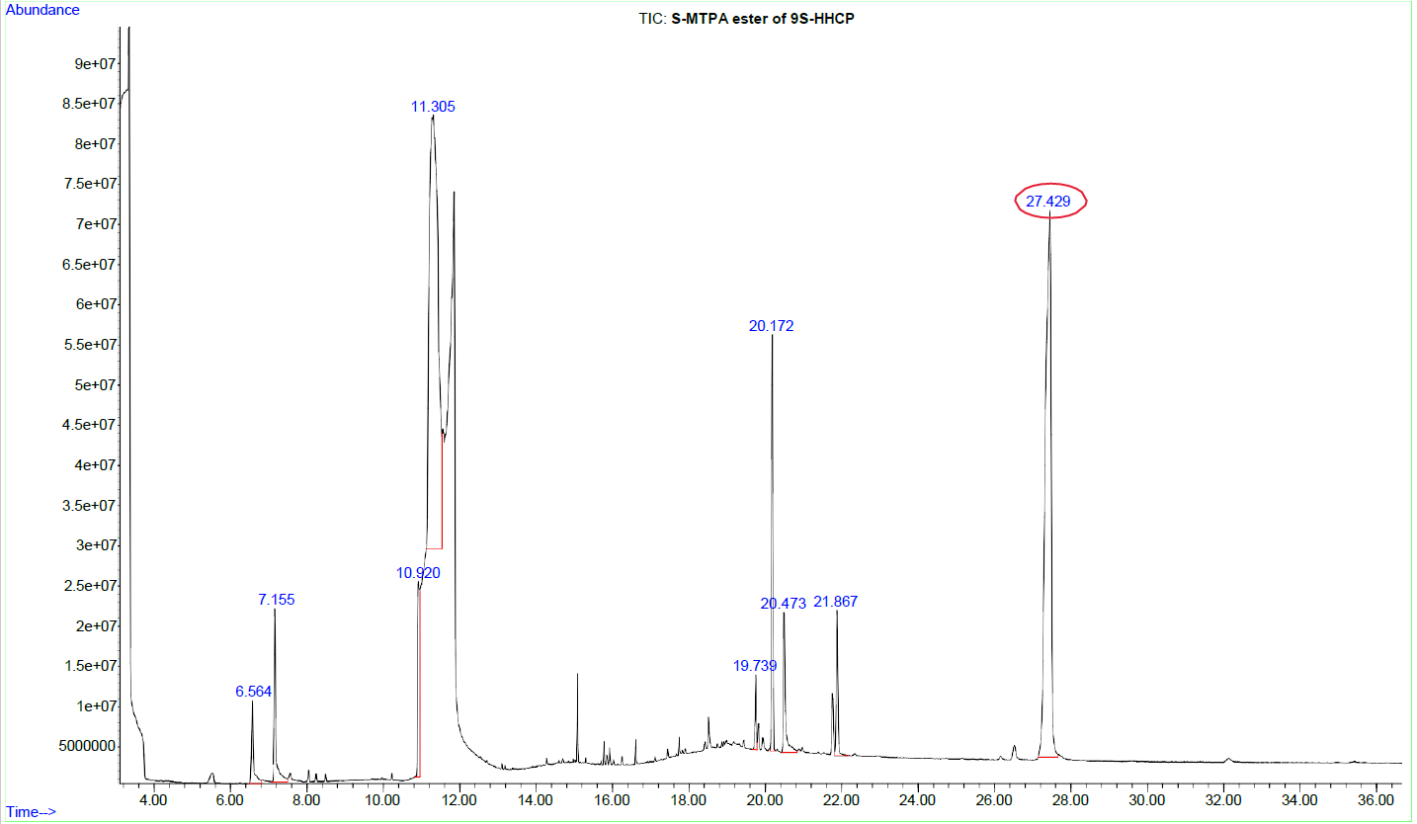
S79: TIC of the (S)-MTPA ester of (9S)-HHCP at 27.43 min.
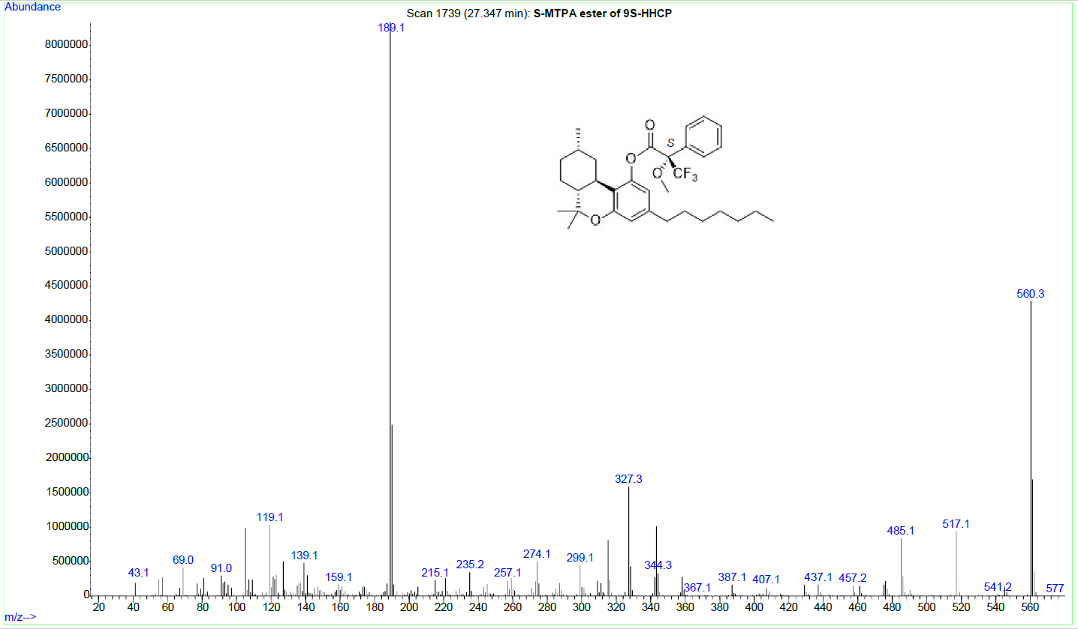
S80: GC-EI-MS of the (S)-MTPA ester of (9S)-HHCP.
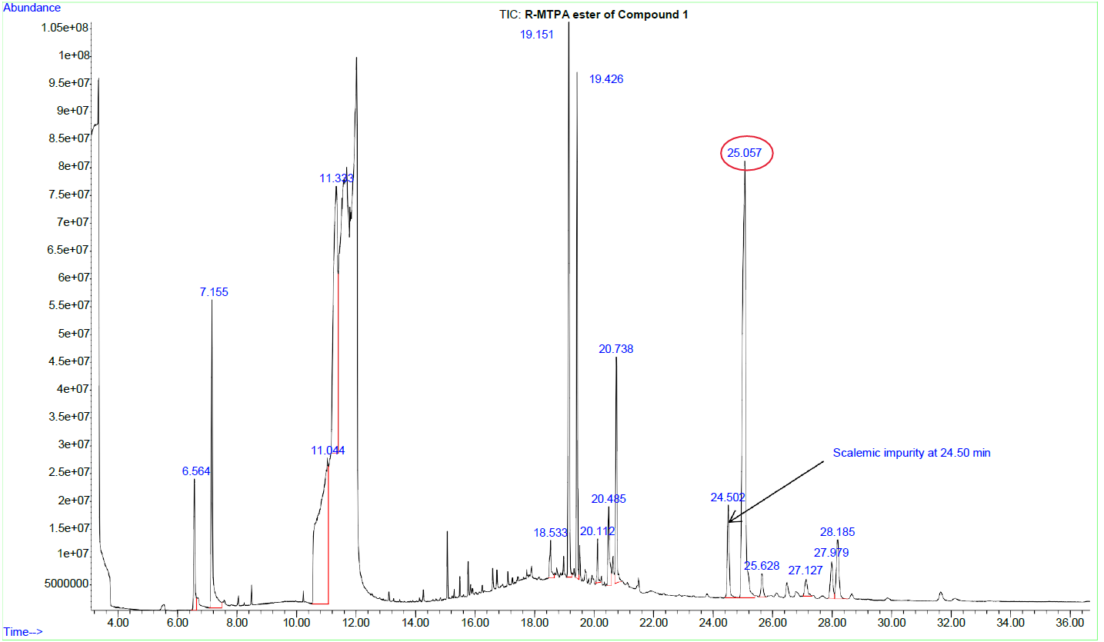
S81: TIC of the (R)-MTPA ester of Compound 1 at 25.06 min. A scalemic impurity is seen at 24.50 min (same retention time (S84) and mass spectrum (S85))
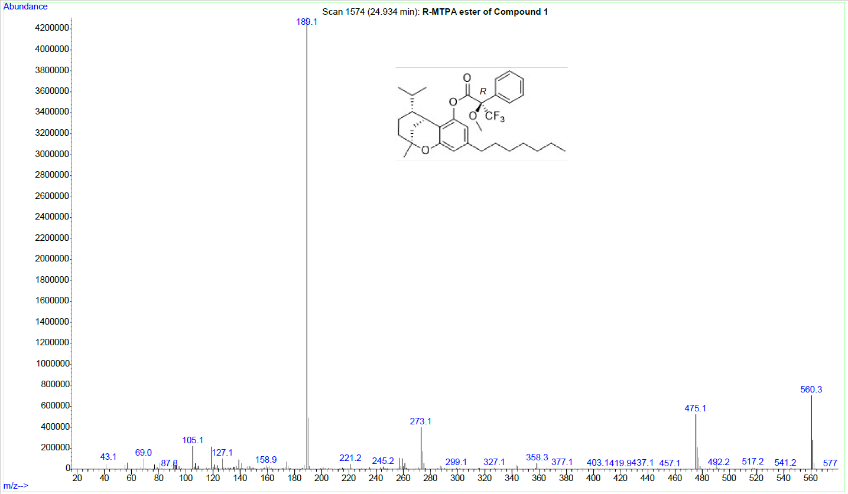
S82: GC-EI-MS of the (R)-MTPA ester of Compound 1. (Enantiomer to S86)
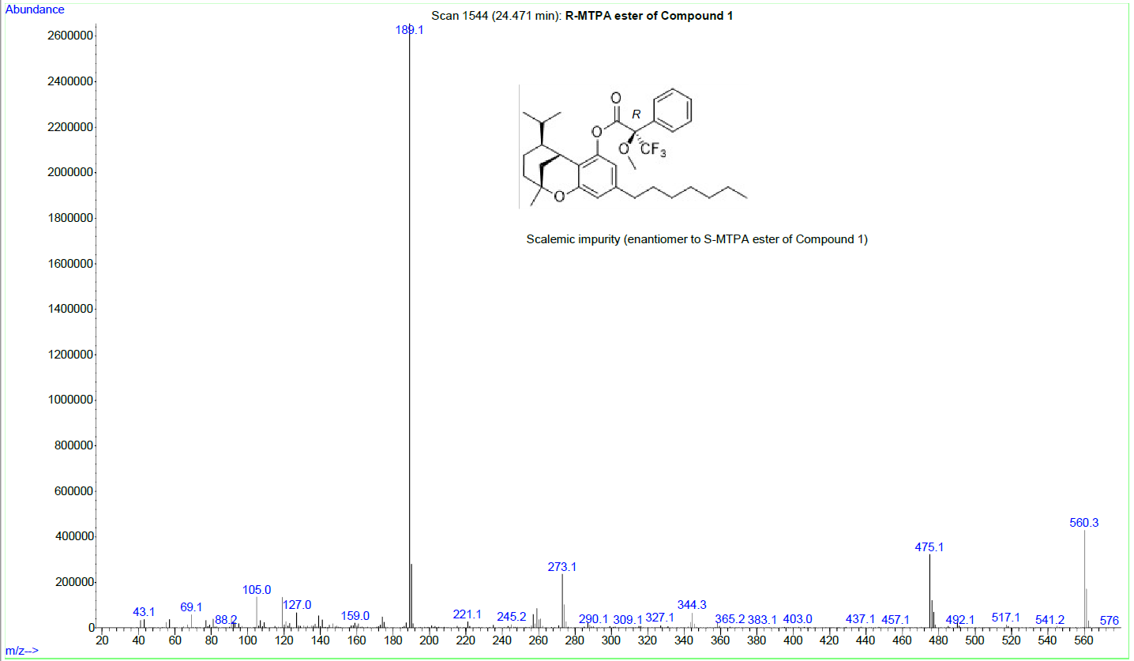
S83: GC-EI-MS of the (R)-MTPA ester of the other enantiomer of Compound 1. (Enantiomer to S85)
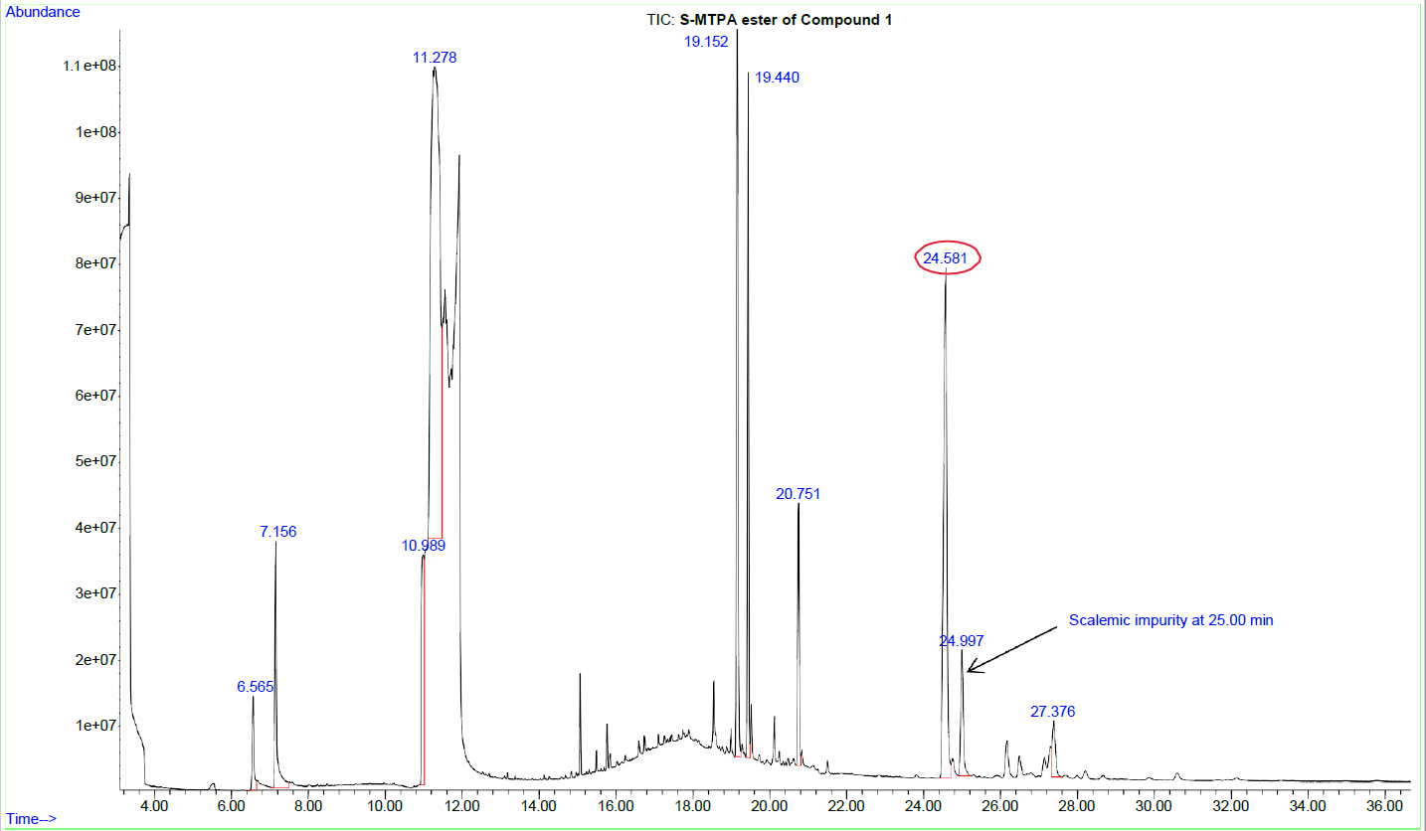
S84: TIC of the (S)-MTPA ester of Compound 1 at 24.58 min. A scalemic impurity is seen at 25.00 min (same retention time as S81.
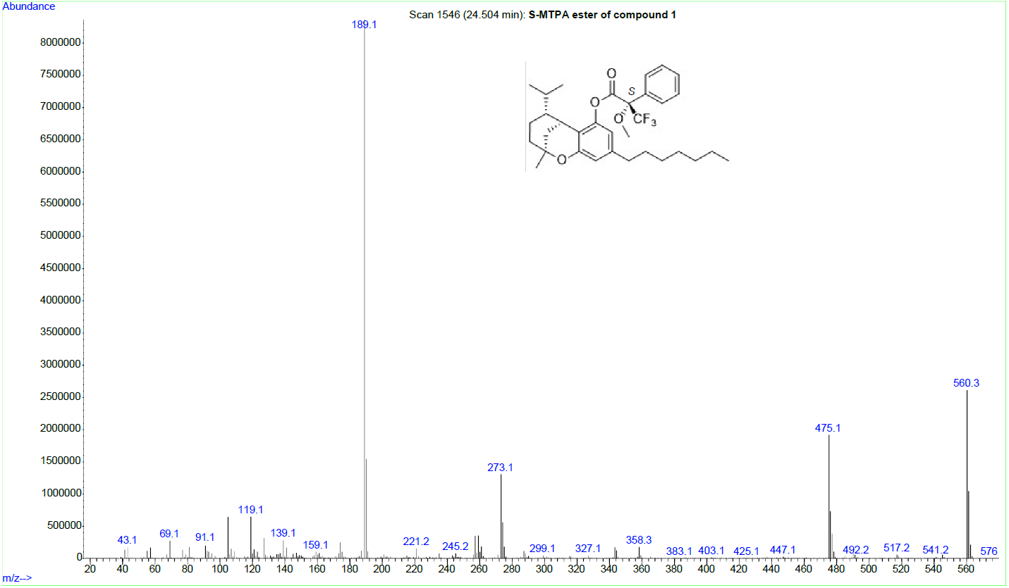
S85: GC-EI-MS of the (S)-MTPA ester of Compound 1. (Enantiomer to S83)
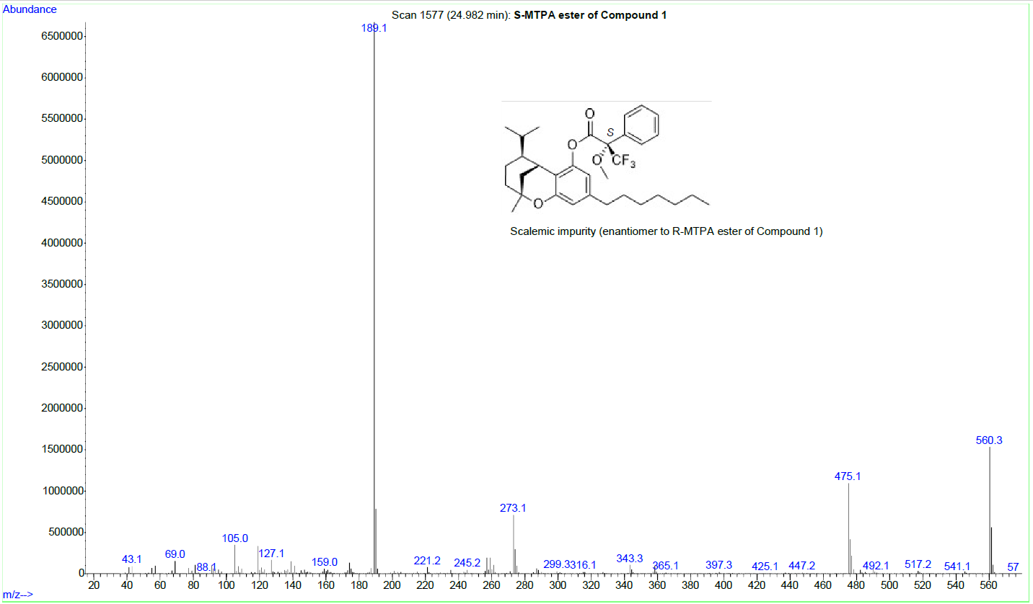
S86: GC-EI-MS of the (S)-MTPA ester of the enantiomer of Compound 1. (Enantiomer to S82)
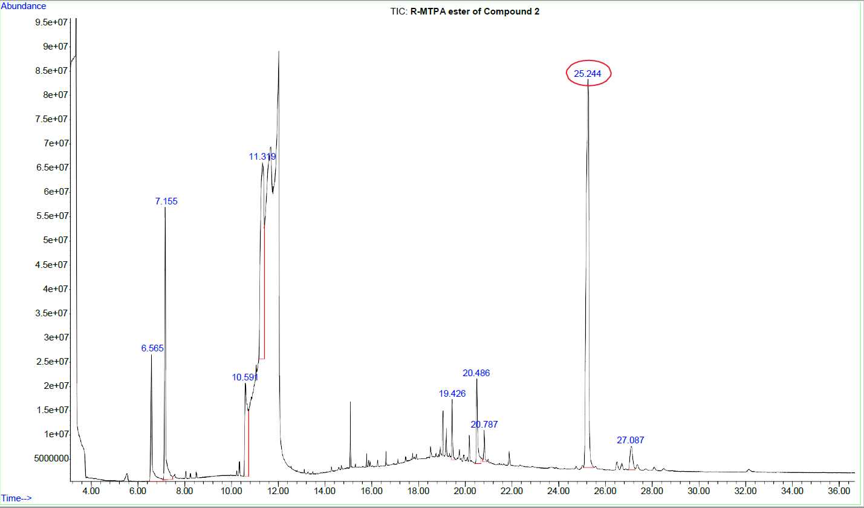
S87: TIC of the (R)-MTPA ester of Compound 2 at 25.24 min.
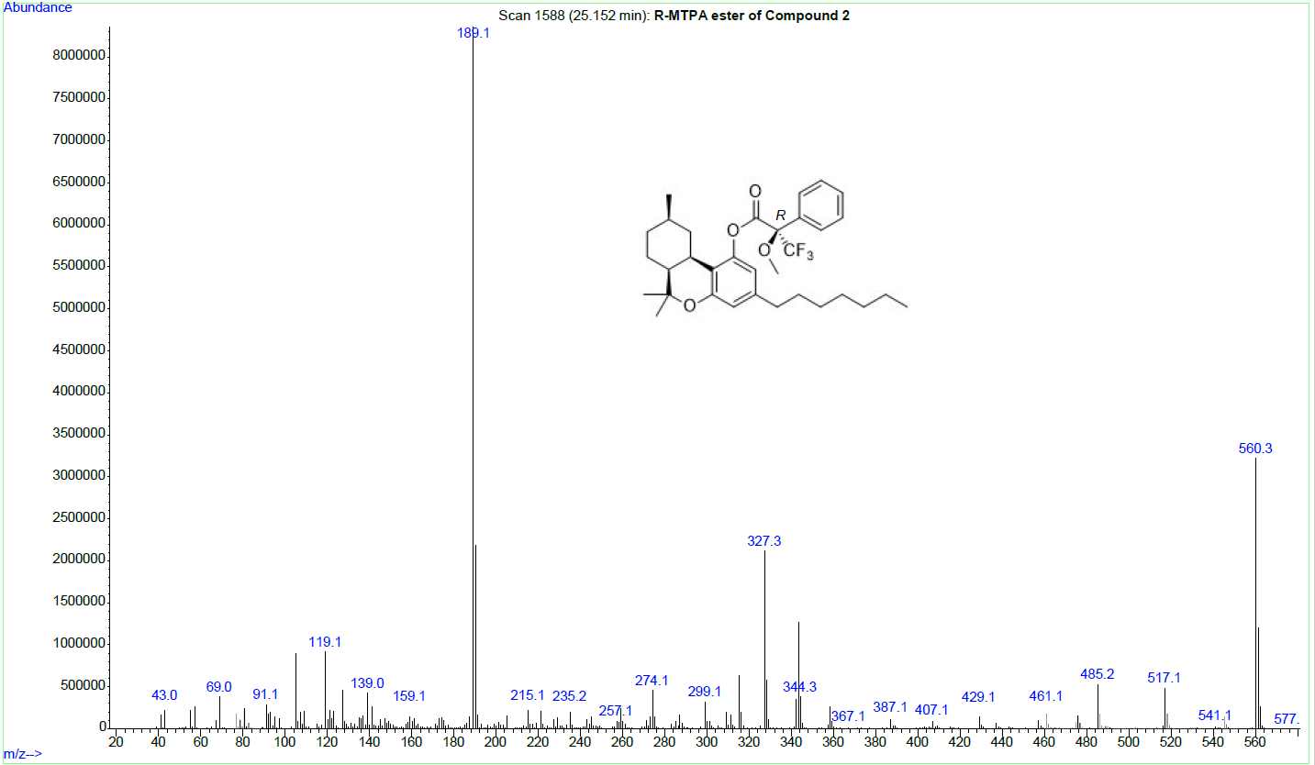
S88: GC-EI-MS of the (R)-MTPA ester of Compound 2.
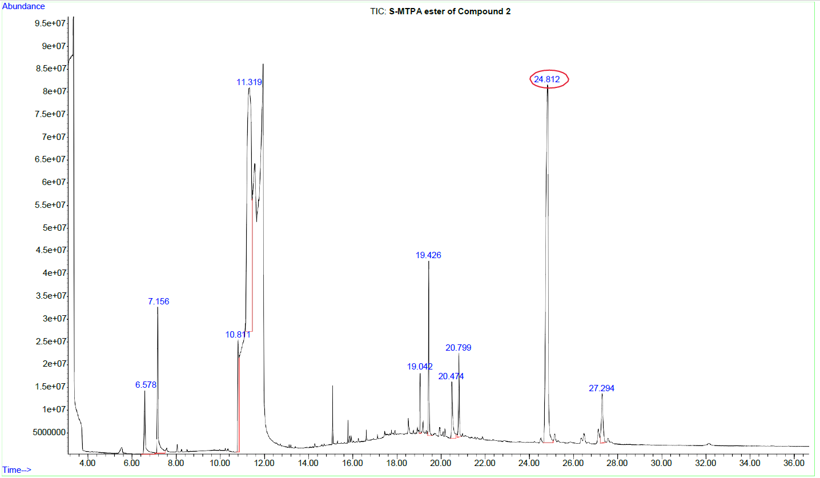
S89: TIC of the (S)-MTPA ester of Compound 2 at 24.81 min.
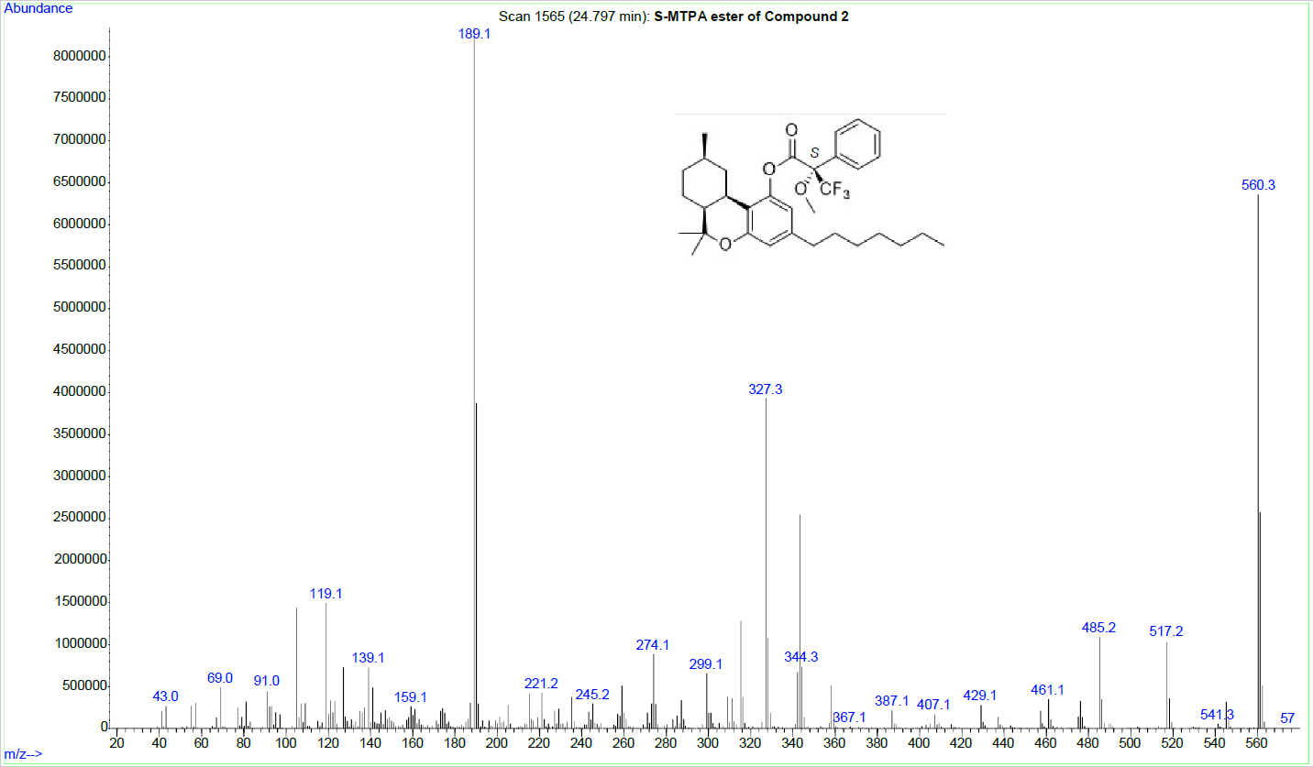
S90: GC-EI-MS of the (S)-MTPA ester of Compound 2.
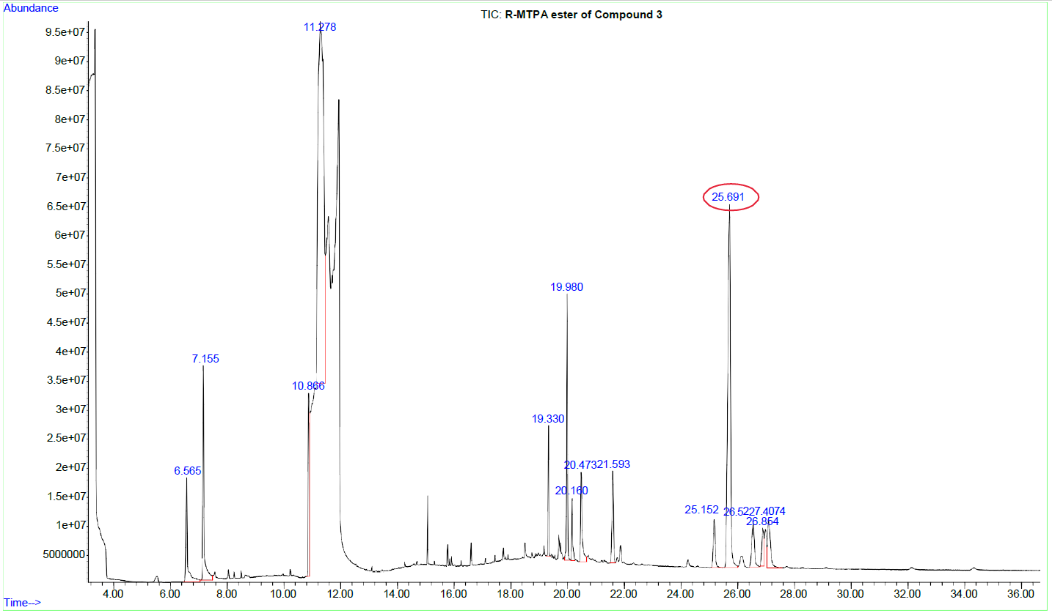
S91: TIC of the (R)-MTPA ester of Compound 3 at 25.69 min. (Identical to (9R)-HHCP)
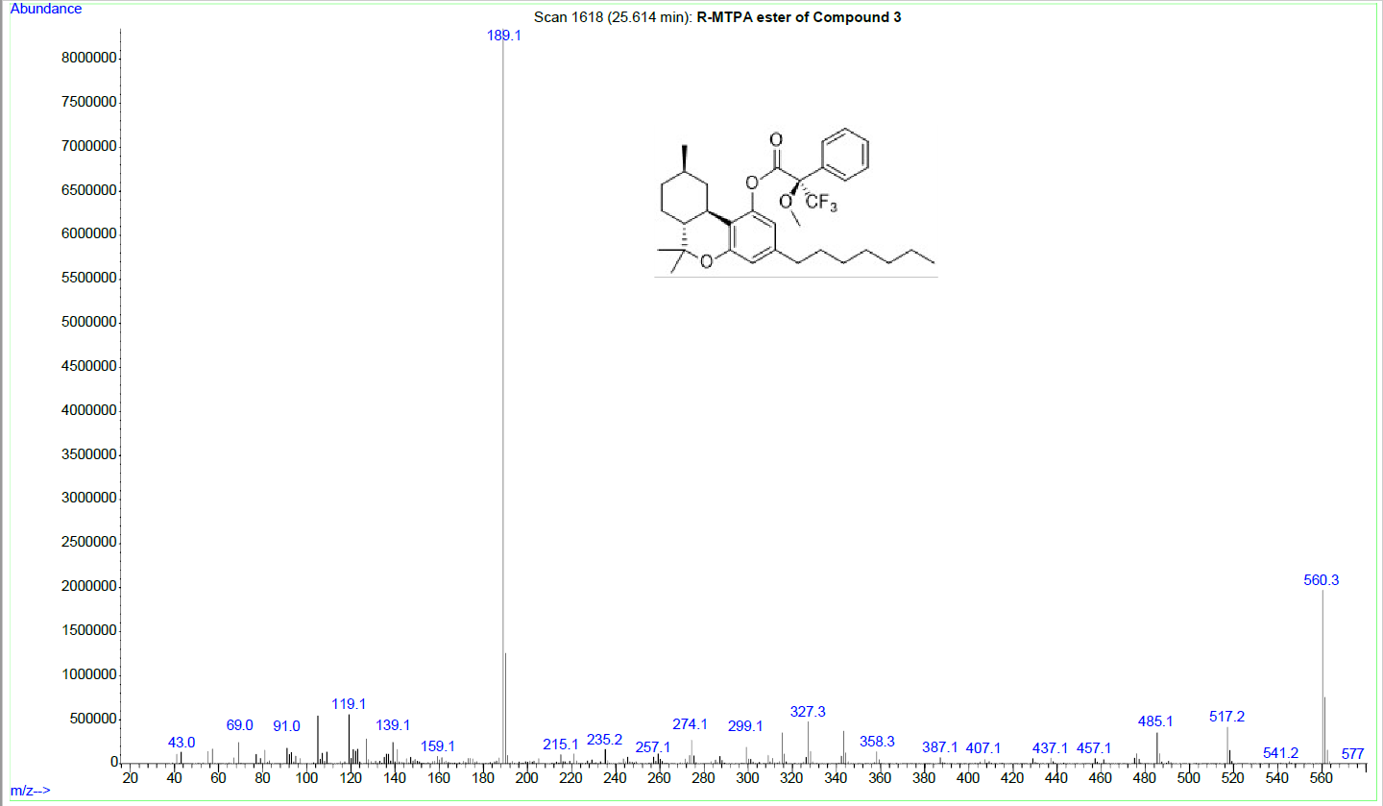
S92: GC-EI-MS of the (R)-MTPA ester of Compound 3. (Identical to (9R)-HHCP)
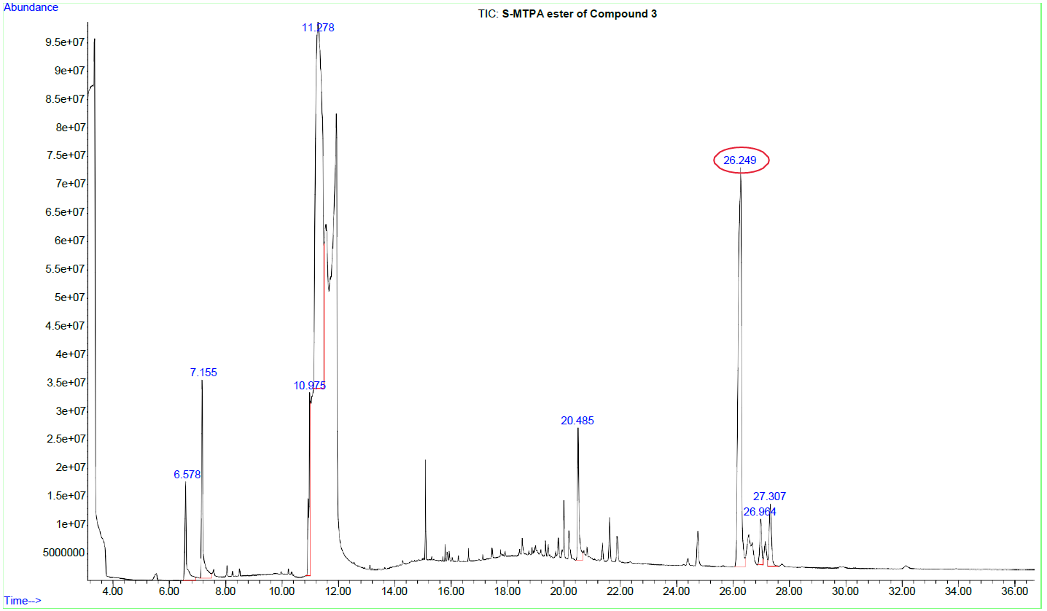
S93: TIC of the (S)-MTPA ester of Compound 3 at 26.25 min. (Identitcal to (9R)-HHCP)
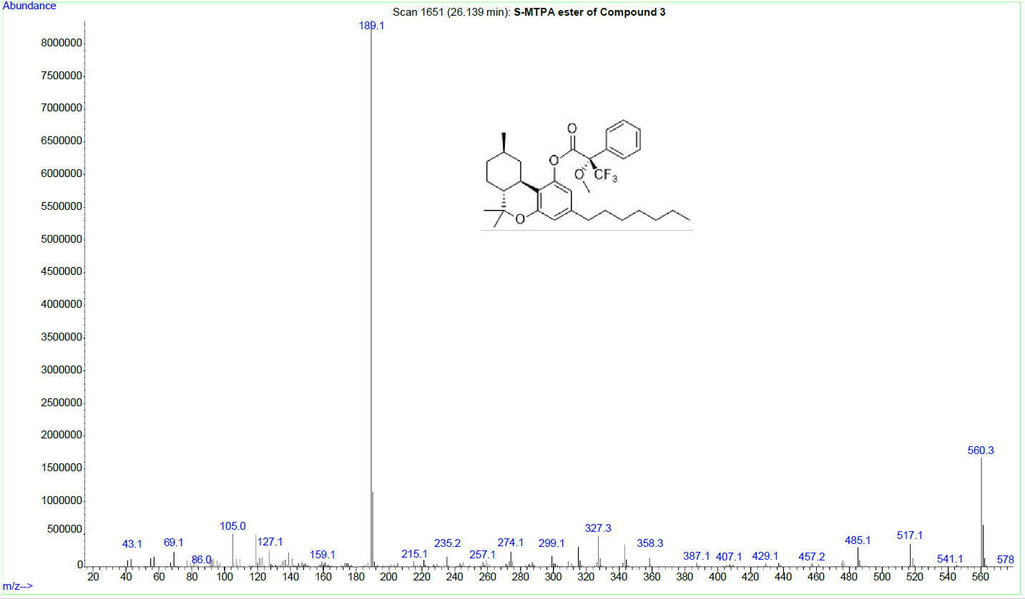
S94: GC-EI-MS of the (S)-MTPA ester of Compound 3. (Identical to (9R)-HHCP)
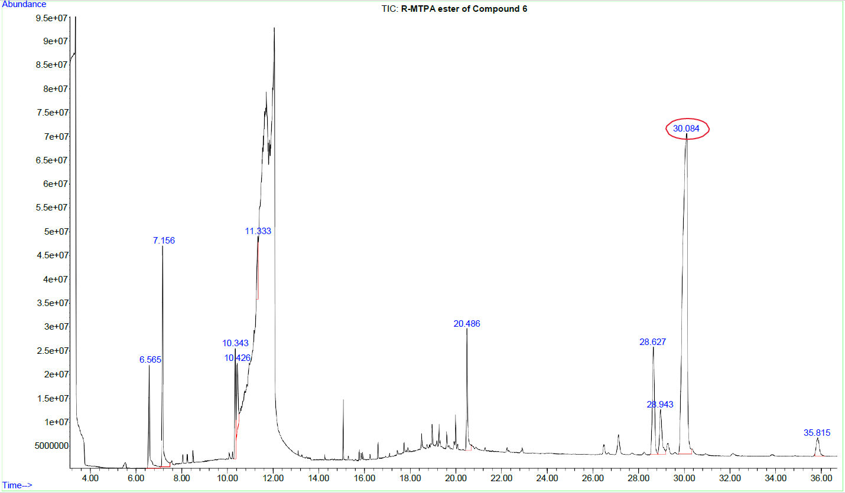
S95: TIC of the (R)-MTPA ester of Compound 6 at 30.08 min.
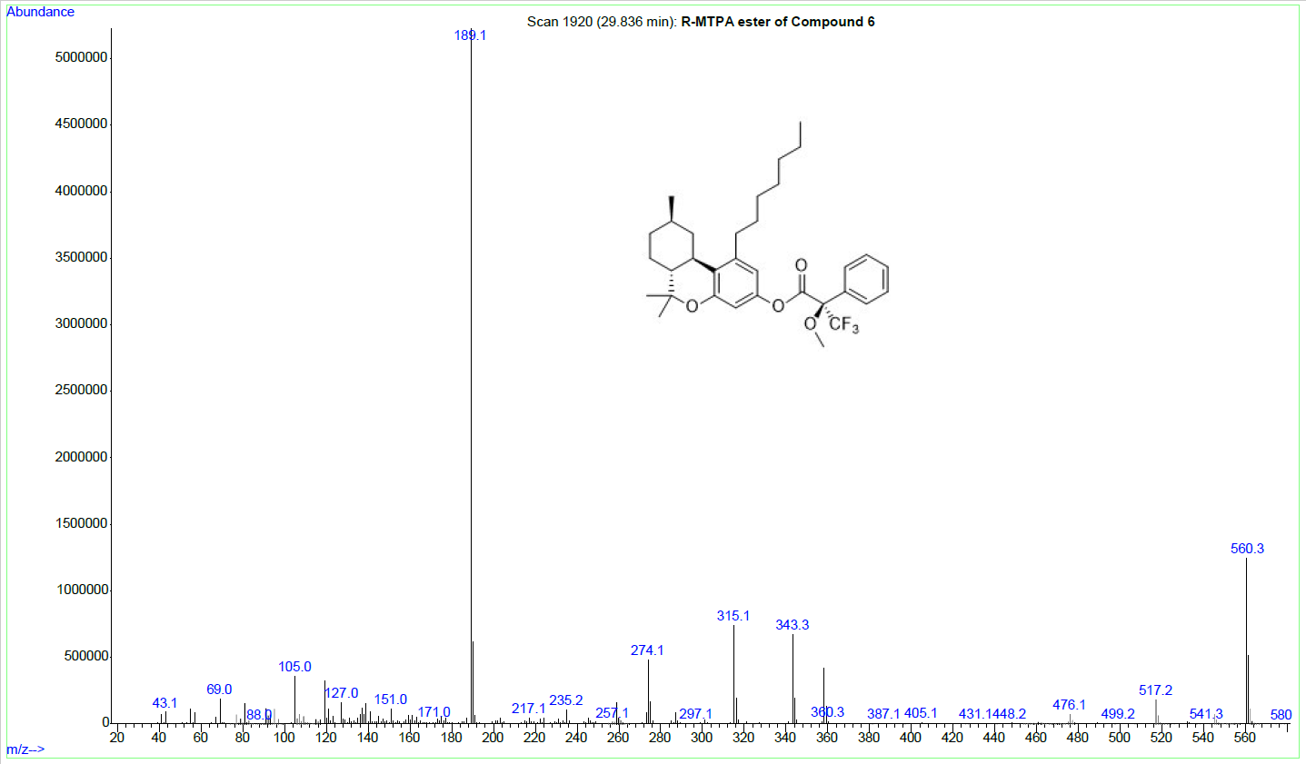
S96: GC-EI-MS of the (R)-MTPA ester of Compound 6.
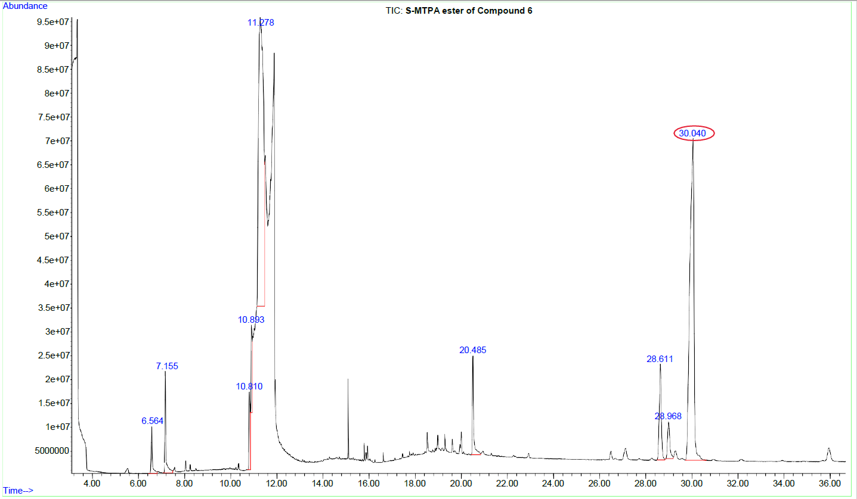
S97: TIC of the (S)-MTPA ester of Compound 6 at 30.04 min.
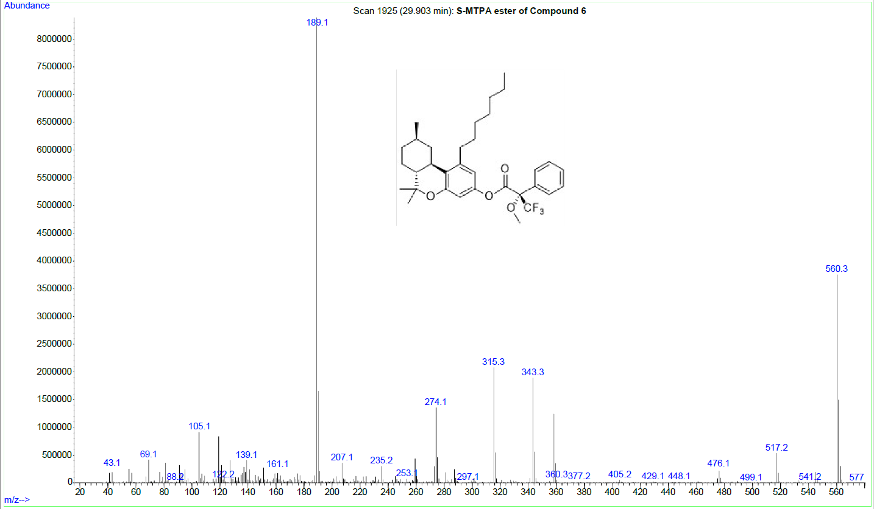
S98: GC-EI-MS of the (S)-MTPA ester of Compound 6.
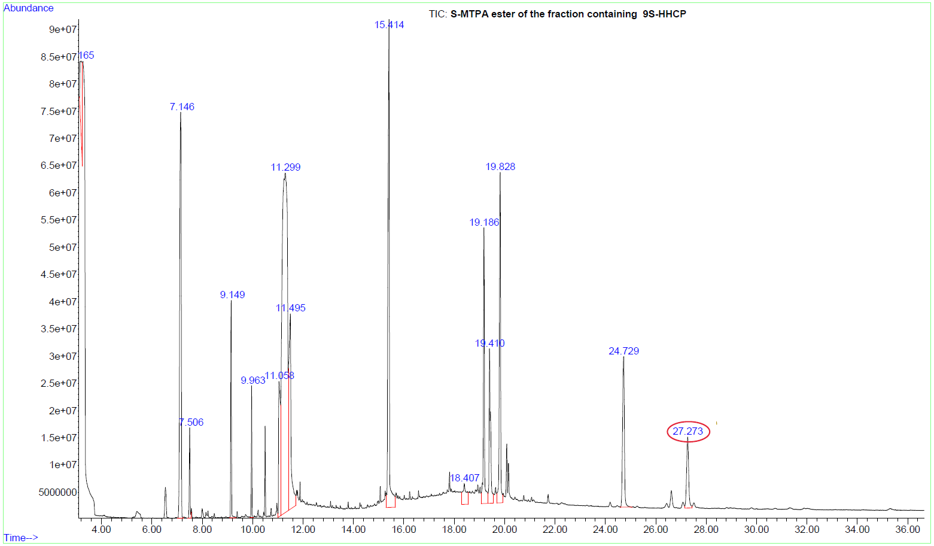
S99: TIC of the fraction containing (9S)-HHCP after derivatization with (R)-MTPA-Cl
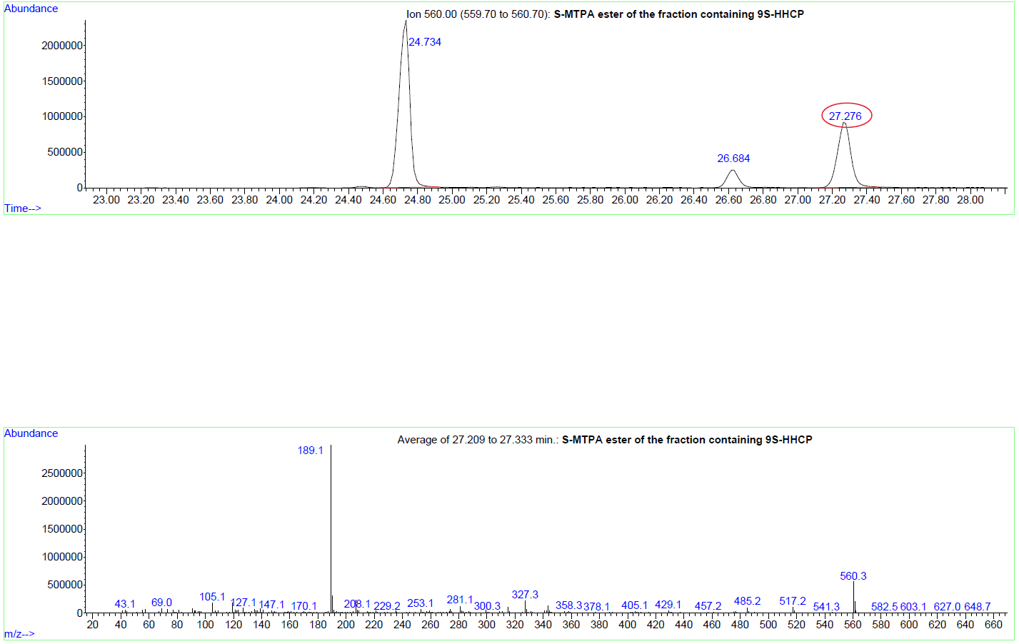
S100: top: XIC(560) of the fraction containing (9S)-HHCP, bottom: GC-EI-MS of (9S)-HHCP (S)-MTPA ester.
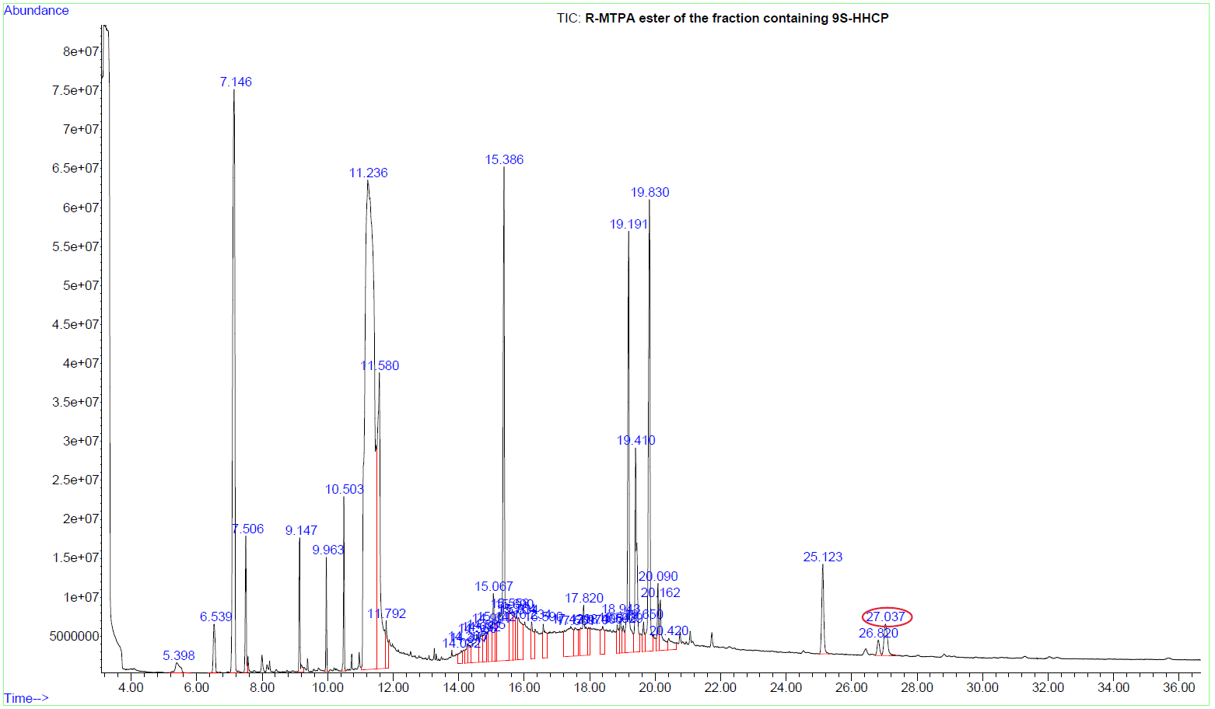S101: TIC of the fraction containing (9S)-HHCP after derivatization with (S)-MTPA-Cl
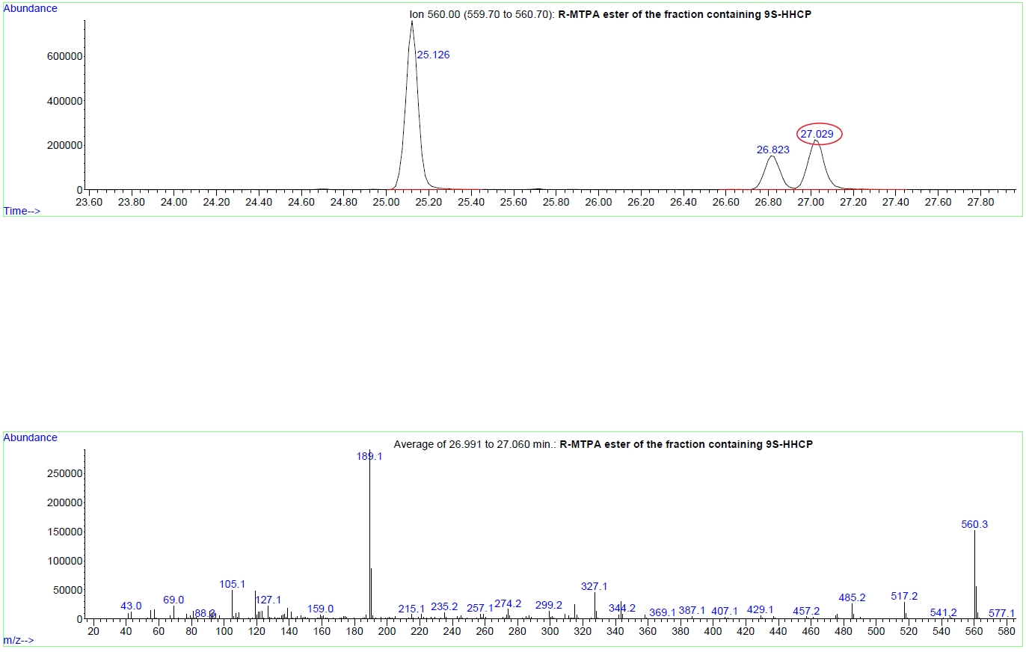S102: top: XIC(560) of the fraction containing (9S)-HHCP, bottom: GC-EI-MS of (9S)-HHCP (R)-MTPA ester.
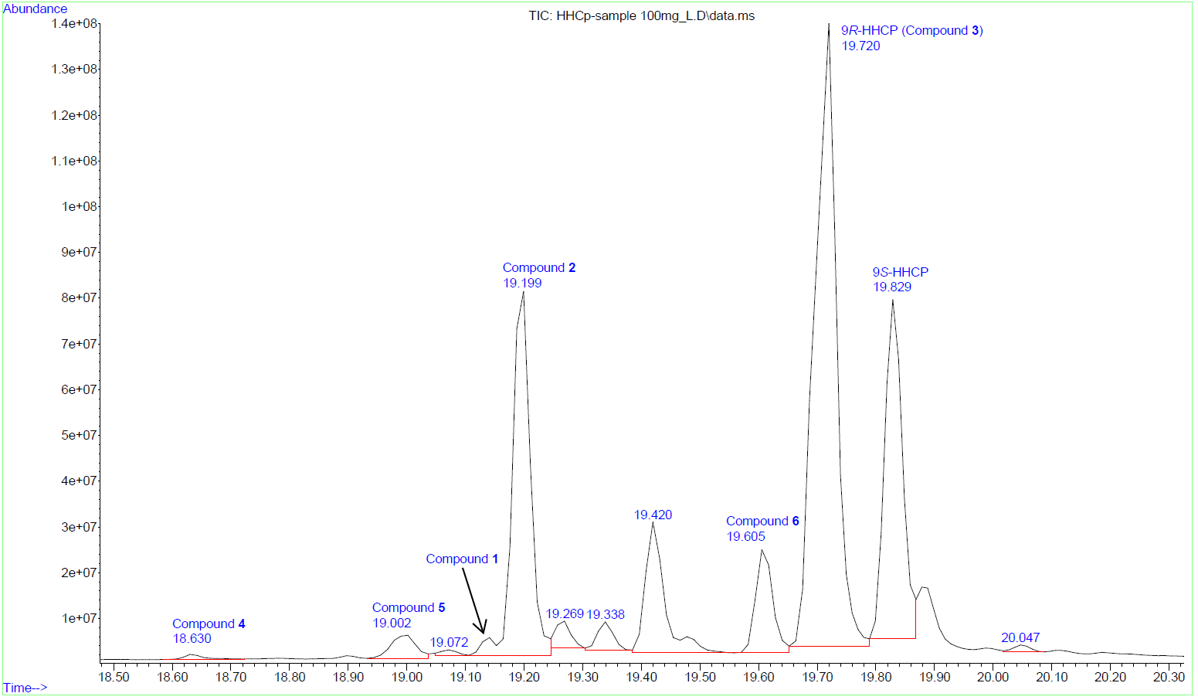
S103: TIC of the HHCP sample (γ = 100 mg/L). Other compounds besides the isolated compounds 1-6 are present.
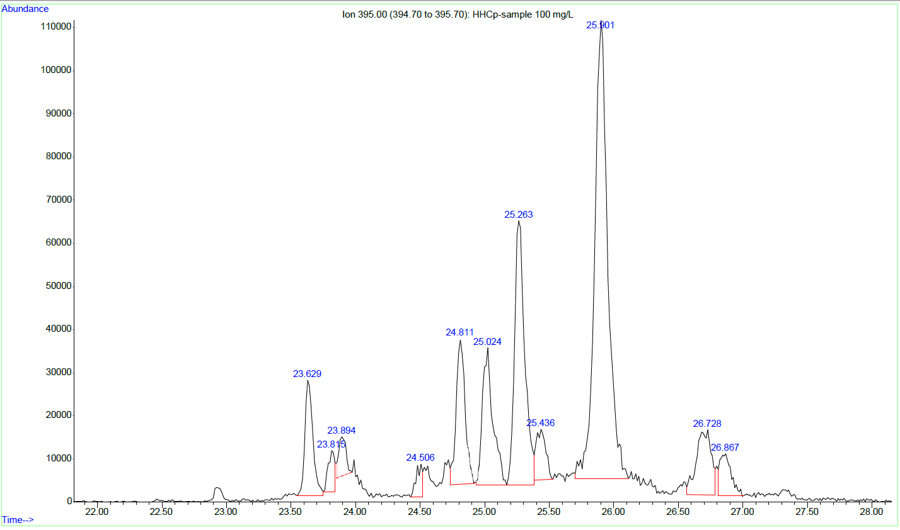
S104: XIC (395) of the HHCP sample (γ = 100 mg/L). High-molecular mass impurities, m/z 395 is a common fragment ion of them.
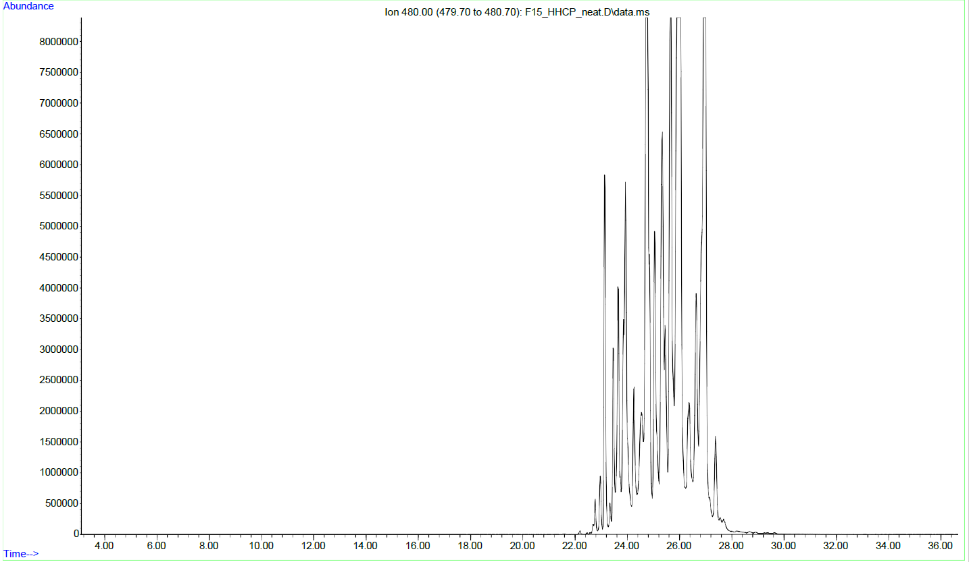
S105: XIC (480) of the underivatized fraction containing the impurities with a high molecular mass.
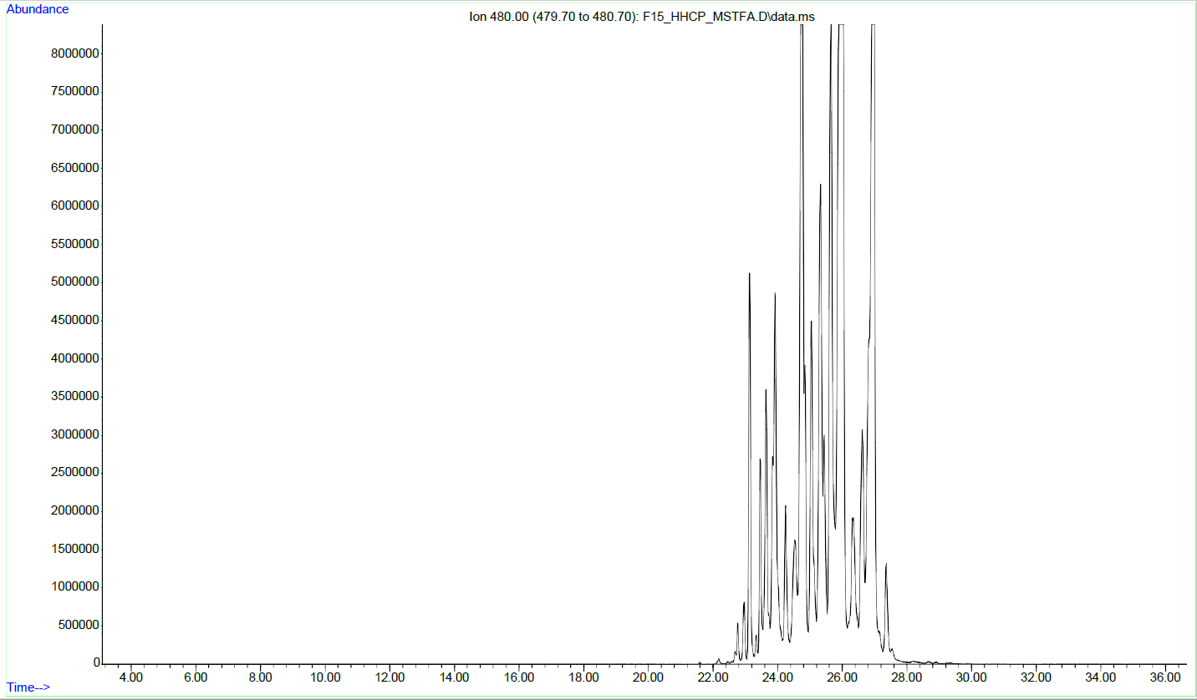
S106: XIC (480) of the MSTFA derivatized fraction containing the impurities with a high molecular mass. The XIC looks identical to S101 indicating that these compounds do not possess reactive groups (phenols, enols).
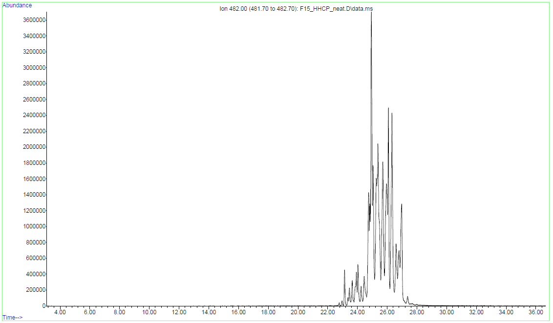
S107: XIC (482) of the underivatized fraction containing the impurities with a high molecular mass.
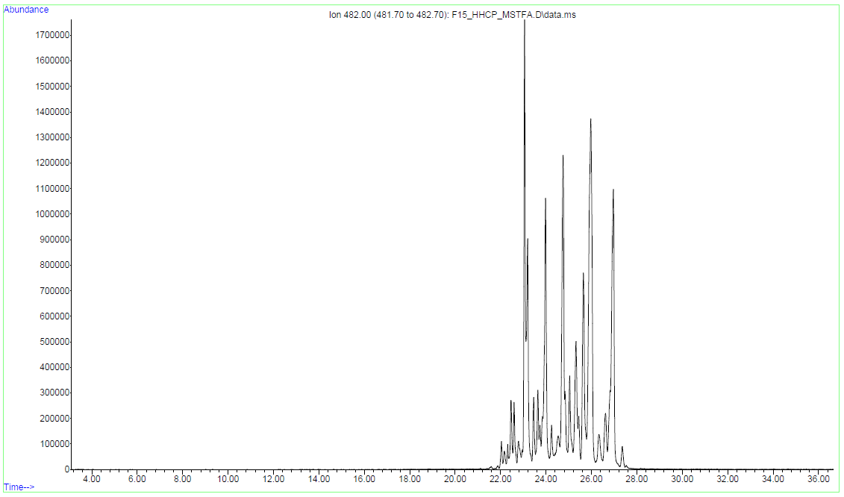
S108: XIC (482) of the MSTFA derivatized fraction containing the impurities with a high molecular mass. XIC looks very different to S103 and of lower abundances. Most compounds with a molecular mass of 482 were derivatized.
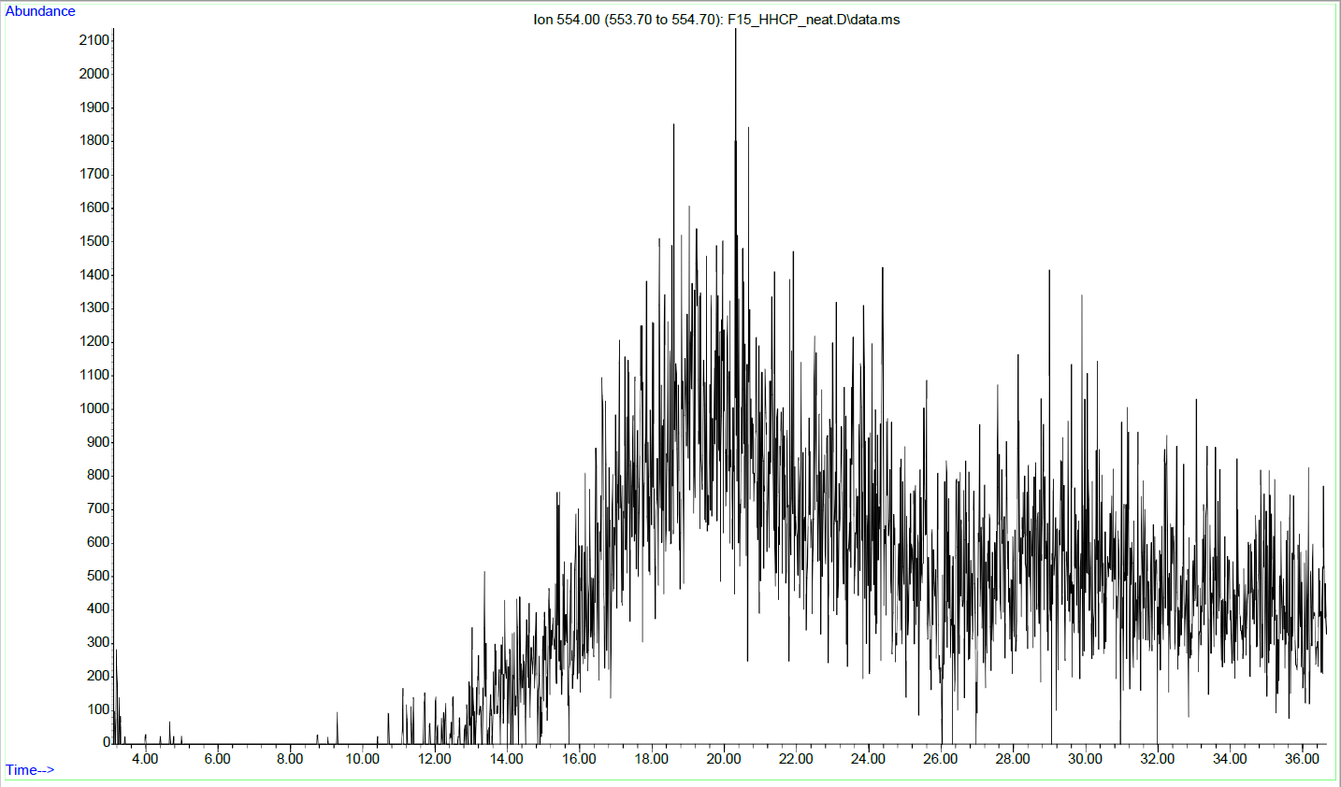
S109: XIC (554) of the underivatized sample with the high molecular mass impurities. No ions with m/z 554 were present prior derivatization.
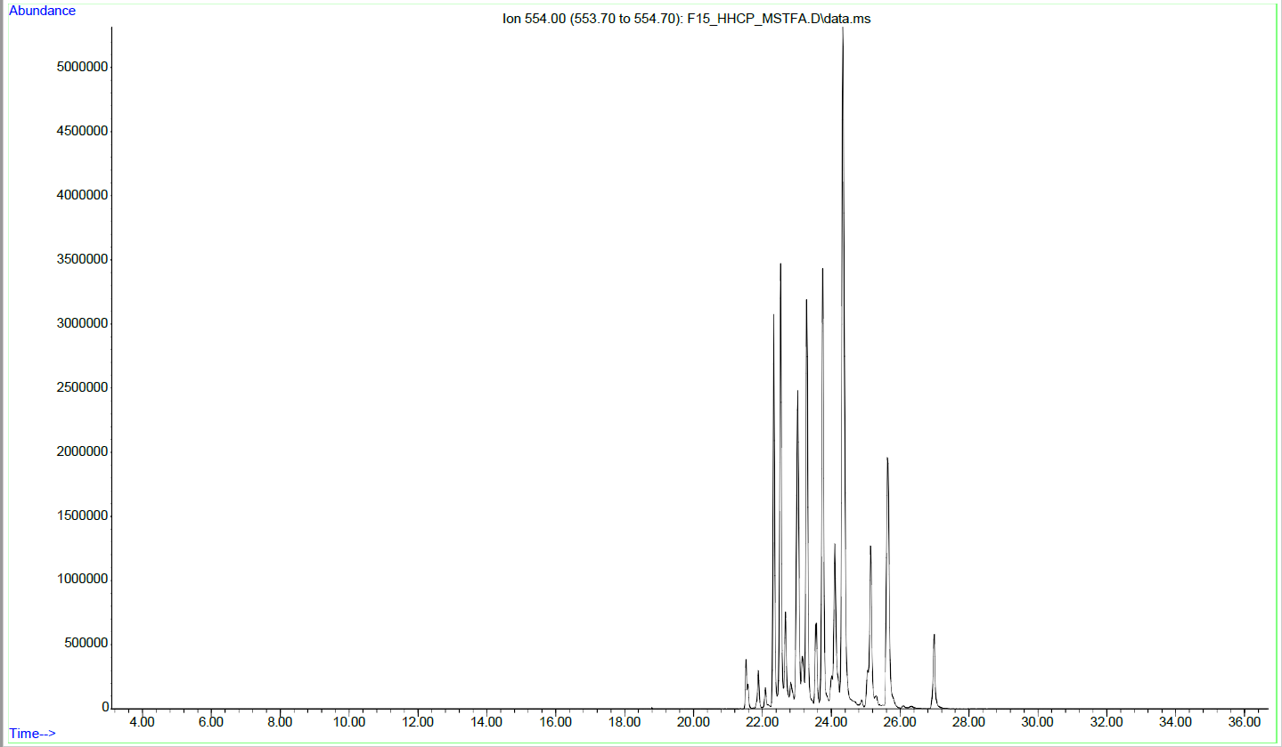
S110: XIC (554) of the MSTFA derivatized sample with the high molecular mass impurities. A lot of compounds with the molecular ion (or fragment ion) m/z 554 are present after trimethylsilylation (482+72).
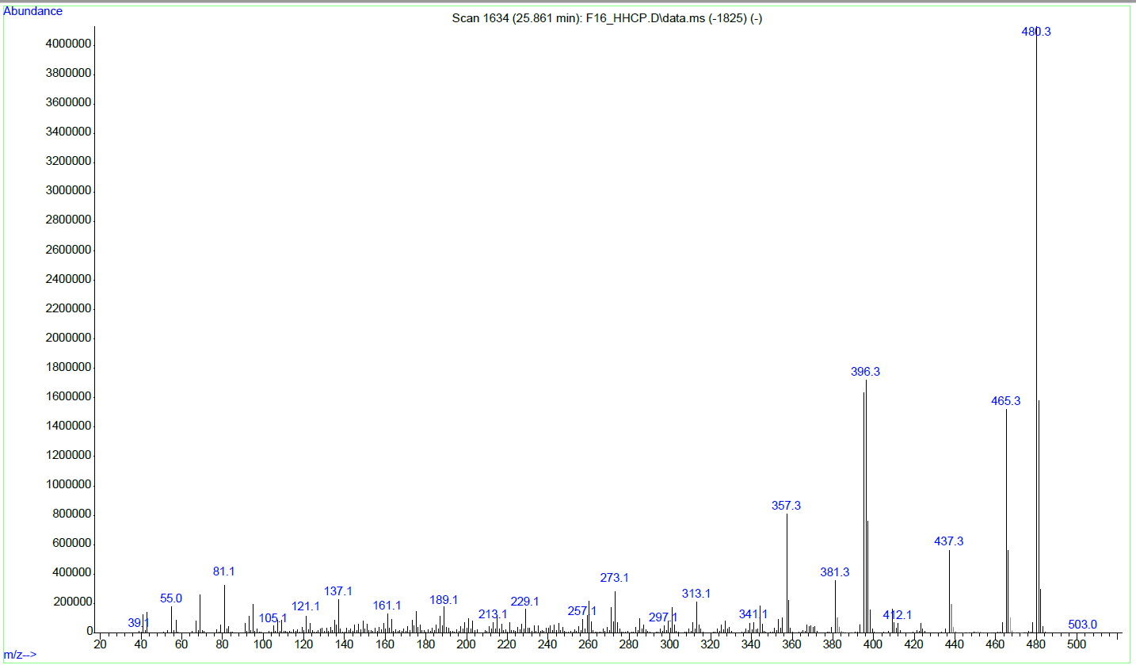
S111: GC-EI-MS of a byproduct with high molecular mass prior silylation. Characteristic fragmentation reactions for HHCP are observable.
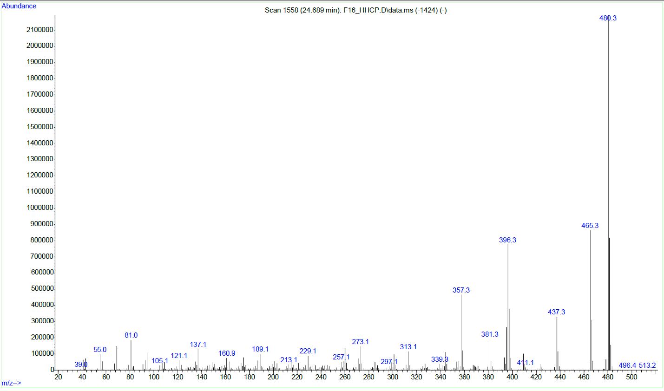
S112: GC-EI-MS of a byproduct with high molecular mass prior silylation. Characteristic fragmentation reactions for HHCP are observable.
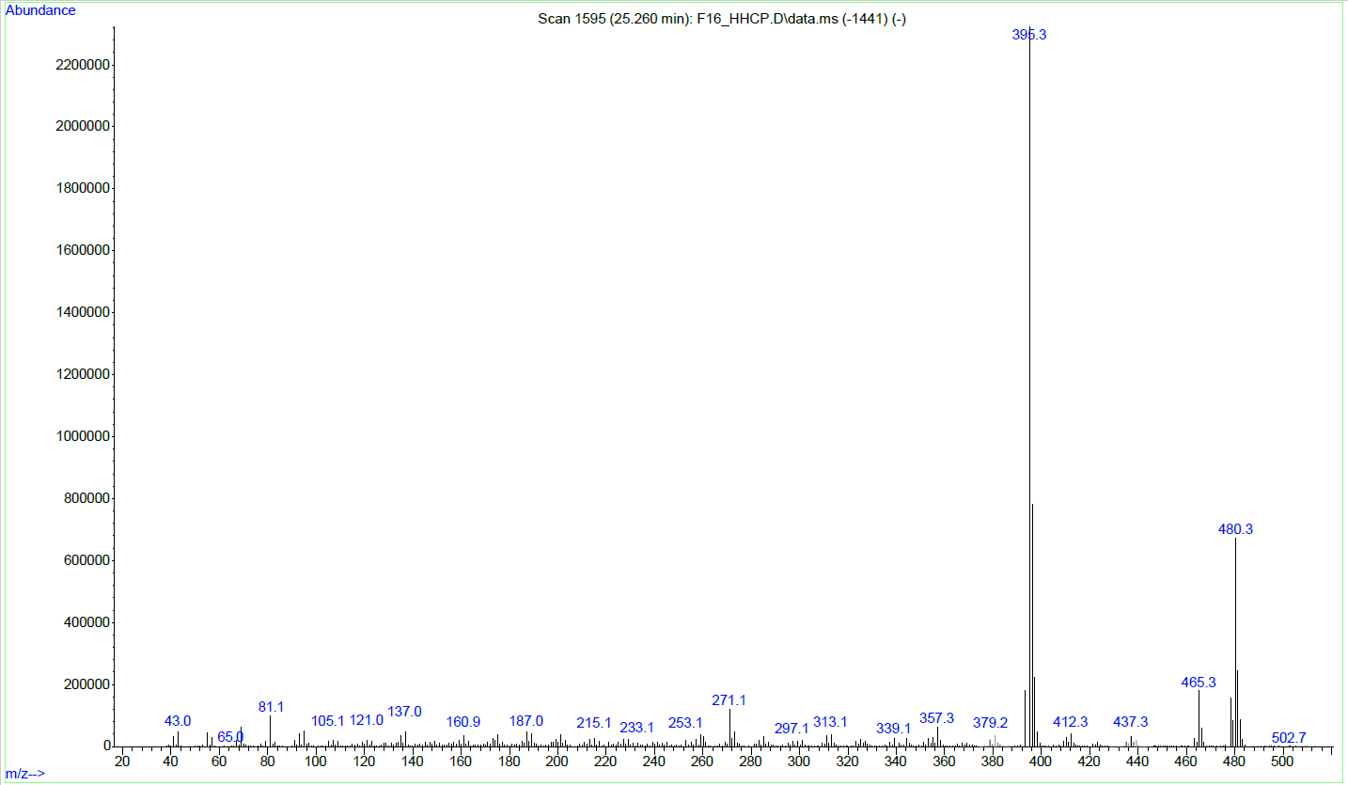
S113: GC-EI-MS of a byproduct with high molecular mass prior silylation. Characteristic fragmentation reactions for dibenzopyran cannabinoids are observable.
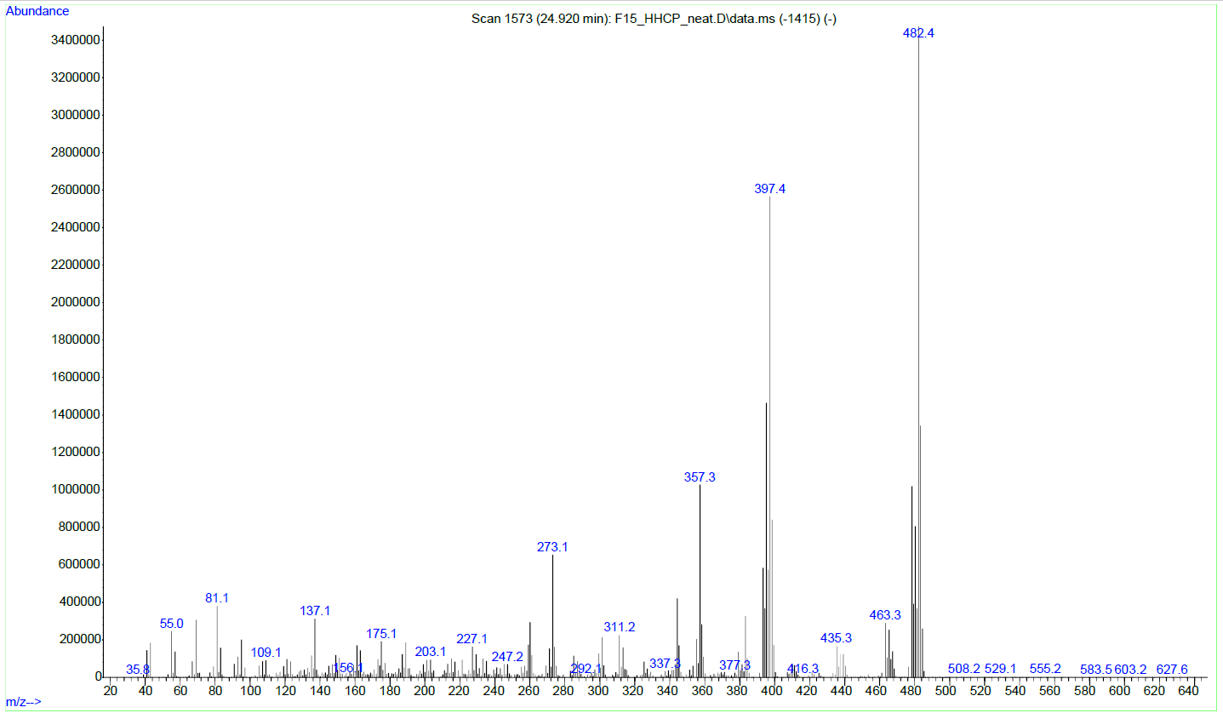
S114: GC-EI-MS of a byproduct with high molecular mass prior silylation. Similar fragmentation reactions as in the isolated ketones 4 and 5 appear.
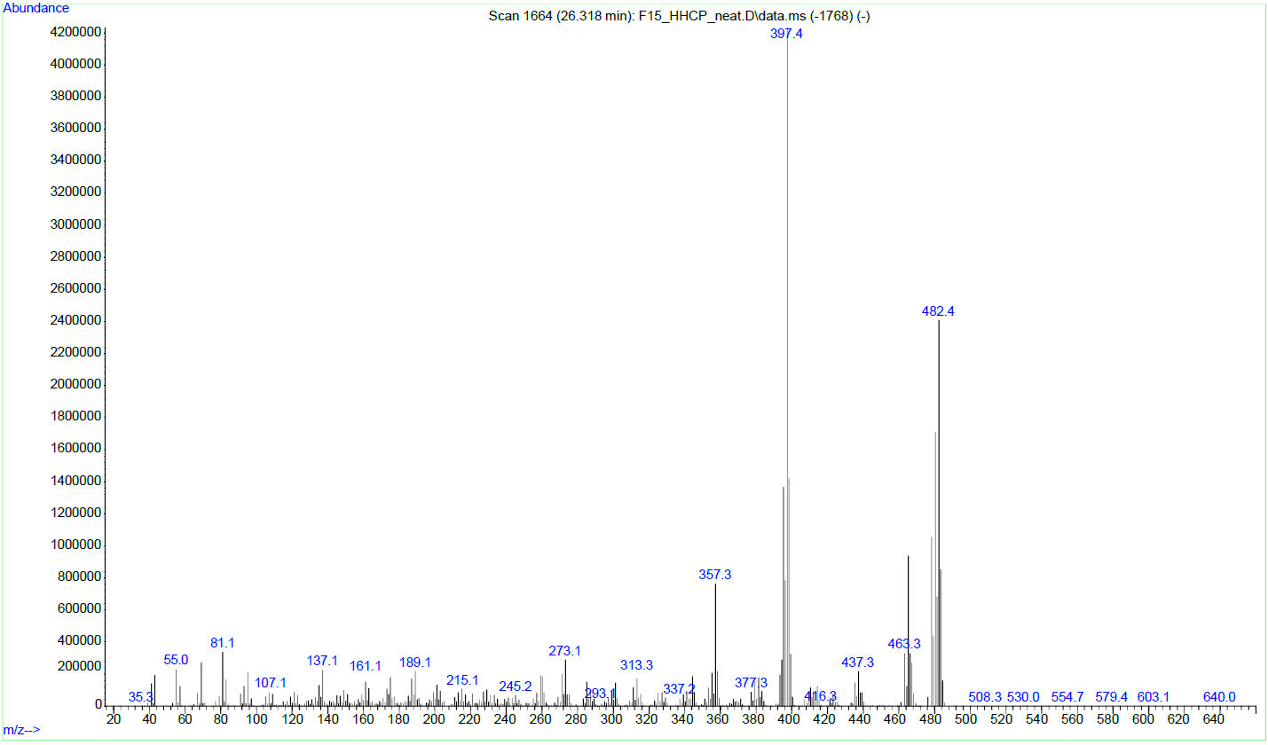
S115: GC-EI-MS of a byproduct with high molecular mass prior silylation. Similar fragmentation reactions as in the isolated ketones 4 and 5 appear.
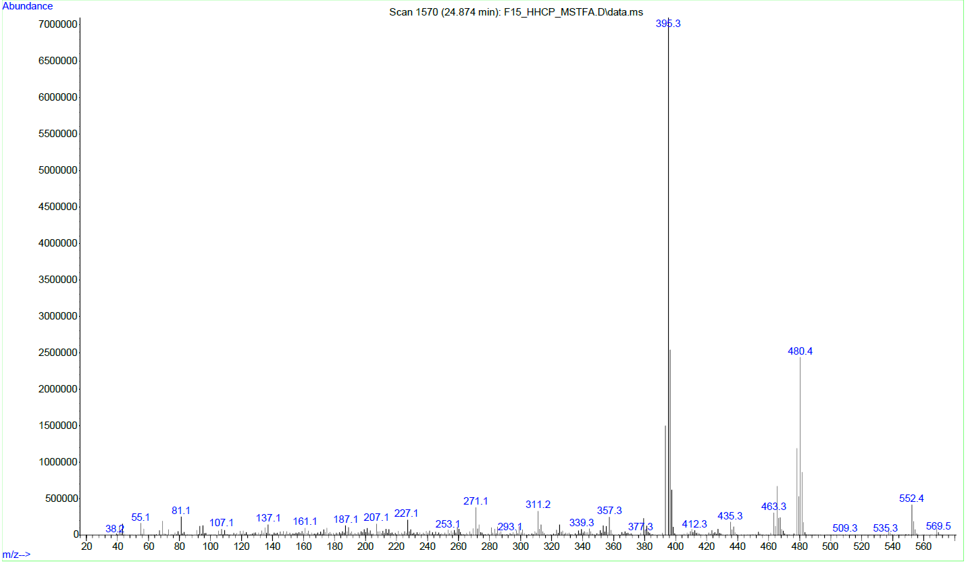
S116: GC-EI-MS of a byproduct with high molecular mass after mono-silylation. Similar fragmentation reactions appear as in dibenzopyran cannabinoids.
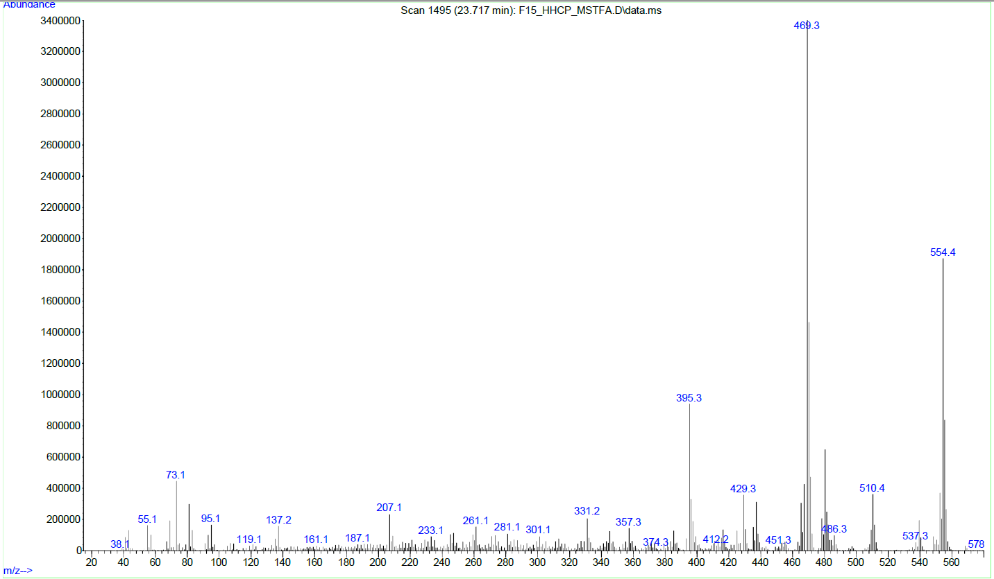
S117: GC-EI-MS of a byproduct with high molecular mass after mono-silylation. Similar fragmentation reactions appear as in dibenzopyran cannabinoids.
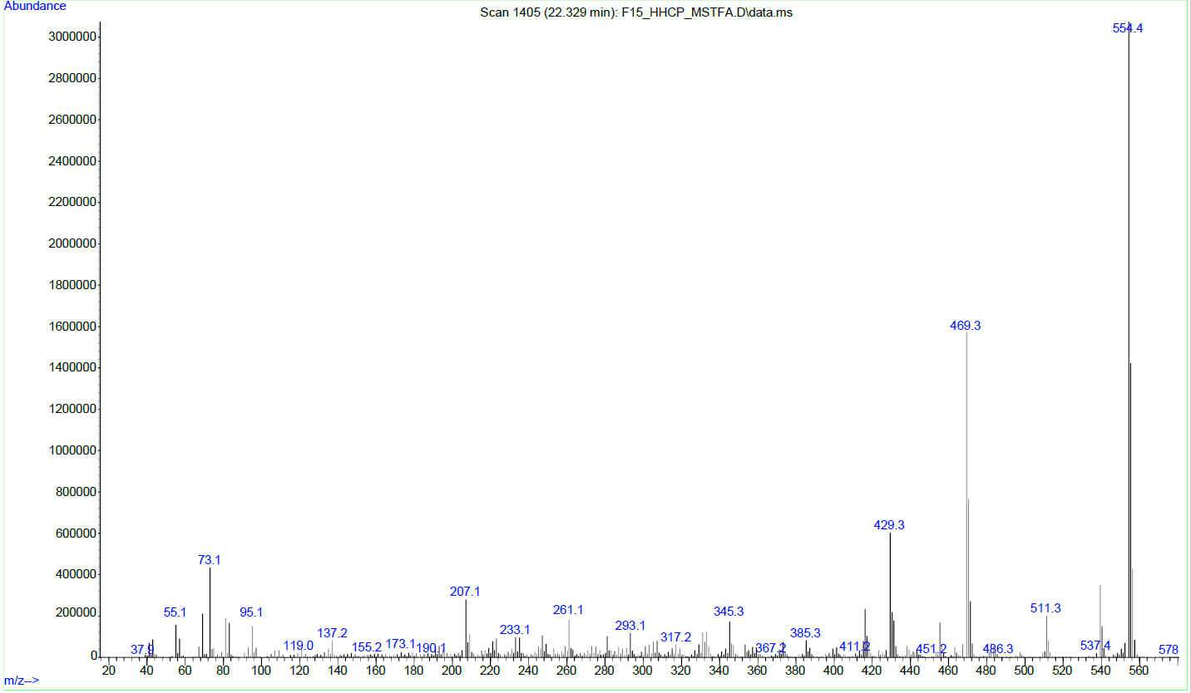
S118: GC-EI-MS of a byproduct with high molecular mass after mono-silylation. Similar fragmentation reactions appear as in dibenzopyran cannabinoids.
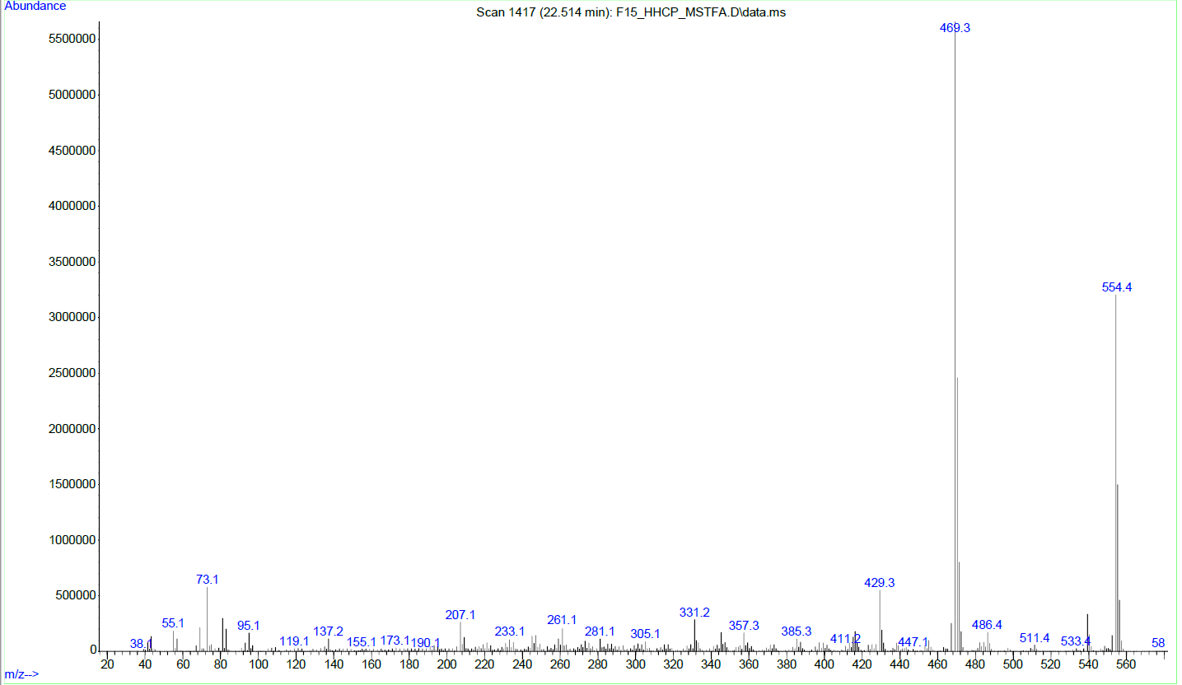S119: GC-EI-MS of a byproduct with high molecular mass after mono-silylation. Similar fragmentation reactions as in the isolated ketones 4 and 5 appear.
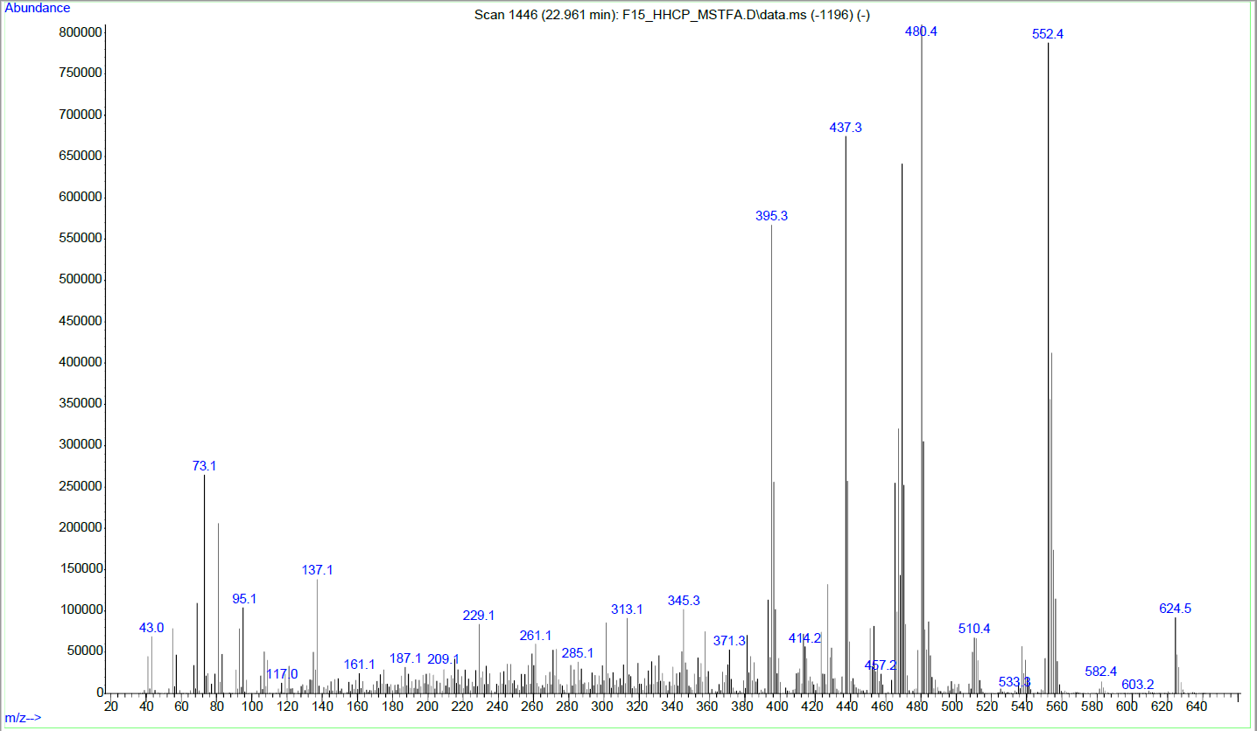
S120: GC-EI-MS of a byproduct with high molecular mass after double-silylation. Similar fragmentation reactions appear as in dibenzopyran cannabinoids.
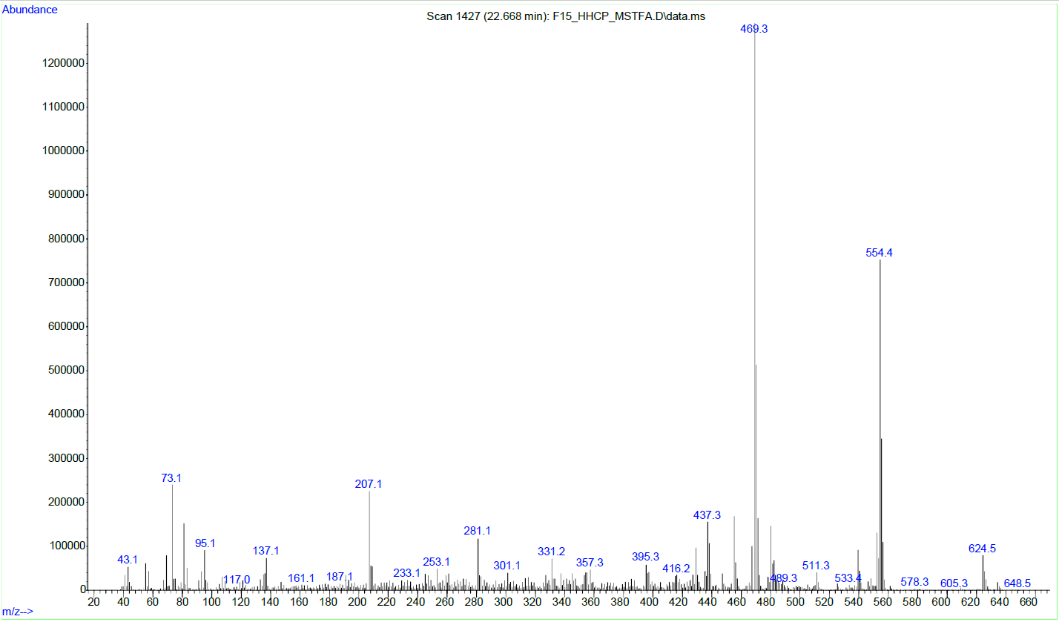
S121: GC-EI-MS of a byproduct with high molecular mass after double-silylation. Similar fragmentation reactions appear as in dibenzopyran cannabinoids.
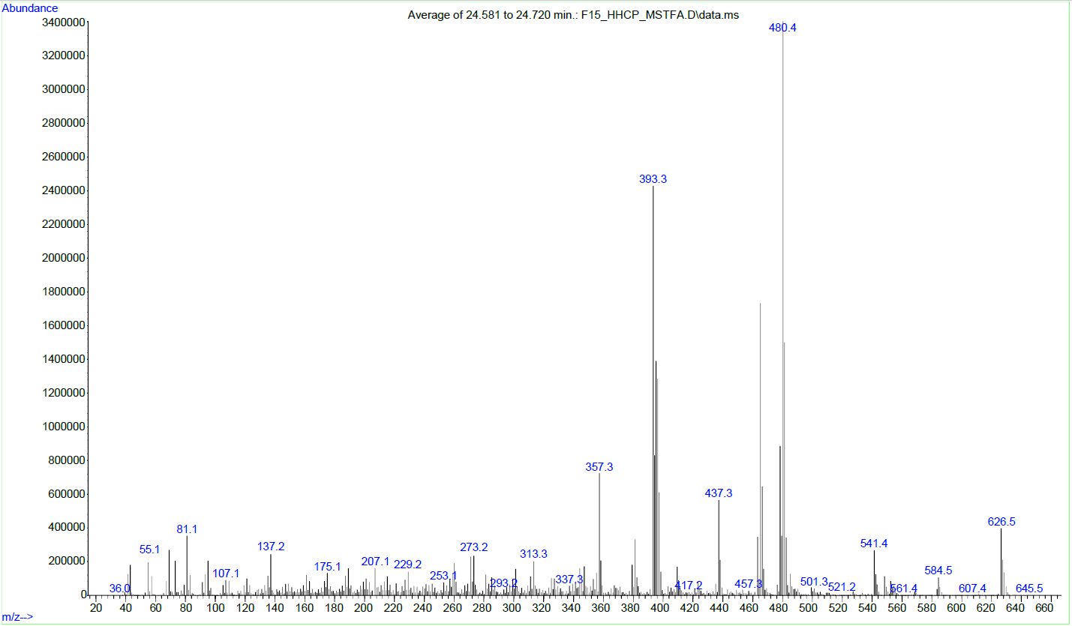
S122: GC-EI-MS of a byproduct with high molecular mass after double-silylation. Similar fragmentation reactions appear as in dibenzopyran cannabinoids.

