Supplementary Figure.1
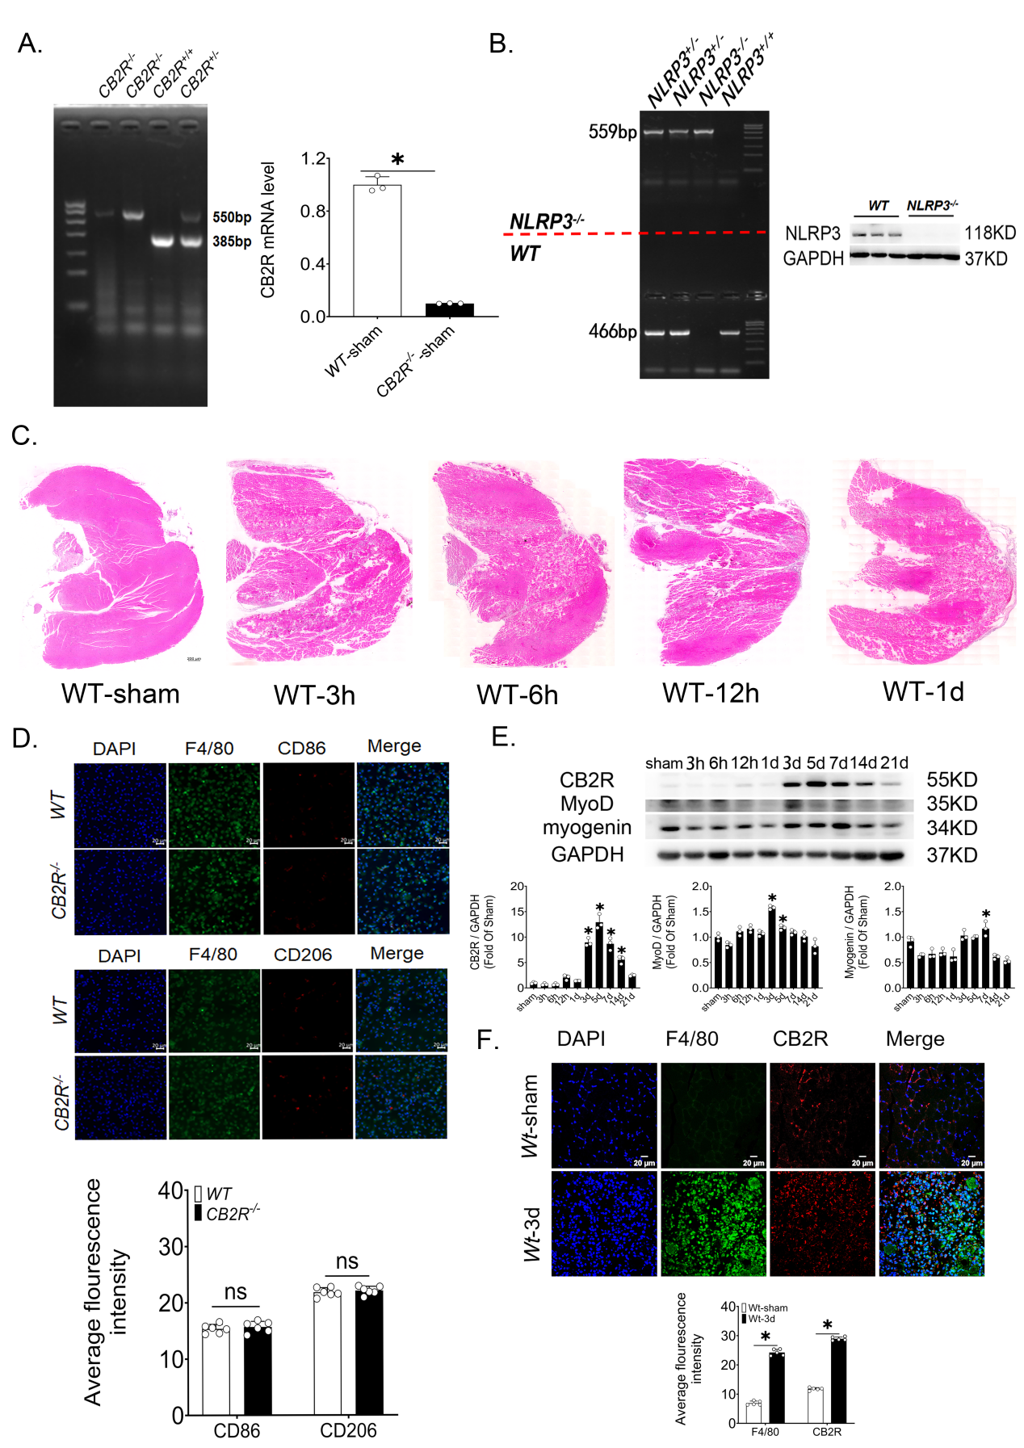

Supplementary Figure.1 Mouse genotype verification, contusion model verification and CB2R knockout aggravate the inflammatory response after skeletal muscle injury
(A) Representative bands of agarose gel electrophoresis of CB2R^{-/-} mouse genotype and qPCR results of CB2R. (B) NLRP3^{-/-} mouse genotype verification. (C) Verification of stability, uniformity and success of skeletal muscle injury model, scale bar=200μm. (D) Polarization of primitive peritoneal macrophages, scale bar=20μm, n=5, ns, no significance. (E) Temporal expression of CB2R, MyoD and myogenin proteins, n=3, data are represented as mean±SD, *p<0.05 vs. sham group. (F) The changes in CB2R expression in macrophages after skeletal muscle injury, n=5, data are represented as mean±SD, *p<0.05 Wt-sham vs. Wt-3d group.
Supplementary Figure.2
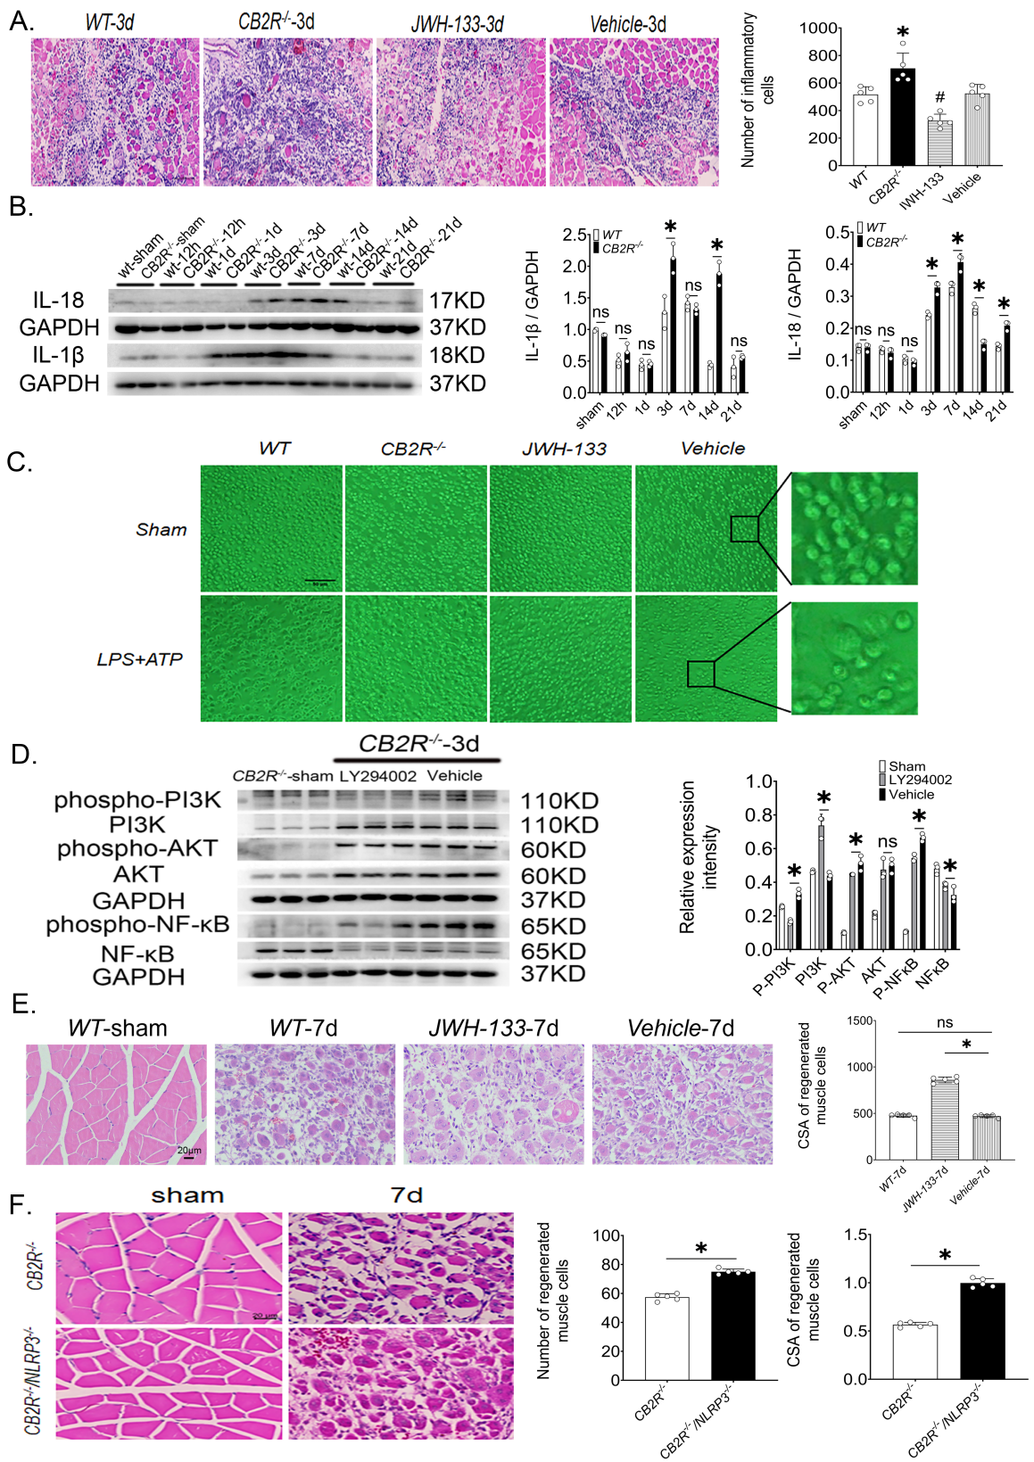

Supplementary Figure.2 Temporal expression pattern of CB2R and optical microscopy pictures of peritoneal macrophages.
(A) Infiltration of inflammatory cells in the injury area, scale bar=100μm, n=5, data are represented as mean±SD, *p<0.05 vs. sham group, #p<0.05 vs. Vehicle group. (B) Temporal expression of IL-18 and IL-1β after skeletal muscle injury in WT mice and CB2R^{-/-} mice, n=3, data are represented as mean±SD, *p<0.05 vs. CB2R^{-/-} group. ns, no significance. (C) Representative light microscope pictures of peritoneal macrophages, scale bar=20μm. (D) Protein expression levels of PI3K, phospho-PI3K, AKT, phospho-AKT, NF-κB and phospho-NF-κB. n=3, *p<0.05 vs. Vehicle group. (E) H&E representative pictures of skeletal muscle regeneration, scale bar=20μm. n=5, *p<0.05 Vehicle-7d vs. JWH-133-7d group. (F) H&E representative pictures of skeletal muscle regeneration, scale bar=20μm, n=5, data are represented as mean±SD, *p<0.05 CB2R^{-/-} vs. CB2R^{-/-}/NLRP3^{-/-} group.

Supplementary Figure.3
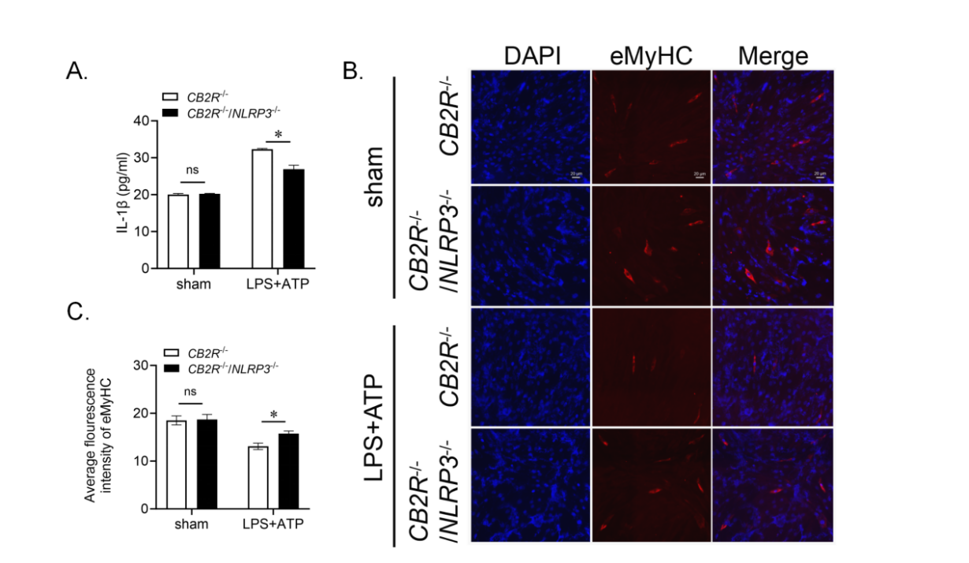

Supplementary Figure.3 CB2R regulates C2C12 myogenic differentiation in an NLRP3-dependent manner.
(A) The release of IL-1β from macrophages after LPS+ATP treatment, n=4, *p<0.05 Cb2r^{-/-}/Nlrp3^{-/-} vs. Cb2r^{-/-} group. (B, C) Expression of eMyHC in C2C12 after treatment with macrophage-conditioned medium, scale bar=20μm, n=3, *p<0.05 sham vs. LPS+ATP group. *p<0.05 Cb2r^{-/-}/Nlrp3^{-/-} vs. Cb2r^{-/-} group

Supplementary Figure.4
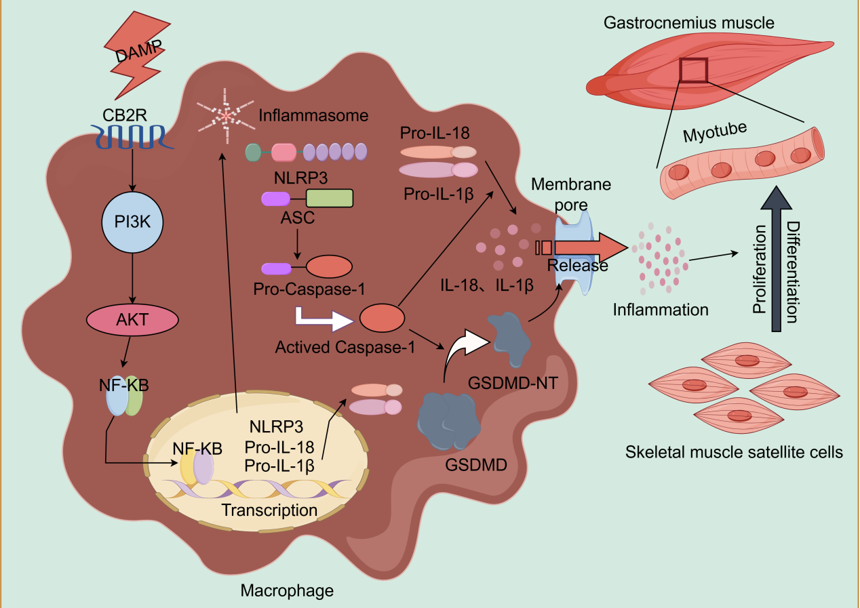
Supplementary Figure.4 Schematic drawing of the major finding
This study demonstrates that CB2R facilitates NLRP3-GSDMD mediated macrophage pyroptosis via the PI3K/AKT/NF-κB pathway, leading to increased release of IL-1β following skeletal muscle injury, aggravate the inflammatory response, and thereby inhibit regeneration after injury.

Supplementary Table.1
GENE NAME | FORWORD | REVERSE
NLRP3 | CTCCAACCATTCTCTGACCAG | ACAGATTGAAGTAAGGCCGG
ASC | AGCAAGAGTAAAAGGTGACCG | TTGAGTTCATCCCCTGACAAG
caspase-1 | TCTGTATTCACGCCCTGTTG | GATAAATTGCTTCCTCTTTGCCC
GSDMD | CTATGCCTCCCTGTTCCTATTG | TGAGTATGGTTCTTGGCTTCC
IL-1β | ACGGACCCCAAAAGATGAAG | TTCTCCACAGCCACAATGAG
GAPDH | CTTTGTCAAGCTCATTTCCTGG | TCTTGCTCAGTGTCCTTGC

