Supplementary Table 1. A breakdown of which models were used over the winter 2023/24 season. Diseases where there has been a longer standing forecast offering have larger ensembles developed, as the suite is iteratively improved. This season the 111 Calls telephonic health triage data source was only available for COVID-19 related triages.
Model | COVID-19 | Influenza | RSV
GAM | Yes | Yes | Yes
ETS | Yes | Yes | No
Regression: Google Trends | Yes | Yes | No
Regression: 111 Online | Yes | Yes | No
Regression: 111 Calls | Yes | No | No

Supplementary Table 2. Bias related forecast scoring measures across disease, metric, and geographies.
Disease | Metric | Geography | Bias | Underprediction | Overprediction
COVID-19 | admissions | nation | 0.31 | 12 | 33
COVID-19 | admissions | region | 0.17 | 1.8 | 2.8
Influenza | admissions | nation | -0.25 | 12 | 4.1
Influenza | admissions | region | -0.21 | 2.5 | 0.63
RSV | admissions | nation | 0.12 | 5.0 | 5.2
RSV | admissions | region | 0.034 | 1.2 | 1.2
COVID-19 | occupancy | nation | 0.36 | 0.017 | 0.12
COVID-19 | occupancy | region | 0.22 | 0.028 | 0.078
Influenza | occupancy | nation | 0.029 | 0.033 | 0.012
Influenza | occupancy | region | -0.093 | 0.059 | 0.03

Supplementary Table 3. Forecast scoring rules across disease, metric, and geographies.
Disease | Metric | Geography | Weighted interval score | Dispersion | Coverage deviation | Median absolute error
COVID-19 | admissions | nation | 57 | 12 | -0.35 | 92
COVID-19 | admissions | region | 8.2 | 3.6 | -0.064 | 15
Influenza | admissions | nation | 26 | 9.7 | -0.062 | 52
Influenza | admissions | region | 5.4 | 2.2 | -0.013 | 9.8
RSV | admissions | nation | 16 | 5.5 | -0.085 | 29
RSV | admissions | region | 3.9 | 1.7 | -0.0013 | 7.3
COVID-19 | occupancy | nation | 0.17 | 0.039 | -0.27 | 0.28
COVID-19 | occupancy | region | 0.19 | 0.083 | -0.074 | 0.36
Influenza | occupancy | nation | 0.087 | 0.042 | 0.014 | 0.17
Influenza | occupancy | region | 0.15 | 0.065 | -0.012 | 0.27

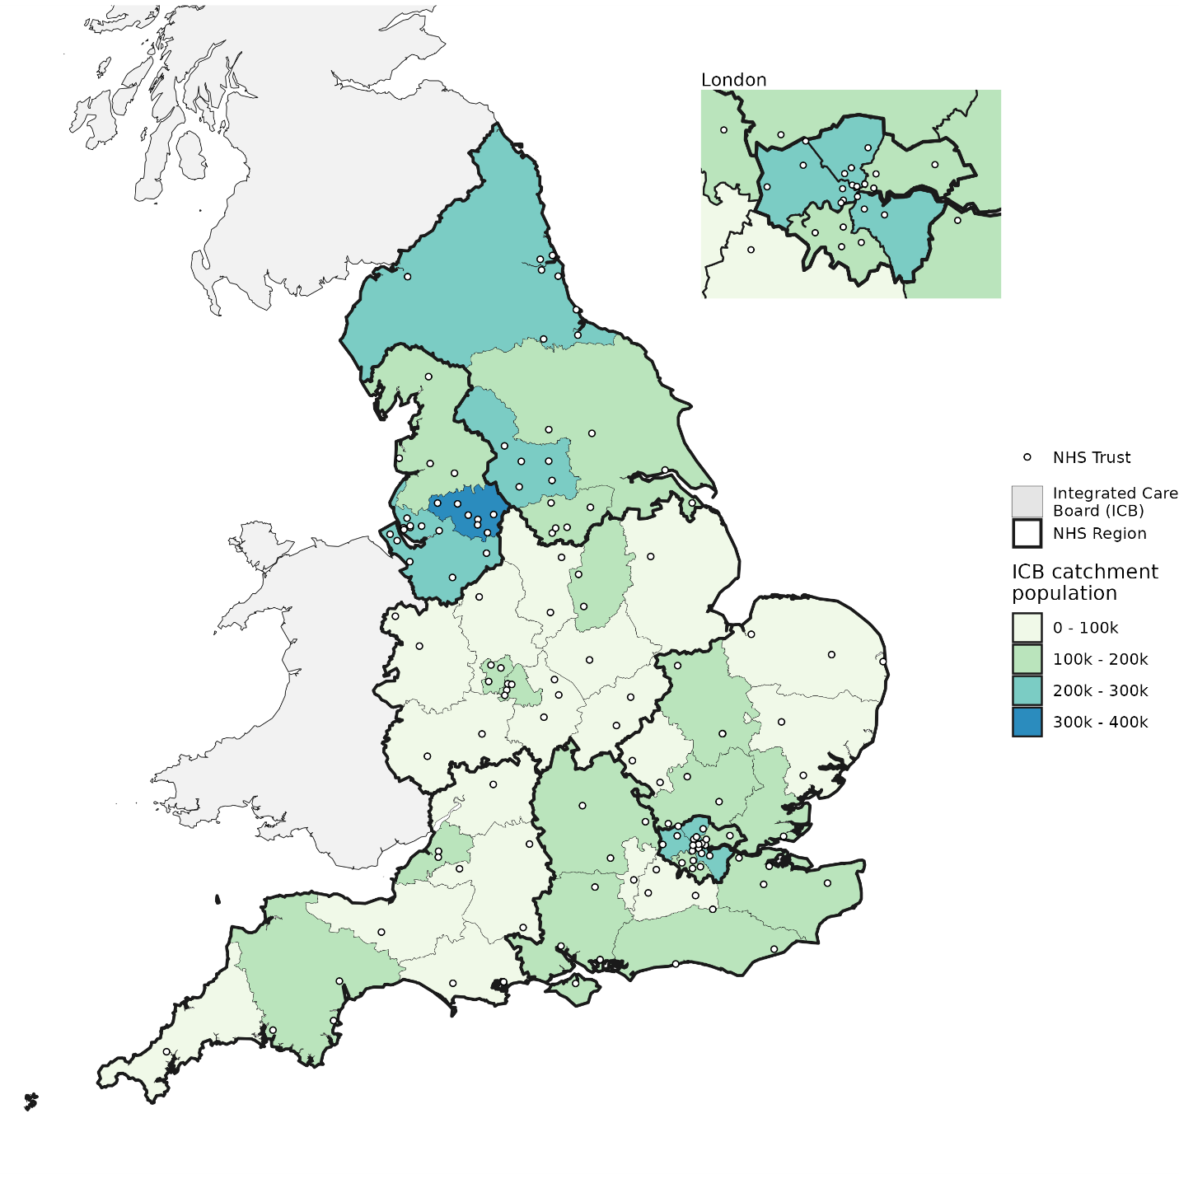Supplementary Figure 1. Map of England with NHS geographies shown. Each acute NHS Trust is shown as a point location based on its headquarters postcode. Each Integrated Care Board (ICB) has a fixed boundary, with one or multiple NHS Trusts within its border, though they treat patients across borders. The 7 NHS regions contain multiple ICBs each.

