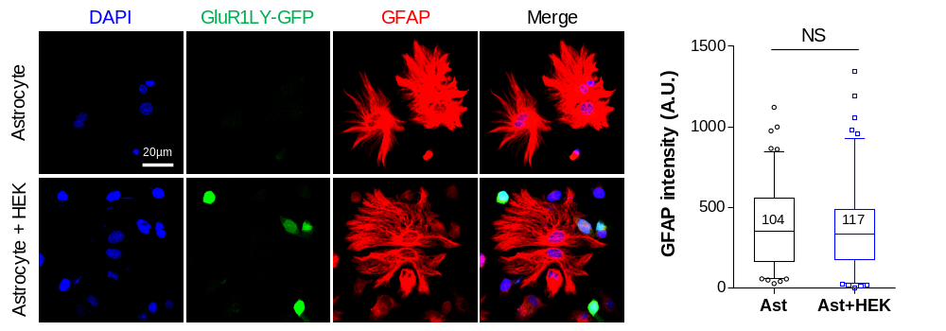
Figure S1. Astrocytic reactivity was not altered by co-culture with GluR1LY-GFP-transfected HEK293T cells. Box-and-whisker graph shows 5 to 95 percentiles. The numbers on the graph indicate the numbers of ROIs analyzed. Significance was analyzed by Student’s t-test.

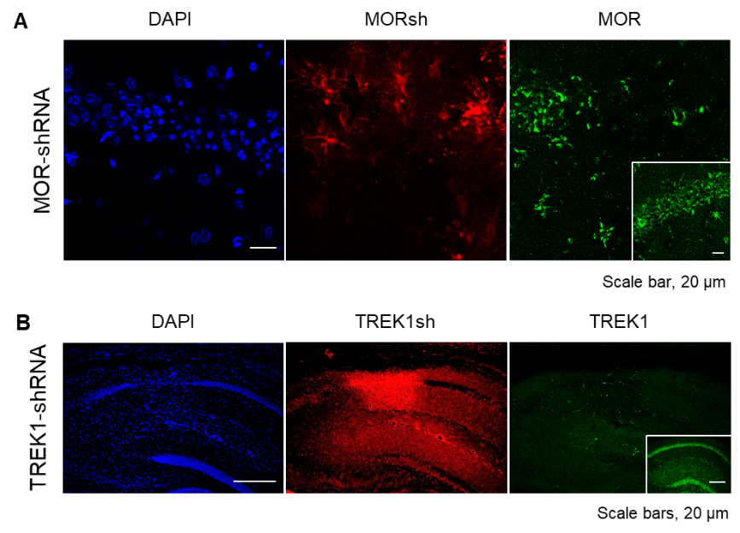
Figure S2. In vivo knockdown efficiency of MOR-shRNA and TREK1-shRNA. (A) Lentivirus carrying MOR-shRNA markedly reduced the hippocampal MOR expression in vivo, compared to scrambed-shRNA (inset). (B) Lentivirus carrying TREK1-shRNA markedly reduced the hippocampal TREK1 expression in vivo, compared to scrambed-shRNA (inset).

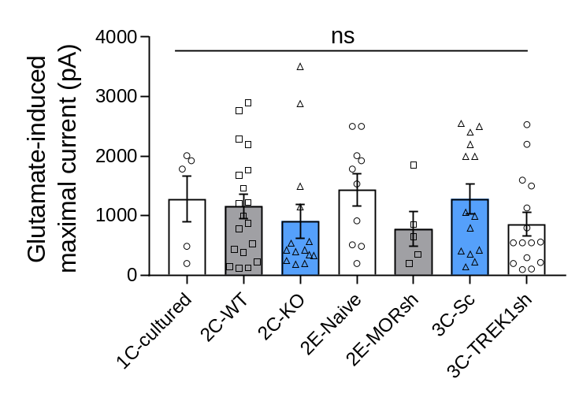
Figure S3. Glutamate (1 mM)-induced maximal inward currents over the all experimental groups. 1C, 2C, 2E, and 3C indicate each figure number. Significance was analyzed by One-way ANOVA with Tukey’s multiple comparison test.

