Table S 1. 3 D Structure of Cannabinoids and proteins related to MEK/AKT/ERK1/2/P13K/Vimentin/E-cadherin signaling pathways
3 D Structure of Tetrahydrocannabivarin-vimentin interaction | 3 D Structure of Tetrahydrocannabivarin-E-cadherin interaction | 3 D Structure of Tetrahydrocannabivarin-AKT interaction | 3 D Structure of Tetrahydrocannabivarin-MEK interaction | 3 D Structure of Tetrahydrocannabivarin-mTOR interaction
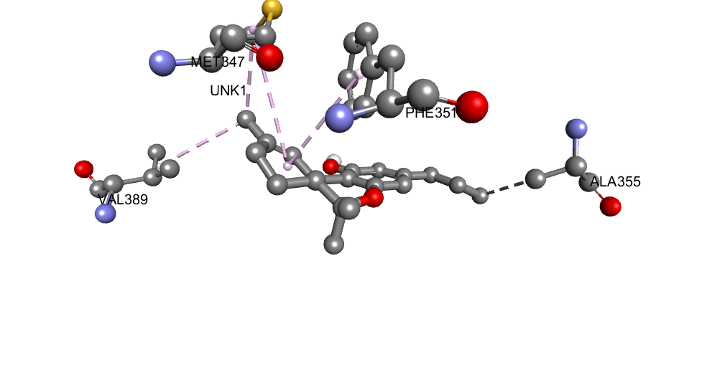 | 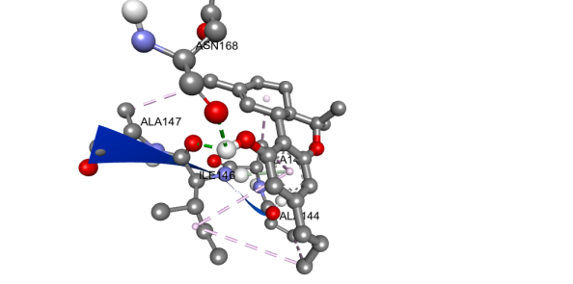 | 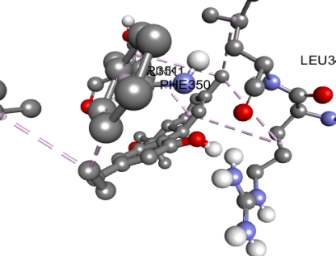 | 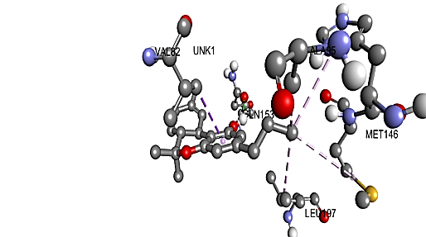 | 
3 D Structure of Tetrahydrocannabivarin-ERK 1 interaction | 3 D Structure of Tetrahydrocannabivarin-ERK 2 interaction | 3 D Structure of Tetrahydrocannabivarin-JNK interaction | 3 D Structure of Tetrahydrocannabivarin-P13K interaction | 3 D Structure of Tetrahydrocannabivarin-P38 interaction
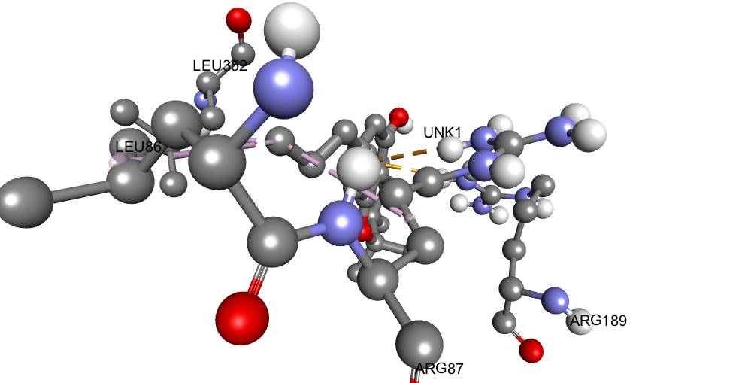 | 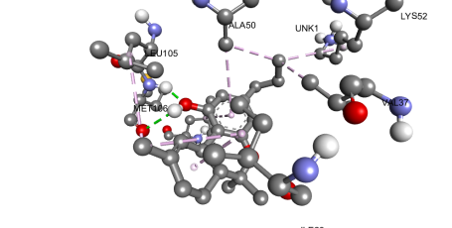 | 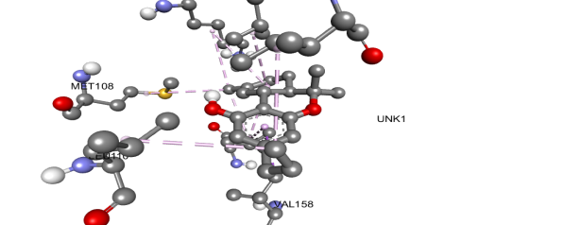 | 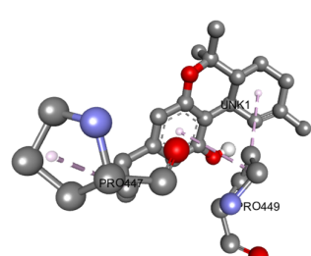 | 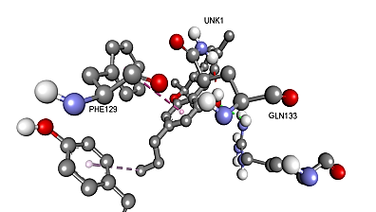

3 D Structure of Canabigerol vimentin interaction | 3 D Structure of Cannabigerol-E-cadherin interaction | 3 D Structure of Cannabigerol -AKT interaction | 3 D Structure of Cannabigerol -MEK interaction | 3 D Structure of Cannabigerol -mTOR interaction
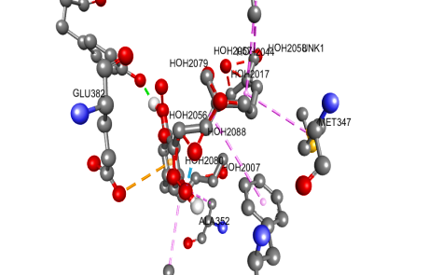 | 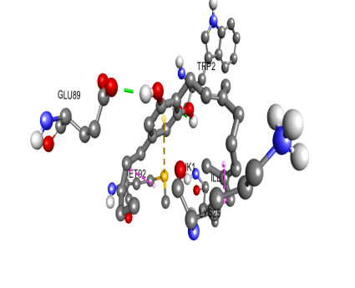 | 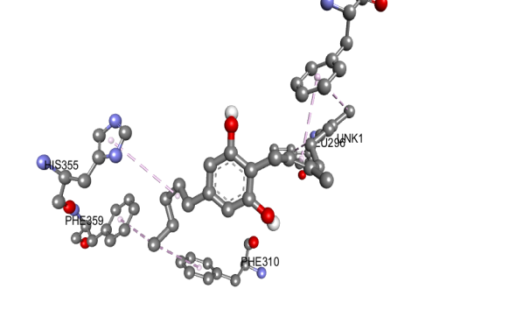 | 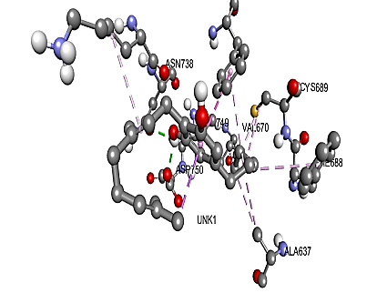 | 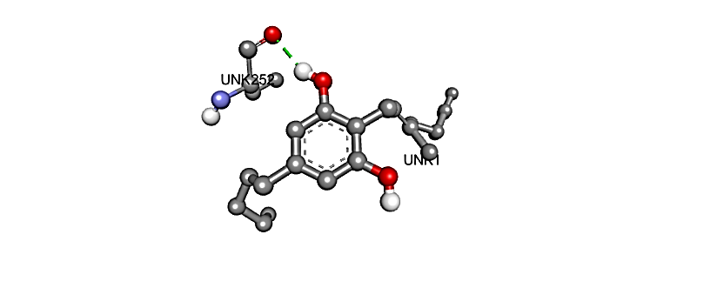
3 D Structure of Canabigerol -ERK 1 interaction | 3 D Structure of Canabigerol -ERK 2 interaction | 3 D Structure of Canabigerol -JNK interaction | 3D Structure of Canabigerol -P13K interaction | 3 D Structure of Canabigerol -P38 interaction
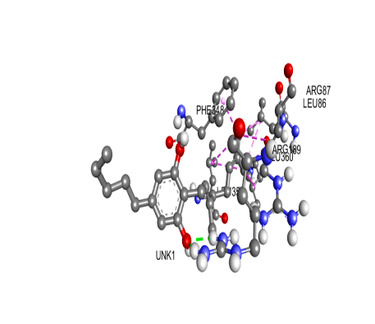 | 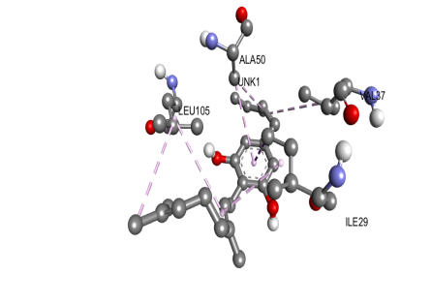 | 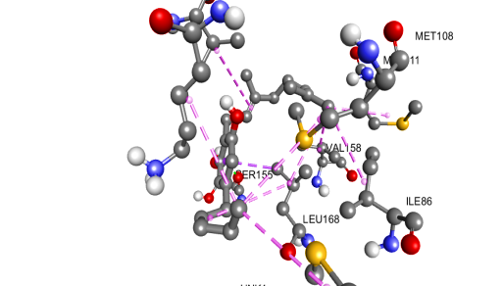  , | 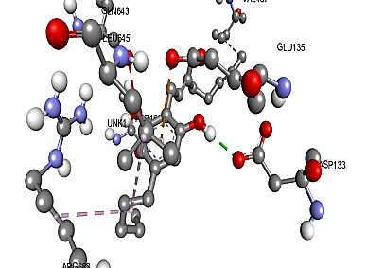 | 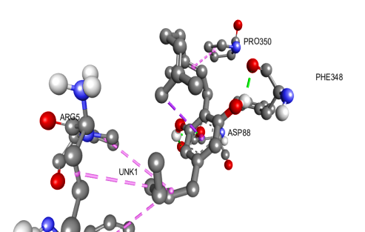
3 D Structure of Cannabidiol -vimentin interaction | 3 D Structure of Cannabidiol-E-cadherin interaction | 3 D Structure of cannabidiol-AKT interaction | 3 D Structure of cannabidiol -MEK interaction | 3 D Structure of cannabidiol -mTOR interaction
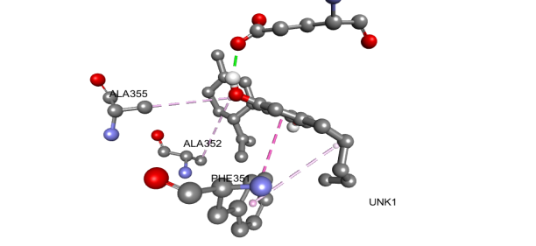 | 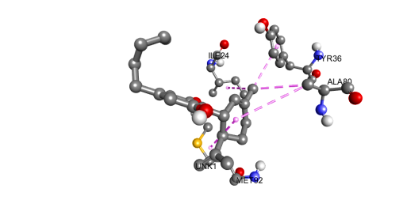 | 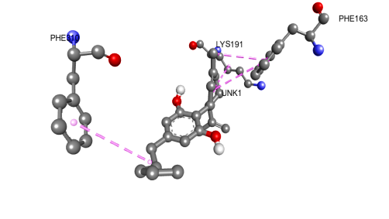 | 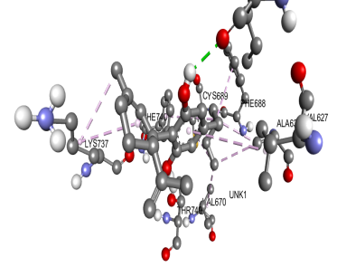 | 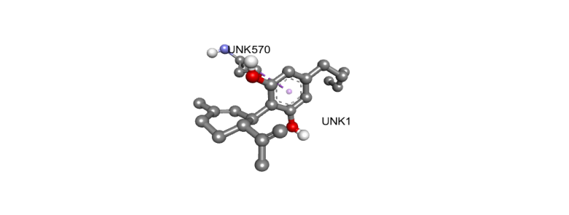
3 D Structure of Cannabidiol -ERK 1 interaction | 3 D Structure of Cannabidiol -ERK 2 interaction | 3 D Structure of Cannabidiol -JNK interaction | 3 D Structure of Cannabidiol -P13K interaction | 3 D Structure of Cannabidiol -P38 interaction
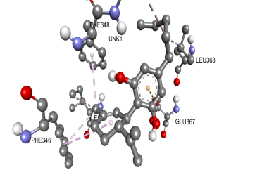 | 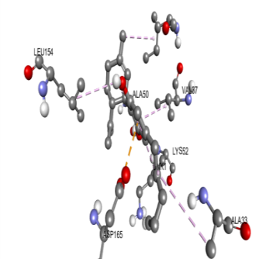 | 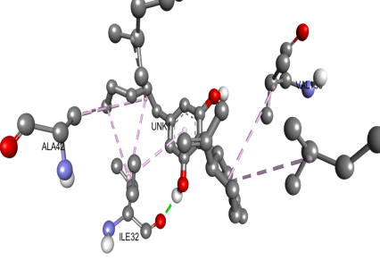 | 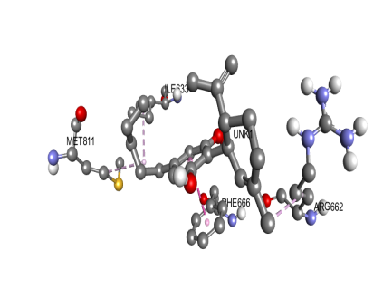 | 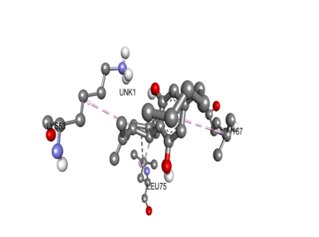

3 D Structure of Cannabichromene-vimentin interaction | 3 D Structure of Cannabichromene -E-cadherin interaction | 3 D Structure of Cannabichromene -AKT interaction | 3 D Structure of Cannabichromene -MEK interaction | 3 D Structure of Cannabichromene -mTOR interaction
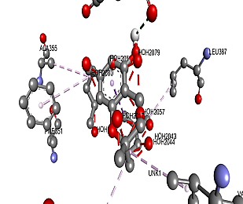 | 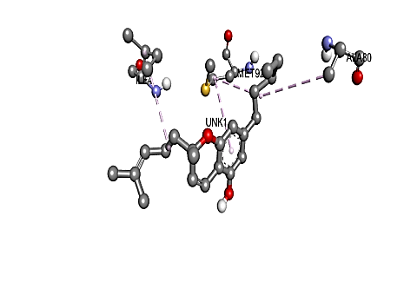 | 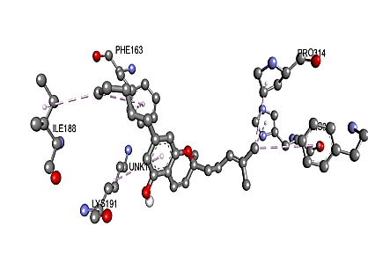 | 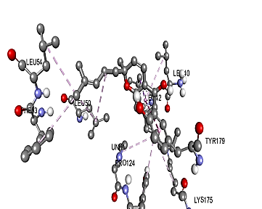 | 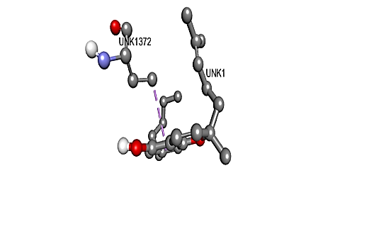
3 D Structure of Cannabichromene -ERK 1 interaction | 3 D Structure of Cannabichromene -ERK 2 interaction | 3 D Structure of Cannabichromene -JNK interaction | 3 D Structure of Cannabichromene -P13K interaction | 3 D Structure of Cannabichromene -P38 interaction
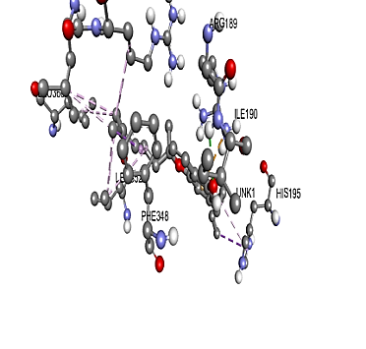 | 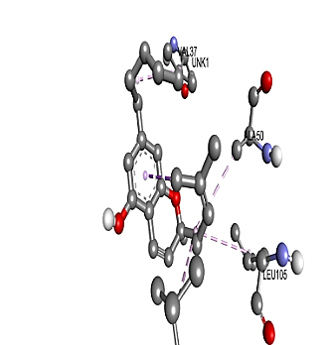 | 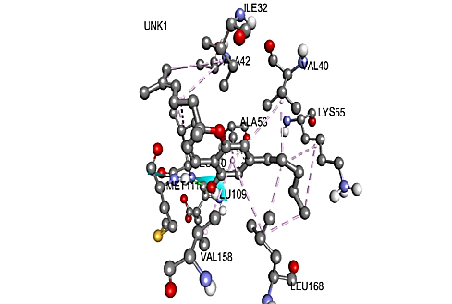 | 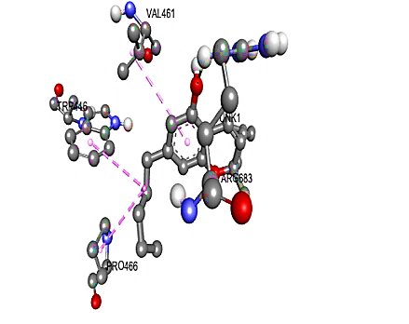 | 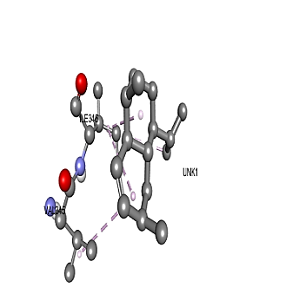

3 D Structure of Tetrahydrocannabinol-vimentin interaction | 3 D Structure of Tetrahydrocannabinol -E-cadherin interaction | 3 D Structure of Tetrahydrocannabinol -AKT interaction | 3 D Structure of Tetrahydrocannabinol -MEK interaction | 3 D Structure of Tetrahydrocannabinol -mTOR interaction
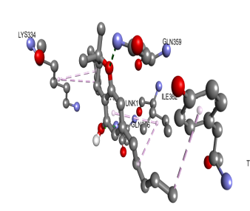 | 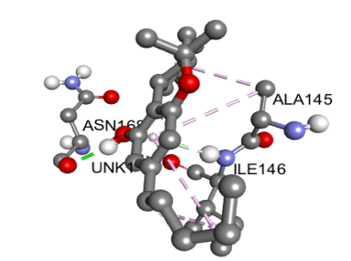 | 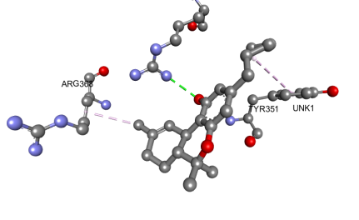 | 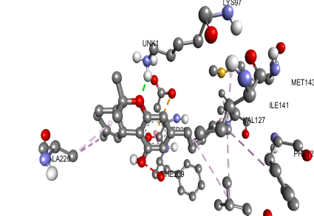 | 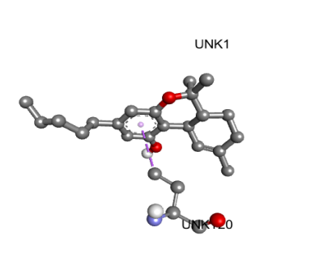
3 D Structure of Tetrahydrocannabinol -ERK 1 interaction | 3 D Structure of Tetrahydrocannabinol -ERK 2 interaction | 3 D Structure of Tetrahydrocannabinol -JNK interaction | 3 D Structure of Tetrahydrocannabinol -P13K interaction | 3 D Structure of Tetrahydrocannabinol -P38 interaction
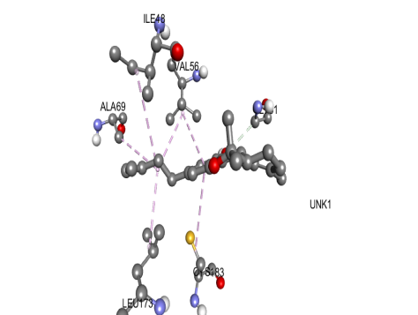 | 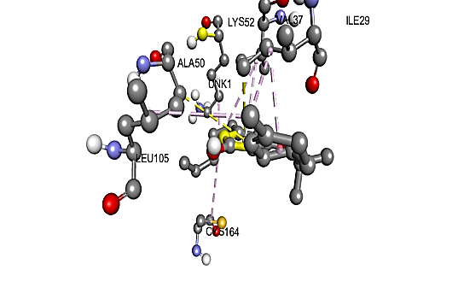 | 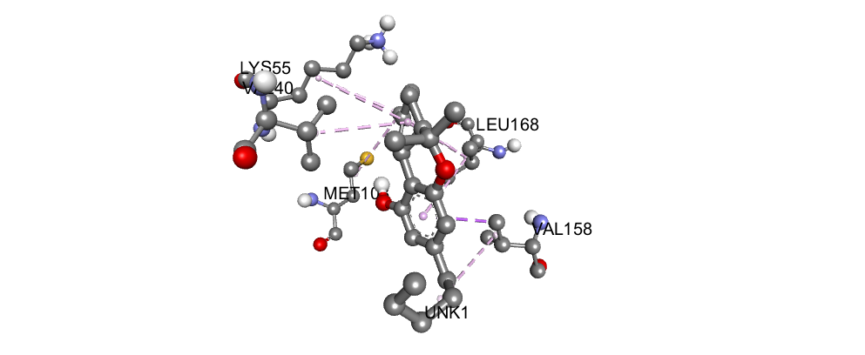 | 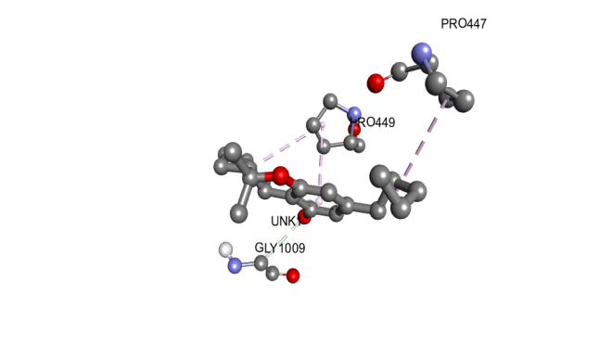 | 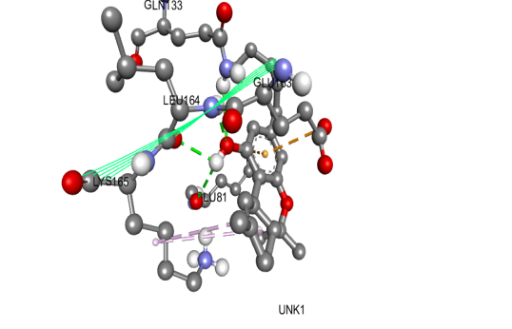

3 D Structure of Cannabinol -vimentin interaction | 3 D Structure of Cannabinol -E-cadherin interaction | 3 D Structure of Cannabinol -AKT interaction | 3 D Structure of Cannabinol -MEK interaction | 3 D Structure of Cannabinol -mTOR interaction
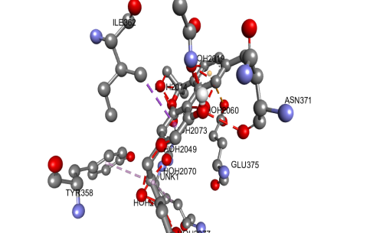 | 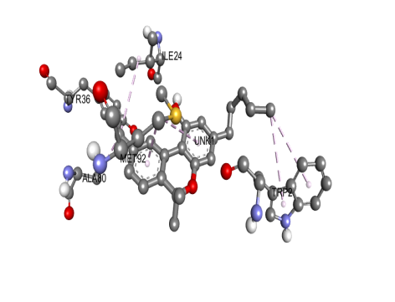 | 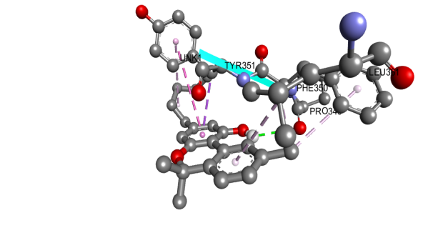 | 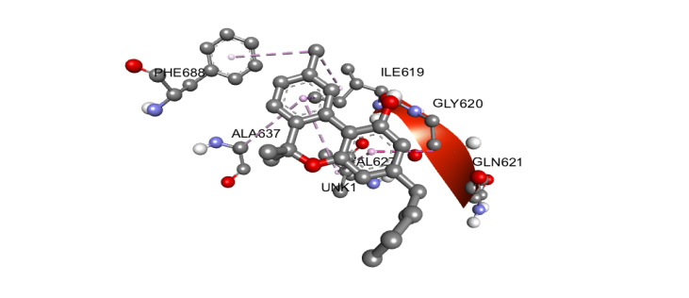 | 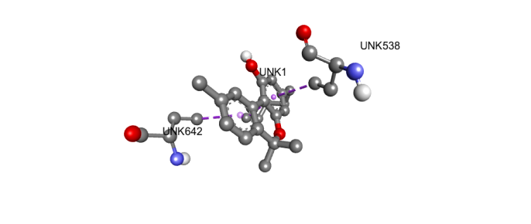
3 D Structure of Cannabinol -ERK 1 interaction | 3 D Structure of Cannabinol -ERK 2 interaction | 3D Structure of Cannabinol -JNK interaction | 3 D Structure of Tetrahydrocannabivarin-P13K interaction | 3 D Structure of Tetrahydrocannabivarin-P38 interaction
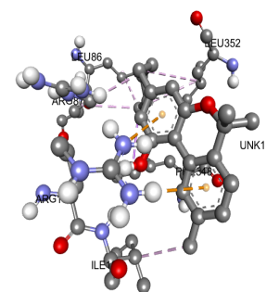 | 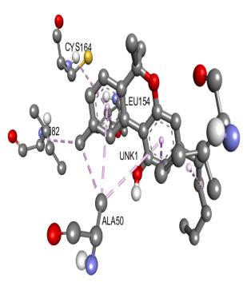 | 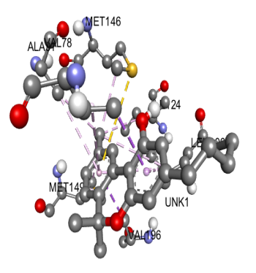 | 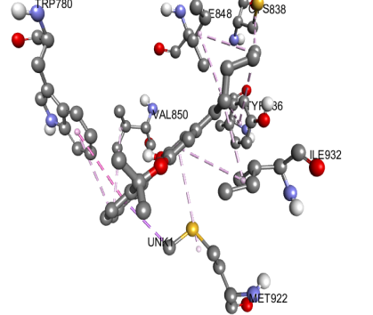 |   

