Supplementary Material
Mining the chemical diversity of the hemp seed (Cannabis sativa L.) metabolome: discovery of a new molecular family widely distributed across hemp

Guillermo Federico Padilla-González^{1*}, Abigail Rosselli¹, Nicholas J. Sadgrove^{1,2}, Max Cui¹, Monique S.J. Simmonds¹
¹Royal Botanic Gardens, Kew, London, United Kingdom.
²Department of Botany and Plant Biotechnology, University of Johannesburg (Auckland Park Campus), Auckland Park, 2006, Johannesburg, South Africa.

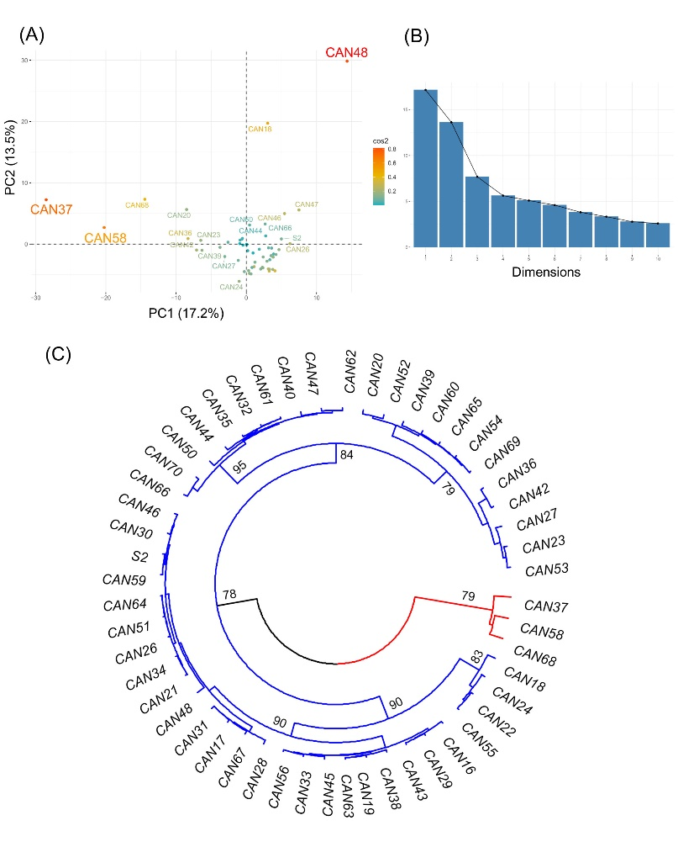
Supplementary Figure 1. Clustering of the fifty-two hemp seed accessions based on the similarities of their metabolic fingerprints detected by LC-MS in negative ion mode. (A) PCA scores plot showing accessions CAN48, CAN58 and CAN37 as outliers; (B) Scree plot and the percentage of variance explained by the first 10 components; (C) HCAbp showing the metabolic clustering of the 52 hemp seed accessions.
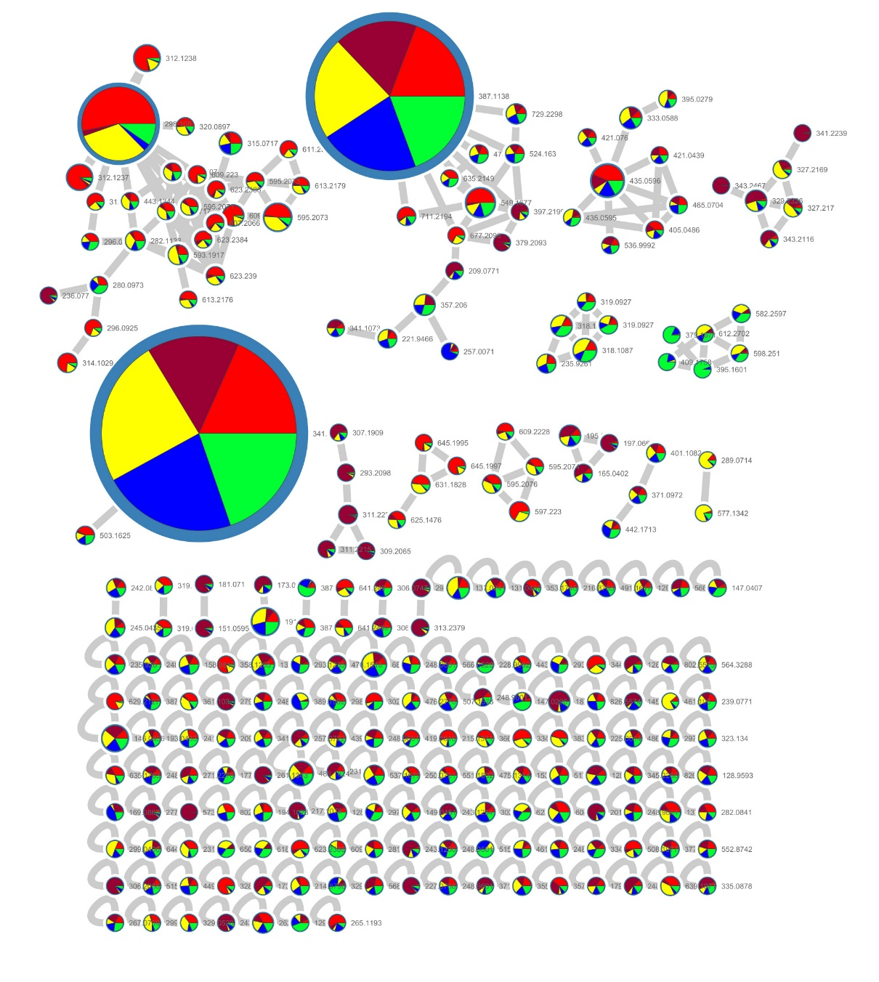
Supplementary Figure 2. Feature Based Molecular Networking (FBMN) of LC-MS data in the negative ionization mode.

