Supplementary Material:
In vitro metabolism of Δ⁸-, Δ⁹-, and Δ¹⁰-THC in human hepatocytes: distinct Δ¹⁰-THC biotransformation and implications for drug testing
Robert Kronstrand^{a,b}, Henrik Green^{a,b}, Markus Loh^{a,c}, Fabian Rüttimann^{a,c}, Manuela Carla Monti^{a,d}
ªDepartment of Biomedical and Clinical Science, Division of Clinical Chemistry and Pharmacology, Linköping University, Linköping, Sweden
^{b}Department of Forensic Genetics and Forensic Toxicology, National Board of Forensic Medicine, Linköping, Sweden
^{c}School of Life Sciences FHNW, University of Applied Sciences and Arts Northwestern Switzerland, Muttenz, Switzerland
^{d}Institute of Forensic Medicine, Department of Biomedical Engineering, University of Basel, Switzerland

*Corresponding author: manuela.monti@unibas.ch

Chapter 1: Mass spectrometer instrument settings p. 2
Chapter 2: MS2 spectra of ∆⁸-THC, ∆⁹-THC, and ∆¹⁰-THC p. 3
Chapter 3: MS2 spectra of metabolites of ∆⁸-THC p. 4-6
Chapter 4: MS2 spectra of metabolites of ∆⁹-THC p. 7-8
Chapter 5: MS2 spectra of metabolites of ∆¹⁰-THC p. 9
Chapter 6: OH-GLUC metabolites of ∆⁸-THC, ∆⁹-THC, and ∆¹⁰-THC p. 10
Chapter 7: Example chromatograms of authentic urine sample p. 11

  - Chapter 1: Mass spectrometer instrument settings
Table S1: Preferred Ion list.
m/z  [M+H]⁺ | Delta m/z (ppm) | Ret. Time (min) | Delta Ret. Time (min) | Collision Energy | Anticipated analyte | Formula
315.2319 | 20 | 6.21 | 0.5 | 20 | THC | C₂₁H₃₀O₂
345.206 | 20 | 4.69 | 0.5 | 20 | THC-COOH | C₂₁H₂₈O₄
331.2268 | 20 | 4.46 | 0.5 | 20 | 11-OH-THC | C₂₁H₃₀O₃
521.2381 | 20 | 2.83 | 0.5 | 20 | THCCOOH gluc | C₂₇H₃₆O₁₀
521.2381 | 20 | 3.08 | 0.5 | 20 | THCCOOH gluc | C₂₇H₃₆O₁₀
507.2589 | 20 | 2.76 | 0.5 | 20 | OH-THC gluc | C₂₇H₃₈O₉
491.2639 | 20 | 4.05 | 0.5 | 20 | THC gluc | C₂₇H₃₈O₈
523.2538 | 20 | 3.21 | 0.5 | 20 | DiOH THC gluc | C₂₇H₃₈O₁₀
347.2217 | 20 | 3.79 | 0.5 | 20 | DiOH | C₂₁H₃₀O₄
347.2217 | 20 | 4.78 | 0.5 | 20 | DiOH | C₂₁H₃₀O₄

  - Analytical method used for additional MS2 spectra
The hepatocyte samples were analyzed employing a complementary method to the one described in the main article. A 1290 Infinity ultra high-performance liquid chromatography (UHPLC) system coupled to a 6550 iFunnel Q quadrupole time-of-flight mass spectrometer (QToF-MS) by Agilent technologies (Sundbyberg, Sweden) was used. The HPLC system was equipped with the same column as described in the main article, namely, a Acquity HSS T3 column (150mm x 2.1mm, ID: 1.8µm) by Waters (Solna, Sweden).
Mobile phases consisted of 100% water with 0.5% formic acid (mobile phase A) and 100% methanol with 0.5% formic acid (mobile phase B). Chromatography was performed at 60 °C. An injection volume of 5 µL was used.
In Fig. S1 the gradient, mass acquisition, and source parameters are presented.
Fig. S1 Further details on the second analytical method.
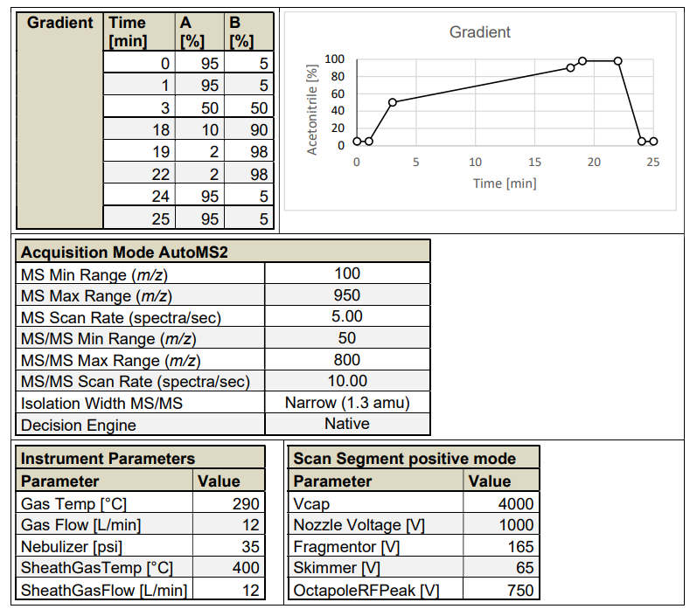

  - Chapter 2: MS2 spectra of ∆⁸-THC, ∆⁹-THC, and ∆¹⁰-THC
Fig. S2: ∆⁸-THC
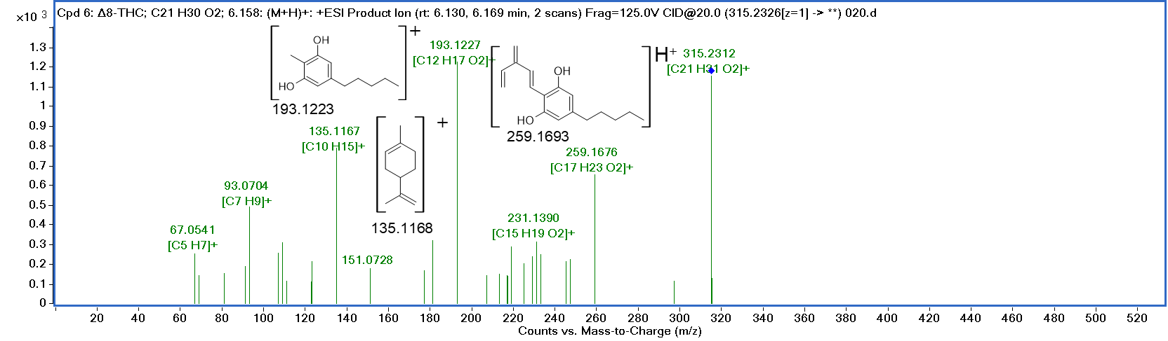
Fig. S3: ∆⁹-THC
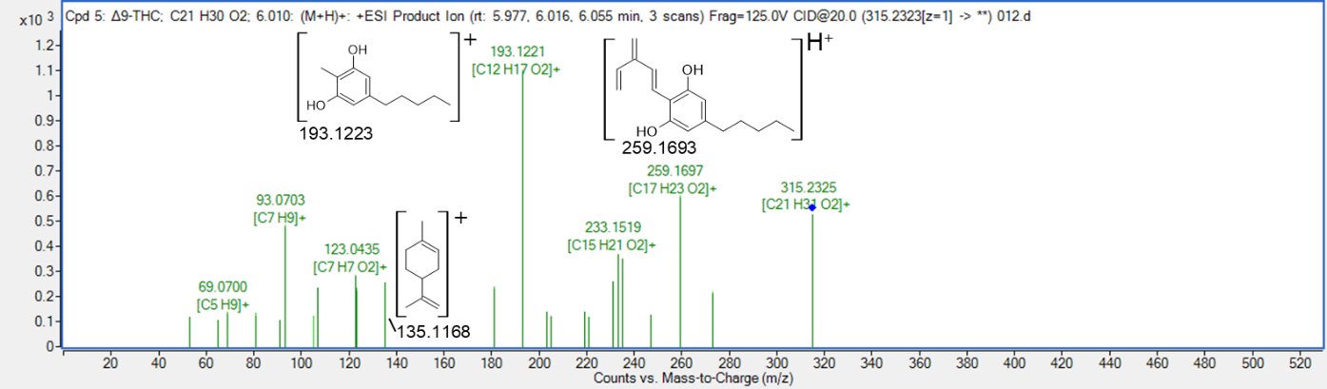
Fig. S4: ∆¹⁰-THC
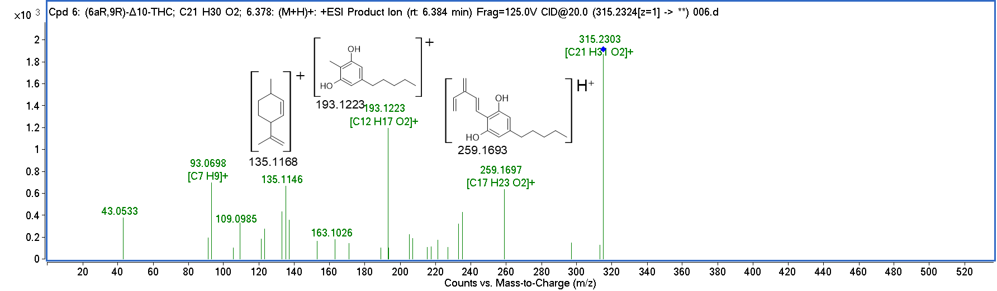

  - Chapter 3: MS2 spectra of metabolites of ∆⁸-THC
Fig. S5: ∆⁸-THC-OH
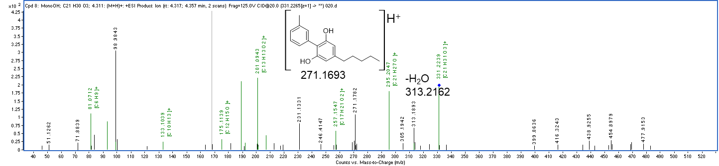
Fig. S6: ∆⁸-THC-OH-GLUC: a) zoomed in version also showing the ion at 299.1995 m/z, b) whole mass range
a)
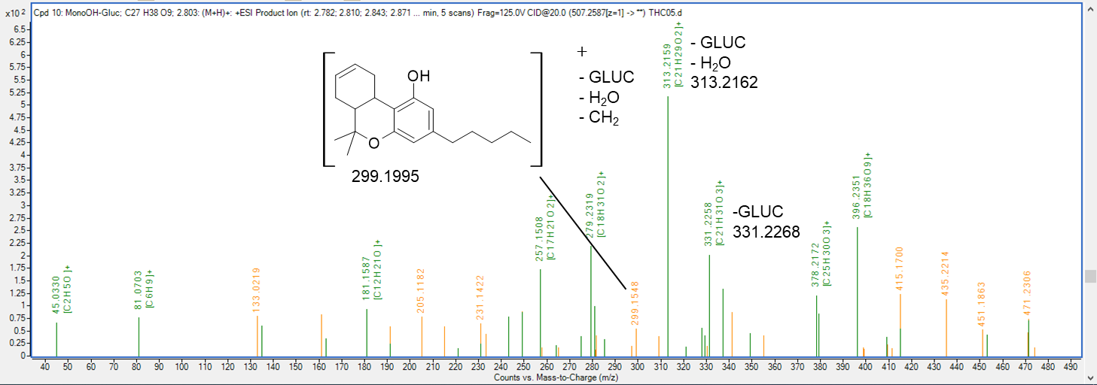

b)
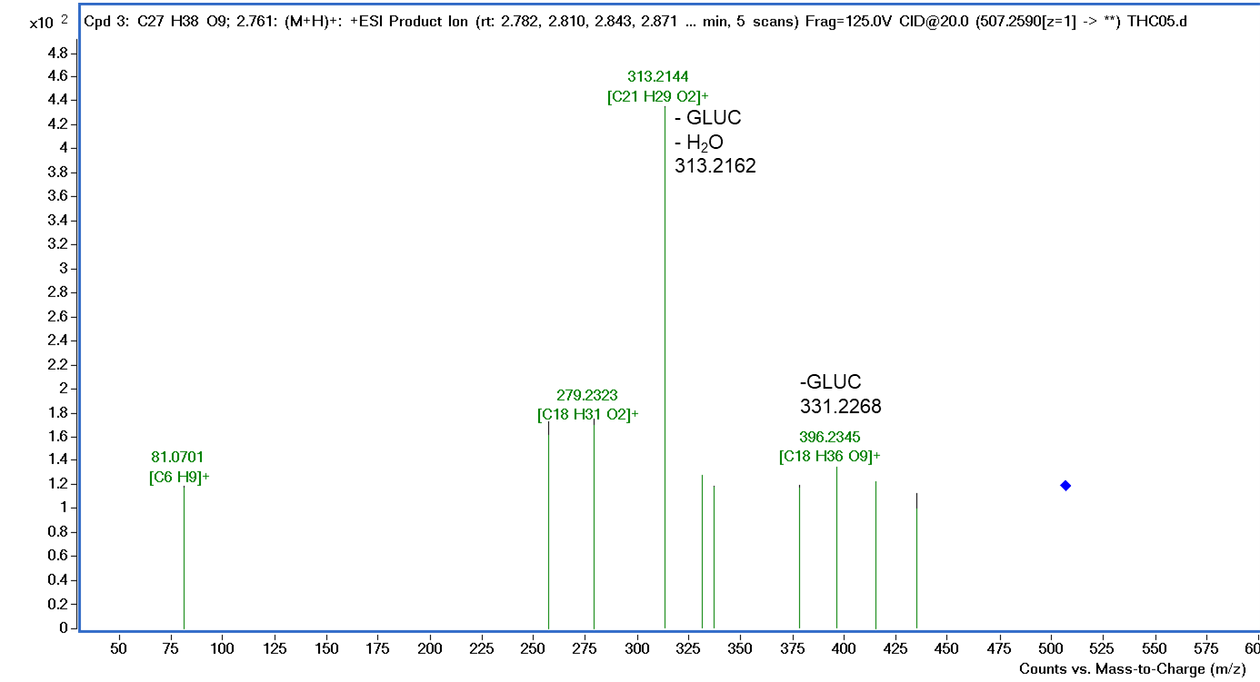
Fig. S7: ∆⁸-THC-COOH
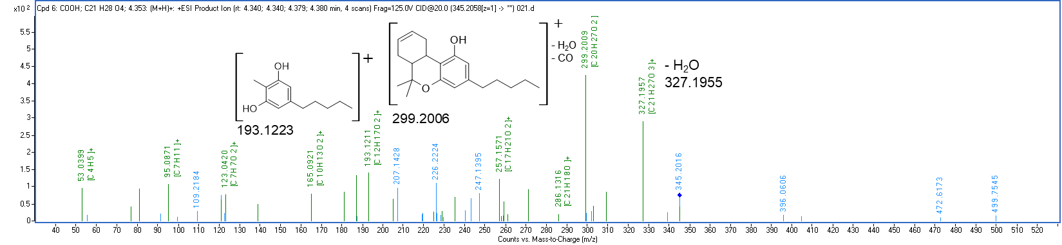

Fig. S8: ∆⁸-THC-COOH-GLUC
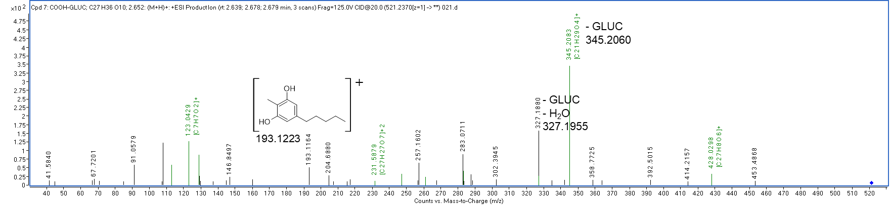
Fig. S9: ∆⁸-THC-DiOH-GLUC
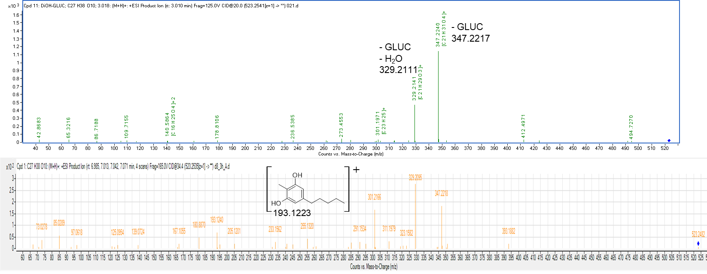
Note: The lower spectrum was obtained using the separate method described in supplementary material chapter 1.
  - Chapter 4: MS2 spectra of metabolites of ∆⁹-THC
Fig. S10: ∆⁹-THC-OH
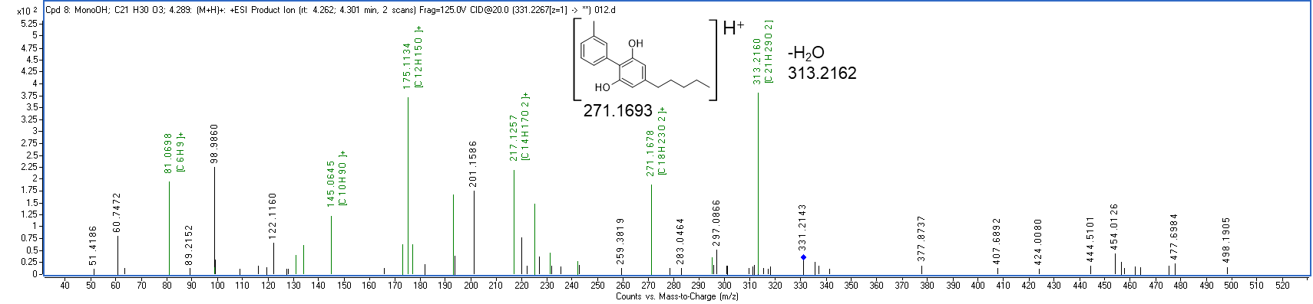

Fig. S11: ∆⁹-THC-OH-GLUC 1
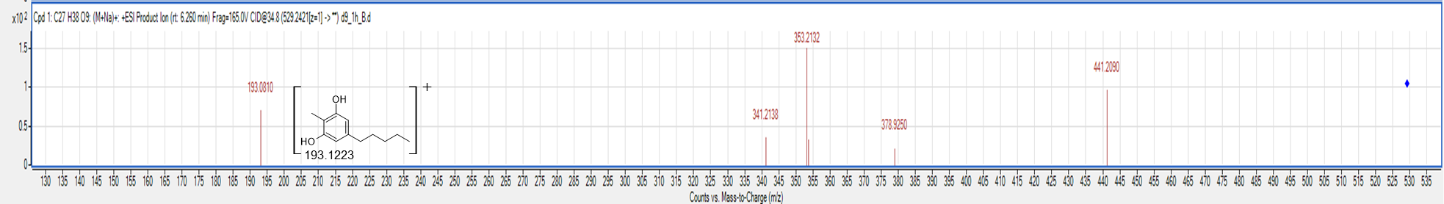
Note: Spectrum was obtained using the separate method described in supplementary material chapter 1.

Fig. S12: ∆⁹-THC-COOH
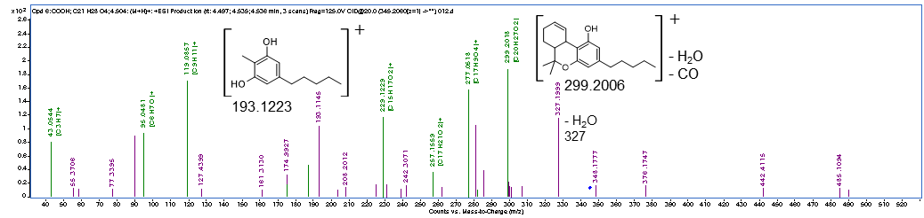
Fig. S13: ∆⁹-THC-COOH-GLUC

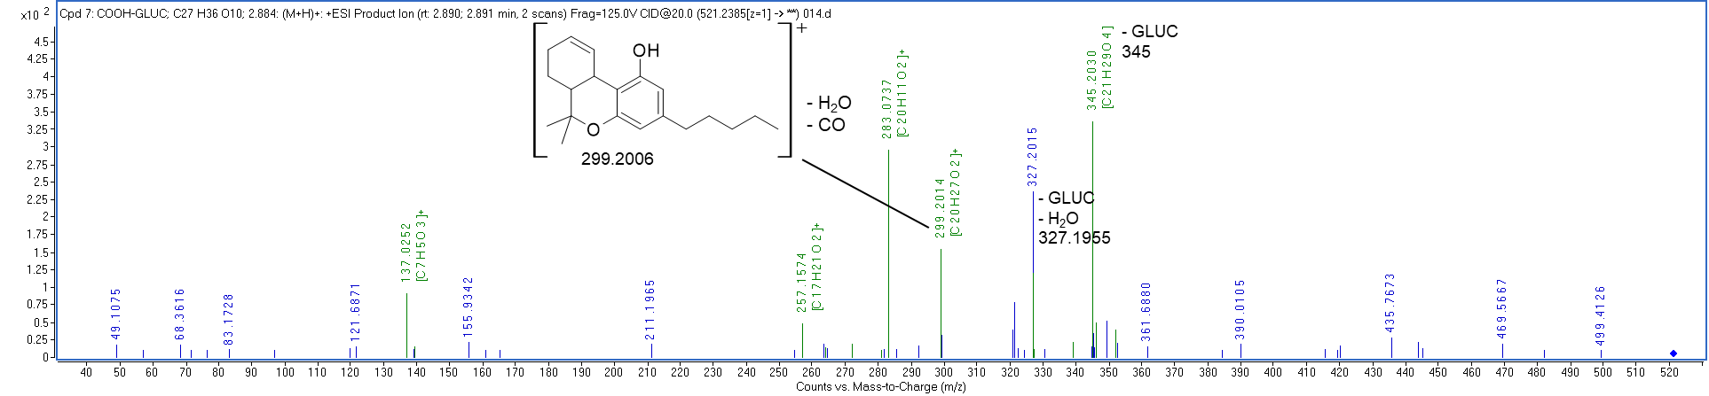

  - Chapter 5: MS2 spectra of metabolites of ∆¹⁰-THC
Fig. S14: ∆¹⁰-THC-GLUC
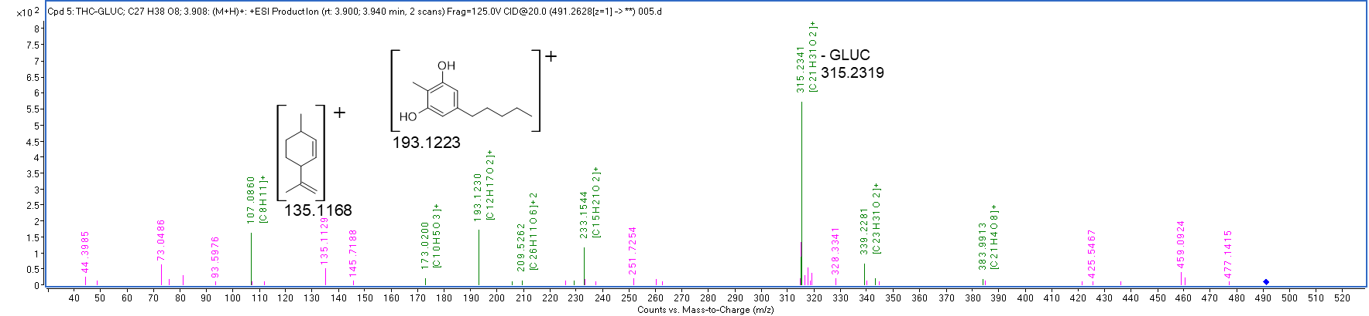
Fig. S15: ∆¹⁰-THC-OH-GLUC
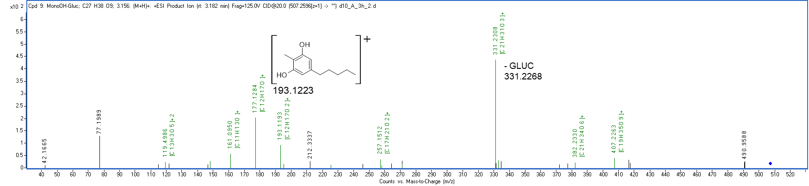
Fig. S16: ∆¹⁰-THC-COOH
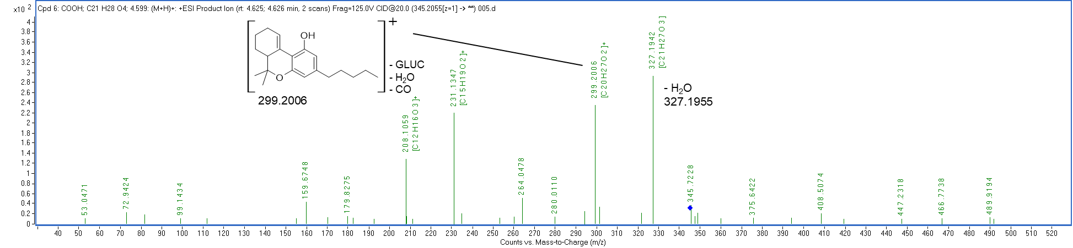
  - Chapter 6: OH-GLUC metabolites of ∆⁸-THC, ∆⁹-THC, and ∆¹⁰-THC
Fig. S17: Chromatograms showing the OH-GLUC metabolites for ∆⁸-THC, ∆⁹-THC, and ∆¹⁰-THC. Please note that the chromatograms are auto-scaled.
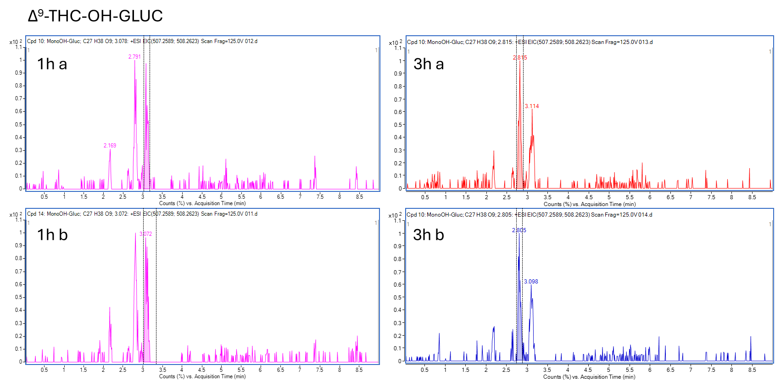
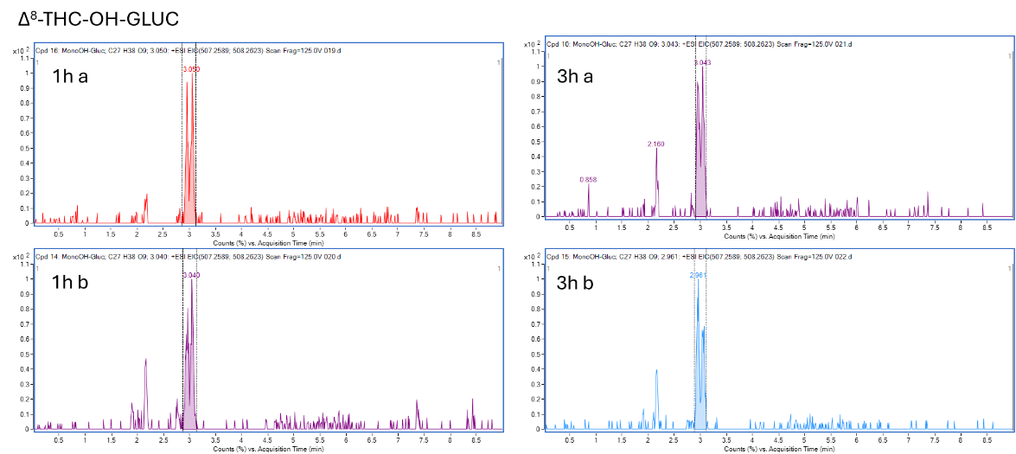
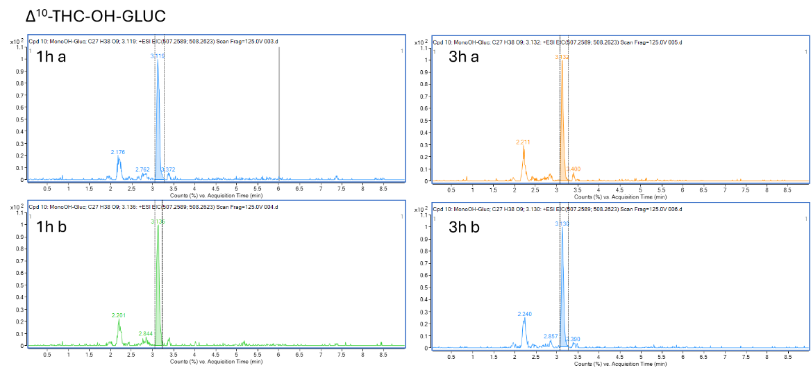
  - Chapter 7: Example chromatograms of authentic urine sample
Fig. S18: Chromatograms of an authentic urine sample.
∆⁹-THC (6.2 min)
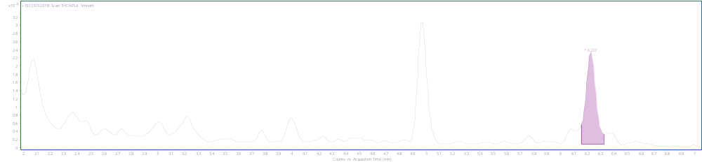
∆⁸-THC-OH (4.3 min) and ∆⁹-THC-OH (4.5 min)
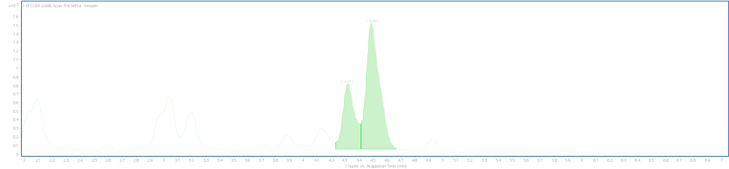
∆⁸-THC-COOH (4.6 min) and ∆⁹-THC-COOH (4.7 min)
