Figure 1. Medication Safety Incidents, 2020-2024, By Department
ADM, Administration; NNU, Neonatal Unit; O+G, Obstetrics and Gynaecology; Paed, Paediatrics.
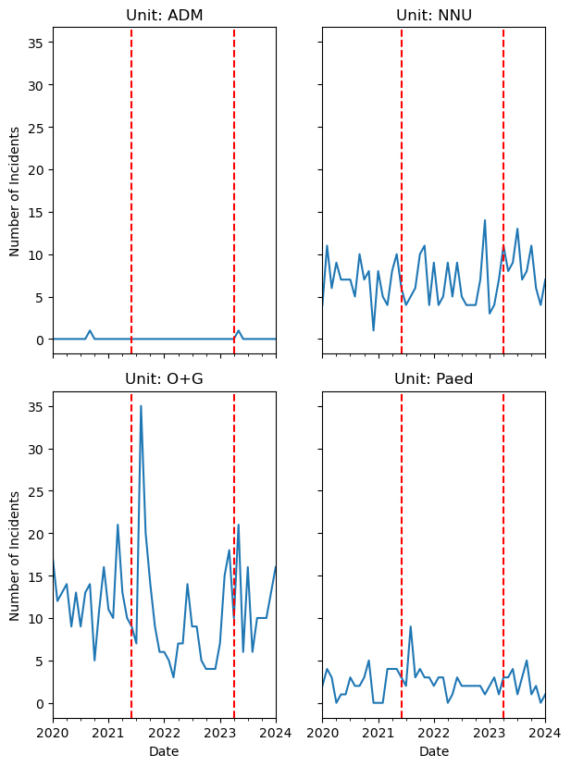
Figure 2. Medication Safety Incidents, 2020-2024, By Service Area
ADM, Administration; AN, Antenatal; BS, Birthing; CPS, Child Protection Services; MGP, Midwifery Group Practice; MOS, Midwifery Outreach; NNU, Neonatal Unit; PIP, Paediatric Inpatients; PN, Post-Natal and Gynaecology; POP, Paediatric Outpatients; WAS, Women’s Assessment Service; WHC, Women’s Health Clinic.
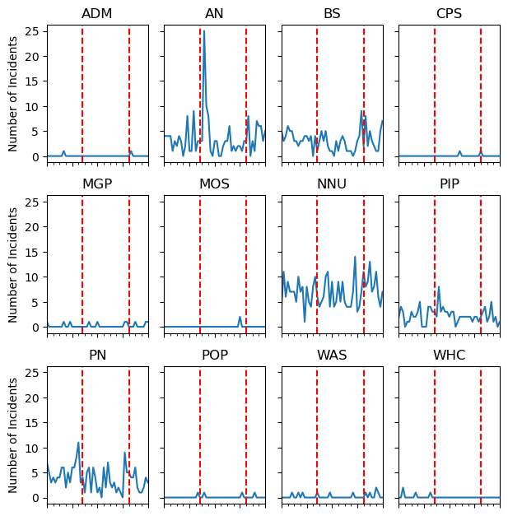

Figure 3. Medication Safety Incidents, 2020-2024, By Level 2 Incident Classification
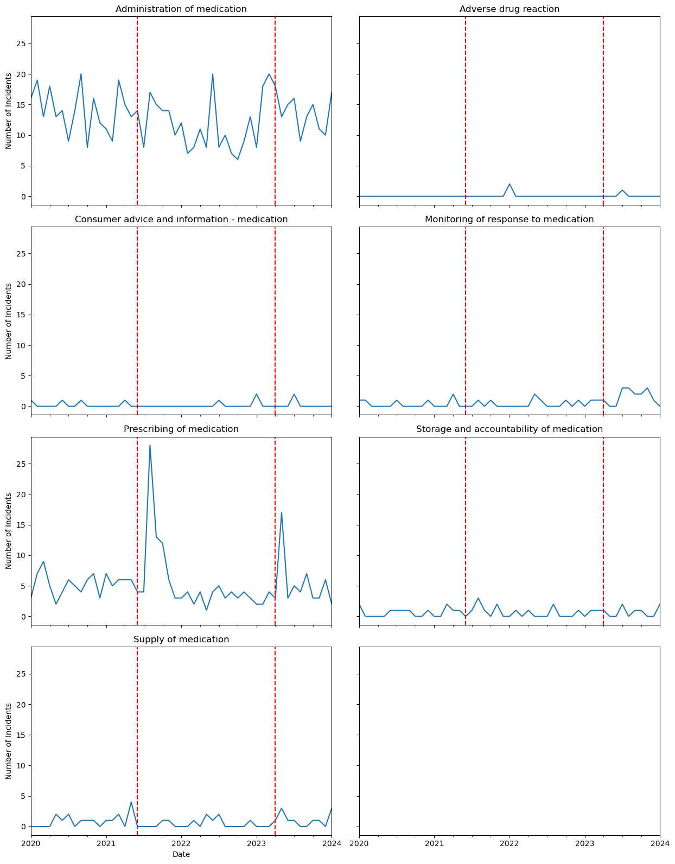

Figure 4. Medication Safety Incidents, 2020-2024, By Level 3 Incident Classification
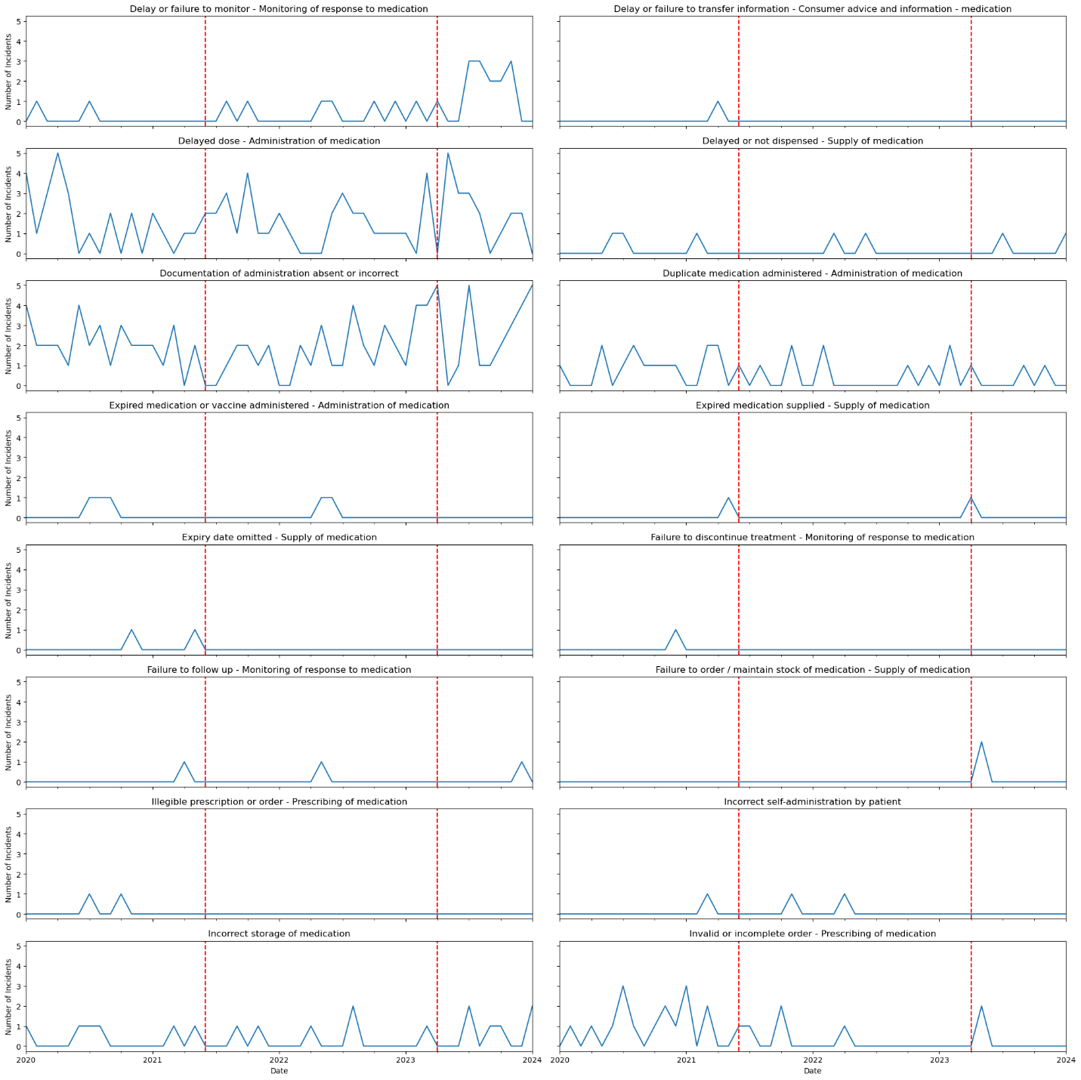

Figure 5. Medication Safety Incidents, 2020-2024, By ISR, Filtered with NLP
