Quantifying heteromer partitioning reveals inflammation-dependent redistribution of microglial adenosine A_{2A} and cannabinoid CB₂ receptors

Supplementary material
Supplementary material provides standard controls for PLA (omission of one primary antibody or one probe; non-transfected cells) and for MolBoolean™ (omission of individual primary antibodies or probes), supporting signal specificity (Supplementary Figures S1 and S2). In addition, microglial activation induced the expected morphological changes, quantified using Iba1-based shape metrics (Supplementary Figure S3), validating the activated model and reinforcing the reliability of the MolBoolean/PLA-derived data and comparisons.
Supplementary Figure S1. Controls of the Proximity Ligation Assays (PLA). Nuclei were stained with Hoechst 33342 (blue). In A-B, HEK-293T cells co-transfected with plasmids encoding for A_{2A}R and for CB₂R. The assay was performed omitting one primary antibody (A) or one of the PLA probes (B). In (C) images from PLA assay performed in non-transfected HEK-293T cells incubated with both primary antibodies and PLA probes. In all panels representative confocal microscopy images are shown.
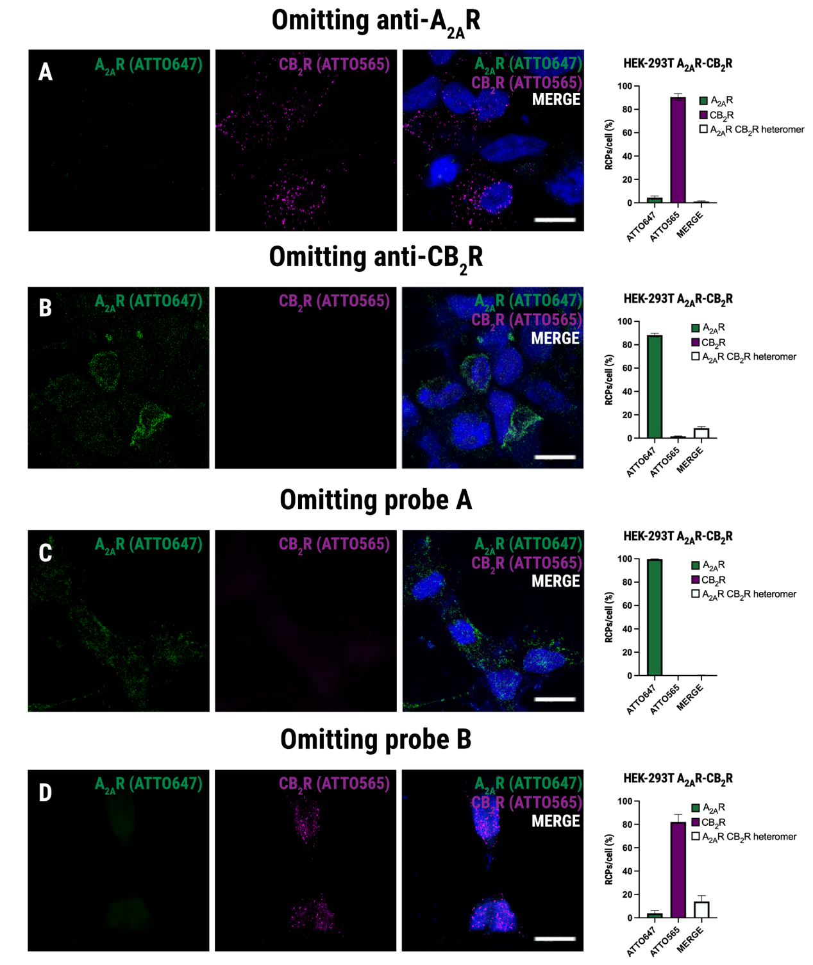
Supplementary Figure S2. MolBoolean™ assay specificity. MolBoolean™ assays were performed in HEK-293T cells co-expressing A_{2A} and CB₂ receptors to assess the specificity of the primary antibodies, and of MolBoolean™ probes. Controls were performed by omitting primary anti-A_{2A}R (A) or anti-CB₂R (B) antibodies or omitting the MolBoolean™ A (C) or B (D) probes. The figure shows representative confocal microscopy images, and the quantification bar graphs (relative distribution of RCPs per cell), green corresponds to A_{2A}R (ATTO647), magenta to CB₂R (ATTO565), and white to A2AR–CB2R heteromers (Merge). Nuclei were stained with Hoechst 33342 (blue). Scale bar = 20 µm. Bars represent mean ± SEM. Data represents analysis from multiple cell images across n=3 independent experiments.
Supplementary figure S3. Morphological changes indicative of microglial activation. Primary microglial cells were treated for 48 hours with vehicle (Control) or with LPS (100 ng/mL) plus IFN-γ (20 ng/mL). Cells were then fixed and stained with Alexa fluor 488-conjugated anti-Iba1 antibody. A) Schematic representation of the morphological parameters quantified. Cell solidity is calculated as the ratio of the cell area to its convex hull area; perimeter and soma area are also measured. Representative confocal microscopy images of Iba1-stained microglia (cyan) in Control (B) and LPS + IFN-γ (C) conditions. Insets show zoomed cells, and right panels display the corresponding processed outlines used for morphological analysis. Scale bar = 20 µm. Box and whisker plots show quantification of morphological parameters: cell solidity (D), perimeter (E), and soma area (F) for control versus activated microglia **p<0.01, ***p<0.001 (Unpaired t-test). Data represent analysis from multiple cell images across n=3 independent experiments.

