Cannabidiol suppresses emergency MDSCs generation by disturbing EEF1B2 mediated C/EBPβ protein synthesis in colorectal adenomas

Authors: Jie Pan^{1,2#}, Lixin Zhao^{1,3#}, Haojie Du¹, Yuyu Zhu¹, Xiaofan Sun¹, Qiang Xu¹, Haibo Cheng⁴*, Hongqi Chen⁵*, Yang Sun^{1,3}*.
#These authors contributed equally to the work.
* Corresponding to
Yang Sun, Ph.D., Professor
School of Life Sciences, Nanjing University, Nanjing 210023 China;
Hongqi Chen, Ph.D.
Shanghai JiaoTong University Affiliated Sixth People’s Hospital, Shanghai 200233, China;
Haibo Cheng, Ph.D., Professor
Nanjing University of Chinese Medicine, Nanjing 210006 China;

Email: yangsun@nju.edu.cn (Y. Sun) or chen_hongqi06@sjtu.edu.cn (H. Chen) or haibocheng@njucm.edu.cn (H. Cheng)
Supplementary Materials includes:
Supplementary Materials and Methods
Fig. S1 to S17 and corresponding supplementary figure legends.
Table S1 to Table S2
Other Supplementary Data for this manuscript include the following:
Data files S1 to S2 (Excel files)

Supplementary Materials and Methods
Cell-Cell Communication between T Cell Subsets and Myeloid-Derived Suppressor Cells
Cell-cell communication analysis was performed using CellChat (v1.6.1) and CellphoneDB (v2.1.1). Both tools were applied to the single-cell RNA sequencing data to infer interaction strengths between T cell subsets and myeloid-derived suppressor cells (G-MDSC and M-MDSC), based on the expression levels of ligand-receptor pairs. In the CellChat workflow, a CellChat object was created from the gene expression matrix, followed by the identification of over-expressed ligands/receptors and their interactions. The “computeCommunProbfunction” was applied to estimate communication probabilities, and results were visualized to highlight key signaling events. For CellphoneDB, statistical analysis was conducted using the raw count matrix and corresponding cell annotations. The output was used to quantify interaction frequency and strength between cell types. Selected ligand-receptor pairs were visualized using the Circlize and pheatmap packages. Both methods were employed in parallel to ensure robust identification of communication pathways between the cell populations of interest.
Pseudotime Analysis
Pseudotime analysis was conducted using Monocle2 v2.30.1 (RRID:SCR_016339) to assess state transitions in neutrophils. The UMI count matrix, along with gene and cell annotations from Seurat, was used to construct a CellDataSet. Variable genes among neutrophil subsets were applied for cell sorting in pseudotime using the DDRTree and orderCells functions. Marker genes for PMN-MDSC, and Eef1b2 gene expression were analyzed along the pseudotime trajectory.
Immunohistochemistry staining
The paraffin embedded tissues were cut into 4-μm-thick sections. The tissue sections were heated and soaked in dimethylbenzene to remove paraffin and rehydration. Then performed antigen retrieval with sodium citrate solution. Next, the tissues were permeabilized with 0.5% Triton 100 for 15 min and blocked with goat serum for 1 h and incubated overnight at 4 °C with primary antibodies (Supplemental Table S1). For immunofluorescence staining, after washing 3 times in PBST, the tissue sections were incubated for 1 h at room temperature with the fluorescent secondary antibodies (Supplemental Table S1). The nuclei were stained with 4′,6-diamidino-2-phenylindole (DAPI) for 10 min. The immunofluorescence images were acquired using Olympus VS200 or a confocal microscope (Zeiss LSM 880 with Airyscan).

SUPPLEMENTARY FIGURES
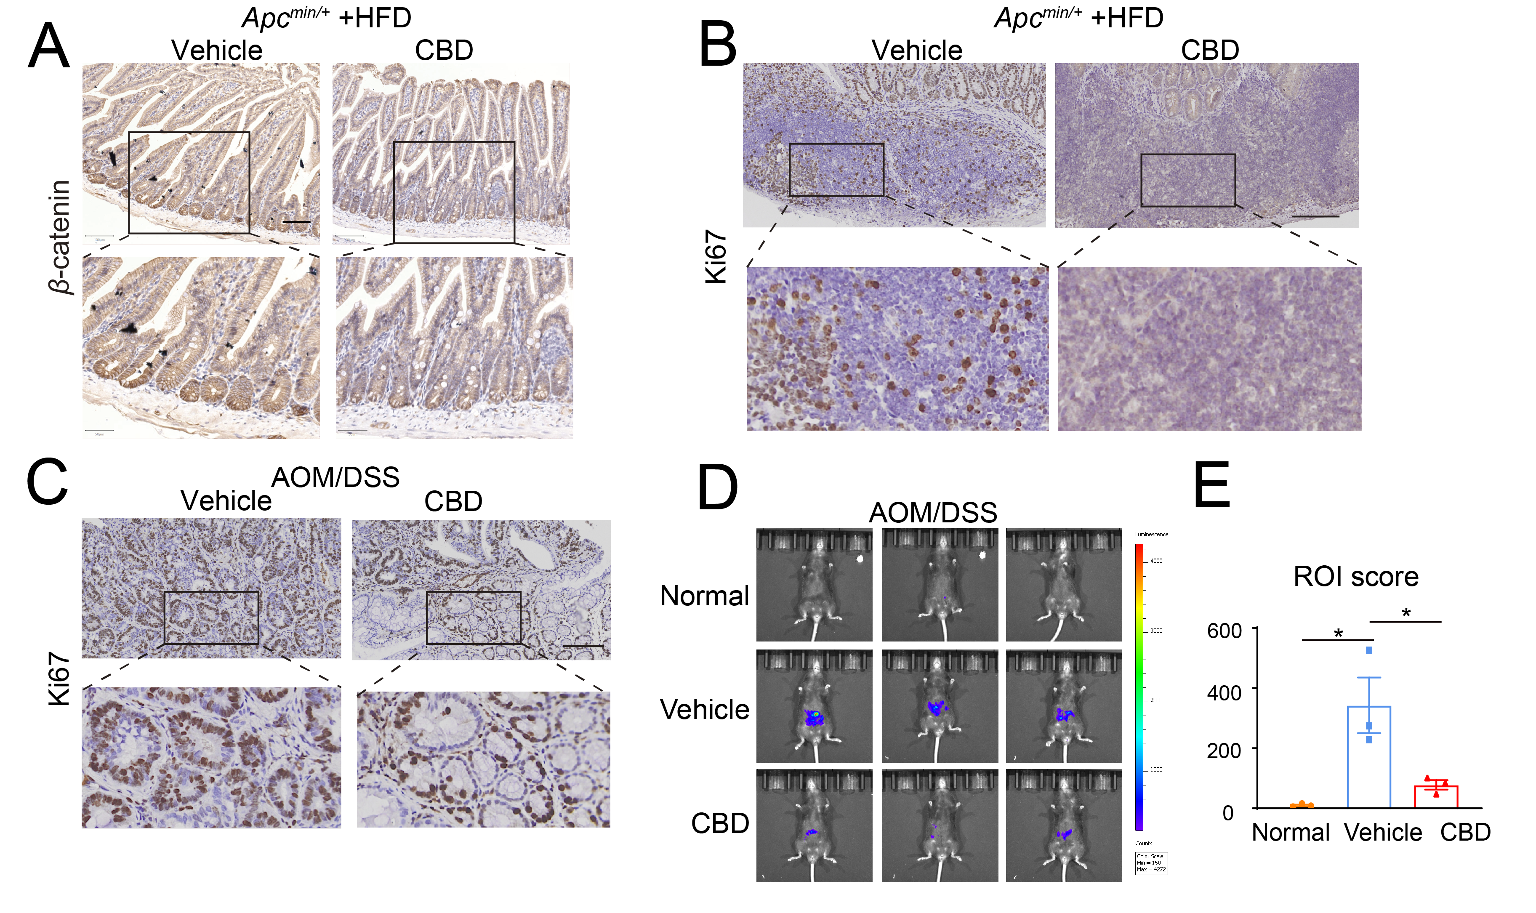
Fig. S1 CBD alleviated the protein expression associated with colon adenomas and intestine inflammation, related to Figure 1.
(A) Representative images of β-catenin expression in colon adenomas detected by IHC staining (n=5). Scale bar, 100 μm. (B) Representative images of Ki67 expression in colon adenomas of Apc^{min/+}+HFD induced colon adenomas model detected by IHC staining (n=5). Scale bar, 100 μm. (C) Representative images of Ki67 expression in colon adenomas of AOM/DSS induced colon adenomas model detected by IHC staining (n=5). Scale bar, 100 μm. (D) Representative images of ROS detection in mice (n=3). (E) The statistical analysis of ROS score in different groups. *P < 0.05. P values were calculated by one-way ANOVA with Tukey’s multiple comparisons test.

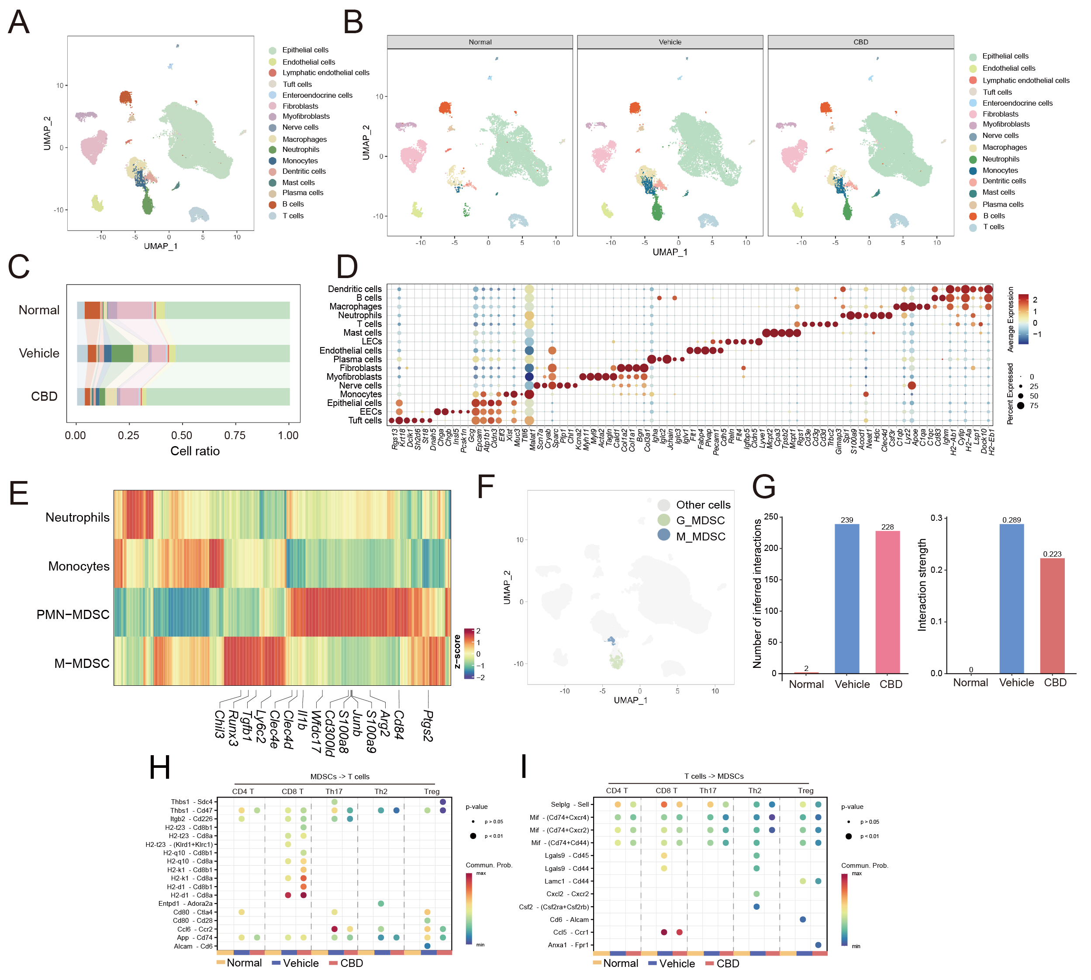

Fig. S2 Identification of different cell clusters by scRNA-Seq, related to Figure 2.
(A) UMAP plot displaying a map of all cells, consisting of 16 annotated cell types. (B) UMAP plots showing cell maps for each group individually (Normal, Vehicle, CBD). (C) Bar chart showing the proportion of the 16 annotated cell types across the three groups. (D) Dot plot illustrating representative marker genes across cell clusters. Dot size indicates the fraction of cells expressing specific genes, while color intensity reflects the relative expression level of these genes. (E) Heatmap showing the scaled expression patterns of top marker genes within each G-MDSC and M-MDSC cluster compared to normal neutrophil and monocyte clusters. (F) UMAP plot displaying the distribution of MDSC clusters. (G) The total number and strength of interaction ligands and receptors between MDSCs and T cells. (H) Detailed interactions of ligands from MDSCs to receptors on different subsets of T cells. (I) Detailed interactions of ligands from different subsets of T cells to receptors on MDSCs.

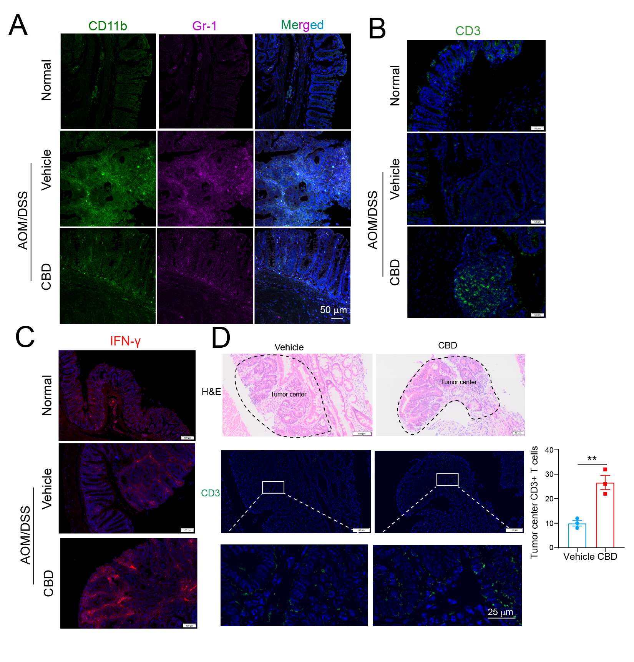
Fig. S3 MDSC, T cell infiltration and IFN-γ expression in colon tissue, related to Figure 3.
(A) Representative images depicting the MDSCs (CD11b⁺Gr-1⁺) number in colon tissue from different groups (n=5). Scale bar, 50 μm. (B) Representative images depicting the T cell (CD3⁺) number in colon tissue from different groups (n=5). Scale bar, 50 μm. (C) Representative images depicting the IFN-γ expression in colon tissue from different groups (n=5). Scale bar, 100 μm. (D) Tumor border line annotated in H&E image in HFD-induced colon adenomas of APC^{min/+} mice and fluorescent image of CD3⁺ T cells infiltrated into tumor center compared to tumor margin (Left). Statistical analysis of infiltrated T cells in tumor center (n=3). Scale bar, 100 μm and 25 μm in the enlarged fluorescent images. **P < 0.01. P values were calculated by two-tailed Student’s t test.

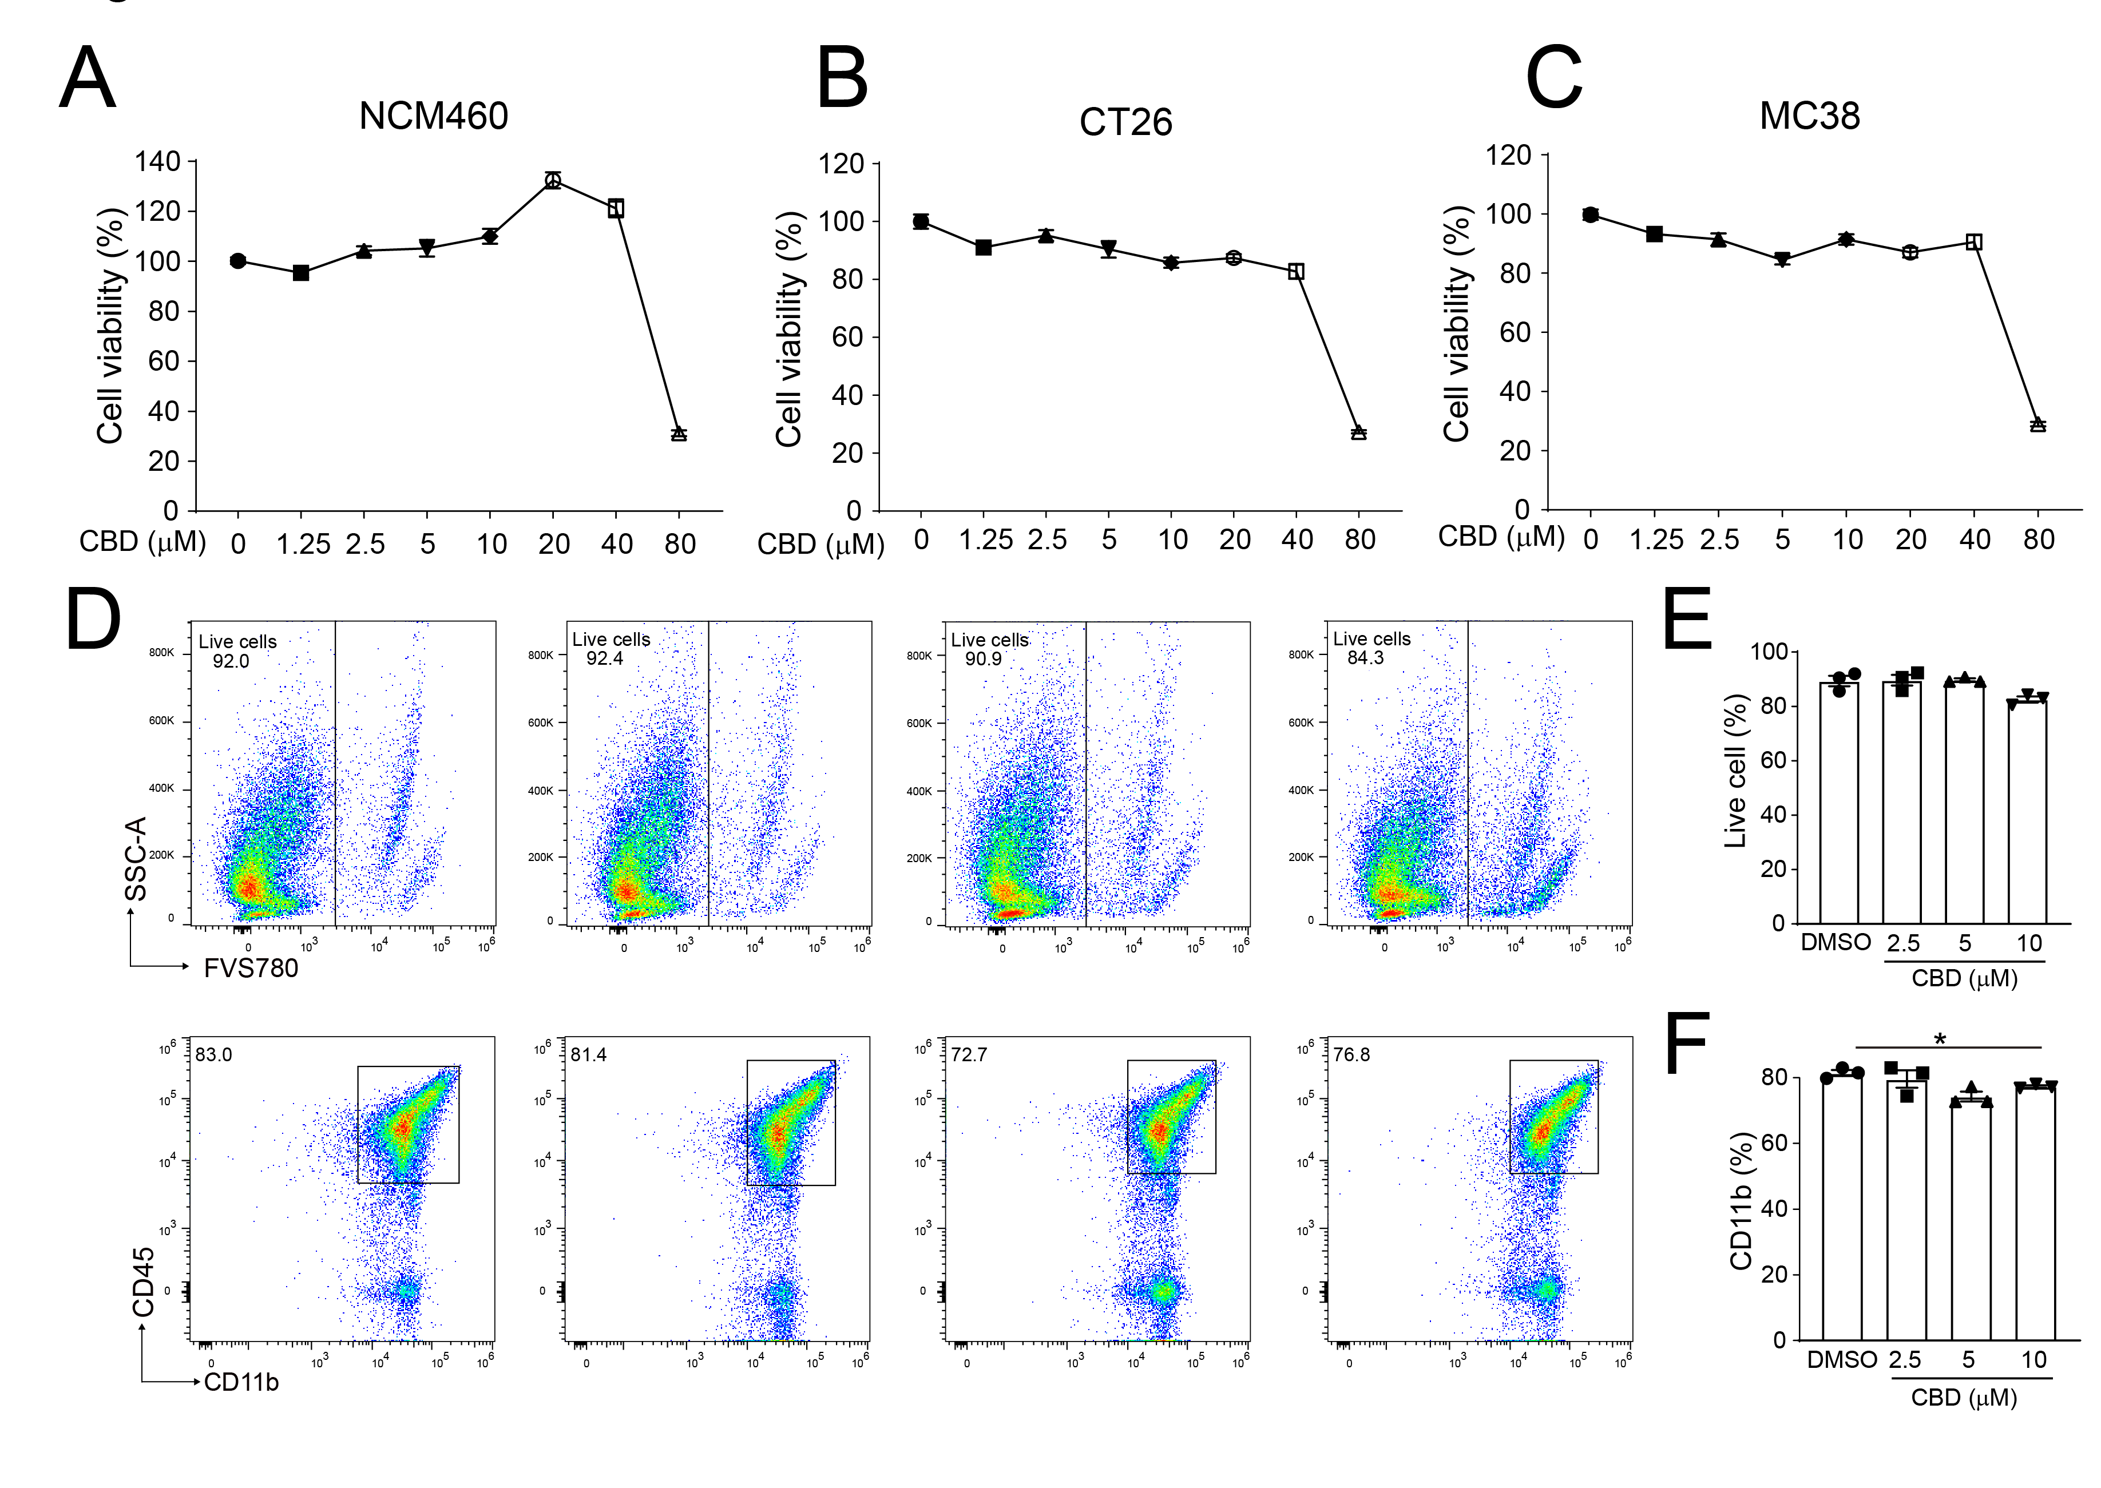
Fig. S4 CBD used in this study has no effect on the cell viability on colon epithelial cells and bone marrow derived MDSCs, related to Figure 3.
(A-C) Cell viability of normal colon epithelial cell NCM460 (A), colorectal cancer cells CT26 (B) and MC38 (C) after different doses of CBD treatment for 24 h detected by CCK8 assay. (D-F) The FACS dot plot of live cells and CD45⁺CD11b⁺ cells in bone marrow derived MDSCs after different doses of CBD treatment for 24 h (D). The statistical analysis of live cells (E) and CD11b⁺ myeloid cells (F). *P < 0.05. P values were calculated by one-way ANOVA with Tukey’s multiple comparisons test.
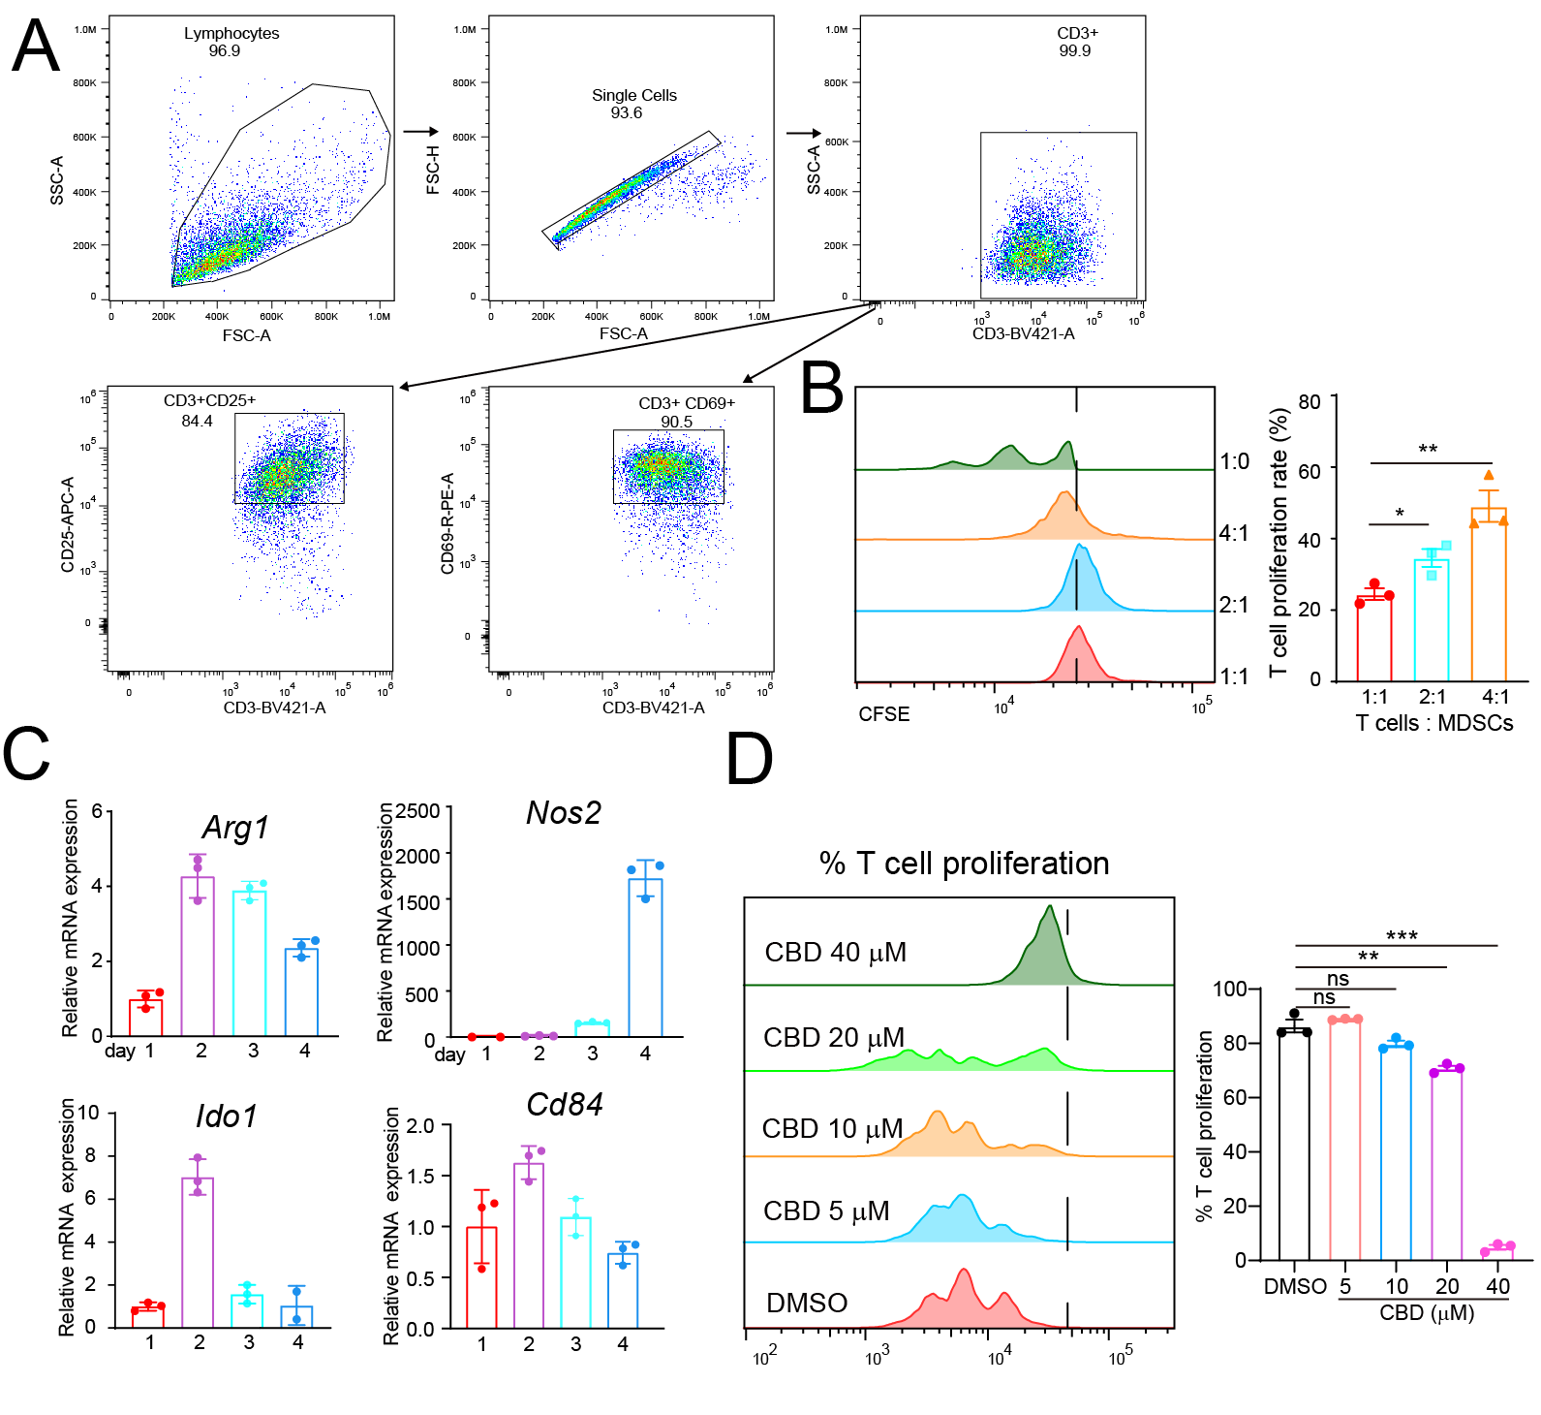

Fig. S5 Identification of immunosuppressive activity of bone marrow derived MDSCs, related to Figure 3.
(A) The FACS plot showed that spleen separated T cells were completely activated by anti-CD3 and anti-CD28 antibody stimulation supplementary with IL-2 (10 ng/mL). (B) Bone marrow derived MDSCs inhibited T cell activation as showed by the CFSE dilution (n=3). (C) The function gene expression in MDSCs increased with the induction time. (D) Direct effect of CBD on T cell proliferation detected by CFSE dilution (n=3). *P < 0.05, **P < 0.01, ***P < 0.001, ns represented not significant. P values were calculated by one-way ANOVA with Tukey’s multiple comparisons test.

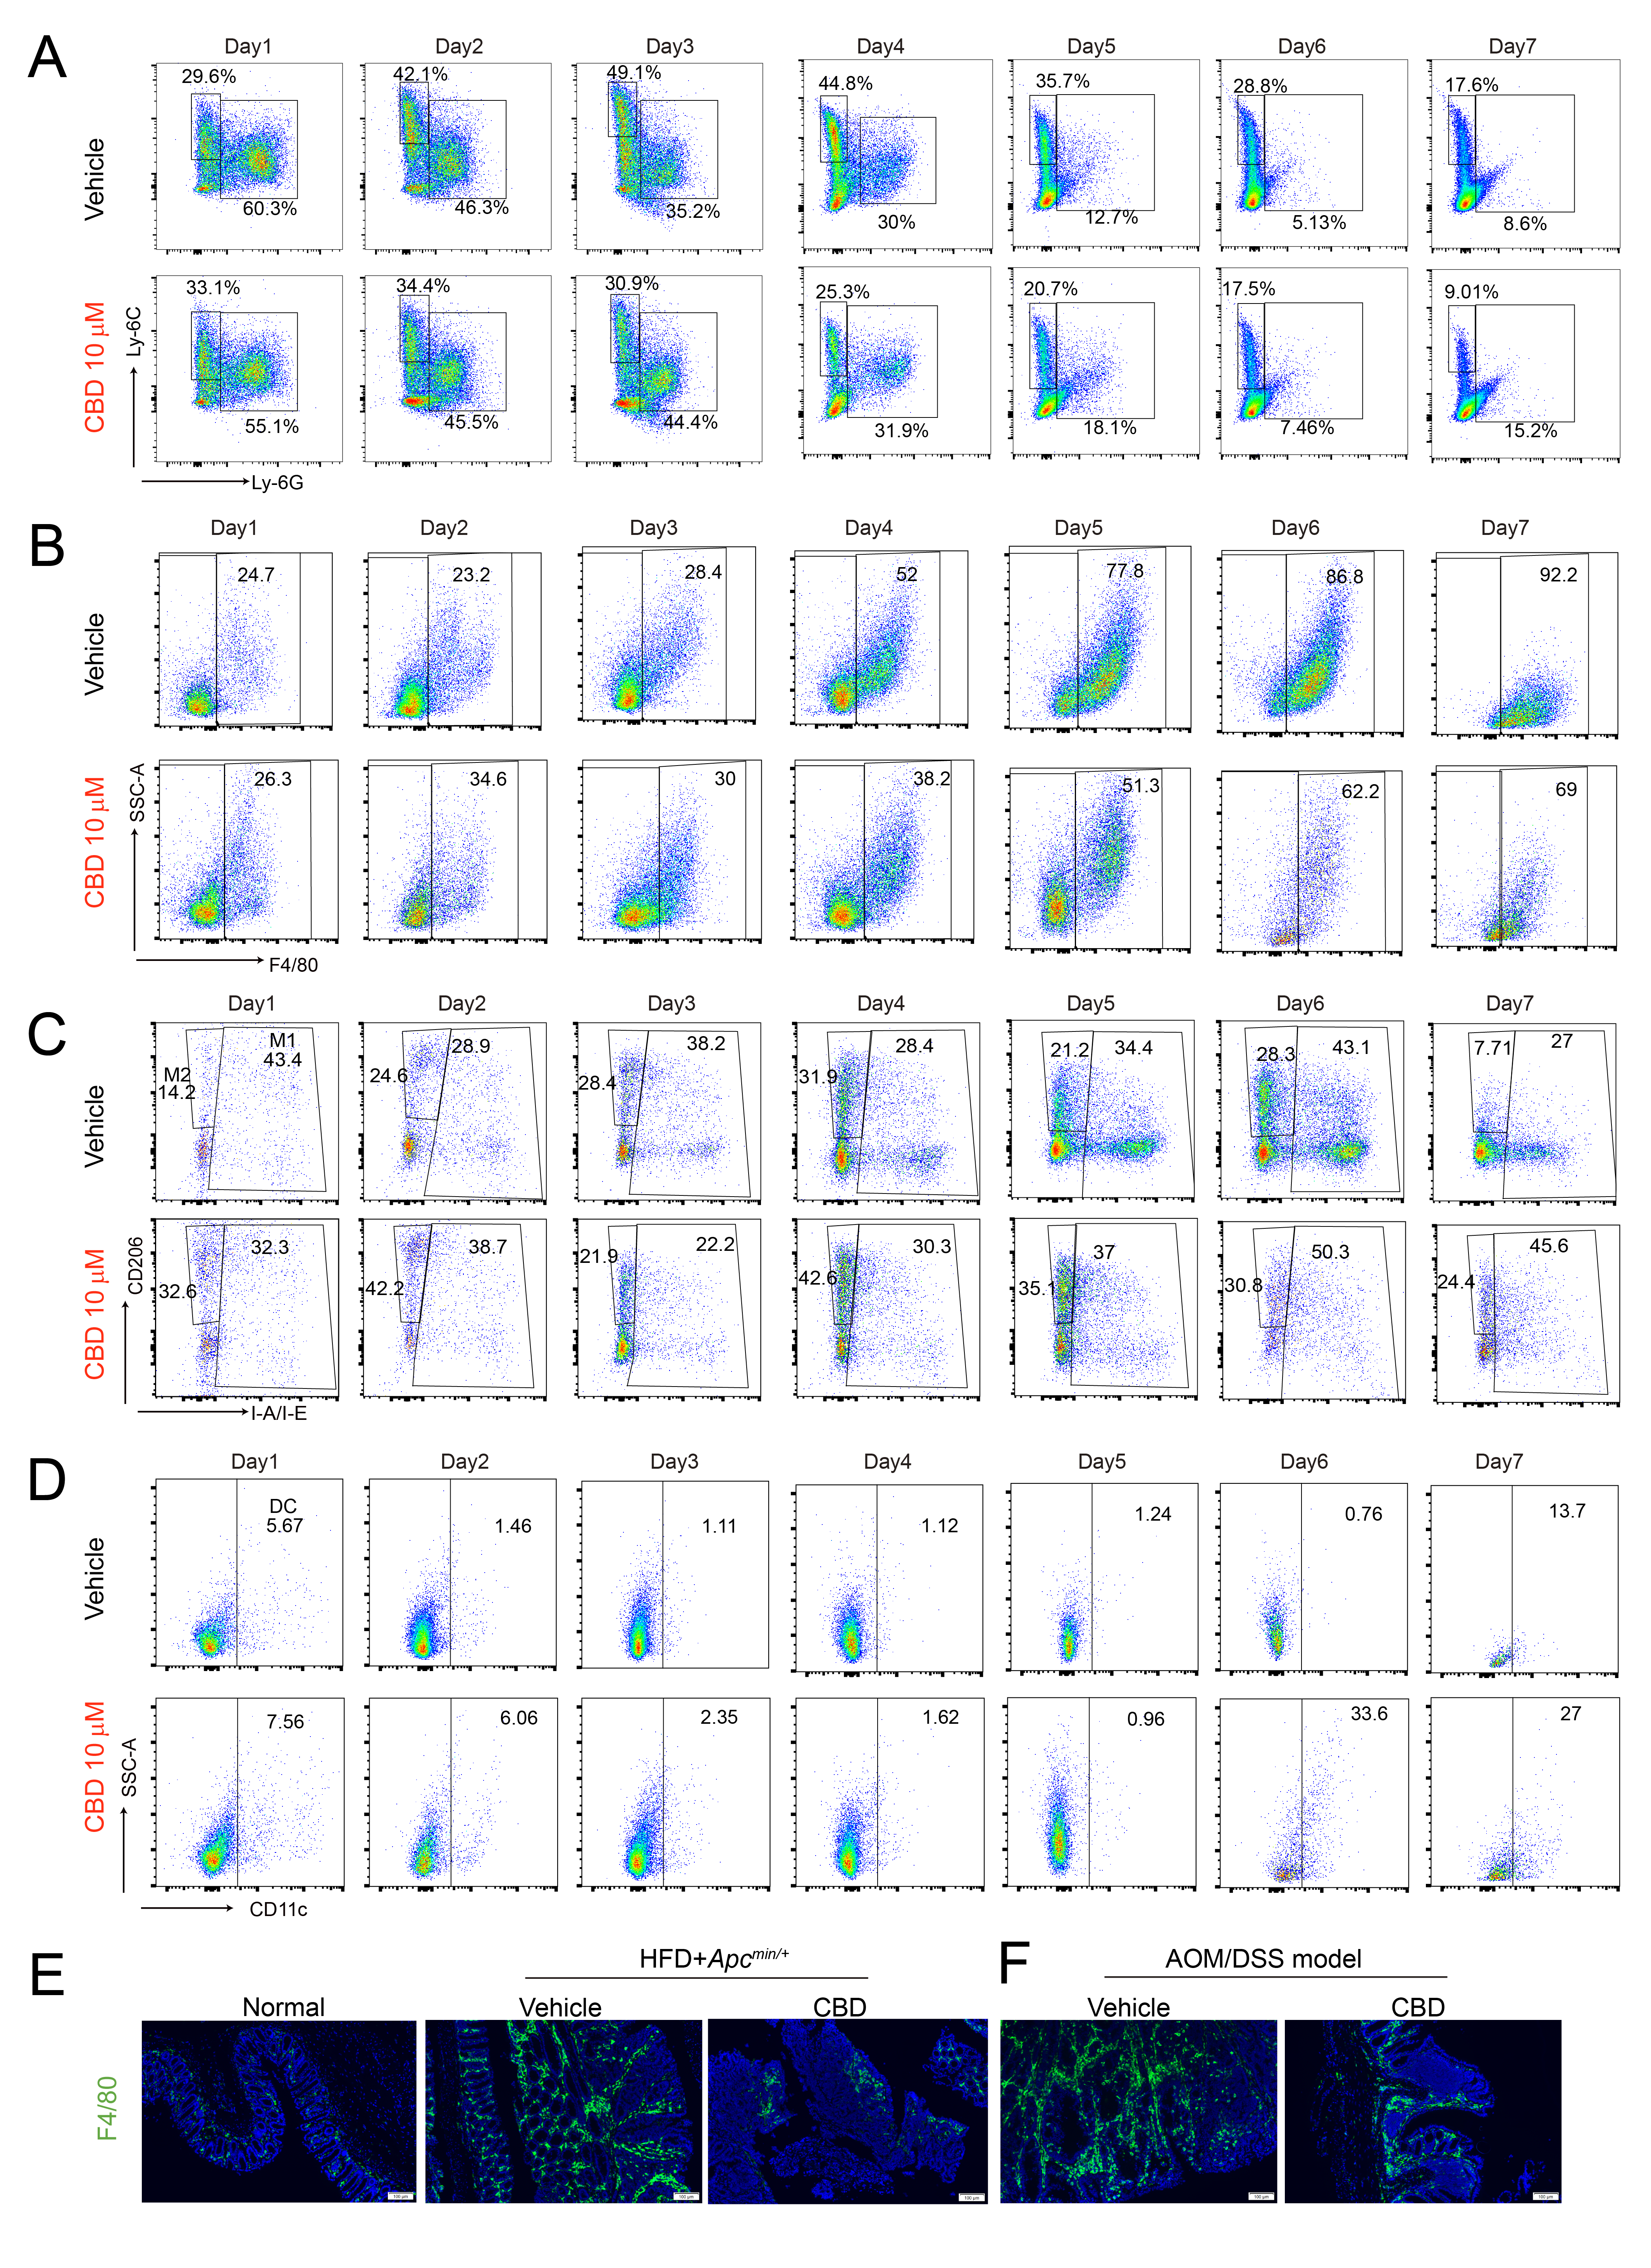
Fig. S6 Myeloid cell composition at different culture time induced from bone marrow cells, related to Figure 3.
(A) Representative FACS plots showing the change of MDSCs differentiated from bone marrow with or without CBD treatment at different time point. (B) Representative FACS plots showing the change of macrophages differentiated from bone marrow with or without CBD treatment at different time point. (C) Representative FACS plots showing the change of M1 or M2 like macrophages differentiated from bone marrow with or without CBD treatment at different time point. (D) Representative FACS plots showing the change of dendritic cell differentiated from bone marrow with or without CBD treatment at different time point. (E-F) CBD reduced the macrophage number in colon tissue in Apc^{min/+} +HFD (E) or AOM/DSS (F) induced mice colon adenomas model. Scale bar, 100 μm.

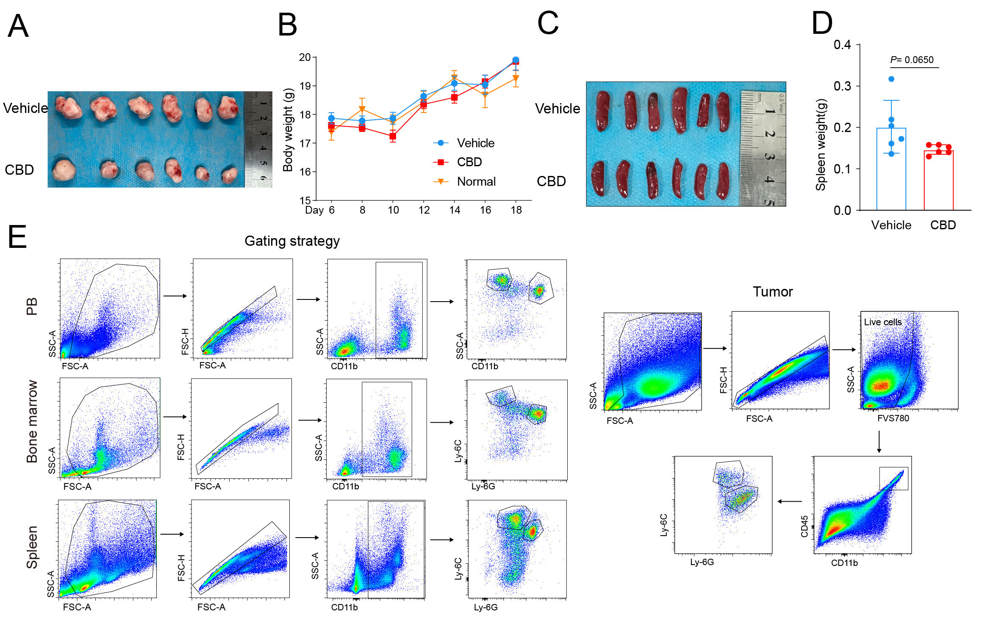
Fig. S7 The effect of CBD on MDSCs generation and systemic inflammation in mice, related to Figure 4.
- MC38 tumor photos at experiment termination (n=6). (B) Body weight of mice in different groups. Normal represented the normal WT C57BL/6 mice with no treatment, n=3. Vehicle represented the MC38 tumor burden mice treated with vehicle control, n=6. CBD represented the MC38 tumor burden mice treated with CBD (10 mg/kg), n=6. (C) Spleen size from vehicle and CBD group. (D) Spleen weight from vehicle and CBD group, n=6. (E) The FACS gating strategy of MDSCs in peripheral blood, bone marrow, spleen and tumor. P values were calculated by two-tailed Student’s t test.

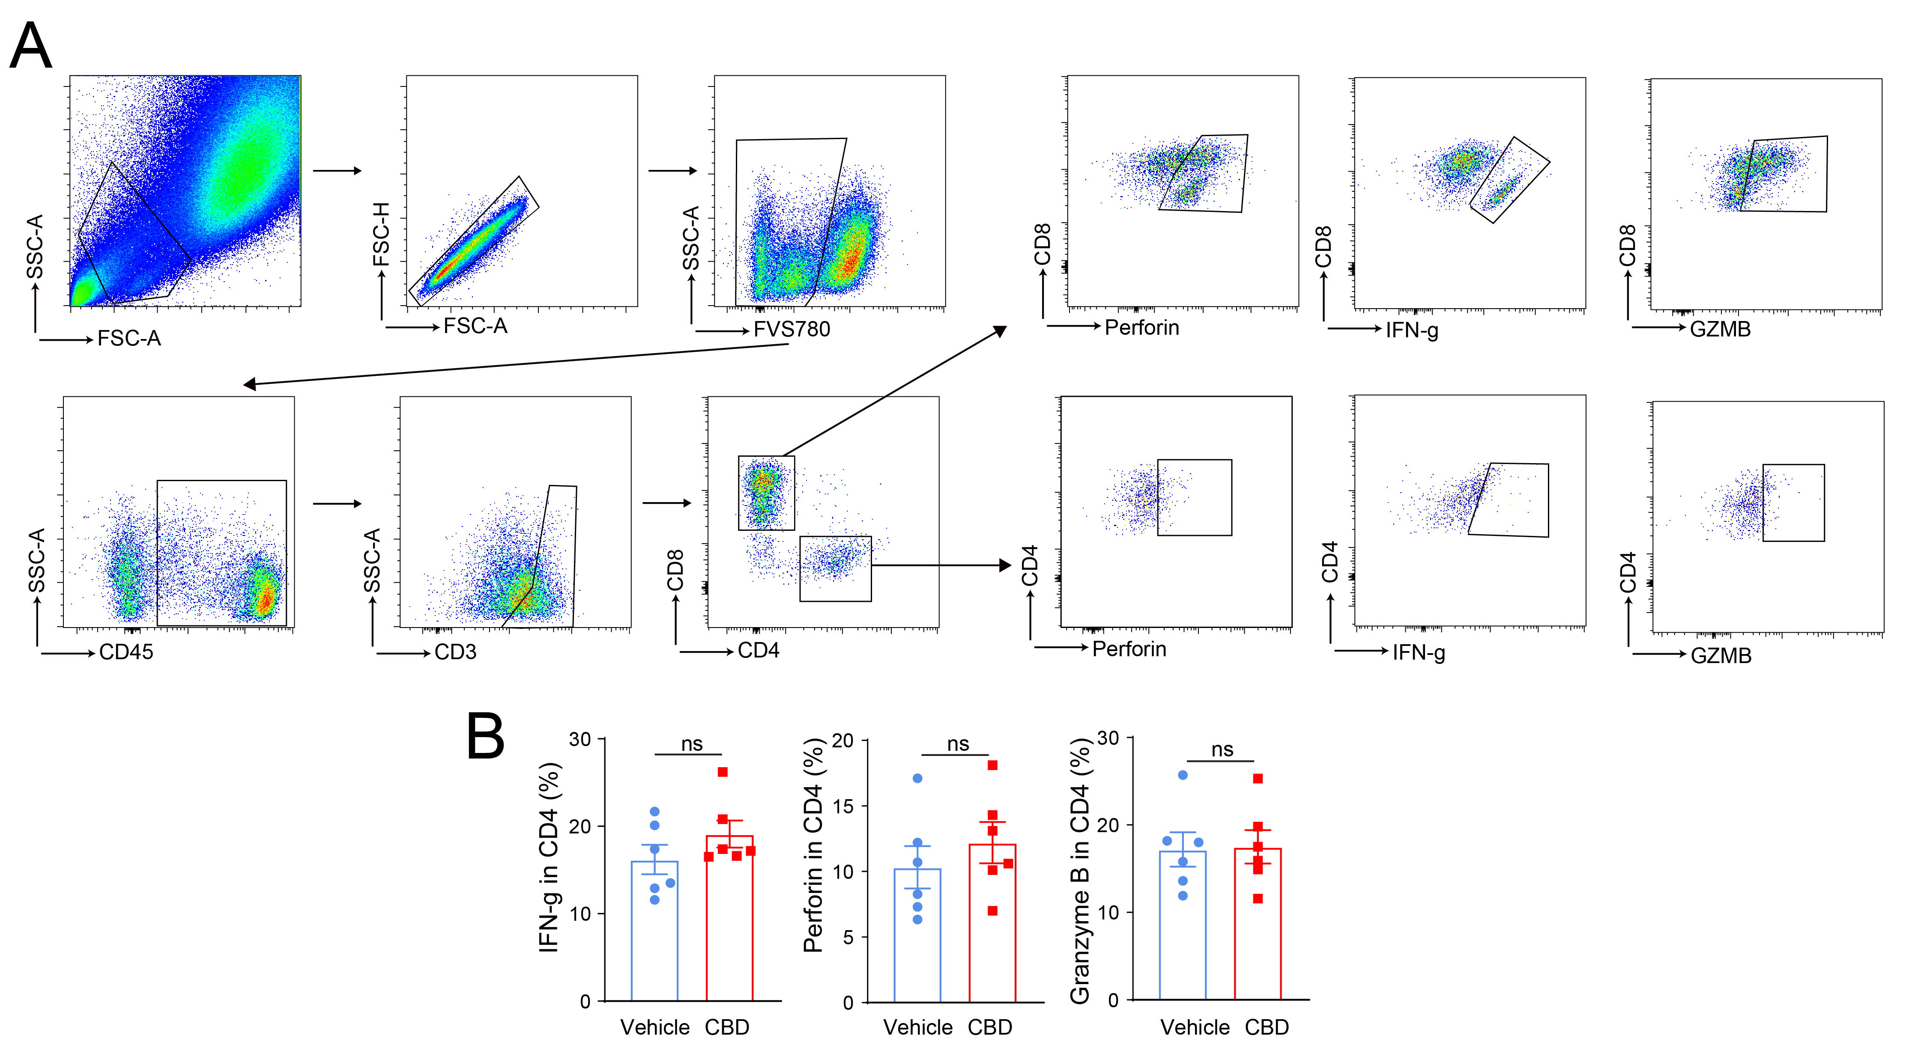
Fig. S8 Cytokine expression after stimulating tumor infiltrating T cell in different groups, related to Figure 4.
- Gating strategy of cytokines in MC38 tumor infiltrating T cells after stimulating with T cell activation cocktails with BFA for 4 h. (B) The statistical analysis of cytokine expression in CD4⁺ T cells in different groups. ns = not significant.
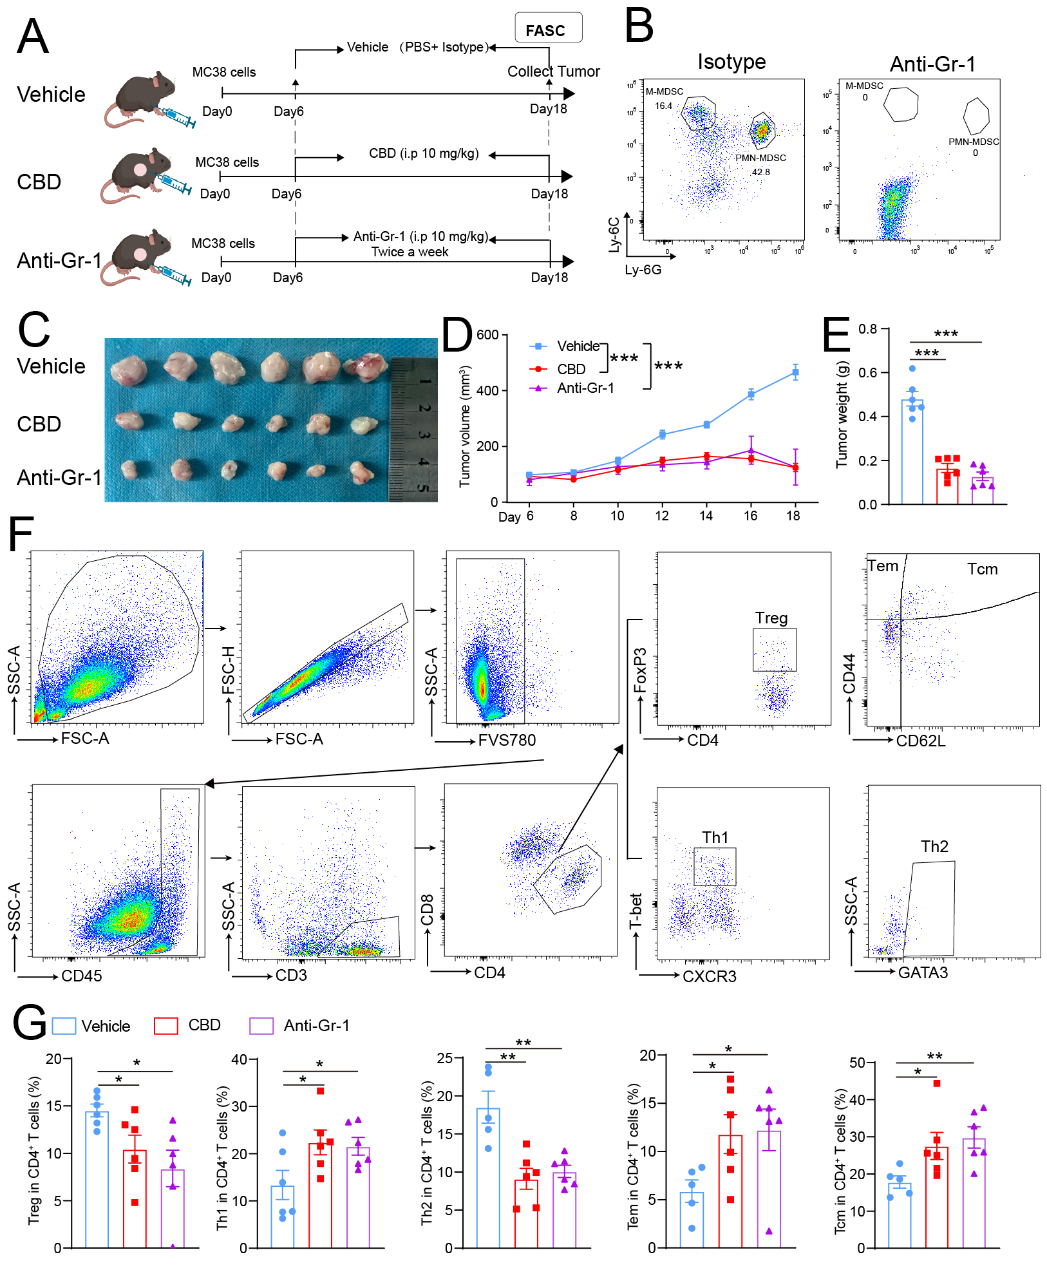
Fig. S9 CBD caused CD4⁺ T cell subsets change dependent on its effect on MDSCs, related to Figure 4. (A) The experimental design and timeline. MC38 cells were inoculated subcutaneously into WT C57BL/6 mice (n=6). After 6 days, the mice were randomly divided into the Vehicle group, CBD group and anti-Gr-1 group. Tumors were collected at the termination and perform FACS for CD4⁺ T cell population analysis. (B) ldentification of efficacy of anti-Gr-1. (C) MC38 tumor photos at experiment termination. (D) Tumor volume in three indicated groups. (E) Tumor weight in three indicated groups. (F) Gating strategy of different CD4⁺ T cell populations. (G) The percentage of Treg, Th1, Th2, Tcm and Tem in CD4⁺ T cells in tumors from 3 different groups. Treg, regulatory T cell; Tcm, central memory T cell; Tem, effector memory T cell. *P < 0.05, **P < 0.01, ***P < 0.001. P values were calculated by Student’s t test or one-way ANOVA with Tukey’s multiple comparisons test.
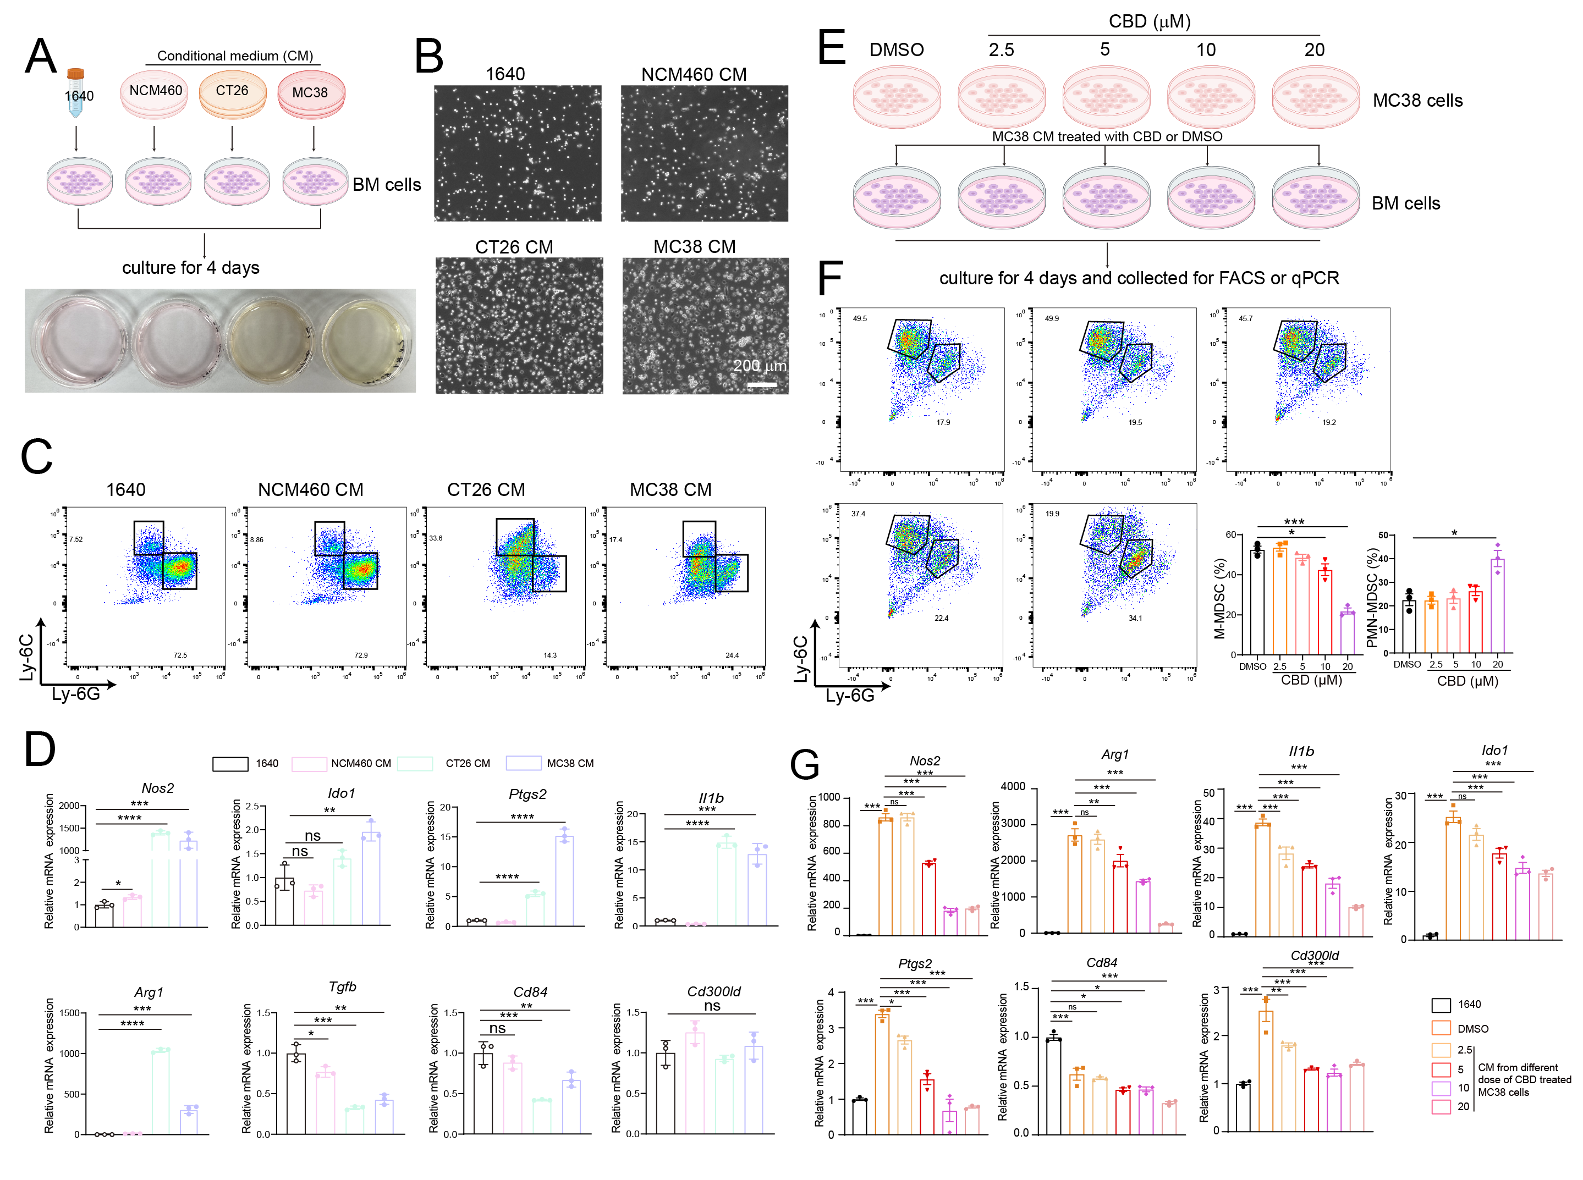
Fig. S10 CBD inhibited the capacity of epithelial colon cancer cells to induce MDSC generation, related to Figure 4. (A) Experiment work flow to using the conditional medium from different epithelial cells types to culture bone marrow cells for 4 days and then detecting the generation of MDSCs. (B) Bright field photos of adherent MDSCs from bone marrow cells after different conditional medium culture. (C) Representative FACS plots of Ly-6C and Ly-6G expressed cells after different conditional medium culture. (D) Function gene expression of MDSCs after different conditional medium culture. n=3. (E) Experiment work flow. MC38 epithelial colon cancer cells were first treated with different doses of CBD for 24 h and refreshed the medium for another 24 h. Collecting the conditional medium from CBD treated MC38 cells to perform FACS analysis or qPCR detection. (F) The percentage of M-MDSCs and PMN-MDSCs generated from bone marrow cells culturing with CBD treated MC38 conditional medium. n=3. (G) Function gene expression of MDSCs after culturing with CBD treated MC38 conditional medium. n=3. *P < 0.05, **P < 0.01, ***P < 0.001. ns = not significant. P values were calculated by Student’s t test or one-way ANOVA with Tukey’s multiple comparisons test.

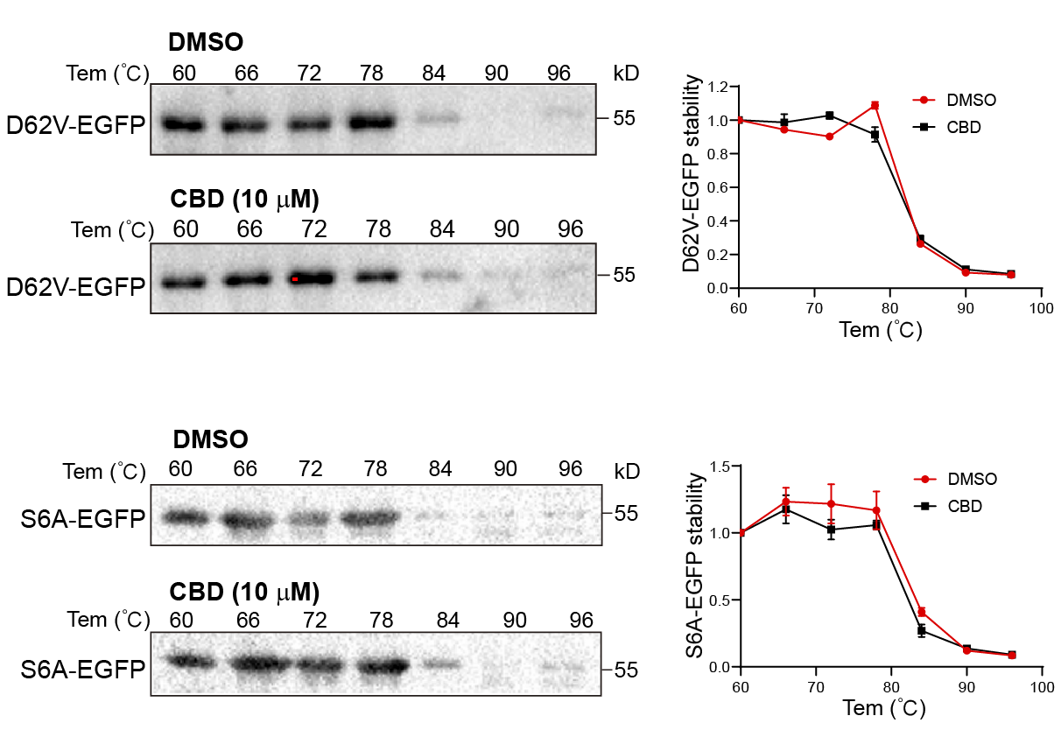

Fig. S11 EEF1B2 point mutation disrupted the interaction between EEF1B2 and CBD, related to Figure 5. The CETSA assay showed D62V and S6A mutation of the GEF domain in EEF1B2 led to no protein resistance difference of EEF1B2 to different temperature gradients between the CBD treated samples and the DMSO control samples. The HEK293T cells were transfected with D62V-EEF1B2-EGFP or S6A-EEF1B2-EGFP plasmid and let them expressing for 48 h. Then the cells were treated with CBD or DMSO for another 1 h. Next collected the cells for CETSA assay in different temperature gradients to detect the EEF1B2 protein stability.

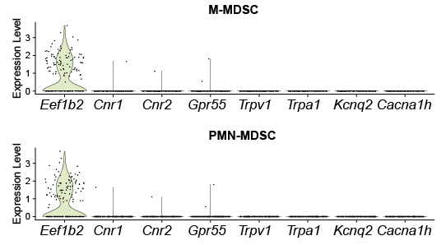

Fig. S12 Gene expression of different previous reported CBD binding protein compared to Eef1b2 in MDSCs, related to Figure 5. The mRNA expression of Eef1b2 and previous reported CBD binding protein Cnr1, Cnr2, Gpr55, Trpv1, Trpa1, Kcnq2, Cacna1h in M-MDSCs and PMN-MDSCs of mice colon analyzed from the scRNA-Seq data.
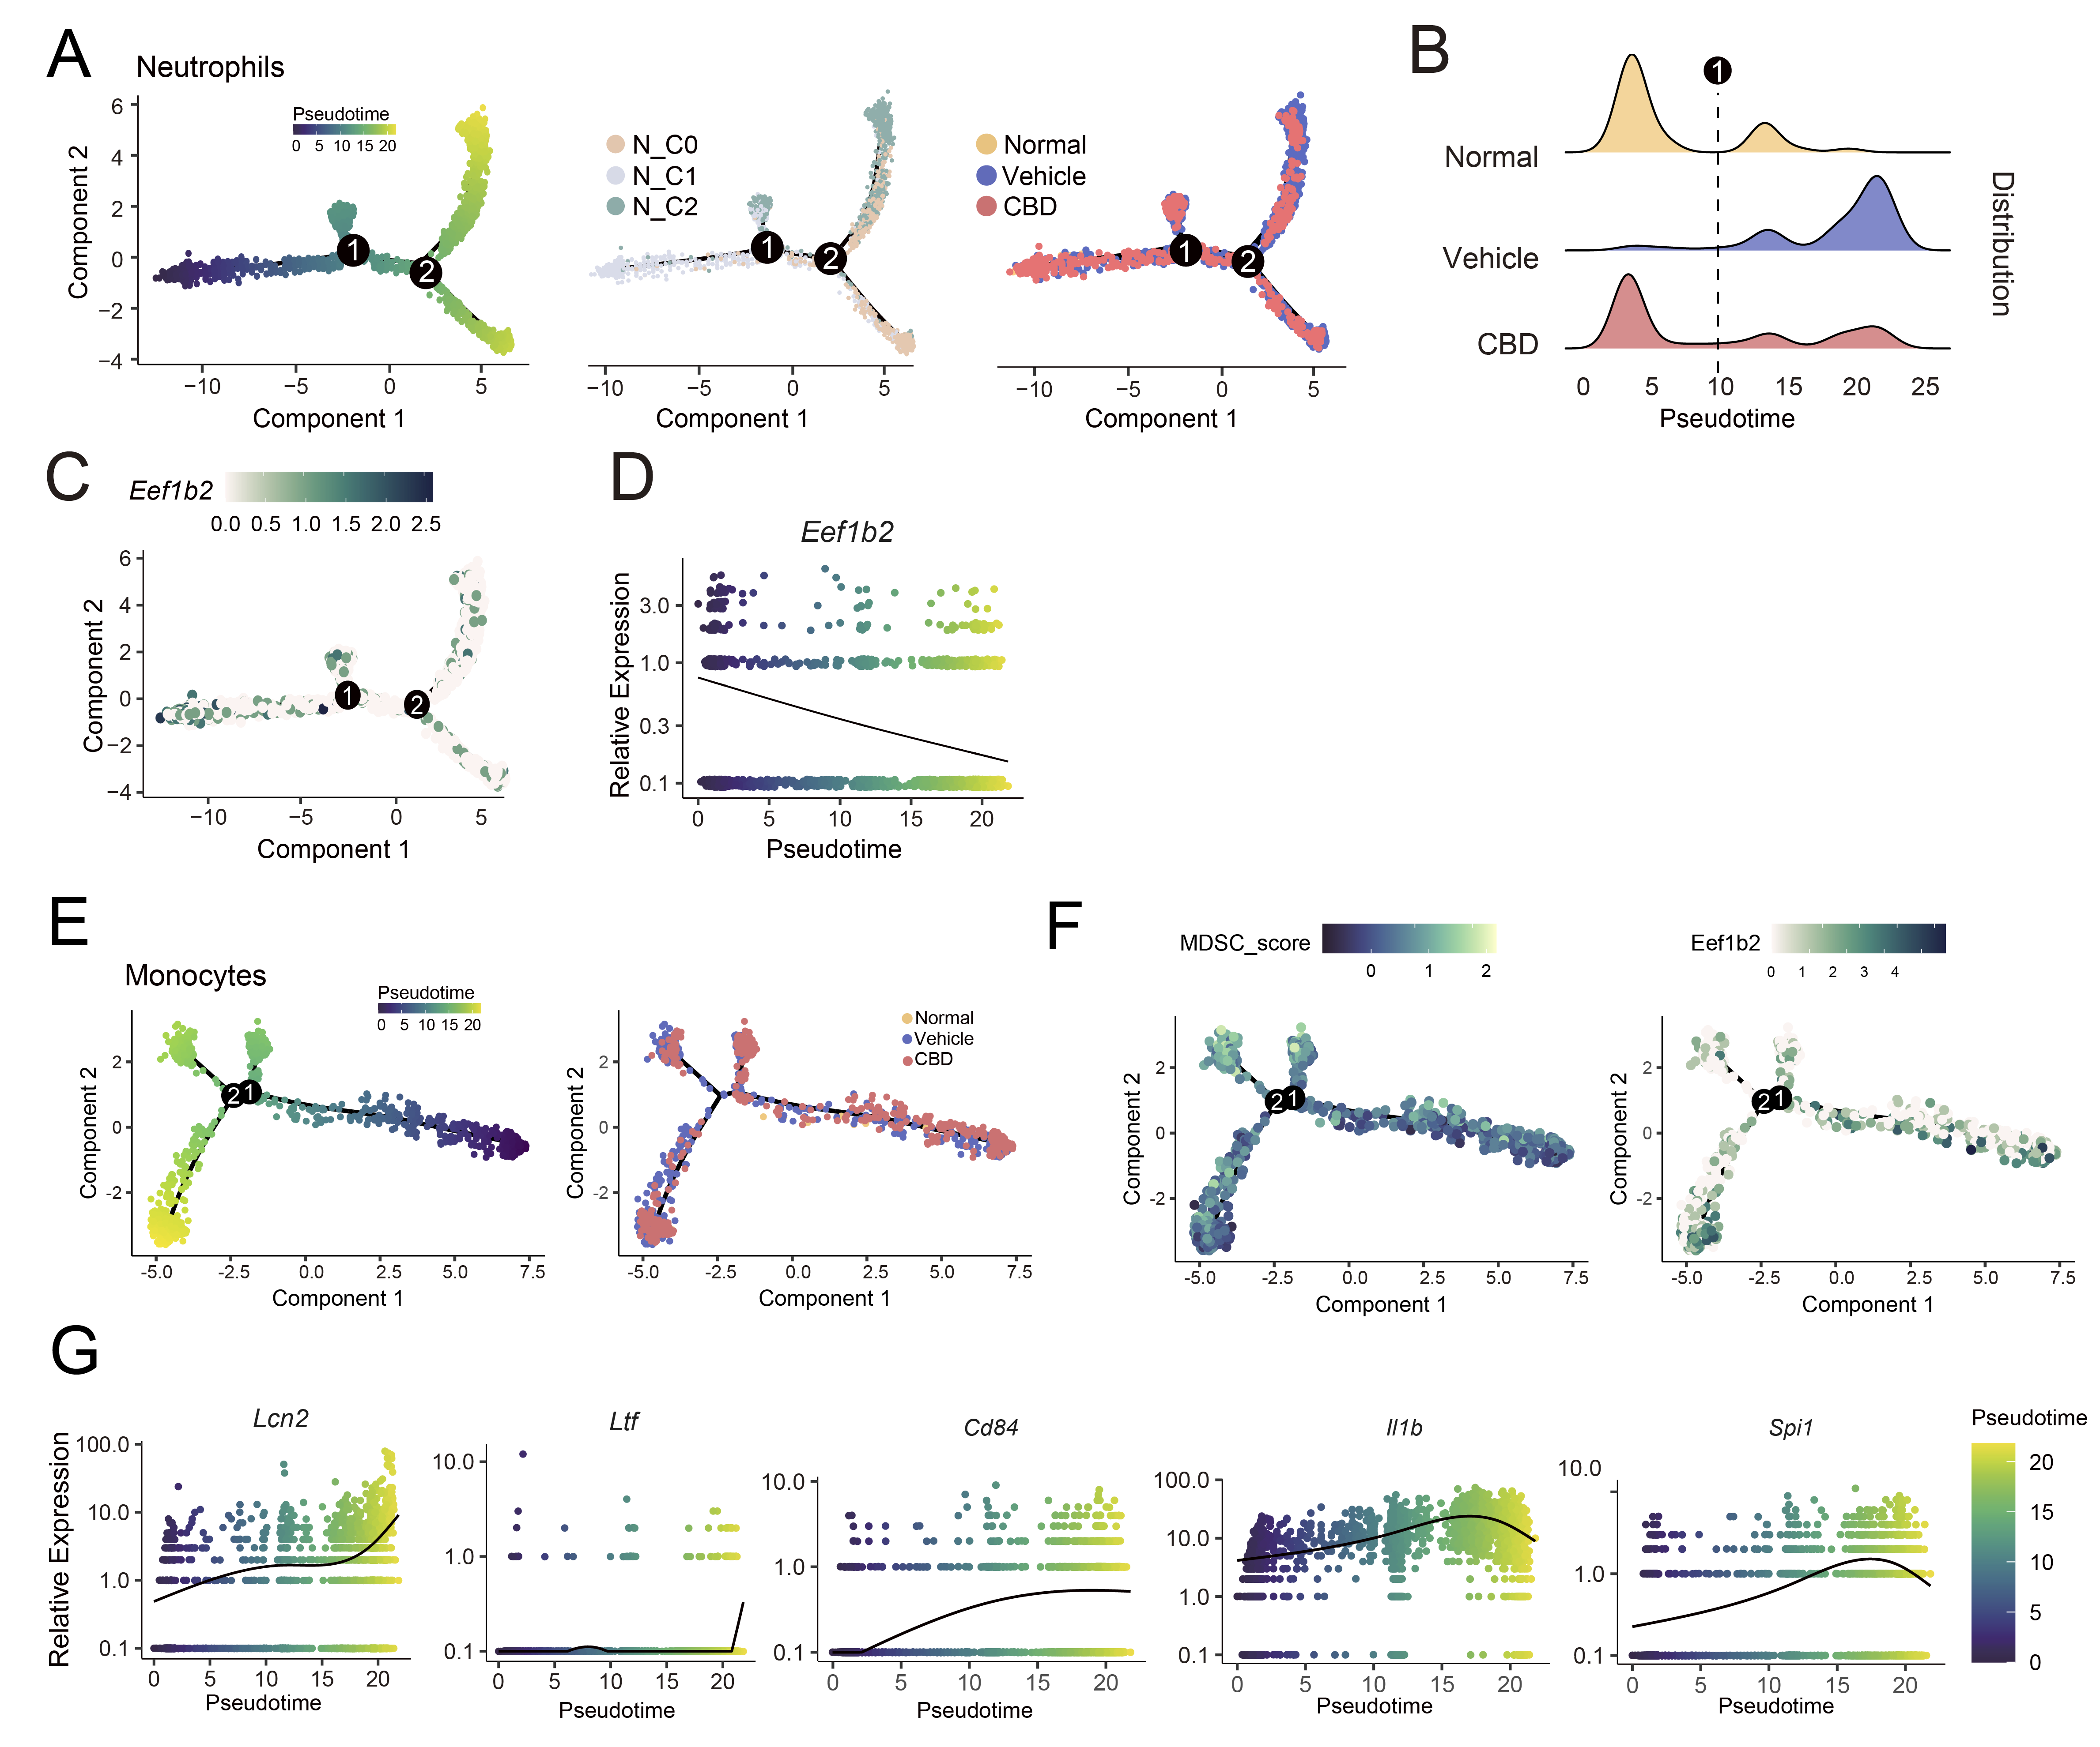
Fig. S13 Pseudotime analysis of EEF1B2 during the generation of MDSCs, related to Figure 6.
(A) Neutrophil-specific monocle analysis on subset of neutrophil clusters showing cellular progression along pseudotime. (B) Distribution of cell distribution over pseudotime for three groups, highlighting group-specific differences in pseudotime progression. (C) Pseudotime-based expression trajectory of Eef1b2 gene, with cells distributed along pseudotime. (D) Pseudotime plot illustrating expression of Eef1b2 decreased when going mature over pseudotime. (E) Pseudotime analysis of monocytes showing cellular progression along pseudotime. (F) Pseudotime-based MDSCs score and Eef1b2 expression with cells distributed along pseudotime. (G) Expression dynamics of mature neutrophil (Lcn2 and Ltf) and MDSCs marker genes (Cd84, Il1b, and Spi1) across pseudotime.
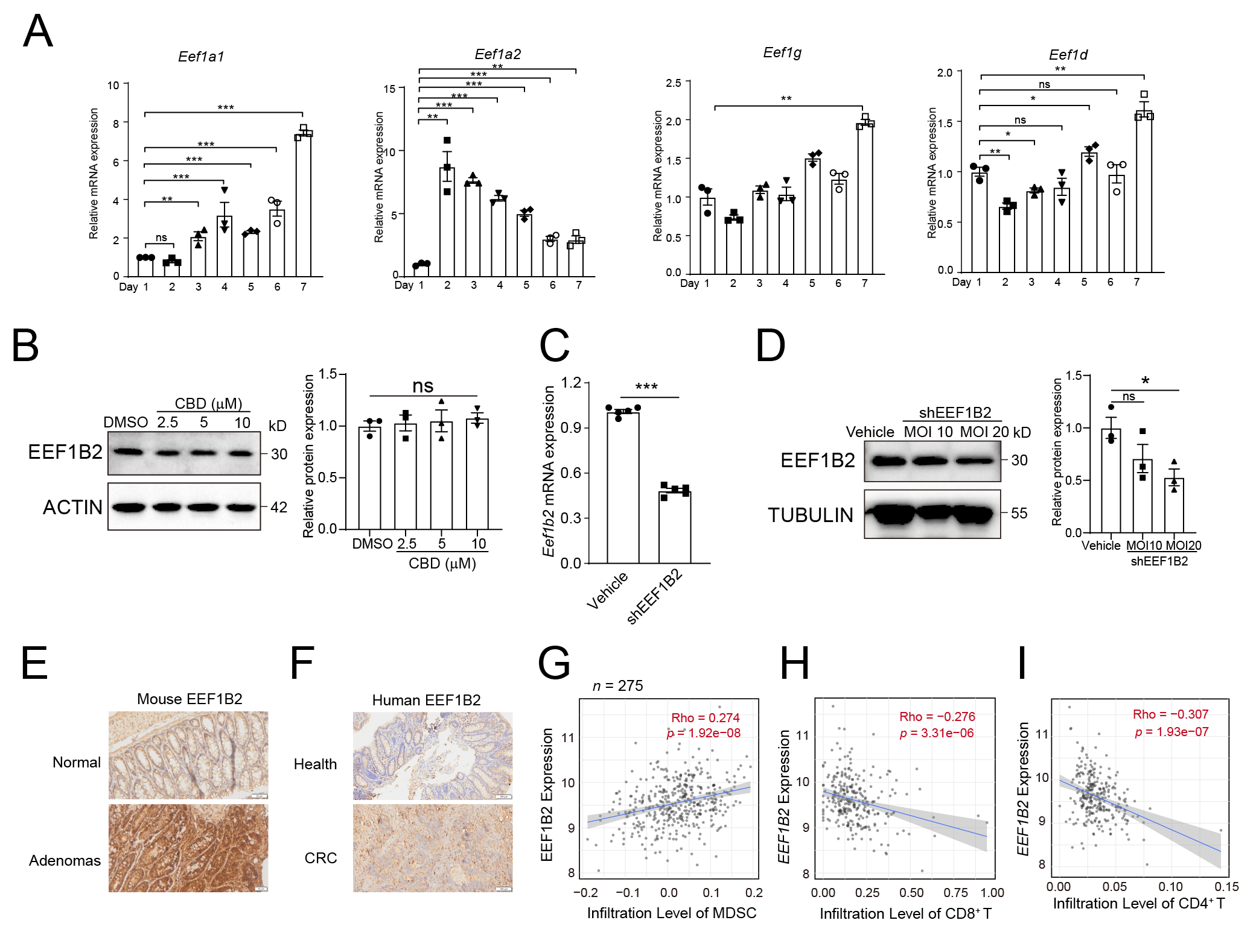
Fig. S14 EEF1B2 is necessary for the function and generation of MDSCs, related to Figure 6.
- The change of gene expression of other eEF family members during the induction of MDSCs from bone marrow cells. (B) CBD treatment had no effect on EEF1B2 protein expression in MDSCs. (C) The efficiency of EEF1B2 knockdown in bone marrow derived MDSCs in the level of mRNA. (D) The efficiency of EEF1B2 knockdown in bone marrow derived MDSCs in the level of protein. (E) EEF1B2 expression increased in mouse colon adenomas compared to normal colon detected by IHC staining. n=3.Scale bar, 50 μm. (F) EEF1B2 expression increased in human colorectal cancer compared to normal colon tissue detected by IHC staining. n=3. Scale bar, 100 μm. (G-I) Correlation between EEF1B2 expression and MDSC infiltration (G), CD8⁺ T cell (H) and CD4⁺ T cell (I) in colon cancer in TCGA database (timer, http://cistrome.dfci. harvard.edu/TIMER/). *P < 0.05, **P < 0.01, ***P < 0.001. P values were calculated by two-tailed Student’s t test between two groups and P values were calculated by one-way ANOVA with Tukey’s multiple comparisons test between three or more groups.

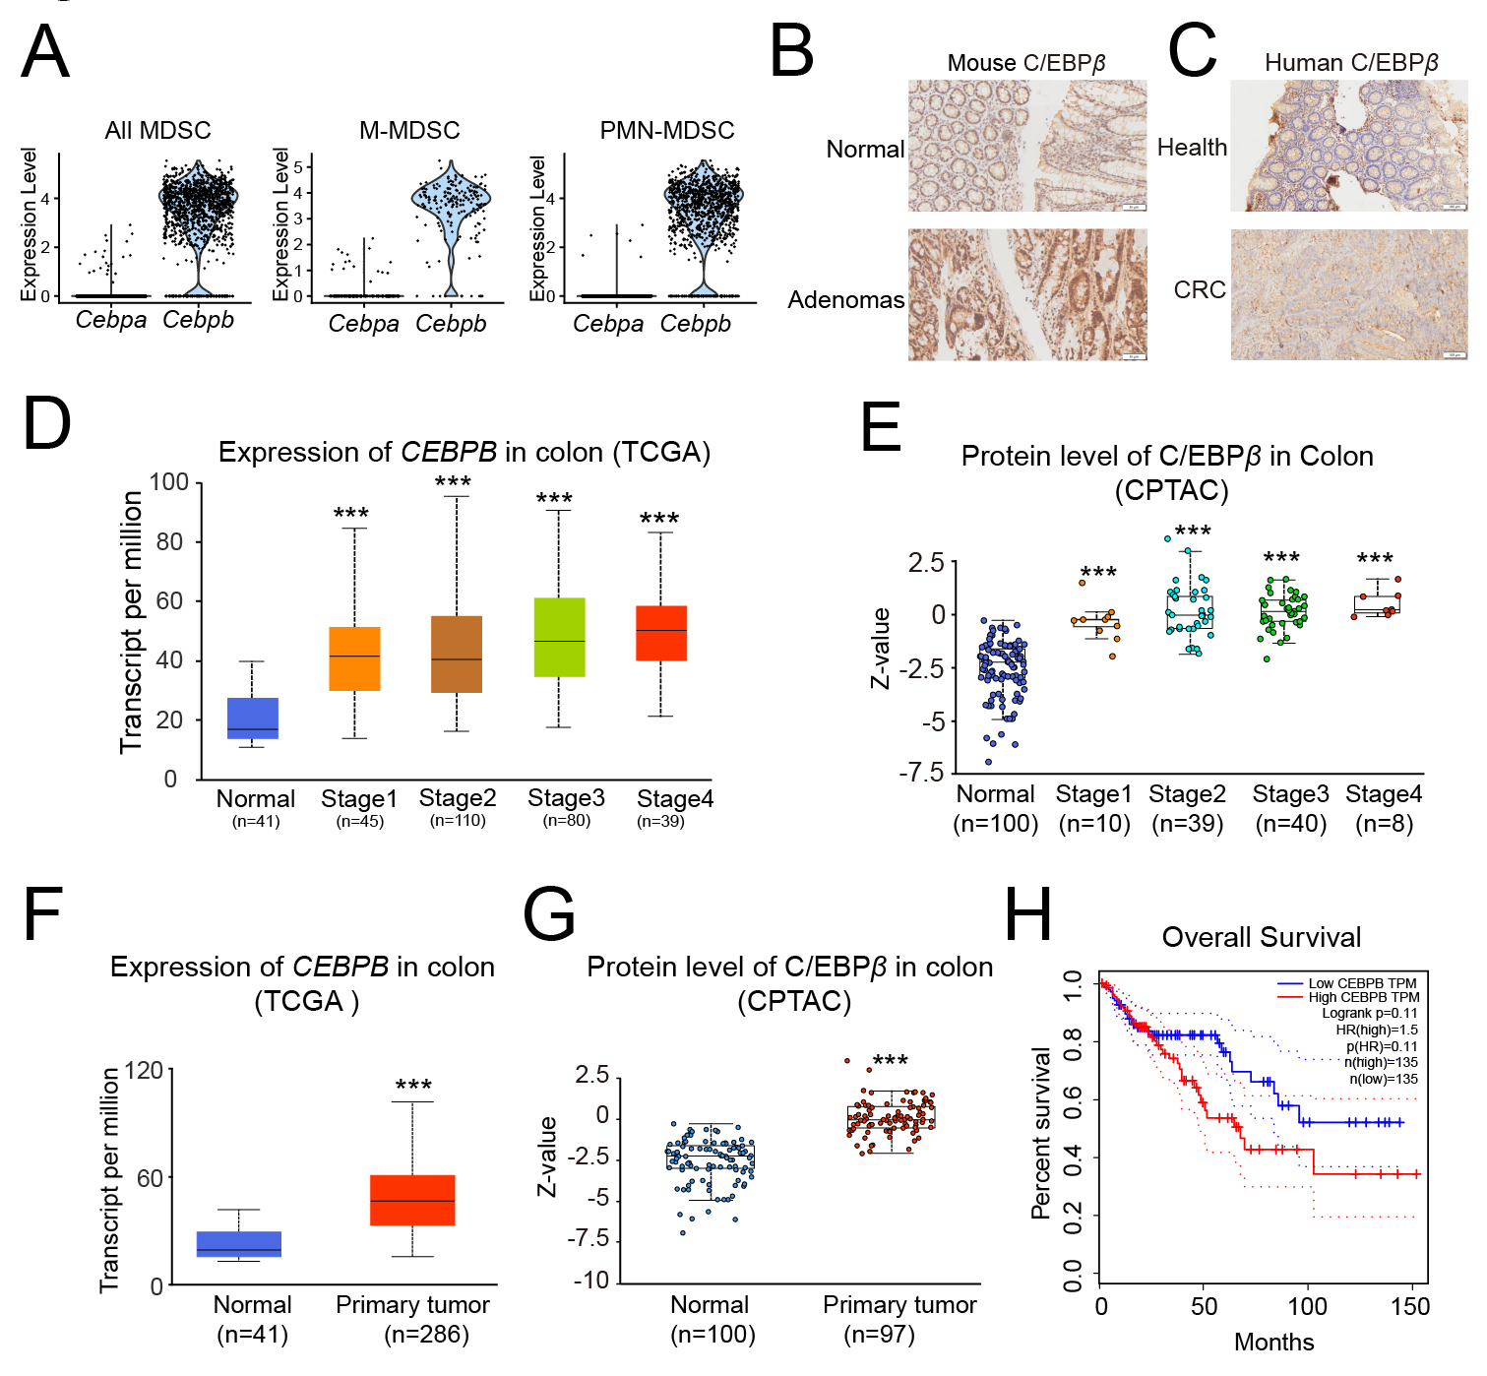
Fig. S15 C/EBPβ expression in mice colon MDSCs and human colon cancers, related to Figure 6.
(A) Cebpb gene expression was higher than Cebpa in MDSCs analyzed from the scRNA-Seq data. (B) C/EBPβ expression increased in mouse colon adenomas compared to normal colon detected by IHC staining. n=3. Scale bar, 50 μm. (C) C/EBPβ expression increased in human colorectal cancer compared to normal colon tissue detected by IHC staining. n=3. Scale bar, 100 μm. (D) CEBPB gene expression increased with the cancer stage in TCGA database. (E) C/EBPβ protein expression increased with the colon cancer stage in CPTAC database. (F) CEBPB gene expression was upregulated in colon tumor tissue. (G) C/EBPβ protein expression was upregulated in colon tumor tissue in CPTAC database (https://ualcan.path.uab.edu/index.html). (H) Kaplan-Meier survival curves comparing the high and low expression of C/EBPβ. ***P < 0.001.
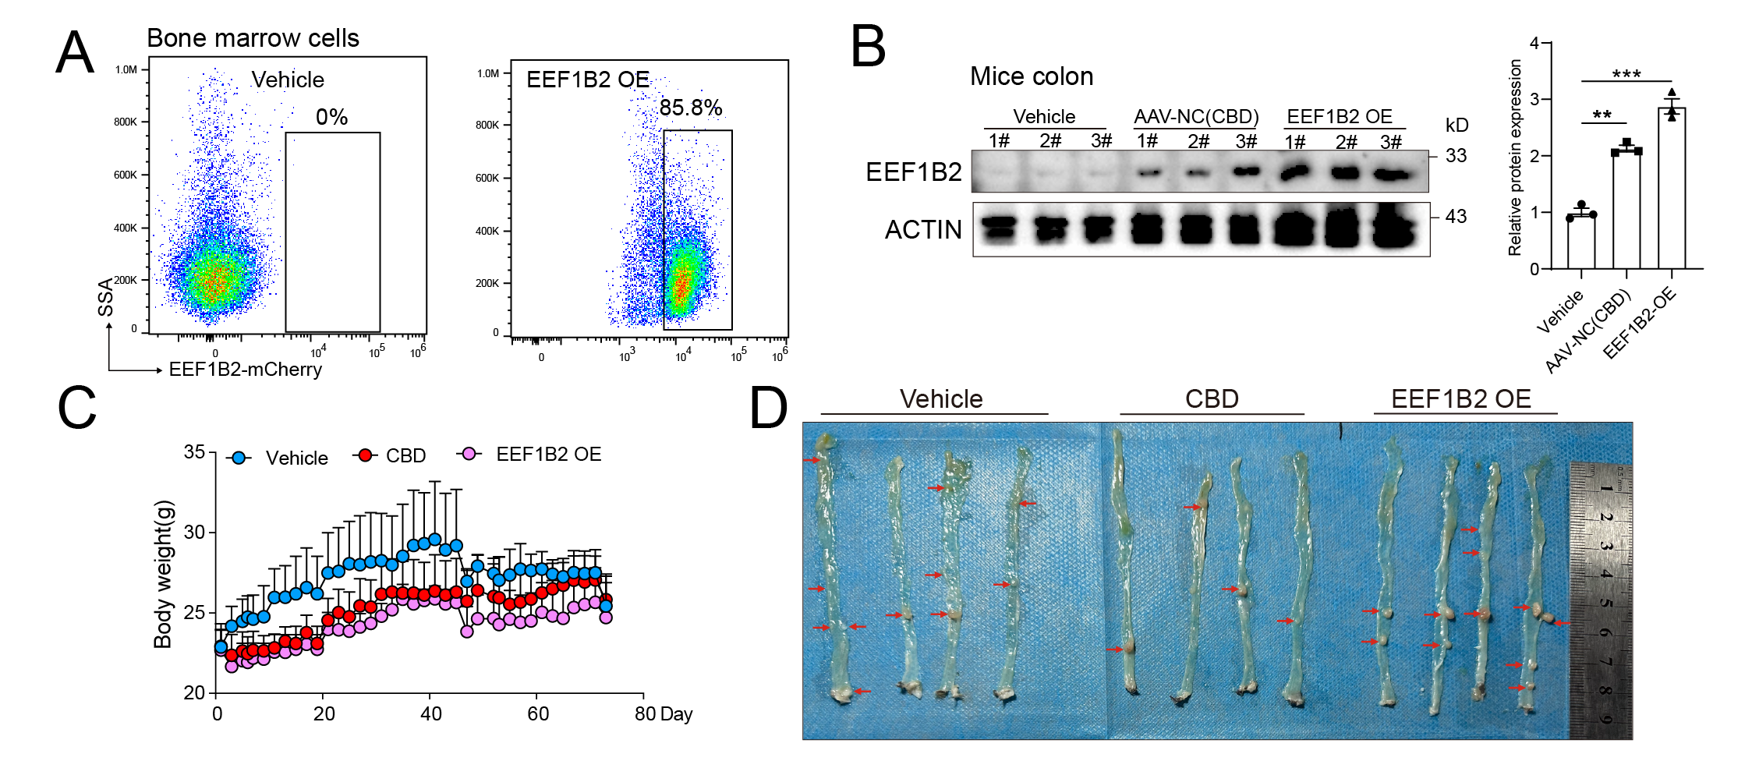

Fig. S16 EEF1B2 overexpression in bone marrow leads to more colorectal adenomas in CBD treated Apc^{min/+}+HFD mice, related to Figure 7.
- The FACS plots showing the successful expression of EEF1B2-mCherry in bone marrow cells. (B) EEF1B2 protein expression in mice colon tissue in different groups. Vehicle, only HFD fed Apc^{min/+} mice treated with vehicle; AAV-NC (CBD), HFD fed Apc^{min/+} mice treated with CBD and AAV-negative empty vector virus; EEF1B2 OE, Apc^{min/+} mice were intra-bone injection of AV-EEF1B2-mCherry virus to overexpress EEF1B2 for 3 weeks and then fed with HFD and treated with CBD. (C) Body weight of mice in different treated groups. (D) The adenomas in mice colon from different groups.
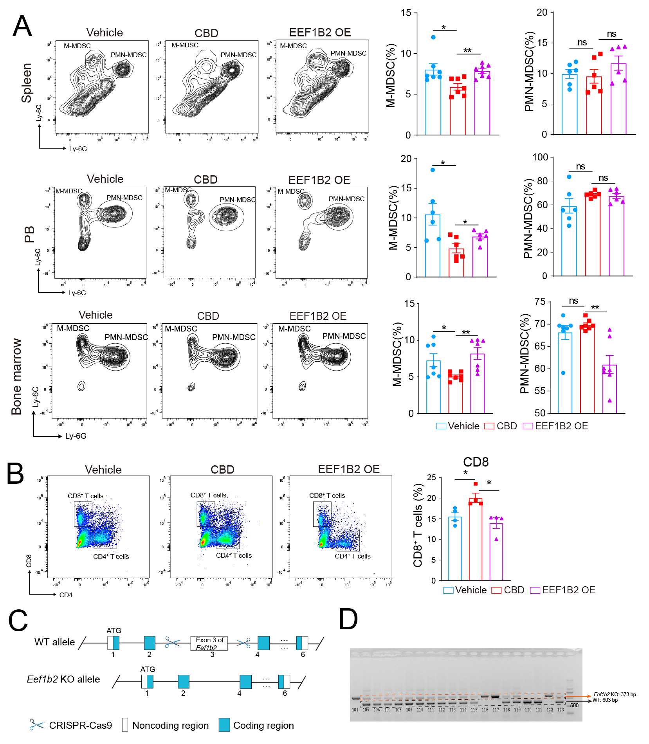
Fig. S17 Effect of EEF1B2 overexpression or deficiency in bone marrow cells on the MDSCs infiltration to tumor site, related to Figure 7.
(A) FACS plot showing the proportion of M-MDSC and PMN-MDSC in mice spleen (n=7), peripheral blood (n=6) and bone marrow (n=6) in different groups. The statistical analysis of the FACS results were showed in the right of FACS plots. (B) The change of CD8⁺ T cells and CD4⁺ T cells in mice spleen in different groups. The statistical analysis of the FACS results were showed in the right of FACS plots, n=4/group. (C) Scheme of establishing Eef1b2 KO mice by CRISPR-Cas9. Exon3 of Eef1b2-204 (ENSMUST00000129339.8) transcript is the knockout region. The region contains 127bp coding sequence. Knocking out the region will result in disruption of protein function. (D) Identification of Eef1b2 knockout. Heterozygous Eef1b2^{+/-} mice had two bands including 630bp wild-type Eef1b2 in one allele and 373 bp that Eef1b2 exon 3 depletion in another allele.

Table S1.
The antibodies used in this study
Antibody | Fluorochrome | Cat number | Company | RRID
Anti-CD11b | FITC | 101205 | BioLegend | RRID:AB_312788
Anti-CD11b | AF700 | 101222 | BioLegend | RRID:AB_493705
Anti-mouse Gr-1 | PE | 108408 | BioLegend | RRID:AB_313373
Anti-mouse CD45 | eFluor 450 | 48-0451-82 | invitrogen | RRID:AB_1518806
Anti-CD11b | PE | 557397 | BD | RRID:AB_396680
Anti-mouse Ly6G | BV711 | 127643 | BioLegend | RRID:AB_2565971
Anti-mouse Ly6C | FITC | 128005 | BioLegend | RRID:AB_1186134
Anti-mouse CD3 | BV421 | 100228 | BioLegend | RRID:AB_2562553
Anti-mouse CD3 | APC | 553066 | BD | RRID:AB_398529
Anti-mouse CD3 | / | 16-0031-82 | eBioscience | RRID:AB_468847
Anti-mouse CD28 | / | 16-0281-82 | eBioscience | RRID:AB_468921
Anti-mouse IFNγ | PE | 12-7311-82 | invitrogen | RRID:AB_466193
Anti-mouse F4/80 | APC | 123116 | BioLegend | RRID:AB_893481
Anti-mouse CD206 | PE | 141706 | BioLegend | RRID:AB_10895754
Anti-mouse  I-A/I-E | PerCP-Cyanine5.5 | 107626 | BioLegend | RRID:AB_2191071
Anti-mouse CD11c | BV605 | 117339 | BioLegend | RRID:AB_2562414
Anti-mouse CD4 | FITC | 100405 | BioLegend | RRID:AB_312691
Anti-mouse CCR4 | PE | 131203 | BioLegend | RRID:AB_1236367
Anti-mouse CD44 | Alexa Fluor 647 | 103018 | BioLegend | RRID:AB_493681
Anti-mouse CD62L | PE | 161204 | BioLegend | RRID:AB_2876576
Anti-mouse FoxP3 | PE | 118903 | BioLegend | RRID:AB_2936574
Anti-mouse GATA3 | Alexa Fluor 647 | 560068 | BD | RRID:AB_1645316
Anti-T-bet | PE | 644809 | BioLegend | RRID:AB_2028583
InVivoMAb  Anti-Gr-1 | / | BE0075 | BioXcell | RRID:AB_10312146
Anti-EEF1B2 | / | 10483-1-AP | Proteintech | RRID:AB_2096985
Anti-CEBPβ | / | ab32358 | Abcam | RRID:AB_726796
Anti-EEF1A1 | / | ab157455 | Abcam | RRID:AB_3094654
Anti-Puromycin | / | ZMS1016 | Sigma | RRID:AB_3099686
Anti-EGFP | / | CAB4211 | invitrogen | RRID:AB_10709851
Anti-Actin | / | 66009-1-Ig | Proteintech | RRID:AB_2687938
Anti-Tubulin | / | 66031-1-Ig | Proteintech | RRID:AB_11042766
Anti-GAPDH | / | 60004-1-Ig | Proteintech | RRID:AB_2107436

Table S2.

Information of Oligonucleotides used in this study.
Name | Primer sequence 5'-3'
Mouse Arg1 | Forward: CTCCAAGCCAAAGTCCTTAGAG
 | Reverse: AGGAGCTGTCATTAGGGACATC
Mouse Nos2 | Forward: GTTCTCAGCCCAACAATACAAGA
 | Reverse: GTGGACGGGTCGATGTCAC
Mouse Ptgs2 | Forward: TGAGCAACTATTCCAAACCAGC
 | Reverse: GCACGTAGTCTTCGATCACTATC
Mouse Tgfb | Forward: CTCCCGTGGCTTCTAGTGC
 | Reverse: GCCTTAGTTTGGACAGGATCTG
Mouse Il1b | Forward: GCAACTGTTCCTGAACTCAACT
 | Reverse: ATCTTTTGGGGTCCGTCAACT
Mouse Cd84 | Forward: ATATAGCTGGAGTCCCTTTGGAG
 | Reverse: AAAGAGCACGGCCAATCCTC
Mouse Ido1 | Forward: GCTTTGCTCTACCACATCCAC
 | Reverse: CAGGCGCTGTAACCTGTGT
Mouse Cd300ld | Forward: ACATTGACCAAGCCCCAAAAA
 | Reverse: AGCAGGGGTAACTCCACAAAG
Mouse Eef1b2 | Forward: TGACCTGTGTCATGCCCTAC
 | Reverse: GCCATACTTGCCCAAAGATTTCT
Mouse Cebpβ | Forward: TCGGGACTTGATGCAATCC
 | Reverse: AAACATCAACAACCCCGC
Mouse Eef1a1 | Forward: GGACACGTAGATTCCGGCAA
 | Reverse: ACTTGGCTCCAGCATGTTGT
Mouse Eef1a2 | Forward: ATTGTGGGTGTCAACAAGATGG
 | Reverse: CATGGCATATTAGGTGAAGGCTC
Mouse Eef1g | Forward: ACCGCACCCCTGAATTTCTC
 | Reverse: CTGGCGTACTTCCTCGCAG
Mouse Eef1d | Forward: GCTCATTGTGAGGATTACCAGTC
 | Reverse: GGCTCGGGGAGTAGGTGAA
shEEF1B2 | GCACAGTATGAGTCCAAGAAA

