Supplementary data

Table S1. Primary and secondary antibodies used in Western Blotting assays
Antibody | Manufacturer | Catalog Number | Host Specie | Dilution | RRID | Supporting Reference
NRF2 | Bio-Rad | VMA00224 | Mouse | 1:1000 | AB_3752226 | Ghosh et al., 2020; Lau et al., 2013
GSK-3β | Sigma-Aldrich | G7914 | Mouse | 1:1000 | AB_477027 | Ma et al., 2012
p-GSK-3β (Ser9) | Sigma-Aldrich | ZRB1557 | Rabbit | 1:1000 | AB_3752227 | Souza-Pereira et al., 2025
PKA | Santa Cruz Biotechnology | sc-365615 | Mouse | 1:1000 | AB_10846720 | Manufacturer datasheet
p-PKA (Ser96) | Santa Cruz Biotechnology | sc-56941 | Mouse | 1:1000 | AB_2168241 | Manufacturer datasheet
Goat anti-mouse IgG-HRP | Santa Cruz Biotechnology | sc-2005 | Goat | 1:10000 | AB_631736 | Manufacturer datasheet
Goat anti-rabbit IgG-HRP | Sigma-Aldrich | A6154 | Goat | 1:10000 | AB_258284 | Manufacturer datasheet

Table S2. Two-way ANOVA results
Variable | Factor | F value | p value | effect size (η²)
Crossing | interaction | F (1, 20) = 5.920 | 0.0245 | 0.228
Crossing | ouabain | F (1, 20) = 6.423 | 0.0197 | 0.243
Crossing | β-caryophyllene | F (1, 20) = 5.437 | 0.0303 | 0.214
Time spent in central area | interaction | F (1, 20) = 2.268 | 0.1477 | 0.102
Time spent in central area | ouabain | F (1, 20) = 6.137 | 0.0223 | 0.235
Time spent in central area | β-caryophyllene | F (1, 20) = 12.57 | 0.0020 | 0.386
Distance traveled | interaction | F (1, 20) = 67.40 | 0.0001 | 0.771
Distance traveled | ouabain | F (1, 20) = 3.138 | 0.0917 | 0.136
Distance traveled | β-caryophyllene | F (1, 20) = 21.32 | 0.0002 | 0.516
Visit to central area | interaction | F (1, 20) = 8.705 | 0.0079 | 0.303
Visit to central area | ouabain | F (1, 20) = 1.685 | 0.2090 | 0.078
Visit to central area | β-caryophyllene | F (1, 20) = 4.025 | 0.0585 | 0.168
Time in open arms | interaction | F (1, 20) = 1.894 | 0.1839 | 0.087
Time in open arms | ouabain | F (1, 20) = 0.095 | 0.7614 | 0.005
Time in open arms | β-caryophyllene | F (1, 20) = 1.450 | 0.2425 | 0.068
Closed arm entries | interaction | F (1, 20) = 1.601 | 0.2203 | 0.074
Closed arm entries | ouabain | F (1, 20) = 31.41 | 0.0001 | 0.611
Closed arm entries | β-caryophyllene | F (1, 20) = 0.817 | 0.3768 | 0.039
Pick-up score | interaction | F (1, 20) = 4.044 | 0.0580 | 0.168
Pick-up score | ouabain | F (1, 20) = 8.115 | 0.0099 | 0.289
Pick-up score | β-caryophyllene | F (1, 20) = 4.044 | 0.0580 | 0.168
GST | interaction | F (1, 20) = 2.110 | 0.1619 | 0.095
GST | ouabain | F (1, 20) = 6.957 | 0.0158 | 0.258
GST | β-caryophyllene | F (1, 20) = 1.519 | 0.2320 | 0.071
SOD | interaction | F (1, 20) = 21.57 | 0.0002 | 0.519
SOD | ouabain | F (1, 20) = 4.520 | 0.0462 | 0.184
SOD | β-caryophyllene | F (1, 20) = 15.29 | 0.0009 | 0.433
CAT | interaction | F (1, 20) = 5.410 | 0.0306 | 0.213
CAT | ouabain | F (1, 20) = 3.475 | 0.0771 | 0.148
CAT | β-caryophyllene | F (1, 20) = 7.531 | 0.0125 | 0.274
TBARs | interaction | F (1, 20) = 18.92 | 0.0003 | 0.486
TBARs | ouabain | F (1, 20) = 2.011 | 0.1716 | 0.091
TBARs | β-caryophyllene | F (1, 20) = 15.36 | 0.0008 | 0.434
NRF2 | interaction | F (1, 20) = 6.919 | 0.0160 | 0.257
NRF2 | ouabain | F (1, 20) = 6.461 | 0.0194 | 0.244
NRF2 | β-caryophyllene | F (1, 20) = 2.626 | 0.1208 | 0.116
total GSK-3β | interaction | F (1, 20) = 1.704 | 0.2065 | 0.079
total GSK-3β | ouabain | F (1, 20) = 4.098 | 0.0565 | 0.170
total GSK-3β | β-caryophyllene | F (1, 20) = 0.185 | 0.6721 | 0.009
phospho GSK-3β | interaction | F (1, 20) = 6.276 | 0.0210 | 0.239
phospho GSK-3β | ouabain | F (1, 20) = 0.159 | 0.6991 | 0.008
phospho GSK-3β | β-caryophyllene | F (1, 20) = 6.576 | 0.0185 | 0.247
Table S2. Two-way ANOVA results (continued)
Variable | Factor | F value | p value | effect size (η²)
GSK-3β ratio | interaction | F (1, 20) = 27.83 | 0.0001 | 0.582
GSK-3β ratio | ouabain | F (1, 20) = 15.46 | 0.0008 | 0.436
GSK-3β ratio | β-caryophyllene | F (1, 20) = 7.130 | 0.0147 | 0.263
total PKA | interaction | F (1, 20) = 5.259 | 0.0328 | 0.208
total PKA | ouabain | F (1, 20) = 0.046 | 0.8317 | 0.002
total PKA | β-caryophyllene | F (1, 20) = 1.471 | 0.2393 | 0.069
phospho PKA | interaction | F (1, 20) = 1.992 | 0.1735 | 0.091
phospho PKA | ouabain | F (1, 20) = 13.86 | 0.0013 | 0.409
phospho PKA | β-caryophyllene | F (1, 20) = 4.235 | 0.0529 | 0.175
PKA ratio | interaction | F (1, 20) = 10.12 | 0.0047 | 0.336
PKA ratio | ouabain | F (1, 20) = 142.8 | 0.0001 | 0.877
PKA ratio | β-caryophyllene | F (1, 20) = 129.9 | 0.0001 | 0.867
CA1 Fluoro-Jade C | interaction | F (1, 16) = 11.59 | 0.0036 | 0.420
CA1 Fluoro-Jade C | ouabain | F (1, 16) = 10.63 | 0.0049 | 0.399
CA1 Fluoro-Jade C | β-caryophyllene | F (1, 16) = 14.03 | 0.0018 | 0.467
CA3 Fluoro-Jade C | interaction | F (1, 16) = 6.111 | 0.0250 | 0.276
CA3 Fluoro-Jade C | ouabain | F (1, 16) = 7.314 | 0.0156 | 0.314
CA3 Fluoro-Jade C | β-caryophyllene | F (1, 16) = 3.305 | 0.0878 | 0.171
Dentate Gyrus Fluoro-Jade C | interaction | F (1, 16) = 7.528 | 0.0144 | 0.320
Dentate Gyrus Fluoro-Jade C | ouabain | F (1, 16) = 9.738 | 0.0066 | 0.378
Dentate Gyrus Fluoro-Jade C | β-caryophyllene | F (1, 16) = 4.252 | 0.0558 | 0.210

Table S3. Tukey comparisons and Cohen's d
Variable | Comparison | p value | cohen's d
Crossing | aCSF:Saline vs. aCSF:BCP | 0.9999 | 0.0397
Crossing | aCSF:Saline vs. OUA:Saline | 0.0108 | 1.7335
Crossing | aCSF:Saline vs. OUA:BCP | 0.9989 | 0.0782
Crossing | aCSF:BCP vs. OUA:Saline | 0.0127 | 2.1179
Crossing | aCSF:BCP vs. OUA:BCP | 0.9999 | 0.0521
Crossing | OUA:Saline vs. OUA:BCP | 0.0149 | 2.0366
Distance traveled | aCSF:Saline vs. aCSF:BCP | 0.0837 | 1.3166
Distance traveled | aCSF:Saline vs. OUA:Saline | <0.0001 | 3.7068
Distance traveled | aCSF:Saline vs. OUA:BCP | 0.2167 | 1.1423
Distance traveled | aCSF:BCP vs. OUA:Saline | 0.0011 | 2.6548
Distance traveled | aCSF:BCP vs. OUA:BCP | 0.001 | 2.9543
Distance traveled | OUA:Saline vs. OUA:BCP | <0.0001 | 6.0100
Time spent in central area | aCSF:Saline vs. aCSF:BCP | 0.4889 | 1.5132
Time spent in central area | aCSF:Saline vs. OUA:Saline | 0.0482 | 1.3643
Time spent in central area | aCSF:Saline vs. OUA:BCP | 0.8732 | 0.5772
Time spent in central area | aCSF:BCP vs. OUA:Saline | 0.0020 | 2.0564
Time spent in central area | aCSF:BCP vs. OUA:BCP | 0.9009 | 0.5211
Time spent in central area | OUA:Saline vs. OUA:BCP | 0.0095 | 1.5833
Visit to central area | aCSF:Saline vs. aCSF:BCP | 0.908 | 0.4675
Visit to central area | aCSF:Saline vs. OUA:Saline | 0.0326 | 1.8257
Visit to central area | aCSF:Saline vs. OUA:BCP | 0.958 | 0.2817
Visit to central area | aCSF:BCP vs. OUA:Saline | 0.1231 | 1.3860
Visit to central area | aCSF:BCP vs. OUA:BCP | 0.653 | 0.6440
Visit to central area | OUA:Saline vs. OUA:BCP | 0.011 | 1.7610
Time in open arms | aCSF:Saline vs. aCSF:BCP | 0.2914 | 1.4152
Time in open arms | aCSF:Saline vs. OUA:Saline | 0.8732 | 0.4405
Time in open arms | aCSF:Saline vs. OUA:BCP | 0.9199 | 0.3833
Time in open arms | aCSF:BCP vs. OUA:Saline | 0.7116 | 0.5917
Time in open arms | aCSF:BCP vs. OUA:BCP | 0.6394 | 0.6811
Time in open arms | OUA:Saline vs. OUA:BCP | 0.9993 | 0.0584
Closed arm entries | aCSF:Saline vs. aCSF:BCP | 0.437 | 1.0742
Closed arm entries | aCSF:Saline vs. OUA:Saline | 0.0005 | 3.3697
Closed arm entries | aCSF:Saline vs. OUA:BCP | 0.0009 | 2.4772
Closed arm entries | aCSF:BCP vs. OUA:Saline | 0.0164 | 2.0820
Closed arm entries | aCSF:BCP vs. OUA:BCP | 0.0285 | 1.5492
Closed arm entries | OUA:Saline vs. OUA:BCP | 0.9939 | 0.1285
Pick-up score | aCSF:Saline vs. aCSF:BCP | >0.9999 | 0
Pick-up score | aCSF:Saline vs. OUA:Saline | 0.0128 | 1.9026
Pick-up score | aCSF:Saline vs. OUA:BCP | 0.9332 | 0.3581
Pick-up score | aCSF:BCP vs. OUA:Saline | 0.0128 | 1.9026
Pick-up score | aCSF:BCP vs. OUA:BCP | 0.9332 | 0.3581
Pick-up score | OUA:Saline vs. OUA:BCP | 0.0456 | 1.4411
Table S3. Tukey comparisons and Cohen's d (continued)
Variable | Comparison | p value | cohen's d
GST | aCSF:Saline vs. aCSF:BCP | 0.9986 | 0.0770
GST | aCSF:Saline vs. OUA:Saline | 0.0413 | 1.8344
GST | aCSF:Saline vs. OUA:BCP | 0.7548 | 0.6678
GST | aCSF:BCP vs. OUA:Saline | 0.0567 | 1.4064
GST | aCSF:BCP vs. OUA:BCP | 0.8357 | 0.4471
GST | OUA:Saline vs. OUA:BCP | 0.2601 | 1.3674
SOD | aCSF:Saline vs. aCSF:BCP | 0.9534 | 0.3252
SOD | aCSF:Saline vs. OUA:Saline | 0.0006 | 3.2584
SOD | aCSF:Saline vs. OUA:BCP | 0.5968 | 0.6577
SOD | aCSF:BCP vs. OUA:Saline | 0.002 | 2.8006
SOD | aCSF:BCP vs. OUA:BCP | 0.3111 | 0.9086
SOD | OUA:Saline vs. OUA:BCP | <0.0001 | 3.2581
CAT | aCSF:Saline vs. aCSF:BCP | 0.9907 | 0.1816
CAT | aCSF:Saline vs. OUA:Saline | 0.0356 | 1.8554
CAT | aCSF:Saline vs. OUA:BCP | 0.9237 | 0.4824
CAT | aCSF:BCP vs. OUA:Saline | 0.0189 | 1.5653
CAT | aCSF:BCP vs. OUA:BCP | 0.9876 | 0.1758
CAT | OUA:Saline vs. OUA:BCP | 0.0092 | 1.9602
TBARs | aCSF:Saline vs. aCSF:BCP | 0.9899 | 0.2254
TBARs | aCSF:Saline vs. OUA:Saline | 0.003 | 2.2077
TBARs | aCSF:Saline vs. OUA:BCP | 0.3167 | 1.1699
TBARs | aCSF:BCP vs. OUA:Saline | 0.006 | 1.9582
TBARs | aCSF:BCP vs. OUA:BCP | 0.1959 | 1.2886
TBARs | OUA:Saline vs. OUA:BCP | <0.0001 | 2.8605
NRF2 | aCSF:Saline vs. aCSF:BCP | 0.8903 | 0.3972
NRF2 | aCSF:Saline vs. OUA:Saline | 0.0078 | 2.2178
NRF2 | aCSF:Saline vs. OUA:BCP | 0.9138 | 0.3439
NRF2 | aCSF:BCP vs. OUA:Saline | 0.0371 | 1.9011
NRF2 | aCSF:BCP vs. OUA:BCP | >0.9999 | 0.0345
NRF2 | OUA:Saline vs. OUA:BCP | 0.0325 | 1.8070
total GSK-3β | aCSF:Saline vs. aCSF:BCP | 0.9247 | 0.3696
total GSK-3β | aCSF:Saline vs. OUA:Saline | 0.119 | 1.1673
total GSK-3β | aCSF:Saline vs. OUA:BCP | 0.6772 | 0.7838
total GSK-3β | aCSF:BCP vs. OUA:Saline | 0.3325 | 0.8754
total GSK-3β | aCSF:BCP vs. OUA:BCP | 0.9561 | 0.3659
total GSK-3β | OUA:Saline vs. OUA:BCP | 0.6176 | 0.6869
phospho GSK-3β | aCSF:Saline vs. aCSF:BCP | >0.9999 | 0.0232
phospho GSK-3β | aCSF:Saline vs. OUA:Saline | 0.2041 | 1.2250
phospho GSK-3β | aCSF:Saline vs. OUA:BCP | 0.4358 | 1.2998
phospho GSK-3β | aCSF:BCP vs. OUA:Saline | 0.1902 | 0.9743
phospho GSK-3β | aCSF:BCP vs. OUA:BCP | 0.4593 | 0.8348
phospho GSK-3β | OUA:Saline vs. OUA:BCP | 0.0092 | 2.1640
Table S3. Tukey comparisons and Cohen's d (continued)
Variable | Comparison | p value | cohen's d
GSK-3β ratio | aCSF:Saline vs. aCSF:BCP | 0.2838 | 0.8425
GSK-3β ratio | aCSF:Saline vs. OUA:Saline | <0.0001 | 2.8900
GSK-3β ratio | aCSF:Saline vs. OUA:BCP | 0.8091 | 0.4261
GSK-3β ratio | aCSF:BCP vs. OUA:Saline | 0.0008 | 3.6649
GSK-3β ratio | aCSF:BCP vs. OUA:BCP | 0.7783 | 0.9881
GSK-3β ratio | OUA:Saline vs. OUA:BCP | <0.0001 | 5.0903
total PKA | aCSF:Saline vs. aCSF:BCP | 0.0942 | 1.5414
total PKA | aCSF:Saline vs. OUA:Saline | 0.3144 | 0.9759
total PKA | aCSF:Saline vs. OUA:BCP | 0.7455 | 0.5877
total PKA | aCSF:BCP vs. OUA:Saline | 0.8937 | 0.4042
total PKA | aCSF:BCP vs. OUA:BCP | 0.4735 | 0.8946
total PKA | OUA:Saline vs. OUA:BCP | 0.8697 | 0.4135
phospho PKA | aCSF:Saline vs. aCSF:BCP | 0.9675 | 0.2484
phospho PKA | aCSF:Saline vs. OUA:Saline | 0.0083 | 2.1671
phospho PKA | aCSF:Saline vs. OUA:BCP | 0.6476 | 0.8421
phospho PKA | aCSF:BCP vs. OUA:Saline | 0.003 | 2.0321
phospho PKA | aCSF:BCP vs. OUA:BCP | 0.383 | 0.9146
phospho PKA | OUA:Saline vs. OUA:BCP | 0.099 | 1.5173
PKA ratio | aCSF:Saline vs. aCSF:BCP | <0.0001 | 7.0206
PKA ratio | aCSF:Saline vs. OUA:Saline | <0.0001 | 3.3338
PKA ratio | aCSF:Saline vs. OUA:BCP | 0.979 | 0.2076
PKA ratio | aCSF:BCP vs. OUA:Saline | <0.0001 | 10.582
PKA ratio | aCSF:BCP vs. OUA:BCP | <0.0001 | 6.7181
PKA ratio | OUA:Saline vs. OUA:BCP | <0.0001 | 2.9621
CA1 Fluoro-Jade C | aCSF:Saline vs. aCSF:BCP | 0.9949 | 0.3439
CA1 Fluoro-Jade C | aCSF:Saline vs. OUA:Saline | 0.0012 | 2.1682
CA1 Fluoro-Jade C | aCSF:Saline vs. OUA:BCP | 0.9856 | 0.4198
CA1 Fluoro-Jade C | aCSF:BCP vs. OUA:Saline | 0.0007 | 2.3801
CA1 Fluoro-Jade C | aCSF:BCP vs. OUA:BCP | 0.9996 | 0.1934
CA1 Fluoro-Jade C | OUA:Saline vs. OUA:BCP | 0.0006 | 2.3812
CA3 Fluoro-Jade C | aCSF:Saline vs. aCSF:BCP | 0.9662 | 0.4592
CA3 Fluoro-Jade C | aCSF:Saline vs. OUA:Saline | 0.0102 | 1.9079
CA3 Fluoro-Jade C | aCSF:Saline vs. OUA:BCP | 0.9219 | 0.7843
CA3 Fluoro-Jade C | aCSF:BCP vs. OUA:Saline | 0.0259 | 1.5312
CA3 Fluoro-Jade C | aCSF:BCP vs. OUA:BCP | 0.9983 | 0.1432
CA3 Fluoro-Jade C | OUA:Saline vs. OUA:BCP | 0.0358 | 1.5192
Dentate Gyrus Fluoro-Jade C | aCSF:Saline vs. aCSF:BCP | 0.962 | 0.8522
Dentate Gyrus Fluoro-Jade C | aCSF:Saline vs. OUA:Saline | 0.0038 | 2.0334
Dentate Gyrus Fluoro-Jade C | aCSF:Saline vs. OUA:BCP | 0.876 | 0.9513
Dentate Gyrus Fluoro-Jade C | aCSF:BCP vs. OUA:Saline | 0.0101 | 1.7509
Dentate Gyrus Fluoro-Jade C | aCSF:BCP vs. OUA:BCP | 0.9931 | 0.2907
Dentate Gyrus Fluoro-Jade C | OUA:Saline vs. OUA:BCP | 0.0174 | 1.5709

Supplementary Table S4. Group descriptive statistics
Variable | Saline + aCSF |  |  | BCP + aCSF |  |  | Saline + OUA |  |  | BCP + OUA
Variable | Mean | Standart deviation |  | Mean | Standart deviation |  | Mean | Standart deviation |  | Mean | Standart deviation
Crossing | 102.0 | 15.2 |  | 102.5 | 9.4 |  | 126.5 | 13.0 |  | 103.0 | 9.8
Distance traveled | 16.5 | 3.0 |  | 20.1 | 2.4 |  | 26.4 | 2.3 |  | 13.7 | 1.9
Time spent in central area | 7.0 | 2.3 |  | 3.5 | 2.3 |  | 13.8 | 6.7 |  | 5.2 | 3.9
Visit to central area | 5.5 | 1.4 |  | 6.2 | 1.5 |  | 8.5 | 1.9 |  | 5.0 | 2.1
Time in open arms | 139.3 | 30.1 |  | 119.7 | 55.5 |  | 91.8 | 36.7 |  | 122.8 | 52.9
Closed arm entries | 8.7 | 0.8 |  | 7.7 | 1.0 |  | 5.5 | 1.0 |  | 5.7 | 1.5
GST | 145.8 | 18.7 |  | 144.0 | 26.0 |  | 113.3 | 16.7 |  | 134.6 | 14.5
SOD | 21.1 | 3.0 |  | 22.1 | 3.2 |  | 30.3 | 2.7 |  | 18.7 | 4.3
CAT | 3.5 | 0.6 |  | 3.3 | 1.3 |  | 5.4 | 1.3 |  | 3.1 | 1.0
TBARs | 67.2 | 14.3 |  | 70.7 | 16.9 |  | 114.5 | 26.7 |  | 46.7 | 20.3
NRF2 | 100.0 | ‘12.4 |  | 95.3 | 11.2 |  | 76.0 | 9.0 |  | 95.7 | 12.5
total GSK-3β | 100.0 | 30.7 |  | 111.1 | 29.2 |  | 142.2 | 40.8 |  | 120.2 | 19.5
phospho GSK-3β | 100.0 | 13.6 |  | 100.5 | 25.3 |  | 76.9 | 22.9 |  | 117.3 | 13.0
GSK-3β ratio | 1.6 | 0.3 |  | 1.4 | 0.1 |  | 0.8 | 0.2 |  | 1.5 | 0.1
total PKA | 100.0 | 15.6 |  | 77.1 | 14.1 |  | 83.6 | 17.9 |  | 90.7 | 16.2
phospho PKA | 100.0 | 13.5 |  | 104.2 | 19.8 |  | 66.6 | 17.1 |  | 89.2 | 12.2
PKA ratio | 0.7 | 0.0 |  | 1.0 | 0.0 |  | 0.6 | 0.0 |  | 0.7 | 0.0
CA1 Fluoro-Jade C | 1.4 | 1.2 |  | 1.1 | 0.4 |  | 7.6 | 3.8 |  | 1.0 | 0.9
CA3 Fluoro-Jade C | 1.4 | 1.1 |  | 2.2 | 2.4 |  | 8.1 | 4.8 |  | 2.5 | 1.8
Dentate Gyrus Fluoro-Jade C | 0.5 | 0.6 |  | 1.5 | 1.4 |  | 8.6 | 5.6 |  | 2.0 | 2.1
Variable | Saline + aCSF |  |  | BCP + aCSF |  |  | Saline + OUA |  |  | BCP + OUA
Variable | Median | Upper Limit | Lower Limit | Median | Upper Limit | Lower Limit | Median | Upper Limit | Lower Limit | Median | Upper Limit | Lower Limit
Pick-up score | 1 | 1.25 | 1 | 1 | 1.25 | 1 | 2.5 | 4.25 | 1.75 | 1 | 2 | 1
‘
Western blot membranes of NRF2 (Fig. 4E), GSK-3β (Fig. 5A), phospho-GSK-3β (Fig. 5B), PKA (Fig. 5D), and phospho-PKA (Fig. 5E). Due to the number of samples and gel capacity limitations, two independent membranes were generated for each target protein (M1 and M2). Treatment conditions for each sample are indicated above the respective lanes using (+) or (−) symbols, representing the presence or absence of ouabain (OUA) and beta-caryophyllene (BCP), respectively. Densitometric analyses were performed using the original full-length, uncropped membranes prior to any image processing. Background areas unrelated to the membranes were removed for presentation purposes.

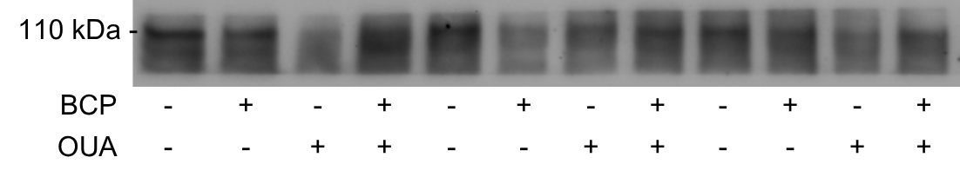
NRF2 – M1

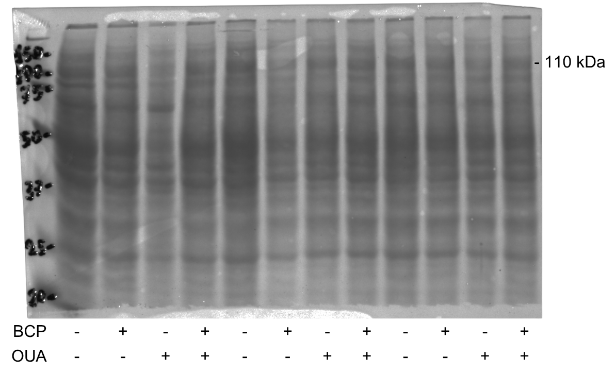
NRF2 – M1 – PonceauS

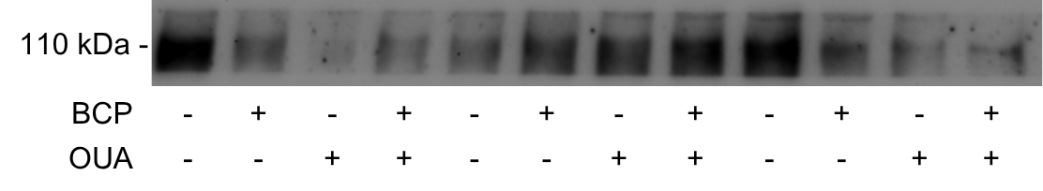
NRF2 – M2

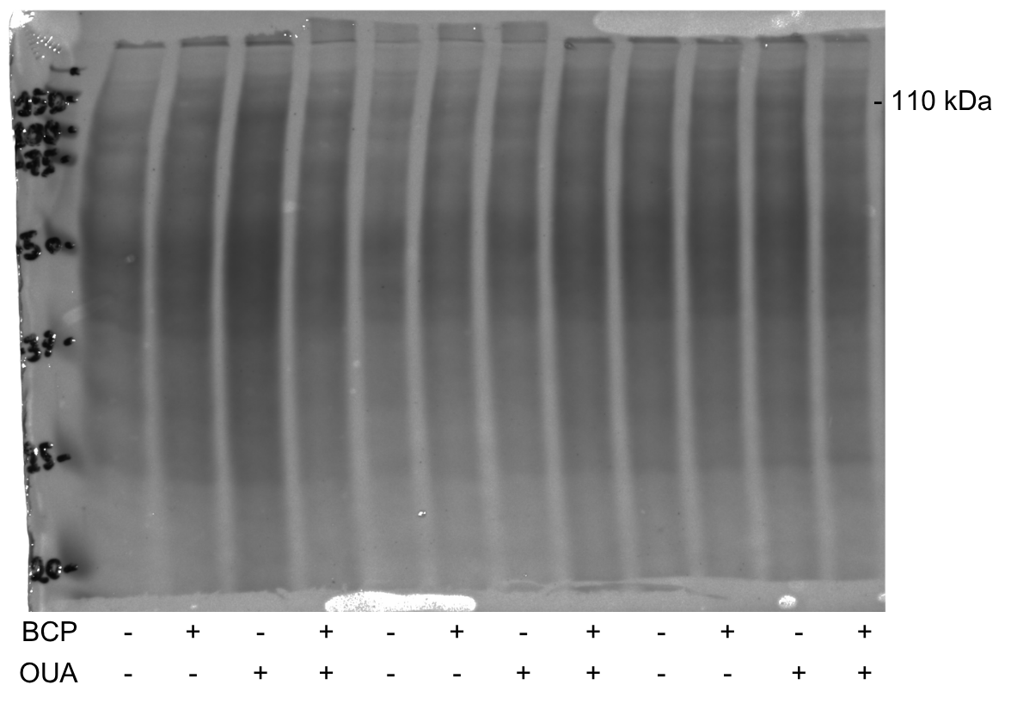
NRF2 – M2 – PonceauS

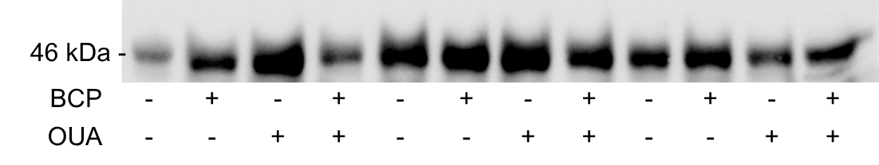
GSK-3β – M1

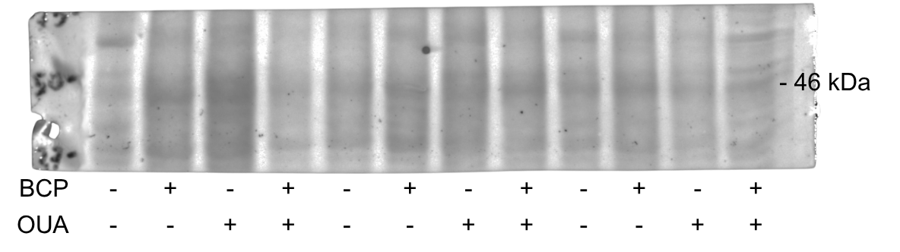
GSK-3β – M1 – PonceauS

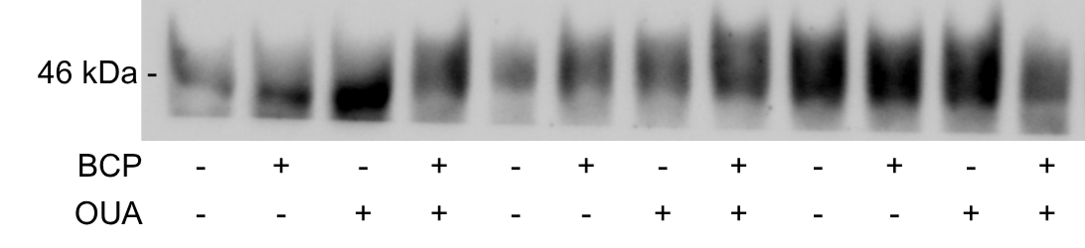
GSK-3β – M2

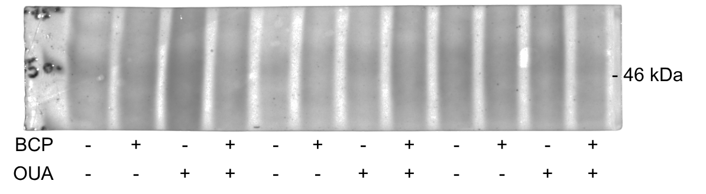
GSK-3β – M2 – PonceauS

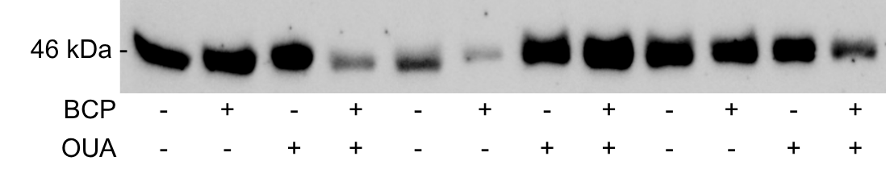
Phospho-GSK-3β (Ser⁹) – M1

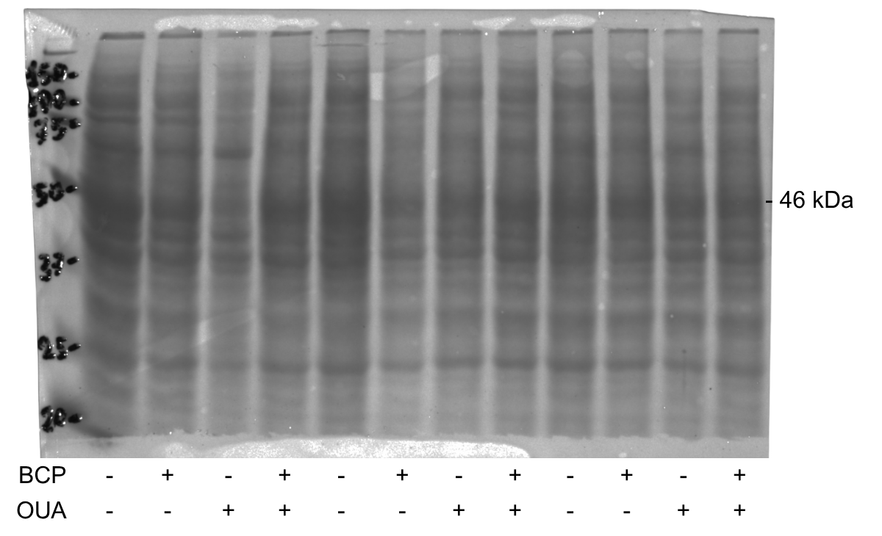
Phospho-GSK-3β (Ser⁹) – M1 – PonceauS

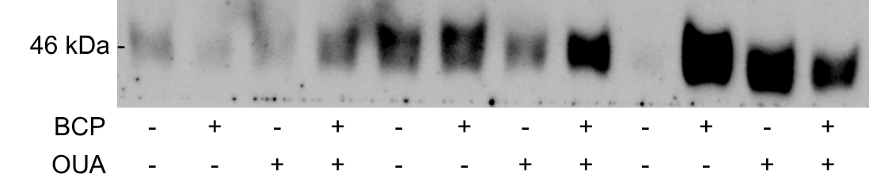
Phospho-GSK-3β (Ser⁹) – M2

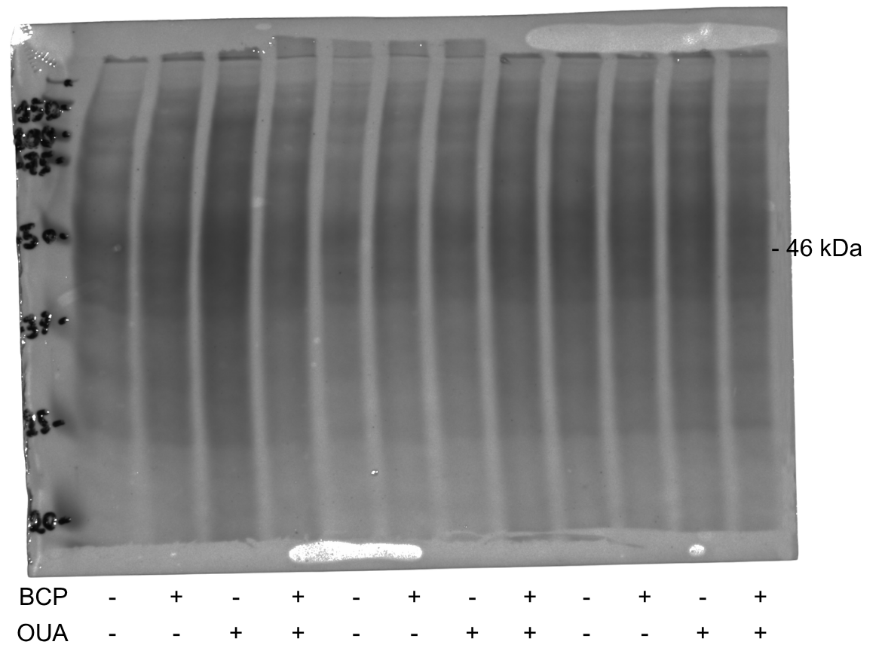
Phospho-GSK-3β (Ser⁹) – M2 – PonceauS

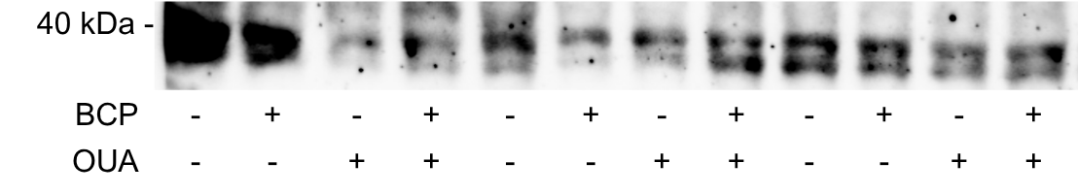
PKA – M1

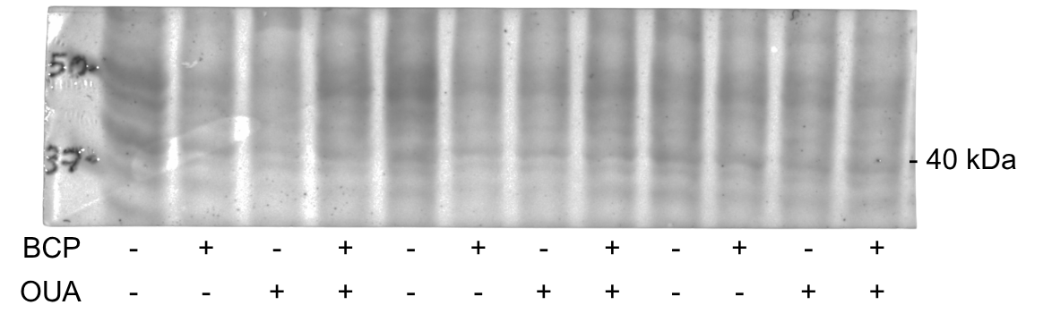
PKA – M1 – PonceauS

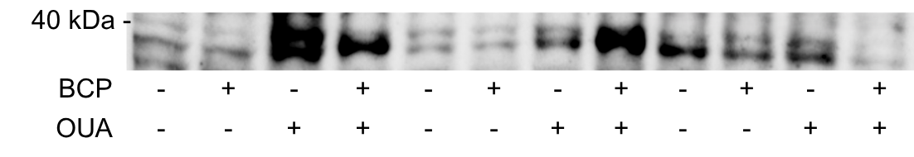
PKA – M2

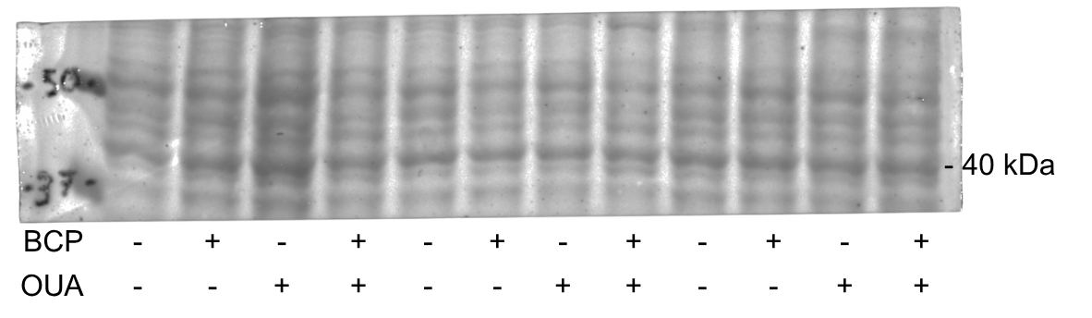
PKA – M2 – PonceauS

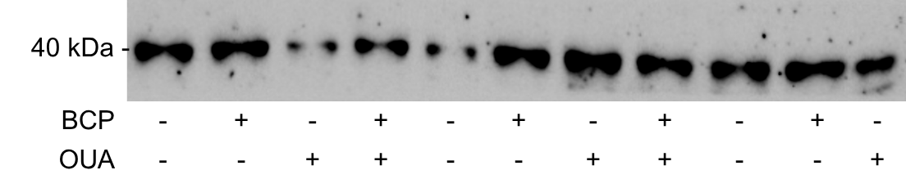
Phospho-PKA (Ser⁹⁶) – M1

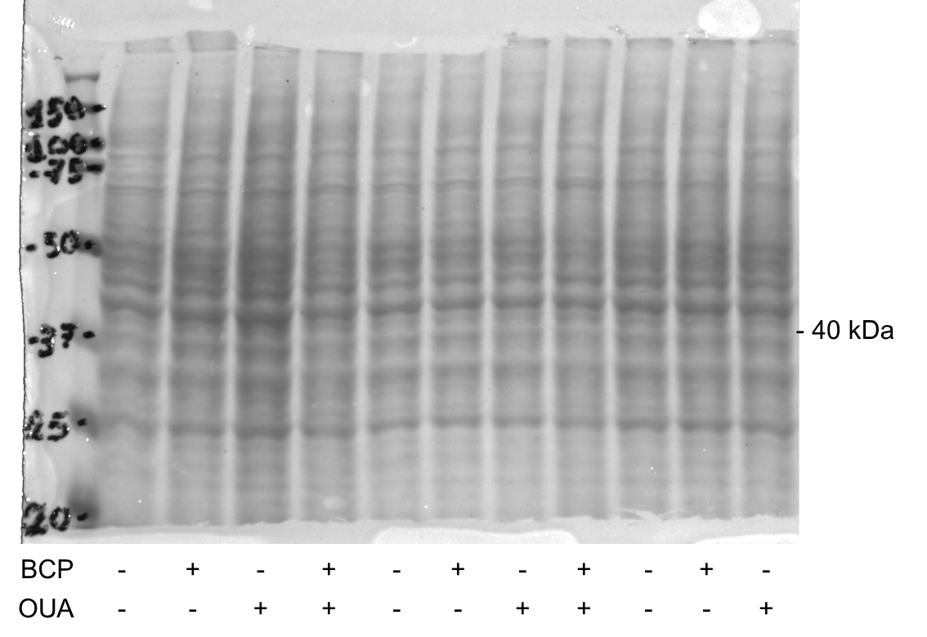
Phospho-PKA (Ser⁹⁶) – M1 – PonceauS

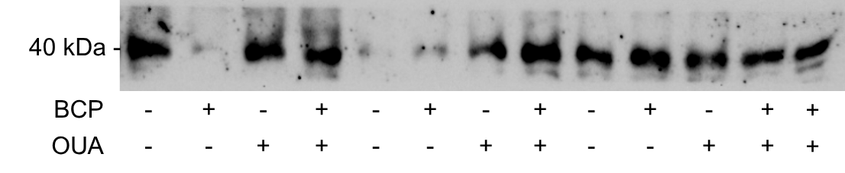
Phospho-PKA (Ser⁹⁶) – M2

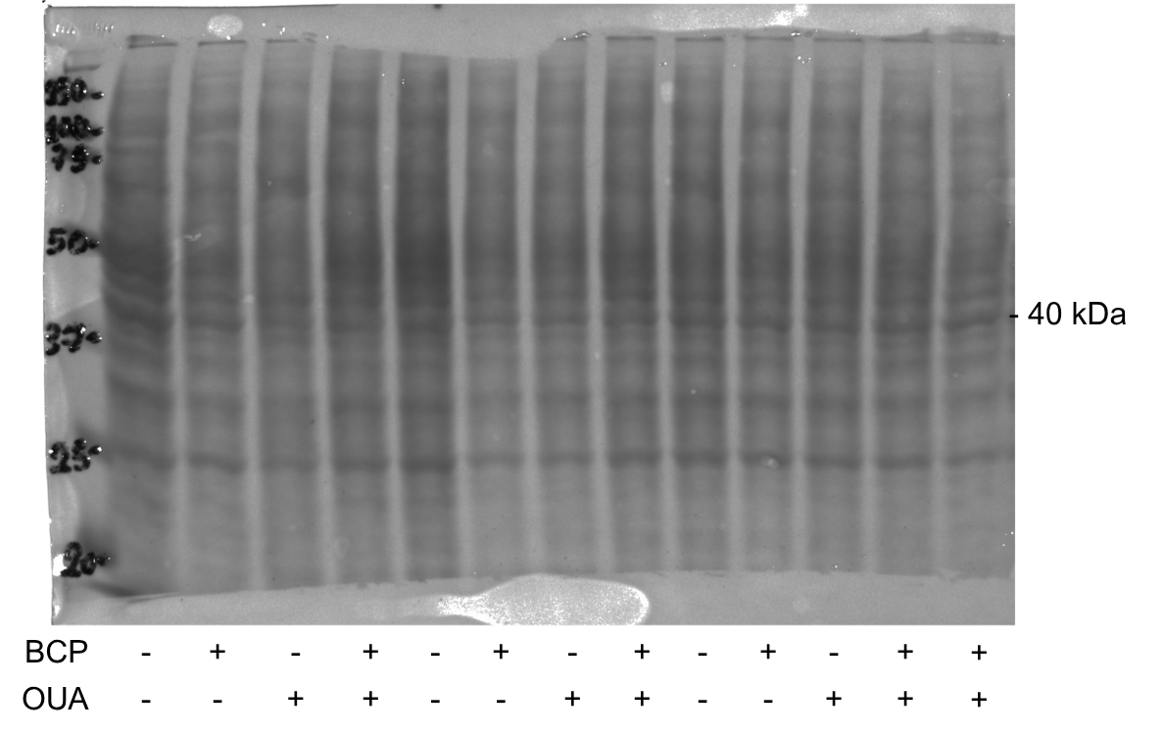
Phospho-PKA (Ser⁹⁶) – M2 – PonceauS

