Period
Severity rate (%)
Event rate (%)

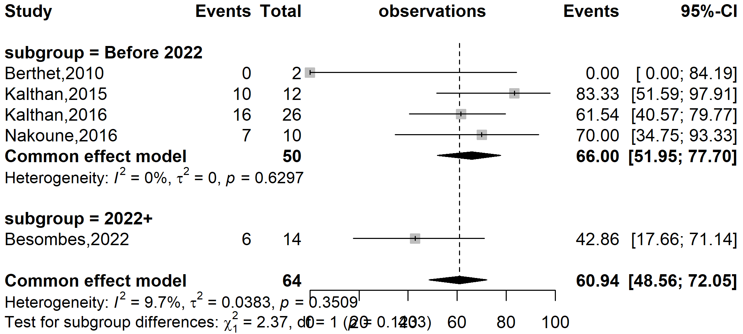
Supplementary Fig. 1 Pooled severity rate by study period among confirmed Mpox cases in Central African Republic (CAR) (the period represents before and since the 2022 pandemic)

Region
Event rate (%)

Severity rate (%)
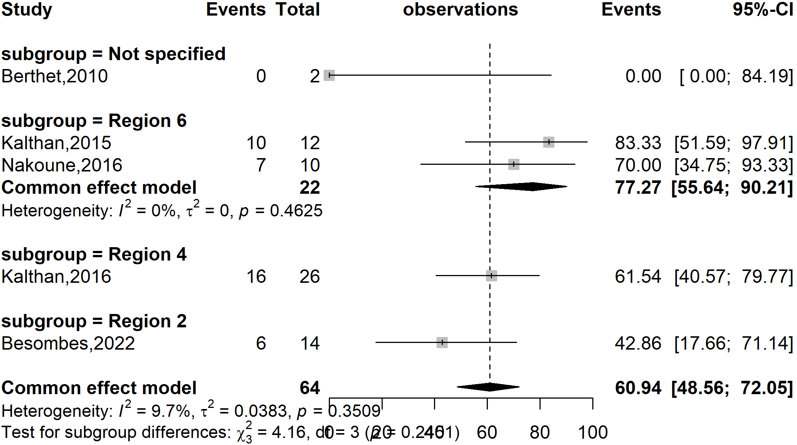
Supplementary Fig. 2 Pooled severity rate by region among confirmed Mpox cases in CAR

Participant
Event rate (%)

Severity rate (%)
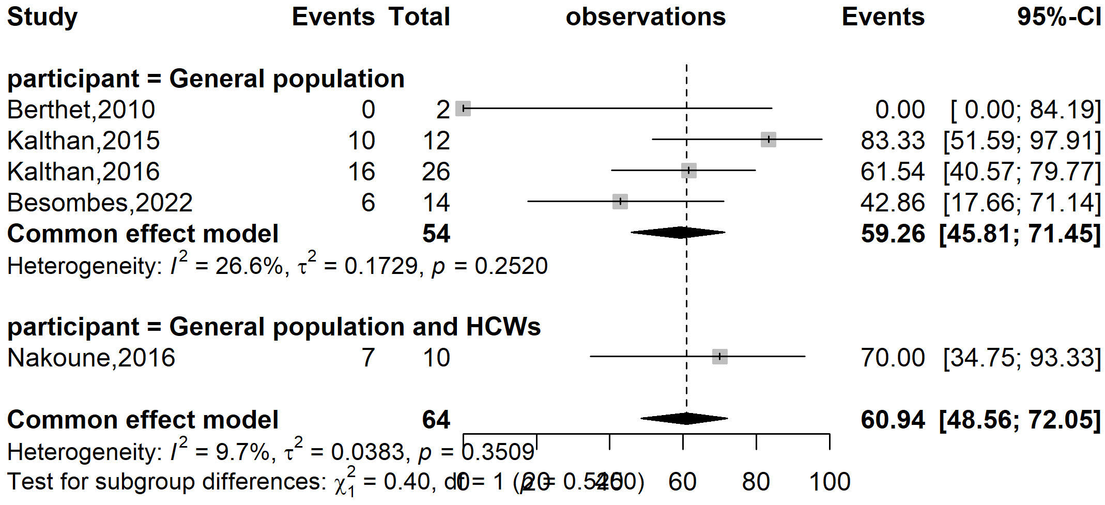
Supplementary Fig. 3 Pooled severity rate by type of participants involved among confirmed Mpox cases in CAR (HCWs: Healthcare workers)

Publication bias

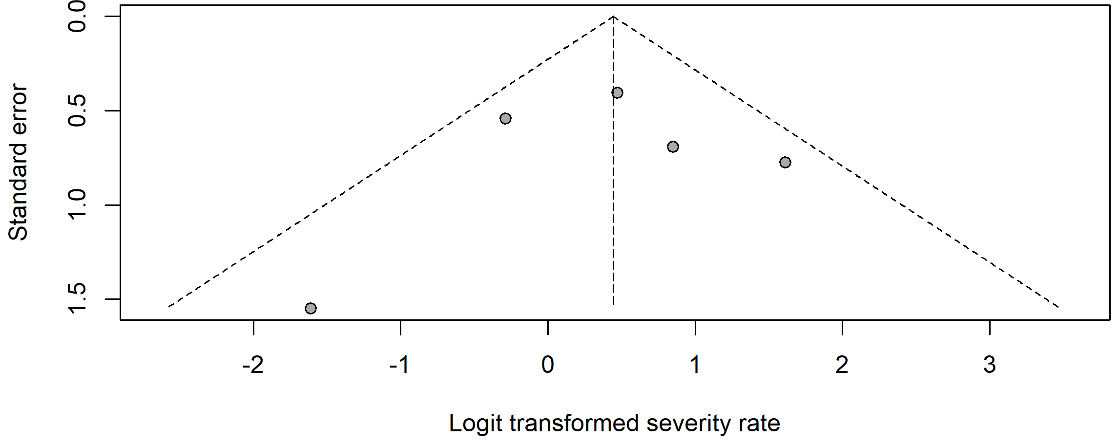
Supplementary Fig. 4 Funnel plot with pseudo 95% confidence limits and tests assessing the publication bias of studies included

Sensitivity analysis
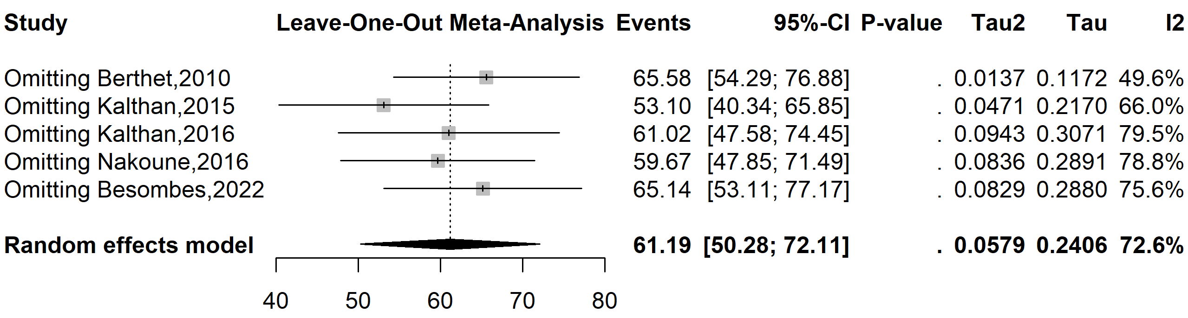
Supplementary Fig. 5 Sensitivity analysis of the Mpox severity rate pooled estimate among confirmed cases in CAR

