Discovering the pharmacodynamics of conolidine and cannabidiol using a cultured neuronal network based workflow

G D C Mendis¹, G Berecki², E Morrisroe², S Pachernegg², M Li², M Varney³, P B Osborne⁴, C A Reid², S Halgamuge^{1,5} and *S Petrou^{2,4}

¹Department of Mechanical Engineering, University of Melbourne, Parkville, VIC 3010, Australia
²Florey Institute of Neuroscience and Mental Health, University of Melbourne, Parkville, VIC 3010, Australia
³Neurolixis, Inc., Dana Point, CA 92629, USA
⁴Department of Anatomy and Neuroscience, University of Melbourne, Parkville, VIC 3010, Australia
⁵Research School of Engineering, College of Engineering and Computer Science, Australian
National University, Canberra ACT 0200, Australia

Corresponding Author: spetrou@unimelb.edu.au

Supplementary Material

Supplementary Table 1 - Definitions of extracted parameters and average values observed in baseline conditions
Average values were calculated using baseline values of all samples used in this study.
Parameter | Mean ± Standard Error of Mean | Definition
avgSCBDur | 87.99 ± 2.51 ms | Duration of single channel bursts averaged across all bursts in all bursting channels
cvSCBDur | 1.36 ± 0.03 | Coefficient of variation of durations of all single channel bursts in all bursting channels
rSCBDur | 1167.52 ± 49.63 ms | Range of durations of all single channel bursts in all bursting channels
avgSCBSize | 16.48 ± 0.53 | Number of spikes in single channel bursts averaged across all bursts in all bursting channels
cvSCBSize | 1.20 ± 0.03 | Coefficient of variation of the number of spikes in single channel bursts in all bursting channels
rSCBSize | 209.74 ± 10.80 | Range of the number of spikes in single channel bursts in all bursting channels
avgNBDur | 177.04 ± 4.26 ms | Network bursts durations averaged across all network bursts
cvNBDur | 0.89 ± 0.02 ms | Coefficient of variation of durations of network bursts
rNBDur | 877.38 ± 41.41 ms | Range of durations of network bursts
avgINBI | 3.12 ± 0.15 s | Inter network burst intervals averaged across all network bursts
cvINBI | 0.71 ± 0.01 | Coefficient of variation of inter network burst intervals
rINBI | 10.37 ± 0.51 s | Range of inter network burst intervals
avgJitter | 80.57 ± 1.87 ms | Jitter between single channel bursts participating in each network burst, averaged across all network bursts
cvJitter | 1.01 ± 0.03 | Coefficient of variation of the jitter between single channel bursts participating in a network burst
rJitter | 498.55 ± 27.93 ms | Range of the jitter between single channel bursts participating in a network burst
NBRate | 0.38 ± 0.02 Hz | Number of network bursts per second
avgNBAmp | 2.10 ± 0.08 µV | Sum of amplitudes of spikes included in a network burst divided by the network burst duration$\left(\frac{\sum{Spike amplitudes}}{Network burst duration}\right)$. Calculated per network burst and averaged across network burst
MFRAll | 6.91 ± 0.27 Hz | Mean firing rate $\left(MFR= \frac{Number of spikes}{Recording time} \right)$ calculated per channel and averaged across channels
MFRIn | 93.91 ± 2.99 Hz | Mean firing rate inside network bursts calculated per channel and averaged across channels
MFROut | 1.65 ± 0.17 Hz | Mean firing rate outside bursts calculated per channel and averaged across channels
MFRRatio | 1361.27 ± 140.35 | Ratio between MFRIn and MFROut $\left(MFR Ratio =\frac{MFRIn}{MFROut}\right)$ calculated per channel and averaged across channels
avgSpkInNBs | 190.53 ± 7.97 | Number of spikes included in each network burst averaged across network bursts
%SpkInNBs | 84.44 ± 1.02 % | Percentage of spikes included in network bursts calculated per channel and then averaged across channels
avgAmp | 29.88 ± 0.38 µV | Amplitude of spikes averaged across each channels and then averaged across all spiking channels

Supplementary Table 2: Means and standard errors of mean observed in the percentage change in features
Feature | Baclofen 1 µM |  | Bicuculline 20 µM |  | Cannabidiol 10 µM |  | Carbamazepine 10 µM |  | Conolidine 30 µM |  | CVIE 100 nM
Feature | Mean | SEM | Mean | SEM | Mean | SEM | Mean | SEM | Mean | SEM | Mean | SEM
avgSCBDur | 102.6 | 34.1 | 29.4 | 9.6 | 7.5 | 4.8 | 14.7 | 15.7 | -27.1 | 7.4 | 17.1 | 9.4
cvSCBDur | -20.3 | 10.1 | -56.3 | 3.0 | -16.4 | 6.0 | 43.7 | 14.3 | -43.4 | 4.9 | -43.5 | 4.4
rSCBDur | -22.1 | 11.4 | -70.9 | 3.2 | -14.5 | 10.1 | 74.1 | 29.8 | -64.4 | 3.4 | -44.7 | 6.8
avgSCBSize | 74.0 | 27.7 | 117.9 | 19.9 | 24.3 | 6.0 | -45.4 | 5.3 | 7.7 | 8.7 | 30.9 | 9.5
cvSCBSize | 0.5 | 13.1 | -46.7 | 4.0 | -22.7 | 5.0 | 7.6 | 4.5 | -56.3 | 3.6 | -42.9 | 4.2
rSCBSize | -22.2 | 11.3 | -49.8 | 8.9 | -7.8 | 11.9 | -30.7 | 7.0 | -73.8 | 2.9 | -47.9 | 6.3
avgNBDur | 85.1 | 30.6 | 20.6 | 7.4 | -14.8 | 4.0 | 81.1 | 73.9 | -18.6 | 7.8 | 25.2 | 8.6
cvNBDur | -28.0 | 10.6 | -64.0 | 4.7 | -19.8 | 6.5 | 39.9 | 6.7 | -47.0 | 5.7 | -42.1 | 5.1
rNBDur | -31.0 | 10.8 | -52.7 | 9.7 | -25.5 | 8.7 | 122.5 | 72.8 | -63.8 | 3.4 | -31.3 | 12.1
avgINBIs | 986.5 | 226.2 | 17.1 | 11.6 | 33.2 | 8.4 | 7.9 | 30.5 | 139.3 | 24.4 | 54.8 | 11.8
cvINBIs | 37.9 | 17.9 | -32.5 | 5.3 | -39.6 | 2.6 | 64.5 | 16.3 | -37.5 | 8.3 | -8.7 | 6.4
rINBIs | 569.1 | 146.3 | -33.5 | 6.5 | -9.5 | 10.2 | 129.0 | 66.5 | 12.6 | 17.0 | 12.2 | 12.4
avgJitter | -6.5 | 14.1 | -50.7 | 6.9 | -23.3 | 6.2 | 150.8 | 128.9 | -9.8 | 9.2 | 27.6 | 8.0
cvJitter | -27.1 | 11.5 | -38.5 | 10.9 | -13.4 | 6.8 | 35.5 | 6.2 | -26.9 | 7.7 | -25.4 | 4.0
rJitter | -57.5 | 8.4 | -67.6 | 8.8 | -36.3 | 7.6 | 138.4 | 86.5 | -41.5 | 8.1 | -17.3 | 9.4
NBRate | -85.9 | 7.0 | -2.4 | 8.0 | -18.2 | 4.8 | 27.4 | 15.8 | -49.8 | 4.5 | -29.3 | 4.7
avgNBAmp | -2.7 | 20.1 | 130.3 | 18.9 | 60.0 | 11.3 | -69.1 | 4.4 | 54.9 | 8.3 | -0.8 | 4.7
MFRAll | -75.6 | 5.3 | 126.3 | 26.1 | -45.1 | 2.6 | -43.3 | 6.2 | -52.4 | 3.9 | -6.3 | 5.6
MFRIn | 8.6 | 15.2 | 136.6 | 22.9 | 42.5 | 8.7 | -68.9 | 3.5 | 49.2 | 10.8 | 12.0 | 5.2
MFROut | -56.9 | 8.1 | -40.8 | 24.5 | -79.6 | 2.1 | 43.0 | 25.2 | -75.2 | 5.0 | -20.7 | 11.2
MFRRatio | 1162 | 338.5 | 1749 | 514 | 938 | 198 | -90.5 | 2.2 | 1686 | 357 | 712 | 258
avgSpkInNB | 93.5 | 28.3 | 204.9 | 40.3 | 18.4 | 5.9 | -52.5 | 18.1 | 17.0 | 11.7 | 40.7 | 11.9
%SpkInNBs | -15.5 | 9.4 | 33.5 | 24.1 | 40.0 | 4.8 | -21.8 | 6.3 | 7.4 | 2.8 | 3.0 | 2.4
avgAmp | -4.7 | 2.4 | -5.8 | 1.7 | 5.2 | 3.7 | -15.5 | 2.3 | 12.6 | 2.3 | 4.4 | 1.3

Feature | Diazepam  1 µM |  | LY341495  5 µM |  | Morphine  10 µM |  | Nickel  200 µM |  | ZD7288  20 µM
Feature | Mean | SEM | Mean | SEM | Mean | SEM | Mean | SEM | Mean | SEM
avgSCBDur | -43.9 | 2.2 | 19.9 | 11.2 | -0.8 | 4.4 | -21.6 | 6.0 | 159.6 | 27.8
cvSCBDur | 11.4 | 5.6 | -29.0 | 4.9 | 0.9 | 4.4 | -11.6 | 8.3 | -24.3 | 5.3
rSCBDur | -54.5 | 5.9 | -39.8 | 8.7 | 8.4 | 20.1 | -24.8 | 18.6 | -5.5 | 9.7
avgSCBSize | -55.9 | 1.8 | 14.5 | 7.7 | 0.7 | 4.7 | -36.0 | 3.9 | 61.9 | 11.9
cvSCBSize | -0.4 | 6.5 | -25.5 | 5.6 | 6.5 | 5.0 | -29.1 | 4.9 | 8.1 | 10.4
rSCBSize | -55.2 | 7.6 | -43.3 | 9.9 | 4.2 | 8.6 | -62.3 | 5.3 | 19.6 | 39.2
avgNBDur | -40.2 | 2.7 | 19.5 | 13.9 | -6.1 | 3.1 | -16.9 | 6.3 | 232.4 | 42.9
cvNBDur | -1.6 | 5.3 | -28.7 | 6.4 | 5.3 | 5.9 | -29.1 | 5.4 | -38.9 | 6.4
rNBDur | -44.4 | 6.2 | -32.6 | 13.2 | 1.7 | 7.5 | -48.4 | 6.3 | 17.2 | 16.2
avgINBIs | -39.7 | 5.4 | 248.8 | 32.2 | -16.9 | 5.2 | 65.7 | 18.4 | 498.8 | 75.1
cvINBIs | -28.0 | 4.7 | 40.1 | 11.1 | 9.0 | 4.5 | 2.9 | 12.0 | -15.6 | 9.1
rINBIs | -43.1 | 5.6 | 292.9 | 76.0 | -11.1 | 5.6 | 102.5 | 46.3 | 194.4 | 41.5
avgJitter | -25.3 | 4.2 | 12.1 | 13.8 | 2.4 | 4.1 | -1.9 | 8.6 | 225.4 | 56.5
cvJitter | -1.6 | 6.1 | -25.3 | 5.7 | 2.5 | 4.5 | -15.0 | 5.6 | -33.2 | 5.4
rJitter | -32.5 | 8.5 | -37.6 | 9.9 | 8.5 | 9.1 | -28.9 | 7.7 | 18.6 | 16.8
NBRate | 84.9 | 12.9 | -60.2 | 10.1 | 29.2 | 8.5 | -25.9 | 8.3 | -76.1 | 3.9
avgNBAmp | -50.1 | 3.3 | 2.1 | 7.4 | -3.9 | 7.7 | -30.4 | 6.6 | -22.0 | 13.5
MFRAll | -33.5 | 3.5 | -57.9 | 3.8 | 11.0 | 4.8 | -49.3 | 3.8 | -50.7 | 5.9
MFRIn | -44.7 | 3.4 | 10.8 | 8.1 | -0.1 | 5.5 | -25.8 | 6.3 | -21.8 | 4.3
MFROut | 24.1 | 7.8 | 3.0 | 41.8 | -1.2 | 3.7 | 15.0 | 11.0 | -62.0 | 6.9
MFRRatio | -59.8 | 11.8 | 2663.6 | 1219.2 | 7.6 | 26.0 | -30.8 | 13.2 | 417.0 | 98.9
avgSpkInNB | -67.3 | 2.1 | 22.0 | 8.7 | -7.1 | 6.1 | -43.5 | 4.9 | 125.3 | 37.3
%SpkInNBs | -9.1 | 1.2 | -3.4 | 2.9 | 1.4 | 0.5 | -12.9 | 3.3 | -1.6 | 4.9
avgAmp | -13.0 | 0.9 | -1.8 | 1.3 | 0.5 | 1.3 | -2.2 | 1.2 | -0.7 | 3.4

Supplementary Table 3: p-values resulting from paired MANOVA tests between Conolidine / Cannabidiol and each of the other drugs
Multivariate analysis of variance (MANOVA) tests were carried out using the Hotelling-Lawley method in RStudio (RStudio Team 2016, RStudio: Integrated Development for R. RStudio Inc., Boston, MA). According to p-values resulting from MANOVA, Baclofen would be the closest drug to both Conolidine and Cannabidiol. This shows that simple statistical tests such MANOVA cannot accurately determine similar drug responses, mainly due to some measured parameters being correlated to each other.
 | Conolidine | Cannabidiol
Baclofen | 0.04365 | 0.001422
Bicuculline | 0.00000003471 | 0.000003259
Carbamazepine | 0.000005783 | 0.000002703
CVIE | 0.0004207 | 0.0001061
Diazepam | 0.000006958 | 0.00002599
LY341495 | 0.001035 | 0.00004353
Morphine | 0.000002787 | 0.000012
Nickel | 0.0001154 | 0.0001456
ZD7288 | 0.001152 | 0.00000246

Supplementary Figure 1: Feature extraction in multielectrode array data
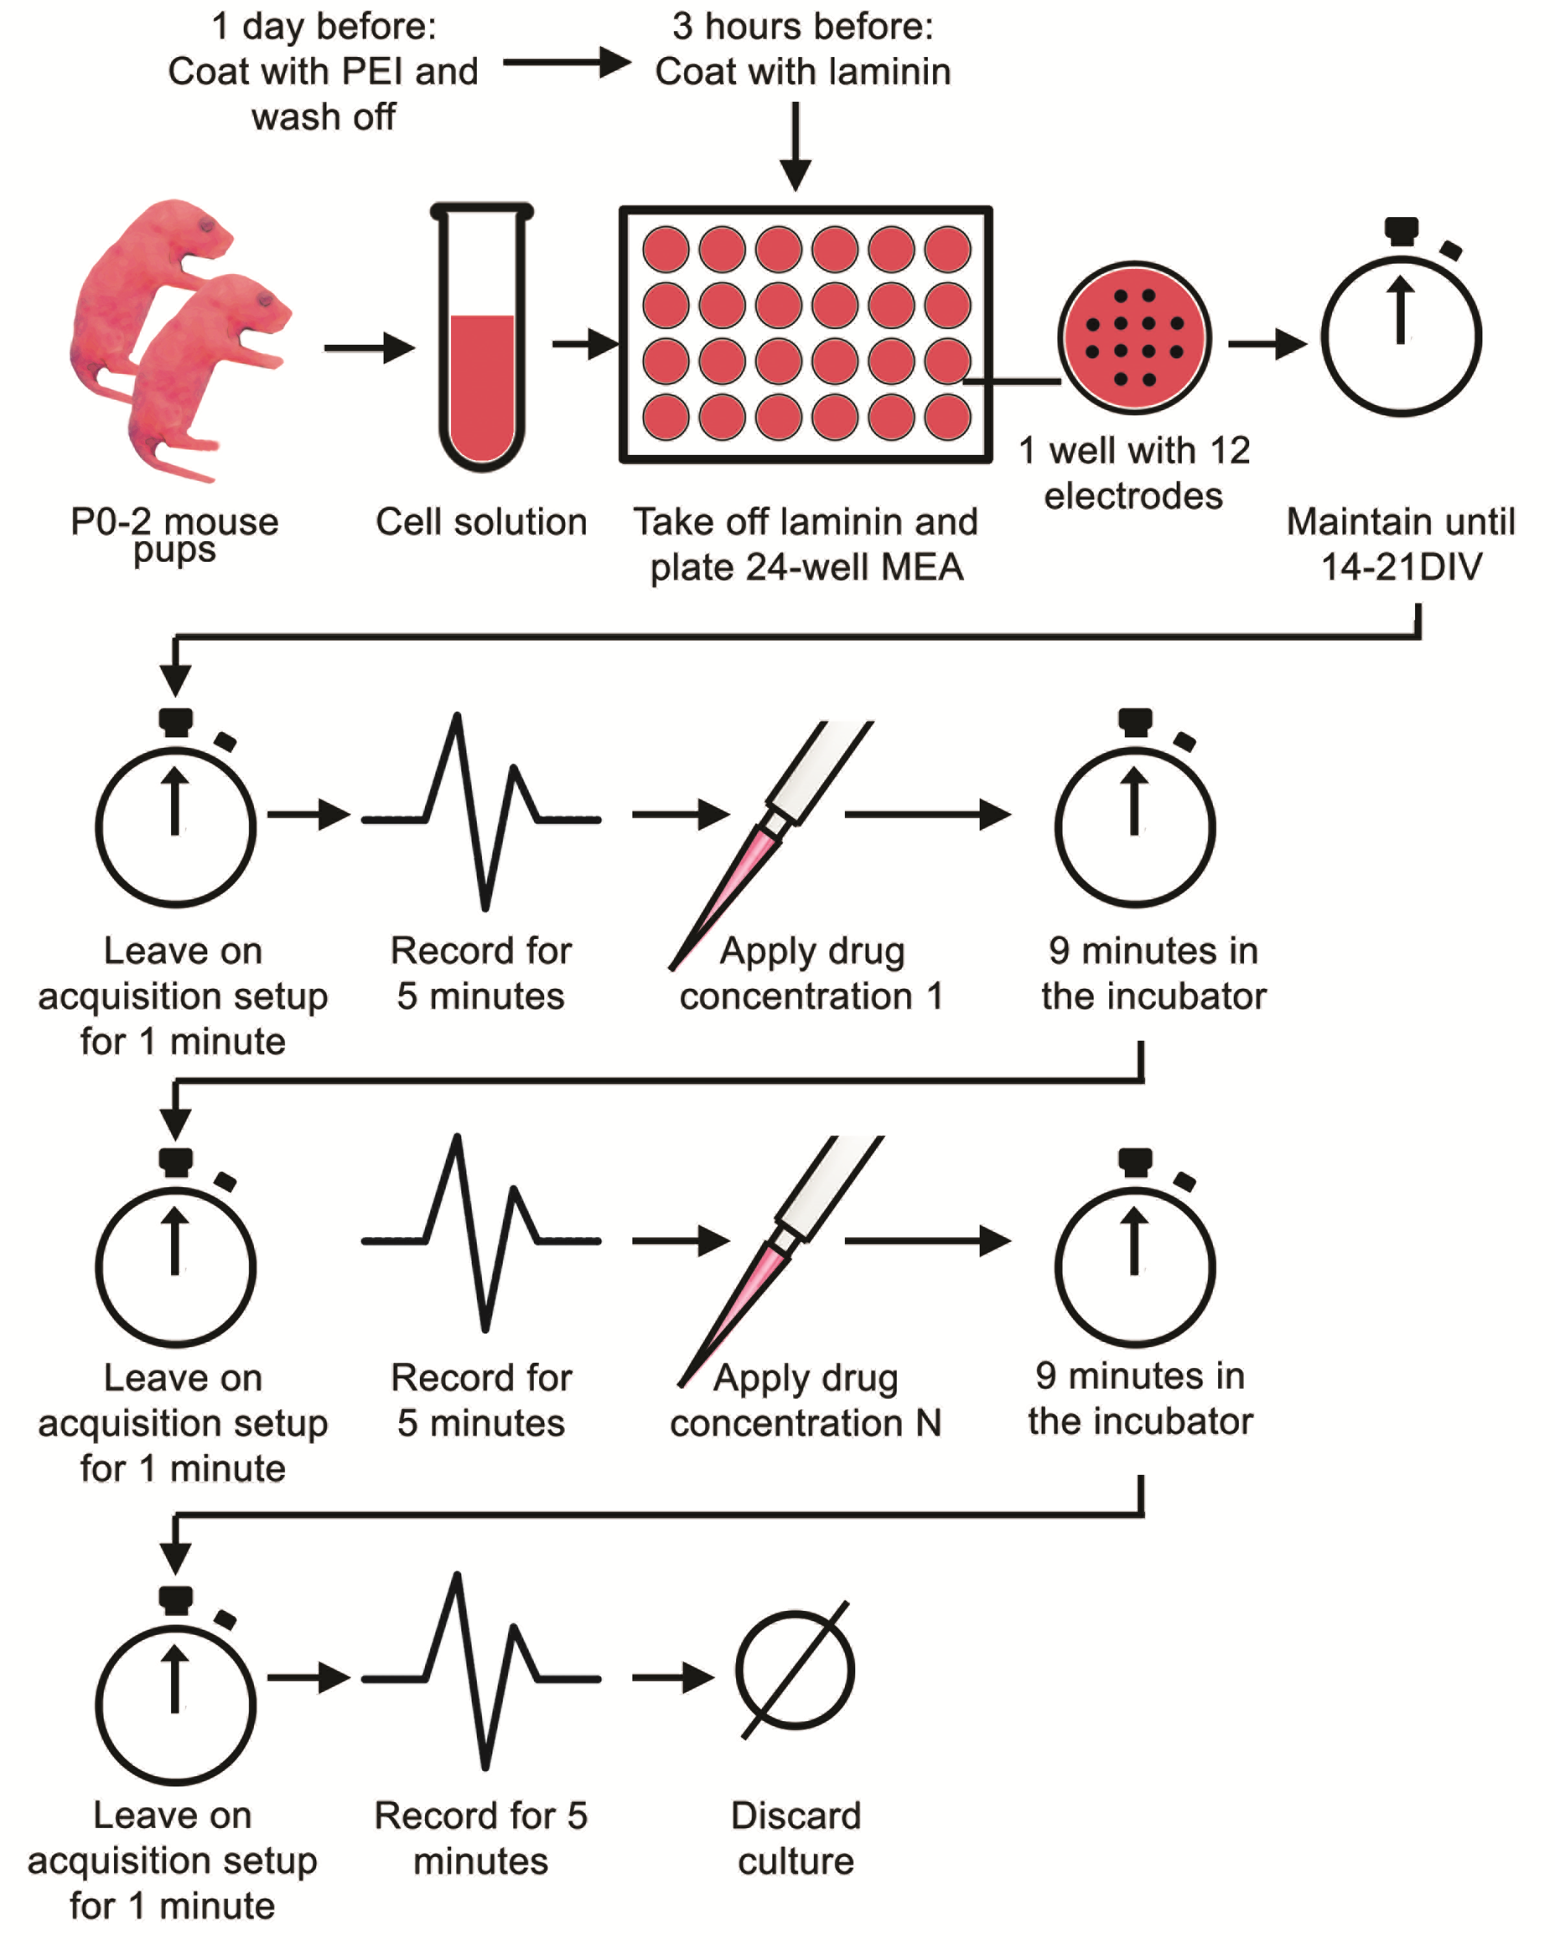

Supplementary Figure 1: The experimental workflow of testing a single drug on multielectrode arrays

Supplementary Figure 2: Feature extraction in multielectrode array data
Supplementary Figure 2: (a) 500 ms recording of 12 channels during a cluster of bursts. Noise is represented in grey while action potentials are shown in red. Action potentials are detected when they cross a threshold set as a multiple of the standard deviation of noise. (b) Dynamics of a neuronal network that can be visualized through raster plots. Each vertical line on a channel represents an action potential (spike). A succession of spikes in close temporal proximity constitutes to a burst, as shown by the group of spikes enclosed by a black rectangle. Simultaneous bursting across multiple channels, as shown in red, corresponds to a network burst (NB). The interval of time from the end of a network burst to the beginning of the next network burst is termed as an Inter-Network Burst Interval (INBI). The time interval between the start of the first single channel burst and the start of the last single-channel burst in a network burst is termed as jitter.

Supplementary Figure 3: Iris Plot
Supplementary Figure 3: Iris plot. Each segment in the circle represents one feature. The colour scales represent the significance of p values (* - p < 0.05, ** - p < 0.01, *** - p < 0.001, **** - p < 0.0001) resulting from paired t-tests (corrected for multiple comparisons) between before and after conditions of a given drug. The red colour scale represents increases and the blue colour scale represents decreases from baseline conditions.

Supplementary Figure 4: Raster plots of baseline activity
Supplementary Figure 4: Raster plots of baseline activity of three cultures, which show network bursting and non-synchronous spikes that occurred between network bursts. Black ticks in each channel represent spike timestamps while red ticks at the bottom represent detected network bursts.

Supplementary Figure 5: Changes in network behavior evoked by 0.1% DMSO
Supplementary Figure 5: Changes in network behaviour evoked by 0.1% DMSO. (a) Representative raster plots of baseline activity of a culture and the activity after application of 0.1% DMSO. (b) Iris plot of conolidine. Each segment in the circle represents one feature. The colour scales represent the significance of p values (* - p < 0.05, ** - p < 0.01, *** - p < 0.001, **** - p < 0.0001) resulting from paired t-tests (n=12) corrected for multiple comparisons.

Supplementary Figure 6: Changes in network behavior evoked by Morphine, LY341495, ZD7288, Diazepam and Carbamazepine
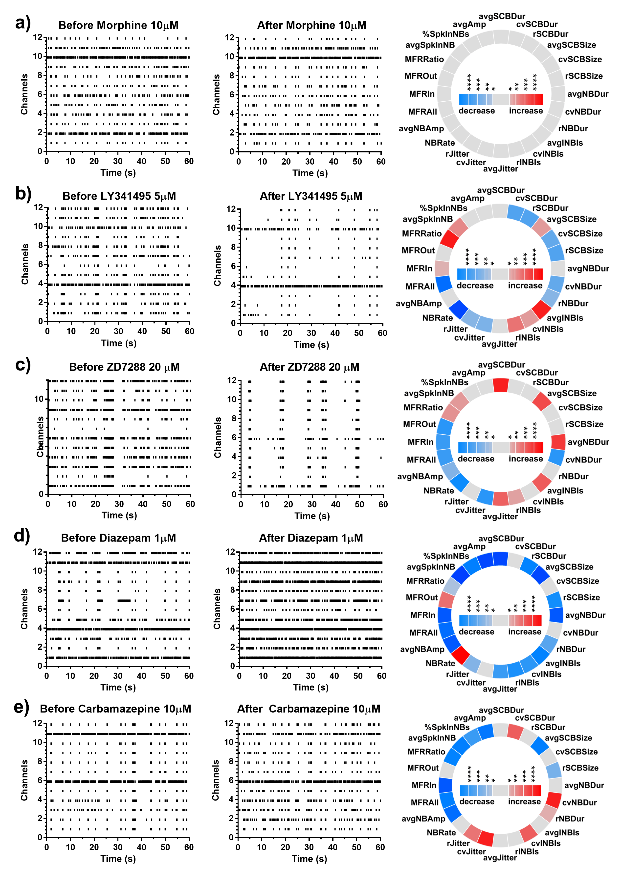
Supplementary Figure 6: Changes in network behaviour evoked by (a) 10 µM Morphine, (b) 5 µM LY341495, (c) 20 µM ZD7288, (d) 1 µM Diazepam and (e) 10 µM Carbamazepine. In each sub plot, representative raster plots of baseline activity of a culture, the activity after drug application and an iris plot showing the statistically significant changes in network features are shown. In the iris plot, each segment in the circle represents one feature. The colour scales represent the significance of p values (* - p < 0.05, ** - p < 0.01, *** - p < 0.001, **** - p < 0.0001) resulting from paired t-tests corrected for multiple comparisons.

Supplementary Figure 7: Distribution of individual samples after Principal Component Analysis and Multi-Dimensional Scaling for Conolidine and other drugs

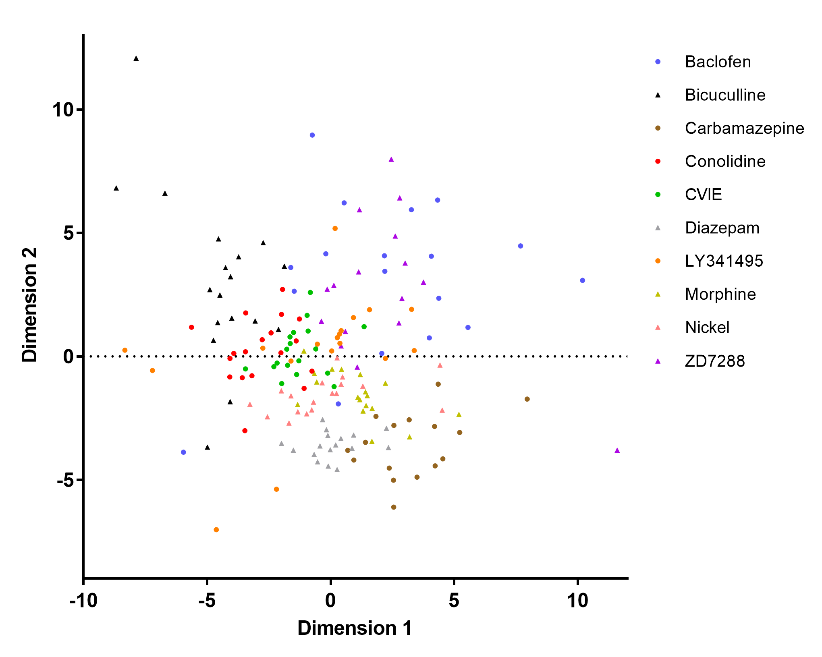

Supplementary Figure 8: Distribution of individual samples after Principal Component Analysis and Multi-Dimensional Scaling for Cannabidiol and other drugs
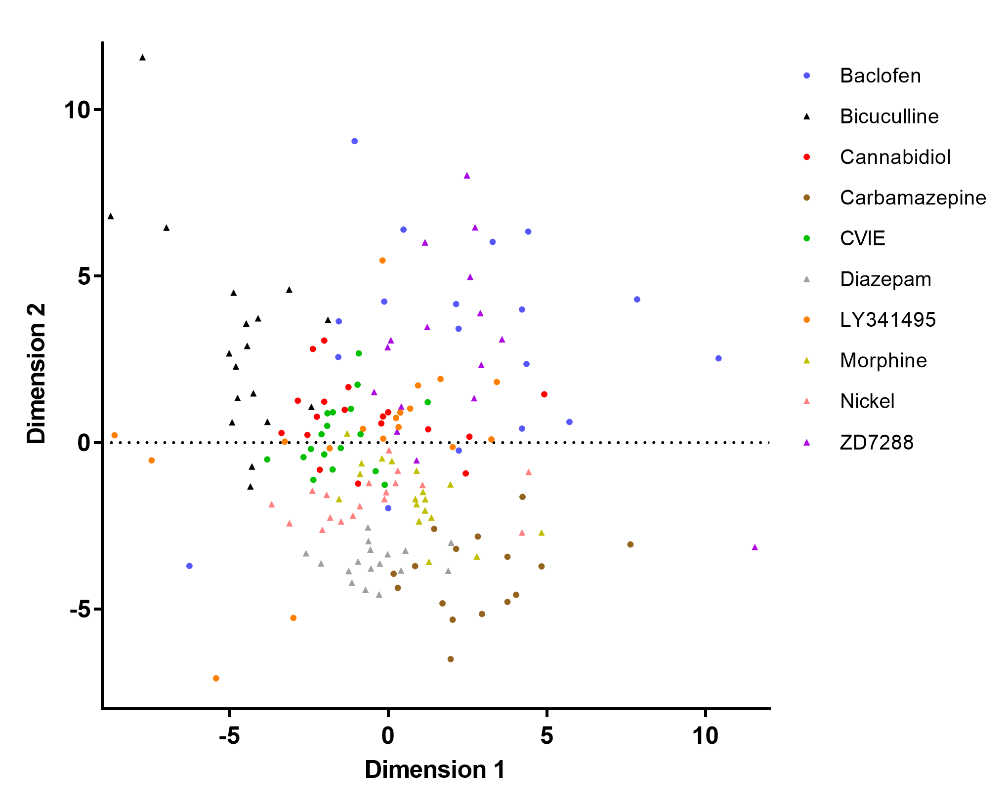
* Scales have been set for optimum visibility of the center of the cluster of points without excluding too many outliers

