S1 Fig: Multivariate Odds Ratios of Outcomes in Patients with Concurrent Cardiotoxic Substance Use and in Patients > 70 Years of Age.

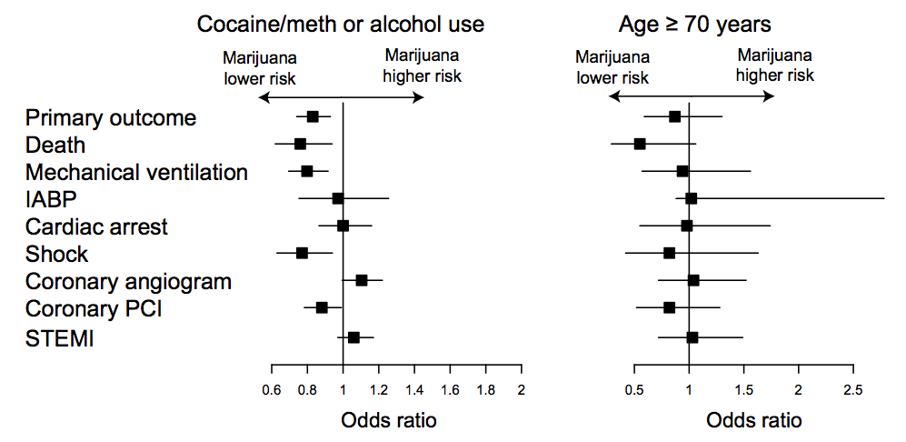

Abbreviations: Vent, Mechanical ventilation; IABP, Intraaortic balloon pump; VF, Ventricular fibrillation; VT, Ventricular tachycardia; Coronary angio, Coronary angiogram; PCI, Percutaneous coronary intervention; STEMI= ST elevation myocardial infarction

