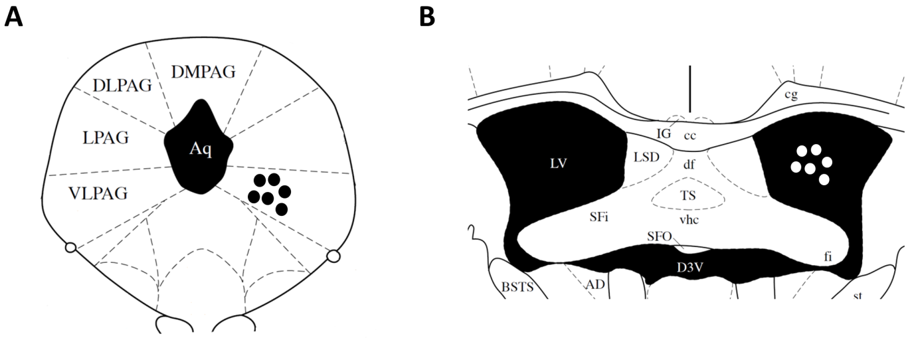
Additional file 1

Figure S1. The representative diagram of i.pag. (A) and i.c.v. (B) microinjections in mice. The diagrams were adapted from mouse brain atlas [44]. The black dots (A) and white dots (B) represent the microinjection sites.

