Supplementary Material

Supplementary Figures and Tables
 | Motion |  |  | Form
 | controls | non-heavy  user | heavy  user | controls | non-heavy  user | heavy  user
n | 50 | 38 | 42 | 50 | 38 | 42
Mean | 20.34 | 18.66 | 28.76 | 20.60 | 19.79 | 17.43
95% CI A. Mean Lower | 18.09 | 16.29 | 26.17 | 18.04 | 17.00 | 15.06
95% CI A. Mean Upper | 22.59 | 21.03 | 31.36 | 23.16 | 22.58 | 19.80
Std. Deviation | 7.901 | 7.212 | 8.325 | 8.992 | 8.479 | 7.597
Pairwise comparison | Motion: Hedges' g (95% CI) |  |  | Form: Hedges' g (95% CI)
Non-heavy users vs. controls | -0.22 [-0.64, 0.20] |  |  | -0.09 [-0.51, 0.33]
Heavy users vs. controls | 1.03 [0.59, 1.47] |  |  | -0.37 [-0.79, 0.04]
Heavy users vs. non-heavy users | 1.28 [0.80, 1.76] |  |  | -0.29 [-0.73, 0.15]

Supplementary Table 1. Descriptive statistics and pairwise standardized effect sizes from the form and motion coherence tasks.

Correlation matrix of the variables
Pearson's Correlations
Variable |  |  |  | Motion |  | Form |  | age |  | SES |  | IQ |  | CEI |  | BAI |  | BDI2
1. Motion |  | Pearson's r |  | —
 |  | p-value |  | —
2. Form |  | Pearson's r |  | -0.138 |  | —
 |  | p-value |  | 0.116 |  | —
3. age |  | Pearson's r |  | 0.148 |  | -0.147 |  | —
 |  | p-value |  | 0.092 |  | 0.094 |  | —
4. SES |  | Pearson's r |  | -0.098 |  | 0.019 |  | 0.086 |  | —
 |  | p-value |  | 0.266 |  | 0.828 |  | 0.329 |  | —
5. IQ |  | Pearson's r |  | 0.006 |  | 0.182 | * | -0.087 |  | -0.148 |  | —
 |  | p-value |  | 0.943 |  | 0.038 |  | 0.322 |  | 0.092 |  | —
6. CEI |  | Pearson's r |  | 0.373 | *** | -0.181 |  | -0.158 |  | -0.112 |  | -0.050 |  | —
 |  | p-value |  | <.001 |  | 0.108 |  | 0.162 |  | 0.324 |  | 0.663 |  | —
7. BAI |  | Pearson's r |  | 0.215 | * | -0.098 |  | -0.040 |  | -0.047 |  | -0.054 |  | 0.100 |  | —
 |  | p-value |  | 0.014 |  | 0.266 |  | 0.651 |  | 0.599 |  | 0.542 |  | 0.379 |  | —
8. BDI2 |  | Pearson's r |  | 0.086 |  | 0.003 |  | 0.004 |  | -0.064 |  | 0.032 |  | 0.128 |  | 0.140 |  | —
 |  | p-value |  | 0.328 |  | 0.972 |  | 0.965 |  | 0.467 |  | 0.714 |  | 0.258 |  | 0.111 |  | —
* p < .05, ** p < .01, *** p < .001 (uncorrected values)

Supplementary Table 2. Correlation matrix of variables.

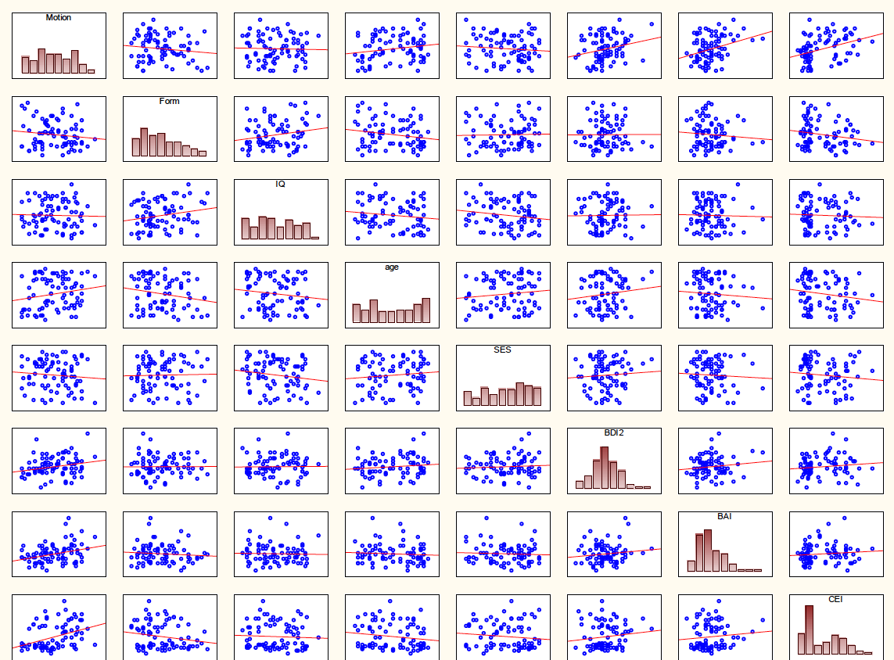

Supplementary Figure 1. Scatterplot of the correlation matrix showing the raw data.
BAI – Beck Anxiety Inventory, BDI-II – Beck Depression Inventory-II CEI - Cannabis Exposure Inventory, SES – socioeconomic status

