SUPPLEMENTARY INFORMATIONS

Methods

Quantify CBD in mouse plasma

Quantification of CBD was performed using the appropriate calibration standards prepared in blank plasma and standard approaches. Briefly, eight calibration standards were prepared in mouse plasma for quantitation of CBD in study samples. Three quality control (QC) samples, high, mid and low, were prepared by diluting the highest standard (50,000 ng/mL CBD) with naive mouse plasma. Calibration standards, QC samples and study samples (plasma) were processed for LC/MS/MS analysis by precipitating each sample with an internal standard solution (acetonitrile containing 50 ng/mL of dextromethorphan, 5 ng/mL diphenhydramine and 125 ng/mL diclofenac). The precipitated samples were centrifuged and each supernatant was transferred to an autosampler plate.

Plasma samples were analyzed using the following LC/MS/MS conditions: HPLC: Shimadzu VP Series 10 System
Autosampler; Shimadzu SIL HTc at ambient temperature; Mobile Phase: A = 0.2% formic acid in water, B = 0.2% formic acid in methanol; Column: 2.1 x 10 mm Peeke Scientific Duragel G C18 guard cartridge; Injection Volume: 10 µL; Gradient: 5% B for 0.25 minutes, then 95% B in 1.25 minutes; Flow Rate: 800 µL/min
Mass Spectrometer: Applied Biosystems/MDS SCIEX API 3000; Interface: TurboIonSpray (ESI) at 400º C; Software: Analyst v1.4.1; Polarity: Positive Ion; Q1/Q3 Ions: 315.13/193.2 for CBD 256.2/167.2 for Diphenhydramine (I.S.) and 272.1/215.2 for Dextromethorphan (I.S.).

Cell Authentication
Human Cell Line Authentication using short-tandem repeat profiling (STR) has been performed for all patient patient-derived primary cells (GBM163 and 3832). Cell lines were obtained from ATCC or collaborators and have been previously authenticated.

Table 1. PK parameters for CBD after i.p. administration
Compound | Route | Dose (mg/kg) | Compound Analyzed | AUC_{0-t}  (µg·hr/mL) | AUC_{0-inf}  (µg·hr/mL) | T_{1/2}  (hr) | C_{max}  (µg/mL) | T_{max}  (hr)
Cannabidiol | IP | 15 | CBD | 1.63 | 1.83 | 7.59 | 3.34 | 0.083
Cannabidiol | IP | 7.5 | CBD | 0.599 | ND | ND | 1.31 | 0.083
ND = not determined as a result of insufficient data. AUC = Area under the curve, T1/2 = half-life, C_{max} = maximum plasma concentration achieved, T_{max} = Time to reach C_{max}.

Supplementary Figure 1. Plasma concentration-time curve for CBD. 15 mg/kg or 7.5 mg/kg of CBD was administered i.p. and blood was collected over a time course of 48 hours. Plasma concentrations are presented on a semi-log scale. In the 15 mg/kg and 7.5 mg/kg group, CBD concentrations were undetectable after 12 and 5 hours, respectively.
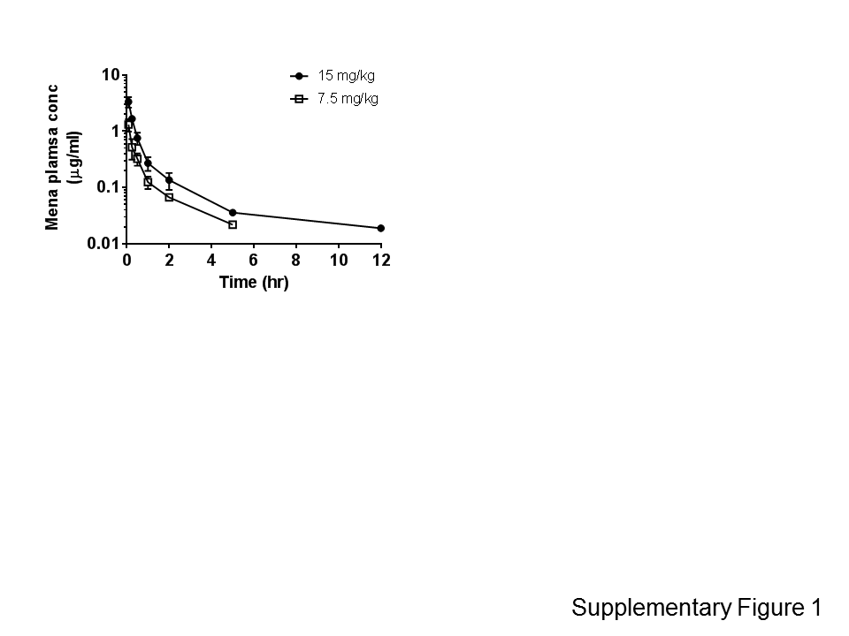

Supplementary Figure 2. In TMZ-insensitive GBM, CBD does not upregulate LC3-II conversion, or inhibit FOXM1 and RAD51 expression. A) MGMT expression in multiple GBM lines. B) T98G and GBM3832 cells were treated with vehicle (control), 1.5 μM CBD, 200 μM TMZ, or 1.5 μM CBD + 200 μM TMZ for 2 days. The expression of MGMT, pAMPK, tAMPK, LC3A, FOXM1, and RAD51 were evaluated using Western analysis and Image J, respectively. Actin served as a loading control.

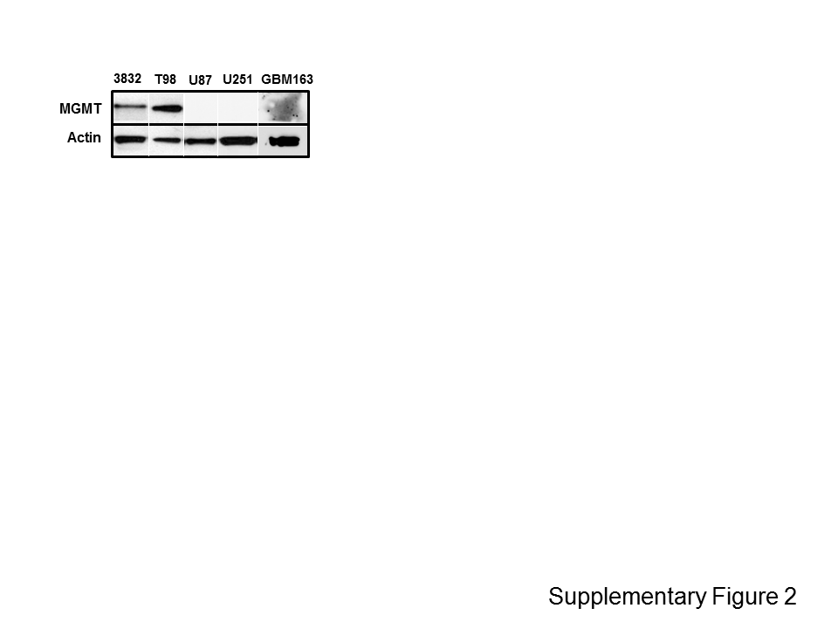

Figure 3. CBD stimulates AMPK, upregulates LC3-II conversion, and Inhibits FOXM1 and RAD51 expression in GBM163X. GBM163X cells were treated with vehicle (control), 3 μM CBD, 500 μM TMZ, or 3 μM CBD + 500 μM TMZ in the presence and absence of TOC for 3 days. The expression of RAD51 was evaluated using A) Western analysis and B) quantified using Image J, respectively. GAPDH served as a loading control.
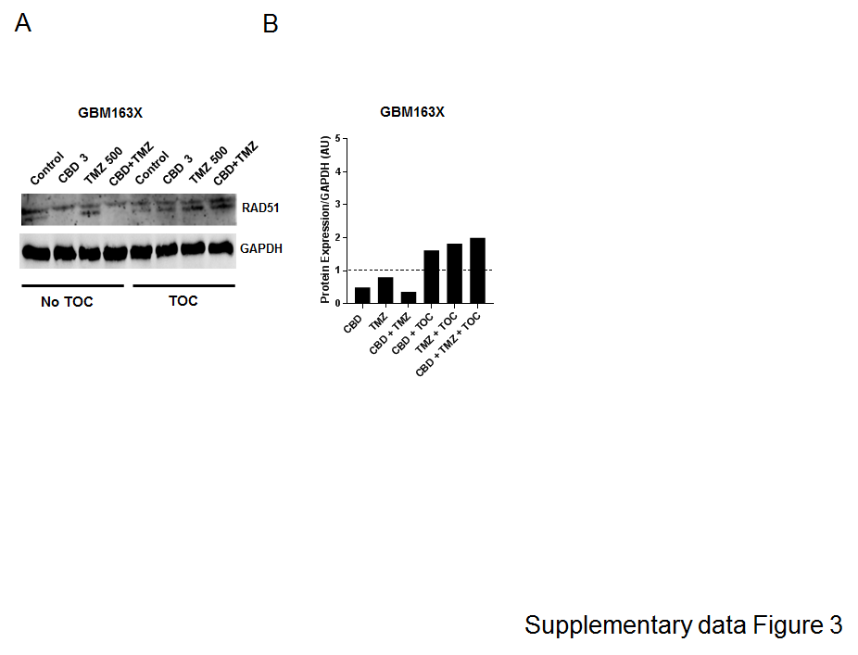

Supplementary Figure 4. Representative microphotographs of RAD51 staining from GBM163-derived i.c. tumors treated as indicated. RAD51 detection was visualized using an Alexa 568- labeled secondary antibody. Counterstaining of the nuclei with DAPI. Samples were collected at the time the animals succumbed to disease. Bar=200μm

