Supplementary Material

Supplementary Table S1: Summary of cycling conditions used in the study.
Step |  | Temperature | Time
Primary denaturation |  | 95°C | 1 min
40 cycles | Denaturation | 95°C | 5 sec
40 cycles | Annealing/Extension | 55°C | 10 sec
Melt curve |  | 65–95 °C | 5 sec /0.5 °C increment

Supplementary Table S2: Primer sequences used for RT-PCR analysis in yellow beans.
Gene | Functional Annotation |  | Primer Sequence (5’-3’) | Reference
Act11 | Actin-11  (Reference gene) | F | TGCATACGTTGGTGATGAGG | (Porteous-Álvarez et al., 2020)
Act11 | Actin-11  (Reference gene) | R | AGCCTTGGGGTTAAGAGGAG | (Porteous-Álvarez et al., 2020)
NifH | Nitrogenase iron protein | F | GGTTGTGACCCGAAAGCTGA | (Bürgmann et al., 2003)
NifH | Nitrogenase iron protein | R | GCGTACATGGCCATCATCTC | (Bürgmann et al., 2003)
AUX6 | Auxin transporter-like protein 2 | F | CGTCGCCGTCTATTGGGCTT | (Nanjareddy et al., 2024)
AUX6 | Auxin transporter-like protein 2 | R | ACCGTGCAAGTGCCCTCAAA | (Nanjareddy et al., 2024)
AUX/IAA | Auxin-responsive protein | F | GCATCCACTCATCGGAATCT | (Ekinci et al., 2023)
AUX/IAA | Auxin-responsive protein | R | GGAACCCGAACATTTTGAAC | (Ekinci et al., 2023)
PVCK01 | Cytokinin oxidase | F | AGGCGAAACCTTAGTCTG | (Zhang et al., 2023)
PVCK01 | Cytokinin oxidase | R | AGCCACTCTGCGTCTCTA | (Zhang et al., 2023)
AIPT3 | Adenylate isopentenyltransferase 3 | F | CAGCCTCTGAAAAACGTTCC | (Ekinci et al., 2023)
AIPT3 | Adenylate isopentenyltransferase 3 | R | TCTCCCAGAAGTGGAATTGG | (Ekinci et al., 2023)
Log1/Log1-like | Cytokinin riboside 5′-monophosphate phosphoribohydrolase (LOG family) | F | TGGCAGTAGTCCAGGGAACA | This study
Log1/Log1-like |  | R | CATCAAACCAATGCTGCCCC | This study

Supplementary Table S3: MLST allelic profiles of BS-114 and BS-116 and housekeeping genes selected for strain-level confirmation
Strain | MLST | Allelic Profile | Reference
BS-114 | Novel | glpF(1), ilvD(48), pta(55), purH(49), pycA(34), rpoD(1), tpiA(1) | (Kaddoura et al., 2026)
BS-116 | ST-105 | glpF(3), ilvD(64), pta(44), purH(66), pycA(2), rpoD(3), tpiA(3) | (Kaddoura et al., 2026)
*Housekeeping genes selected for strain-level confirmation in this study are shown in bold.

Supplementary Table S4: Primer sequences used for housekeeping-gene amplification and strain-level confirmation
Primer | Sequence (5’–3’) | Expected Amplicon Size (bp) | Reference
pycA-F | AAATCAGARGCGAAAGC | 545 bp | (Le et al., 2019)
pycA-R | CCTGAGCGGTAAGCCAT | 545 bp | (Le et al., 2019)
pta-F | ATACATATGAAGGSATGGAAGA | 610 bp | (Le et al., 2019)
pta-R | TAGCCGATGTTTCCTGCT | 610 bp | (Le et al., 2019)
purH-F | TTTGAGAAAAAACAATCGCT | 568 bp | (Le et al., 2019)
purH-R | TCGGCTCCCTTTTCGTCGG | 568 bp | (Le et al., 2019)
ilvD-F | ATGAGATATTCGCTGCC | 622 bp | (Le et al., 2019)
ilvD-R | CTTCGTTAATGCGTTCTAAAGAG | 622 bp | (Le et al., 2019)

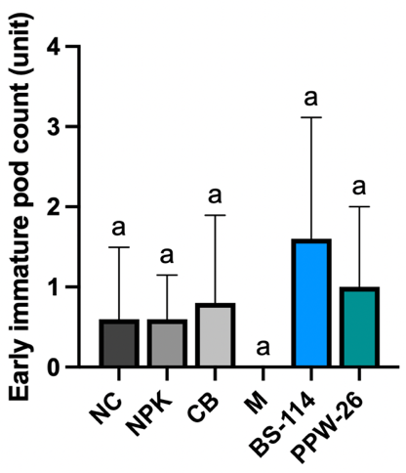
Supplementary Figure S1: Vegetative growth parameters of treated yellow bean plants at week 6. NC, non-inoculated control; NPK, chemical control; CB, fermented algae-based commercial biostimulant control; M, LB media control; BS-114, Bacillus subtilis strain 114; PPW-26, Pseudomonas wadenswilerensis strain 26. Average early immature pod count per plant (week 6). Values represent mean ±SD (n= 5). Different letters indicate significant difference relative to the control according to one-way ANOVA followed by Dunnett’s post-hoc test (P < 0.05).

