Supporting Information
Development of a novel risk score reflecting the relative harm potential of synthetic cannabinoids, based on prevalence estimates, well-documented intoxication cases and basic pharmacological data
Michaela J. Sommer^{1,2,3}*, Katharina Elisabeth Grafinger^{1,3,4}*, Maren Hermanns-Clausen^{3,6}, Volker Auwärter^{1,3}

¹Institute of Forensic Medicine, Forensic Toxicology, Medical Center – University of Freiburg, Freiburg, Germany
²Hermann Staudinger Graduate School, University of Freiburg, Freiburg, Germany
³Faculty of Medicine, University of Freiburg, Freiburg, Germany
⁴Institute of Forensic Medicine, Forensic Toxicology and Chemistry, University of Bern, Switzerland
⁶Poisons Information Center, Department of General Pediatrics, Adolescent Medicine and Neonatology, Center for Pediatrics, Medical Center – University of Freiburg, Freiburg, Germany
*these authors contributed equally to this work

Sample preparation and LC-MS/MS analysis
Serum/blood samples
The analysis of serum/blood samples was performed according to a validated method by Angerer et al.¹ using a seven-point calibration curve (0.1-2 ng/mL). Samples were extracted in a two-step extraction protocol. In short to 1 mL of serum/blood, 10 μL of internal standard (c = 25 ng/mL) and 0.5 mL carbonate buffer (pH 10) were added, followed by the first extraction using 1.5 mL hexane/ethyl acetate (99/1, vv). This solution was gently mixed for 5 min, followed by centrifugation at 2860 g for 20 min. 1 mL of supernatant were transferred to a new vial and extracted with1.5 mL n-hexane/ethyl acetate (80/20, vv), followed by gently mixing for 5 min and centrifugation at 2860 g for 20 min. 1 mL of each supernatant was transferred to one new autosampler vial and evaporated to dryness using N₂ at 40°C, followed by reconstitution in 100 μL of mobile phase.
Serum/blood samples were analysed on a Shimadzu Prominence HPLC system (Duisburg, Germany) coupled to a AB Sciex QTrap 4000 triple quadrupole liner ion trap mass spectrometer (Darmstadt, Germany) with a Kinetex C18, 100 Å (100 x 2.1 mm, 2.6 μm) column. The mobile phase consisted of water with 1% acetonitrile, 2 mmol/L ammonium formate and 0.1% formic acid (A) and acetonitrile with 2 mmol/L ammonium formate and 0.1% formic acid (B). The following elution gradient was applied: 20% B held for 1 minute, increased to 60% over 1.5 minutes, further increased to 65% over 1.5 min and held constant for 1 minutes, and further increased to 99% B over 3 minutes and kept for 2 minutes. The starting gradient was re-established rapidly in 0.2 minutes (20% B) and held for 1.8 minutes, resulting in a total runtime of 12 minutes.
Urine samples
Urine samples were analysed according to previously published and validated method by Franz et al.². For sample preparation 0.5 mL of phosphate buffer (pH 6) and 30 μL of β-glucuronidase were added to 0.5 mL of urine. Incubation was for 60 min at 45°C. This was followed by protein precipitation using 1.5 mL acetonitrile containing the internal standard (c = 2 ng/mL) and 0.56 mL 10 M ammonium formate solution, followed by shaking and centrifugation. 1 mL of the organic phase was transferred into an autosampler vial and evaporated to dryness under N₂. The samples were reconstituted in 200 μL mobile phase.
Urine sample analysis was performed on a Dionex UltiMate® 3000RS UHPLC (Thermo Scientific, Dreieich, Germany) coupled to an API 5000TM triple quadrupole instrument with a TurboIonSpray® interface (Sciex, Darmstadt, Germany). Separation was performed on a Luna C18 100 Å (150 x 2 mm, 5 μm) column with the mobile phase consisting of 0.2% HCOOH and 2 mmol/L NH⁴+HCOO⁻ in water (A) and acetonitrile (B). Following gradient was applied: starting condition of mobile phase B was 50%, linearly increased to 60% within 3.5 min, further increased to 70% within 2 min, further increased to 75% within 1 min, further increased to 80% within 1 min, further increased to 90% in 1.5 min, held for 2.5 min, decreased to starting conditions of 50% in 0.5 min and held for 3.0 min for re-equilibration.

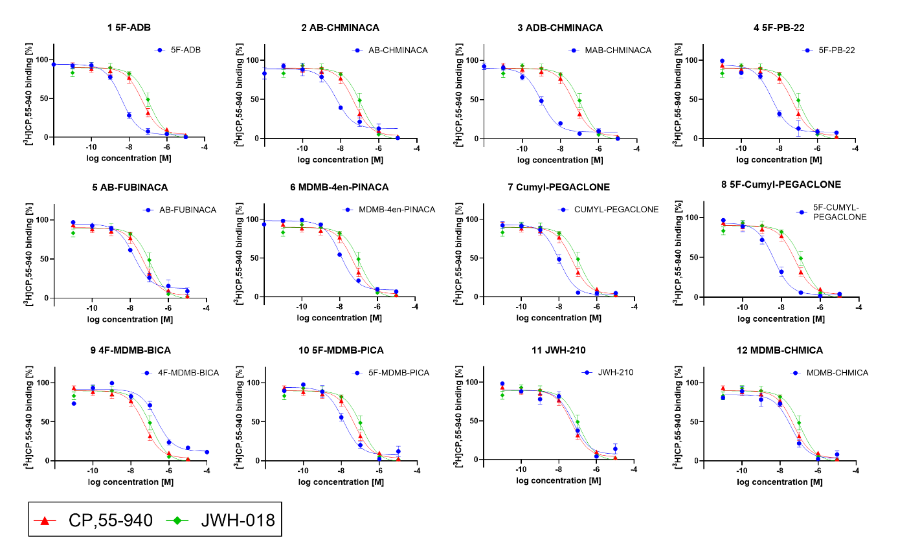
SI Figure 1: Concentration-displacement curves at the human CB₁ receptor derived from the competitive [³H]CP,55-940 mediated in vitro receptor affinity assay upon the concentration-dependent stimulation with the twelve test compounds and two reference compounds. Data given as mean receptor affinity ± SEM (n=3 or higher).
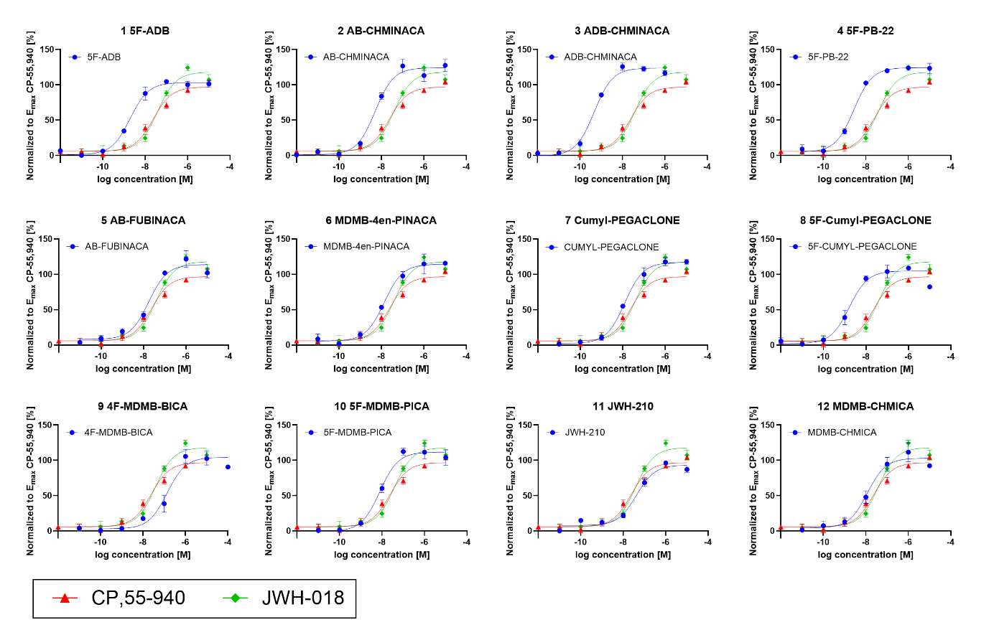SI Figure 2: Concentration dependent interaction of [³⁵S]-GTPγS with the human CB1 upon stimulation with the twelve test compounds. The data is depicted as mean receptor activation ± SEM (n=3), normalized to the E_{max} of CP-55,940 (100 %).

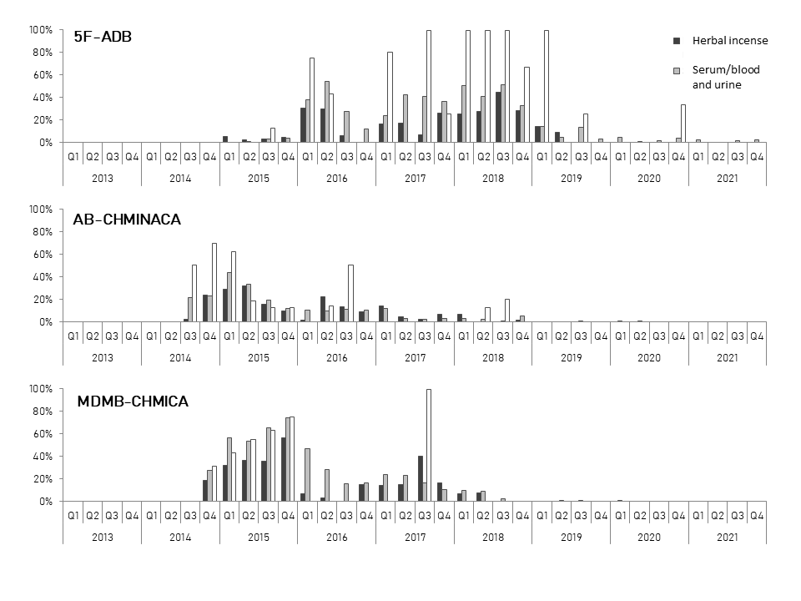
SI Figure 3: Percentage of the respective SCRAs included in this study in herbal incense samples, serum/blood and urine samples analysed in the Institute of Forensic Medicine Freiburg in the study period 2013 to 2021.

SI Figure 3 continued
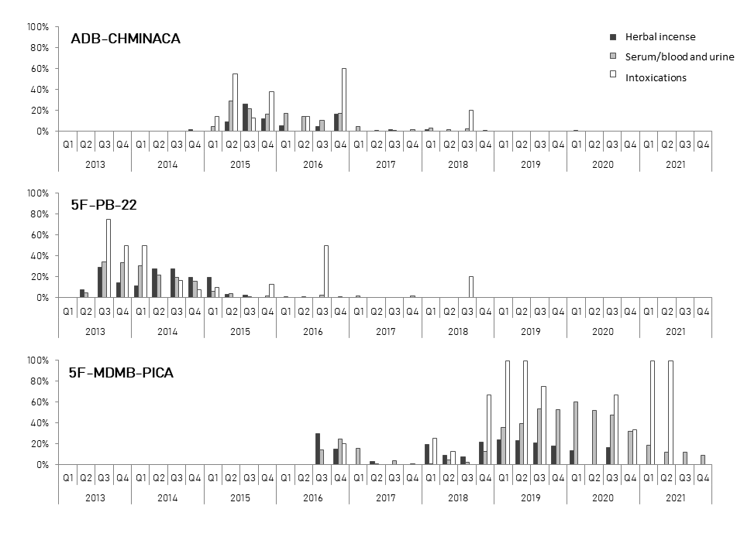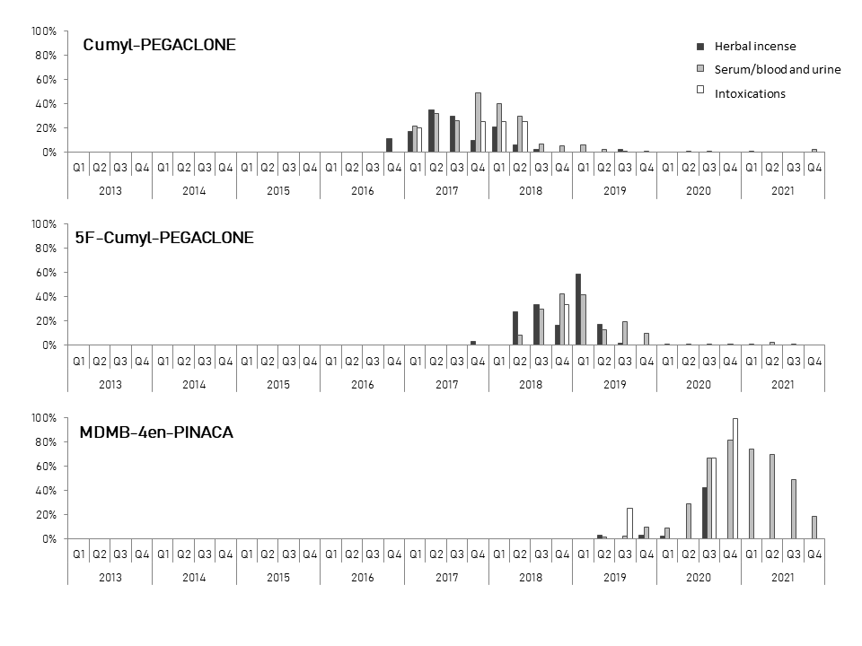
SI Figure 3 continued

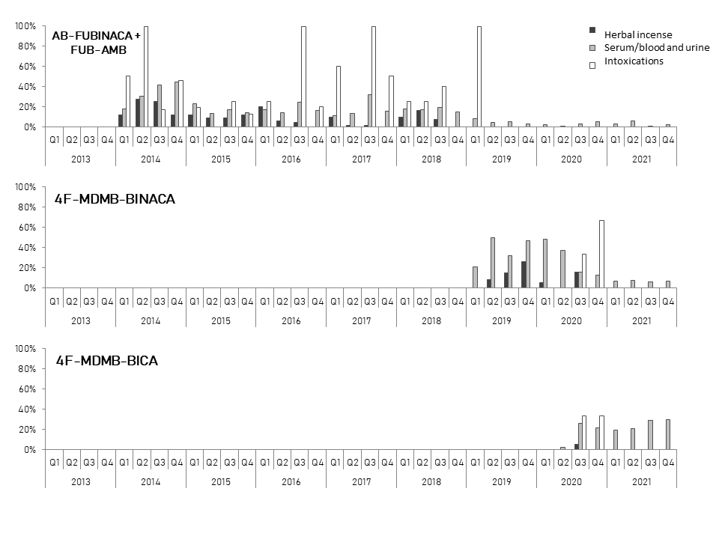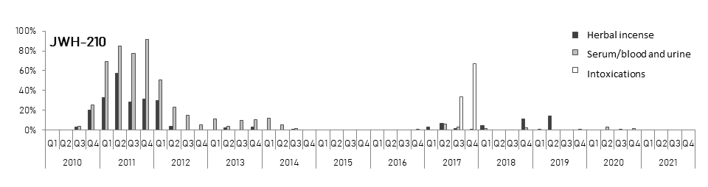

SI Table 1: Materials
Compound | Vendor | Location of Vendor
Absolute ethanol | Sigma Aldrich | Steinheim, Germany
MgCl₂ | Sigma Aldrich | Steinheim, Germany
TRIS HCl (tris(hydroxymethyl)aminomethane hydrochloride) | Sigma Aldrich | Steinheim, Germany
Bovine serum albumin (BSA) | Sigma Aldrich | Steinheim, Germany
EGTA (ethylene glycol-bis(β-aminoethyl ether)-N,N,N′,N′-tetraacetic acid) | Sigma Aldrich | Steinheim, Germany
GDP (guanosine-5’-disphosphate sodium salt) | Sigma Aldrich | Steinheim, Germany
GTPγS (guanosine-5’-(γ-thio)triphosphate tetralithium salt) | Sigma Aldrich | Steinheim, Germany
DMSO (dimethyl sulfoxide) | Sigma Aldrich | Steinheim, Germany
Sodium chloride | Carl Roth | Karlsruhe, Germany
Sodium hydroxide  (≥ 99%, p.a., pellets) | Carl Roth | Karlsruhe, Germany
MultiScreen™ filter plates (1.2 μm) | Merck | Darmstadt, Germany
Sodium carbonate | Merck | Darmstadt, Germany
Isopropanol (Prepsolv®) | Merck | Darmstadt, Germany
(±)-CP-55,940 | Cayman Chemical Company | Hamburg, Germany
JWH-018 | Lipomed | Arlesheim, Switzerland
Human CB₁ membrane preparations (HEK293-EBNA) | Perkin Elmer | Waltham, USA
Ultima Gold™ (liquid scintillation cocktail) | Perkin Elmer | Waltham, USA
[³H]CP-55,940 (149 Ci/mmol) | Perkin Elmer | Waltham, USA
[³⁵S]-GTPγS (1250 Ci/mmol) | Perkin Elmer | Waltham, USA
Deionized water | ELGA (Medica® Pro deionizer) | Celle, Germany
5F-ADB | Cayman Chemicals | Tallinn, Estonia
AB-CHMINICA | Cayman Chemicals | Tallinn, Estonia
MDMB-CHMICA | Cayman Chemicals | Tallinn, Estonia
5F-PB-22 | Cayman Chemicals | Tallinn, Estonia
MAB-CHMINACA | Cayman Chemicals | Tallinn, Estonia
AB-FUBINACA | Cayman Chemicals | –
5F-MDMB-PICA | Forensic Institute Zurich | Zurich, Switzerland
JWH-210 | Forensic Institute Zurich | Zurich, Switzerland
4F-MDMB-BICA | Forensic Institute Zurich | Zurich, Switzerland
MDMB-4en-PINACA | Slovenian National Forensic Laboratory | Slovenia
Cumyl-PEGACLONE | Research group of Dr. Samuel Banister, University of Sydney | Sydney, Australia
5F-Cumyl-PEGACLONE | Research group of Dr. Samuel Banister, University of Sydney | Sydney, Australia

SI Table 2: Number of total and individual SCRA intoxications per quarter in the study period from 2013-2021
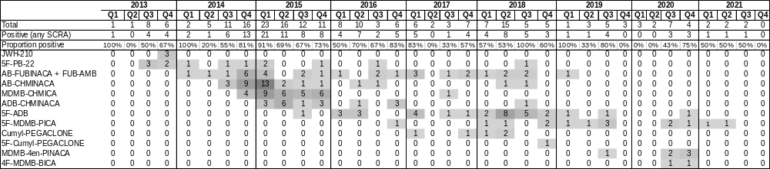
SI Table 3: Percentage of individual SCRA intoxications in the respective quarter in the study period from 2013-2021
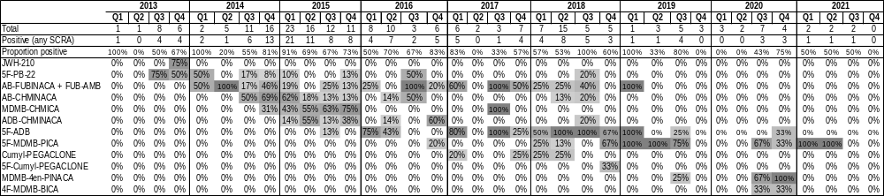

SI Table 4: Total number of analysed serum/blood samples for SCRAs per quarter in the study period from 2013-2021. Number of serum/blood samples positive for at least one SCRA and serum/blood samples positive for each individual SCRA.
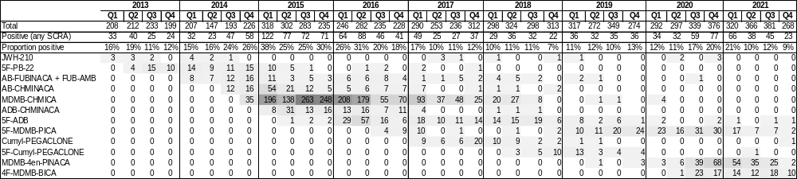
SI Table 5: Percentage of serum/blood samples positive for each individual SCRA per quarter in the study period from 2013-2021.
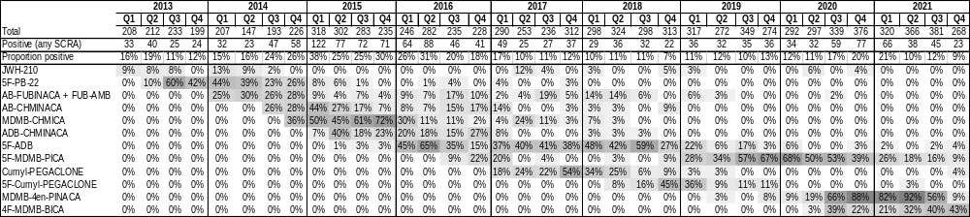

SI Table 6: Total number of analysed urine samples for SCRAs per quartal in the study period from 2013-2021. Number of urine samples positive for at least one SCRA and urine samples positive for each individual SCRA.
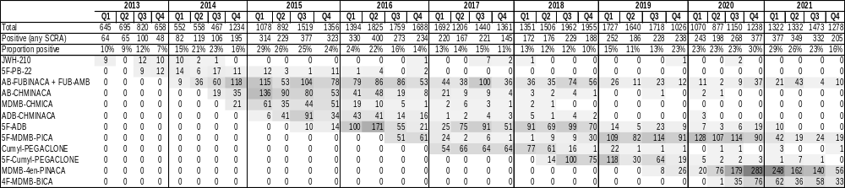
SI Table 7: Percentage of urine samples positive for each individual SCRA per quartal in the study period from 2013-2021
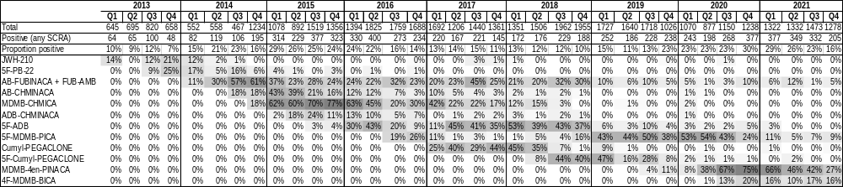.

SI Table 8: Example data for two intoxication cases used for the calculation of the risk score (G₂ und G₃), including recorded symptoms, quantified and confirmed SCRAs and other drugs of abuse, as well as the evaluation regarding the Poison Severity Score and Toxicological Significance Score;
Case |  | sample type |  | Concentration of evaluated SCRA | Recorded symptoms |  | Other confirmed SCRAs | Other confirmed drugs of abuse |  | PSS |  | TSS
AB-CHMINACA
A | Serum |  | 9.5 ng/mL |  | bradycardia (35 bpm/min), seizure, hypokalaemia |  |  |  | 3-MMC approximately 320 ng/mL |  | 3 | 2
A | Urine |  | positive |  | bradycardia (35 bpm/min), seizure, hypokalaemia |  |  |  | 3-MMC |  | 3 | 2
B | Serum |  | ca. 27 ng/mL |  | Tachycardia, nystagmus, disorientation, anxiety,  headaches | 5F-PB-22 ca. 1.5 ng/mL; 5F-AKB-48 < 0.1 ng/mL; THJ-018 < 0.1 ng/mL; THJ-2201 < 0.1 ng/mL |  |  |  |  | 2 | 3
B | Urine |  | positive |  | Tachycardia, nystagmus, disorientation, anxiety,  headaches | 5F-AKB-48; PB-22-5F; THJ-018; THJ-2201; FUB-AMB/AB-FUBINACA hint |  |  |  |  | 2 | 3

References
1. Angerer V, Süssenbach F, Hirschinger N, Auwärter V. Validated LC-MS/MS method for qualitative and quantitative analysis of 75 synthetic cannabinoids in serum. The International Association of Forensic Science 2015; 2015; Florence, Italy.
2. Franz F, Angerer V, Jechle H, et al. Immunoassay screening in urine for synthetic cannabinoids - an evaluation of the diagnostic efficiency. Clin Chem Lab Med. 2017;55(9):1375-1384.

