Supporting information:
Towards a cannabis terroir: untargeted metabolomic profiling of authentic samples using gas chromatography – high resolution mass spectrometry (GC-HRMS) and liquid chromatography – high resolution tandem mass spectrometry (LC-HRMS/MS)

Sandra N. Poetzsch^{1*}, Michael Poetzsch², Thomas Kraemer¹ and Andrea E. Steuer¹
¹Department of Forensic Pharmacology and Toxicology, Zurich Institute of Forensic Medicine, University of Zurich, Winterthurerstrasse 190/52, 8057 Zurich, Switzerland
²Swiss Drug Testing GmbH, Technoparkstrasse 2, 8406 Wintherthur, Switzerland

* Corresponding author:
Dr. Sandra N. Poetzsch
University of Zurich
Zurich Institute of Forensic Medicine
Department of Forensic Pharmacology and Toxicology
Winterthurerstrasse 190/52
CH-8057 Zurich
Switzerland
E-Mail address: sandra.poetzsch@irm.uzh.ch

Table S1: Numbers, growing conditions (OD = outdoor, ID = indoor, GH = greenhouse) producers and names of the cannabis varieties
Variety No. | Condition | Producer | Variety Name
S01 | OD | Slow Farm SA | Limoncello
S02 | OD | Grünhaus AG | Saparot
S03 | OD | Alplant Switzerland | Biscotti
S04 | OD | Grünkraft | Fruity Juice
S05 | OD | Slow Farm SA | Fragolina
S06 | OD | Bio-Can AG | CPure Fedtonic
S07 | OD | Slow Farm SA | Cookies Kush
S08 | OD | Grünhaus AG/ JYM Seeds | Amarelle
S09 | OD | AAREHANF | Mango Haze
S10 | OD | grow team basel | Fenocheese
S11 | ID | Chanvre DC | Strawberry
S12 | ID | Cannabar | Gold Haze
S13 | ID | Alplant Switzerland | Crystal Snow
S14 | ID | Sainfort Production GmbH | Limo
S15 | ID | Helvetic Hemp | Helvetic Love
S16 | ID | Majestik | Crystal White
S17 | ID | Herba di Berna AG | Cannaqueen
S18 | ID | Sainfort Production GmbH | CT
S19 | ID | Canna Invest SA | Mon Joint® Limoncello
S20 | ID | Sibannac GmbH | Holy Shit Rhabarbie
S21 | ID | Vertical Growing GmbH | Cannatonic
S22 | ID | CannaResearch GmbH | CR Pineapple Express
S23 | ID | Sainfort Production GmbH | HQ
S24 | ID | Research a plant | Tonic Berry
S25 | ID | Grünkraft | OG Kush
S26 | ID | Vertical Growing GmbH | Limoncello
S27 | ID | Canna Invest SA | Mon Joint® Calanda Kush
S28 | GH | Greenville Gardening GmbH | Cannaberry
S29 | GH | Chanvre DC | NLX
S30 | GH | Slow Farm SA | Cookies Kush
S31 | GH | Alplant Switzerland | Pretorian
S32 | GH | Greenville Gardening GmbH | Skywalker OG
S33 | GH | Bio-Can AG | CPure Fedtonic
S34 | GH | Grünkraft | Swiss Cheese Premium
S35 | GH | Slow Farm SA | Arancia Tonic

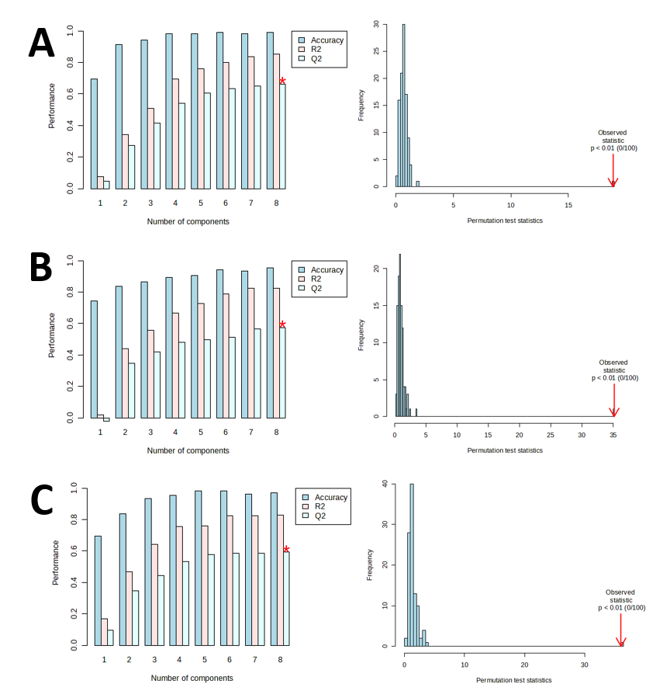
Figure S1 Cross-validation (5-fold CV) and permutation testing results of the PLS-DA plots comparing the growing conditions with (A) GC-HRMS, (B) LC-HRMS in negative mode and (C) LC-HRMS in positive mode

Mass spectra of the most important GC-HRMS features

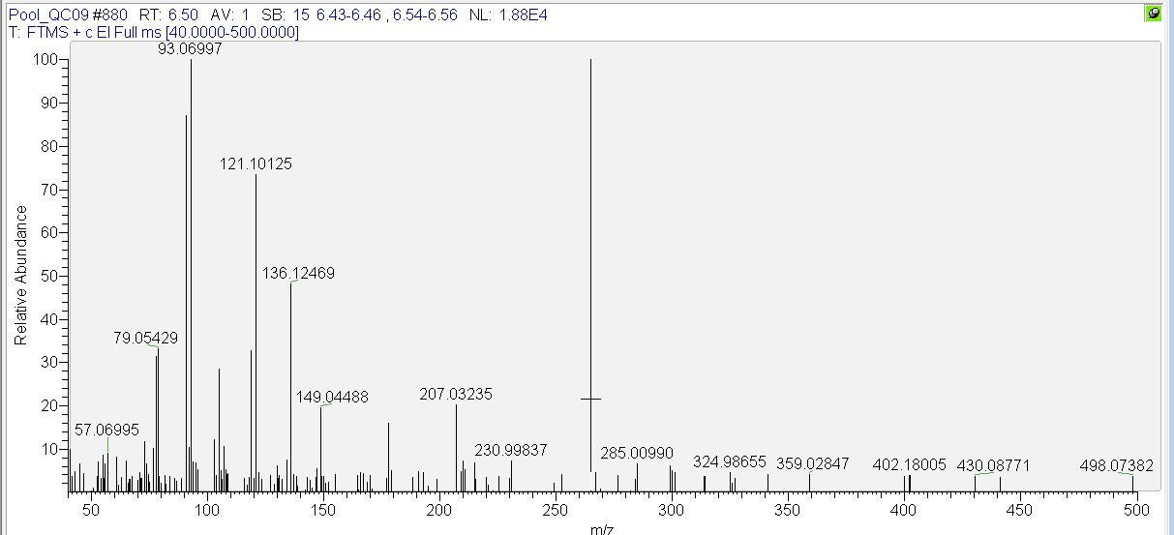
Figure S2 Mass spectrum in the QC pool sample of 3-carene

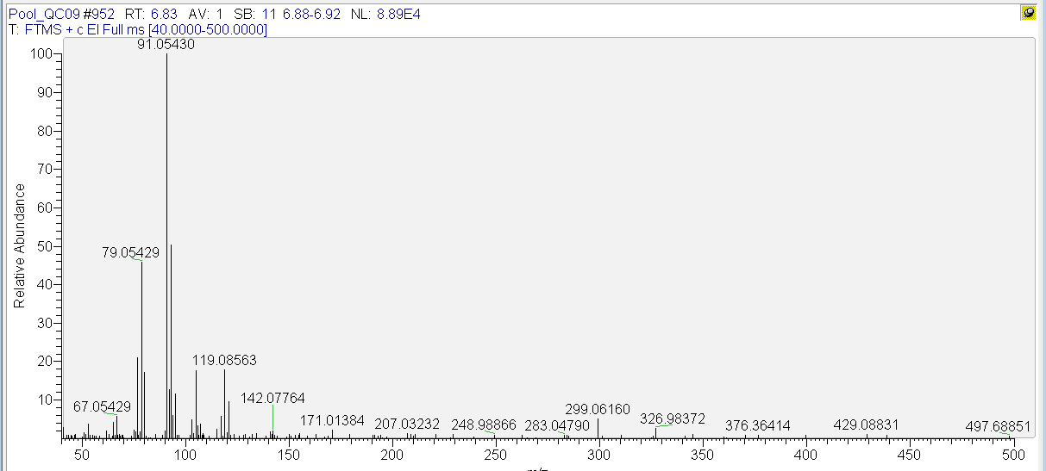
Figure S3 Mass spectrum in the QC pool sample of beta-ocimene

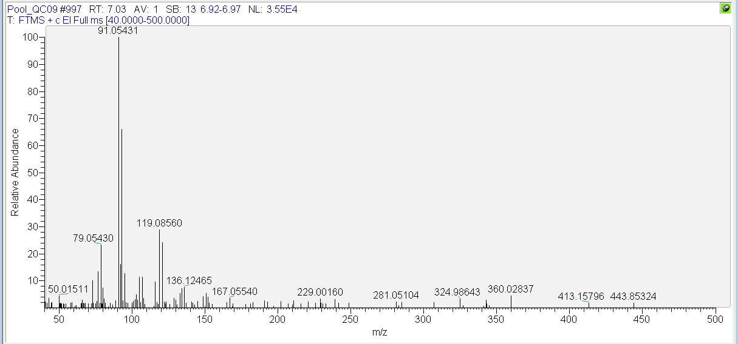
Figure S4 Mass spectrum in the QC pool sample of gamma-terpinene

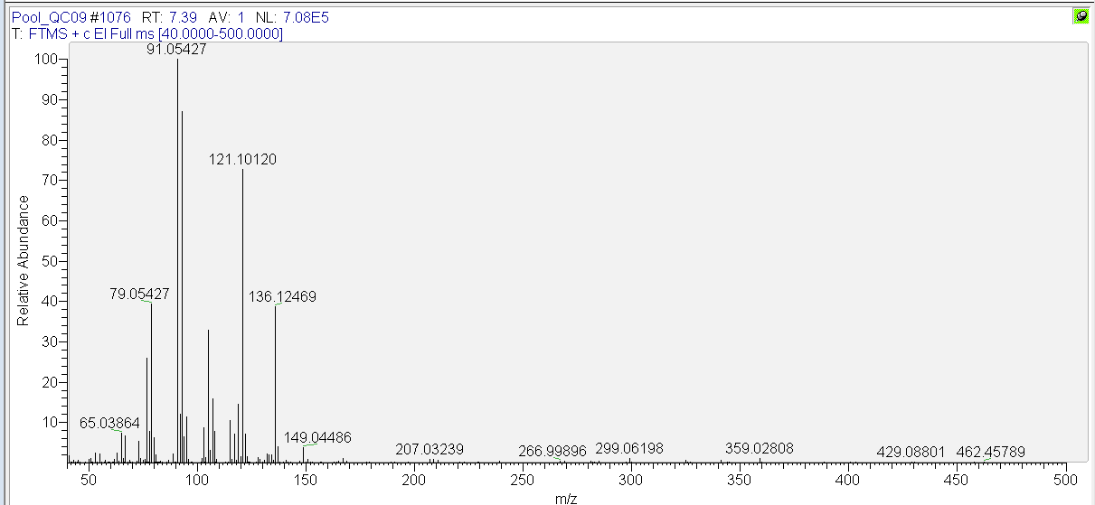
Figure S5 Mass spectrum in the QC pool sample of terpinolene

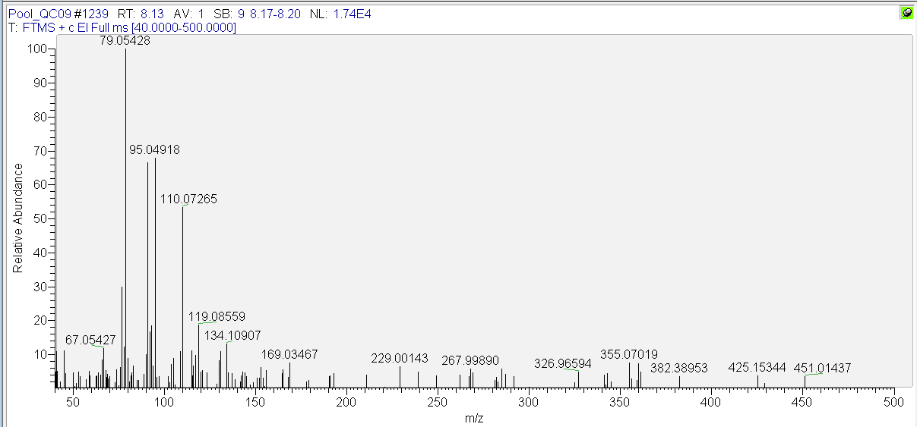
Figure S6 Mass spectrum in the QC pool sample of the monoterpene with RT 8.13 and m/z 79.0543

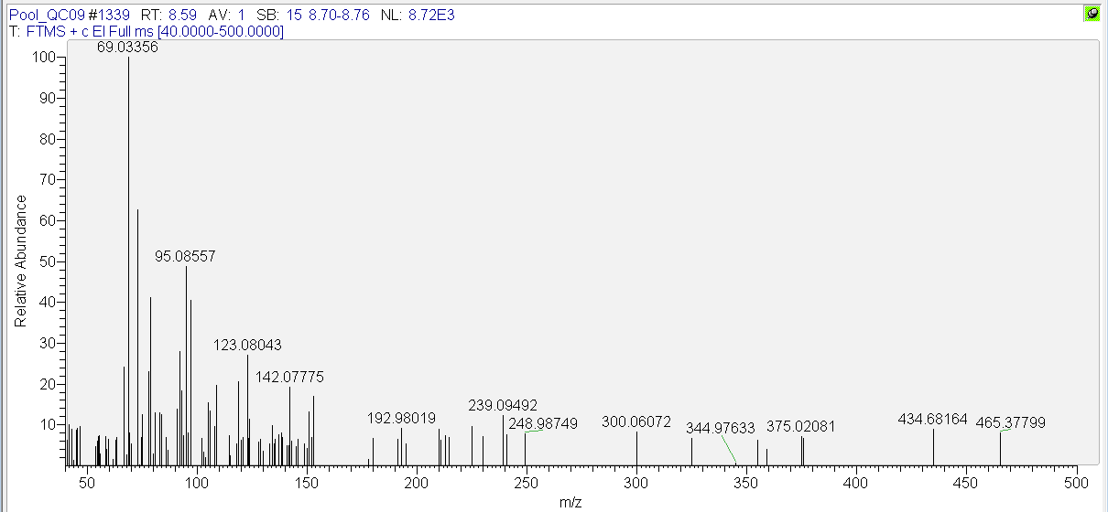
Figure S7 Mass spectrum in the QC pool sample of the monoterpene with RT 8.59 and m/z 69.0336

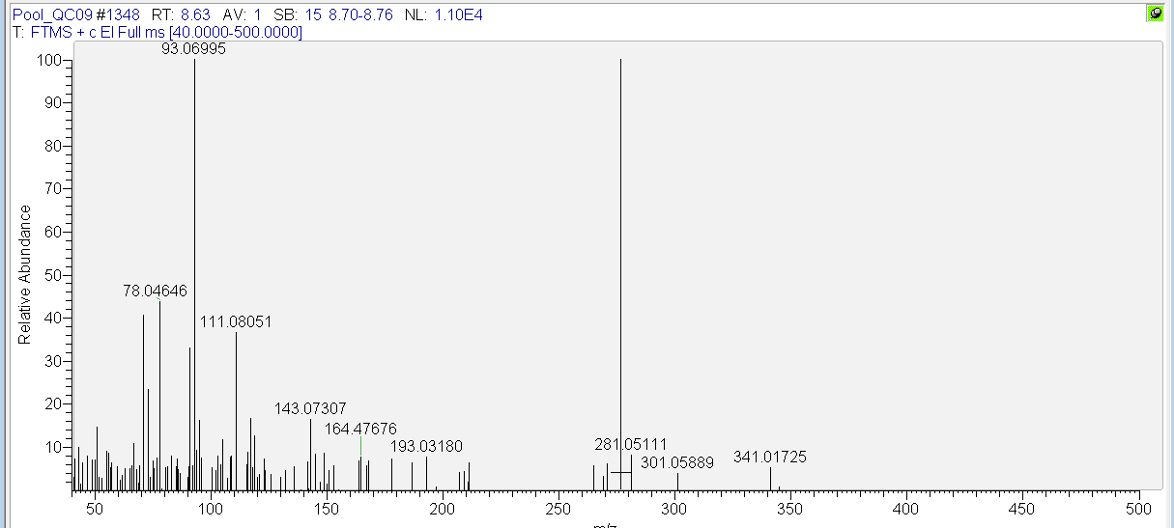
Figure S8 Mass spectrum in the QC pool sample of the monoterpene with RT 8.63 min and m/z 111.0800

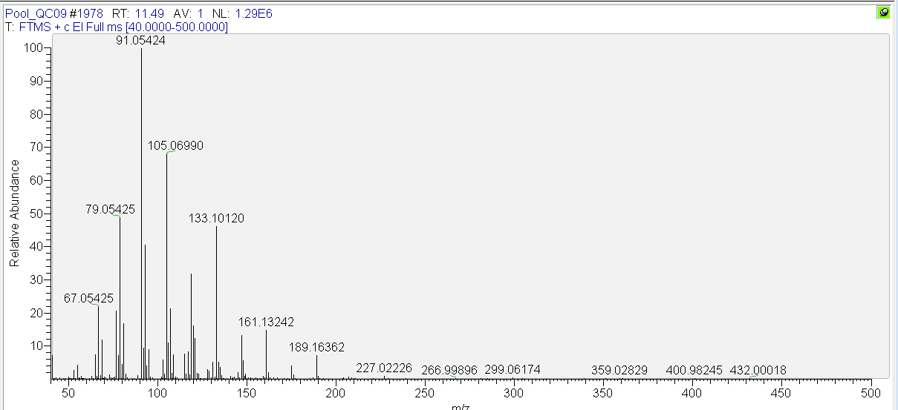
Figure S9 Mass spectrum in the QC pool sample of beta-caryophyllene

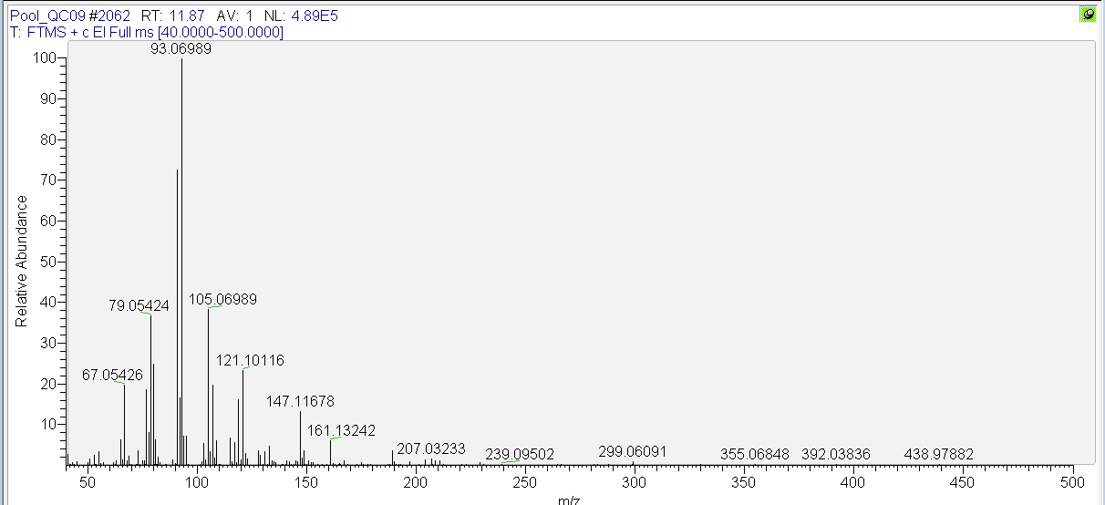
Figure S10 Mass spectrum in the QC pool sample of alpha-humulene

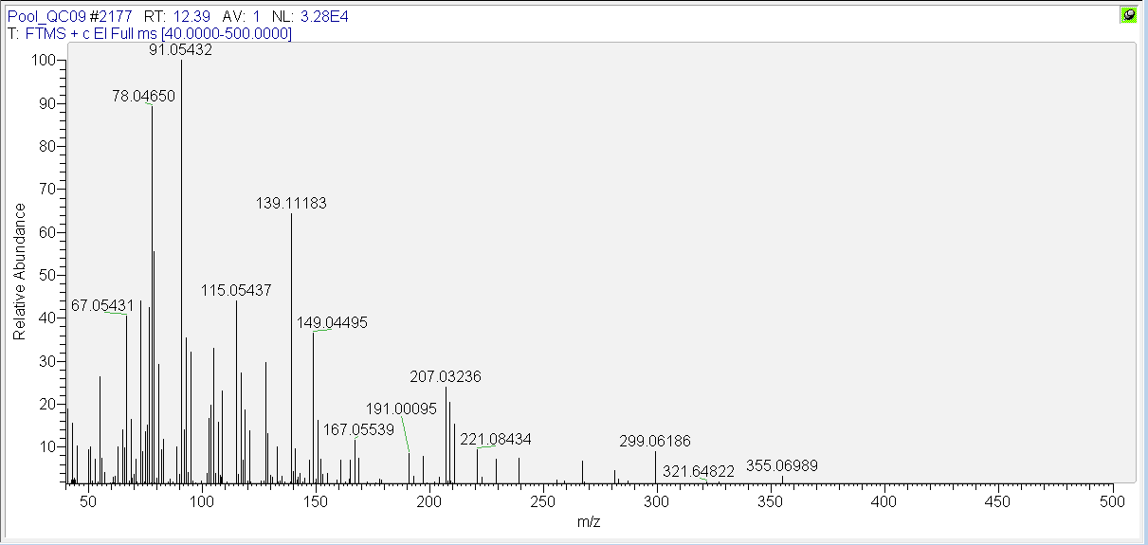
Figure S11 Mass spectrum in the QC pool sample of the sesquiterpene with RT 12.39 min and m/z 139.1118

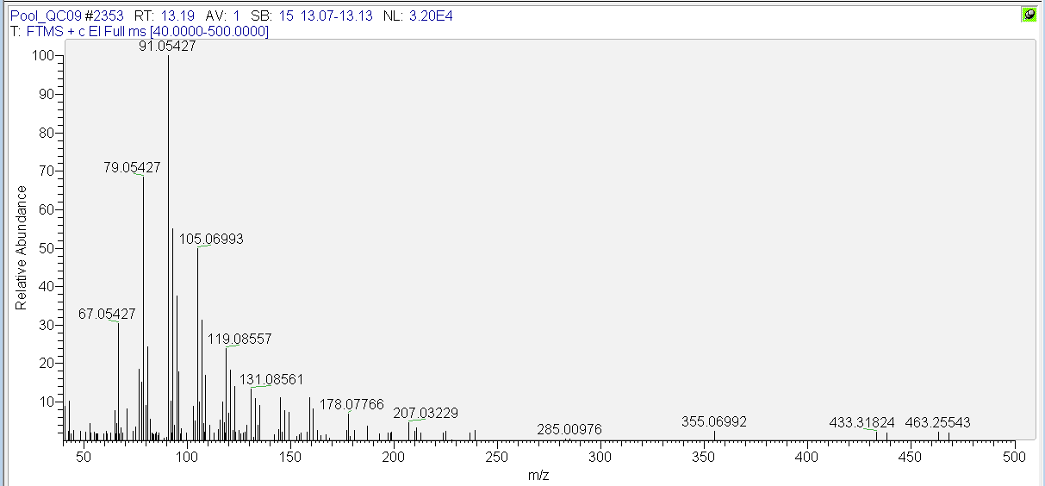
Figure S12 Mass spectrum in the QC pool sample of caryophyllene oxide

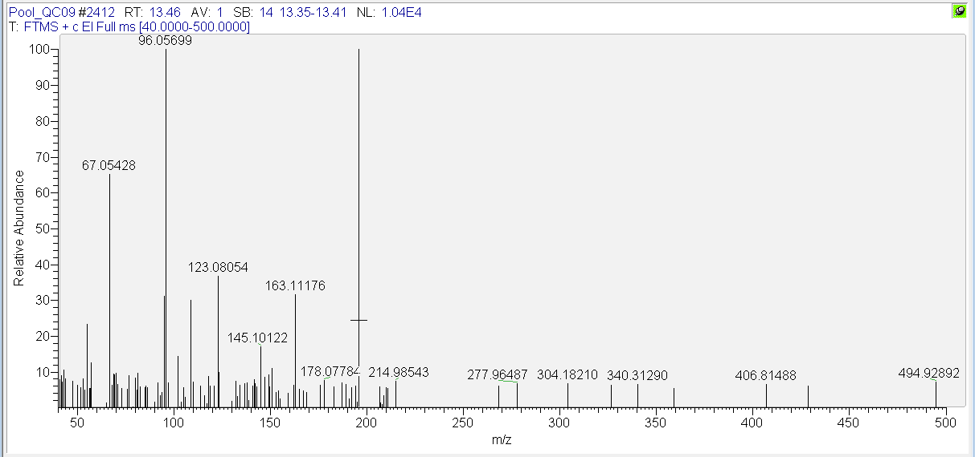
Figure S13 Mass spectrum in the QC pool sample of the unidentified feature with RT 13.46 min and m/z 96.0570

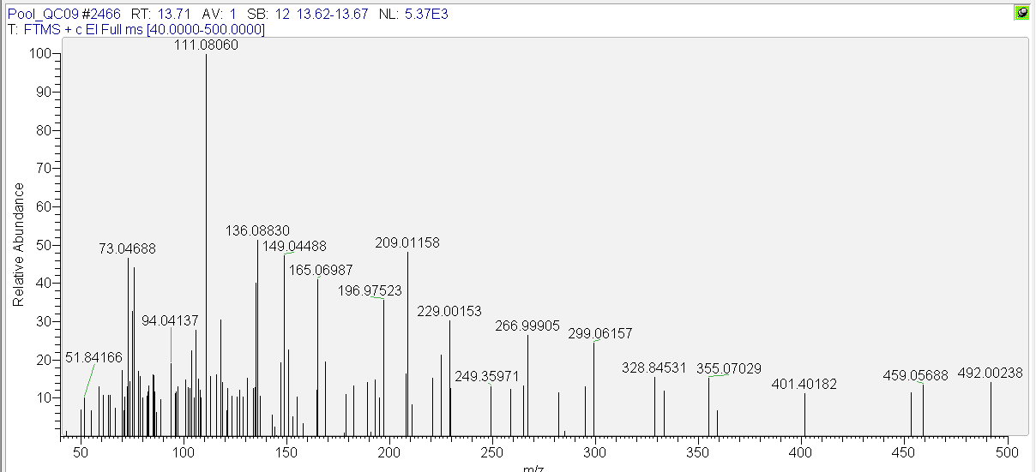
Figure S14 Mass spectrum in the QC pool sample of the sesquiterpene with RT 13.71 and m/z 111.0805

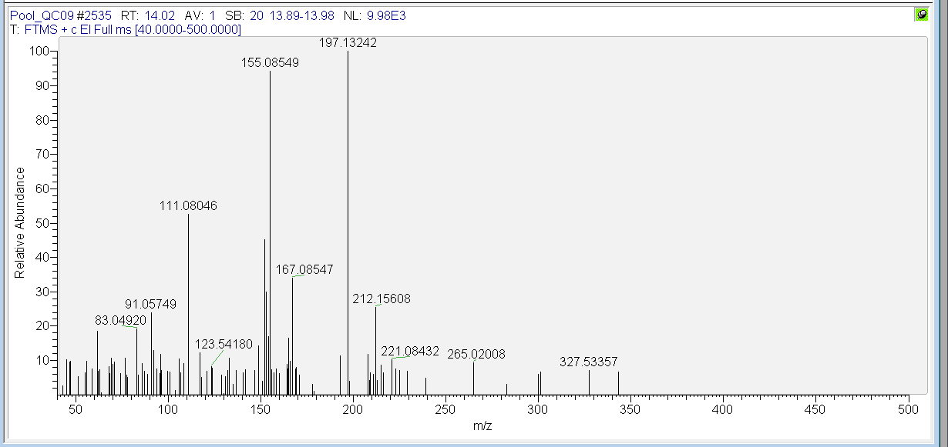
Figure S15 Mass spectrum in the QC pool sample of the sesquiterpene with RT 14.02 and m/z 111.0805

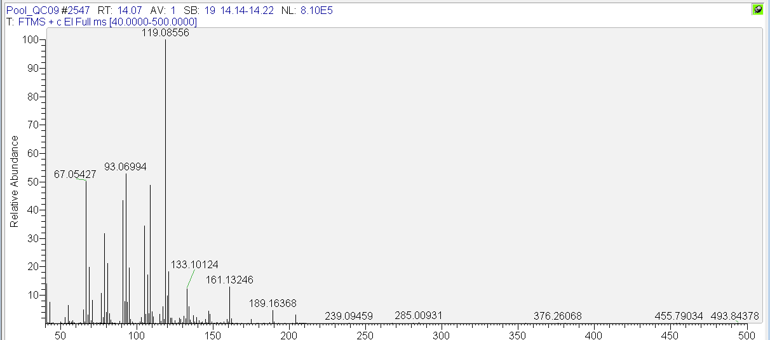
Figure S16 Mass spectrum in the QC pool sample of alpha-bisabolol

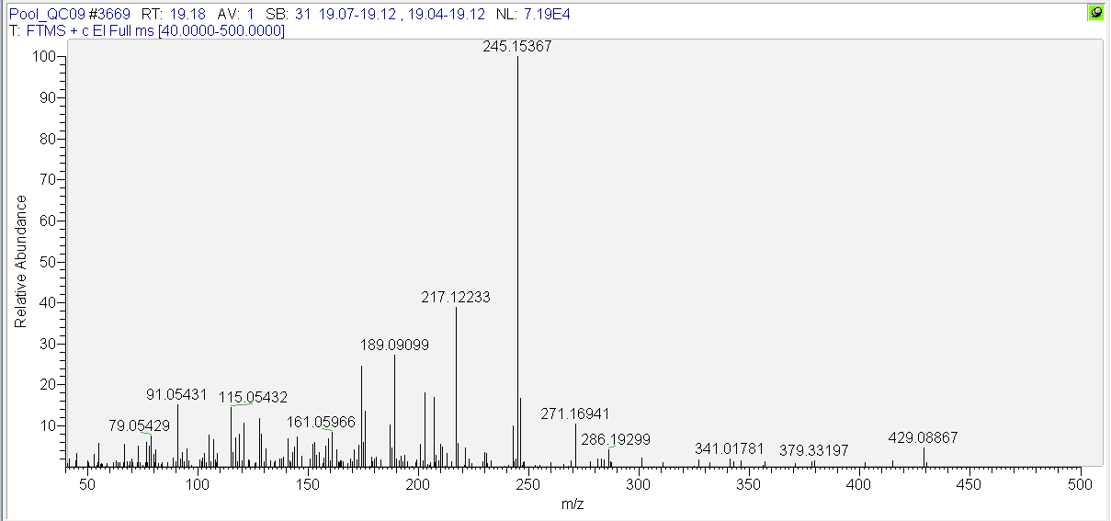
Figure S17 Mass spectrum in the QC pool sample of the cannabinoid with RT 19.18 min and m/z 189.0910

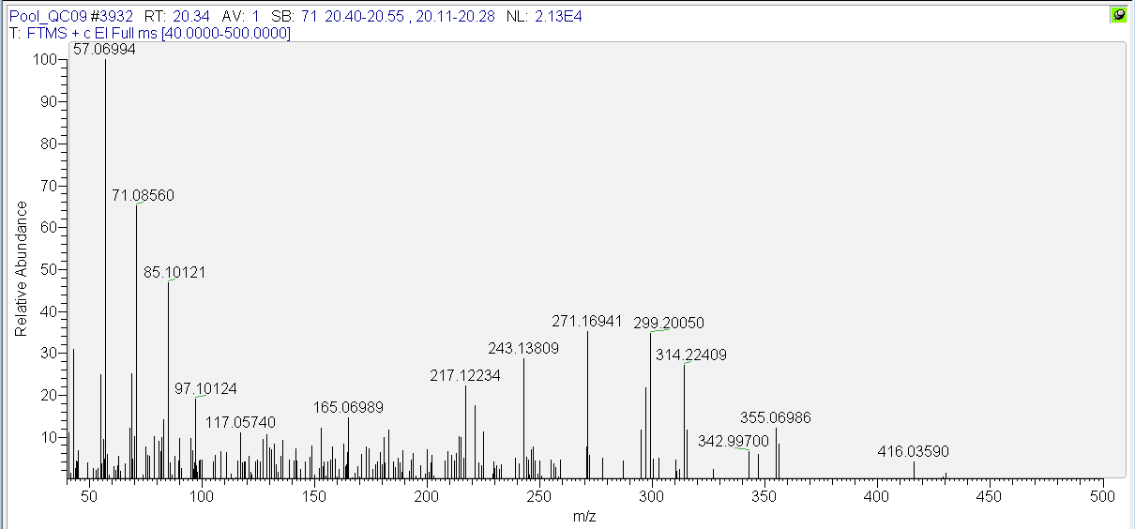
Figure S18 Mass spectrum in the QC pool sample of pentacosane

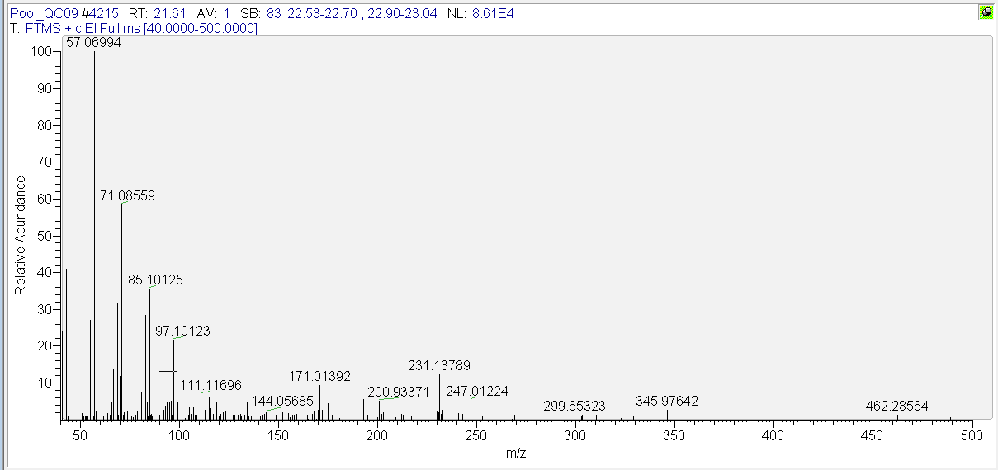
Figure S19 Mass spectrum in the QC pool sample of heptacosane

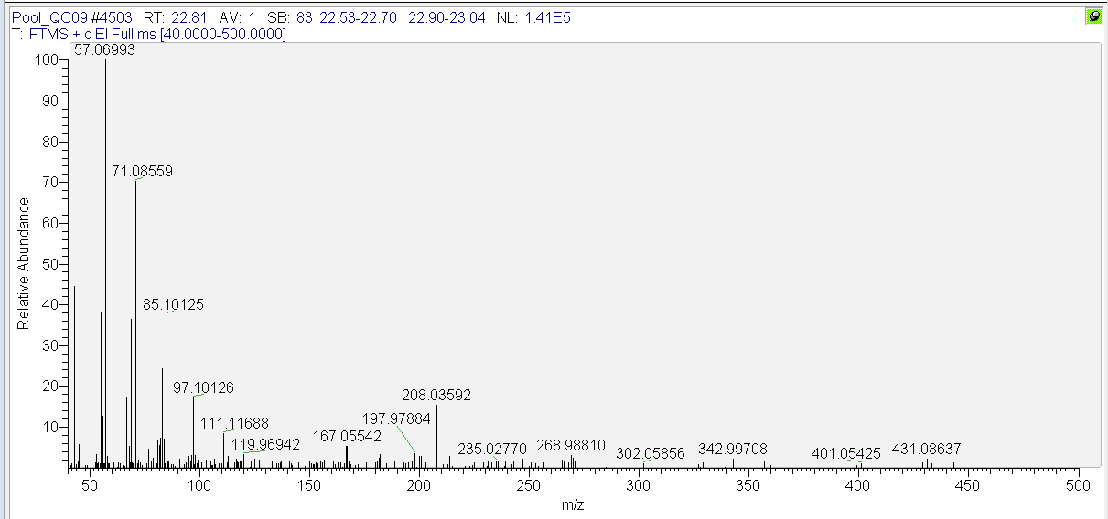
Figure S20 Mass spectrum in the QC pool sample of pentacosane

Mass spectra of the most important LC-HRMS features in positive ionization
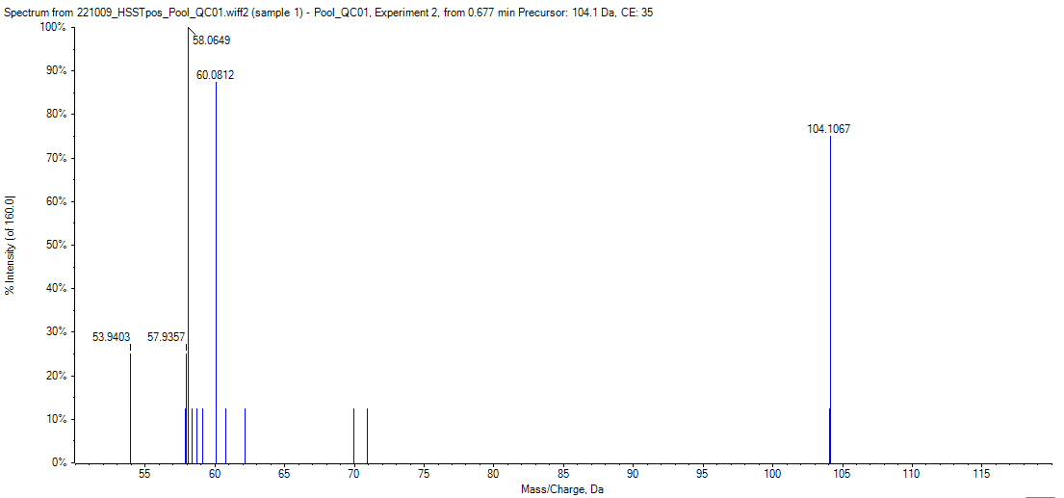
Figure S21 Mass spectrum in the QC pool sample of choline (RP)

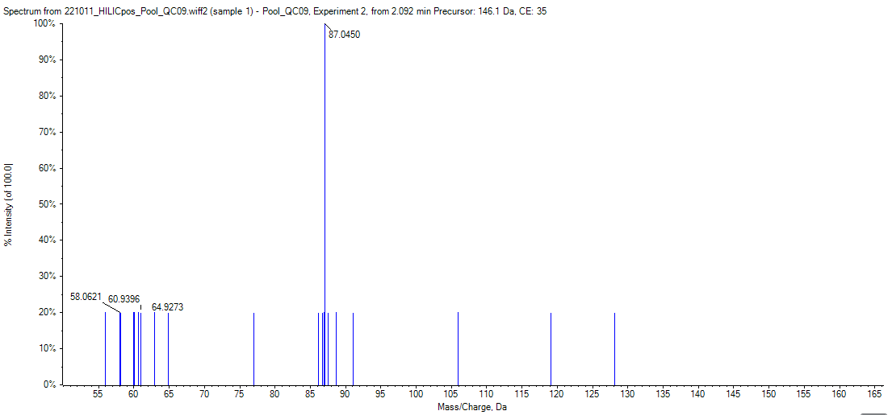
Figure S22 Mass spectrum in the QC pool sample of the unidentified feature with RT 2.06 min and m/z 146.1177

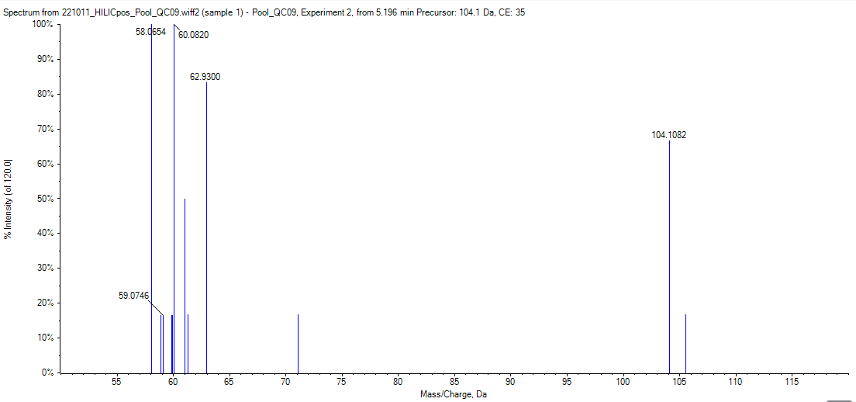
Figure S23 Mass spectrum in the QC pool sample of choline (HILIC)

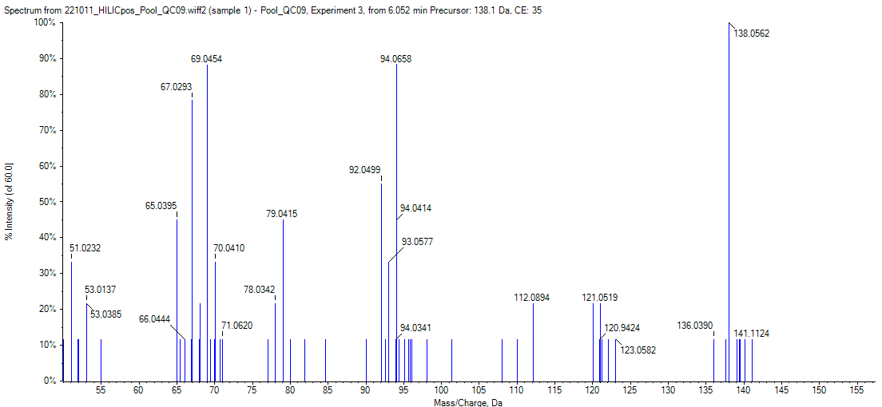
Figure S24 Mass spectrum in the QC pool sample of trigonelline
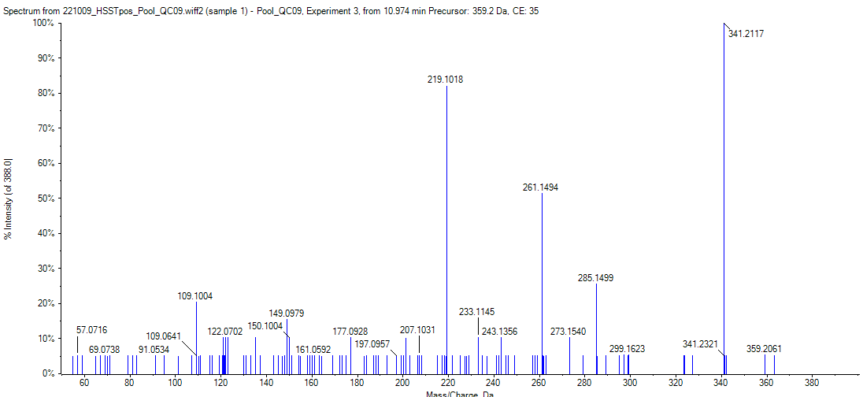
Figure S25 Mass spectrum in the QC pool sample of the unidentified feature at 10.97 min with m/z 359.226
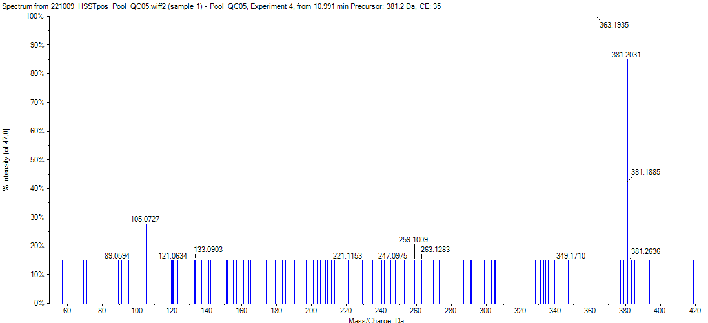
Figure S26 Mass spectrum in the QC pool sample of the unidentified feature at RT 10.97 with m/z 381.2034

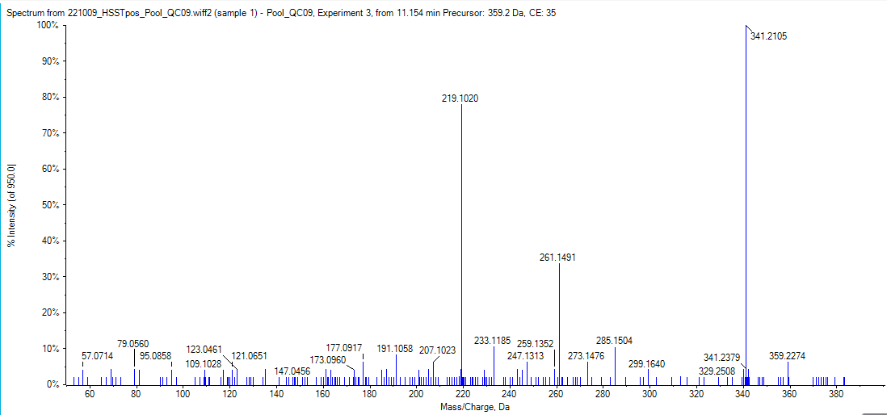
Figure S27 Mass spectrum in the QC pool sample of the cannabinoid at 11.16 min with m/z 359.2219

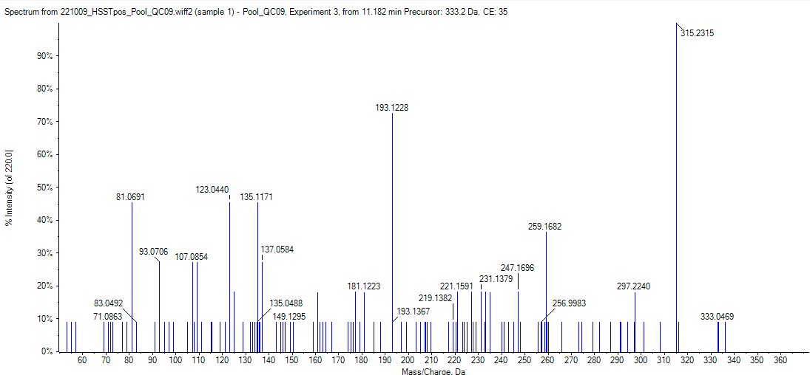
Figure S28 Mass spectrum in the QC pool sample of the cannabinoid at 11.19 in with m/z 333.2429

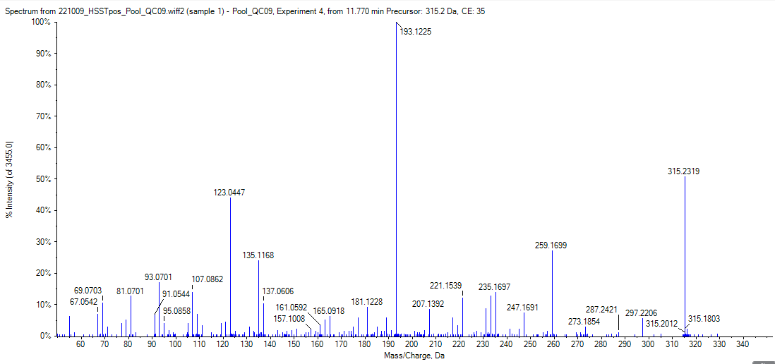
Figure S29 Mass spectrum in the QC pool sample of CBD
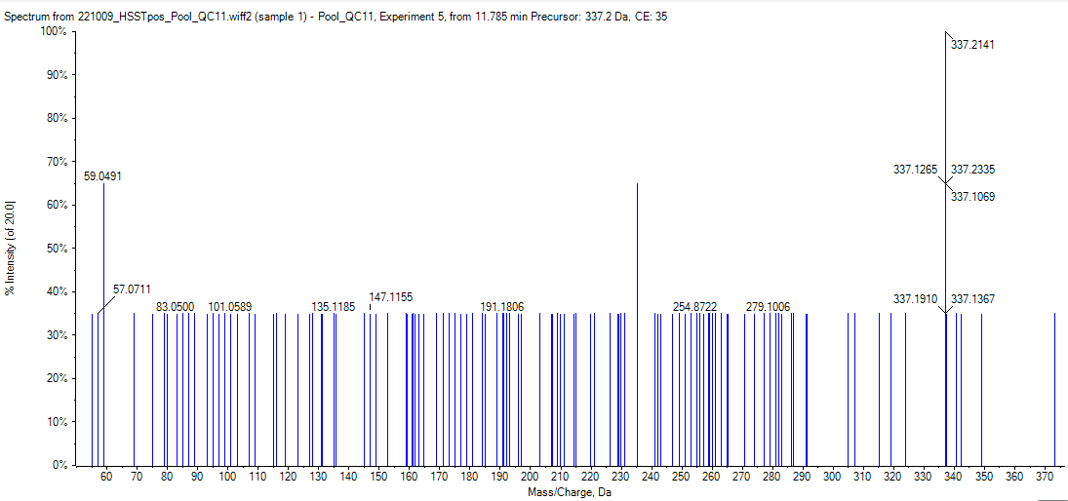
Figure S30 Mass spectrum in the QC pool sample of the unidentified feature at 11.80 min with m/z 337.2145

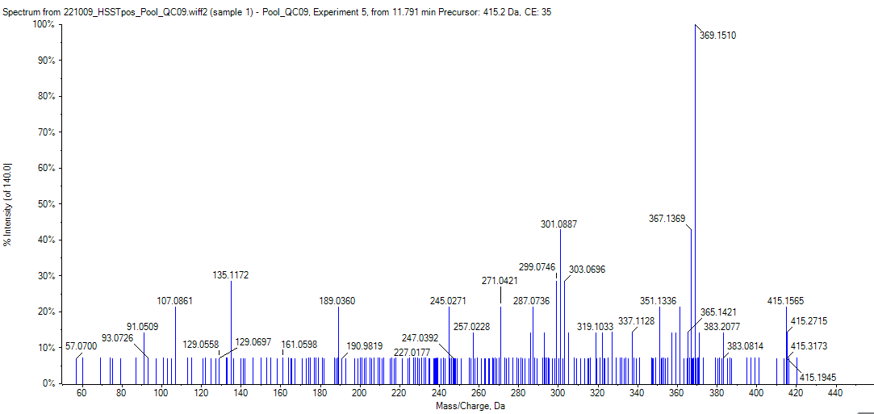
Figure S31 Mass spectrum in the QC pool sample of the unidentified feature at RT 11.80 min with m/z 415.1586

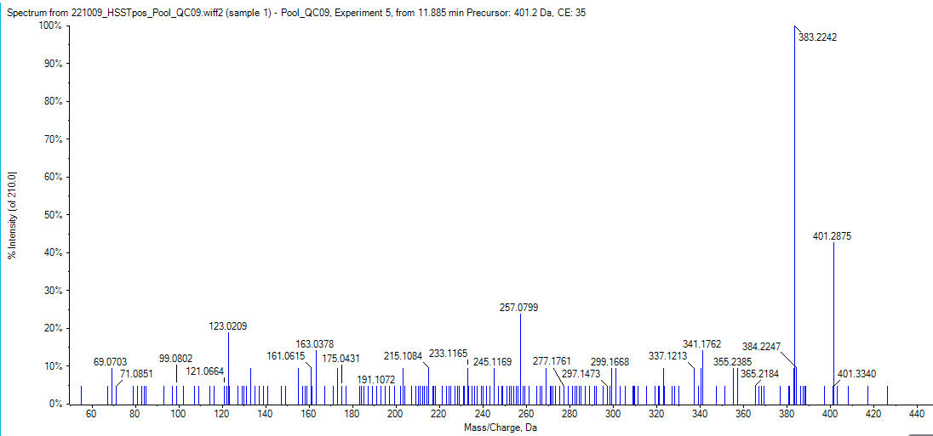
Figure S32 Mass spectrum in the QC pool sample of the unidentified feature at RT 11.90 min with m/z 401.2331

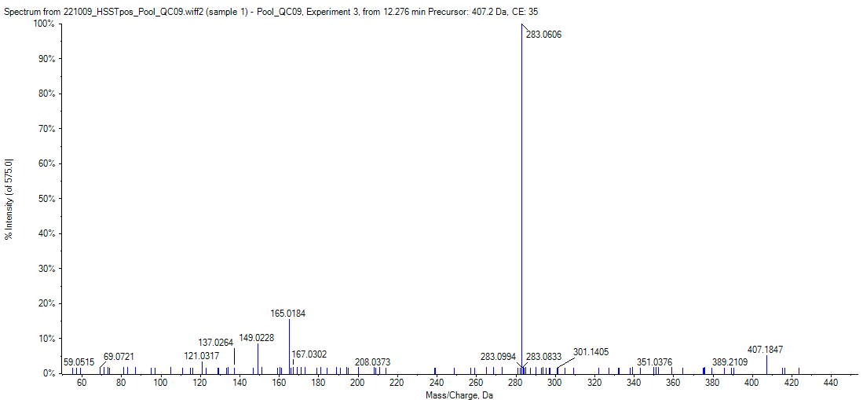
Figure S33 Mass spectrum in the QC pool sample of the flavonoide at 12.29 in with m/z 407.1856

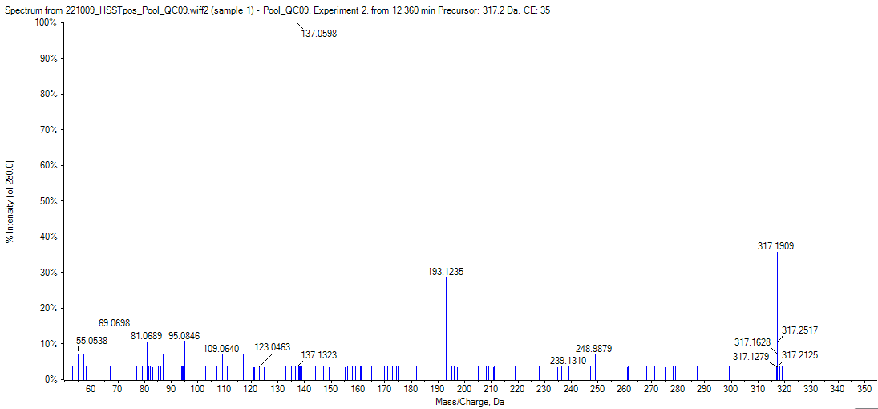
Figure S34 Mass spectrum in the QC pool sample of the unidentified feature at 12.37 min with m/Z 317.2485

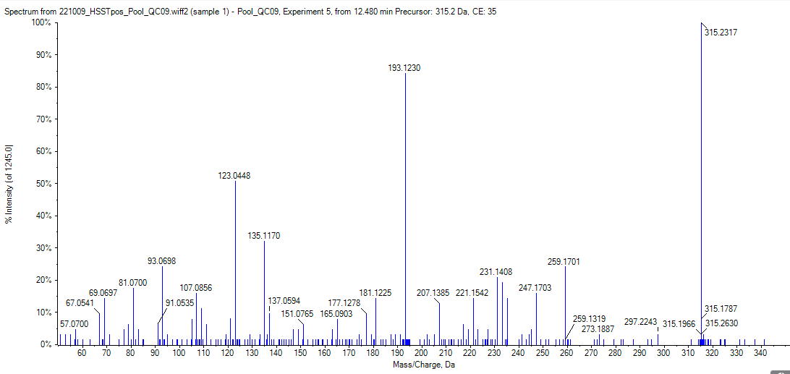
Figure S35 Mass spectrum in the QC pool sample of d9-THC

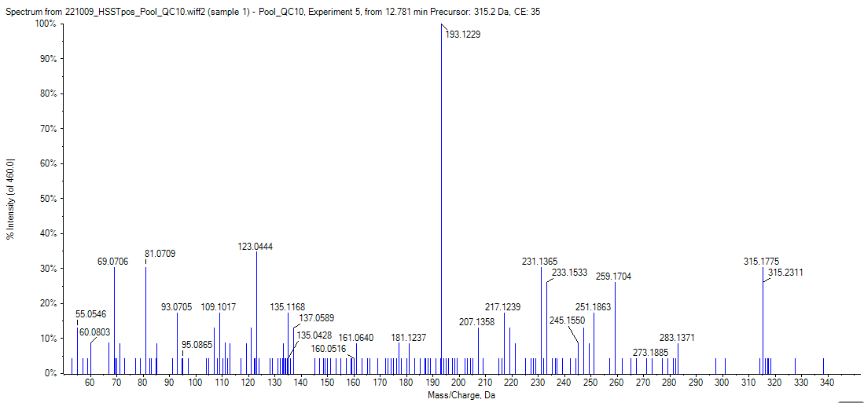
Figure S36 Mass spectrum in the QC pool sample of the cannabinoid at RT 12.77 min with m/z 315.2323

Mass spectra of the most important LC-HRMS features in negative ionization
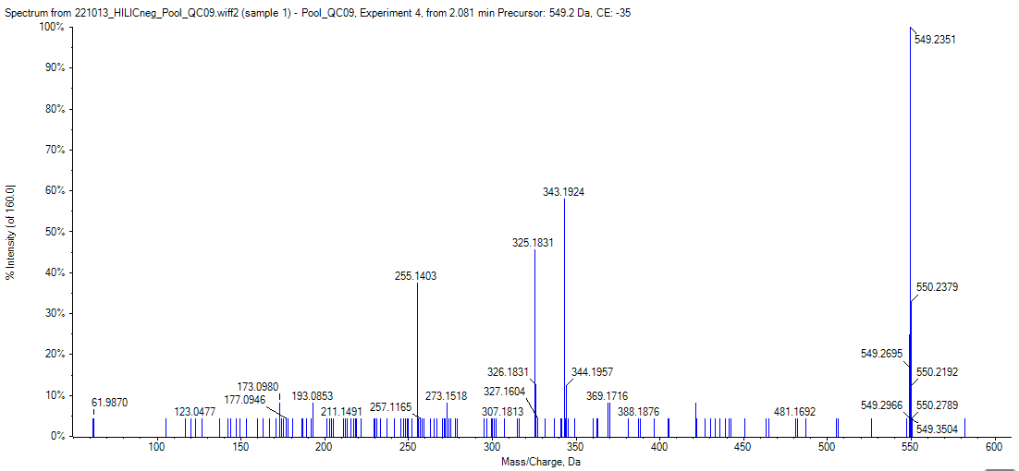
Figure S37 Mass spectrum in the QC pool sample of the unidentified feature at RT 2.06 min (HILIC) with m/z 549.2342
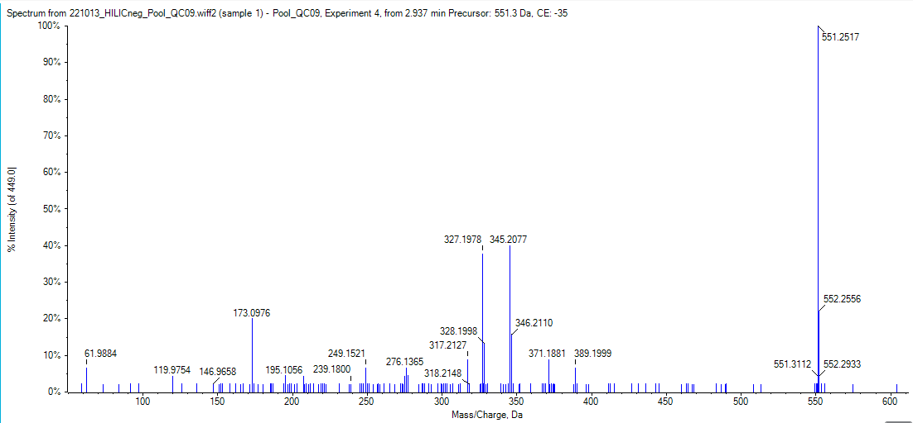
Figure S38 Mass spectrum in the QC pool sample of the terpene glycoside at RT 2.94 min (HILIC) with m/z 551.2502
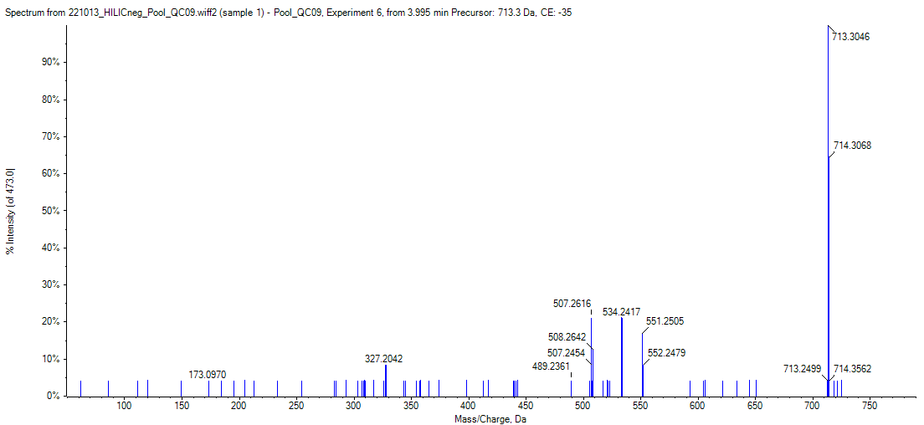
Figure S39 Mass spectrum in the QC pool sample of the unidentified feature at RT 3.99 min (HILIC) with m/z 713.3019

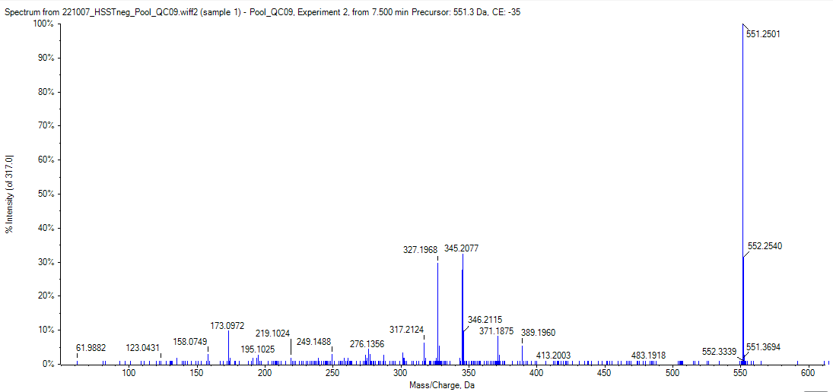
Figure S40 Mass spectrum in the QC pool sample of the terpene glycoside at 7.50 min (RP) and m/z 551.2499

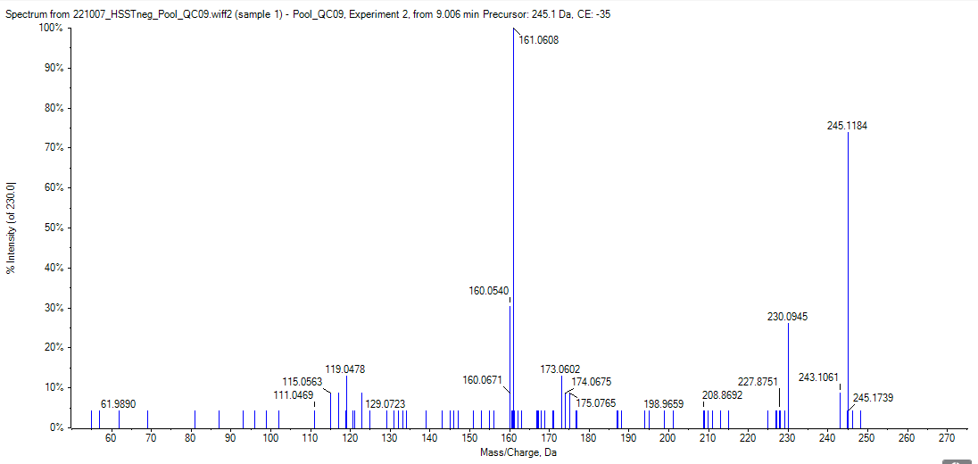
Figure S41 Mass spectrum in the QC pool sample of the terpene derivate at RT 9.00 min (RP) and m/z 245.1181

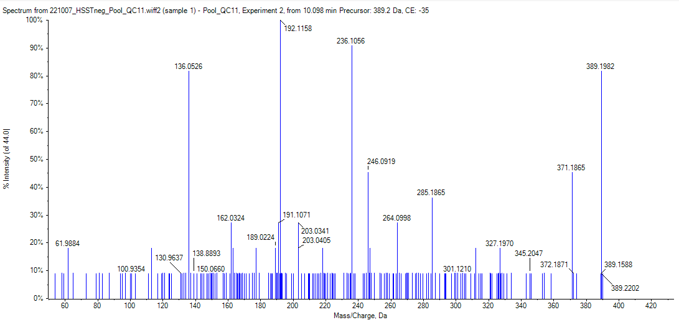
Figure S42 Mass spectrum in the QC pool sample of the unidentified feature at RT 10.12 min (RP) and m/z 389.1970

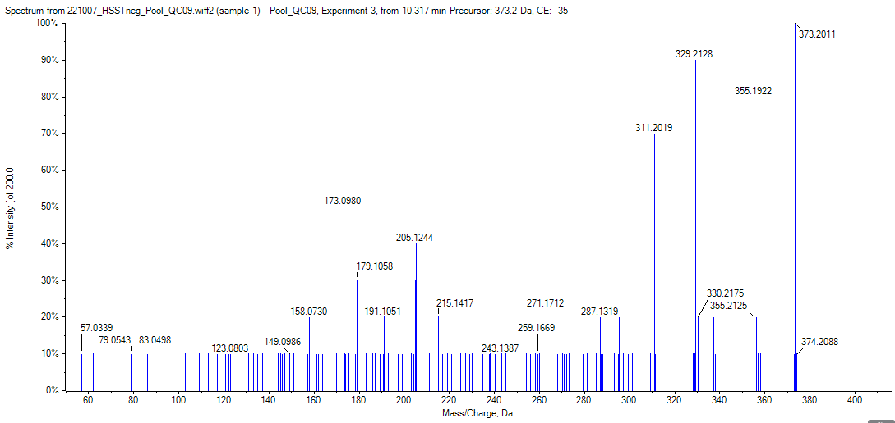
Figure S43 Mass spectrum in the QC pool sample of the unidentified feature at 10.31 min (RP) and m/z 373.2020

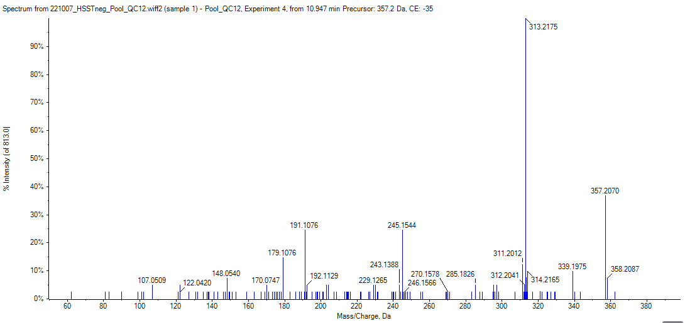
Figure S44 Mass spectrum in the QC pool sample of the cannabinoid at RT 10.98 min (RP) and m/z 357.2068

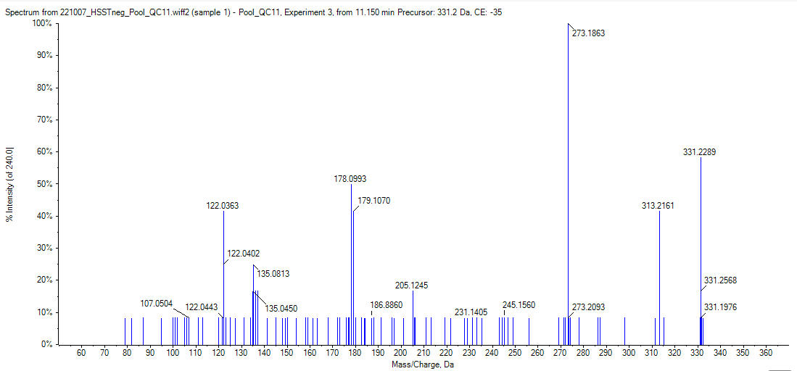
Figure S45 Mass spectrum in the QC pool sample of the unidentified feature at 11.20 min with m/z 331.2282

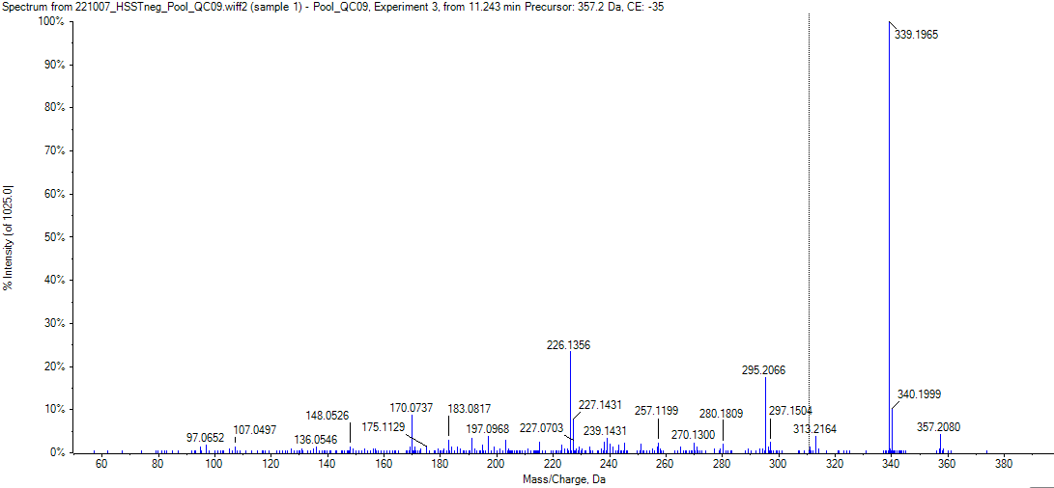
Figure S46 Mass spectrum in the QC pool sample of the unidentified feature at RT 11.24 min and m/z 357.2069

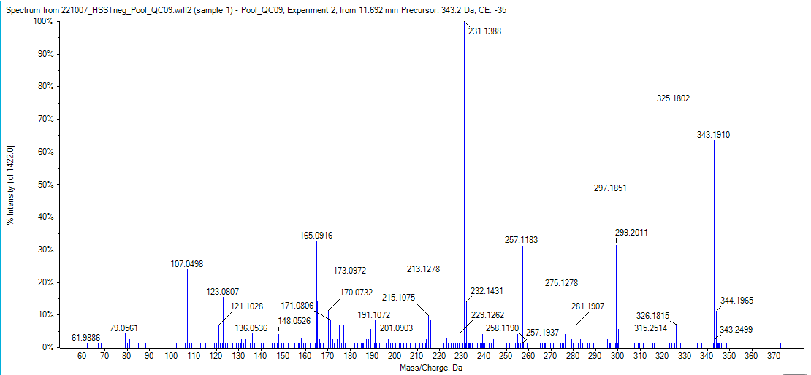
Figure S47 Mass spectrum in the QC pool sample of the cannabinoid at RT 11.69 min (RP) and m/z 343.1908

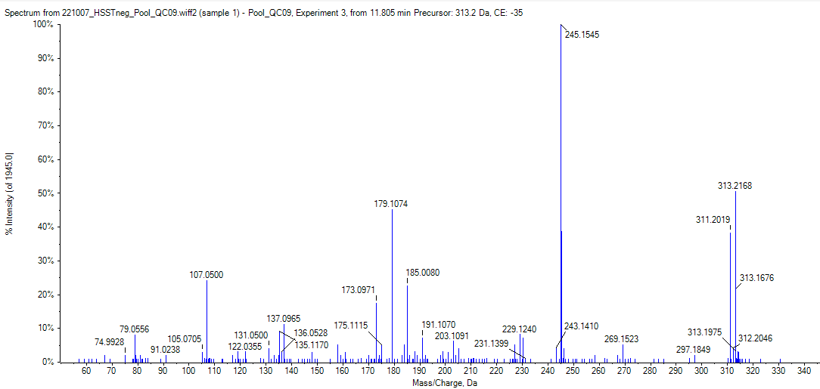
Figure S48 Mass spectrum in the QC pool sample of CBD

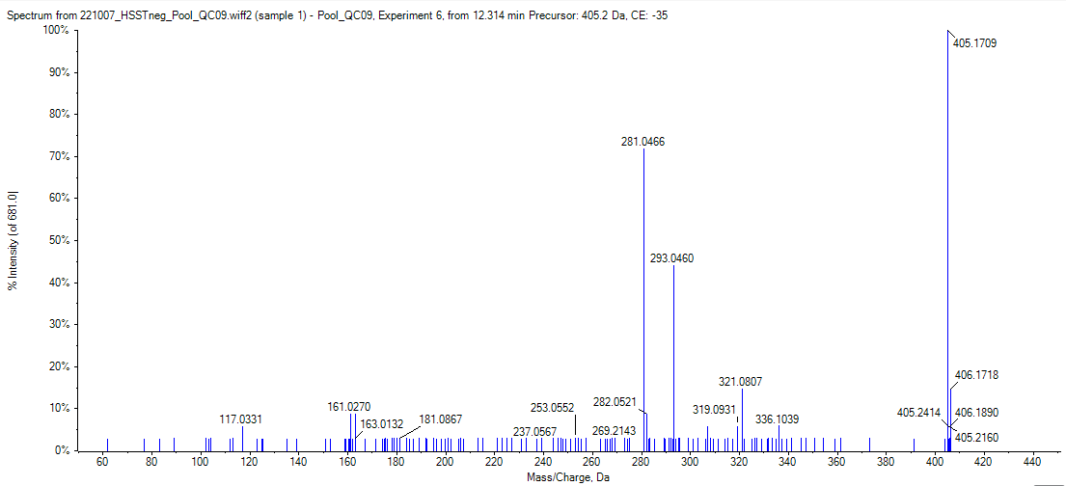
Figure S49 Mass spectrum in the QC pool sample of the flavonoid at RT 12.29 min and m/z 405.1706

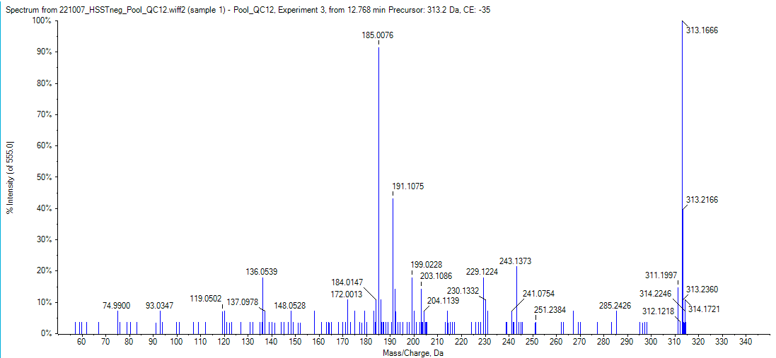
Figure S50 Mass spectrum in the QC pool sample of THC

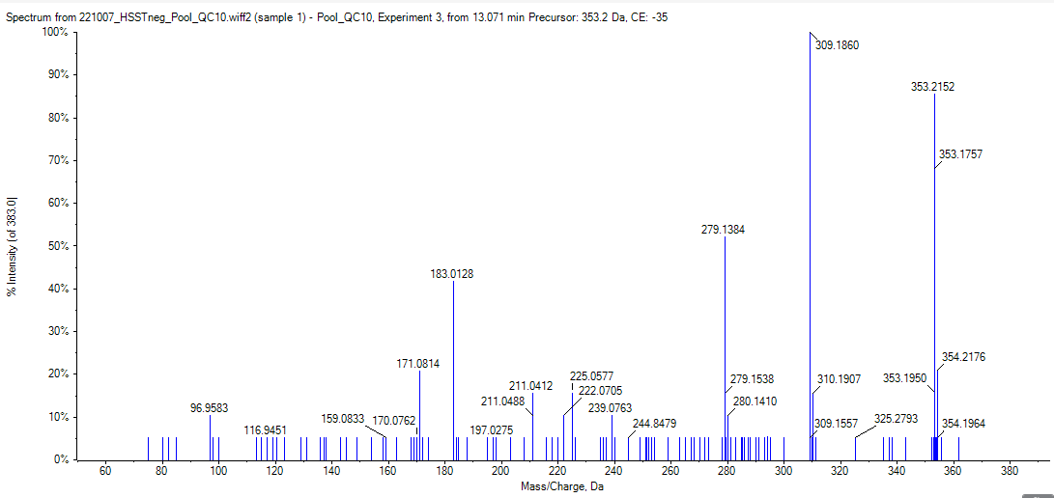
Figure S51 Mass spectrum in the QC pool sample of CBNA

