Supplementary Information
Reconsidering the case against risk prediction in self-harm: routinely collected health data can distinguish groups at differential risk across the cohort
J Oxley, L Schölin, G Brennan, A Anand, J Brett, M Eddleston, C Humphries

Contents
Table S1. Cohort flow.
Table S2. Training and held-out test set comparison, by 365-day composite outcome.
Table S3. Final hyperparameter values per model.
Table S4–S6. Full coefficient lists per model (retained predictors with coefficients and odds ratios).
Table S7–S9. Bootstrap retention frequencies and coefficient confidence intervals per model.
Figure S1–S3. Bootstrap feature retention frequency per model.
Figure S4–S6. Bootstrap coefficient dot-interval plots per model.
Table S10. Bootstrap retention frequencies for the full candidate predictor set, by follow-up window.

Table S1. Cohort flow
Numbers and changes through each filtering step from raw TrakCare emergency-attendance data to the final analysis cohort.
Step | Attendances | Δ attendances | Patients
Attendances with a matching discharge diagnosis code | 6,763 | - | 4,095
Selecting the index (earliest) attendance per patient | 4,095 | -2,668 | 4,095

Table S2. Training and held-out test set comparison
Counts and proportions for each candidate feature, split by 80%/20% training/test sample and by 365-day composite outcome. P-values are from the corresponding chi-squared/Fisher (categorical) or Wilcoxon (continuous) tests on the training data and are provided for illustration only. "< 10" indicates a cell suppressed under NHS Scotland statistical disclosure control.
Variable | Test, no event (n=714) | Test, event (n=106) | Training, no event (n=2,855) | Training, event (n=420)
Age (years) | 32 (23-48) | 44 (30.25-57) | 32 (24-47) | 41 (26.75-56)
GP diagnoses (count) | 0 (0-0) | 0 (0-1) | 0 (0-0) | 0 (0-1)
Polypharmacy (VTM count) | 1 (0-2) | 2 (1-5) | 1 (0-2) | 2 (1-4)
Sex: F | 434 (60.78%) | 66 (62.26%) | 1747 (61.19%) | 259 (61.67%)
Sex: M | 280 (39.22%) | 40 (37.74%) | 1108 (38.81%) | 161 (38.33%)
SIMD Quintile: 1 | 134 (18.77%) | 26 (24.53%) | 654 (22.91%) | 95 (22.62%)
SIMD Quintile: 2 | 221 (30.95%) | 44 (41.51%) | 833 (29.18%) | 109 (25.95%)
SIMD Quintile: 3 | 134 (18.77%) | 12 (11.32%) | 482 (16.88%) | 81 (19.29%)
SIMD Quintile: 4 | 101 (14.15%) | 14 (13.21%) | 396 (13.87%) | 62 (14.76%)
SIMD Quintile: 5 | 102 (14.29%) | 10 (9.43%) | 420 (14.71%) | 69 (16.43%)
SIMD Quintile: NA | 22 (3.08%) | NA | 70 (2.45%) | < 10
SIMD: missing | 22 (3.08%) | < 10 | 70 (2.45%) | < 10
Rx: Substance-dependence | 40 (5.6%) | 17 (16.04%) | 158 (5.53%) | 59 (14.05%)
Rx: Antiepileptics | 60 (8.4%) | 24 (22.64%) | 285 (9.98%) | 82 (19.52%)
Rx: Antidepressants | 335 (46.92%) | 70 (66.04%) | 1366 (47.85%) | 283 (67.38%)
Rx: Hypnotics / anxiolytics | 148 (20.73%) | 45 (42.45%) | 584 (20.46%) | 186 (44.29%)
Rx: Analgesics | 95 (13.31%) | 25 (23.58%) | 394 (13.8%) | 75 (17.86%)
Rx: Antipsychotic-class | 82 (11.48%) | 34 (32.08%) | 280 (9.81%) | 150 (35.71%)
Rx: CNS stimulant (ADHD) | < 10 | < 10 | 21 (0.74%) | < 10
Any outpatient appt. | 297 (41.6%) | 75 (70.75%) | 1154 (40.42%) | 295 (70.24%)
Outpatient appt.: attended | 286 (40.06%) | 74 (69.81%) | 1103 (38.63%) | 291 (69.29%)
Outpatient appt.: not attended | 143 (20.03%) | 52 (49.06%) | 606 (21.23%) | 201 (47.86%)
Outpatient: General psychiatry | 275 (38.52%) | 70 (66.04%) | 1075 (37.65%) | 266 (63.33%)
Outpatient: Forensic psychiatry | < 10 | < 10 | 14 (0.49%) | < 10
Outpatient: Geriatric psychiatry | 14 (1.96%) | < 10 | 34 (1.19%) | 29 (6.9%)
Outpatient: Clinical psychology | < 10 | < 10 | 34 (1.19%) | < 10
Outpatient: Child & adolescent psychiatry | < 10 | < 10 | 37 (1.3%) | < 10
Outpatient: Learning disability | < 10 | < 10 | 32 (1.12%) | < 10
GP dx: Other psychiatric / substance misuse | 30 (4.2%) | < 10 | 122 (4.27%) | 28 (6.67%)
GP dx: Alcohol problems | 23 (3.22%) | < 10 | 118 (4.13%) | 44 (10.48%)
GP dx: Depression | 66 (9.24%) | 10 (9.43%) | 209 (7.32%) | 51 (12.14%)
GP dx: Anxiety | 50 (7%) | < 10 | 153 (5.36%) | 40 (9.52%)
GP dx: Personality disorder | 13 (1.82%) | < 10 | 71 (2.49%) | 33 (7.86%)
GP dx: Hyperkinetic disorder | < 10 | < 10 | < 10 | < 10
GP dx: Anorexia / bulimia | < 10 | < 10 | < 10 | < 10
GP dx: Dementia | < 10 | < 10 | < 10 | < 10
GP dx: Schizophrenia | < 10 | < 10 | < 10 | 15 (3.57%)
GP dx: Autism spectrum | < 10 | < 10 | 13 (0.46%) | < 10
GP dx: Delirium (non-substance) | < 10 | < 10 | < 10 | < 10
GP dx: Alcoholic liver disease | < 10 | < 10 | < 10 | < 10
GP dx: Intellectual disability | < 10 | < 10 | < 10 | < 10
GP dx: Bipolar disorder | < 10 | < 10 | < 10 | < 10
GP dx: OCD | < 10 | < 10 | < 10 | < 10

Table S3. Final hyperparameter values
Hyperparameter values selected by nested 5-fold cross-validation on the training set, maximising AUROC. α governs the mixing between LASSO and ridge regularisation (α=1 corresponds to pure LASSO); λ is the overall penalty strength.
Window | α (mixing parameter) | λ (overall penalty) | Events / total (%)
0–7 days | 0.8 | 0.0076 | 224 (5.47%)
8–30 days | 1.0 (pure LASSO) | 0.0027 | 82 (2.00%)
31–365 days | 0.5 | 0.0085 | 325 (7.94%)

Table S4. Full coefficient list, 0–7 day model
All 37 candidate predictors with their elastic-net-fitted coefficient and corresponding odds ratio. Coefficients of exactly zero indicate predictors dropped by L1 regularisation.
Feature | Coefficient (log-odds) | Odds ratio
(Intercept) | -3.233 | 0.04
Age (years) | 0.002 | 1.00
Sex | 0.000 | -
SIMD quintile | 0.000 | -
SIMD: missing | 0.000 | -
Polypharmacy (VTM count) | 0.041 | 1.04
Rx: Substance-dependence | 0.000 | -
Rx: Antiepileptics | 0.000 | -
Rx: Antidepressants | 0.000 | -
Rx: Hypnotics / anxiolytics | 0.370 | 1.45
Rx: Analgesics | 0.000 | -
Rx: Antipsychotic-class | 0.294 | 1.34
Rx: CNS stimulant (ADHD) | 0.000 | -
Any outpatient appt. | 0.000 | -
Outpatient appt.: attended | 0.166 | 1.18
Outpatient appt.: not attended | 0.000 | -
Outpatient: General psychiatry | 0.000 | -
Outpatient: Forensic psychiatry | 0.000 | -
Outpatient: Geriatric psychiatry | 0.000 | -
Outpatient: Clinical psychology | 0.000 | -
Outpatient: Child & adolescent psychiatry | 0.000 | -
Outpatient: Learning disability | 0.000 | -
GP diagnoses (count) | 0.000 | -
GP dx: Other psychiatric / substance misuse | 0.000 | -
GP dx: Alcohol problems | 0.000 | -
GP dx: Depression | 0.000 | -
GP dx: Anxiety | 0.000 | -
GP dx: Personality disorder | 0.000 | -
GP dx: Hyperkinetic disorder | 0.000 | -
GP dx: Anorexia / bulimia | 0.000 | -
GP dx: Dementia | 0.000 | -
GP dx: Schizophrenia | 1.105 | 3.02
GP dx: Autism spectrum | 0.000 | -
GP dx: Delirium (non-substance) | 0.000 | -
GP dx: Alcoholic liver disease | 0.000 | -
GP dx: Intellectual disability | 0.000 | -
GP dx: Bipolar disorder | 0.000 | -
GP dx: OCD | 0.000 | -

Table S5. Full coefficient list, 8–30 day model
All 37 candidate predictors with their elastic-net-fitted coefficient and corresponding odds ratio.
Feature | Coefficient (log-odds) | Odds ratio
(Intercept) | -4.013 | 0.02
Age (years) | 0.000 | -
Sex | 0.000 | -
SIMD quintile | 0.000 | -
SIMD: missing | 0.000 | -
Polypharmacy (VTM count) | 0.017 | 1.02
Rx: Substance-dependence | 0.000 | -
Rx: Antiepileptics | 0.000 | -
Rx: Antidepressants | 0.000 | -
Rx: Hypnotics / anxiolytics | 0.000 | -
Rx: Analgesics | 0.000 | -
Rx: Antipsychotic-class | 0.000 | -
Rx: CNS stimulant (ADHD) | 0.000 | -
Any outpatient appt. | 0.000 | -
Outpatient appt.: attended | 0.000 | -
Outpatient appt.: not attended | 0.000 | -
Outpatient: General psychiatry | 0.000 | -
Outpatient: Forensic psychiatry | 0.000 | -
Outpatient: Geriatric psychiatry | 1.059 | 2.88
Outpatient: Clinical psychology | 0.000 | -
Outpatient: Child & adolescent psychiatry | 0.000 | -
Outpatient: Learning disability | 0.000 | -
GP diagnoses (count) | 0.000 | -
GP dx: Other psychiatric / substance misuse | 0.000 | -
GP dx: Alcohol problems | 0.000 | -
GP dx: Depression | 0.000 | -
GP dx: Anxiety | 0.000 | -
GP dx: Personality disorder | 0.000 | -
GP dx: Hyperkinetic disorder | 0.000 | -
GP dx: Anorexia / bulimia | 0.000 | -
GP dx: Dementia | 0.000 | -
GP dx: Schizophrenia | 0.000 | -
GP dx: Autism spectrum | 0.000 | -
GP dx: Delirium (non-substance) | 0.000 | -
GP dx: Alcoholic liver disease | 0.429 | 1.54
GP dx: Intellectual disability | 0.000 | -
GP dx: Bipolar disorder | 0.000 | -
GP dx: OCD | 0.000 | -

Table S6. Full coefficient list, 31–365 day model
All 37 candidate predictors with their elastic-net-fitted coefficient and corresponding odds ratio.
Feature | Coefficient (log-odds) | Odds ratio
(Intercept) | -3.097 | 0.05
Age (years) | 0.004 | 1.00
Sex | 0.000 | -
SIMD quintile | 0.000 | -
SIMD: missing | 0.000 | -
Polypharmacy (VTM count) | 0.098 | 1.10
Rx: Substance-dependence | 0.190 | 1.21
Rx: Antiepileptics | 0.000 | -
Rx: Antidepressants | 0.000 | -
Rx: Hypnotics / anxiolytics | 0.000 | -
Rx: Analgesics | 0.000 | -
Rx: Antipsychotic-class | 0.485 | 1.62
Rx: CNS stimulant (ADHD) | 0.000 | -
Any outpatient appt. | 0.029 | 1.03
Outpatient appt.: attended | 0.218 | 1.24
Outpatient appt.: not attended | 0.263 | 1.30
Outpatient: General psychiatry | 0.000 | -
Outpatient: Forensic psychiatry | 0.000 | -
Outpatient: Geriatric psychiatry | 0.000 | -
Outpatient: Clinical psychology | 0.000 | -
Outpatient: Child & adolescent psychiatry | 0.000 | -
Outpatient: Learning disability | 0.000 | -
GP diagnoses (count) | 0.002 | 1.00
GP dx: Other psychiatric / substance misuse | 0.000 | -
GP dx: Alcohol problems | 0.000 | -
GP dx: Depression | 0.000 | -
GP dx: Anxiety | 0.000 | -
GP dx: Personality disorder | 0.000 | -
GP dx: Hyperkinetic disorder | 0.000 | -
GP dx: Anorexia / bulimia | 0.000 | -
GP dx: Dementia | 0.000 | -
GP dx: Schizophrenia | 0.000 | -
GP dx: Autism spectrum | 0.000 | -
GP dx: Delirium (non-substance) | 0.000 | -
GP dx: Alcoholic liver disease | 0.000 | -
GP dx: Intellectual disability | 0.000 | -
GP dx: Bipolar disorder | 0.000 | -
GP dx: OCD | 0.000 | -

Table S7. Bootstrap retention frequencies, 0–7 day model
Across 1,000 bootstrap resamples of the training data, the proportion of iterations in which each candidate predictor was retained by the elastic-net penalty, alongside median coefficient and bootstrap 95% confidence interval. Sorted by retention frequency.
Feature | Retention frequency (%) | Median coefficient | Lower 95% CI | Upper 95% CI
Age (years) | 99.7 | 0.015 | 0.003 | 0.028
Rx: Hypnotics / anxiolytics | 99.4 | 0.592 | 0.163 | 1.028
GP dx: Schizophrenia | 97.9 | 1.754 | 0.000 | 3.152
Outpatient appt.: attended | 97.3 | 0.372 | 0.000 | 2.463
Rx: Antipsychotic-class | 97.0 | 0.446 | 0.000 | 0.970
GP dx: Depression | 73.1 | 0.224 | 0.000 | 0.811
GP dx: Alcoholic liver disease | 73.1 | 0.991 | -0.780 | 3.129
Rx: Antiepileptics | 71.1 | 0.127 | -0.050 | 0.617
GP dx: Anorexia / bulimia | 69.7 | -0.421 | -5.315 | 0.000
GP dx: Bipolar disorder | 69.5 | 0.346 | -1.374 | 2.037
Outpatient: Geriatric psychiatry | 67.2 | 0.134 | -0.294 | 1.077
Outpatient: Forensic psychiatry | 60.7 | 0.163 | -1.010 | 1.947
GP dx: Autism spectrum | 57.7 | 0.000 | -4.796 | 0.497
Polypharmacy (VTM count) | 57.0 | 0.002 | -0.083 | 0.115
GP dx: Dementia | 55.6 | 0.000 | -2.277 | 1.652
GP dx: Hyperkinetic disorder | 55.5 | 0.000 | -4.581 | 2.089
Rx: Antidepressants | 51.9 | 0.000 | -0.107 | 0.449
Rx: Analgesics | 51.4 | 0.000 | -0.653 | 0.032
Rx: Substance-dependence | 51.2 | 0.000 | -0.819 | 0.151
Outpatient: Clinical psychology | 50.5 | 0.000 | -1.235 | 1.119
SIMD: missing | 49.6 | 0.000 | -4.175 | 0.000
Outpatient: Child & adolescent psychiatry | 48.9 | 0.000 | -3.397 | 0.382
Outpatient: Learning disability | 48.8 | 0.000 | -3.065 | 0.186
GP dx: Personality disorder | 48.4 | 0.000 | -0.696 | 0.574
Outpatient: General psychiatry | 47.2 | 0.000 | 0.000 | 0.845
GP dx: Alcohol problems | 47.2 | 0.000 | -1.091 | 0.065
Rx: CNS stimulant (ADHD) | 45.5 | 0.000 | -2.675 | 1.047
Sex | 45.4 | 0.000 | -0.159 | 0.373
GP dx: Delirium (non-substance) | 45.2 | 0.000 | -4.301 | 0.000
Any outpatient appt. | 44.0 | 0.000 | -2.675 | 0.382
GP dx: Anxiety | 43.5 | 0.000 | -0.434 | 0.558
GP dx: Other psychiatric / substance misuse | 43.4 | 0.000 | -0.826 | 0.242
Outpatient appt.: not attended | 43.0 | 0.000 | -0.335 | 0.292
SIMD quintile | 41.7 | 0.000 | -0.071 | 0.103
GP dx: Intellectual disability | 30.6 | 0.000 | -3.653 | 0.000
GP diagnoses (count) | 16.0 | 0.000 | -0.028 | 0.104
GP dx: OCD | 12.8 | 0.000 | -2.814 | 0.000

Table S8. Bootstrap retention frequencies, 8–30 day model
Across 1,000 bootstrap resamples of the training data, the proportion of iterations in which each candidate predictor was retained by the elastic-net penalty, alongside median coefficient and bootstrap 95% confidence interval. Sorted by retention frequency.
Feature | Retention frequency (%) | Median coefficient | Lower 95% CI | Upper 95% CI
Outpatient: Geriatric psychiatry | 96.9 | 1.767 | 0.000 | 3.104
Polypharmacy (VTM count) | 86.3 | 0.055 | 0.000 | 0.205
GP dx: Alcoholic liver disease | 80.0 | 2.153 | 0.000 | 5.223
GP dx: Anorexia / bulimia | 70.7 | 1.174 | -0.218 | 3.250
Outpatient appt.: attended | 69.3 | 0.106 | 0.000 | 0.829
Any outpatient appt. | 66.8 | 0.088 | 0.000 | 0.829
Rx: Antipsychotic-class | 66.7 | 0.136 | 0.000 | 0.910
GP dx: Autism spectrum | 63.1 | 0.756 | 0.000 | 3.032
Rx: Substance-dependence | 62.3 | 0.174 | 0.000 | 1.003
GP dx: Dementia | 61.7 | -0.339 | -3.043 | 0.000
Outpatient appt.: not attended | 51.4 | 0.000 | -0.148 | 0.538
GP dx: Alcohol problems | 47.7 | 0.000 | 0.000 | 1.277
GP dx: Anxiety | 44.8 | 0.000 | 0.000 | 1.150
GP dx: Schizophrenia | 42.8 | 0.000 | -1.977 | 1.630
GP dx: Personality disorder | 41.7 | 0.000 | -0.250 | 0.960
GP diagnoses (count) | 40.8 | 0.000 | 0.000 | 0.261
SIMD quintile | 39.8 | 0.000 | -0.245 | 0.000
Rx: Hypnotics / anxiolytics | 39.8 | 0.000 | -0.286 | 0.548
Outpatient: Forensic psychiatry | 37.0 | 0.000 | -0.977 | 1.970
GP dx: Other psychiatric / substance misuse | 35.3 | 0.000 | -0.336 | 0.920
Outpatient: Clinical psychology | 34.3 | 0.000 | -1.476 | 1.133
Rx: Antidepressants | 34.0 | 0.000 | -0.126 | 0.558
Outpatient: General psychiatry | 32.4 | 0.000 | 0.000 | 0.612
Outpatient: Child & adolescent psychiatry | 31.8 | 0.000 | -2.135 | 0.000
Sex | 29.7 | 0.000 | -0.662 | 0.000
Outpatient: Learning disability | 29.5 | 0.000 | -1.122 | 1.381
Rx: Antiepileptics | 29.3 | 0.000 | -0.459 | 0.554
GP dx: Delirium (non-substance) | 28.3 | 0.000 | -3.155 | 0.000
GP dx: Bipolar disorder | 28.0 | 0.000 | -1.860 | 0.000
Age (years) | 26.7 | 0.000 | -0.001 | 0.015
Rx: Analgesics | 26.5 | 0.000 | -0.367 | 0.495
Rx: CNS stimulant (ADHD) | 23.5 | 0.000 | -1.496 | 0.000
GP dx: Depression | 21.3 | 0.000 | -0.697 | 0.194
GP dx: Hyperkinetic disorder | 18.7 | 0.000 | -0.984 | 0.000
SIMD: missing | 18.6 | 0.000 | -0.916 | 0.601
GP dx: Intellectual disability | 8.3 | 0.000 | -0.935 | 0.000
GP dx: OCD | 4.9 | 0.000 | -1.014 | 0.000

Table S9. Bootstrap retention frequencies, 31–365 day model
Across 1,000 bootstrap resamples of the training data, the proportion of iterations in which each candidate predictor was retained by the elastic-net penalty, alongside median coefficient and bootstrap 95% confidence interval. Sorted by retention frequency.
Feature | Retention frequency (%) | Median coefficient | Lower 95% CI | Upper 95% CI
Rx: Antipsychotic-class | 100.0 | 0.660 | 0.275 | 1.111
Age (years) | 99.9 | 0.018 | 0.006 | 0.033
Outpatient appt.: attended | 99.5 | 0.421 | 0.094 | 2.136
Rx: Substance-dependence | 96.5 | 0.428 | 0.000 | 0.925
Polypharmacy (VTM count) | 95.5 | 0.080 | 0.000 | 0.195
Outpatient appt.: not attended | 95.5 | 0.291 | 0.000 | 0.657
GP dx: Alcohol problems | 91.5 | 0.465 | 0.000 | 1.021
GP dx: Personality disorder | 87.4 | 0.397 | 0.000 | 1.140
GP dx: Schizophrenia | 84.0 | 0.682 | 0.000 | 1.928
GP dx: Anorexia / bulimia | 82.7 | 0.872 | 0.000 | 2.208
GP dx: Delirium (non-substance) | 72.1 | -0.745 | -6.581 | 0.000
Outpatient: Child & adolescent psychiatry | 70.6 | 0.647 | 0.000 | 1.973
Rx: Hypnotics / anxiolytics | 68.3 | 0.064 | -0.185 | 0.390
GP dx: Intellectual disability | 66.5 | 0.425 | -1.390 | 4.091
SIMD: missing | 64.1 | -0.217 | -4.622 | 0.000
GP dx: Alcoholic liver disease | 58.8 | -0.004 | -5.877 | 0.640
SIMD quintile | 56.7 | 0.005 | -0.013 | 0.131
Outpatient: General psychiatry | 56.7 | 0.028 | 0.000 | 0.848
GP dx: Dementia | 55.3 | 0.000 | -1.431 | 1.699
Rx: Antidepressants | 53.8 | 0.004 | -0.051 | 0.440
GP dx: Bipolar disorder | 52.2 | 0.000 | -1.374 | 1.213
Outpatient: Learning disability | 51.1 | 0.000 | -2.340 | 0.224
Rx: CNS stimulant (ADHD) | 50.1 | 0.000 | -4.604 | 0.176
GP dx: Autism spectrum | 50.1 | 0.000 | -2.063 | 1.240
GP dx: Hyperkinetic disorder | 49.2 | 0.000 | -3.217 | 1.618
Outpatient: Forensic psychiatry | 49.1 | 0.000 | -1.102 | 1.743
Outpatient: Geriatric psychiatry | 48.4 | 0.000 | -0.649 | 0.704
Outpatient: Clinical psychology | 48.4 | 0.000 | -0.729 | 0.829
Rx: Antiepileptics | 45.8 | 0.000 | -0.323 | 0.322
Any outpatient appt. | 45.0 | 0.000 | -2.385 | 0.254
Rx: Analgesics | 40.9 | 0.000 | -0.552 | 0.041
GP dx: Other psychiatric / substance misuse | 40.8 | 0.000 | -0.604 | 0.240
Sex | 39.3 | 0.000 | -0.077 | 0.298
GP diagnoses (count) | 39.0 | 0.000 | 0.000 | 0.180
GP dx: Anxiety | 37.2 | 0.000 | -0.366 | 0.545
GP dx: Depression | 35.0 | 0.000 | -0.520 | 0.134
GP dx: OCD | 17.2 | 0.000 | -4.440 | 0.000

Figure S1. Bootstrap feature retention frequency, 0–7 day model
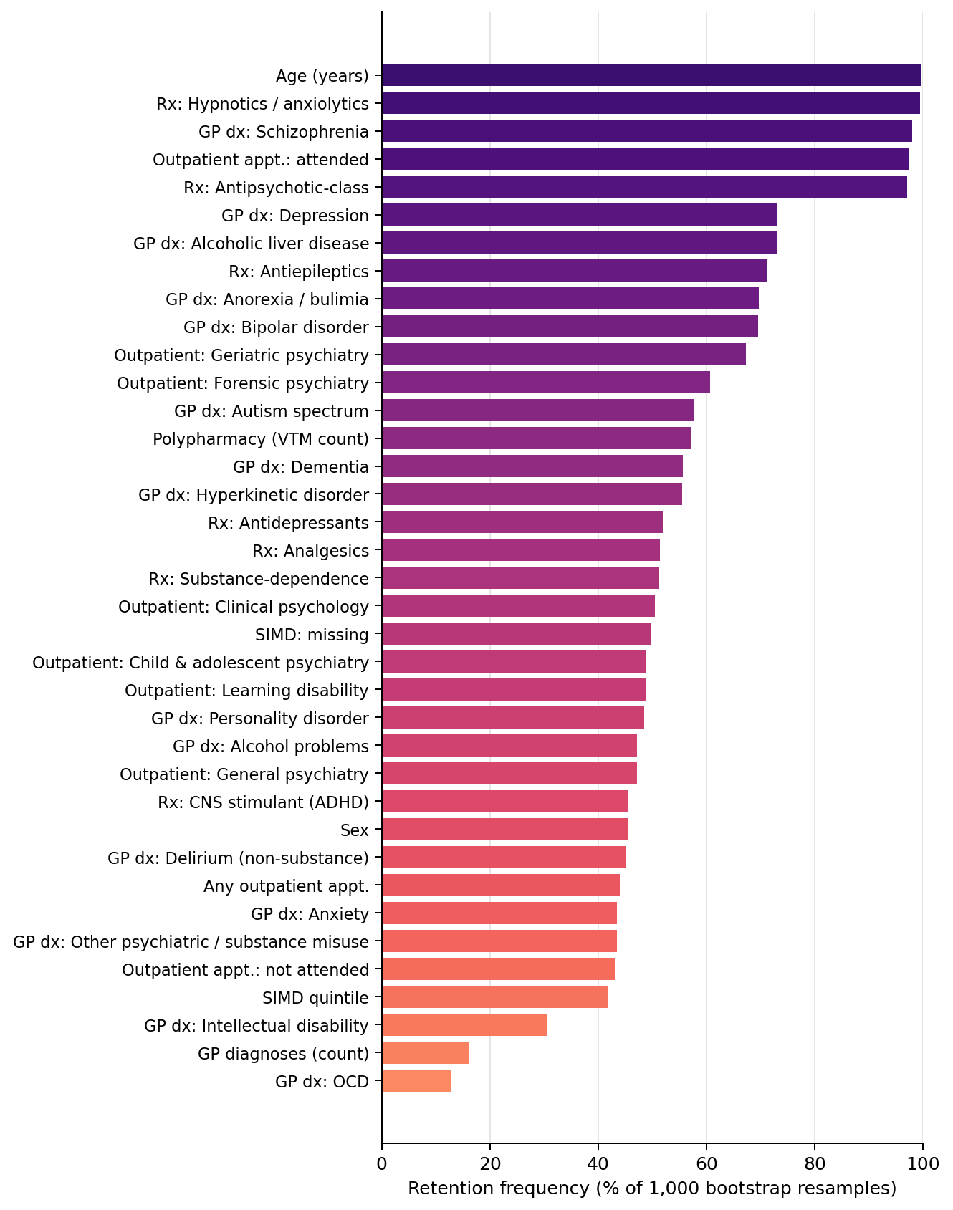
Proportion of 1,000 bootstrap resamples of the training data in which each candidate predictor was retained by the elastic-net penalty (non-zero coefficient), 0–7 day model. Predictors are ordered by retention frequency.

Figure S2. Bootstrap feature retention frequency, 8–30 day model
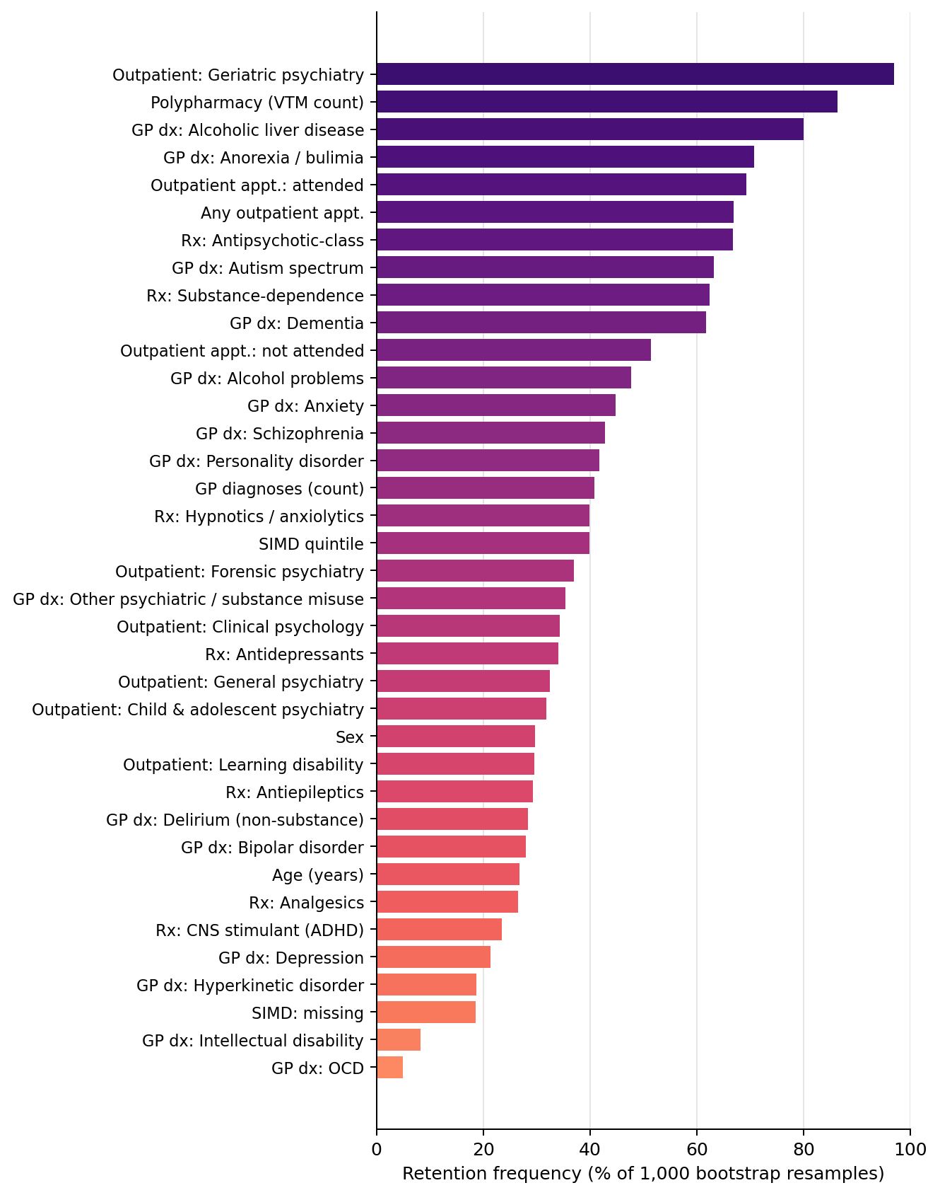
Proportion of 1,000 bootstrap resamples of the training data in which each candidate predictor was retained by the elastic-net penalty (non-zero coefficient), 8–30 day model.

Figure S3. Bootstrap feature retention frequency, 31–365 day model
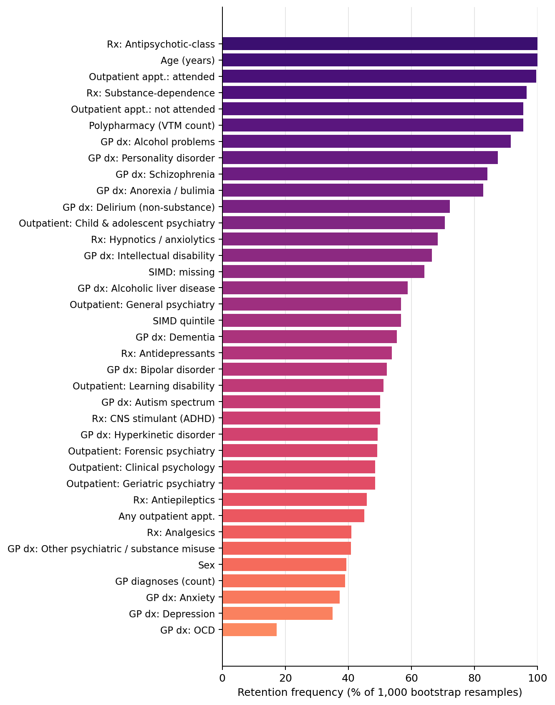
Proportion of 1,000 bootstrap resamples of the training data in which each candidate predictor was retained by the elastic-net penalty (non-zero coefficient), 31–365 day model.

Figure S4. Bootstrap coefficient dot-interval plot, 0–7 day model
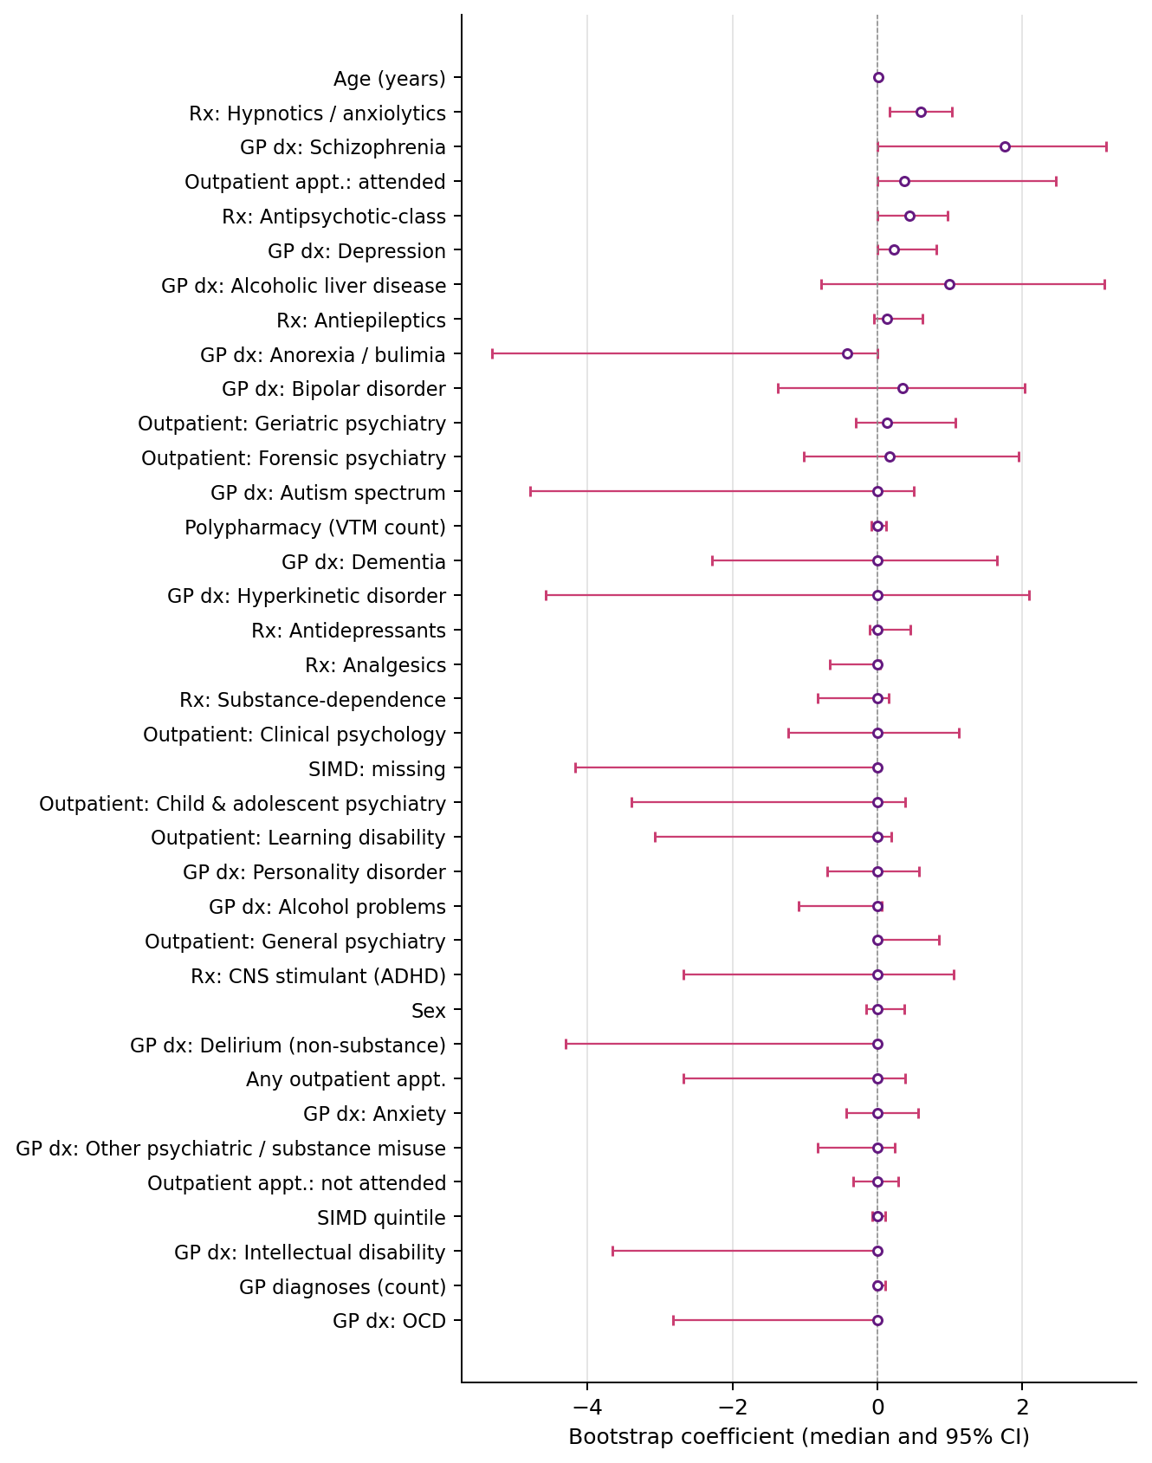
Median and 95% confidence interval of the coefficient for each candidate predictor across 1,000 bootstrap resamples of the training data, 0–7 day model. Predictors ordered by retention frequency.

Figure S5. Bootstrap coefficient dot-interval plot, 8–30 day model
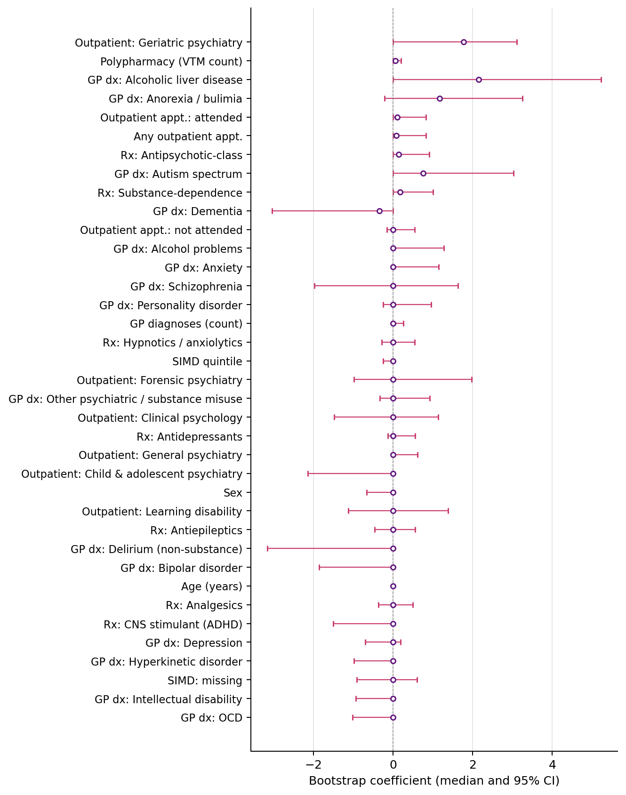
Median and 95% confidence interval of the coefficient for each candidate predictor across 1,000 bootstrap resamples of the training data, 8–30 day model.

Figure S6. Bootstrap coefficient dot-interval plot, 31–365 day model
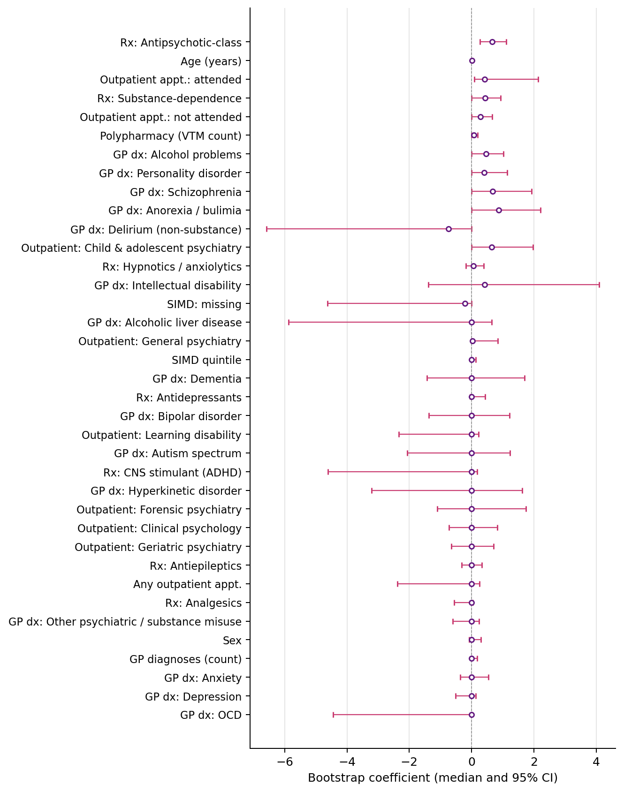
Median and 95% confidence interval of the coefficient for each candidate predictor across 1,000 bootstrap resamples of the training data, 31–365 day model.

Table S10. Categories of feature retained per follow-up window
Illustrative classification of retained features (non-zero coefficients) from the final elastic-net models. Originally Table 3 of the main paper. All retained coefficients carried positive sign (associated with increased odds of the composite outcome). Specific features should be interpreted as illustrative of the feature classes the model draws on, not as a definitive ranking.
Feature category (illustrative) | 0–7 days | 8–30 days | 31–365 days
Age | retained (+) | - | retained (+)
Polypharmacy (unique VTM count) | retained (+) | retained (+) | retained (+)
Prior MH-specialty outpatient contact | retained (+) | retained (+) | retained (+)
Antipsychotic prescribing | retained (+) | - | retained (+)
Hypnotic / anxiolytic prescribing | retained (+) | - | -
Substance-dependence prescribing | - | - | retained (+)
Severe MH GP diagnosis (schizophrenia) | retained (+) | - | -
Physical multimorbidity (alcoholic liver disease) | - | retained (+) | -
Total GP diagnoses (multimorbidity) | - | - | retained (+)

