FIGURE S2 Chromatograms for the calibration standards using cocaine as an example. The calibration curve of cocaine (see Figure S1B) converts the instrument response, which is the integrated peak area, to a concentration in the solution injected.

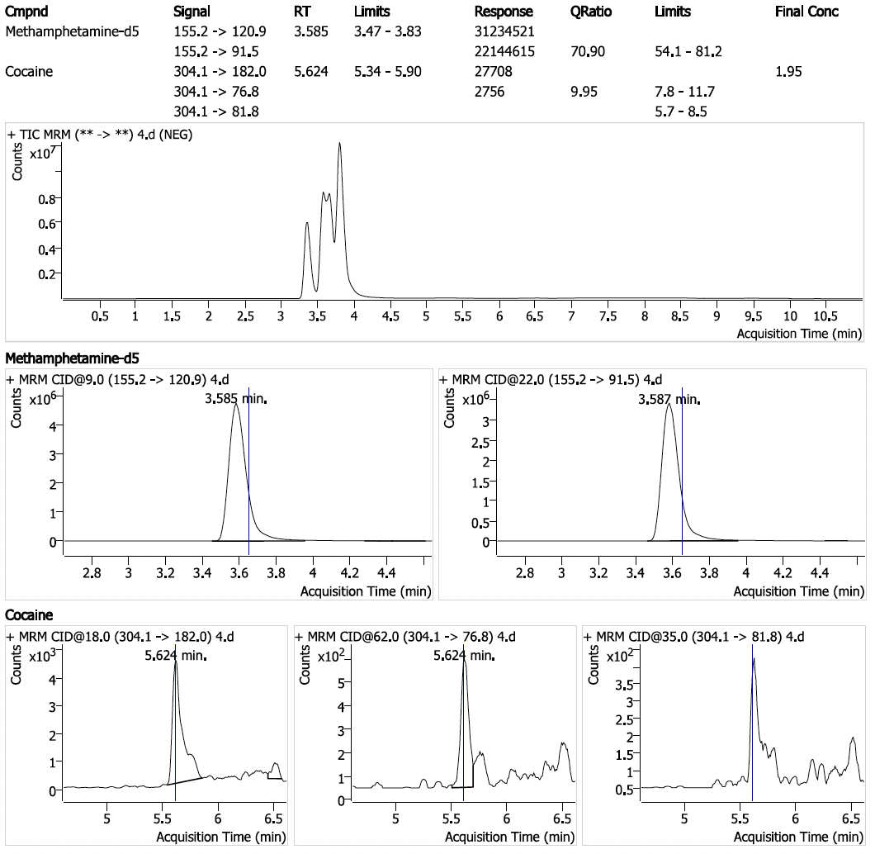
- 0 ng/mL standard (solvent blank)

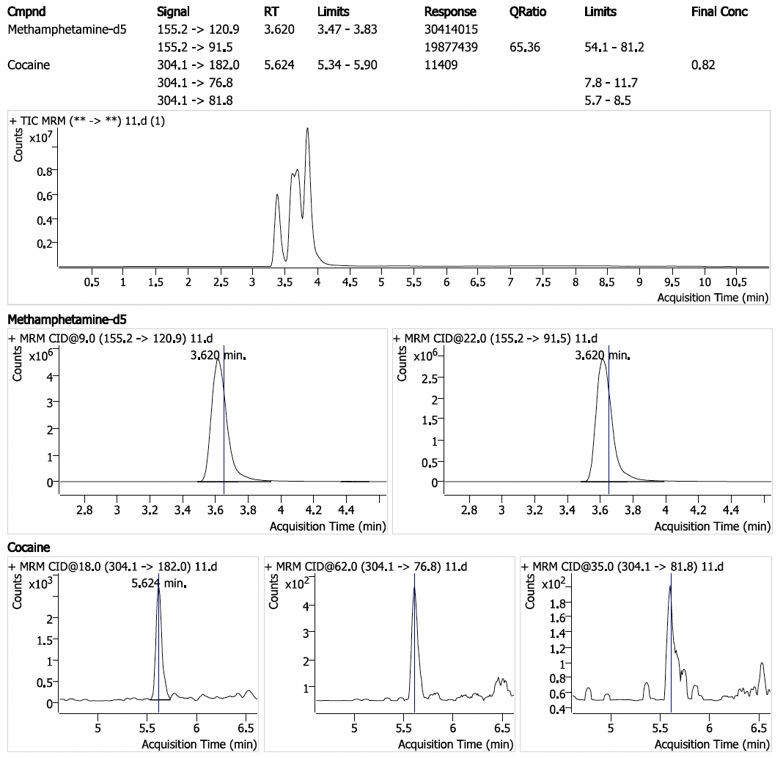

- 1 ng/mL standard

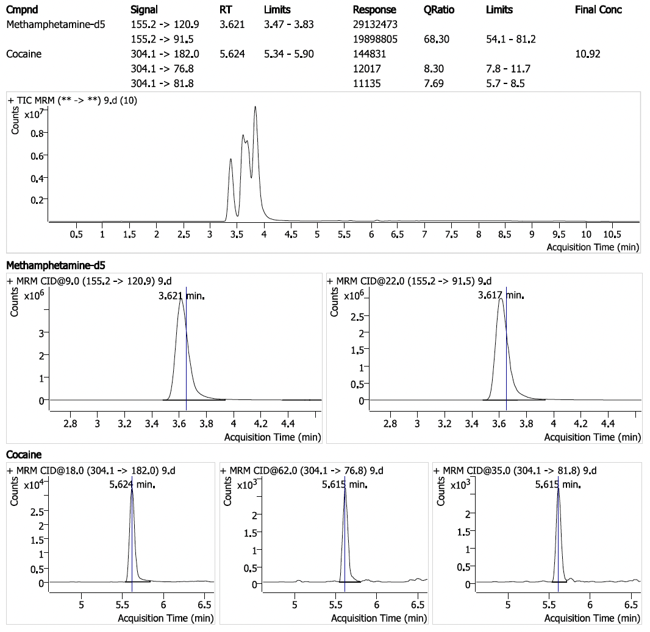
- 10 ng/mL standard

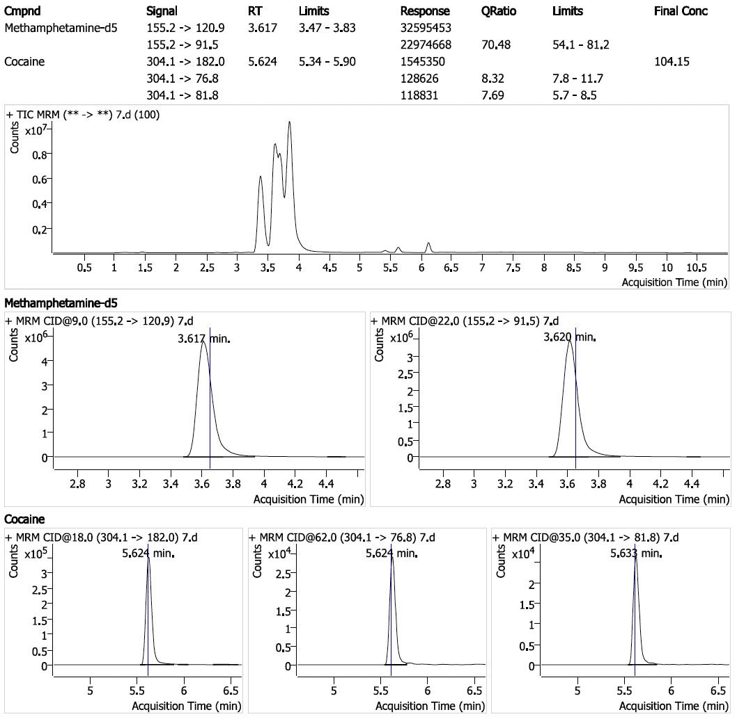

- 100 ng/mL standard

