Supplementary Figures 1A-I: Distributions of nine substance use phenotypes included in GWAS analyses for PLWH.
A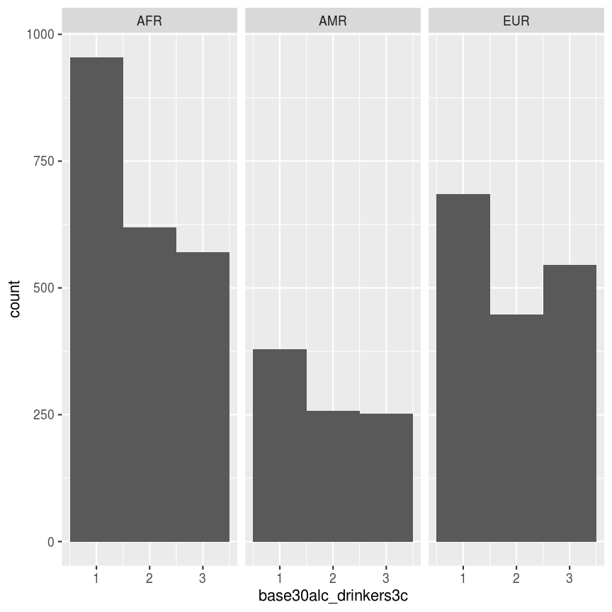 | B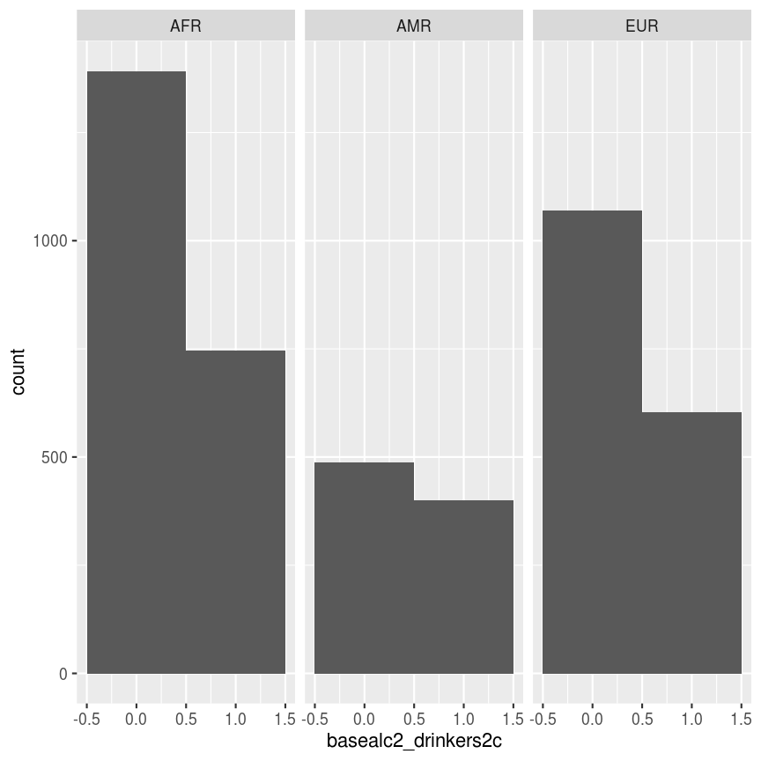 | C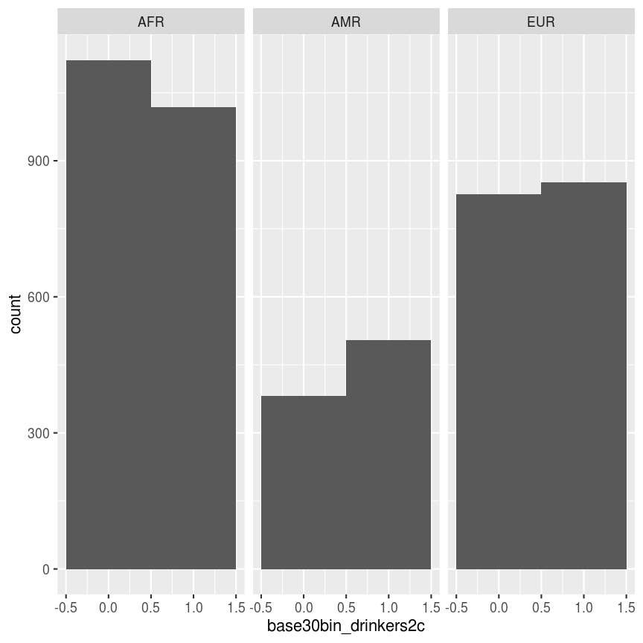
D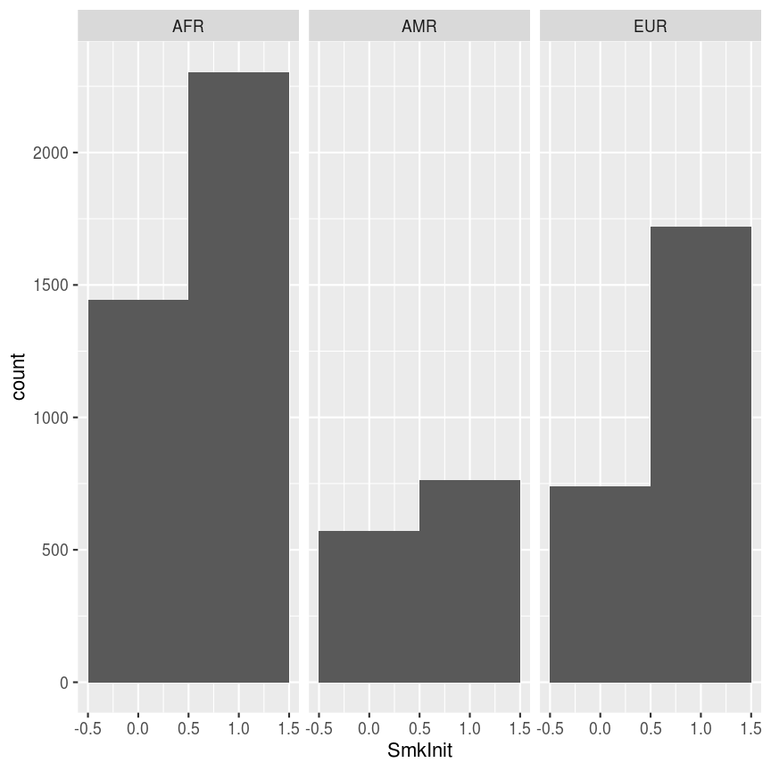 | E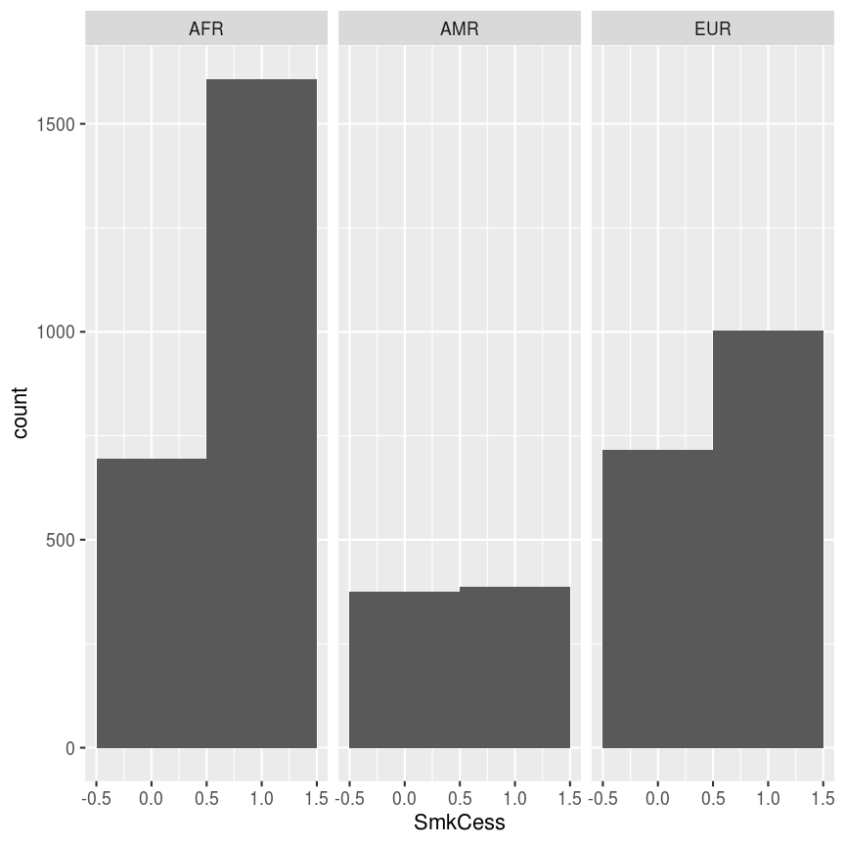 | F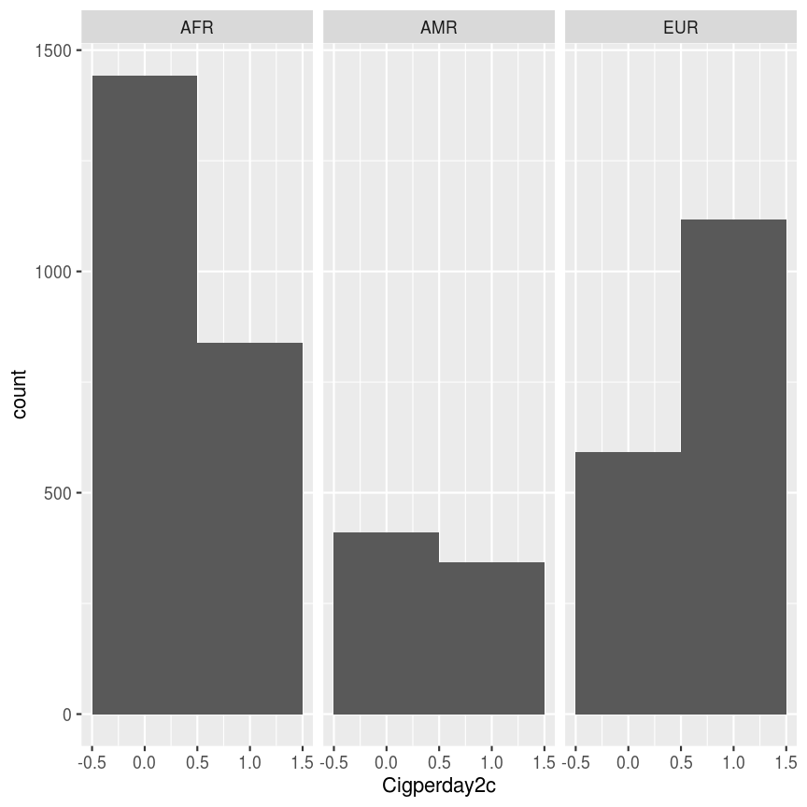
G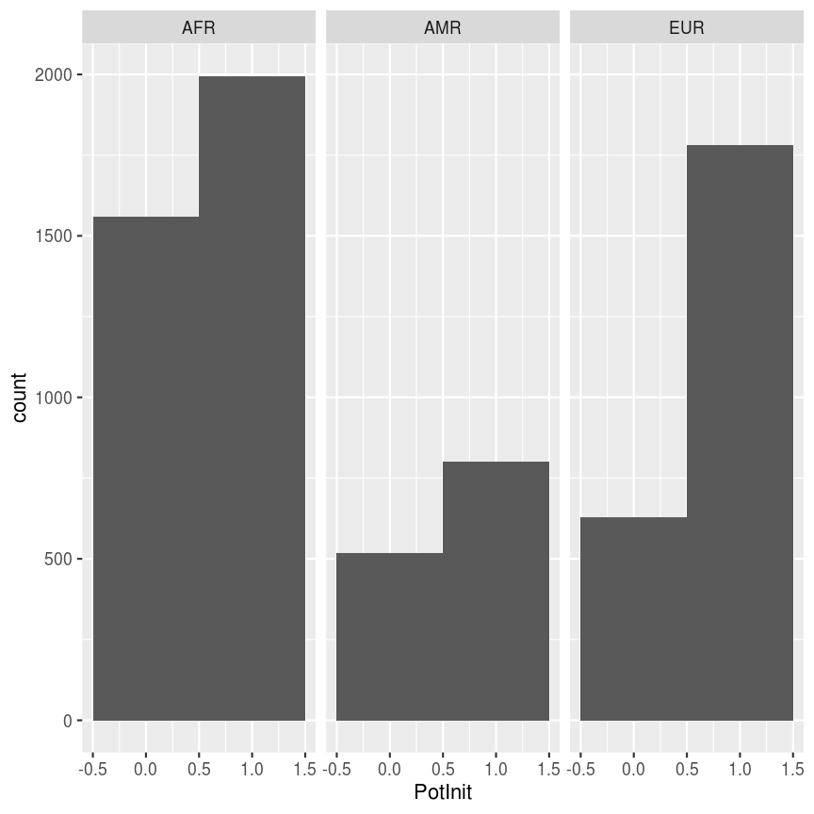 | H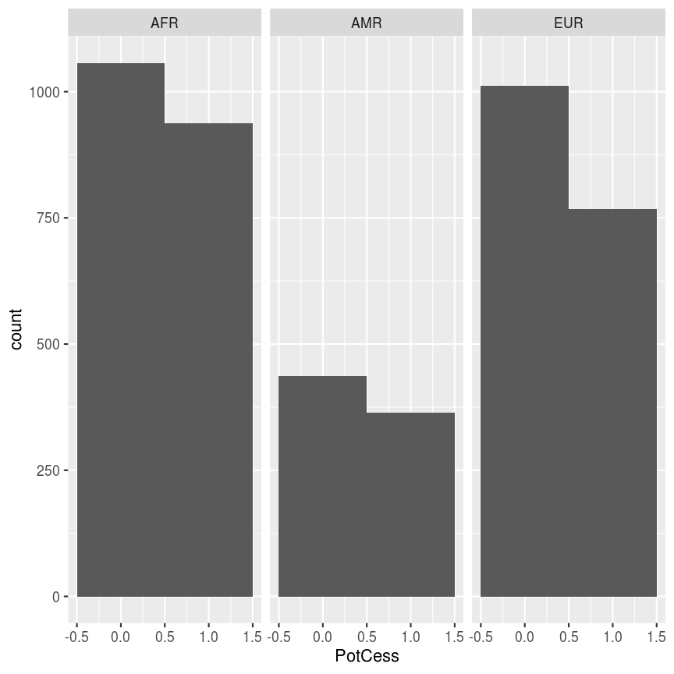 | I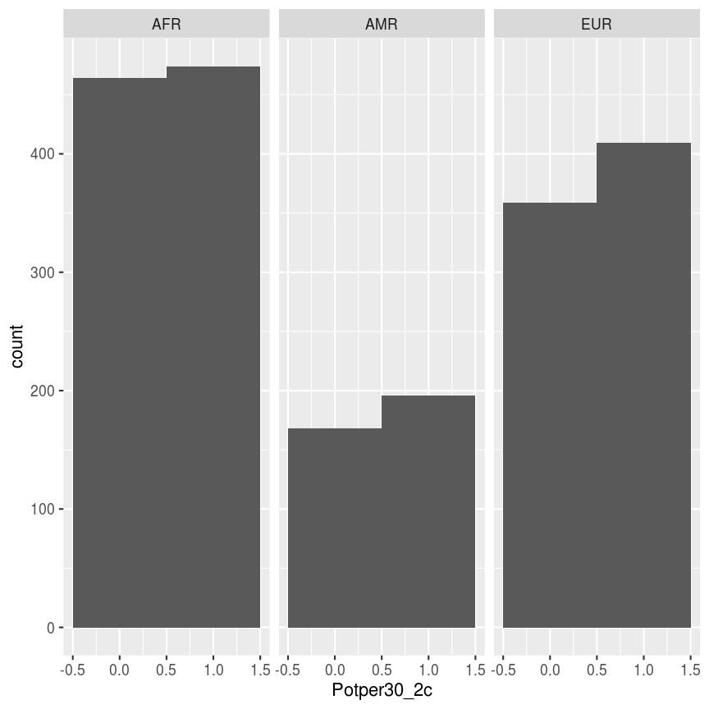
(A) Question 1 of the AUDIT-C: Alcohol use in the last 30 days - continuous; (B) Question 2 of the AUDIT-C: Number of drinks on a typical day of drinking - binary; (C) Question 3 of AUDIT-C: Frequency of binge drinking (5+ drinks) in the last 30 days - binary; (D) Smoking initiation - binary; (E) Smoking cessation - binary; (F) cigarettes per day among smokers - continuous; (G) Cannabis use initiation - binary; (H) Cannabis use cessation - binary; and (I) Cannabis use frequency in the last three months - binary.

