Supplementary material

Appendix 1 – Definition of contaminants
Definition of contaminants
Bacillus species
Coagulase-negative Staphylococcus
Corynebacterium species (diphteroids)
Micrococcus species
Cutibacterium (previously Propionibacterium)
Alpha-haemolytic Streptococcus (other than Strep. pneumoniae)
Pseudomonas (other than P. aeruginosa)
Other environmental non-fermenting gram-negative rods

Appendix 2 – Eligible articles reporting on typhoid incidence
Citation | First  author | Publication  year | Title | Project | Notes
¹ | Chanthavilay | 2020 | Estimation of Incidence of Typhoid and Paratyphoid Fever in Vientiane, Lao People’s Democratic Republic |  | Included
² | Cutting | 2022 | Facility-based disease surveillance and Bayesian hierarchical modeling to estimate endemic typhoid fever incidence, Kilimanjaro Region, Tanzania, 2007–2018 |  | Not included because overlap with TSAP
³ | Garrett | 2022 | Incidence of typhoid and paratyphoid fever in Bangladesh, Nepal, and Pakistan: results of the Surveillance for Enteric Fever in Asia Project | Surveillance for Enteric Fever in Asia Project  (SEAP) | Data from study sites Pakistan and Nepal are included
⁴ | John | 2018 | Estimating the incidence of enteric fever in children in India: a multi-site, active fever surveillance of pediatric cohorts | Surveillance of Enteric Fever in India  (SEFI) | Data from study site Vellore included
⁵ | Marks | 2022 | The Severe Typhoid in Africa Program: Incidences of Typhoid Fever in Burkina Faso, Democratic Republic of Congo, Ethiopia, Ghana, Madagascar, and Nigeria | Severe Typhoid in Africa Program  (SETA) | Included: 5 study sites were not eligible as no typhoid incidence was reported. One study site Madagascar, Mahajanga was excluded because only <10 probable pathogens were isolated.
⁶ | Marks | 2017 | Incidence of invasive salmonella disease in sub-Saharan Africa: a multicentre population-based surveillance study | Typhoid Fever Surveillance in Africa  (TSAP) | Included
⁷ | Meiring | 2021 | Burden of enteric fever at three urban sites in Africa and Asia: a multicentre population-based study | Strategic Typhoid Alliance across Africa and Asia (STRATAA) | Not included
⁸ | Ng’eno | 2023 | Dynamic Incidence of Typhoid Fever over a 10-Year Period (2010-2019) in Kibera, an Urban Informal Settlement in Nairobi, Kenya |  | Not included because overlap with TSAP
^{9,10} | Oo | 2019 | Incidence of Typhoid and Paratyphoid Fevers Among Adolescents and Adults in Yangon, Myanmar |  | Included, prevalence data  abstracted from publication ¹⁰
¹¹ | Patel | 2021 | Safety and Efficacy of a Typhoid Conjugate Vaccine in Malawian Children | Typhoid Vaccine Acceleration Consortium (TyVAC) - Malawi | Data from the control arm included
¹² | Qadri | 2021 | Protection by vaccination of children against typhoid fever with a Vi-tetanus toxoid conjugate vaccine in urban Bangladesh: a cluster-randomised trial | Typhoid Vaccine Acceleration Consortium (TyVAC) - Bangladesh | Data from the cluster control arm  are included
¹³ | Shakya | 2021 | Efficacy of typhoid conjugate vaccine in Nepal: final results of a phase 3, randomised, controlled trial | Typhoid Vaccine Acceleration Consortium (TyVAC) - Nepal | Data from the control arm included
¹⁴ | Yousafzai | 2021 | Effectiveness of typhoid conjugate vaccine against culture confirmed Salmonella enterica serotype Typhi in an extensively drug-resistant outbreak setting of Hyderabad, Pakistan: a cohort study |  | Not included.

Appendix 3 – Map of countries of the study sites of typhoid incidence and prevalence of community-onset bloodstream infections, published 2017-2024
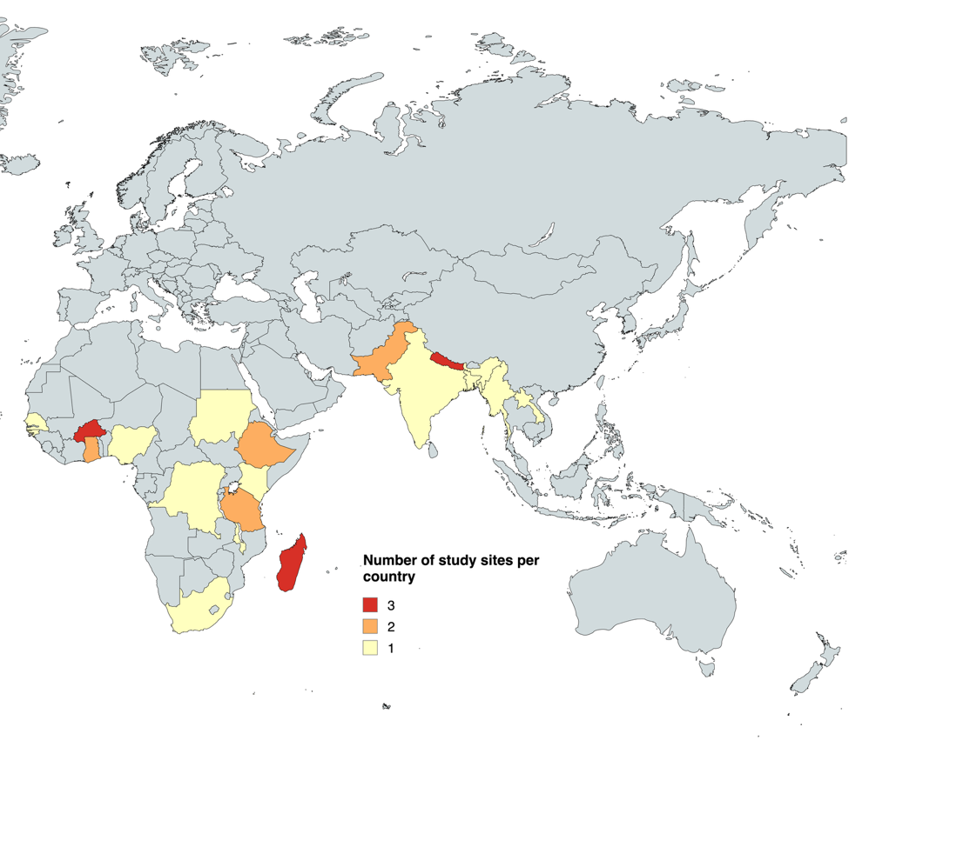

Appendix 4 – Distribution of blood culture results across study sites, sorted from high typhoid incidence to low typhoid incidence study sites
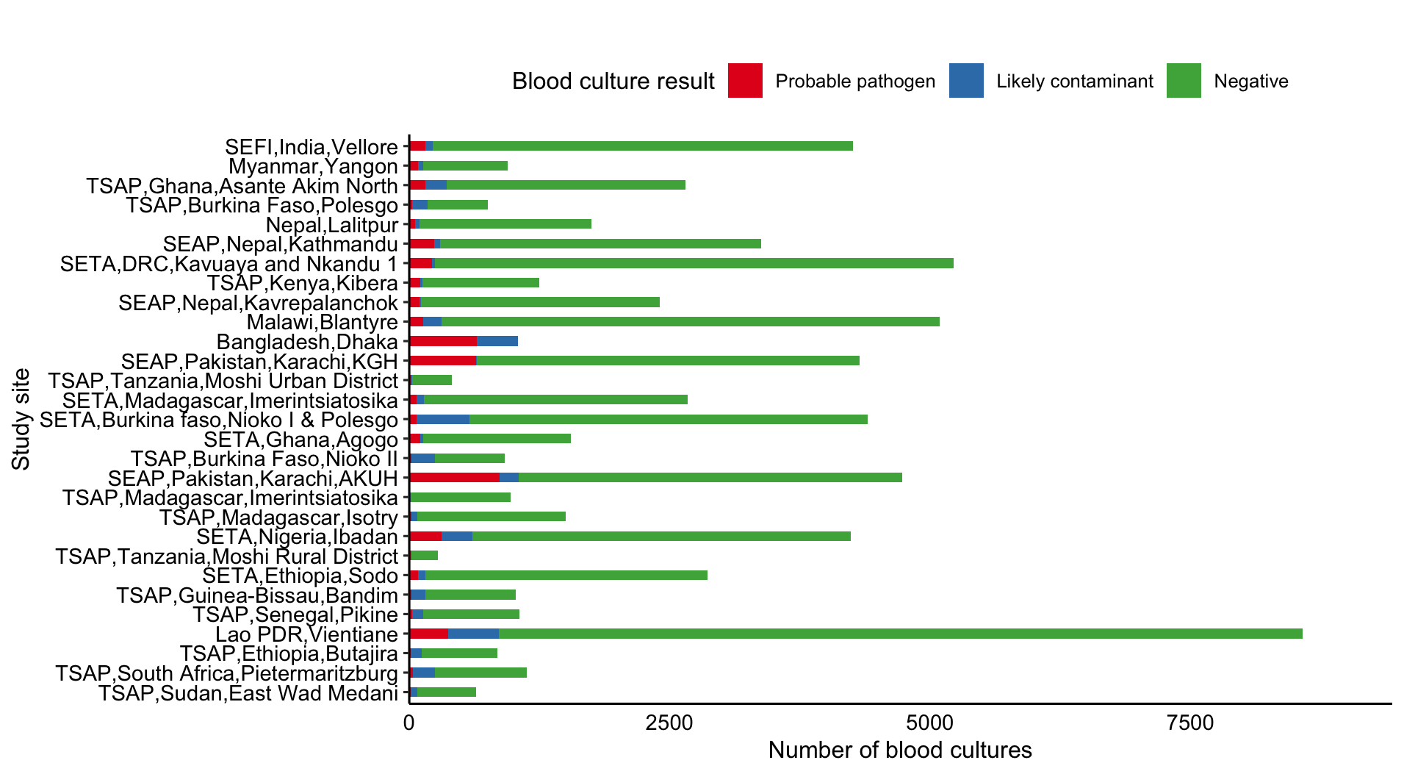
SEAP, Surveillance for Enteric Fever in Asia Project (SEAP); SEFI, Surveillance of Enteric Fever in India; SETA, Severe Typhoid in Africa Program (SETA); TSAP, Typhoid Fever Surveillance in Africa.
Blood culture negative data were not available for Bangladesh, Dhaka.

Appendix 5 – Top five rank order probable pathogens isolated from bloodstream infections across study sites, sorted by highest typhoid incidence study site
Study site (Project, Country, Locality) | Reference | Number of probable pathogens | Top five rank order of probable pathogens: Isolate genus species (number of isolates)
 |  |  | 1 | 2 | 3 | 4 | 5
Bangladesh,Dhaka | ¹² | 646 | S. Typhi (544) | S. Paratyphi A (73) | E. coli (7) | Salmonella nontyphoidal serovars (5) | Staphylococcus  aureus (4)
Lao PDR,Vientiane | ¹ | 375 | E. coli (148) | Klebsiella  pneumoniae (49) | Staphylococcus  aureus (34) | Salmonella nontyphoidal serovars (23) | S. Typhi (20)
Malawi,Blantyre | ¹¹ | 137 | S. Typhi (112) | Salmonella nontyphoidal serovars (12) | Streptococcus  pneumoniae (4) | E. coli (3) | Cryptococcus  neoformans (1)
Myanmar,Yangon | ⁹ | 83 | S. Typhi (33) | E. coli (19) | S. Paratyphi A (10) | Klebsiella  pneumoniae (6) | Staphylococcus  aureus (6)
Nepal,Lalitpur | ¹³ | 57 | S. Typhi (49) | S. Paratyphi A (4) | E. coli (2) | Enterococcus species (1) | Staphylococcus  aureus (1)
SEAP,Nepal,Kathmandu | ³ | 236 | S. Typhi (174) | S. Paratyphi A (42) | E. coli (11) | Klebsiella  pneumoniae (5) | Aeromonas species (1)
SEAP,Nepal,Kavrepalanchok | ³ | 97 | S. Typhi (75) | S. Paratyphi A (13) | E. coli (6) | Enterococcus species (1) | Salmonella nontyphoidal serovars (1)
SEAP,Pakistan,Karachi,AKUH | ³ | 864 | S. Typhi (716) | S. Paratyphi A (87) | E. coli (36) | Salmonella nontyphoidal serovars (4) | Klebsiella  pneumoniae (3)
SEAP,Pakistan,Karachi,KGH | ³ | 644 | S. Typhi (637) | E. coli (2) | S. Paratyphi A (2) | Enterobacter species (1) | Salmonella nontyphoidal serovars (1)
SEFI,India,Vellore | ⁴ | 156 | S. Typhi (147) | Salmonella nontyphoidal serovars (2) | S. Paratyphi A (2) | Streptococcus  pneumoniae (2) | Enterococcus species (1)
SETA,Burkina Faso,  Nioko I & Polesgo | ⁵ | 68 | Staphylococcus  aureus (29) | E. coli (11) | S. Typhi (11) | Salmonella nontyphoidal serovars (9) | Citrobacter freundii (2)
SETA,DRC,  Kavuaya and Nkandu 1 | ⁵ | 218 | Salmonella nontyphoidal serovars (144) | S. Typhi (51) | E. coli (16) | Staphylococcus  aureus (3) | Enterococcus species (2)
SETA,Ethiopia,Sodo | ⁵ | 81 | Staphylococcus  aureus (63) | S. Typhi (7) | Pseudomonas  aeruginosa (4) | Enterobacter  cloacae (2) | Erwinia species (2)
SETA,Ghana,Agogo | ⁵ | 102 | S. Typhi (60) | Salmonella nontyphoidal serovars (13) | E. coli (11) | Staphylococcus  aureus (6) | Streptococcus  pneumoniae (6)
SETA,Madagascar,  Imerintsiatosika | ⁵ | 72 | S. Typhi (49) | Streptococcus  pneumoniae (14) | E. coli (6) | Staphylococcus  aureus (3) | NA
SETA,Nigeria,Ibadan | ⁵ | 310 | Staphylococcus  aureus (180) | S. Typhi (65) | Salmonella nontyphoidal serovars (28) | E. coli (6) | Candida albicans (4)
TSAP,Burkina Faso,Nioko II | ⁶ | 24 | Salmonella nontyphoidal serovars (10) | S. Typhi (5) | E. coli (3) | Enterococcus  faecalis (2) | Aeromonas species (1)
TSAP,Burkina Faso,Polesgo | ⁶ | 27 | S. Typhi (13) | E. coli (4) | Salmonella nontyphoidal serovars (4) | Proteus mirabilis (2) | Pseudomonas  aeruginosa (2)
TSAP,Ethiopia,Butajira | ⁶ | 12 | S. Typhi (3) | E. coli (2) | Leclercia  adecarboxylata (2) | Staphylococcus  aureus (2) | Streptococcus  pneumoniae (2)
TSAP,Ghana,  Asante Akim North | ⁶ | 157 | Salmonella nontyphoidal serovars (59) | S. Typhi (30) | Klebsiella  pneumoniae (22) | Streptococcus  pneumoniae (17) | Staphylococcus  aureus (16)
TSAP,Guinea-Bissau,Bandim | ⁶ | 20 | Salmonella nontyphoidal serovars (8) | Staphylococcus  aureus (4) | S. Typhi (3) | Enterobacter  cloacae (2) | Streptococcus  pneumoniae (2)
TSAP,Kenya,Kibera | ⁶ | 107 | S. Typhi (54) | Staphylococcus  aureus (33) | Streptococcus  pneumoniae (10) | Salmonella nontyphoidal serovars (6) | E. coli (4)
TSAP,Madagascar,  Imerintsiatosika | ⁶ | 10 | S. Typhi (6) | E. coli (1) | Salmonella nontyphoidal serovars (1) | Streptococcus  pneumoniae (1) | Yersinia pestis (1)
TSAP,Madagascar,Isotry | ⁶ | 20 | Candida species (6) | Enterobacter  cloacae (3) | S. Typhi (3) | Klebsiella oxytoca (2) | Enterobacter  asburiae (1)
TSAP,Senegal,Pikine | ⁶ | 29 | E. coli (9) | S. Typhi (7) | Salmonella nontyphoidal serovars (4) | S. Paratyphi A (3) | Enterobacter  cloacae (2)
TSAP,South Africa,  Pietermaritzburg | ⁶ | 36 | Staphylococcus  aureus (10) | Streptococcus  pneumoniae (7) | E. coli (5) | Cryptococcus  neoformans (4) | S. Typhi (2)
TSAP,Sudan,  East Wad Medani | ⁶ | 11 | E. coli (3) | Staphylococcus  aureus (3) | Proteus  mirabilis (2) | Enterococcus  casseliflavus (1) | Pasteurella  pneumotropica (1)
TSAP,Tanzania,  Moshi Rural District | ⁶ | 11 | E. coli (4) | S. Typhi (3) | Clostridium  species (1) | Salmonella nontyphoidal serovars (1) | Staphylococcus  aureus (1)
TSAP,Tanzania,  Moshi Urban District | ⁶ | 15 | S. Typhi (6) | E. coli (5) | Proteus  mirabilis (1) | Salmonella nontyphoidal serovars (1) | Streptococcus  pneumoniae (1)

SEAP, Surveillance for Enteric Fever in Asia Project (SEAP); SEFI, Surveillance of Enteric Fever in India; SETA, Severe Typhoid in Africa Program (SETA); TSAP, Typhoid Fever Surveillance in Africa.

Appendix 6 - Metrics from sentinel bloodstream infection stratified by hospitalisation status, 2017-2024

Study site | Hospital admission | Number of S. Typhi among probable pathogens (%) | Rank order of S. Typhi | S. Typhi prevalence / E. coli prevalence (ratio) | S. Typhi prevalence /  'stably endemic organisms'* prevalence (ratio)
Bangladesh,Dhaka ¹² | no | 522/621 (84.1) | 1 | 522/7 (74.6) | 522/13 (40.2)
Bangladesh,Dhaka ¹² | yes | 22/25 (88.0) | 1
Lao PDR,Vientiane ¹ | yes | 20/375 (5.3) | 5 | 20/148 (0.1) | 20/191 (0.1)
Malawi,Blantyre ¹¹ | yes | 12/14 (85.7) | 1
SETA,Burkina faso,Nioko I & Polesgo Marks, 2024 #595} | yes | 1/1 (100) | 1
SETA,DRC,Kavuaya and Nkandu 1 ⁵ | yes | 10/22 (45.5) | 1 | 10/6 (1.7) | 10/6 (1.7)
SETA,Ethiopia,Sodo ⁵ | yes | 1/13 (7.7) | 4 |  | 1/10 (0.1)
SETA,Ghana,Agogo ⁵ | yes | 21/40 (52.5) | 1 | 21/2 (10.5) | 21/9 (2.3)
SETA,Nigeria,Ibadan ⁵ | yes | 26/118 (22) | 2 | 26/5 (5.2) | 26/57 (0.5)
TSAP,Burkina Faso,Nioko II ⁶ | no | 5/23 (21.7) | 2 | 5/3 (1.7) | 5/4 (1.3)
TSAP,Burkina Faso,Nioko II ⁶ | yes | 0/1 (0)
TSAP,Burkina Faso,Polesgo ⁶ | no | 13/27 (48.1) | 1 | 13/4 (3.3) | 13/4 (3.3)
TSAP,Ethiopia,Butajira ⁶ | no | 3/10 (30) | 1 | 3/2 (1.5) | 3/5 (0.6)
TSAP,Ethiopia,Butajira ⁶ | yes | 0/2 (0) |  |  | 0/1 (0)
TSAP,Ghana,Asante Akim North ⁶ | yes | 30/157 (19.1) | 2 | 30/7 (4.3) | 30/40 (0.8)
TSAP,Guinea-Bissau,Bandim ⁶ | no | 2/15 (13.3) | 3 |  | 2/5 (0.4)
TSAP,Guinea-Bissau,Bandim ⁶ | yes | 1/5 (20.0) | 3 |  | 1/1 (1)
TSAP,Kenya,Kibera ⁶ | no | 54/107 (50.5) | 1 | 54/4 (13.5) | 54/47 (1.1)
TSAP,Madagascar,Imerintsiatosika ⁶ | no | 6/10 (60.0) | 1 | 6/1 (6) | 6/2 (3)
TSAP,Madagascar,Isotry ⁶ | no | 3/20 (15.0) | 3 |  | 3/2 (1.5)
TSAP,Senegal,Pikine ⁶ | no | 5/15 (33.3) | 2 | 5/6 (0.8) | 5/6 (0.8)
TSAP,Senegal,Pikine ⁶ | yes | 2/14 (14.3) | 4 | 2/3 (0.7) | 2/3 (0.7)
TSAP,South Africa,Pietermaritzburg ⁶ | yes | 2/36 (5.6) | 5 | 2/5 (0.4) | 2/22 (0.1)
TSAP,Sudan,East Wad Medani ⁶ | no | 0/11 (0.0) |  | 0/3 (0) | 0/6 (0)
TSAP,Tanzania,Moshi Rural District ⁶ | no | 1/4 (25.0) | 3 | 1/1 (1) | 1/2 (0.5)
TSAP,Tanzania,Moshi Rural District ⁶ | yes | 2/7 (28.6) | 2 | 2/3 (0.7) | 2/4 (0.5)
TSAP,Tanzania,Moshi Urban District ⁶ | no | 2/5 (40.0) | 1 |  | 2/1 (2)
TSAP,Tanzania,Moshi Urban District ⁶ | yes | 4/10 (40.0) | 2 | 4/5 (0.8) | 4/5 (0.8)
CI, confidence interval; NA, not available; SETA, Severe Typhoid Fever Surveillance in Africa; TSAP, Typhoid Fever Surveillance in Africa Program. *Stably endemic organisms were defined as E. coli, S. pneumoniae, or S. aureus.

Appendix 7 – Association of metrics from bloodstream infections from sentinel sites with typhoid incidence by meta-regression and univariate ordinal regression analysis, 2017-2024

 | Meta-regression for log typhoid incidence estimate | Univariate ordinal regression analysis for low, medium and high typhoid incidence estimate levels±
Metrics of sentinel bloodstream infection | Beta (95%CI) | OR (95%CI)
Each 1% increase in prevalence of S. Typhi among probable pathogens (n=29) | 0.05 (0.03-0.07) | 1.08 (1.04-1.17)
Each increase in rank order of S. Typhi among probable pathogens (n=28) | -0.97 (-1.39- -0.55) | 0.24 (0.07-0.55)
Log S. Typhi to E. coli ratio (n=25) | 0.86 (0.62-1.10) | 2.91 (1.49-7.43)
Log S. Typhi to 'stably endemic organisms' ratio *(n=29) | 0.84 (0.62-1.06) | 3.75 (1.81-10.7)
OR, odds ratio
± Low typhoid incidence (<10/100,000 person-years); medium typhoid incidence (10-100/100,000 person-years); high typhoid incidence (>100/100,000 person-years)
*Stably endemic organisms were defined as E. coli, S. pneumoniae, or S. aureus.

Appendix 8 – Bubble plots of meta-regression of metrics from sentinel blood stream infections with log typhoid incidence (A, prevalence of S. Typhi among probable pathogens; B, rank order of S. Typhi among probable pathogens; C, ratio log S. Typhi to E. coli ratio; D, log ratio S. Typhi to ‘stably endemic organisms’ ratio)
A:
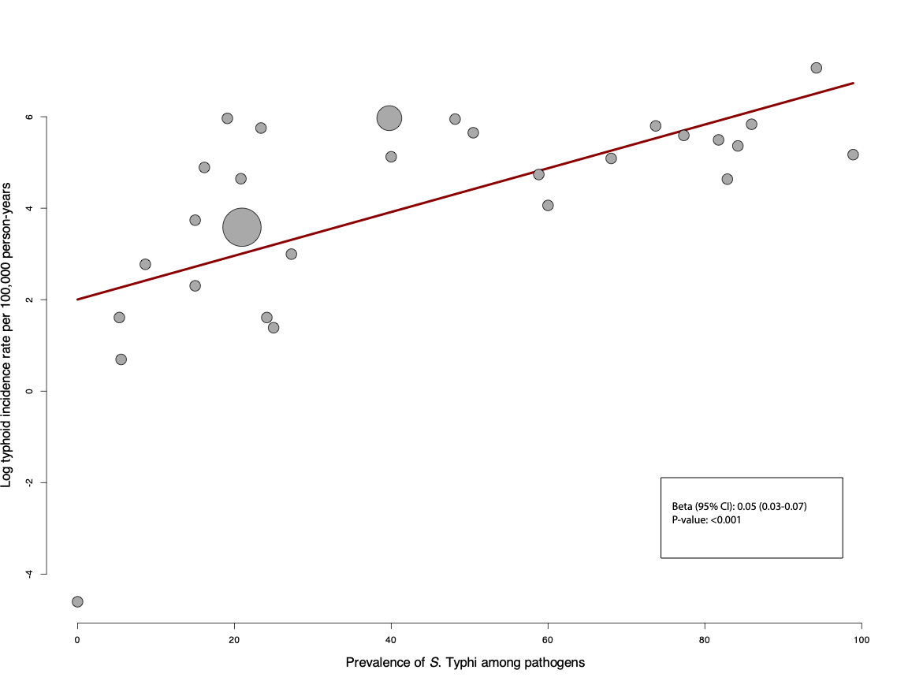
B:
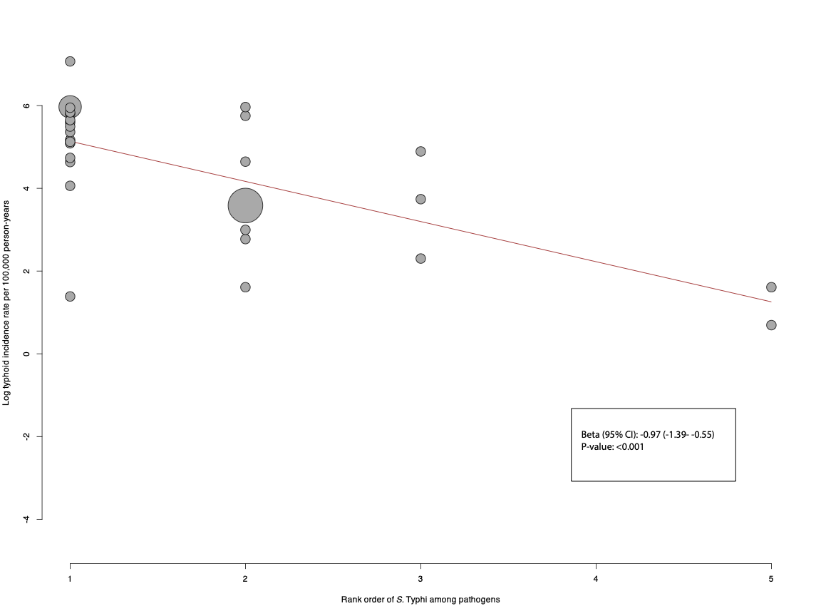

C:
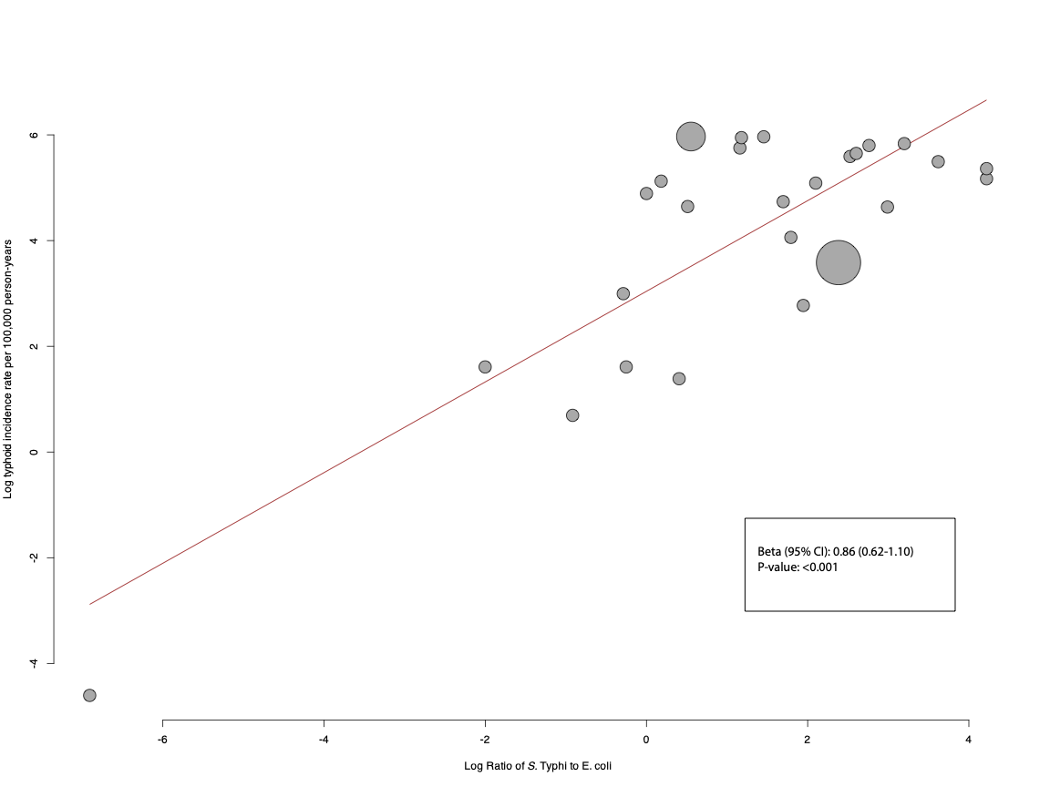

D:
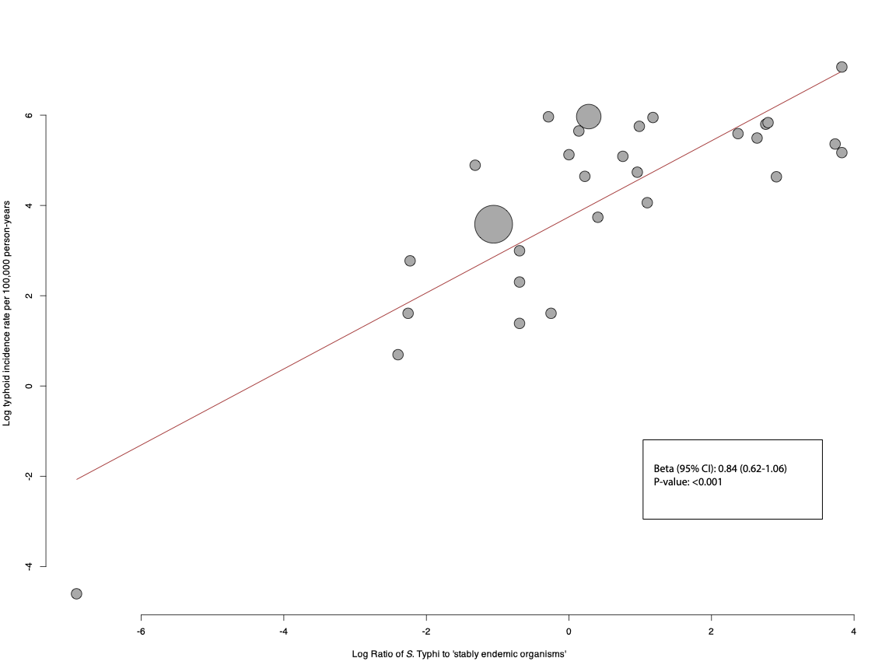

Appendix 9 – Summary of model comparisons for metrics of bloodstream infections of sentinel sites for typhoid incidence level in ordinal regression analysis, 2017-2024
Models were compared using the likelihood ratio test and the AIC. Model selection was based on model performance, parsimony, and ease of implementation.

Model 1 Prevalence of S. Typhi of probable pathogens
Model 2 Rank order of S. Typhi
Model 2b Prevalence of S. Typhi of probable pathogens and rank order of S. Typhi
Model 3 Log ratio of S. Typhi to E. coli
Model 3b Prevalence of S. Typhi of probable pathogens and log ratio of S. Typhi to E. coli
Model 4 Log ratio of S. Typhi to 'stably endemic organisms'
Model 4b Prevalence of Typhi of probable pathogens and log ratio of S. Typhi to 'stably endemic organisms'
 | P-value | AIC | Decision
Model 1 vs Model 2 | 0.33 | 37.4 vs 39.0 | Keep model 1
Model 1 vs Model 2b | 1 | 37.4 vs 38.5 | Keep model 1
Model 1 vs Model 3 | 1 | 37.4 vs 38.5 | Keep model 1
Model 1 vs Model 3b | 0.16 | 37.4 vs 37.4 | Keep model 1 based on parsimony
Model 1 vs Model 4 | <0.01 | 37.4 vs 34.5 | Keep model 4
Model 4 vs Model 4b | 0.85 | 34.5 vs 36.4 | Keep model 4
AIC, Akaike Information Criterion

Final model: model 1 (prevalence of S. Typhi of probable pathogens as sole predictor) was selected based on parsimony and ease of calculation, since calculation of ratios and log transformation is a complicating factor for policy makers.

The formula to calculate the predicted probabilities is presented below:

$P (Incidence) = low) = \frac{1}{1+e^{-(LP1\text{)}}}$
$$P (Incidence) = medium) = \frac{1}{1+e^{-(LP2\text{)}}}-\frac{1}{1+e^{-(LP1\text{)}}}$$
$$P (Incidence) = high) = 1- \frac{1}{1+e^{-(LP2\text{)}}}$$

LP refers to the linear predictor in a proportional odds logistic regression model. The LPs for the thresholds are defined as follows:
LP₁ (low vs. medium or high): LP₁ = 0.5846 (Intercept) - 0.0813 * prevalence of S. Typhi of pathogens
LP₂ (low/medium vs high): LP₂ =2.3051 (Intercept) - 0.0813 * prevalence of S. Typhi of pathogens
LP₃ (high vs medium/low): LP₃₌ -2.3051 (Intercept) + prevalence of S. Typhi of pathogens

Appendix 10 – Calibration plots: predicted probability vs observed proportion of the model for typhoid incidence level, 2017-2024

Low typhoid incidence vs medium and high typhoid incidence
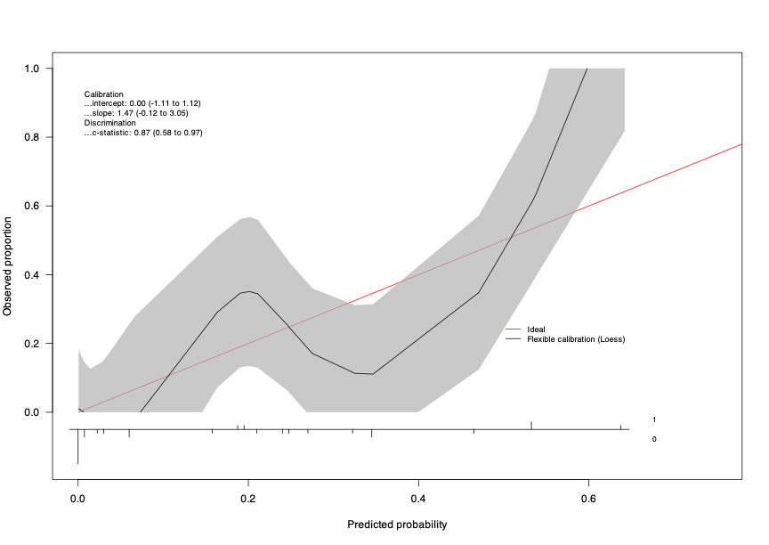

Medium typhoid incidence vs low and high typhoid incidence
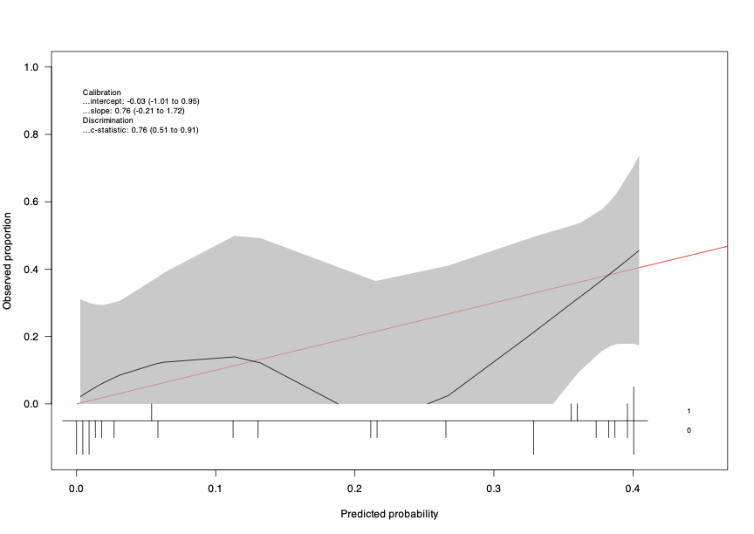

High typhoid incidence vs low and medium typhoid incidence
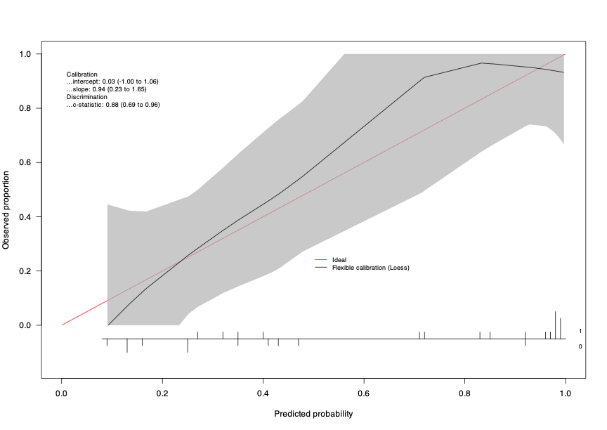

Appendix 11 – Decision curve analysis of the prediction model for typhoid incidence level, 2017-2024
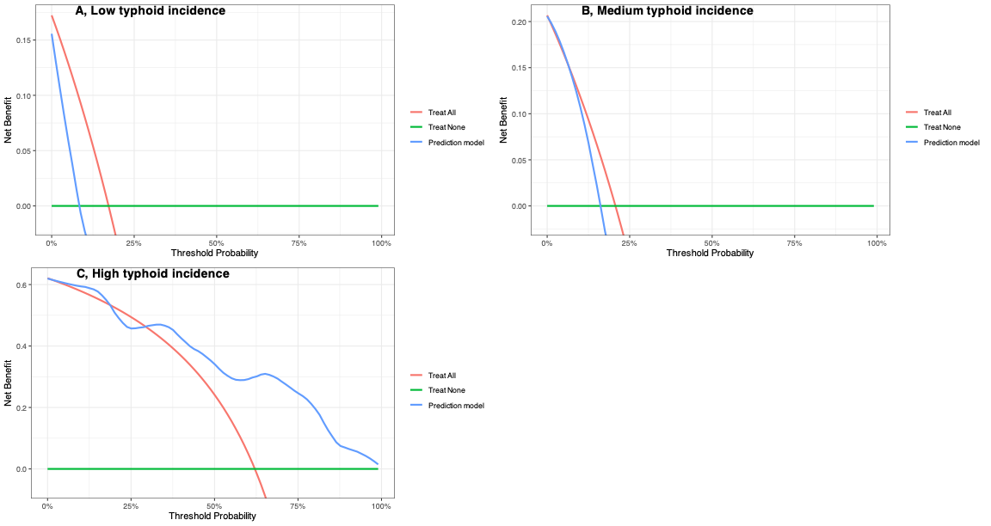

Appendix 12 - Simulated predicted probabilities for range of prevalence of S. Typhi among probable pathogens for typhoid incidence levels according to the final model
Prevalence of S. Typhi among probable pathogens, % | Predicted probability for low typhoid incidence site, % | Predicted probability for medium typhoid incidence site, % | Predicted probability for high typhoid incidence site, % | Suggested interpretation for typhoid incidence
1 | 62.3 | 27.9 | 9.8 | Low
5 | 54.4 | 32.5 | 13.0 | Low
10 | 44.3 | 37.3 | 18.4 | Low
15 | 34.7 | 40.1 | 25.2 | Medium
20 | 26.1 | 40.3 | 33.6 | Medium
25 | 19.0 | 37.7 | 43.2 | High
30 | 13.5 | 33.1 | 53.3 | High
40 | 6.5 | 21.5 | 72.0 | High
50 | 3.0 | 11.7 | 85.3 | High

Appendix 13 - Metrics from sentinel bloodstream infection calculated for S. Paratyphi A and non-typhoidal S., 2017-2024
Study site:  Project, Country, Locality (reference) | Paratyphoid A incidence estimate per  100,000 person-years  (95% CI) |  | Number of  S. Paratyphi A among  probable pathogens (%) |  | Rank order of S.  Paratyphi A | S. Paratyphi A / E. coli (ratio) |  | S. Paratyphi A/  'stably endemic organisms'* (ratio)
Lao PDR,Vientiane ¹ | 1 | (0-1) | 2/375 | (0.5) | 21 | 2/148 | (0.0) | 375/191 | (0.0)
Nepal,Lalitpur ¹³ | 33 | (12-72) | 4/57 | (7.0) | 2 | 4/2 | (2.0) | 57/3 | (1.3)
SEAP,Nepal,Kathmandu ³ | 81 | (56-118) | 42/236 | (17.8) | 2 | 42/11 | (3.8) | 236/11 | (3.8)
SEAP,Nepal,Kavrepalanchok ³ | 46 | (34-62) | 13/97 | (13.4) | 2 | 13/6 | (2.2) | 97/7 | (1.9)
SEAP,Pakistan,Karachi,AKUH ³ | 23 | (19-29) | 87/864 | (10.1) | 2 | 87/36 | (2.4) | 864/39 | (2.2)
SEAP,Pakistan,Karachi,KGH ³ | 1 | (1-1) | 2/644 | (0.3) | 3 | 2/2 | (1.0) | 644/3 | (0.7)
SEFI,India,Vellore ⁴ | 8 | (1-44) | 2/156 | (1.3) | 3 | 2/0 | - | 156/3 | (0.7)
AKUH, Aga Khan University Hospital; CI, confidence interval; KGH, Kharadar General Hospital; SEAP, Surveillance for Enteric Fever in Asia Project; SEFI, Surveillance of Enteric Fever in India; *Stably endemic organisms were defined as E. coli, S. pneumoniae, or S. aureus.

Study site:  Project, Country, Locality (reference) | Non-typhoidal salmonella incidence estimate per  100,000 person-years  (95% CI) |  | Number of  non-typhoidal salmonella among  probable pathogens (%) |  | Rank order of non-typhoidal salmonella | Non-typhoidal salmonella. prevalence / E. coli prevalence (ratio) |  | Non-typhoidal salmonella prevalence /  'stably endemic organisms' prevalence * (ratio)
TSAP,Burkina Faso,Nioko II ⁶ | 237 | (178-316) | 10/24 | (41.7) | 1 | 10/3 | (3.3) | 24/4 | (2.5)
TSAP,Burkina Faso,Polesgo ⁶ | 431 | (162-1147) | 4/27 | (14.8) | 3 | 4/4 | (1.0) | 27/4 | (1.0)
TSAP,Ethiopia,Butajira ⁶ | 0 |  | 0/12 | (0.0) | - | 0/2 | (0.0) | 12/6 | (0.0)
TSAP,Ghana,Asante Akim North ⁶ | 742 | (631-873) | 59/157 | (37.6) | 1 | 59/7 | (8.4) | 157/40 | (1.5)
TSAP,Guinea-Bissau,Bandim ⁶ | 37 | (24-57) | 8/20 | (40.0) | 1 | 8/0 |  | 20/6 | (1.3)
TSAP,Kenya,Kibera ⁶ | 32 | (14-70) | 6/107 | (5.6) | 4 | 6/4 | (1.5) | 107/47 | (0.1)
TSAP,Madagascar,Imerintsiatosika ⁶ | 9 | (2-50) | 1/10 | (10.0) | 3 | 1/1 | (1.0) | 10/2 | (0.5)
TSAP,Madagascar,Isotry ⁶ | 0 | (0-0) | 0/20 | (0.0) | - | 0/0 |  | 20/2 | (0.0)
TSAP,Senegal,Pikine ⁶ | 5 |  | 4/29 | (13.8) | 3 | 4/9 | (0.4) | 29/9 | (0.4)
TSAP,South Africa,Pietermaritzburg ⁶ | 0 |  | 0/36 | (0.0) | - | 0/5 | (0.0) | 36/22 | (0.0)
TSAP,Sudan,East Wad Medani ⁶ | 0 | (0-0) | 0/11 | (0.0) | - | 0/3 | (0.0) | 11/6 | (0.0)
TSAP,Tanzania,Moshi Rural District ⁶ | 7 | (2-23) | 1/11 | (9.1) | 4 | 1/4 | (0.3) | 11/6 | (0.2)
TSAP,Tanzania,Moshi Urban District ⁶ | 19 | (5-64) | 1/15 | (6.7) | 4 | 1/5 | (0.2) | 15/6 | (0.2)
CI, confidence interval; TSAP, Typhoid Fever Surveillance in Africa Program. *Stably endemic organisms were defined as E. coli, S. pneumoniae, or S. aureus.

 | Meta-regression for log non-typhoidal S. incidence estimate | Univariate ordinal regression analysis for low, medium and high non-typhoidal S. incidence estimate levels±
Metrics of sentinel bloodstream infection | Beta (95%CI) | OR (95%CI)
Prevalence of non-typhoidal S. among probable pathogens (n=13) | 0.2 (0.08-0.33) | 1.12 (1.03-1.26)
Rank order of non-typhoidal S. among probable pathogens (n=9) | -0.98 (-2.7-0.73) | 0.43 (0.12-1.18)
Log non-typhoidal S. to E. coli ratio (n=11) | 1.16 (0.68-1.63) | 3.95 (1.32-30.6)
Log non-typhoidal S. to 'stably endemic organisms' ratio *(n=13) | 1.23 (0.76-1.69) | 3.40 (1.35-18.7)
OR, odds ratio
± Low incidence (<10/100,000 person-years); medium incidence (10-100/100,000 person-years); high incidence (>100/100,000 person-years)
*Stably endemic organisms were defined as E. coli, S. pneumoniae, or S. aureus.

References
1. Chanthavilay P, Mayxay M, Xongmixay P, et al. Estimation of Incidence of Typhoid and Paratyphoid Fever in Vientiane, Lao People's Democratic Republic. Am J Trop Med Hyg 2020; 102(4): 744–8.
2. Cutting ER, Simmons RA, Madut DB, et al. Facility-based disease surveillance and Bayesian hierarchical modeling to estimate endemic typhoid fever incidence, Kilimanjaro Region, Tanzania, 2007-2018. PLoS Negl Trop Dis 2022; 16(7): e0010516.
3. Garrett DO, Longley AT, Aiemjoy K, et al. Incidence of typhoid and paratyphoid fever in Bangladesh, Nepal, and Pakistan: results of the Surveillance for Enteric Fever in Asia Project. Lancet Glob Health 2022; 10(7): e978–e88.
4. John J, Bavdekar A, Rongsen-Chandola T, Dutta S, Kang G. Estimating the incidence of enteric fever in children in India: a multi-site, active fever surveillance of pediatric cohorts. BMC Public Health 2018; 18(1): 594.
5. Marks F, Im J, Park SE, et al. Incidence of typhoid fever in Burkina Faso, Democratic Republic of the Congo, Ethiopia, Ghana, Madagascar, and Nigeria (the Severe Typhoid in Africa programme): a population-based study. The Lancet Global Health 2024; 12(4): e599–e610.
6. Marks F, von Kalckreuth V, Aaby P, et al. Incidence of invasive salmonella disease in sub-Saharan Africa: a multicentre population-based surveillance study. The Lancet Global Health 2017; 5(3): e310–e23.
7. Meiring JE, Shakya M, Khanam F, et al. Burden of enteric fever at three urban sites in Africa and Asia: a multicentre population-based study. The Lancet Global Health 2021; 9(12): e1688–e96.
8. Ng'eno E, Lind M, Audi A, et al. Dynamic Incidence of Typhoid Fever over a 10-Year Period (2010-2019) in Kibera, an Urban Informal Settlement in Nairobi, Kenya. Am J Trop Med Hyg 2023; 109(1): 22–31.
9. Oo WT, Myat TO, Htike WW, et al. Incidence of Typhoid and Paratyphoid Fevers Among Adolescents and Adults in Yangon, Myanmar. Clin Infect Dis 2019; 68(Suppl 2): S124–s9.
10. Myat TO, Oo KM, Mone HK, et al. A prospective study of bloodstream infections among febrile adolescents and adults attending Yangon General Hospital, Yangon, Myanmar. PLoS Negl Trop Dis 2020; 14(4): e0008268.
11. Patel PD, Patel P, Liang Y, et al. Safety and Efficacy of a Typhoid Conjugate Vaccine in Malawian Children. New England Journal of Medicine 2021; 385(12): 1104–15.
12. Qadri F, Khanam F, Liu X, et al. Protection by vaccination of children against typhoid fever with a Vi-tetanus toxoid conjugate vaccine in urban Bangladesh: a cluster-randomised trial. The Lancet 2021; 398(10301): 675–84.
13. Shakya M, Voysey M, Theiss-Nyland K, et al. Efficacy of typhoid conjugate vaccine in Nepal: final results of a phase 3, randomised, controlled trial. The Lancet Global Health 2021; 9(11): e1561–e8.
14. Yousafzai MT, Karim S, Qureshi S, et al. Effectiveness of typhoid conjugate vaccine against culture-confirmed Salmonella enterica serotype Typhi in an extensively drug-resistant outbreak setting of Hyderabad, Pakistan: a cohort study. Lancet Glob Health 2021; 9(8): e1154–e62.

