Therapist effects in real-world rehabilitation outcomes: a cohort study of the nationwide GLA:D osteoarthritis management program in Denmark
Phillips Edomwonyi Obasohan, Joe Palmer, David Alderson, Dahai Yu, Dorte T. Grønne, Ewa M. Roos, Søren T. Skou, George Peat

SUPPLEMENTARY DATA
List of R packages used | 2
Figure S1. Heatmap of missing data | 4
Table S1. Descriptive characteristics of patients (n=23,021) and therapists (n=657) after multiple imputation | 5
Table S2. Descriptive characteristics of patients (n=9,720) and therapists (n=403) in the complete case analysis dataset | 6
Model coefficients and performance on multiply imputed data for secondary outcomes
Table S3. ≥50% pain reduction at 3 months | 7
Table S4. Pain intensity (0-100) at 3 months | 9
Table S5. HOOS/KOOS Quality of Life Score (0-100) at 3 months | 10
Table S6. EQ5D Health Utility Score (-0.757-1.000) at 3 months | 12
Table S7. EQ5D VAS (0-100) at 3 months | 13
Model coefficients and performance on complete case analysis for primary and secondary outcomes
Table S8. ≥50% pain reduction at 3 months | 14
Table S9. Pain intensity (0-100) at 3 months | 16
Table S10. HOOS/KOOS Quality of Life Score (0-100) at 3 months | 17
Table S11. EQ5D Health Utility Score (-0.757-1.000) at 3 months | 19
Table S12. EQ5D VAS (0-100) at 3 months | 20
Table S13. ≥30% pain reduction at 3 months | 21
Funnel plots of therapist-specific case-mix-adjusted outcomes on multiply imputed data
Figure S2. ≥50% pain reduction at 3 months | 24
Figure S3. Pain intensity (0-100) at 3 months | 24
Figure S4. HOOS/KOOS Quality of Life Score (0-100) at 3 months | 25
Figure S5. EQ5D Health Utility Score (-0.757-1.000) at 3 months | 25
Figure S6. EQ5D VAS (0-100) at 3 months | 26
Funnel plots of therapist-specific case-mix-adjusted outcomes on complete case analysis
Figure S7. ≥50% pain reduction at 3 months | 26
Figure S8. Pain intensity (0-100) at 3 months | 27
Figure S9. HOOS/KOOS Quality of Life Score (0-100) at 3 months | 27
Figure S10. EQ5D Health Utility Score (-0.757-1.000) at 3 months | 28
Figure S11. EQ5D VAS (0-100) at 3 months | 28
Figure S12. ≥30% pain reduction at 3 months | 29
Figure S13. Summary of ICC estimates of ‘therapist effects’ for primary and secondary outcomes, multiply imputed data and complete case analysis | 30

List of R packages used
boot | Canty A, Ripley B (2025). _boot: Bootstrap Functions_. R package version 1.3-32, <https://CRAN.R-project.org/package=boot>.  Davison A, Hinkley D (1997). _Bootstrap Methods and Their Applications_. Cambridge University Press, Cambridge. ISBN 0-521-57391-2, doi:10.1017/CBO9780511802843 <https://doi.org/10.1017/CBO9780511802843>.
broom | Robinson D, Hayes A, Couch S (2025). _broom: Convert Statistical Objects into Tidy Tibbles_. R package version 1.0.10, <https://CRAN.R-project.org/package=broom>.
car | Fox J, Weisberg S (2019). _An R Companion to Applied Regression_, Third edition. Sage, Thousand Oaks CA.<https://www.john-fox.ca/Companion/>.
DescTools | Signorell A (2025). _DescTools: Tools for Descriptive Statistics_. R package version 0.99.60, <https://CRAN.R-project.org/package=DescTools>.
DHARMa | Hartig F (2024). _DHARMa: Residual Diagnostics for Hierarchical (Multi-Level / Mixed) Regression Models_. R package version 0.4.7, <https://CRAN.R-project.org/package=DHARMa>.
dplyr | Wickham H, François R, Henry L, Müller K, Vaughan D (2023). _dplyr: A Grammar of Data Manipulation_. R package version 1.1.4, <https://CRAN.R-project.org/package=dplyr>.
ggplot2 | H. Wickham. ggplot2: Elegant Graphics for Data Analysis. Springer-Verlag New York, 2016.
haven | Wickham H, Miller E, Smith D (2025). _haven: Import and Export 'SPSS', 'Stata' and 'SAS' Files_. R package version 2.5.5, <https://CRAN.R-project.org/package=haven>.
Hmisc | Harrell Jr F (2025). _Hmisc: Harrell Miscellaneous_. R package version 5.2-4, <https://CRAN.R-project.org/package=Hmisc>.
lme4 | Douglas Bates, Martin Maechler, Ben Bolker, Steve Walker (2015). Fitting Linear Mixed-Effects Models Using lme4. Journal of Statistical Software, 67(1), 1-48. doi:10.18637/jss.v067.i01.
lmerTest | Kuznetsova A, Brockhoff PB, Christensen RHB (2017). “lmerTest Package: Tests in Linear Mixed Effects Models.” _Journal of Statistical Software_, *82*(13), 1-26. doi:10.18637/jss.v082.i13 <https://doi.org/10.18637/jss.v082.i13>.
mice | Stef van Buuren, Karin Groothuis-Oudshoorn (2011). mice: Multivariate Imputation by Chained Equations in R. Journal of Statistical
miceadds | Robitzsch, A., & Grund, S. (2025). miceadds: Some Additional Multiple Imputation Functions, Especially for 'mice'. R package version 3.18-36. https://CRAN.R-project.org/package=miceadds Software, 45(3), 1-67. DOI 10.18637/jss.v045.i03.
mitml | Grund S, Robitzsch A, Luedtke O (2023). _mitml: Tools for Multiple Imputation in Multilevel Modeling_. R package version 0.4-5, <https://CRAN.R-project.org/package=mitml>.
narian | Tierney N, Cook D (2023). “Expanding Tidy Data Principles to Facilitate Missing Data Exploration, Visualization and Assessment of Imputations.” _Journal of Statistical Software_, *105*(7), 1-31. doi:10.18637/jss.v105.i07 <https://doi.org/10.18637/jss.v105.i07>.
openxlsx | Schauberger P, Walker A (2025). _openxlsx: Read, Write and Edit xlsx Files_. R package version 4.2.8.1, <https://CRAN.R-project.org/package=openxlsx>.
performance | Lüdecke et al., (2021). performance: An R Package for Assessment, Comparison and Testing of Statistical Models. Journal of Open Source Software, 6(60), 3139. https://doi.org/10.21105/joss.03139
pROC | Xavier Robin, Natacha Turck, Alexandre Hainard, Natalia Tiberti, Frédérique Lisacek, Jean-Charles Sanchez and Markus Müller (2011). pROC: an open-source package for R and S+ to analyze and compare ROC curves. BMC Bioinformatics, 12, p. 77. DOI: 10.1186/1471-2105-12-77 <http://www.biomedcentral.com/1471-2105/12/77/>
readxl | Wickham H, Bryan J (2025). _readxl: Read Excel Files_. R package version 1.4.5, <https://CRAN.R-project.org/package=readxl>.
scales | Wickham H, Pedersen T, Seidel D (2025). _scales: Scale Functions for Visualization_. R package version 1.4.0. <https://CRAN.R-project.org/package=scales>.
sjPlot | Lüdecke D (2025). _sjPlot: Data Visualization for Statistics in Social Science_. R package version 2.9.0, <https://CRAN.R-project.org/package=sjPlot>.
skimr | Waring E, Quinn M, McNamara A, Arino de la Rubia E, Zhu H, Ellis S (2025). _skimr: Compact and Flexible Summaries of Data_. R package version 2.2.1, <https://CRAN.R-project.org/package=skimr>.
stringr | Wickham H (2025). _stringr: Simple, Consistent Wrappers for Common String Operations_. R package version 1.6.0, <https://CRAN.R-project.org/package=stringr>.
tidyr | Wickham H, Vaughan D, Girlich M (2024). _tidyr: Tidy Messy Data_. R package version 1.3.1, <https://CRAN.R-project.org/package=tidyr>.
VIM | Alexander Kowarik, Matthias Templ (2016). Imputation with the R Package VIM. Journal of Statistical Software, 74(7), 1-16. doi:10.18637/jss.v074.i07
writexl | Ooms J (2025). _writexl: Export Data Frames to Excel 'xlsx' Format_. R package version 1.5.4, <https://CRAN.R-project.org/package=writexl>.

Figure S1. Heatmap of missing data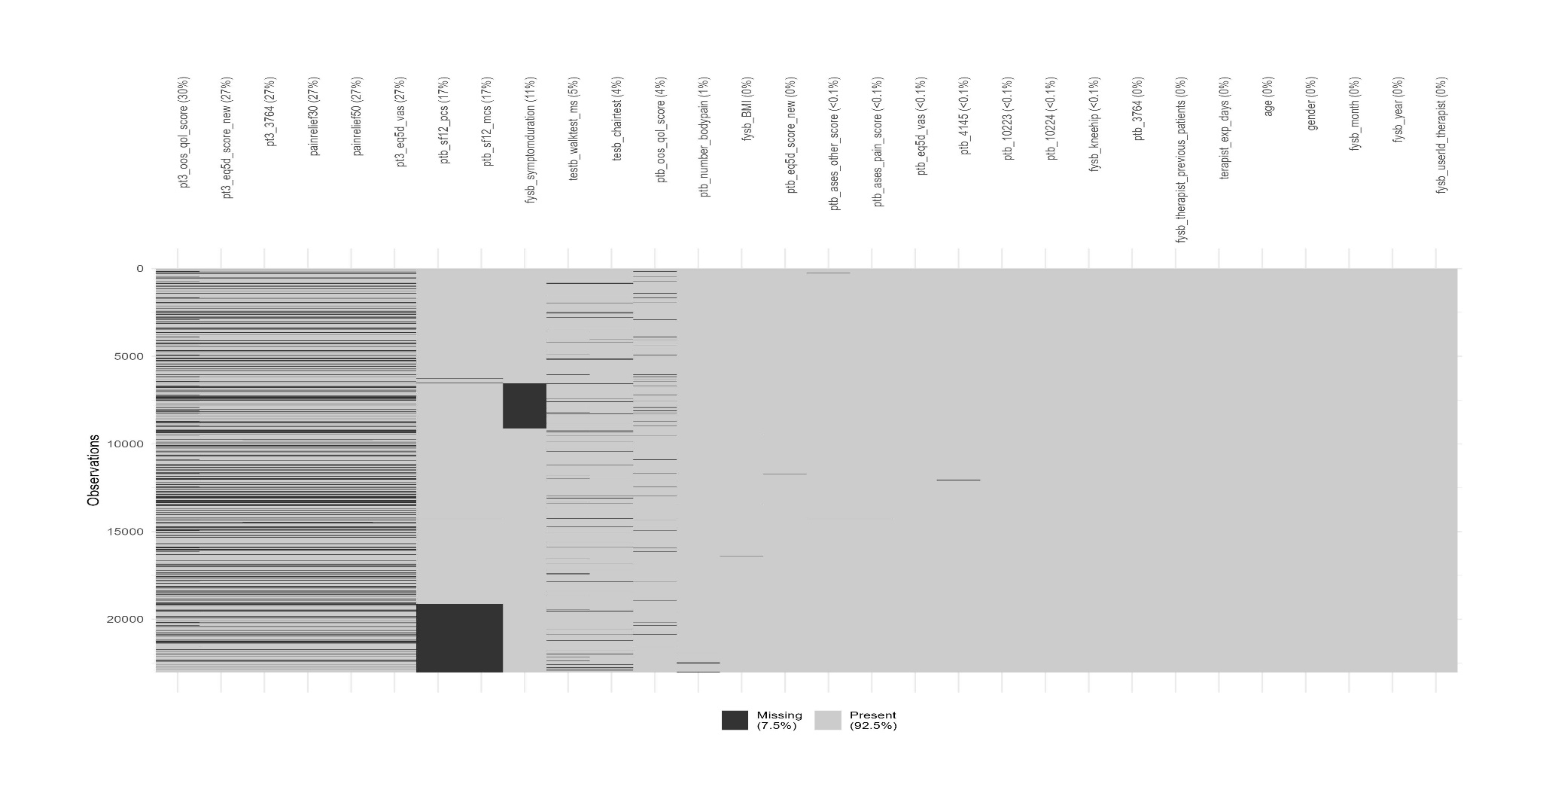

Table S1. Descriptive characteristics of patients (n=23,021) and therapists (n=657) after multiple imputation
 | Valid N | Miss % | %
Therapists
Number of patients treated: median (IQR) | 657 | 0 | 36 (16, 72)
Days since therapist certification: median (IQR) | 657 | 0 | 645 (313, 1077)
Patients
Age (years): mean (SD) | 23,021 | 0 | 65.0 (9.8)
Female sex | 23,021 | 0 | 74.4
Born in Denmark | 23,009 | <1 | 96.0
Danish citizen | 23,009 | <1 | 98.4
Body mass index (kg/m²): mean (SD) | 22,956 | <1 | 29.0 (5.5)
Symptom duration (months): median (IQR) | 20,408 | 11 | 18 (6, 48)
40m walk test at baseline (m/sec): mean (SD) | 21,792 | 5 | 1.4 (0.3)
Chair test at baseline (no.): mean (SD) | 22,158 | 4 | 11.4 (3.8)
No. of pain areas at baseline: mean (SD) | 22,851 | <1 | 4.0 (3.3)
UCLA Activity score (0-10): mean (SD) | 23,004 | <1 | 5.5 (1.8)
Primary complaint | 23,019 | <1
Hip |  |  | 25.8
Knee |  |  | 74.2
Month of enrollment on GLA:D | 23,021 | 0
January |  |  | 11.4
February |  |  | 7.6
March |  |  | 8.3
April |  |  | 8.6
May |  |  | 7.6
June |  |  | 5.7
July |  |  | 4.4
August |  |  | 12.6
September |  |  | 9.6
October |  |  | 11.8
November |  |  | 7.0
December |  |  | 5.4
Year of enrollment on GLA:D | 23,021 | 0
2014 |  |  | 5.3
2015 |  |  | 14.5
2016 |  |  | 22.4
2017 |  |  | 21.6
2018 |  |  | 19.5
2019 |  |  | 16.8
Arthritis Self-Efficacy Scale: Pain at baseline (10-100): mean (SD) | 23,002 | <1 | 61.9 (20.0)
Arthritis Self-Efficacy Scale: Other at baseline (10-100): mean (SD) | 22,998 | <1 | 66.6 (18.3)
SF-12 Physical Component Summary at baseline (0-100): mean (SD) | 19,076 | 17 | 35.3 (8.2)
SF-12 Mental Component Summary at baseline (0-100): mean (SD) | 19,076 | 17 | 51.1 (10.1)
Pain intensity at baseline (0-100): mean (SD) | 23,021 | 0 | 61.3 (14.5)
Pain intensity at 3 months (0-100): mean (SD) | 16,746 | 27 | 41.2 (22.6)
Experienced ≥30% reduction in pain at 3 months | 16,746 | 27 | 52.6
Experienced ≥50% reduction in pain at 3 months | 16,746 | 27 | 36.9
HOOS/KOOS QOL at baseline (0-100): mean (SD) | 22,215 | 4 | 40.9 (14.3)
HOOS/KOOS QOL at 3 months (0-100): mean (SD) | 16,221 | 30 | 47.5 (16.5)
EQ5D VAS at baseline (0-100): mean (SD) | 23,003 | <1 | 64.8 (19.0)
EQ5D VAS at 3 months (0-100): mean (SD) | 16,748 | 27 | 69.2 (19.3)
EQ5D utility score at baseline (-0.757-1.000): mean (SD) | 22,996 | <1 | 0.710 (0.216)
EQ5D utility score at 3 months (-0.757-1.000): mean (SD) | 16,743 | 27 | 0.774 (0.209)
Figures represent N (%) unless otherwise stated
Miss % = rate of missing data for each variable
GLA:D Good Life with osteoArthritis in Denmark; EQ5D EuroQoL-5 dimensions; HOOS Hip Osteoarthritis Outcome Score; IQR Interquartile range; KOOS Knee Osteoarthritis Outcome Score; QOL Quality of Life; SD Standard deviation; UCLA University of California, Los Angeles; VAS Visual Analogue Score

Table S2. Descriptive characteristics of patients (n=9,720) and therapists (n=403) in the complete case analysis dataset
 | Valid N | Miss % | N | %
Therapists
Number of patients treated: median (IQR) | 403 | 0 | 18 (13, 29)
Days since therapist certification: median (IQR) | 403 | 0 | 591 (304, 995)
Patients
Age (years): mean (SD) | 9,720 | 0 | 64.8 (9.5)
Female sex | 9,720 | 0 | 7,297 | 75.1
Born in Denmark | 9,720 | 0 | 9,370 | 96.4
Danish citizen | 9,720 | 0 | 9,575 | 98.5
Body mass index (kg/m²): mean (SD) | 9,720 | 0 | 28.8 (5.4)
Symptom duration (months): median (IQR) | 9,720 | 0 | 18 (6, 50)
40m walk test at baseline (m/sec): mean (SD) | 9,720 | 0 | 1.5 (0.3)
Chair test at baseline (no.): mean (SD) | 9,720 | 0 | 11.6 (3.7)
No. of pain areas at baseline: mean (SD) | 9,720 | 0 | 4.6 (3.0)
UCLA Activity score (0-10): mean (SD) | 9,720 | 0 | 5.6 (1.8)
Primary complaint | 9,720 | 0
Hip |  |  | 2,418 | 24.9
Knee |  |  | 7,302 | 75.1
Month of enrollment on GLA:D | 9,720 | 0
January |  |  | 1,255 | 12.9
February |  |  | 809 | 8.3
March |  |  | 879 | 9.0
April |  |  | 958 | 9.9
May |  |  | 681 | 7.0
June |  |  | 420 | 4.3
July |  |  | 363 | 3.7
August |  |  | 1063 | 10.9
September |  |  | 743 | 7.6
October |  |  | 963 | 9.9
November |  |  | 822 | 8.5
December |  |  | 764 | 7.9
Year of enrollment on GLA:D | 9,720 | 0
2014 |  |  | 792 | 8.1
2015 |  |  | 2,192 | 22.6
2016 |  |  | 1,565 | 16.1
2017 |  |  | 2,854 | 29.4
2018 |  |  | 2,317 | 23.8
2019 |  |  | 0 | 0.0
Arthritis Self-Efficacy Scale: Pain at baseline (10-100): mean (SD) | 9,720 | 0 | 63.5 (19.6)
Arthritis Self-Efficacy Scale: Other at baseline (10-100): mean (SD) | 9,720 | 0 | 68.1 (17.6)
SF-12 Physical Component Summary at baseline (0-100): mean (SD) | 9,720 | 0 | 35.7 (8.2)
SF-12 Mental Component Summary at baseline (0-100): mean (SD) | 9,720 | 0 | 51.6 (9.9)
Pain intensity at baseline (0-100): mean (SD) | 9,720 | 0 | 60.8 (14.2)
Pain intensity at 3 months (0-100): mean (SD) | 9,720 | 0 | 41.0 (22.6)
Experienced ≥30% reduction in pain at 3 months | 9,720 | 0 | 5,150 | 53.0
Experienced ≥50% reduction in pain at 3 months | 9,720 | 0 | 3,442 | 35.4
HOOS/KOOS QOL at baseline (0-100): mean (SD) | 9,720 | 0 | 41.2 (13.9)
HOOS/KOOS QOL at 3 months (0-100): mean (SD) | 9,720 | 0 | 47.6 (16.5)
EQ5D VAS at baseline (0-100): mean (SD) | 9,720 | 0 | 66.1 (18.4)
EQ5D VAS at 3 months (0-100): mean (SD) | 9,720 | 0 | 70.3 (18.7)
EQ5D utility score at baseline (-0.757-1.000): mean (SD) | 9,720 | 0 | 0.723 (0.205)
EQ5D utility score at 3 months (-0.757-1.000): mean (SD) | 9,720 | 0 | 0.781 (0.201)
Figures represent N (%) unless otherwise stated
Miss % = rate of missing data for each variable
GLA:D Good Life with osteoArthritis in Denmark; EQ5D EuroQoL-5 dimensions; HOOS Hip Osteoarthritis Outcome Score; IQR Interquartile range; KOOS Knee Osteoarthritis Outcome Score; QOL Quality of Life; SD Standard deviation; UCLA University of California, Los Angeles; VAS Visual Analogue Score

Table S3. Random intercept logistic regression models for ≥50% pain reduction at 3 months: multiply imputed data
 | Model 0 | Model 1 | Model 2
 | ‘Null’ model | Patient-level adjustment model | ‘Full model’
 | N=23,021 | N=23,021 | N=23,021
 |  | aOR (95%CI) | aOR (95%CI)
Therapist-level variables
Number of patients treated |  |  | 0.96 (0.92, 1.01)
Days since therapist certification |  |  | 1.01 (0.96, 1.07)
Patient-level variables
Age |  | 0.93 (0.90, 0.97) | 0.93 (0.90, 0.97)
Female sex |  | 1.08 (1.00, 1.17) | 1.08 (1.00, 1.17)
Born in Denmark |  | 1.03 (0.84, 1.28) | 1.03 (0.84, 1.28)
Danish citizen |  | 1.20 (0.87, 1.65) | 1.20 (0.87, 1.65)
Month of entry (ref: January)
February |  | 1.07 (0.92, 1.25) | 1.07 (0.92, 1.25)
March |  | 1.28 (1.11, 1.48) | 1.29 (1.11, 1.49)
April |  | 1.15 (1.00, 1.32) | 1.15 (1.00, 1.32)
May |  | 1.31 (1.12, 1.52) | 1.31 (1.13, 1.53)
June |  | 1.21 (1.04, 1.42) | 1.22 (1.04, 1.43)
July |  | 1.04 (0.87, 1.25) | 1.05 (0.88, 1.25)
August |  | 1.13 (0.98, 1.29) | 1.13 (0.98, 1.30)
September |  | 1.13 (0.98, 1.30) | 1.13 (0.98, 1.30)
October |  | 1.19 (1.05, 1.36) | 1.19 (1.05, 1.36)
November |  | 1.15 (0.99, 1.35) | 1.16 (1.00, 1.35)
December |  | 1.08 (0.91, 1.29) | 1.09 (0.92, 1.30)
Year of entry (ref: 2014)
2015 |  | 0.92 (0.79, 1.08) | 0.93 (0.80, 1.09)
2016 |  | 0.85 (0.73, 0.99) | 0.86 (0.74, 1.01)
2017 |  | 1.02 (0.88, 1.19) | 1.04 (0.89, 1.22)
2018 |  | 1.08 (0.92, 1.26) | 1.10 (0.93, 1.30)
2019 |  | 0.93 (0.79, 1.09) | 0.96 (0.80, 1.15)
Most affected joint is hip (ref: knee) |  | 0.84 (0.78, 0.90) | 0.84 (0.78, 0.90)
BMI (kg/m²) |  | 0.95 (0.92, 0.99) | 0.95 (0.92, 0.99)
Duration of symptoms (months) |  | 0.89 (0.86, 0.93) | 0.89 (0.86, 0.93)
40m walk test at baseline |  | 1.09 (1.04, 1.14) | 1.09 (1.04, 1.14)
No. of chair stands during 30sec at baseline |  | 1.05 (1.01, 1.09) | 1.05 (1.01, 1.09)
No. of painful body areas (0-56) at baseline |  | 0.89 (0.86, 0.93) | 0.89 (0.86, 0.93)
UCLA - Physical activity (1-10) at baseline |  | 0.98 (0.95, 1.02) | 0.98 (0.95, 1.02)
KOOS/HOOS QOL (0-100) at baseline |  | 1.10 (1.05, 1.14) | 1.09 (1.05, 1.14)
ASES: Other (10-100) at baseline |  | 0.98 (0.92, 1.04) | 0.98 (0.92, 1.04)
ASES: Pain (10-100) at baseline |  | 1.26 (1.19, 1.33) | 1.26 (1.19, 1.33)
EQ-VAS (0-100) at baseline |  | 1.09 (1.04, 1.14) | 1.09 (1.04, 1.14)
EQ-5D Health Utility score (-0.757-1) at baseline |  | 1.19 (1.13, 1.25) | 1.19 (1.13, 1.25)
SF-12 PCS (0-100) at baseline |  | 0.96 (0.92, 1.01) | 0.96 (0.92, 1.01)
SF-12 MCS (0-100) at baseline |  | 0.93 (0.89, 0.98) | 0.93 (0.89, 0.98)
Pain intensity (0-100) at baseline |  | 1.53 (1.48, 1.59) | 1.53 (1.48, 1.59)
VPC (ICC) | 0.007  (0.004, 0.009) | 0.007  (0.004, 0.010) | 0.007  (0.004, 0.010)
AIC | 30301.68 | 28969.16 | 28969.17
BIC | 30317.77 | 29266.79 | 29282.9
AUC | 0.597 | 0.655 | 0.655
NB All predictors standardised and centred
AIC Akaike Information Criterion; ASES Arthritis Self-Efficacy Scale; BIC Bayesian Information Criterion; EQ5D EuroQoL-5 dimensions; HOOS Hip Osteoarthritis Outcome Score; ICC Intra-class Correlation Coefficient; IQR Interquartile range; KOOS Knee Osteoarthritis Outcome Score; MCS Mental Component Score; aOR adjusted Odds Ratio; PCS Physical Component Score; QOL Quality of Life; SD Standard deviation; UCLA University of California, Los Angeles; VAS Visual Analogue Score; VPC Variance Partition Coefficient; 95%CI 95 percent confidence interval

Table S4. Random intercept linear regression models for pain intensity (0-100) at 3 months: multiply imputed data
 | Model 0 | Model 1 | Model 2
 | ‘Null’ model | Patient-level adjustment model | ‘Full model’
 | N=23,021 | N=23,021 | N=23,021
 |  | Adj.b (95%CI) | Adj.b (95%CI)
Therapist-level variables
Number of patients treated |  |  | 0.019 (-0.002, 0.039)
Days since therapist certification |  |  | -0.001 (-0.022, 0.020)
Patient-level variables
Age |  | 0.034 (0.020, 0.048) | 0.034 (0.019, 0.048)
Female sex |  | -0.037 (-0.065, -0.008) | -0.037 (-0.066, -0.009)
Born in Denmark |  | -0.017 (-0.092, 0.058) | -0.016 (-0.091, 0.059)
Danish citizen |  | -0.031 (-0.147, 0.085) | -0.031 (-0.147, 0.085)
Month of entry (ref: January)
February |  | 0.006 (-0.051, 0.062) | 0.006 (-0.051, 0.063)
March |  | -0.056 (-0.112, -0.001) | -0.057 (-0.113, -0.002)
April |  | -0.046 (-0.101, 0.009) | -0.047 (-0.101, 0.008)
May |  | -0.070 (-0.127, -0.013) | -0.071 (-0.128, -0.014)
June |  | -0.052 (-0.114, 0.011) | -0.055 (-0.117, 0.008)
July |  | -0.013 (-0.082, 0.055) | -0.016 (-0.085, 0.052)
August |  | -0.033 (-0.083, 0.017) | -0.035 (-0.086, 0.015)
September |  | -0.016 (-0.070, 0.037) | -0.020 (-0.073, 0.034)
October |  | -0.070 (-0.121, -0.019) | -0.070 (-0.125, -0.023)
November |  | -0.065 (-0.124, -0.006) | -0.069 (-0.128, -0.010)
December |  | 0.024 (-0.040, 0.088) | 0.019 (-0.045, 0.083)
Year of entry (ref: 2014)
2015 |  | 0.050 (-0.012, 0.113) | 0.044 (-0.019, 0.107)
2016 |  | 0.094 (0.034, 0.155) | 0.083 (0.021, 0.145)
2017 |  | 0.023 (-0.038, 0.084) | 0.007 (-0.058, 0.072)
2018 |  | -0.001 (-0.063, 0.061) | -0.022 (-0.091, 0.047)
2019 |  | 0.043 (-0.021, 0.107) | 0.017 (-0.057, 0.092)
Most affected joint is hip (ref: knee) |  | 0.121 (0.093, 0.150) | 0.121 (0.093, 0.149)
BMI (kg/m²) |  | 0.026 (0.013, 0.039) | 0.026 (0.013, 0.039)
Duration of symptoms (months) |  | 0.051 (0.039, 0.064) | 0.051 (0.039, 0.063)
40m walk test at baseline |  | -0.042 (-0.059, -0.025) | -0.043 (-0.060, -0.026)
No. of chair stands during 30sec at baseline |  | -0.026 (-0.040, -0.011) | -0.026 (-0.041, -0.011)
No. of painful body areas (0-56) at baseline |  | 0.044 (0.031, 0.057) | 0.044 (0.031, 0.057)
UCLA - Physical activity (1-10) at baseline |  | 0.009 (-0.004, 0.023) | 0.009 (-0.004, 0.023)
KOOS/HOOS QOL (0-100) at baseline |  | -0.050 (-0.066, -0.035) | -0.050 (-0.066, -0.035)
ASES: Other (10-100) at baseline |  | 0.012 (-0.009, 0.033) | 0.012 (-0.009, 0.033)
ASES: Pain (10-100) at baseline |  | -0.111 (-0.135, -0.097) | -0.116 (-0.136, -0.097)
EQ-VAS (0-100) at baseline |  | -0.049 (-0.064, -0.033) | -0.048 (-0.064, -0.033)
EQ-5D Health Utility score (-0.757-1) at baseline |  | -0.111 (-0.129, -0.094) | -0.111 (-0.128, -0.094)
SF-12 PCS (0-100) at baseline |  | 0.003 (-0.014, 0.020) | 0.003 (-0.014, 0.020)
SF-12 MCS (0-100) at baseline |  | 0.031 (0.016, 0.046) | 0.031 (0.016, 0.046)
Pain intensity (0-100) at baseline |  | 0.119 (0.105, 0.133) | 0.119 (0.105, 0.133)
VPC (ICC) | 0.008  (0.006, 0.010) | 0.009  (0.006, 0.011) | 0.009  (0.006, 0.011)
AIC | 65172.45 | 62549.8 | 62563.48
BIC | 65196.58 | 62855.48 | 62885.24
NB All predictors standardised and centred
Adj.b Adjusted beta coefficient; AIC Akaike Information Criterion; ASES Arthritis Self-Efficacy Scale; BIC Bayesian Information Criterion; EQ5D EuroQoL-5 dimensions; HOOS Hip Osteoarthritis Outcome Score; ICC Intra-class Correlation Coefficient; IQR Interquartile range; KOOS Knee Osteoarthritis Outcome Score; MCS Mental Component Score; PCS Physical Component Score; QOL Quality of Life; SD Standard deviation; UCLA University of California, Los Angeles; VAS Visual Analogue Score; VPC Variance Partition Coefficient; 95%CI 95 percent confidence interval

Table S5. Random intercept linear regression models for HOOS/KOOS Quality of Life Score (0-100) at 3 months: multiply imputed data
 | Model 0 | Model 1 | Model 2
 | ‘Null’ model | Patient-level adjustment model | ‘Full model’
 | N=23,021 | N=23,021 | N=23,021
 |  | Adj.b (95%CI) | Adj.b (95%CI)
Therapist-level variables
Number of patients treated |  |  | -0.005 (-0.022, 0.012)
Days since therapist certification |  |  | 0.016 (-0.003, 0.034)
Patient-level variables
Age |  | 0.029 (0.017, 0.042) | 0.030 (0.017, 0.042)
Female sex |  | 0.060 (0.034, 0.085) | 0.060 (0.034, 0.085)
Born in Denmark |  | 0.004 (-0.066, 0.067) | 0.001 (-0.066, 0.068)
Danish citizen |  | -0.027 (-0.130, 0.077) | -0.026 (-0.129, 0.077)
Month of entry (ref: January)
February |  | -0.006 (-0.057, 0.044) | -0.005 (-0.056, 0.045)
March |  | 0.046 (-0.004, 0.095) | 0.045 (-0.004, 0.094)
April |  | 0.053 (0.004, 0.102) | 0.052 (0.003, 0.101)
May |  | 0.038 (-0.013, 0.089) | 0.037 (-0.013, 0.088)
June |  | 0.060 (0.005, 0.116) | 0.059 (0.003, 0.115)
July |  | 0.015 (-0.046, 0.076) | 0.014 (-0.047, 0.075)
August |  | 0.040 (-0.004, 0.085) | 0.036 (-0.009, 0.081)
September |  | 0.036 (-0.012, 0.084) | 0.033 (-0.015, 0.080)
October |  | 0.052 (0.007, 0.097) | 0.048 (0.003, 0.093)
November |  | 0.036 (-0.017, 0.089) | 0.032 (-0.020, 0.085)
December |  | -0.035 (-0.092, 0.023) | -0.039 (-0.096, 0.018)
Year of entry (ref: 2014)
2015 |  | -0.001 (-0.056, 0.055) | -0.006 (-0.062, 0.050)
2016 |  | -0.011 (-0.064, 0.043) | -0.021 (-0.076, 0.034)
2017 |  | -0.024 (-0.078, 0.031) | -0.039 (-0.096, 0.019)
2018 |  | 0.027 (-0.028, 0.082) | 0.005 (-0.055, 0.066)
2019 |  | 0.017 (-0.039, 0.074) | -0.010 (-0.076, 0.055)
Most affected joint is hip (ref: knee) |  | -0.012 (-0.037, 0.014) | -0.012 (-0.037, 0.013)
BMI (kg/m²) |  | -0.013 (-0.025, -0.001) | -0.013 (-0.025, -0.001)
Duration of symptoms (months) |  | -0.045 (-0.056, -0.034) | -0.045 (-0.056, -0.034)
40m walk test at baseline |  | 0.019 (0.004, 0.033) | 0.019 (0.004, 0.034)
No. of chair stands during 30sec at baseline |  | 0.027 (0.014, 0.040) | 0.026 (0.013, 0.039)
No. of painful body areas (0-56) at baseline |  | -0.022 (-0.033, -0.010) | -0.022 (-0.033, -0.010)
UCLA - Physical activity (1-10) at baseline |  | -0.025 (-0.037, -0.013) | -0.025 (-0.037, -0.013)
KOOS/HOOS QOL (0-100) at baseline |  | 0.364 (0.350, 0.378) | 0.364 (0.350, 0.378)
ASES: Other (10-100) at baseline |  | 0.005 (-0.014, 0.024) | 0.005 (-0.014, 0.024)
ASES: Pain (10-100) at baseline |  | 0.082 (0.065, 0.099) | 0.082 (0.065, 0.100)
EQ-VAS (0-100) at baseline |  | 0.028 (0.014, 0.042) | 0.028 (0.014, 0.042)
EQ-5D Health Utility score (-0.757-1) at baseline |  | 0.072 (0.056, 0.087) | 0.072 (0.056, 0.087)
SF-12 PCS (0-100) at baseline |  | 0.100 (0.085, 0.115) | 0.100 (0.085, 0.115)
SF-12 MCS (0-100) at baseline |  | 0.026 (0.013, 0.040) | 0.026 (0.013, 0.040)
Pain intensity (0-100) at baseline |  | 0.014 (0.001, 0.026) | 0.014 (0.001, 0.026)
VPC (ICC) | 0.008  (0.007, 0.010) | 0.006  (0.005, 0.008) | 0.006  (0.005, 0.008)
AIC | 65185.74 | 57259.65 | 57275.56
BIC | 65209.87 | 57565.32 | 57597.33
NB All predictors standardised and centred
Adj.b Adjusted beta coefficient; AIC Akaike Information Criterion; ASES Arthritis Self-Efficacy Scale; BIC Bayesian Information Criterion; EQ5D EuroQoL-5 dimensions; HOOS Hip Osteoarthritis Outcome Score; ICC Intra-class Correlation Coefficient; IQR Interquartile range; KOOS Knee Osteoarthritis Outcome Score; MCS Mental Component Score; PCS Physical Component Score; QOL Quality of Life; SD Standard deviation; UCLA University of California, Los Angeles; VAS Visual Analogue Score; VPC Variance Partition Coefficient; 95%CI 95 percent confidence interval

Table S6. Random intercept linear regression models for EQ5D Health Utility Score (-0.757-1.000) at 3 months: multiply imputed data
 | Model 0 | Model 1 | Model 2
 | ‘Null’ model | Patient-level adjustment model | ‘Full model’
 | N=23,021 | N=23,021 | N=23,021
 |  | Adj.b (95%CI) | Adj.b (95%CI)
Therapist-level variables
Number of patients treated |  |  | -0.008 (-0.024, 0.008)
Days since therapist certification |  |  | 0.003 (-0.015, 0.020)
Patient-level variables
Age |  | 0.016 (0.003, 0.029) | 0.016 (0.004, 0.029)
Female sex |  | 0.124 (0.099, 0.150) | 0.125 (0.099, 0.150)
Born in Denmark |  | -0.076 (-0.143, -0.008) | -0.076 (-0.143, -0.008)
Danish citizen |  | -0.024 (-0.128, 0.080) | -0.024 (-0.128, 0.080)
Month of entry (ref: January)
February |  | 0.001 (-0.050, 0.052) | 0.001 (-0.050, 0.052)
March |  | 0.004 (-0.046, 0.053) | 0.004 (-0.045, 0.054)
April |  | 0.013 (-0.036, 0.062) | 0.013 (-0.036, 0.062)
May |  | 0.013 (-0.038, 0.065) | 0.014 (-0.037, 0.065)
June |  | 0.031 (-0.025, 0.087) | 0.032 (-0.024, 0.088)
July |  | 0.050 (-0.011, 0.111) | 0.051 (-0.010, 0.112)
August |  | 0.027 (-0.017, 0.072) | 0.027 (-0.017, 0.072)
September |  | 0.015 (-0.033, 0.063) | 0.016 (-0.032, 0.064)
October |  | 0.059 (0.014, 0.104) | 0.060 (0.014, 0.105)
November |  | 0.028 (-0.025, 0.081) | 0.029 (-0.024, 0.082)
December |  | -0.011 (-0.068, 0.047) | -0.009 (-0.067, 0.048)
Year of entry (ref: 2014)
2015 |  | -0.023 (-0.079, 0.033) | -0.022 (-0.078, 0.035)
2016 |  | -0.019 (-0.072, 0.035) | -0.017 (-0.071, 0.038)
2017 |  | -0.025 (-0.079, 0.030) | -0.022 (-0.078, 0.035)
2018 |  | -0.039 (-0.094, 0.016) | -0.035 (-0.095, 0.024)
2019 |  | -0.046 (-0.102, 0.011) | -0.041 (-0.105, 0.023)
Most affected joint is hip (ref: knee) |  | -0.141 (-0.167, -0.116) | -0.141 (-0.167, -0.116)
BMI (kg/m²) |  | -0.013 (-0.025, -0.001) | -0.013 (-0.025, -0.001)
Duration of symptoms (months) |  | -0.018 (-0.029, -0.007) | -0.018 (-0.029, -0.007)
40m walk test at baseline |  | 0.039 (0.024, 0.053) | 0.039 (0.024, 0.054)
No. of chair stands during 30sec at baseline |  | 0.018 (0.005, 0.031) | 0.018 (0.005, 0.031)
No. of painful body areas (0-56) at baseline |  | -0.030 (-0.041, -0.018) | -0.030 (-0.041, -0.018)
UCLA - Physical activity (1-10) at baseline |  | 0.005 (-0.007, 0.017) | 0.005 (-0.007, 0.017)
KOOS/HOOS QOL (0-100) at baseline |  | 0.059 (0.045, 0.073) | 0.059 (0.045, 0.073)
ASES: Other (10-100) at baseline |  | 0.047 (0.028, 0.065) | 0.047 (0.028, 0.066)
ASES: Pain (10-100) at baseline |  | 0.053 (0.035, 0.070) | 0.053 (0.036, 0.071)
EQ-VAS (0-100) at baseline |  | 0.044 (0.030, 0.057) | 0.044 (0.030, 0.057)
EQ-5D Health Utility score (-0.757-1) at baseline |  | 0.355 (0.339, 0.370) | 0.355 (0.339, 0.370)
SF-12 PCS (0-100) at baseline |  | 0.063 (0.048, 0.078) | 0.063 (0.048, 0.078)
SF-12 MCS (0-100) at baseline |  | 0.068 (0.054, 0.082) | 0.068 (0.055, 0.082)
Pain intensity (0-100) at baseline |  | -0.004 (-0.017, 0.008) | -0.004 (-0.017, 0.008)
VPC (ICC) | 0.008  (0.006, 0.010) | 0.003  (0.001, 0.005) | 0.003  (0.001, 0.005)
AIC | 66094.29 | 57553.07 | 57571.25
BIC | 66118.43 | 57858.75 | 57893.02
NB All predictors standardised and centred
Adj.b Adjusted beta coefficient; AIC Akaike Information Criterion; ASES Arthritis Self-Efficacy Scale; BIC Bayesian Information Criterion; EQ5D EuroQoL-5 dimensions; HOOS Hip Osteoarthritis Outcome Score; ICC Intra-class Correlation Coefficient; IQR Interquartile range; KOOS Knee Osteoarthritis Outcome Score; MCS Mental Component Score; PCS Physical Component Score; QOL Quality of Life; SD Standard deviation; UCLA University of California, Los Angeles; VAS Visual Analogue Score; VPC Variance Partition Coefficient; 95%CI 95 percent confidence interval

Table S7. Random intercept linear regression models for EQ5D VAS (0-100) at 3 months: multiply imputed data
 | Model 0 | Model 1 | Model 2
 | ‘Null’ model | Patient-level adjustment model | ‘Full model’
 | N=23,021 | N=23,021 | N=23,021
 |  | Adj.b (95%CI) | Adj.b (95%CI)
Therapist-level variables
Number of patients treated |  |  | -0.001 (-0.017, 0.016)
Days since therapist certification |  |  | 0.018 (0.001, 0.036)
Patient-level variables
Age |  | 0.010 (-0.003, 0.023) | 0.010 (-0.003, 0.023)
Female sex |  | 0.052 (0.026, 0.077) | 0.052 (0.026, 0.077)
Born in Denmark |  | 0.039 (-0.029, 0.106) | 0.039 (-0.028, 0.107)
Danish citizen |  | 0.006 (-0.098, 0.110) | 0.007 (-0.097, 0.111)
Month of entry (ref: January)
February |  | 0.019 (-0.032, 0.070) | 0.020 (-0.031, 0.071)
March |  | -0.003 (-0.053, 0.046) | -0.004 (-0.054, 0.046)
April |  | 0.028 (-0.021, 0.077) | 0.027 (-0.022, 0.077)
May |  | 0.019 (-0.032, 0.071) | 0.019 (-0.033, 0.070)
June |  | 0.011 (-0.046, 0.067) | 0.008 (-0.048, 0.065)
July |  | -0.033 (-0.094, 0.028) | -0.036 (-0.097, 0.026)
August |  | 0.040 (-0.005, 0.085) | 0.034 (-0.011, 0.079)
September |  | -0.002 (-0.050, 0.046) | -0.007 (-0.055, 0.041)
October |  | -0.012 (-0.058, 0.033) | -0.018 (-0.064, 0.028)
November |  | 0.014 (-0.039, 0.067) | 0.009 (-0.044, 0.063)
December |  | 0.007 (-0.050, 0.065) | 0.001 (-0.057, 0.059)
Year of entry (ref: 2014)
2015 |  | -0.025 (-0.081, 0.031) | -0.033 (-0.089, 0.024)
2016 |  | -0.055 (-0.108, -0.001) | -0.068 (-0.123, -0.013)
2017 |  | -0.065 (-0.120, -0.011) | -0.086 (-0.143, -0.029)
2018 |  | -0.070 (-0.125, -0.015) | -0.099 (-0.159, -0.039)
2019 |  | -0.125 (-0.182, -0.068) | -0.162 (-0.227, -0.098)
Most affected joint is hip (ref: knee) |  | -0.096 (-0.122, -0.071) | -0.097 (-0.122, -0.071)
BMI (kg/m²) |  | -0.024 (-0.036, -0.012) | -0.024 (-0.036, -0.012)
Duration of symptoms (months) |  | -0.024 (-0.035, -0.013) | -0.024 (-0.035, -0.013)
40m walk test at baseline |  | 0.022 (0.008, 0.037) | 0.023 (0.008, 0.037)
No. of chair stands during 30sec at baseline |  | 0.022 (0.009, 0.035) | 0.022 (0.008, 0.035)
No. of painful body areas (0-56) at baseline |  | -0.041 (-0.052, -0.029) | -0.041 (-0.052, -0.029)
UCLA - Physical activity (1-10) at baseline |  | 0.021 (0.008, 0.033) | 0.021 (0.008, 0.032)
KOOS/HOOS QOL (0-100) at baseline |  | 0.018 (0.004, 0.032) | 0.018 (0.003, 0.032)
ASES: Other (10-100) at baseline |  | 0.087 (0.068, 0.106) | 0.087 (0.068, 0.106)
ASES: Pain (10-100) at baseline |  | 0.054 (0.036, 0.071) | 0.053 (0.036, 0.071)
EQ-VAS (0-100) at baseline |  | 0.286 (0.272, 0.300) | 0.286 (0.272, 0.300)
EQ-5D Health Utility score (-0.757-1) at baseline |  | 0.036 (0.020, 0.51) | 0.036 (0.020, 0.51)
SF-12 PCS (0-100) at baseline |  | 0.116 (0.101, 0.131) | 0.116 (0.101, 0.131)
SF-12 MCS (0-100) at baseline |  | 0.083 (0.069, 0.097) | 0.083 (0.069, 0.096)
Pain intensity (0-100) at baseline |  | 0.009 (-0.003, 0.021) | 0.009 (-0.004, 0.021)
VPC (ICC) | 0.011  (0.009, 0.013) | 0.004  (0.002, 0.006) | 0.004  (0.002, 0.005)
AIC | 65465.27 | 57694.32 | 57707.77
BIC | 65489.40 | 58000.00 | 58029.53
NB All predictors standardised and centred
Adj.b Adjusted beta coefficient; AIC Akaike Information Criterion; ASES Arthritis Self-Efficacy Scale; BIC Bayesian Information Criterion; EQ5D EuroQoL-5 dimensions; HOOS Hip Osteoarthritis Outcome Score; ICC Intra-class Correlation Coefficient; IQR Interquartile range; KOOS Knee Osteoarthritis Outcome Score; MCS Mental Component Score; PCS Physical Component Score; QOL Quality of Life; SD Standard deviation; UCLA University of California, Los Angeles; VAS Visual Analogue Score; VPC Variance Partition Coefficient; 95%CI 95 percent confidence interval

Table S8. Random intercept logistic regression models for ≥50% pain reduction at 3 months: complete case analysis
 | Model 0 | Model 1 | Model 2
 | ‘Null’ model | Patient-level adjustment model | ‘Full model’
 | N=9,720 | N=9,720 | N=9,720
 |  | aOR (95%CI) | aOR (95%CI)
Therapist-level variables
Number of patients treated |  |  | 0.94 (0.88, 1.01)
Days since therapist certification |  |  | 1.02 (0.95, 1.10)
Patient-level variables
Age |  | 0.92 (0.87, 0.97) | 0.92 (0.88, 0.97)
Female sex |  | 1.19 (1.07, 1.32) | 1.19 (1.08, 1.33)
Born in Denmark |  | 1.02 (0.76, 1.37) | 1.02 (0.76, 1.37)
Danish citizen |  | 1.29 (0.83, 2.01) | 1.29 (0.83, 2.01)
Month of enrollment on GLA:D (ref: January)
February |  | 1.04 (0.86, 1.27) | 1.04 (0.86, 1.27)
March |  | 1.38 (1.14, 1.66) | 1.38 (1.15, 1.67)
April |  | 1.15 (0.96, 1.39) | 1.16 (0.96, 1.39)
May |  | 1.32 (1.08, 1.62) | 1.32 (1.08, 1.62)
June |  | 1.11 (0.87, 1.42) | 1.11 (0.87, 1.43)
July |  | 1.11 (0.86, 1.44) | 1.12 (0.86, 1.45)
August |  | 1.11 (0.93, 1.34) | 1.11 (0.93, 1.34)
September |  | 1.13 (0.92, 1.39) | 1.14 (0.93, 1.40)
October |  | 1.22 (1.01, 1.48) | 1.23 (1.02, 1.49)
November |  | 1.12 (0.92, 1.37) | 1.14 (0.93, 1.38)
December |  | 1.10 (0.90, 1.35) | 1.12 (0.92, 1.37)
Year of enrollment on GLA:D (ref: 2014)
2015 |  | 1.03 (0.86, 1.24) | 1.05 (0.87, 1.26)
2016 |  | 0.99 (0.81, 1.22) | 1.02 (0.82, 1.25)
2017 |  | 1.09 (0.91, 1.30) | 1.12 (0.92, 1.37)
2018 |  | 1.18 (0.98, 1.42) | 1.23 (0.99, 1.54)
2019 |  | - | -
Most affected joint is hip (ref: knee) |  | 0.90 (0.81, 1.00) | 0.90 (0.81, 1.00)
BMI (kg/m²) |  | 0.95 (0.91, 1.00) | 0.95 (0.91, 1.00)
Duration of symptoms (months) |  | 0.88 (0.84, 0.93) | 0.88 (0.84, 0.93)
40m walk test at baseline |  | 1.12 (1.05, 1.19) | 1.12 (1.06, 1.19)
No. of chair stands during 30sec at baseline |  | 1.08 (1.02, 1.14) | 1.08 (1.02, 1.14)
No. of painful body areas (0-56) at baseline |  | 0.84 (0.80, 0.89) | 0.84 (0.80, 0.89)
UCLA - Physical activity (1-10) at baseline |  | 0.99 (0.95, 1.04) | 0.99 (0.95, 1.04)
KOOS/HOOS QOL (0-100) at baseline |  | 1.14 (1.08, 1.21) | 1.14 (1.08, 1.21)
ASES: Other (10-100) at baseline |  | 1.01 (0.93, 1.09) | 1.01 (0.93, 1.09)
ASES: Pain (10-100) at baseline |  | 1.31 (1.22, 1.40) | 1.31 (1.22, 1.41)
EQ-VAS (0-100) at baseline |  | 1.07 (1.01, 1.13) | 1.07 (1.01, 1.13)
EQ-5D Health Utility score (-0.757-1) at baseline |  | 1.15 (1.08, 1.22) | 1.15 (1.08, 1.22)
SF-12 PCS (0-100) at baseline |  | 0.94 (0.89, 1.00) | 0.94 (0.89, 1.00)
SF-12 MCS (0-100) at baseline |  | 0.96 (0.91, 1.02) | 0.96 (0.91, 1.02)
Pain intensity (0-100) at baseline |  | 1.34 (1.28, 1.41) | 1.34 (1.28, 1.41)
VPC (ICC) | 0.012  (0.002, 0.022) | 0.013  (0.003, 0.024) | 0.013  (0.001, 0.022)
AIC | 12627.76 | 12065.79 | 12066.7
BIC | 12642.12 | 12324.34 | 12339.62
AUC | 0.622 | 0.667 | 0.667
NB All predictors standardised and centred
AIC Akaike Information Criterion; ASES Arthritis Self-Efficacy Scale; BIC Bayesian Information Criterion; EQ5D EuroQoL-5 dimensions; HOOS Hip Osteoarthritis Outcome Score; ICC Intra-class Correlation Coefficient; IQR Interquartile range; KOOS Knee Osteoarthritis Outcome Score; MCS Mental Component Score; aOR adjusted Odds Ratio; PCS Physical Component Score; QOL Quality of Life; SD Standard deviation; UCLA University of California, Los Angeles; VAS Visual Analogue Score; VPC Variance Partition Coefficient; 95%CI 95 percent confidence interval

Table S9. Random intercept linear regression models for pain intensity (0-100) at 3 months: complete case analysis
 | Model 0 | Model 1 | Model 2
 | ‘Null’ model | Patient-level adjustment model | ‘Full model’
 | N=9,720 | N=9,720 | N=9,720
 |  | Adj.b (95%CI) | Adj.b (95%CI)
Therapist-level variables
Number of patients treated |  |  | 0.026 (-0.005, 0.058)
Days since therapist certification |  |  | -0.007 (-0.040, 0.026)
Patient-level variables
Age |  | 0.035 (0.014, 0.056) | 0.034 (0.013, 0.056)
Female sex |  | -0.086 (-0.129, -0.042) | -0.087 (-0.130, -0.043)
Born in Denmark |  | -0.040 (-0.163, 0.082) | -0.040 (-0.163, 0.083)
Danish citizen |  | -0.056 (-0.245, 0.132) | -0.057 (-0.245, 0.131)
Month of entry (ref: January)
February |  | 0.044 (-0.037, 0.126) | 0.044 (-0.037, 0.126)
March |  | -0.085 (-0.164, -0.005) | -0.086 (-0.165, -0.006)
April |  | -0.040 (-0.117, 0.038) | -0.040 (-0.118, 0.038)
May |  | -0.069 (-0.156, 0.017) | -0.070 (-0.157, 0.016)
June |  | -0.033 (-0.136, 0.071) | -0.036 (-0.139, 0.068)
July |  | -0.041 (-0.150, 0.069) | -0.044 (-0.153, 0.066)
August |  | -0.008 (-0.085, 0.070) | -0.009 (-0.087, 0.069)
September |  | -0.025 (-0.110, 0.061) | -0.029 (-0.115, 0.058)
October |  | -0.065 (-0.145, 0.015) | -0.068 (-0.149, 0.012)
November |  | -0.087 (-0.169, -0.004) | -0.092 (-0.175, -0.009)
December |  | 0.030 (-0.054, 0.114) | 0.024 (-0.061, 0.109)
Year of entry (ref: 2014)
2015 |  | 0.004 (-0.073, 0.080) | 0.003 (-0.081, 0.075)
2016 |  | 0.038 (-0.047, 0.123) | 0.025 (-0.064, 0.115)
2017 |  | 0.001 (-0.076, 0.078) | 0.016 (-0.103, 0.071)
2018 |  | -0.051 (-0.130, 0.028) | -0.075 (-0.173, 0.024)
2019 |  | - | -
Most affected joint is hip (ref: knee) |  | 0.095 (0.051, 0.139) | 0.095 (0.051, 0.138)
BMI (kg/m²) |  | 0.025 (0.005, 0.045) | 0.025 (0.005, 0.045)
Duration of symptoms (months) |  | 0.054 (0.035, 0.073) | 0.054 (0.035, 0.073)
40m walk test at baseline |  | -0.051 (-0.076, -0.025) | -0.052 (-0.077, -0.027)
No. of chair stands during 30sec at baseline |  | -0.029 (-0.051, -0.007) | -0.029 (-0.051, -0.007)
No. of painful body areas (0-56) at baseline |  | 0.057 (0.037, 0.077) | 0.057 (0.037, 0.076)
UCLA - Physical activity (1-10) at baseline |  | 0.004 (-0.017, 0.024) | 0.004 (-0.017, 0.024)
KOOS/HOOS QOL (0-100) at baseline |  | -0.074 (-0.097, -0.050) | -0.073 (-0.097, -0.050)
ASES: Other (10-100) at baseline |  | -0.001 (-0.033, 0.031) | -0.001 (-0.033, 0.031)
ASES: Pain (10-100) at baseline |  | -0.132 (-0.161, -0.103) | -0.132 (-0.161, -0.103)
EQ-VAS (0-100) at baseline |  | -0.038 (-0.061, -0.014) | -0.038 (-0.061, -0.014)
EQ-5D Health Utility score (-0.757-1) at baseline |  | -0.082 (-0.108, -0.057) | -0.082 (-0.108, -0.056)
SF-12 PCS (0-100) at baseline |  | 0.002 (-0.023, 0.028) | 0.002 (-0.024, 0.027)
SF-12 MCS (0-100) at baseline |  | 0.023 (0.000, 0.045) | 0.023 (0.000, 0.045)
Pain intensity (0-100) at baseline |  | 0.165 (0.144, 0.186) | 0.165 (0.144, 0.186)
VPC (ICC) | 0.015  (0.006, 0.023) | 0.016  (0.005, 0.025) | 0.016  (0.007, 0.022)
AIC | 27569.49 | 26206.81 | 26220.89
BIC | 27591.03 | 26472.55 | 26500.99
NB All predictors standardised and centred
Adj.b Adjusted beta coefficient; AIC Akaike Information Criterion; ASES Arthritis Self-Efficacy Scale; BIC Bayesian Information Criterion; EQ5D EuroQoL-5 dimensions; HOOS Hip Osteoarthritis Outcome Score; ICC Intra-class Correlation Coefficient; IQR Interquartile range; KOOS Knee Osteoarthritis Outcome Score; MCS Mental Component Score; PCS Physical Component Score; QOL Quality of Life; SD Standard deviation; UCLA University of California, Los Angeles; VAS Visual Analogue Score; VPC Variance Partition Coefficient; 95%CI 95 percent confidence interval

Table S10. Random intercept linear regression models for HOOS/KOOS Quality of Life Score (0-100) at 3 months: complete case analysis
 | Model 0 | Model 1 | Model 2
 | ‘Null’ model | Patient-level adjustment model | ‘Full model’
 | N=9,720 | N=9,720 | N=9,720
 |  | Adj.b (95%CI) | Adj.b (95%CI)
Therapist-level variables
Number of patients treated |  |  | -0.005 (-0.032, 0.022)
Days since therapist certification |  |  | 0.016 (-0.012, 0.045)
Patient-level variables
Age |  | 0.006 (-0.013, 0.025) | 0.006 (-0.013, 0.025)
Female sex |  | 0.086 (0.047, 0.125) | 0.086 (0.047, 0.125)
Born in Denmark |  | 0.000 (-0.110, 0.110) | 0.000 (-0.110, 0.110)
Danish citizen |  | -0.006 (-0.174, 0.163) | -0.005 (-0.173, 0.164)
Month of entry (ref: January)
February |  | -0.014 (-0.087, 0.059) | -0.012 (-0.085, 0.061)
March |  | 0.070 (-0.001, 0.142) | 0.070 (-0.001, 0.142)
April |  | 0.060 (-0.010, 0.129) | 0.059 (-0.010, 0.129)
May |  | 0.056 (-0.022, 0.133) | 0.055 (-0.022, 0.133)
June |  | 0.046 (-0.047, 0.138) | 0.044 (-0.048, 0.137)
July |  | 0.027 (-0.071, 0.124) | 0.025 (-0.073, 0.123)
August |  | 0.015 (-0.054, 0.085) | 0.011 (-0.059, 0.081)
September |  | 0.038 (-0.039, 0.115) | 0.034 (-0.043, 0.111)
October |  | 0.057 (-0.015, 0.128) | 0.052 (-0.020, 0.124)
November |  | 0.044 (-0.030, 0.118) | 0.040 (-0.034, 0.114)
December |  | -0.017 (-0.092, 0.058) | -0.023 (-0.099, 0.053)
Year of entry (ref: 2014)
2015 |  | 0.031 (-0.037, 0.100) | 0.025 (-0.045, 0.094)
2016 |  | 0.011 (-0.065, 0.087) | -0.002 (-0.081, 0.078)
2017 |  | -0.007 (-0.076, 0.061) | -0.026 (-0.103, 0.051)
2018 |  | 0.057 (-0.013, 0.127) | 0.029 (-0.057, 0.116)
2019 |  | - | -
Most affected joint is hip (ref: knee) |  | 0.011 (-0.028, 0.050) | 0.011 (-0.028, 0.050)
BMI (kg/m²) |  | -0.026 (-0.044, -0.008) | -0.026 (-0.044, -0.008)
Duration of symptoms (months) |  | -0.046 (-0.063, -0.029) | -0.046 (-0.063, -0.029)
40m walk test at baseline |  | 0.022 (0.000, 0.045) | 0.023 (0.001, 0.045)
No. of chair stands during 30sec at baseline |  | 0.024 (0.004, 0.044) | 0.024 (0.004, 0.043)
No. of painful body areas (0-56) at baseline |  | -0.029 (-0.047, -0.011) | -0.029 (-0.047, -0.011)
UCLA - Physical activity (1-10) at baseline |  | -0.022 (-0.040, -0.004) | -0.022 (-0.040, -0.004)
KOOS/HOOS QOL (0-100) at baseline |  | 0.376 (0.355, 0.397) | 0.376 (0.355, 0.397)
ASES: Other (10-100) at baseline |  | 0.022 (-0.006, 0.051) | 0.022 (-0.006, 0.050)
ASES: Pain (10-100) at baseline |  | 0.082 (0.056, 0.108) | 0.082 (0.056, 0.108)
EQ-VAS (0-100) at baseline |  | 0.027 (0.006, 0.048) | 0.027 (0.006, 0.048)
EQ-5D Health Utility score (-0.757-1) at baseline |  | 0.056 (0.033, 0.079) | 0.056 (0.033, 0.079)
SF-12 PCS (0-100) at baseline |  | 0.101 (0.078, 0.124) | 0.101 (0.078, 0.124)
SF-12 MCS (0-100) at baseline |  | 0.025 (0.005, 0.045) | 0.025 (0.005, 0.045)
Pain intensity (0-100) at baseline |  | -0.009 (-0.028, 0.010) | -0.009 (-0.028, 0.010)
VPC (ICC) | 0.014  (0.006, 0.026) | 0.012  (0.002, 0.022) | 0.012  (0.003, 0.022)
AIC | 27572.00 | 24055.61 | 24071.95
BIC | 27593.55 | 24321.34 | 24352.05
NB All predictors standardised and centred
Adj.b Adjusted beta coefficient; AIC Akaike Information Criterion; ASES Arthritis Self-Efficacy Scale; BIC Bayesian Information Criterion; EQ5D EuroQoL-5 dimensions; HOOS Hip Osteoarthritis Outcome Score; ICC Intra-class Correlation Coefficient; IQR Interquartile range; KOOS Knee Osteoarthritis Outcome Score; MCS Mental Component Score; PCS Physical Component Score; QOL Quality of Life; SD Standard deviation; UCLA University of California, Los Angeles; VAS Visual Analogue Score; VPC Variance Partition Coefficient; 95%CI 95 percent confidence interval

Table S11. Random intercept linear regression models for EQ5D Health Utility Score (-0.757-1.000) at 3 months: complete case analysis
 | Model 0 | Model 1 | Model 2
 | ‘Null’ model | Patient-level adjustment model | ‘Full model’
 | N=9,720 | N=9,720 | N=9,720
 |  | Adj.b (95%CI) | Adj.b (95%CI)
Therapist-level variables
Number of patients treated |  |  | -0.014 (-0.040, 0.013)
Days since therapist certification |  |  | 0.011 (-0.017, 0.039)
Patient-level variables
Age |  | 0.000 (-0.019, 0.019) | 0.000 (-0.019, 0.020)
Female sex |  | 0.140 (0.100, 0.179) | 0.140 (0.101, 0.180)
Born in Denmark |  | -0.057 (-0.168, 0.054) | -0.057 (-0.168, 0.054)
Danish citizen |  | 0.007 (-0.163, 0.177) | 0.008 (-0.162, 0.178)
Month of entry (ref: January)
February |  | -0.028 (-0.101, 0.046) | -0.027 (-0.100, 0.047)
March |  | 0.002 (-0.069, 0.074) | 0.003 (-0.069, 0.075)
April |  | 0.002 (-0.068, 0.073) | 0.002 (-0.068, 0.073)
May |  | 0.026 (-0.052, 0.104) | 0.026 (-0.052, 0.104)
June |  | 0.020 (-0.073, 0.113) | 0.020 (-0.073, 0.114)
July |  | 0.059 (-0.040, 0.157) | 0.060 (-0.039, 0.158)
August |  | -0.019 (-0.089, 0.051) | -0.021 (-0.091, 0.049)
September |  | -0.006 (-0.084, 0.071) | -0.007 (-0.084, 0.071)
October |  | 0.036 (-0.036, 0.108) | 0.035 (-0.037, 0.108)
November |  | 0.055 (-0.019, 0.129) | 0.055 (-0.019, 0.130)
December |  | -0.010 (-0.086, 0.065) | -0.010 (-0.087, 0.066)
Year of entry (ref: 2014)
2015 |  | -0.016 (-0.085, 0.053) | -0.017 (-0.087, 0.053)
2016 |  | 0.002 (-0.075, 0.078) | 0.002 (-0.075, 0.078)
2017 |  | -0.032 (-0.101, 0.036) | -0.034 (-0.110, 0.041)
2018 |  | -0.022 (-0.093, 0.048) | -0.027 (-0.111, 0.058)
2019 |  | - | -
Most affected joint is hip (ref: knee) |  | -0.142 (-0.181, -0.102) | -0.142 (-0.181, -0.102)
BMI (kg/m²) |  | -0.015 (-0.033, 0.004) | -0.015 (-0.033, 0.004)
Duration of symptoms (months) |  | -0.024 (-0.041, -0.007) | -0.024 (-0.041, -0.007)
40m walk test at baseline |  | 0.031 (0.009, 0.054) | 0.033 (0.010, 0.055)
No. of chair stands during 30sec at baseline |  | 0.022 (0.002, 0.042) | 0.021 (0.001, 0.041)
No. of painful body areas (0-56) at baseline |  | -0.040 (-0.058, -0.022) | -0.040 (-0.058, -0.022)
UCLA - Physical activity (1-10) at baseline |  | -0.001 (-0.020, 0.017) | -0.001 (-0.020, 0.017)
KOOS/HOOS QOL (0-100) at baseline |  | 0.081 (0.059, 0.102) | 0.080 (0.059, 0.102)
ASES: Other (10-100) at baseline |  | 0.063 (0.034, 0.092) | 0.063 (0.034, 0.091)
ASES: Pain (10-100) at baseline |  | 0.054 (0.028, 0.080) | 0.054 (0.028, 0.080)
EQ-VAS (0-100) at baseline |  | 0.043 (0.022, 0.064) | 0.043 (0.022, 0.064)
EQ-5D Health Utility score (-0.757-1) at baseline |  | 0.298 (0.275, 0.321) | 0.298 (0.274, 0.321)
SF-12 PCS (0-100) at baseline |  | 0.081 (0.058, 0.104) | 0.081 (0.058, 0.104)
SF-12 MCS (0-100) at baseline |  | 0.059 (0.039, 0.080) | 0.059 (0.039, 0.080)
Pain intensity (0-100) at baseline |  | -0.025 (0.044, -0.006) | -0.025 (0.044, -0.006)
VPC (ICC) | 0.012  (0.001, 0.022) | 0.008  (0.001, 0.016) | 0.008  (0.000, 0.019)
AIC | 27578.86 | 24215.12 | 24231.9
BIC | 27600.41 | 24480.85 | 24511.99
NB All predictors standardised and centred
Adj.b Adjusted beta coefficient; AIC Akaike Information Criterion; ASES Arthritis Self-Efficacy Scale; BIC Bayesian Information Criterion; EQ5D EuroQoL-5 dimensions; HOOS Hip Osteoarthritis Outcome Score; ICC Intra-class Correlation Coefficient; IQR Interquartile range; KOOS Knee Osteoarthritis Outcome Score; MCS Mental Component Score; PCS Physical Component Score; QOL Quality of Life; SD Standard deviation; UCLA University of California, Los Angeles; VAS Visual Analogue Score; VPC Variance Partition Coefficient; 95%CI 95 percent confidence interval

Table S12. Random intercept linear regression models for EQ5D VAS (0-100) at 3 months: complete case analysis
 | Model 0 | Model 1 | Model 2
 | ‘Null’ model | Patient-level adjustment model | ‘Full model’
 | N=9,720 | N=9,720 | N=9,720
 |  | Adj.b (95%CI) | Adj.b (95%CI)
Therapist-level variables
Number of patients treated |  |  | 0.011 (-0.015, 0.038)
Days since therapist certification |  |  | 0.010 (-0.018, 0.037)
Patient-level variables
Age |  | 0.004 (-0.015, 0.023) | 0.004 (-0.016, 0.023)
Female sex |  | 0.094 (0.054, 0.133) | 0.093 (0.054, 0.132)
Born in Denmark |  | 0.042 (-0.069, 0.152) | 0.042 (-0.068, 0.153)
Danish citizen |  | 0.060 (-0.109, 0.230) | 0.061 (-0.109, 0.230)
Month of entry (ref: January)
February |  | 0.022 (-0.052, 0.095) | 0.023 (-0.050, 0.096)
March |  | 0.049 (-0.023, 0.120) | 0.048 (-0.024, 0.119)
April |  | 0.020 (-0.050, 0.090) | 0.020 (-0.050, 0.090)
May |  | 0.050 (-0.028, 0.128) | 0.049 (-0.029, 0.127)
June |  | -0.019 (-0.112, 0.074) | -0.022 (-0.115, 0.071)
July |  | -0.012 (-0.089, 0.066) | -0.015 (-0.113, 0.084)
August |  | -0.005 (-0.075, 0.065) | -0.009 (-0.079, 0.061)
September |  | -0.012 (-0.089, 0.066) | -0.017 (-0.095, 0.061)
October |  | -0.024 (-0.095, 0.048) | -0.029 (-0.101, 0.043)
November |  | 0.057 (-0.017, 0.131) | 0.050 (-0.024, 0.125)
December |  | 0.038 (-0.038, 0.114) | 0.030 (-0.046, 0.106)
Year of entry (ref: 2014)
2015 |  | -0.033 (-0.101, 0.036) | -0.042 (-0.111, 0.028)
2016 |  | -0.061 (-0.137, 0.015) | -0.078 (-0.158, 0.001)
2017 |  | -0.087 (-0.156, -0.019) | -0.111 (-0.187, -0.036)
2018 |  | -0.075 (-0.145, -0.005) | -0.110 (-0.195, -0.026)
2019 |  | - | -
Most affected joint is hip (ref: knee) |  | -0.096 (-0.135, -0.057) | -0.096 (-0.136, -0.057)
BMI (kg/m²) |  | -0.028 (-0.046, -0.010) | -0.028 (-0.046, -0.010)
Duration of symptoms (months) |  | -0.024 (-0.041, -0.007) | -0.025 (-0.042, -0.008)
40m walk test at baseline |  | 0.019 (-0.003, 0.042) | 0.019 (-0.004, 0.041)
No. of chair stands during 30sec at baseline |  | 0.030 (0.010, 0.049) | 0.029 (0.009, 0.049)
No. of painful body areas (0-56) at baseline |  | -0.056 (-0.074, -0.039) | -0.056 (-0.074, -0.038)
UCLA - Physical activity (1-10) at baseline |  | 0.018 (0.000, 0.036) | 0.018 (0.000, 0.037)
KOOS/HOOS QOL (0-100) at baseline |  | 0.038 (0.017, 0.059) | 0.038 (0.017, 0.059)
ASES: Other (10-100) at baseline |  | 0.095 (0.067, 0.124) | 0.095 (0.067, 0.124)
ASES: Pain (10-100) at baseline |  | 0.051 (0.025, 0.077) | 0.051 (0.025, 0.077)
EQ-VAS (0-100) at baseline |  | 0.291 (0.270, 0.312) | 0.291 (0.270, 0.312)
EQ-5D Health Utility score (-0.757-1) at baseline |  | 0.026 (0.003, 0.049) | 0.026 (0.003, 0.049)
SF-12 PCS (0-100) at baseline |  | 0.114 (0.091, 0.137) | 0.113 (0.090, 0.136)
SF-12 MCS (0-100) at baseline |  | 0.070 (0.050, 0.090) | 0.070 (0.049, 0.090)
Pain intensity (0-100) at baseline |  | -0.009 (-0.027, 0.010) | -0.009 (-0.028, 0.010)
VPC (ICC) | 0.015  (0.001, 0.026) | 0.008  (0.001, 0.015) | 0.008  (0.002, 0.018)
AIC | 27559.49 | 24161.87 | 24176.97
BIC | 27581.03 | 24427.6 | 24457.07
NB All predictors standardised and centred
Adj.b Adjusted beta coefficient; AIC Akaike Information Criterion; ASES Arthritis Self-Efficacy Scale; BIC Bayesian Information Criterion; EQ5D EuroQoL-5 dimensions; HOOS Hip Osteoarthritis Outcome Score; ICC Intra-class Correlation Coefficient; IQR Interquartile range; KOOS Knee Osteoarthritis Outcome Score; MCS Mental Component Score; PCS Physical Component Score; QOL Quality of Life; SD Standard deviation; UCLA University of California, Los Angeles; VAS Visual Analogue Score; VPC Variance Partition Coefficient; 95%CI 95 percent confidence interval

Table S13. Random intercept logistic regression models for ≥30% pain reduction at 3 months: complete case analysis
 | Model 0 | Model 1 | Model 2
 | ‘Null’ model | Patient-level adjustment model | ‘Full model’
 | N=9,720 | N=9,720 | N=9,720
 |  | aOR (95%CI) | aOR (95%CI)
Therapist-level variables
Number of patients treated |  |  | 0.96 (0.90, 1.03)
Days since therapist certification |  |  | 0.99 (0.92, 1.07)
Patient-level variables
Age |  | 0.94 (0.90, 0.99) | 0.94 (0.90, 0.99)
Female sex |  | 1.25 (1.13, 1.38) | 1.25 (1.13, 1.38)
Born in Denmark |  | 1.07 (0.81, 1.42) | 1.07 (0.81, 1.42)
Danish citizen |  | 1.18 (0.76, 1.82) | 1.18 (0.76, 1.82)
Month of enrollment on GLA:D (ref: January)
February |  | 0.94 (0.78, 1.13) | 0.94 (0.78, 1.13)
March |  | 1.27 (1.06, 1.53) | 1.28 (1.06, 1.53)
April |  | 1.14 (0.96, 1.36) | 1.14 (0.96, 1.37)
May |  | 1.17 (0.96, 1.43) | 1.17 (0.96, 1.43)
June |  | 1.10 (0.87, 1.40) | 1.11 (0.87, 1.40)
July |  | 1.19 (0.93, 1.53) | 1.20 (0.94, 1.55)
August |  | 1.10 (0.92, 1.31) | 1.11 (0.93, 1.32)
September |  | 1.13 (0.93, 1.37) | 1.14 (0.94, 1.39)
October |  | 1.12 (0.93, 1.34) | 1.13 (0.94, 1.36)
November |  | 1.23 (1.02, 1.49) | 1.25 (1.03, 1.51)
December |  | 1.00 (0.82, 1.21) | 1.01 (0.83, 1.23)
Year of enrollment on GLA:D (ref: 2014)
2015 |  | 1.02 (0.86, 1.21) | 1.04 (0.87, 1.24)
2016 |  | 0.96 (0.79, 1.17) | 1.00 (0.81, 1.22)
2017 |  | 1.03 (0.86, 1.22) | 1.08 (0.89, 1.31)
2018 |  | 1.20 (1.00, 1.43) | 1.28 (1.03, 1.60)
2019 |  | - | -
Most affected joint is hip (ref: knee) |  | 0.86 (0.78, 0.95) | 0.86 (0.78, 0.95)
BMI (kg/m²) |  | 0.96 (0.92, 1.01) | 0.96 (0.92, 1.01)
Duration of symptoms (months) |  | 0.91 (0.87, 0.95) | 0.91 (0.87, 0.95)
40m walk test at baseline |  | 1.12 (1.05, 1.18) | 1.12 (1.06, 1.19)
No. of chair stands during 30sec at baseline |  | 1.05 (0.99, 1.10) | 1.05 (1.00, 1.10)
No. of painful body areas (0-56) at baseline |  | 0.89 (0.85, 0.93) | 0.89 (0.85, 0.93)
UCLA - Physical activity (1-10) at baseline |  | 1.02 (0.98, 1.07) | 1.02 (0.98, 1.07)
KOOS/HOOS QOL (0-100) at baseline |  | 1.15 (1.09, 1.22) | 1.15 (1.09, 1.22)
ASES: Other (10-100) at baseline |  | 0.98 (0.91, 1.05) | 0.98 (0.91, 1.05)
ASES: Pain (10-100) at baseline |  | 1.34 (1.25, 1.43) | 1.34 (1.25, 1.43)
EQ-VAS (0-100) at baseline |  | 1.07 (1.02, 1.13) | 1.07 (1.02, 1.13)
EQ-5D Health Utility score (-0.757-1) at baseline |  | 1.14 (1.08, 1.21) | 1.14 (1.08, 1.21)
SF-12 PCS (0-100) at baseline |  | 1.01 (0.96, 1.08) | 1.01 (0.96, 1.08)
SF-12 MCS (0-100) at baseline |  | 0.97 (0.92, 1.02) | 0.97 (0.92, 1.02)
Pain intensity (0-100) at baseline |  | 1.43 (1.36, 1.50) | 1.43 (1.36, 1.50)
VPC (ICC) | 0.014  (0.005, 0.026) | 0.015  (0.005, 0.025) | 0.015  (0.005, 0.024)
AIC | 13423.96 | 12774.19 | 12776.08
BIC | 13438.32 | 13032.74 | 13048.99
AUC | 0.620 | 0.672 | 0.672
NB All predictors standardised and centred
AIC Akaike Information Criterion; ASES Arthritis Self-Efficacy Scale; BIC Bayesian Information Criterion; EQ5D EuroQoL-5 dimensions; HOOS Hip Osteoarthritis Outcome Score; ICC Intra-class Correlation Coefficient; IQR Interquartile range; KOOS Knee Osteoarthritis Outcome Score; MCS Mental Component Score; aOR adjusted Odds Ratio; PCS Physical Component Score; QOL Quality of Life; SD Standard deviation; UCLA University of California, Los Angeles; VAS Visual Analogue Score; VPC Variance Partition Coefficient; 95%CI 95 percent confidence interval

Figure S2. Funnel plot of therapist-specific case-mix-adjusted pain relief50 outcome at 3 months: multiply imputed data
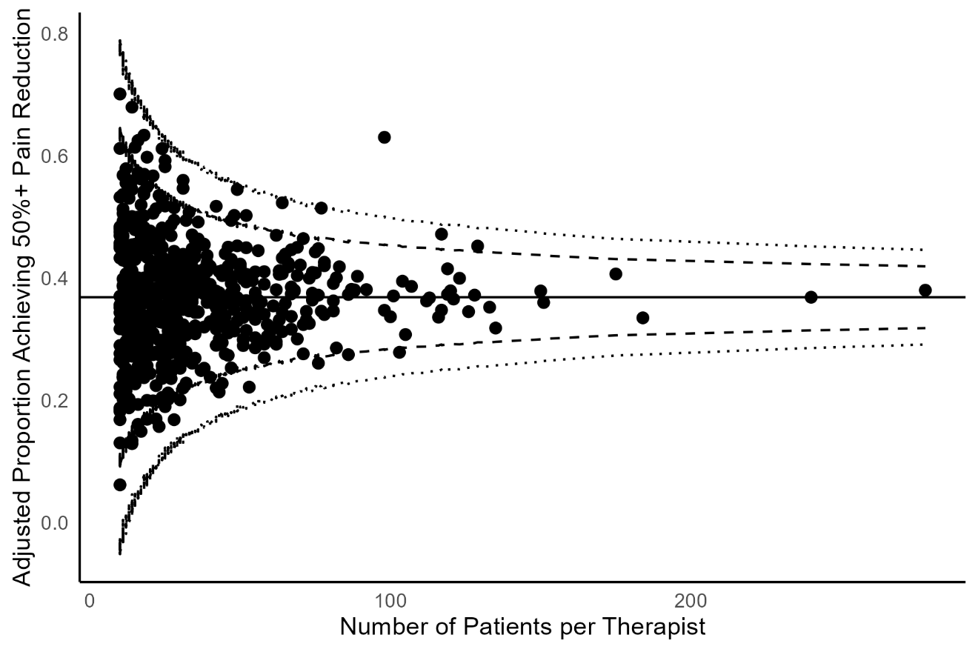

Figure S3. Funnel plot of therapist-specific case-mix-adjusted pain intensity (0-100) outcome at 3 months: multiply imputed data
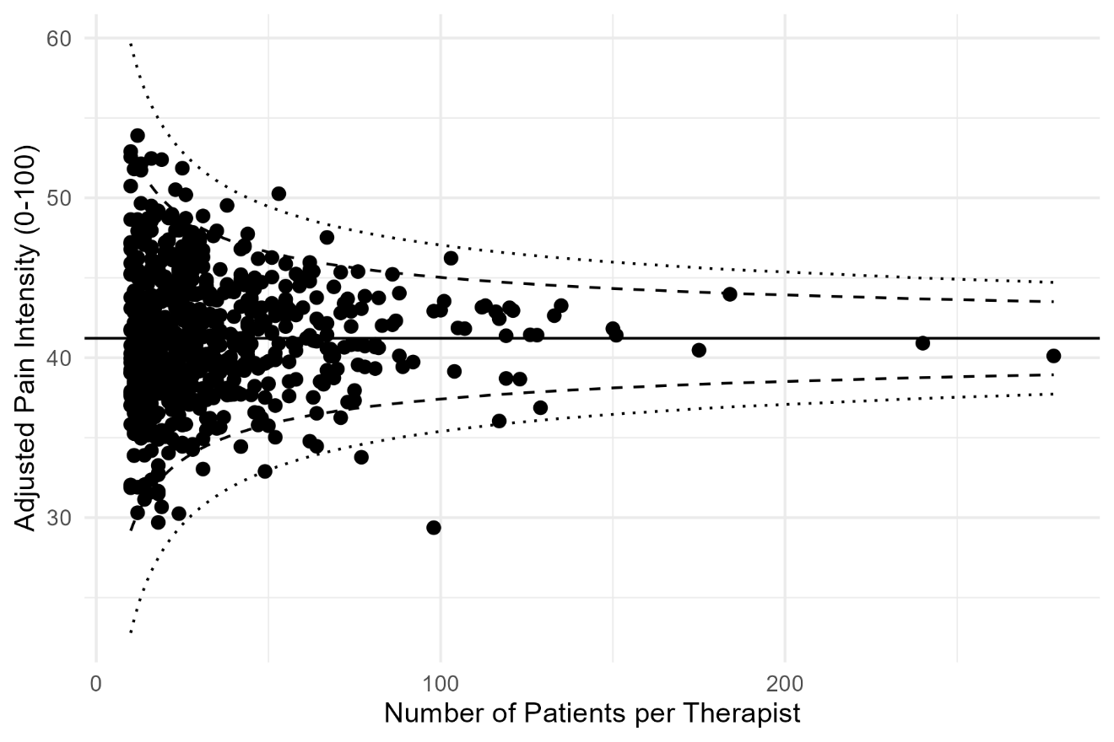
Figure S4. Funnel plot of therapist-specific case-mix-adjusted HOOS/KOOS QOL score (0-100) outcome at 3 months: multiply imputed data
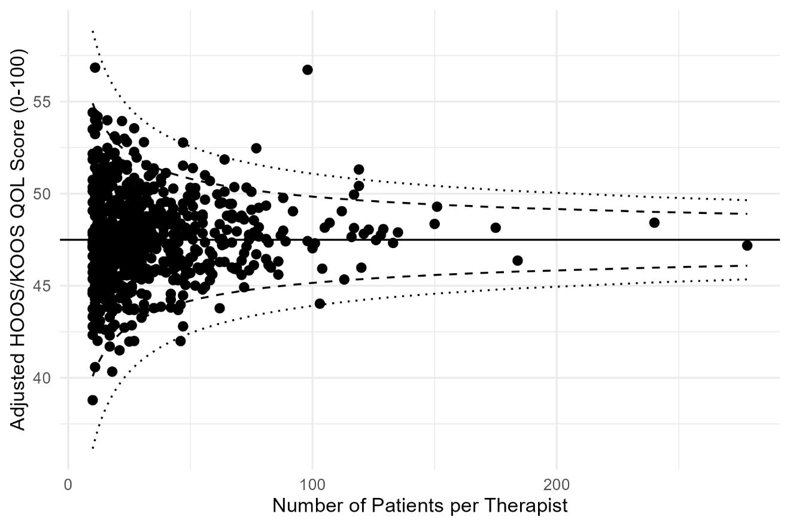
Figure S5. Funnel plot of therapist-specific case-mix-adjusted EQ5D Health Utility Score (-0.757-1.000) at 3 months: multiply imputed data
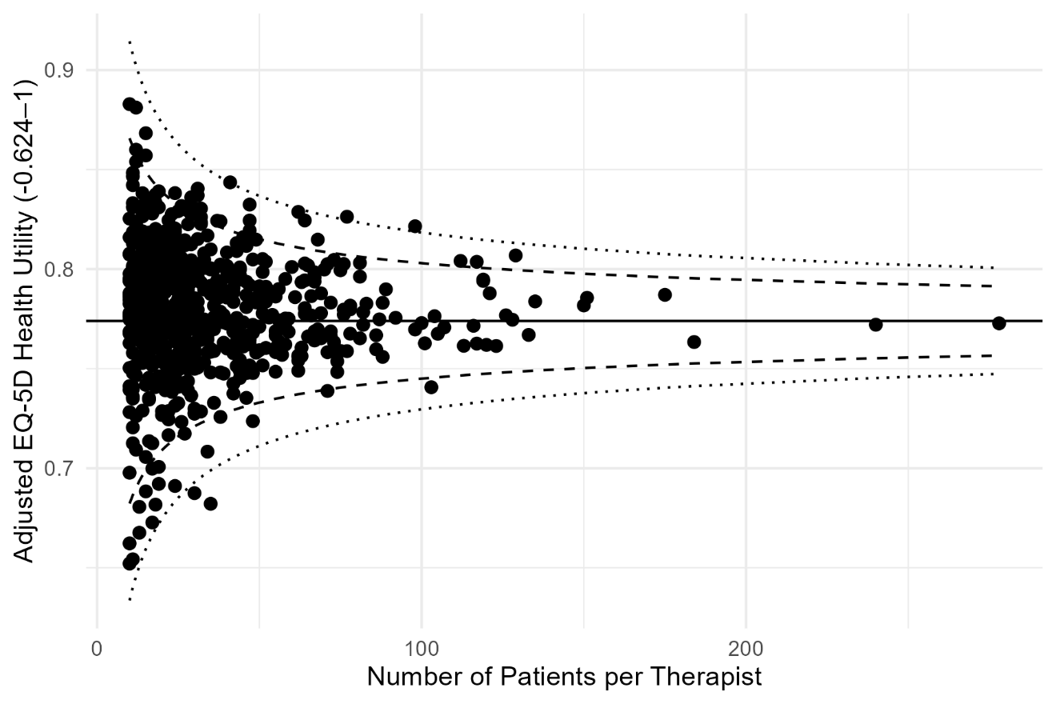
Figure S6. Funnel plot of therapist-specific case-mix-adjusted EQ5D VAS (0-100) at 3 months: multiply imputed data
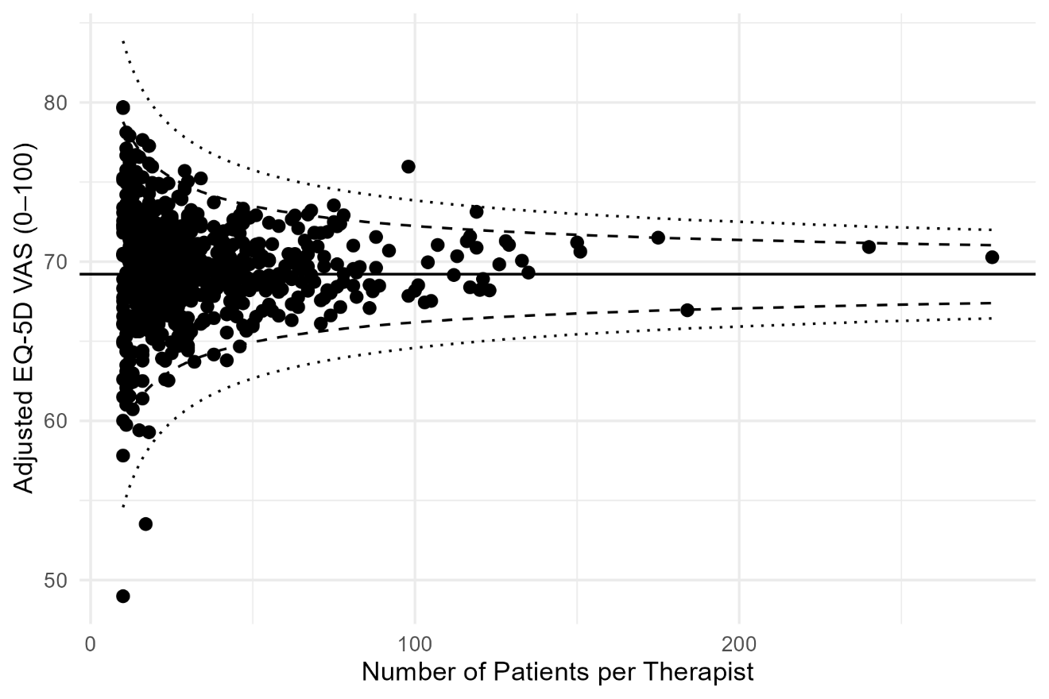
Figure S7. Funnel plot of case-mix-adjusted pain relief50 outcome at 3 months: complete case analysis
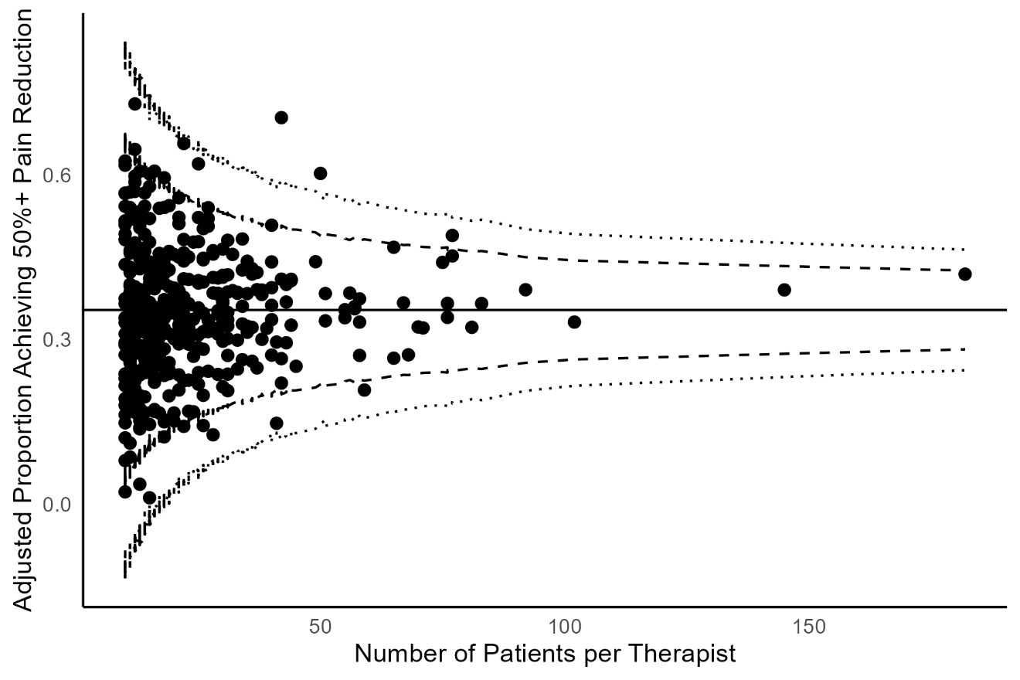

Figure S8. Funnel plot of therapist-specific case-mix-adjusted pain intensity (0-100) outcome at 3 months: complete case analysis
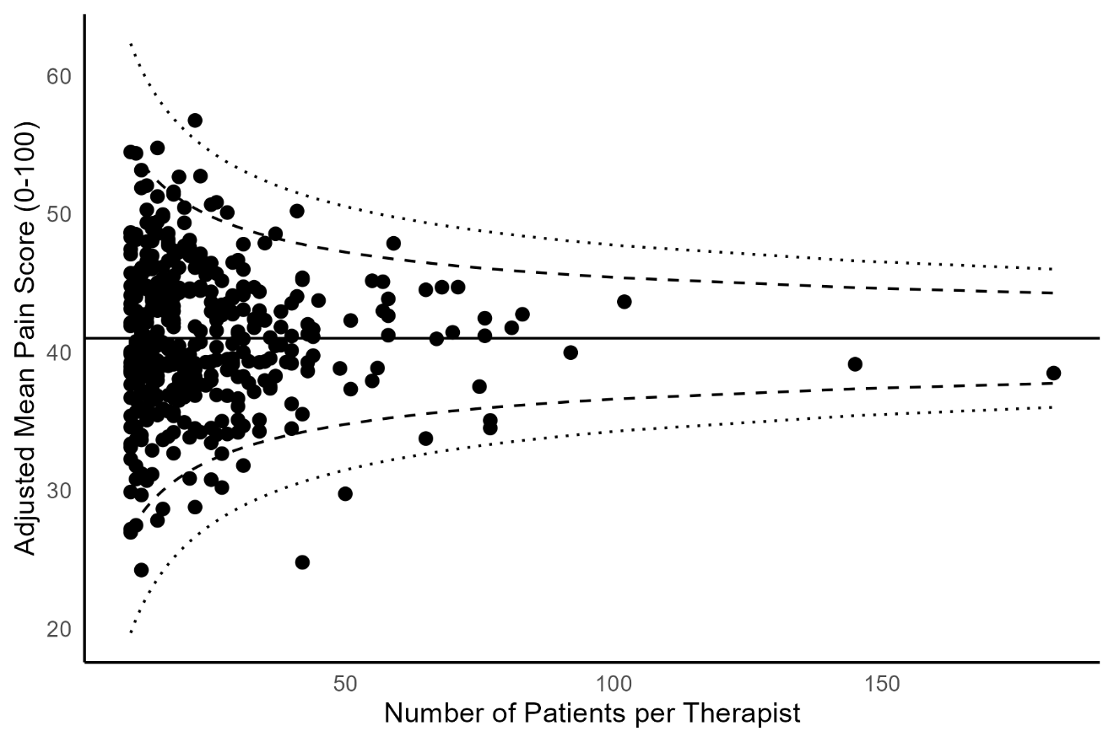
Figure S9. Funnel plot of therapist-specific case-mix-adjusted HOOS/KOOS score (0-100) outcome at 3 months: complete case analysis
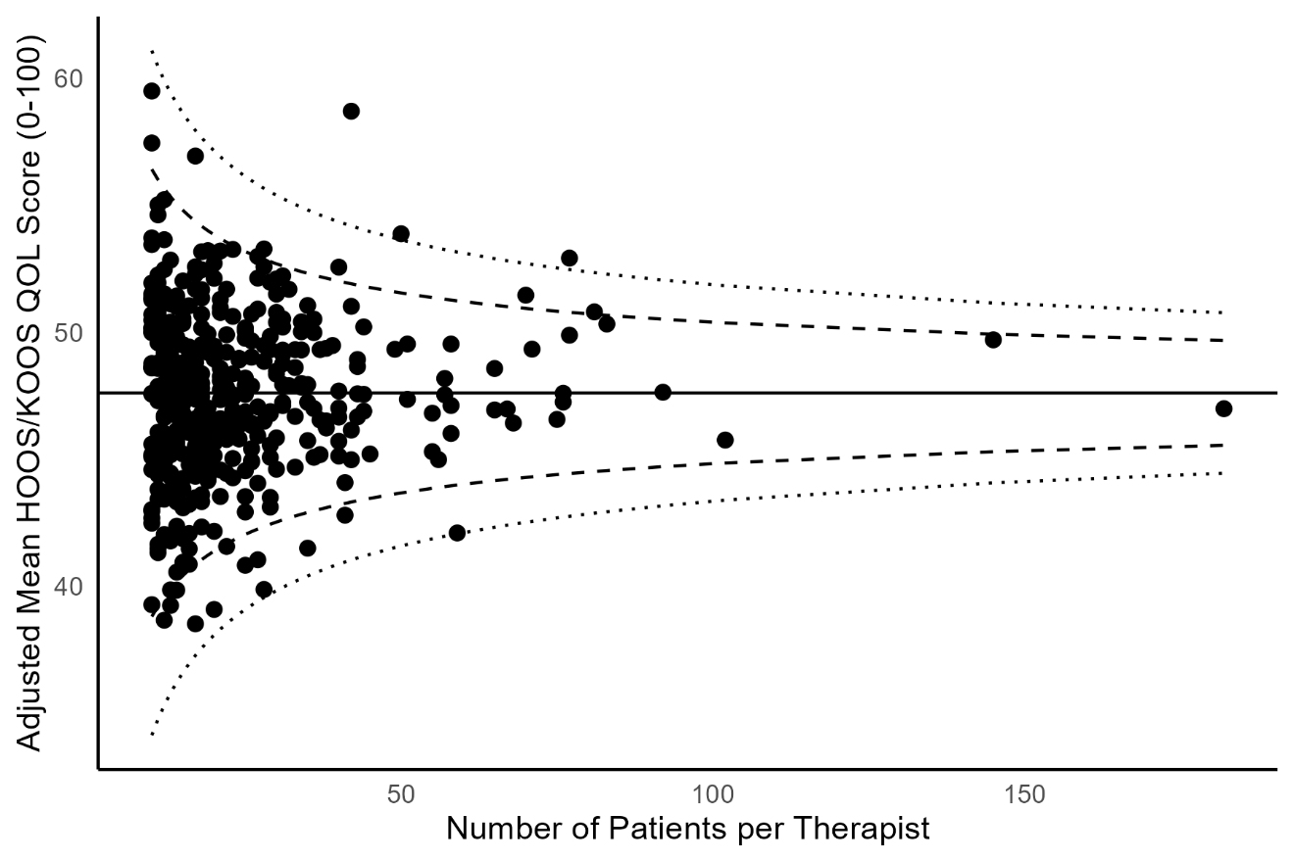
Figure S10. Funnel plot of therapist-specific case-mix-adjusted EQ5D Health Utility Score (-0.757-1.000) at 3 months: complete case analysis
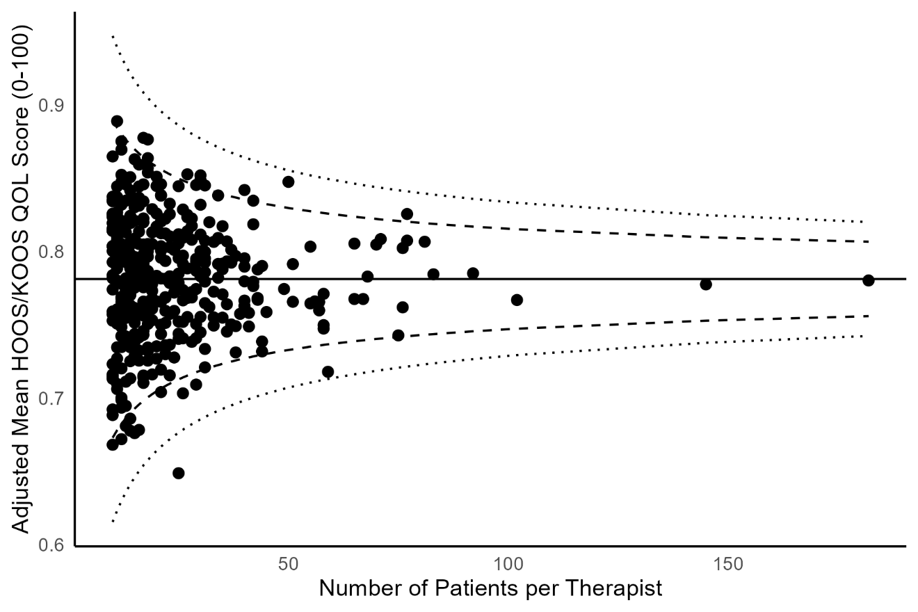
Figure S11. Funnel plot of therapist-specific case-mix-adjusted EQ5D VAS (0-100) at 3 months: complete case analysis
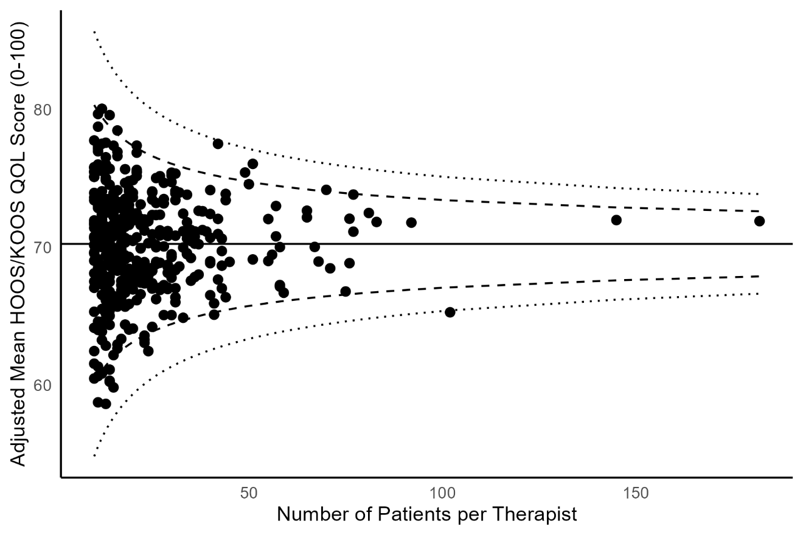
Figure S12. Funnel plot of therapist-specific case-mix-adjusted pain relief30 outcome at 3 months: complete case analysis
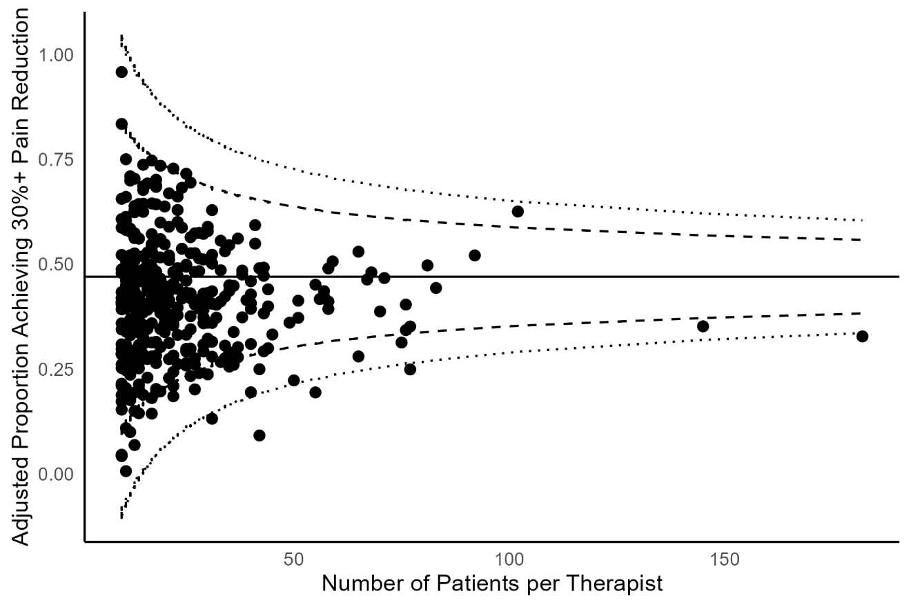

Figure S13. Summary of ICC estimates of ‘therapist effects’ for primary and secondary outcomes, multiply imputed data and complete case analysis